UNITED STATES
SECURITIES AND EXCHANGE COMMISSION
Washington, D.C. 20549

FORM 10-Q

☒ QUARTERLY REPORT UNDER SECTION 13 OR 15(d) OF THE SECURITIES EXCHANGE ACT OF 1934

For the quarterly period ended June 30, 2024

☐ TRANSITION REPORT UNDER SECTION 13 OR 15(d) OF THE EXCHANGE ACT OF 1934

For the transition period from _______ to _______

Commission file number: 001-32501

REED’S, INC.
(Exact name of registrant as specified in its charter)

Delaware |  | 35-2177773
(State of  incorporation) |  | (I.R.S. Employer  Identification No.)

201 Merritt 7, Norwalk, CT. 06851
(Address of principal executive offices) (Zip Code)

(800) 997-3337
(Registrant’s telephone number, including area code)

Securities registered pursuant to Section 12(b) of the Act: None

Title of Each Class |  | Trading Symbol |  | Names of each exchange on which registered

Indicate the number of shares outstanding of each of the issuer’s classes of common stock, as of the latest practicable date: There were a total of 4,187,291 shares of Common Stock outstanding as of May 10, 2024.

Indicate by check mark whether the registrant (1) has filed all reports required to be filed by Section 13 or 15(d) of the Securities Exchange Act of 1934 during the preceding 12 months (or for such shorter period that the registrant was required to file such reports), and (2) has been subject to such filing requirements for the past 90 days.

Yes ☒ No ☐

Indicate by check mark whether the registrant has submitted electronically, every Interactive Data File required to be submitted pursuant to Rule 405 of Regulation S-T (§232.405 of this chapter) during the preceding 12 months (or for such shorter period that the registrant was required to submit such files). Yes ☒ No ☐

Indicate by check mark whether the registrant is a large accelerated filer, an accelerated filer, a non-accelerated filer, a smaller reporting company or an emerging growth company. See definitions of “large accelerated filer,” “accelerated filer,” “smaller reporting company” and “emerging growth company” in Rule 12b-2 of the Exchange Act.:

Large Accelerated Filer ☐ | Accelerated Filer ☐ | Non-Accelerated Filer ☒
Smaller Reporting Company ☒ | Emerging Growth Company ☐

If an emerging growth company, indicate by check mark if the registrant has elected not to use the extended transition period for complying with any new or revised financial accounting standards provided pursuant to Section 13(a) of the Exchange Act. ☐

Indicate by check mark whether the issuer is a shell company (as defined in Rule 12b-2 of the Exchange Act). Yes ☐ No ☒

There are 4,187,291 shares outstanding as of August 1, 2024.

TABLE OF CONTENTS

PART I - FINANCIAL INFORMATION |  | F-1
Item 1. Condensed Financial Statements |  | F-1
Condensed Balance Sheets - June 30, 2024 (Unaudited) and December 31, 2023 |  | F-1
Condensed Statements of Operations for the three and six months ended June 30, 2024 and 2023 (Unaudited) |  | F-2
Condensed Statements of Changes in Stockholders’ Deficit for the three and six months ended June 30, 2024 and 2023 (Unaudited) |  | F-3
Condensed Statements of Cash Flows for the six months ended June 30, 2024 and 2023 (Unaudited) |  | F-4
Notes to Condensed Financial Statements three and six months ended June 30, 2024 and 2023 (Unaudited) |  | F-5
Item 2. Management’s Discussion and Analysis of Financial Condition and Results of Operations |  | 1
Item 3. Quantitative and Qualitative Disclosures About Market Risk |  | 10
Item 4. Controls and Procedures |  | 11
PART II – OTHER INFORMATION |  | 11
Item 1. Legal Proceedings |  | 11
Item 1A. Risk Factors |  | 11
Item 2. Unregistered Sales of Equity Securities and Use of Proceeds |  | 11
Item 3. Defaults Upon Senior Securities |  | 11
Item 4. Mine Safety Disclosures |  | 11
Item 5. Other Information |  | 11
Item 6. Exhibits |  | 11

i

CAUTIONARY STATEMENT REGARDING FORWARD-LOOKING STATEMENTS AND INFORMATION

This report contains statements reflecting our views about our future performance that constitute “forward-looking statements” within the meaning of the Private Securities Litigation Reform Act of 1995 (Reform Act). Statements that constitute forward-looking statements within the meaning of the Reform Act are generally identified through the inclusion of words such as “aim,” “anticipate,” “believe,” “drive,” “estimate,” “expect,” “expressed confidence,” “forecast,” “future,” “goal,” “guidance,” “intend,” “may,” “objective,” “outlook,” “plan,” “position,” “potential,” “project,” “seek,” “should,” “strategy,” “target,” “will” or similar statements or variations of such words and other similar expressions. All statements addressing our future operating performance, and statements addressing events and developments that we expect or anticipate will occur in the future, are forward-looking statements within the meaning of the Reform Act. These forward-looking statements are based on currently available information, operating plans and projections about future events and trends. They inherently involve risks and uncertainties that could cause actual results to differ materially from those predicted in any such forward-looking statement. These risks and uncertainties include, but are not limited to, those described in “Part I, Item 1A. Risk Factors” of our Annual Report on Form 10-K for the fiscal year ended December 31, 2023 (“2023 Form 10-K”) as updated by “Part II, Item 1A” of this report should be considered when evaluating our trends and future results. Investors are cautioned not to place undue reliance on any such forward-looking statements, which speak only as of the date they are made. We undertake no obligation to update any forward-looking statement, whether as a result of new information, future events or otherwise. The discussion of risks in this report is by no means all-inclusive but is designed to highlight what we believe are important factors to consider when evaluating our future performance.

ii

Part I – FINANCIAL INFORMATION

Item 1. Financial Statements

REED’S, INC.
CONDENSED BALANCE SHEETS
(Amounts in thousands, except share amounts)

 |  | June 30,  2024 |  |  |  | December 31,  2023
 |  | (Unaudited)
ASSETS
Current assets:
Cash |  | $ | 326 |  |  | $ | 603
Accounts receivable, net of allowance of $210 and $860, respectively |  |  | 5,297 |  |  |  | 3,571
Inventory |  |  | 10,223 |  |  |  | 11,300
Receivable from former related party |  |  | 259 |  |  |  | 259
Prepaid expenses and other current assets |  |  | 1,621 |  |  |  | 2,028
Total current assets |  |  | 17,726 |  |  |  | 17,761
Property and equipment, net of accumulated depreciation of $1,205 and $1,068, respectively |  |  | 384 |  |  |  | 493
Intangible assets |  |  | 635 |  |  |  | 629
Total assets |  | $ | 18,745 |  |  | $ | 18,883
LIABILITIES AND STOCKHOLDERS’ DEFICIT
Current liabilities:
Accounts payable |  | $ | 8,432 |  |  | $ | 9,133
Accrued expenses |  |  | 946 |  |  |  | 1,096
Revolving line of credit, net of capitalized financing costs of $121 and $201, respectively |  |  | 9,003 |  |  |  | 9,758
Payable to former related party |  |  | 213 |  |  |  | 259
Current portion of convertible notes payable, net of debt discount of $414 and $424, respectively |  |  | 18,407 |  |  |  | 6,737
Current portion of lease liabilities |  |  | 103 |  |  |  | 207
Total current liabilities |  |  | 37,104 |  |  |  | 27,190
SAFE investments |  |  | 5,490 |  |  |  | -
Convertible note payable, net of debt discount of $0 and $148, respectively, less current portion |  |  | - |  |  |  | 10,874
Total liabilities |  |  | 42,594 |  |  |  | 38,064
Stockholders’ deficit:
Series A Convertible Preferred stock, $10 par value, 500,000 shares authorized, 9,411 shares issued and outstanding |  |  | 94 |  |  |  | 94
Common stock, $.0001 par value, 180,000,000 shares authorized; 4,187,291 and 4,187,291 shares issued and outstanding, respectively |  |  | - |  |  |  | -
Additional paid in capital |  |  | 119,674 |  |  |  | 119,452
Accumulated deficit |  |  | (143,617 | ) |  |  | (138,727 | )
Total stockholders’ deficit |  |  | (23,849 | ) |  |  | (19,181 | )
Total liabilities and stockholders’ deficit |  | $ | 18,745 |  |  | $ | 18,883

The accompanying notes are an integral part of these financial statements.

F-1

REED’S, INC.
CONDENSED STATEMENTS OF OPERATIONS
For the Three and Six Months Ended June 30, 2024 and 2023
(Unaudited)
(Amounts in thousands, except share and per share amounts)

 |  | 2024 |  |  |  | 2023 |  |  |  | 2024 |  |  |  | 2023
 |  | Three Months Ended  June 30, |  |  |  |  |  |  |  | Six Months Ended  June 30,
 |  | 2024 |  |  |  | 2023 |  |  |  | 2024 |  |  |  | 2023
Net Sales |  | $ | 11,874 |  |  | $ | 10,005 |  |  | $ | 21,469 |  |  | $ | 21,162
Cost of goods sold |  |  | 8,043 |  |  |  | 7,496 |  |  |  | 14,225 |  |  |  | 15,955
Gross profit |  |  | 3,831 |  |  |  | 2,509 |  |  |  | 7,244 |  |  |  | 5,207
Operating expenses:
Delivery and handling expense |  |  | 1,423 |  |  |  | 1,686 |  |  |  | 2,925 |  |  |  | 3,806
Selling and marketing expense |  |  | 1,097 |  |  |  | 1,259 |  |  |  | 2,190 |  |  |  | 2,706
General and administrative expense |  |  | 1,980 |  |  |  | 1,311 |  |  |  | 3,448 |  |  |  | 3,020
Total operating expenses |  |  | 4,500 |  |  |  | 4,256 |  |  |  | 8,563 |  |  |  | 9,532
Loss from operations |  |  | (669 | ) |  |  | (1,747 | ) |  |  | (1,319 | ) |  |  | (4,325 | )
Interest expense |  |  | (1,150 | ) |  |  | (1,387 | ) |  |  | (2,173 | ) |  |  | (3,166 | )
Change in fair value of SAFE investments |  |  | (1,393 | ) |  |  | - |  |  |  | (1,393 | ) |  |  | -
Net loss |  |  | (3,212 | ) |  |  | (3,134 | ) |  |  | (4,885 | ) |  |  | (7,491 | )
Dividends on Series A Convertible Preferred Stock |  |  | (5 | ) |  |  | (5 | ) |  |  | (5 | ) |  |  | (5 | )
Net Loss Attributable to Common Stockholders |  | $ | (3,217 | ) |  | $ | (3,139 | ) |  | $ | (4,890 | ) |  | $ | (7,496 | )
Loss per share – basic and diluted |  | $ | (0.77 | ) |  | $ | (0.99 | ) |  | $ | (1.17 | ) |  | $ | (2.59 | )
Weighted average number of shares outstanding – basic and diluted |  |  | 4,187,291 |  |  |  | 3,179,661 |  |  |  | 4,187,291 |  |  |  | 2,892,860

The accompanying notes are an integral part of these condensed financial statements.

F-2

REED’S, INC.
CONDENSED STATEMENTS OF CHANGES IN STOCKHOLDERS’ DEFICIT
For the Three and Six Months Ended June 30, 2024 and 2023
(Unaudited)
(Amounts in thousands except share amounts)

 |  | Shares |  |  |  | Amount |  |  |  | Shares |  |  |  | Amount |  |  |  | Capital |  |  |  | Deficit |  |  |  | Deficit
 |  | Common Stock |  |  |  |  |  |  |  | Preferred Stock |  |  |  |  |  |  |  | Additional Paid In |  |  |  | Accumulated |  |  |  | Total Stockholders’
 |  | Shares |  |  |  | Amount |  |  |  | Shares |  |  |  | Amount |  |  |  | Capital |  |  |  | Deficit |  |  |  | Deficit
Balance, March 31, 2024 |  |  | 4,187,291 |  |  | $ | - |  |  |  | 9,411 |  |  | $ | 94 |  |  | $ | 119,581 |  |  | $ | (140,400 | ) |  | $ | (20,725 | )
Fair value of vested options |  |  |  |  |  |  |  |  |  |  |  |  |  |  |  |  |  |  | 93 |  |  |  |  |  |  |  | 93
Dividends on Series A Convertible Preferred Stock |  |  | - |  |  |  | - |  |  |  |  |  |  |  | - |  |  |  |  |  |  |  | (5 | ) |  |  | (5 | )
Net loss |  |  |  |  |  |  |  |  |  |  | - |  |  |  | - |  |  |  | - |  |  |  | (3,212 | ) |  |  | (3,212 | )
Balance, June 30, 2024 |  |  | 4,187,291 |  |  | $ | - |  |  |  | 9,411 |  |  | $ | 94 |  |  | $ | 119,674 |  |  | $ | (143,617 | ) |  | $ | (23,849 | )

 |  | Shares |  |  |  | Amount |  |  |  | Shares |  |  |  | Amount |  |  |  | Capital |  |  |  | Deficit |  |  |  | Deficit
 |  | Common Stock |  |  |  |  |  |  |  | Preferred Stock |  |  |  |  |  |  |  | Additional Paid In |  |  |  | Accumulated |  |  |  | Total Stockholders’
 |  | Shares |  |  |  | Amount |  |  |  | Shares |  |  |  | Amount |  |  |  | Capital |  |  |  | Deficit |  |  |  | Deficit
Balance, December 31, 2023 |  |  | 4,187,291 |  |  | $ | - |  |  |  | 9,411 |  |  | $ | 94 |  |  | $ | 119,452 |  |  | $ | (138,727 | ) |  | $ | (19,181 | )
Fair value of vested options |  |  |  |  |  |  |  |  |  |  |  |  |  |  |  |  |  |  | 222 |  |  |  |  |  |  |  | 222
Dividends on Series A Convertible Preferred Stock |  |  | - |  |  |  | - |  |  |  |  |  |  |  | - |  |  |  |  |  |  |  | (5 | ) |  |  | (5 | )
Net loss |  |  |  |  |  |  |  |  |  |  | - |  |  |  | - |  |  |  | - |  |  |  | (4,885 | ) |  |  | (4,885 | )
Balance, June 30, 2024 |  |  | 4,187,291 |  |  | $ | - |  |  |  | 9,411 |  |  | $ | 94 |  |  | $ | 119,674 |  |  | $ | (143,617 | ) |  | $ | (23,849 | )

 |  | Shares |  |  |  | Amount |  |  |  | Shares |  |  |  | Amount |  |  |  | Capital |  |  |  | Deficit |  |  |  | Deficit
 |  | Common Stock |  |  |  |  |  |  |  | Preferred Stock |  |  |  |  |  |  |  | Additional Paid In |  |  |  | Accumulated |  |  |  | Total Stockholders’
 |  | Shares |  |  |  | Amount |  |  |  | Shares |  |  |  | Amount |  |  |  | Capital |  |  |  | Deficit |  |  |  | Deficit
Balance, March 31, 2023 |  |  | 2,602,399 |  |  | $ | - |  |  |  | 9,411 |  |  | $ | 94 |  |  | $ | 115,140 |  |  | $ | (127,556 | ) |  | $ | (12,322 | )
Fair value of vested options |  |  |  |  |  |  |  |  |  |  |  |  |  |  |  |  |  |  | (18 | ) |  |  |  |  |  |  | (18 | )
Dividends on Series A Convertible Preferred Stock |  |  | - |  |  |  | - |  |  |  |  |  |  |  | - |  |  |  |  |  |  |  | (5 | ) |  |  | (5 | )
Common shares issued for cash, net of offering costs |  |  | 1,566,732 |  |  |  | - |  |  |  |  |  |  |  |  |  |  |  | 4,016 |  |  |  |  |  |  |  | 4,016
Net loss |  |  |  |  |  |  |  |  |  |  | - |  |  |  | - |  |  |  | - |  |  |  | (3,134 | ) |  |  | (3,134 | )
Balance, June 30, 2023 |  |  | 4,169,131 |  |  | $ | - |  |  |  | 9,411 |  |  | $ | 94 |  |  | $ | 119,138 |  |  | $ | (130,695 | ) |  | $ | (11,463 | )

 |  | Shares |  |  |  | Amount |  |  |  | Shares |  |  |  | Amount |  |  |  | Capital |  |  |  | Deficit |  |  |  | Deficit
 |  | Common Stock |  |  |  |  |  |  |  | Preferred Stock |  |  |  |  |  |  |  | Additional Paid In |  |  |  | Accumulated |  |  |  | Total Stockholders’
 |  | Shares |  |  |  | Amount |  |  |  | Shares |  |  |  | Amount |  |  |  | Capital |  |  |  | Deficit |  |  |  | Deficit
Balance, December 31, 2022 |  |  | 2,519,485 |  |  | $ | - |  |  |  | 9,411 |  |  | $ | 94 |  |  | $ | 114,635 |  |  | $ | (123,199 | ) |  | $ | (8,470 | )
Balance |  |  | 2,519,485 |  |  | $ | - |  |  |  | 9,411 |  |  | $ | 94 |  |  | $ | 114,635 |  |  | $ | (123,199 | ) |  | $ | (8,470 | )
Fair value of vested options |  |  |  |  |  |  |  |  |  |  |  |  |  |  |  |  |  |  | 211 |  |  |  |  |  |  |  | 211
Fair value of vested restricted shares granted to officers |  |  | 750 |  |  |  |  |  |  |  |  |  |  |  |  |  |  |  | 4 |  |  |  |  |  |  |  | 4
Repurchase of common stock |  |  | (274 | ) |  |  |  |  |  |  |  |  |  |  |  |  |  |  | (1 | ) |  |  |  |  |  |  | (1 | )
Common shares issued for financing costs |  |  | 82,438 |  |  |  |  |  |  |  |  |  |  |  |  |  |  |  | 273 |  |  |  |  |  |  |  | 273
Dividends on Series A Convertible Preferred Stock |  |  | - |  |  |  | - |  |  |  |  |  |  |  | - |  |  |  |  |  |  |  | (5 | ) |  |  | (5 | )
Common shares issued for cash, net of offering costs |  |  | 1,566,732 |  |  |  | - |  |  |  |  |  |  |  |  |  |  |  | 4,016 |  |  |  |  |  |  |  | 4,016
Net loss |  |  |  |  |  |  |  |  |  |  | - |  |  |  | - |  |  |  | - |  |  |  | (7,491 | ) |  |  | (7,491 | )
Balance, June 30, 2023 |  |  | 4,169,131 |  |  | $ | - |  |  |  | 9,411 |  |  | $ | 94 |  |  | $ | 119,138 |  |  | $ | (130,695 | ) |  | $ | (11,463 | )
Balance |  |  | 4,169,131 |  |  | $ | - |  |  |  | 9,411 |  |  | $ | 94 |  |  | $ | 119,138 |  |  | $ | (130,695 | ) |  | $ | (11,463 | )

The accompanying notes are an integral part of these condensed financial statements.

F-3

REED’S, INC.
CONDENSED STATEMENTS OF CASH FLOWS
For the Six Months Ended June 30, 2024 and 2023
(Unaudited)
(Amounts in thousands)

 |  | June 30,  2024 |  |  |  | June 30,  2023
Cash flows from operating activities:
Net loss |  | $ | (4,885 | ) |  | $ | (7,491 | )
Adjustments to reconcile net loss to net cash used in operating activities:
Depreciation |  |  | 58 |  |  |  | 79
Loss on disposal of property and equipment |  |  |  |  |  |  | 9
Amortization of debt discount |  |  | 390 |  |  |  | 712
Fair value of vested options |  |  | 222 |  |  |  | 213
Fair value of vested restricted shares granted to officers |  |  |  |  |  |  | 3
Change in the fair value of SAFE investments |  |  | 1,393 |  |  |  | -
Change in allowance for doubtful accounts |  |  | (650 | ) |  |  | 54
Inventory write-downs |  |  | (1,009 | ) |  |  | (207 | )
Accrued interest |  |  | 638 |  |  |  | 1,773
Changes in operating assets and liabilities:
Accounts receivable |  |  | (1,075 | ) |  |  | 1,882
Inventory |  |  | 2,086 |  |  |  | 2,692
Prepaid expenses and other assets |  |  | (594 | ) |  |  | 59
Decrease in right of use assets |  |  | 79 |  |  |  | 67
Accounts payable |  |  | 299 |  |  |  | (2,603 | )
Accrued expenses |  |  | (155 | ) |  |  | 560
Lease liabilities |  |  | (104 | ) |  |  | (90 | )
Net cash used in operating activities |  |  | (3,307 | ) |  |  | (2,288 | )
Cash flows from investing activities:
Trademark costs |  |  | (6 | ) |  |  | (1 | )
Purchase of property and equipment |  |  | (28 | ) |  |  | -
Sale of property and equipment |  |  | - |  |  |  | 68
Net cash provided by in investing activities |  |  | (34 | ) |  |  | 67
Cash flows from financing activities:
Proceeds from line of credit |  |  | 19,501 |  |  |  | 19,099
Payments on line of credit |  |  | (20,336 | ) |  |  | (23,594 | )
Proceeds from convertible note payable, net of expenses |  |  | - |  |  |  | 3,797
Payment of convertible note payable |  |  |  |  |  |  | (268 | )
Proceeds from sale of common stock |  |  | - |  |  |  | 4,016
Proceeds from SAFE agreement |  |  | 4,097 |  |  |  | -
Repurchase of common stock |  |  | - |  |  |  | (1 | )
Payment of cash recorded as debt discount |  |  | (152 | ) |  |  | -
Amounts from former related party, net |  |  | (46 | ) |  |  | (914 | )
Net cash provided by financing activities |  |  | 3,064 |  |  |  | 2,135
Net decrease in cash |  |  | (277 | ) |  |  | (86 | )
Cash at beginning of period |  |  | 603 |  |  |  | 533
Cash at end of period |  | $ | 326 |  |  | $ | 447
Supplemental disclosures of cash flow information:
Cash paid for interest |  | $ | 1,146 |  |  | $ | 658
Non-cash investing and financing activities:
Dividends on Series A Convertible Preferred Stock |  | $ | 5 |  |  | $ | 5

The accompanying notes are an integral part of these condensed financial statements.

F-4

REED’S, INC.
NOTES TO CONDENSED FINANCIAL STATEMENTS
Three and Six Months Ended June 30, 2024 and 2023 (Unaudited)
(In thousands, except share and per share amounts)

1. Summary of Significant Accounting Policies

Basis of Presentation

The accompanying condensed financial statements of Reed’s, Inc. (the “Company”, “we”, “us”, or “our”), have been prepared in conformity with accounting principles generally accepted in the United States of America (“U.S. GAAP”) and the applicable rules and regulations of the Securities and Exchange Commission (the “SEC”) regarding interim financial reporting. Certain information and note disclosures normally included in the financial statements prepared in accordance with U.S. GAAP have been condensed or omitted pursuant to such rules and regulations. We believe that the disclosures contained in these condensed financial statements are adequate to make the information presented herein not misleading. These condensed financial statements should be read in conjunction with the financial statements contained in the Company’s Annual Report on Form 10-K for the year ended December 31, 2023, filed with the SEC on April 1, 2024. The accompanying condensed financial statements are unaudited, but in the opinion of management contain all adjustments, including normal recurring adjustments, necessary to present fairly the Company’s financial position as of June 30, 2024, and the results of its operations and its cash flows for the six months ended June 30, 2024 and 2023. The balance sheet as of December 31, 2023 is derived from the Company’s audited financial statements.

The results of operations for the six months ended June 30, 2024, are not necessarily indicative of the results of operations to be expected for the full fiscal year ending December 31, 2024.

Going Concern

The accompanying financial statements have been prepared on a going concern basis, which contemplates the realization of assets and the settlement of liabilities and commitments in the normal course of business. As reflected in the accompanying financial statements, for the six months ended June 30, 2024, the Company recorded a net loss of $4,885, and utilized $3,307 of cash in operations and at June 30, 2024, had a working capital deficiency of $19,378 and a stockholders’ deficit of $23,849. As of June 30, 2024, the Company borrowed $9,124 on its line of credit and owed $18,821 on its Notes (See Note 5 and Note 6 for further detail). These factors raise substantial doubt about the Company’s ability to continue as a going concern within one year of the date that the financial statements are issued. The financial statements do not include any adjustments related to the recoverability and classification of recorded asset amounts or the amounts and classification of liabilities that might be necessary should the Company be unable to continue as a going concern.

As of June 30, 2024, we had a cash balance of $326, no availability under our line of credit and $3,876 of additional borrowing capacity from the credit facility assuming there is availability under the terms.

On July 26, 2024, Norman E. Snyder Jr, CEO of the Company, provided a personal guaranty for a $500 over advance on our existing line of credit with ACS. On August 1, 2024, the Company funded $1,400 pursuant to an option exercise by Whitebox under the Option Notes.

Historically, we have financed our operations through public and private sales of common stock, issuance of preferred and common stock, convertible debt instruments, term loans and credit lines from financial institutions, and cash generated from operations. To alleviate these conditions, management is currently evaluating various funding alternatives and may seek to raise additional funds through the issuance of equity, mezzanine or debt securities, through arrangements with strategic partners or through obtaining credit from financial institutions. The Company is continuing to discuss restructuring of debt with existing lenders and is exploring new financing opportunities to address the line of credit which comes due in March 2025 (see Note 5) and the portion of the debt under the Notes which comes due on December 15, 2024 (see Note 6). As we seek additional sources of financing, there can be no assurance that such financing would be available to us on favorable terms or at all. Our ability to obtain additional financing in the debt and equity capital markets is subject to several factors, including market and economic conditions, our performance and investor sentiment with respect to us and our industry.

We have also taken decisive action to improve our margins, including fully outsourcing our manufacturing process, streamlining our product portfolio, negotiating improved vendor contracts and restructuring our selling prices.

F-5

Recent Trends - Market Conditions

Although the U.S. economy continued to grow throughout 2023 and into Q2 2024, the higher inflation, the actions by the Federal Reserve to address inflation, and rising energy prices create uncertainty about the future economic environment which will continue to evolve and may impact our business in future periods. We have experienced supply chain challenges, including increased lead times, as well as inflation of raw materials, logistics and labor costs due to availability constraints and high demand. Although we regularly monitor companies in our supply chain, and use alternative suppliers when necessary and available, supply chain constraints could cause a disruption in our ability to obtain raw materials required to manufacture our products and adversely affect our operations.

During the three months ending June 30, 2024, the Company continued to experience moderation from the elevated freight costs experienced in 2023. The average cost of shipping and handling for the three months ended June 30, 2024, was $2.18 as compared to $3.05 in the three months ended June 30, 2023. During the six months ended June 30, 2024, the average cost of shipping and handling was $2.54 per case, as compared to $3.27 per case for the six months ended June 30, 2023. Although the Company has experienced decreases in freight costs over the last four quarters, in the Company’s opinion there remains a volatile environment and the Company will continue to monitor pricing and availability in transportation. Mitigation plans have been implemented to manage this risk. The Company has been negatively impacted by supply chain challenges affecting our ability to benefit from strong demand for, and increased sales of our product. The disruption caused by labor shortages, significant raw material cost inflation, logistics issues and increased freight costs, and ongoing port congestion, resulted in suppressed margins. The Company has experienced moderation in inflation and anticipates this to continue throughout 2024.

Use of Estimates

The preparation of financial statements in conformity with generally accepted accounting principles requires management to make estimates and assumptions that affect the reported amounts of assets and liabilities, disclosures of contingent assets and liabilities at the date of the financial statements, and the reported amounts of revenues and expenses during the reporting period. Actual results could differ from those estimates. Those estimates and assumptions include estimates for credit loss reserves for accounts receivable, assumptions used in valuing inventories at net realizable value, impairment testing of recorded long-term tangible and intangible assets, the valuation allowance for deferred tax assets, accruals for potential liabilities, assumptions made in valuing stock instruments issued for services, assumptions in determining the fair value of our safe investments and assumptions used in the determination of the Company’s liquidity.

Revenue Recognition

The Company recognizes revenue in accordance with Accounting Standards Codification (ASC) 606, Revenue from Contracts with Customers (“ASC 606”). Revenue and costs of sales are recognized when control of the products transfers to our customer, which generally occurs upon shipment from our facilities. The Company’s performance obligations are satisfied at that time. The Company does not have any significant contracts with customers requiring performance beyond delivery, and contracts with customers contain no incentives or discounts that could cause revenue to be allocated or adjusted over time. Shipping and handling activities are performed before the customer obtains control of the goods and therefore represent a fulfilment activity rather than a promised service to the customer. All of the Company’s products are offered for sale as finished goods only, and there are no performance obligations required post-shipment for customers to derive the expected value from them.

The Company does not allow for returns, except for damaged products when the damage occurred pre-fulfilment. Damaged product returns have historically been insignificant. Because of this, the stand-alone nature of our products, and our assessment of performance obligations and transaction pricing for our sales contracts, we do not currently maintain a contract asset or liability balance for obligations. We assess our contracts and the reasonableness of our conclusions on a quarterly basis.

Loss per Common Share

Basic earnings (loss) per share is computed by dividing the net income (loss) applicable to common stockholders by the weighted average number of shares of common stock outstanding during the year, excluding shares of unvested restricted common stock. Shares of restricted stock are included in the basic weighted average number of common shares outstanding from the time they vest. Diluted earnings (loss) per share is computed by dividing the net income applicable to common stockholders by the weighted average number of common shares outstanding plus the number of additional common shares that would have been outstanding if all dilutive potential common shares had been issued, using the treasury stock method. Shares of restricted stock are included in the diluted weighted average number of common shares outstanding from the date they are granted. Potential common shares are excluded from the computation when their effect is antidilutive.

F-6

For the periods ended June 30, 2024 and 2023, the calculations of basic and diluted loss per share are the same because potential dilutive securities would have had an anti-dilutive effect. The potentially dilutive securities consisted of the following:

Schedule of Potentially Dilutive Securities
 |  | June 30,  2024 |  |  |  | June 30,  2023
Warrants |  |  | 549,292 |  |  |  | 549,292
Options |  |  | 139,869 |  |  |  | 152,035
Convertible note payable |  |  | 1,563,309 |  |  |  | 1,415,826
Common stock equivalent of Series A Convertible Preferred stock |  |  | 753 |  |  |  | 753
Total |  |  | 2,253,223 |  |  |  | 2,117,906

Stock Compensation Expense

The Company periodically issues stock options and restricted stock awards to employees and non-employees in non-capital raising transactions for services and for financing costs. The Company accounts for such grants issued and vesting based on ASC 718, Compensation-Stock Compensation whereby the value of the award is measured on the date of grant and recognized for employees as compensation expense on the straight-line basis over the vesting period. Recognition of compensation expense for non-employees is in the same period and manner as if the Company had paid cash for the services. The Company recognizes the fair value of stock-based compensation within its Statements of Operations with classification depending on the nature of the services rendered.

The fair value of the Company’s stock options is estimated using the Black-Scholes-Merton Option Pricing model, which uses certain assumptions related to risk-free interest rates, expected volatility, expected life of the stock options or restricted stock, and future dividends. Compensation expense is recorded based upon the value derived from the Black-Scholes-Merton Option Pricing model and based on actual experience. The assumptions used in the Black-Scholes-Merton Option Pricing model could materially affect compensation expense recorded in future periods.

Advertising Costs

Advertising costs are expensed as incurred and are included in selling and marketing expense. Advertising costs for the three months ended June 30, 2024, and 2023, aggregated $13 and $27, respectively. Advertising costs for the six months ended June 30, 2024, and 2023, aggregated $30 and $83, respectively.

Concentrations

Net sales. During the three months ended June 30, 2024, three customers accounted for 20%, 15%, and 13% of gross billing, respectively, and during the six months ended June 30, 2024, three customers accounted for 18%, 15%, and 12% of gross billing, respectively. During the three months ended June 30, 2023, three customers accounted for 18%, 12%, and 12% of gross billing, respectively, and during the six months ended June 30, 2023, two customers accounted for 18% and 12% of gross billing, respectively. No other customers exceeded 10% of sales in either period.

Accounts receivable. As of June 30, 2024, the Company had accounts receivable from two customers which comprised 31% and 11% of its gross accounts receivable, respectively. As of December 31, 2023, the Company had accounts receivable from three customers which comprised 24%, 15% and 11% of its gross accounts receivable, respectively. No other customers exceeded 10% of gross accounts receivable in either period.

The Company utilizes co-packers to produce 100% of its products. During the six months ended June 30, 2024 and the year ended December 31, 2023, the Company utilized six separate co-packers for most its production and bottling of beverage products in the United States. The Company has long-standing relationships with two different co-packers, and a third co-packing agreement with California Custom Beverage LLC (“CCB”), a former related party (see Note 11). Although there are other packers, a change in co-packers may cause a delay in the production process, which could ultimately affect operating results.

F-7

Purchases from vendors. During the six months ended June 30, 2024, the Company’s two largest vendors accounted for approximately 11% and 11% of all purchases. During the six months ended June 30, 2023, the Company’s largest vendor accounted for approximately 11% of all purchases. No other vendors exceeded 10% of all purchases in either period.

Accounts payable. As of June 30, 2024, one vendor accounted for 17% of total accounts payable. As of December 31, 2023, two vendors accounted for 10% and 10% of total accounts payable, respectively. No other vendors exceeded 10% of accounts payable in either period.

Fair Value of Financial Instruments

The Company uses various inputs in determining the fair value of its financial assets and liabilities and measures these assets on a recurring basis. Financial assets recorded at fair value are categorized by the level of subjectivity associated with the inputs used to measure their fair value. ASC 820 defines the following levels of subjectivity associated with the inputs:

Level 1—Quoted prices in active markets for identical assets or liabilities.
Level 2—Inputs, other than the quoted prices in active markets, that are observable either directly or indirectly.
Level 3—Unobservable inputs based on the Company’s assumptions.

The carrying amounts of financial assets and liabilities, such as cash and cash equivalents, accounts receivable, short-term bank loans, accounts payable, notes payable and other payables, approximate their fair values because of the short maturity of these instruments. The carrying values of capital lease obligations and long-term financing obligations approximate their fair values because interest rates on these obligations are based on prevailing market interest rates.

The fair value of our liability under our SAFE investments are determined using level 3 inputs.

Reclassifications

Certain prior year amounts have been reclassified for consistency with the current period presentation. Collection from customers amounting to $1,217 that was previously presented as a deduction from prepaid expenses at December 31, 2023 have been reclassed as an offset against accounts receivable. This reclassification had no effect on the reported results of operations or cash flows.

Recent Accounting Pronouncements

In November 2023, the FASB issued ASU 2023-07, Segment Reporting (Topic 280): Improvements to Reportable Segment Disclosure, which is intended to improve reportable segment disclosure requirements, primarily through enhanced disclosures about significant segment expense categories that are regularly provided to the chief operating decision maker and included in each reported measure of a segment’s profit or loss. The update also requires all annual disclosures about a reportable segment’s profit or loss and assets to be provided in interim periods and for entities with a single reportable segment to provide all the disclosures required by ASC 280, Segment Reporting, including the significant segment expense disclosures. This standard became effective for the Company on January 1, 2024. to The adoption of 2023-7 did not have a material impact on the Company’s results of operations, financial position or cash flows.

In September 2022, the Financial Accounting Standards Board (FASB) issued Accounting Standards Update (ASU) 2022-04, Liabilities—Supplier Finance Programs (Subtopic 405-50): Disclosure of Supplier Finance Program Obligations. The ASU requires buyers to disclose information about their supplier finance programs. Interim and annual requirements include the disclosure of outstanding amounts under the obligations as of the end of the reporting period, and annual requirements include a roll-forward of those obligations for the annual reporting period, as well as a description of payment and other key terms of the programs. This update is effective for annual periods beginning after December 15, 2022, and interim periods within those fiscal years, except for the requirement to disclose roll-forward information, which is effective for fiscal years beginning after December 15, 2023. The Company adopted ASU 2022-04 on January 1, 2023, and there was no material impact on our financial statements.

F-8

Other recent accounting pronouncements and guidance issued by the FASB, its Emerging Issues Task Force, the American Institute of Certified Public Accountants, and the Securities and Exchange Commission did not or are not believed by management to have a material impact on the Company’s present or future financial statements.

2. Inventory

Inventory is valued at the lower of cost (first-in, first-out) or net realizable value, net of write downs, and is comprised of the following (in thousands):

Schedule of Inventory
 |  | June 30,  2024 |  |  |  | December 31,  2023
Raw materials and packaging |  | $ | 6,806 |  |  | $ | 6,445
Finished products |  |  | 3,417 |  |  |  | 4,855
Total |  | $ | 10,223 |  |  | $ | 11,300

3. Property and Equipment

Property and equipment are comprised of the following (in thousands):

Schedule of Property and Equipment
 |  | June 30,  2024 |  |  |  | December 31,  2023
Right-of-use assets under operating leases |  | $ | 724 |  |  | $ | 724
Computer hardware and software |  |  | 400 |  |  |  | 400
Machinery and equipment |  |  | 352 |  |  |  | 352
Construction in progress |  |  | 113 |  |  |  | 85
Total cost |  |  | 1,589 |  |  |  | 1,561
Accumulated depreciation and amortization |  |  | (1,205 | ) |  |  | (1,068 | )
Net book value |  | $ | 384 |  |  | $ | 493

Depreciation expense for the six months ended June 30, 2024 and 2023 was $58 and $79, respectively, and amortization of right-of-use assets for the six months ended June 30, 2024 and 2023 was $79 and $67, respectively.

4. Intangible Assets

Intangible assets consist of the following (in thousands):

Summary of Intangible Assets
 |  | June 30,  2024 |  |  |  | December 31,  2023
Brand names |  | $ | 576 |  |  | $ | 576
Trademarks |  |  | 59 |  |  |  | 53
Total |  | $ | 635 |  |  | $ | 629

F-9

5. Line of Credit

The Company’s credit facility consisted of the following (in thousands):

Schedule of Amount Outstanding Under Credit Facilities
 |  | June 30,  2024 |  |  |  | December 31,  2023
Line of credit – Alterna Capital Solutions |  | $ | 9,124 |  |  | $ | 9,959
Less: capitalized financing costs |  |  | (121 | ) |  |  | (201 | )
Total |  | $ | 9,003 |  |  | $ | 9,758

In March, 2022, the Company entered into a financing agreement for a line of credit with Alterna Capital Solutions (“ACS”) The ACS line of credit is for a term of 3 years, provides for borrowings of up to $13,000, and is secured by eligible accounts receivable and inventory, and are subject to a collateral sharing agreement with Whitebox, another secured lender (see Note 6). An over advance rider provides for up to $500 of additional borrowing above the collateralized base (the “Over Advance”) up to a total borrowing of $13,400. As of June 30, 2024, there was no remaining availability under the line of credit, and $3,876 of borrowing capacity available.

Borrowings based on receivables bears an interest of prime plus 4.75% but not less than 8.0% (13.25% at June 30, 2024 and 13.25% at December 31, 2023). Borrowings based on inventory bears an interest of prime plus 5.25% but not less than 8.5% (13.90% at June 30, 2024 and 13.90% at December 31, 2023). The additional over advance rider bears a rate of prime plus 12.75%, but not less than 16.00% (25.00% at June 30, 2024 and 18.00% at December 31, 2023). Additionally, the line of credit is subject to monthly monitoring fee of $1 with a minimum usage requirement on the credit facility. A loan balance of less than $1,500 will bear interest at a rate in line with account receivables advances plus the monthly monitoring fee of $1.

The Company incurred $483 of direct costs of the transaction, consisting primarily of broker, bank and legal fees. These costs have been capitalized and are being amortized over the 3-year life of the ACS agreement. The unamortized debt discount balance was $201 at December 31, 2023. For the six months ended June 30, 2024, amortization of debt discount was $80, and as of June 30, 2024, the remaining unamortized debt discount balance is $121.

On July 26, 2024, Norman E. Snyder Jr, CEO of the Company, provided a personal guaranty for a $500 over advance on our existing line of credit. The over advance is scheduled to be repaid by September 6, 2024.

6. Secured Notes Payable

Amounts outstanding under the Company’s secured convertible notes payable are as follows (amounts in 000’s except share amounts):

Schedule of Secured Convertible Notes Payable
 |  | June 30,  2024 |  |  |  | December 31,  2023
Secured Convertible “Original” Notes Payable (A) |  | $ | 10,250 |  |  | $ | 10,250
Secured “Option” Notes Payable (B) |  |  | 4,050 |  |  |  | 4,050
Secured Convertible “Option” Notes Payable |  |  | 4,050 |  |  |  | 4,050
Accrued interest |  |  | 1,288 |  |  |  | 1,059
Accrued interest on excess debt borrowing |  |  | 3,233 |  |  |  | 2,824
Capitalized financing costs |  |  | (414 | ) |  |  | (572 | )
Total |  | $ | 18,407 |  |  | $ | 17,611

Secured Notes

 | (A) | In May 2022, the Company issued $11,250 of convertible notes payable (the “Original Notes”) to entities affiliated with Whitebox Advisors, LLC (collectively, “Whitebox”). The Original Notes bear interest at 10% per annum (with 5% per annum payable in cash and 5% per annum payable in kind (“PIK”) by adding such PIK interest to the principal amount of the notes), are secured by substantially all of the Company’s assets (including all of its intellectual property) and are subject to a collateral sharing agreement with Alterna Capital (ACS), the Company’s existing secured lender. The Original Notes mature the earlier of June 30, 2025 or the scheduled maturity of any unsecured indebtedness incurred by the Company that is junior in right of payment to Note obligations. At each of June 30, 2024 and December 31, 2023, the principal balance of the Original Notes was $10,250.  Upon conversion or early payment, holders of the Original Notes are entitled to receive an interest make-whole payment, as defined, equal to the sum of the remaining scheduled payments of interest on the Original Notes that would be due at maturity, payable, at the Company’s option, in cash or in shares of common stock. On August 1, 2022, the Original Notes were amended to add a 10% fee (“Excess ABL Fee’) commencing with the fiscal month ending October 31, 2022 for the amount that the Company’s line of credit with ACS exceeds (i) (x) prior to November 30, 2024, $9,500,000 and (y) on and after November 30, 2024, $6,500,000, if the Company has not publicly announced or is not actively pursuing a proposed transaction as a result of which the Company reasonably believes that its Common Stock will be listed on a national securities exchange) or $9,500,000 otherwise, minus (ii) any amounts repaid to ACS pursuant to the Option Notes (not to exceed $500,000) plus (iii) the aggregate principal amount of Original Notes voluntarily converted into Conversion Consideration (as defined therein), in each case subject to the terms of the collateral sharing agreement; provided that the sum of the amounts in clauses (i), (ii) and (ii) above shall not exceed $10,500,000 minus any amounts repaid ACS as contemplated by the Option Notes (not to exceed $500,000).

F-10

The Original Notes have an amortization feature which requires the Company to make monthly payments of principal of $200 plus accrued interest, payable in cash or in shares of the Company’s common stock at the option of the Company, based on 90% of the average prices of the Company’s common stock, as defined During 2023, Whitebox waived the requirement for the Company to pay the December 2022 to October 2023 monthly amortization payments on the Original Notes. The November 2023 amortization payment of $200 principal was paid, and the amortization payment for December 2023 to May 2024 was waived. The amortization period resumed on June 1, 2024.

 | (B) | At the time of issuance of the Original Notes, the Company also granted the investors an option to purchase up to an additional $12,000,000 aggregate principal amount of “Option Notes”. At June 30, 2024 and December 31, 2023, the principal balance of the Option Notes was $4,050. On August 1, 2024, the principal balance of the Option Notes was $6,504. As of August 1, 2024, the Option Notes mature on the earlier of December 15, 2024, and ninety one days before the schedule maturity of any unsecured indebtedness incurred by Reed’s that is junior in right of payment to its Note obligations. The Option Notes bear interest in arrears on the outstanding principal amount at a rate of 11.13% per annum, payable in cash. The Option Notes may be prepaid without premium or penalty. Unless $1,400 of the principal amount is prepaid, payment of any Option Note on the maturity date (or due to an acceleration (whether declared or automatic)) shall be accompanied by an additional amount (such amount, the “MOIC Deficiency Amount”), if any, sufficient to achieve a 1.13:1.00 multiple of invested capital from August 1, 2024 (the “MOIC”) on the aggregate Principal Amount of the Option Notes being paid.

Waiver of Default

On August 1, 2024, the Whitebox waived the specified events of default under the Original Notes and Option Notes (collectively referred to herein as the “Notes”) and temporarily waived any requirement that the Company conduct a repurchase of Original Notes in the event of a Make-Whole Fundamental Change (as defined in the Original Notes) through December 15, 2024 (See Note 13)

F-11

Accrued Interest

At December 31, 2023, the balance of accrued interest was $3,883. During the period ended June 30, 2024, the Company recorded interest of $1,152, made up of $743 of interest on the Notes, and $409 related to the excess ABL fees and made payments of $514 towards accrued interest At June 30, 2024, the balance of accrued interest was $4,521.

Debt Discount

At December 31, 2023, the unamortized debt discount was $572. During the period ended June 30, 2024, the Company incurred $152 of costs for the aforementioned waivers. These costs have been capitalized and are being amortized over the term of the Notes or waiver period. For the six months ended June 30, 2024, amortization of debt discount was $310, and as of June 30, 2024, the remaining unamortized debt discount balance is $414.

7. Leases Liabilities

During the six months ended June 30, 2024 and 2023, lease costs totaled $89 and $67, respectively.

As of December 31, 2023, operating lease liabilities totaled $207. During the six months ended June 30, 2024, the Company made payments of $104 towards its operating lease liability. As of June 30, 2024, operating lease liabilities totaled $103.

As of June 30, 2024, the weighted average remaining lease terms for an operating lease are 0.50 years. As of June 30, 2024, the weighted average discount rate on the operating lease is 12.60%.

8. Simple Agreements for Future Equity (“SAFE”) Investments

The Company’s SAFE Investments consisted of the following (in thousands):
Schedule of Simple Agreement for Future Equity Investments
 |  | June 30,  2024 |  |  |  | December 31,  2023
Fair value at issuance |  | $ | 4,097 |  |  | $ | -
Change in fair value during period |  |  | 1,393 |  |  |  | -
Fair value at end of period |  | $ | 5,490 |  |  | $ | -

During the first quarter of 2024, the Company received $4.1 million in gross proceeds from three significant stockholders of the Company, D&D Source of Life Holding LTD (“D&D”) and Union Square Park Partners LP, and John J. Bello, the Company’s Chairman, pursuant to Simple Agreements for Future Equity (“SAFE”) agreements. The SAFE investments will convert into the next equity financing of Reed’s on the same terms and conditions as investors in Reed’s next equity financing at the lesser of $1.50 per share or the per share price in the financing. Until such time as the SAFE investments convert to equity the approximately $4.1 million received is recorded as a liability. D&D was given the right to designate a second independent director nominee to the board of directors of Reed’s and the company agreed to limit the size of its board of directors to nine (9) for so long as D&D owns 25% or more of the equity securities of the Company. As of June 30, 2024, we determined out SAFE investments had a value of $5,490 based on a Monte Carlo simulation with the following assumptions:

 | ● | The probability of potential transactions
 | ● | Stock price of $1.67 as of valuation date
 | ● | Market capitalization of $4.2 million
 | ● | Volatility of 130% based upon the observed historical volatilities of the Company and publicly traded peers

Risk-free rate of 5.47% and 5.5% based on US Treasury yields as of valuation date

During the six months ended June 30, 2024, the Company recorded a change in fair value of the SAFE investments of $1,393, which was recorded as a component of other expense in the accompanying Condensed Statement of operations.

F-12

9. Stock-Based Compensation

Stock Options

The following table summarizes stock option activity during the six months ended June 30, 2024:
Schedule of Stock Option Activity
 |  | Shares |  |  |  | Weighted-  Average  Exercise Price |  |  |  | Weighted-  Average  Remaining  Contractual  Terms  (Years) |  |  |  | Aggregate  Intrinsic  Value
Outstanding at December 31, 2023 |  |  | 145,012 |  |  | $ | 45.09 |  |  |  | 6.75 |  |  | $ | -
Granted |  |  | - |  |  | $ | -
Exercised |  |  | - |  |  | $ | -
Unvested forfeited |  |  | - |  |  | $ | -
Vested forfeited |  |  | (5,143 | ) |  | $ | 67.38
Outstanding at June 30, 2024 |  |  | 139,869 |  |  | $ | 44.53 |  |  |  | 6.34 |  |  | $ | -
Exercisable at June 30, 2024 |  |  | 113,685 |  |  | $ | 49.78 |  |  |  | 5.99 |  |  | $ | -

During the six months ended June 30, 2024 and 2023, the Company recognized $222 and $216 of compensation expense relating to vested stock options. As of June 30, 2024, the aggregate amount of unvested compensation related to stock options was approximately $209 which will be recognized as an expense as the options vest in future periods through March 28, 2027.

As of June 30, 2024, the outstanding and exercisable options have no intrinsic value. The aggregate intrinsic value was calculated as the difference between the closing market price as of June 30, 2024, which was $1.67, and the exercise price of the outstanding stock options.

10. Stock Warrants

The Company’s warrant activity during the six months ended June 30, 2024, is as follows:
Schedule of Warrant Activity
 |  | Shares |  |  |  | Weighted-  Average  Exercise  Price |  |  |  | Weighted-  Average  Remaining  Contractual  Terms  (Years) |  |  |  | Aggregate  Intrinsic  Value
Outstanding at December 31, 2023 |  |  | 549,292 |  |  | $ | 8.77 |  |  |  | 2.84 |  |  | $ | -
Granted |  |  | - |  |  |  | - |  |  |  | -
Exercised |  |  | - |  |  |  | - |  |  |  | -
Forfeited |  |  | - |  |  |  | - |  |  |  | -
Outstanding at June 30, 2024 |  |  | 549,292 |  |  | $ | 8.77 |  |  |  | 2.34 |  |  | $ | -
Exercisable at June 30, 2024 |  |  | 549,292 |  |  | $ | 8.77 |  |  |  | 2.34 |  |  | $ | -

As of June 30, 2024, the outstanding and exercisable warrants have no aggregate intrinsic value. The aggregate intrinsic value was calculated as the difference between the closing market price as of June 30, 2024, which was $1.67, and the exercise price of the Company’s warrants to purchase common stock.

11. Transactions with California Custom Beverage, LLC, former related party

In December 2018, the Company signed a co-packing agreement with California Custom Beverage, LLC’s (“CCB”), an entity owned by Christopher J. Reed, a former related party, pursuant to which CCB agreed to produce certain products for the Company for agreed fees. The co-packing agreement, as amended, includes certain provisions for product inputs, shrinkage, and quality assurance. Also beginning in 2019, CCB agreed to pay the Company a 5% royalty through 2021 on certain private label sales made by CCB.

F-13

At June 30, 2024 and 2023, accounts receivable due from and accounts payable due to CCB were as follows:
Schedule of Related Parties
 |  | June 30,  2024 |  |  |  | December 31,  2023
Accounts receivable, net of provision of $1,123 and $1,123 at June 30, 2024 and December 31, 2023, respectively |  |  | 259 |  |  |  | 259
Accounts payable |  |  | (213 | ) |  |  | (259 | )
Net (payable) receivable |  |  | 46 |  |  |  | -

In addition, on April 19, 2023, the Company received a letter from CCB demanding payment of various amounts, including the $452 and $452 outstanding at June 30, 2024 and December 31, 2023, respectively. The Company has determined that the probability of realizing any loss on the demand from CCB is remote and therefore has not recorded any additional accruals related to the demand.

12. Commitments and Contingencies

During 2023, the firm engaged an investment bank to explore financing options for the Company. We have a maximum obligation of $1.2M in fees so far in this engagement. These fees will be recognized on a success basis and will be paid out only if a transaction is finalized.

In 2018, CCB assumed the monthly payments on our lease obligation for a Los Angeles manufacturing plant for payments through September 2024, and our release from the obligation by the lessor, however, is dependent upon CCB’s deposit of $1,200 of security with the lessor. As of June 30, 2024, $800 has been deposited with the lessor and Chris J. Reed has placed approximately 7,260 shares of the Company’s common stock valued at $12 that remain in escrow with the lessor.

We are, and from time to time, we be a party to claims and legal proceedings arising in the ordinary course of business. Our management evaluates our exposure to these claims and proceedings individually and in the aggregate and provides for potential losses on such litigation if the amount of the loss is estimable and the loss is probable.

We believe that there are no material litigation matters at the current time. Although the result of such litigation matters and claims cannot be predicted with certainty, we believe that the final outcome of such claims and proceedings will not have a material adverse impact on our financial position, liquidity, or results of operations.

13. Subsequent Events

Option Exercise and Amendment to Secured Notes

On August 1, 2024, the Company entered into an Option Exercise and Sixth Amendment (“Exercise and Amendment Agreement”) to the Notes with Whitebox.

Pursuant to the Exercise and Amendment Agreement, holders of the Original Notes exercised an option to purchase an aggregate of approximately $6,504 Option Notes for an amount in cash equal to $1,400,000, together with the exchange of all principal, interest, fees and other amounts owning with respect to the already outstanding Option Notes in the aggregate amount of $5,104. The Option Notes mature on the earlier of December 15, 2024, and ninety one days before the schedule maturity of any unsecured indebtedness incurred by the Company that is junior in right of payment to its Note obligations. The Option Notes bear interest in arrears on the outstanding principal amount at a rate of 11.13% per annum, payable in cash. The Option Notes may be prepaid without premium or penalty. Unless $1,400 of the principal amount is prepaid, payment of any Option Note on the maturity date (or due to an acceleration (whether declared or automatic)) shall be accompanied by an additional amount (such amount, the “MOIC Deficiency Amount”), if any, sufficient to achieve a 1.13:1.00 multiple of invested capital since August 1, 2024 (the “MOIC”) on the aggregate principal amount of the Option Notes being paid. The MOIC Deficiency Amount shall be calculated based on (i) the sum of all fees, original issue discount, interest, premiums, principal and other payments received in cash by the applicable holders in respect of the Option Notes since August 1, 2024 (excluding any reimbursement of out-of-pocket costs or expenses reimbursed and any indemnification payments made to the applicable Holders in respect of the Option Notes), as the numerator, and (ii) the aggregate principal amount of the Option Notes on August 1, 2024, as the denominator.

Pursuant to the Exercise and Amendment Agreement, Whitebox temporarily waived the specified events of default under the Notes and temporarily waived any requirement that the Company conduct a repurchase of Original Notes in the event of a Make-Whole Fundamental Change (as defined in the Original Notes), subject to the terms and conditions therein.

Line of Credit Over Advance Guaranty

On July 26, 2024, Norman E. Snyder Jr., CEO of the Company, provided a personal guaranty of $500 for an over advance on our existing line of credit (see note 5). The over advance is scheduled to be repaid by September 6, 2024.

Commercial Office Lease

On May 10 2024, the Company entered into a new lease with Merritt 7 Ventures LLC, for commercial office space for its corporate headquarters. The lease has an 11 year term and is expected to commence in December 2024. Aggregate monthly base rent for the first year of the lease shall be $8,590. Base rent shall increase incrementally on an annual basis by approximately 3.6%. Customary tax and electricity rent assessments in addition to base rent are payable. In year one, the aggregate of these charges is $7,409 per month. Total payments over the life of the lease are expected to be $2,129.

F-14

Item 2. Management’s Discussion and Analysis of Financial Condition and Results of Operations

Our discussion and analysis is intended to help the reader understand our results of operations and financial condition and is provided as an addition to, and should be read in connection with, our condensed financial statements and the accompanying notes. Cautionary statements on page [ii] of this report and in “Part I, Item 1A. Risk Factors” of our 2023 Form 10-K as updated by “Part II, Item 1A” of this report, should be considered when evaluating our trends and future results.

In addition to our GAAP results, the following discussion includes Modified EBITDA as a supplemental measure of our performance. We present Modified EBITDA because we believe it assists investors and analysts in comparing our performance across reporting periods on a consistent basis by excluding items that we do not believe are indicative of our core operating performance. In addition, we use Modified EBITDA in developing our internal budgets, forecasts, and strategic plan; in analyzing the effectiveness of our business strategies in evaluating potential acquisitions; making compensation decisions; and in communications with our board of directors concerning our financial performance. Modified EBITDA is not a recognized measurement under GAAP and should not be considered as an alternative to net income, income from operations or any other performance measure derived in accordance with GAAP, or as an alternative to cash flow from operating activities as a measure of liquidity. We define Modified EBITDA as net income (loss), plus interest expense, depreciation and amortization, stock-based compensation, changes in fair value of warrant expense, and one-time restructuring-related costs including employee severance and asset impairment.

The following discussion also includes the use of gross billing, a key performance indicator and metric. Gross billing represents invoiced amounts to distributors and retailers, excluding sales adjustments. Gross billing may include deductions from MSRP or “list price”, where applicable, and excludes promotional costs of generating such sales. Management utilizes gross billing to monitor operating performance of products and salespersons, which performance can be masked by the effect of promotional or other allowances. Management believes that the presentation of gross billing provides a useful measure of Reed’s operating performance.

Amounts presented in the discussion below are in thousands, except share and per share amounts.

Results of Operations

Overview

During the six months ended June 30, 2024, the Company continued to strengthen its supply chain, implement gross margin enhancement initiatives, drive efficiencies in transportation and warehouse costs and reduce operating expenses. In addition, it continues to build its innovation pipeline with sustained growth in Reed’s Real Ginger Ale, Virgil’s Zero Sugar handcrafted sodas, Reed’s Classic and Stormy Mule, and Reed’s Hard Ginger Ale.

The Company remains focused on driving sales growth, improving gross margin, and reducing freight costs. The sales growth focus is on channel expansion, increase in store placements, new product introduction and improved sales execution. The margin enhancement initiative is driven by packaging savings, co-packer upgrades, and better leveraged purchasing and improved efficiency. Underpinning these initiatives is a focus on strategically reducing operating costs particularly delivery and handling expenses. In addition, the Company continues to augment its co-packer network to drive further efficiencies and build proper levels of inventory at the appropriate location to maximize delivery metrics.

Recent Trends – Market Conditions

Although the U.S. economy continued to grow throughout 2023 and into Q2 2024, the higher inflation, the actions by the Federal Reserve to address inflation, and rising energy prices create uncertainty about the future economic environment which will continue to evolve and may impact our business in future periods. We have experienced supply chain challenges, including increased lead times, as well as inflation of raw materials, logistics and labor costs due to availability constraints and high demand. Although we regularly monitor companies in our supply chain, and use alternative suppliers when necessary and available, supply chain constraints could cause a disruption in our ability to obtain raw materials required to manufacture our products and adversely affect our operations.

1

During the three months ending June 30, 2024, the Company continued to experience moderation from the elevated freight costs experienced in 2023. The average cost of shipping and handling for the three months ended June 30, 2024, was $2.18 as compared to $3.05 in the three months ended June 30, 2023. During the six months ended June 30, 2024, the average cost of shipping and handling was $2.54 per case, as compared to $3.27 per case for the six months ended June 30, 2023. Although the Company has experienced decreases in freight costs over the last four quarters, in the Company’s opinion there remains a volatile environment and the Company will continue to monitor pricing and availability in transportation. Mitigation plans have been implemented to manage this risk. The Company has been negatively impacted by supply chain challenges affecting our ability to benefit from strong demand for, and increased sales of our product. The disruption caused by labor shortages, significant raw material cost inflation, logistics issues and increased freight costs, and ongoing port congestion, resulted in suppressed margins. The Company has experienced moderation in inflation and anticipates this to continue throughout 2024.

During the six months ended June 30, 2024, we continued to generate cash flows to meet our short-term liquidity needs, and we expected to maintain access to the capital markets.

Results of Operations – Three Months Ended June 30, 2024, as compared to Three Months Ended June 30, 2023

The following table sets forth key statistics for the three months ended June 30, 2023 and 2022, respectively, in thousands.

 |  | Three Months Ended  June 30, |  |  |  |  |  |  |  | Pct.
 |  | 2024 |  |  |  | 2023 |  |  |  | Change
Gross billing (A) |  | $ | 13,584 |  |  | $ | 11,164 |  |  |  | 22 | %
Less: Promotional and other allowances (B) |  |  | 1,710 |  |  |  | 1,159 |  |  |  | 48 | %
Net sales |  | $ | 11,874 |  |  | $ | 10,005 |  |  |  | 19 | %
Cost of goods sold |  |  | 8,043 |  |  |  | 7,496 |  |  |  | 7 | %
% of Gross billing |  |  | 59 | % |  |  | 67 | %
% of Net sales |  |  | 68 | % |  |  | 75 | %
Gross profit |  | $ | 3,831 |  |  | $ | 2,509 |  |  |  | 53 | %
% of Net sales |  |  | 32 | % |  |  | 25 | %
Expenses
Delivery and handling |  | $ | 1,423 |  |  | $ | 1,686 |  |  |  | -16 | %
% of Net sales |  |  | 12 | % |  |  | 17 | %
Dollar per case ($) |  | $ | 2.18 |  |  | $ | 3.05
Selling and marketing |  |  | 1,097 |  |  |  | 1,259 |  |  |  | -13 | %
% of Net sales |  |  | 9 | % |  |  | 13 | %
General and administrative |  |  | 1,980 |  |  |  | 1,311 |  |  |  | 51 | %
% of Net sales |  |  | 17 | % |  |  | 13 | %
Total operating expenses |  |  | 4,500 |  |  |  | 4,256 |  |  |  | 6 | %
Loss from operations |  | $ | (669 | ) |  | $ | (1,747 | ) |  |  | -62 | %
Interest expense and other income (expense) |  | $ | (2,543 | ) |  | $ | (1,387 | ) |  |  | 83 | %
Net loss |  | $ | (3,212 | ) |  | $ | (3,134 | ) |  |  | 2 | %
Loss per share – basic and diluted |  | $ | (0.77 | ) |  | $ | (0.99 | ) |  |  | -22 | %
Weighted average shares outstanding - basic & diluted |  |  | 4,187,291 |  |  |  | 3,179,661 |  |  |  | 32 | %

2

(A) We define gross billing as the total sales for the Company unadjusted for costs related to generating those sales. Management utilizes gross billing as an indicator of and to monitor operating performance of products and salespersons before the effect of any promotional or other allowances, which are determined in accordance with GAAP, and can mask certain performance issues. We believe that the presentation of gross billing provides a useful measure of our operating performance. Additionally, gross billing may not be comparable to similarly titled measures used by other companies, as gross billing has been defined by our internal reporting practices.

(B) We define promotional and other allowances as costs deducted from gross billing which are associated with generating those sales. Management utilizes promotional and other allowances as an indicator of and to monitor operating performance of products, salespersons, and customer agreements. We believe that the presentation of promotional and other allowances provides a useful measure of our operating performance. The presentation of promotional and other allowances facilitates an evaluation of their impact on the determination of net sales and the spending levels incurred or correlated with such sales. The expenditures described in this line item are determined in accordance with GAAP and meet GAAP requirements, the disclosure thereof does not conform to GAAP presentation requirements. Additionally, our definition of promotional and other allowances may not be comparable to similar items presented by other companies. Promotional and other allowances primarily include consideration given to the Company’s distributors or retail customers including, but not limited to the following: (i) reimbursements given to the Company’s distributors for agreed portions of their promotional spend with retailers, including slotting, shelf space allowances and other fees for both new and existing products; (ii) the Company’s agreed share of fees given to distributors and/or directly to retailers for in-store marketing and promotional activities; (iii) the Company’s agreed share of slotting, shelf space allowances and other fees given directly to retailers; (iv) incentives given to the Company’s distributors and/or retailers for achieving or exceeding certain predetermined sales goals; and (v) discounted or free products. Promotional and other allowances constitute a material portion of our marketing activities. The Company’s promotional allowance programs with its numerous distributors and/or retailers are executed through separate agreements in the ordinary course of business. These agreements generally provide for one or more of the arrangements described above and are of varying durations, ranging from one week to one year.

Sales, Cost of Sales, and Gross Margins

The following chart sets forth key statistics for the transition of the Company’s top line activity from the second quarter of 2023 through the second quarter of 2024.

 |  |  |  | 2024 |  |  |  |  |  |  |  |  |  |  |  |  |  |  |  |  |  |  |  | 2023 |  |  |  |  |  |  |  |  |  |  |  | Q2 Per Case |  |  |  |  |  |  |  |  |  |  |  | H1 Per Case
 |  |  |  | Q1 |  |  |  | Q2 |  |  |  | H1 |  |  |  | Q2  vs  PY |  |  |  | H1  vs  PY |  |  |  | Q1 |  |  |  | Q2 |  |  |  | H1 |  |  |  | 2024 |  |  |  | 2023 |  |  |  | vs PY |  |  |  | 2024 |  |  |  | 2023 |  |  |  | vs  PY
Cases:
 |  | Reed’s |  |  | 348 |  |  |  | 413 |  |  |  | 761 |  |  |  | 16 | % |  |  | 5 | % |  |  | 370 |  |  |  | 355 |  |  |  | 725
 |  | Virgil’s |  |  | 151 |  |  |  | 239 |  |  |  | 390 |  |  |  | 21 | % |  |  | -11 | % |  |  | 241 |  |  |  | 197 |  |  |  | 438
 |  | Total Core |  |  | 499 |  |  |  | 652 |  |  |  | 1,151 |  |  |  | 18 | % |  |  | -1 | % |  |  | 611 |  |  |  | 552 |  |  |  | 1,163
 |  | Non Core |  |  | - |  |  |  | - |  |  |  | - |  |  |  | - | % |  |  |  | % |  |  | 2 |  |  |  | - |  |  |  | 2
 |  | Total |  |  | 499 |  |  |  | 652 |  |  |  | 1,151 |  |  |  | 18 | % |  |  | -1 | % |  |  | 613 |  |  |  | 552 |  |  |  | 1,165
Gross Billing:
 |  | Core |  | $ | 10,377 |  |  | $ | 13,584 |  |  | $ | 23,961 |  |  |  | 22 | % |  |  | 2 | % |  | $ | 12,333 |  |  | $ | 11,095 |  |  | $ | 23,429 |  |  | $ | 20.8 |  |  | $ | 20.1 |  |  |  | 4 | % |  | $ | 20.8 |  |  | $ | 20.2 |  |  |  | 3 | %
 |  | Non Core |  |  | 2 |  |  |  | - |  |  |  | 2 |  |  |  | -100 | % |  |  | -99 | % |  |  | 120 |  |  |  | 69 |  |  |  | 189 |  |  |  | - |  |  |  |  |  |  |  |  | % |  |  |  |  |  |  | 2 |  |  |  | -99 | %
 |  | Total |  | $ | 10,379 |  |  | $ | 13,584 |  |  | $ | 23,963 |  |  |  | 22 | % |  |  | 1 | % |  | $ | 12,453 |  |  | $ | 11,164 |  |  | $ | 23,618 |  |  | $ | 20.8 |  |  |  | 20.2 |  |  |  | 3 | % |  |  | 20.8 |  |  |  | 20.7 |  |  |  | 3 | %
Discounts: |  | Total |  | $ | (784 | ) |  | $ | (1,710 | ) |  | $ | (2,494 | ) |  |  | 48 | % |  |  | 2 | % |  | $ | (1,296 | ) |  | $ | (1,159 | ) |  | $ | (2,456 | ) |  | $ | (2.6 | ) |  | $ | (2.1 | ) |  |  | -25 | % |  | $ | (2,2 | ) |  | $ | (2.1 | ) |  |  | 3 | %
COGS:
 |  | Core |  | $ | (6,182 | ) |  | $ | (8,043 | ) |  | $ | (14,225 | ) |  |  | 9 | % |  |  | -10 | % |  | $ | (8,422 | ) |  | $ | (7,408 | ) |  | $ | (15,830 | ) |  | $ | (12.3 | ) |  | $ | (13.4 | ) |  |  | -8 | % |  | $ | (12.4 | ) |  | $ | (13.6 | ) |  |  | -9 | %
 |  | Non Core |  |  | - |  |  |  | - |  |  |  | - |  |  |  |  | % |  |  |  | % |  |  | (37 | ) |  |  | (88 | ) |  |  | (125 | ) |  |  | - |  |  |  | - |  |  |  | - | % |  |  | - |  |  |  | - |  |  |  | - | %
 |  | Total |  | $ | (6,182 | ) |  | $ | (8,043 | ) |  | $ | (14,225 | ) |  |  | 7 | % |  |  | -11 | % |  | $ | (8,459 | ) |  | $ | (7,496 | ) |  | $ | (15,955 | ) |  | $ | (12.3 | ) |  | $ | (13,6 | ) |  |  | -9 | % |  | $ | (12.4 | ) |  | $ | (13.7 | ) |  |  | -10 | %
Gross Profit: |  |  |  | $ | 3,413 |  |  | $ | 3,831 |  |  | $ | 7,244 |  |  |  | 53 | % |  |  | 39 | % |  | $ | 2,698 |  |  | $ | 2,509 |  |  | $ | 5,207 |  |  | $ | 5.88 |  |  | $ | 4.6 |  |  |  | 29 | % |  | $ | 6.3 |  |  | $ | 4.8 |  |  |  | 41 | %
as % Net Sales |  |  |  |  | 36 | % |  |  | 32 | % |  |  | 34 | % |  |  |  |  |  |  |  |  |  |  | 24 | % |  |  | 25 | % |  |  | 25 | %

3

Sales, Cost of Sales, and Gross Margins

As part of the Company’s ongoing initiative to simplify and streamline operations the Company has identified core products on which to place its strategic focus. These core products consist of Reed’s and Virgil’s branded beverages. Non-core products consist primarily of Wellness Shots, candy and slower selling discontinued Reed’s and Virgil’s SKUs.

Core beverage volume for the three months ended June 30, 2024, represents 99% of all beverage volume.

Core brand gross billing increased by 22% to $13,584 compared to $11,095 during the same period last year, driven by a Reed’s volume increase of 16% and Virgil’s volume increase of 21%. The result is an increase in total gross billing of 22%, to $13,584 during the three months ended June 30, 2023, from $11,164 in the same period last year. Price on our core brands increased 4% to $20.84 per case.

Discounts as a percentage of gross sales was 13% compared to 10% in the same period last year. As a result, net sales revenue increased 19% in the three months ended June 30, 2024, to $11,874, compared to $10,005 in the same period last year.

Cost of Goods Sold

Cost of goods sold increased $547 during the three months ended June 30, 2024, as compared to the same period last year. As a percentage of net sales, cost of goods sold for the three months ended June 30, 2024, was 68% as compared to 75% for the same period last year.

The total cost of goods per case decreased to $12.34 per case in the three months ended June 30, 2024, from $13.58 per case for the same period last year.

Gross Margin

Gross margin was 32% for the three months ended June 30, 2024, compared to 25% for the same period last year.

Operating Expenses

Delivery and Handling Expenses

Delivery and handling expenses consist of delivery costs to customers and warehousing costs incurred for handling our finished goods after production. Delivery and handling expenses decreased by $263 in the three months ended June 30, 2024, to $1,423 from $1,686 in the same period last year, driven by our efforts to mitigate inflationary costs. Delivery costs in the three months ended June 30, 2024, were 12% of net sales and $2.18 per case, compared to 17% of net sales and $3.05 per case during the same period last year.

Selling and Marketing Expenses

Marketing expenses consist of direct marketing, marketing labor, and marketing support costs. Selling expenses consist of all other selling-related expenses including personnel and contractor support. Total selling and marketing expenses were $1,097 during the three months ended June 30, 2024, compared to $1,259 during the same period last year. As a percentage of net sales, selling and marketing costs was 9% during the three months ended June 30, 2024, as compared to 13% during the same period last year. The decrease was primarily driven by lower marketing costs, service fees and product sampling costs partially offset by higher broker commissions.

4

General and Administrative Expenses

General and administrative expenses consist primarily of the cost of executive, administrative, and finance personnel, as well as professional fees. General and administrative expenses increased in the three months ended June 30, 2024, to $1,980 from $1,311, an increase of $669 over the same period last year. As a percentage of net sales, general and administrative expenses were 17% during the three months ended June 30, 2024, as compared to 13% during the same period last year. The increase was driven by higher professional fees, legal settlements and higher stock compensation.

Loss from Operations

The loss from operations was $669 for the three months ended June 30, 2024, as compared to a loss of $1,747 in the same period last year driven by decreased gross profit offset by decreases in operating expenses discussed above.

Interest and Other Expense

Interest and other expense for the three months ended June 30, 2024, consisted of $1,150 of interest expense and $1,393 of the change in fair value of our SAFE investments. During the same period last year, interest and other expense consisted solely of $1,387 of interest expense.

Modified EBITDA

In addition to our GAAP results, we present Modified EBITDA as a supplemental measure of our performance. However, Modified EBITDA is not a recognized measurement under GAAP and should not be considered as an alternative to net income, income from operations or any other performance measure derived in accordance with GAAP, or as an alternative to cash flow from operating activities as a measure of liquidity. We define Modified EBITDA as net income (loss), plus interest expense, tax expense, depreciation and amortization, stock-based compensation, changes in fair value of warrant expense, change in fair value of SAFE agreements, legal and insurance settlements, non-recurring professional fees inventory write-offs associated with exited categories and major packaging and formula changes, one-time changes in policy, impact of changes to accounting methodology and one-time restructuring-related costs including employee severance and asset impairment.

Management considers our core operating performance to be that which our managers can affect in any particular period through their management of the resources that affect our underlying revenue and profit generating operations during that period. Non-GAAP adjustments to our results prepared in accordance with GAAP are itemized below. You are encouraged to evaluate these adjustments and the reasons we consider them appropriate for supplemental analysis. In evaluating Modified EBITDA, you should be aware that in the future we may incur expenses that are the same as or similar to some of the adjustments in this presentation. Our presentation of Modified EBITDA should not be construed as an inference that our future results will be unaffected by unusual or non-recurring items.

Set forth below is a reconciliation of net loss to Modified EBITDA for the three months ended June 30, 2024 and 2023 (unaudited; in thousands):

Three Months Ended
June 30
 |  | 2024 |  |  |  | 2023
Net loss |  | $ | (3,212 | ) |  | $ | (3,134 | )
Modified EBITDA adjustments:
Depreciation and amortization |  |  | 70 |  |  |  | 66
Tax expense |  |  | 21
Interest expense |  |  | 1,150 |  |  |  | 1,387
Change in fair value of SAFE investments |  |  | 1,393 |  |  |  | -
Stock option and other noncash compensation |  |  | 93 |  |  |  | (17 | )
Professional fees |  |  | 334 |  |  |  | -
Severance |  |  | 26 |  |  |  | 92
Legal settlements |  |  | 170 |  |  |  | -
Total EBITDA adjustments |  | $ | 3,257 |  |  | $ | 1,528
Modified EBITDA |  | $ | 45 |  |  | $ | (1,606 | )

5

We present Modified EBITDA because we believe it assists investors and analysts in comparing our performance across reporting periods on a consistent basis by excluding items that we do not believe are indicative of our core operating performance. In addition, we use Modified EBITDA in developing our internal budgets, forecasts and strategic plan; in analyzing the effectiveness of our business strategies in evaluating potential acquisitions; making compensation decisions; and in communications with our board of directors concerning our financial performance. Modified EBITDA has limitations as an analytical tool, which includes, among others, the following:

 | ● | Modified EBITDA does not reflect our cash expenditures, or future requirements, for capital expenditures or contractual commitments;
 | ● | Modified EBITDA does not reflect changes in, or cash requirements for, our working capital needs;
 | ● | Modified EBITDA does not reflect future interest expense, or the cash requirements necessary to service interest or principal payments, on our debts; and
 | ● | Although depreciation and amortization are non-cash charges, the assets being depreciated and amortized will often have to be replaced in the future, and Modified EBITDA does not reflect any cash requirements for such replacements.

Results of Operations – Six months ended June 30, 2024, as compared to Six Months Ended June 30, 2023

The following table sets forth key statistics for the six months ended June 30, 2024 and 2023, respectively, in thousands.

 |  | Six Months Ended June 30, |  |  |  |  |  |  |  | Pct.
 |  | 2024 |  |  |  | 2023 |  |  |  | Change
Gross billing (A) |  | $ | 23,963 |  |  | $ | 23,618 |  |  |  | 1 | %
Less: Promotional and other allowances (B) |  |  | 2,494 |  |  |  | 2,456 |  |  |  | 2 | %
Net sales |  | $ | 21,469 |  |  | $ | 21,162 |  |  |  | 1 | %
Cost of goods sold |  |  | 14,225 |  |  |  | 15,955 |  |  |  | -11 | %
% of Gross billing |  |  | 59 | % |  |  | 68 | %
% of Net sales |  |  | 66 | % |  |  | 75 | %
Gross profit |  | $ | 7,244 |  |  | $ | 5,207 |  |  |  | 39 | %
% of Net sales |  |  | 34 | % |  |  | 25 | %
Expenses
Delivery and handling |  | $ | 2,925 |  |  | $ | 3,806 |  |  |  | -23 | %
% of Net sales |  |  | 14 | % |  |  | 18 | %
Dollar per case ($) |  |  | 2.54 |  |  |  | 3.27
Selling and marketing |  |  | 2,190 |  |  |  | 2,706 |  |  |  | -19 | %
% of Net sales |  |  | 10 | % |  |  | 13 | %
General and administrative |  |  | 3,448 |  |  |  | 3,020 |  |  |  | 14 | %
% of Net sales |  |  | 16 | % |  |  | 14 | %
Total operating expenses |  |  | 8,563 |  |  |  | 9,532 |  |  |  | -10 | %
Loss from operations |  | $ | (1,319 | ) |  | $ | (4,325 | ) |  |  | -70 | %
Interest expense and other income (expense) |  |  | (3,566 | ) |  |  | (3,166 | ) |  |  | 13 | %
Net loss |  | $ | (4,885 | ) |  | $ | (7,491 | ) |  |  | -35 | %
Loss per share – basic and diluted |  | $ | (1.17 | ) |  | $ | (2.59 | ) |  |  | -55 | %
Weighted average shares outstanding - basic & diluted |  |  | 4,187,291 |  |  |  | 2,892,860 |  |  |  | 45 | %

6

 | (A) | We define gross billing as the total sales for the Company unadjusted for costs related to generating those sales. Management utilizes gross billing as an indicator of and to monitor operating performance of products and salespersons before the effect of any promotional or other allowances, which are determined in accordance with GAAP, and can mask certain performance issues. We believe that the presentation of gross billing provides a useful measure of our operating performance. Additionally, gross billing may not be comparable to similarly titled measures used by other companies, as gross billing have been defined by our internal reporting practices.
 | (B) | We define promotional and other allowances as costs deducted from gross billing which are associated with generating those sales. Management utilizes promotional and other allowances as an indicator of and to monitor operating performance of products, salespersons, and customer agreements. We believe that the presentation of promotional and other allowances provides a useful measure of our operating performance. The presentation of promotional and other allowances facilitates an evaluation of their impact on the determination of net sales and the spending levels incurred or correlated with such sales. The expenditures described in this line item are determined in accordance with GAAP and meet GAAP requirements, the disclosure thereof does not conform to GAAP presentation requirements. Additionally, our definition of promotional and other allowances may not be comparable to similar items presented by other companies. Promotional and other allowances primarily include consideration given to the Company’s distributors or retail customers including, but not limited to the following: (i) reimbursements given to the Company’s distributors for agreed portions of their promotional spend with retailers, including slotting, shelf space allowances and other fees for both new and existing products; (ii) the Company’s agreed share of fees given to distributors and/or directly to retailers for in-store marketing and promotional activities; (iii) the Company’s agreed share of slotting, shelf space allowances and other fees given directly to retailers; (iv) incentives given to the Company’s distributors and/or retailers for achieving or exceeding certain predetermined sales goals; and (v) discounted or free products. Promotional and other allowances constitute a material portion of our marketing activities. The Company’s promotional allowance programs with its numerous distributors and/or retailers are executed through separate agreements in the ordinary course of business. These agreements generally provide for one or more of the arrangements described above and are of varying durations, ranging from one week to one year.

Sales, Cost of Sales, and Gross Margins

As part of the Company’s ongoing initiative to simplify and streamline operations the Company has identified core products on which to place its strategic focus. These core products consist of Reed’s and Virgil’s branded beverages. Non-core products consist primarily of Wellness Shots, candy and slower selling discontinued Reed’s and Virgil’s SKUs.

Core beverage volume for the six months ended June 30, 2023, represents 99% of all beverage volume.

Core brand gross billing increased by 2% to $23,962 compared to $23,429 during the same period last year, driven by Reed’s volume decline of 5% and Virgil’s volume decline of 11%. The result is an increase in total gross billing of 1%, to $23,963 during the six months ended June 30, 2024, from $23,618 in the same period last year. Price on our core brands increased 3% to $20.82 per case. The decrease was a result of volume declines that have impacted the CSD segment as a result of price increases coupled with the Company’s inability to produce sufficient levels of inventory to meet current demand as a result of tighter credit terms from suppliers.

Discounts as a percentage of gross sales was 10% compared to 10% in the same period last year. As a result, net sales revenue increased 1% in the six months ended June 30, 2024, to $21,469, compared to $21,162 in the same period last year.

7

Cost of Goods Sold

Cost of goods sold decreased $1,730 during the six months ended June 30, 2024, as compared to the same period last year. As a percentage of net sales, cost of goods sold for the six months ended June 30, 2024, was 66% as compared to 75% for the same period last year.

The total cost of goods per case decreased to $12.36 per case in the six months ended June 30, 2024, from $13.70 per case for the same period last year. The cost of goods sold per case on core brands was $12.36 during the six months ended June 30, 2024, compared to $13.59 for the same period last year.

Gross Margin

Gross margin increased to 34% for the six months ended June 30, 2023, compared to 25% for the same period last year.

Operating Expenses

Delivery and Handling Expenses

Delivery and handling expenses consist of delivery costs to customers and warehousing costs incurred for handling our finished goods after production. Delivery and handling expenses decreased by $881 in the six months ended June 30, 2024, to $2,925 from $3,806 in the same period last year, driven by our efforts to mitigate inflationary costs. Delivery costs in the six months ended June 30, 2024, were 14% of net sales and $2.54 per case, compared to 18% of net sales and $3.27 per case during the same period last year.

Selling and Marketing Expenses

Marketing expenses consist of direct marketing, marketing labor, and marketing support costs. Selling expenses consist of all other selling-related expenses including personnel and contractor support. Total selling and marketing expenses were $2,190 during the six months ended June 30, 2024, compared to $2,706 during the same period last year. As a percentage of net sales, selling and marketing were 10% of net sales during the six months ended June 30, 2024, as compared to 13% of net sales during the same period last year. The decrease was driven by lower service fees, and reduced sampling, trade show and marketing spend partially offset by higher broker fees.

General and Administrative Expenses

General and administrative expenses consist primarily of the cost of executive, administrative, and finance personnel, as well as professional fees. General and administrative expenses increased in the six months ended June 30, 2024, to $3,448 from $3,020, an increase of $428 over the same period last year. The increase was driven by higher legal settlements costs and professional fees spending partially offset by lower public company costs.

Loss from Operations

The loss from operations was $1,319 for the six months ended June 30, 2024, as compared to a loss of $4,325 in the same period last year driven by increased gross profit and decreased operating expenses discussed above.

Interest and Other Expense

Interest and other expense for the six months ended June 30, 2024, consisted of $2,173 of interest expense and $1,393 of the change in fair value of our SAFE investments. During the same period last year, interest and other expense consisted solely of $3,166 of interest expense.

Modified EBITDA

In addition to our GAAP results, we present Modified EBITDA as a supplemental measure of our performance. However, Modified EBITDA is not a recognized measurement under GAAP and should not be considered as an alternative to net income, income from operations or any other performance measure derived in accordance with GAAP, or as an alternative to cash flow from operating activities as a measure of liquidity. We define Modified EBITDA as net income (loss), plus interest expense, tax expense, depreciation and amortization, stock-based compensation, changes in fair value of warrant expense, change in fair value of SAFE agreements, legal and insurance settlements, non-recurring professional fees inventory write-offs associated with exited categories and major packaging and formula changes, one-time changes in policy, impact of changes to accounting methodology and one-time restructuring-related costs including employee severance and asset impairment.

8

Management considers our core operating performance to be that which our managers can affect in any particular period through their management of the resources that affect our underlying revenue and profit generating operations during that period. Non-GAAP adjustments to our results prepared in accordance with GAAP are itemized below. You are encouraged to evaluate these adjustments and the reasons we consider them appropriate for supplemental analysis. In evaluating Modified EBITDA, you should be aware that in the future we may incur expenses that are the same as or similar to some of the adjustments in this presentation. Our presentation of Modified EBITDA should not be construed as an inference that our future results will be unaffected by unusual or non-recurring items.

Set forth below is a reconciliation of net loss to Modified EBITDA for the six months ended June 30, 2022 and 2021 (unaudited; in thousands):

 |  | Six Months Ended June 30,
 |  | 2024 |  |  |  | 2023
Net loss |  | $ | (4,885 | ) |  | $ | (7,491 | )
Modified EBITDA adjustments:
Depreciation and amortization |  |  | 138 |  |  |  | 146
Income taxes |  |  | 75 |  |  |  | -
Interest expense |  |  | 2,173 |  |  |  | 3,166
Change in fair value of SAFE investments |  |  | 1,393
Product quality hold write-down |  |  | 29 |  |  |  | -
Stock option and other noncash compensation |  |  | 222 |  |  |  | 216
Professional fees |  |  | 334 |  |  |  | 92
Severance expense |  |  | 26 |  |  |  | -
Legal settlements |  |  | 170 |  |  |  | -
Total EBITDA adjustments |  | $ | 4,560 |  |  | $ | 3,620
Modified EBITDA |  | $ | (325 | ) |  | $ | (3,871 | )

We present Modified EBITDA because we believe it assists investors and analysts in comparing our performance across reporting periods on a consistent basis by excluding items that we do not believe are indicative of our core operating performance. In addition, we use Modified EBITDA in developing our internal budgets, forecasts and strategic plan; in analyzing the effectiveness of our business strategies in evaluating potential acquisitions; making compensation decisions; and in communications with our board of directors concerning our financial performance. Modified EBITDA has limitations as an analytical tool, which includes, among others, the following:

 | ● | Modified EBITDA does not reflect our cash expenditures, or future requirements, for capital expenditures or contractual commitments;
 | ● | Modified EBITDA does not reflect changes in, or cash requirements for, our working capital needs;
 | ● | Modified EBITDA does not reflect future interest expense, or the cash requirements necessary to service interest or principal payments, on our debts; and
 | ● | Although depreciation and amortization are non-cash charges, the assets being depreciated and amortized will often have to be replaced in the future, and Modified EBITDA does not reflect any cash requirements for such replacements.

9

Going Concern

The accompanying financial statements have been prepared on a going concern basis, which contemplates the realization of assets and the settlement of liabilities and commitments in the normal course of business. As reflected in the accompanying financial statements, for the six months ended June 30, 2024, the Company recorded a net loss of $4,885, and utilized $3,307 of cash in operations and at June 30, 2024, had a working capital deficiency of $19,378 and a stockholders’ deficit of $23,849. As of June 30, 2024, the Company borrowed $9,124 on its line of credit and owed $18,821on its Notes (See Note 5 and Note 6 for further detail). These factors raise substantial doubt about the Company’s ability to continue as a going concern within one year of the date that the financial statements are issued. The financial statements do not include any adjustments related to the recoverability and classification of recorded asset amounts or the amounts and classification of liabilities that might be necessary should the Company be unable to continue as a going concern.

As of June 30, 2024, we had a cash balance of $326, no availability under our line of credit and $3,876 of additional borrowing capacity from the credit facility assuming there is availability under the terms.

On July 26, 2024, Norman E. Snyder Jr, CEO of the Company, provided a personal guaranty for a $500 over advance on our existing line of credit with ACS. On August 1, 2024, the Company funded $1,400 pursuant to an option exercise by Whitebox under the Option Notes.

Historically, we have financed our operations through public and private sales of common stock, issuance of preferred and common stock, convertible debt instruments, term loans and credit lines from financial institutions, and cash generated from operations. To alleviate these conditions, management is currently evaluating various funding alternatives and may seek to raise additional funds through the issuance of equity, mezzanine or debt securities, through arrangements with strategic partners or through obtaining credit from financial institutions. The Company is continuing to discuss restructuring of debt with existing lenders and is exploring new financing opportunities to address the line of credit which comes due in March 2025 (see Note 5) and the portion of debt under the Notes that is due under on December 15, 2024 (see Note 6). As we seek additional sources of financing, there can be no assurance that such financing would be available to us on favorable terms or at all. Our ability to obtain additional financing in the debt and equity capital markets is subject to several factors, including market and economic conditions, our performance and investor sentiment with respect to us and our industry.

We have also taken decisive action to improve our margins, including fully outsourcing our manufacturing process, streamlining our product portfolio, negotiating improved vendor contracts and restructuring our selling prices.

Notes Payable and Existing Financing

Please refer to Notes 5 and 6 in the accompanying condensed financial statements for a description of our existing line of credit agreement and outstanding notes payable.

Critical Accounting Policies and Estimates

The preparation of the Company’s financial statements in conformity with generally accepted accounting principles in the United States (“U.S. GAAP”) requires management to make estimates and assumptions that affect the reported amounts of assets and liabilities at the date of the financial statements and the reported amounts of expenses during the reporting period. Some of those judgments can be subjective and complex, and therefore, actual results could differ materially from those estimates under different assumptions or conditions. Management bases its estimates on historical experience and on various assumptions that are believed to be reasonable in relation to the financial statements taken as a whole under the circumstances, the results of which form the basis for making judgments about the carrying values of assets and liabilities that are not readily apparent from other sources. Management regularly evaluates the key factors and assumptions used to develop the estimates utilizing currently available information, changes in facts and circumstances, historical experience and reasonable assumptions. After such evaluations, if deemed appropriate, those estimates are adjusted accordingly. Actual results could differ from those estimates. Significant estimates include those related to assumptions used in estimates for reserves of uncollectible accounts, inventory obsolescence, depreciable lives of property and equipment, analysis of impairments of recorded long-term tangible and intangible assets, realization of deferred tax assets, accruals for potential liabilities and assumptions made in valuing stock instruments issued for services. There were no changes to our critical accounting policies described in the condensed financial statements included in our 2023 10-K that impacted our condensed financial statements and related notes included herein.

Recent Accounting Pronouncements

See Note 2 of the Notes to Condensed Financial Statements for a discussion of recent accounting pronouncements.

Item 3. Quantitative and Qualitative Disclosures About Market Risk.

A smaller reporting company is not required to provide the information required by this Item.

Item 4. Controls and Procedures.

Evaluation of Disclosure Controls and Procedures

Under the supervision and with the participation of our management, including our Chief Executive Officer and our Chief Financial Officer, we conducted an evaluation of our disclosure controls and procedures (as defined in Rules 13a-15(e) and 15d-15(e) under the Securities Exchange Act of 1934, as amended (the “Exchange Act”). Based on this evaluation, our Chief Executive Officer and our Chief Financial Officer concluded that the Company’s disclosure controls and procedures were effective as of June 30, 2024, to provide reasonable assurance that information required to be disclosed in the reports that we file or submit under the Exchange Act is recorded, processed, summarized and reported within the time periods specified in the SEC’s rules and forms, and that such information is accumulated and communicated to our management, including our Chief Executive Officer and Chief Financial Officer, as appropriate, to allow timely decisions regarding required disclosures.

Changes in Internal Control Over Financial Reporting

There have been no changes in the Company’s internal control over financial reporting during the three months ended June 30, 2024 that have materially affected, or are reasonably likely to materially affect, the Company’s internal control over financial reporting.

10

PART II – OTHER INFORMATION

Item 1. Legal Proceedings

We are, and from time to time, may be subject to a variety of variety of litigation, claims, legal or regulatory proceedings, inquiries and investigations from time to time in the ordinary course of business. Management evaluates, and periodically re-evaluates, whether the final result of any of the foregoing may be expected to have a material adverse effect on our financial condition, results of operations or cash flows. Management has determined that no disclosure is required under this Item 1.

Item 1A. Risk Factors

There have been no material changes with respect to the risk factors disclosed in our 2023 Form 10-K.

Item 2. Unregistered Sales of Equity Securities and Use of Proceeds

None that have not been previously disclosed in a Current Report on Form 8-K.

Item 3. Defaults Upon Senior Securities

None.

Item 4. Mine Safety Disclosures

Not applicable.

Item 5. Other Information

Trading Plans

During the fiscal quarter ended June 30, 2024, none of our directors or officers (as defined in Rule 16a-1(f) under the Act) informed us of the adoption or termination of a “Rule 10b5-1 trading arrangement” or a “non-Rule 10b5-1 trading arrangement,” as those terms are defined in Item 408 of Regulation S-K.

Commercial Office Lease

On May 10 2024, the Company entered into a new lease with Merritt 7 Ventures LLC, for its corporate headquarters. The lease has an 11 year term and is expected to commence in December 2024. Aggregate monthly base rent for the first year of the lease shall be $8,590. Base rent shall increase incrementally on an annual basis by approximately 3.6%. Customary tax and electricity rent assessments in addition to base rent are payable. In year one, the aggregate of these charges is $7,409 per month. Total payments over the life of the lease are expected to be $2,129.

Item 6. Exhibits

See Exhibit Index on page. 13.

11

INDEX TO EXHIBITS
ITEM 15(a)(3)

The following is a list of the exhibits filed as part of this Form 10-Q. The documents incorporated by reference can be viewed on the SEC’s website at http://www.sec.gov.

Exhibit

3(i) | Certificate of Incorporation of Reeds, Inc. which is incorporated herein by reference to exhibit 3(iv) to Form 10-K filed with SEC on May 15, 2023.
3(ii) | Amended and Restated Bylaws of Reed’s, Inc. which is incorporated by reference to Exhibit 3.8 to Form 10-K/A filed with the SEC on April 8, 2020.
4.1 | Form of Option Note in favor of Wilmington Savings Fund Society, FSB dated August 1, 2024.
10.1 | Option Exercise and Sixth Amendment to the 10% Secured Convertible Notes by and between Reed’s, Inc. and each holder and Wilmington Savings Fund Society, FSB, holder representative and collateral agent dated August 1, 2024.
10.2 | Lease by and between Merritt 7 Venture LLC and Reed’s Inc. dated May 10, 2024.
10.3 | Limited Waiver and Deferral Agreement by and between Reed’s, Inc. and each holder and Wilmington Savings Fund Society, FSB, holder representative and collateral agent dated May 17, 2024 which is incorporated by reference to Exhibit 10.3 to Form 10-Q filed May 20, 2024.
10.4 | Amendment to Limited Waiver, Deferral, and Amendment and Restatement Agreement by and between Reed’s, Inc. and each holder and Wilmington Savings Fund Society, FSB, holder representative and collateral agent dated April 1, 2024 which is incorporated by reference to Exhibit 10.1 to Form 8-K/A as filed with the SEC on April 3, 2024.
31 | Certification of our Chief Executive Officer and our Chief Financial Officer pursuant to Section 302 of the Sarbanes-Oxley Act of 2002.
32 | Certification of our Chief Executive Officer and our Chief Financial Officer pursuant to Section 906 of the Sarbanes-Oxley Act of 2002.
101 | The following materials from Reed’s, Inc.’s Quarterly Report on Form 10-Q for the quarter ended June 30, 2024 formatted in iXBRL (Inline eXtensible Business Reporting Language): (i) the Condensed Balance Sheets, (ii) the Condensed Statements of Operations, (iii) the Condensed Statements of Changes in Stockholders (Deficit), (iv) the Condensed Statements of Cash Flows, and (v) Notes to Condensed Financial Statements.
104 | The cover page from the Reed’s, Inc. Quarterly Report on Form 10-Q for the quarter ended June 30, 2024, formatted in Inline XBRL and contained in Exhibit 101.

12

SIGNATURES

Pursuant to the requirements of the Securities Exchange Act of 1934, the registrant has duly caused this report to be signed on its behalf by the undersigned thereunto duly authorized.

 | Reed’s, Inc.
 | (Registrant)
Date: August 13, 2024 | /s/ Norman E. Snyder, Jr.
 | Norman E. Snyder, Jr.
 | Chief Executive Officer
 | (Principal Executive Officer)
Date: August 13, 2024 | /s/ Joann Tinnelly
 | Joann Tinnelly
 | Chief Financial Officer
 | (Principal Financial Officer)

13

Exhibit 4.1

THE SECURITIES REPRESENTED HEREBY HAVE NOT BEEN REGISTERED UNDER THE SECURITIES ACT (AS DEFINED HEREIN) OR UNDER ANY STATE SECURITIES LAWS. BY ITS ACQUISITION HEREOF, THE HOLDER AGREES FOR THE BENEFIT OF THE BORROWER (AS DEFINED HEREIN) THAT IT WILL NOT OFFER, SELL, PLEDGE OR OTHERWISE TRANSFER THESE SECURITIES OR ANY BENEFICIAL INTEREST HEREIN, EXCEPT: (A) TO THE BORROWER OR ANY SUBSIDIARY THEREOF; (B) PURSUANT TO A REGISTRATION STATEMENT WHICH HAS BECOME EFFECTIVE UNDER THE SECURITIES ACT; (C) PURSUANT TO AN EXEMPTION FROM REGISTRATION PROVIDED BY RULE 144 UNDER THE SECURITIES ACT; OR (D) PURSUANT TO ANY OTHER EXEMPTION FROM, OR IN A TRANSACTION NOT SUBJECT TO, THE REGISTRATION REQUIREMENTS OF THE SECURITIES ACT AND ANY APPLICABLE STATE SECURITIES LAWS.

PRIOR TO THE REGISTRATION OF ANY TRANSFER IN ACCORDANCE WITH CLAUSE (C) OR (D) ABOVE, THE BORROWER RESERVES THE RIGHT TO REQUIRE THE DELIVERY OF SUCH CERTIFICATIONS, OPINIONS OF COUNSEL OR OTHER EVIDENCE AS MAY REASONABLY BE REQUIRED IN ORDER TO DETERMINE THAT THE PROPOSED TRANSFER IS BEING MADE IN COMPLIANCE WITH THE SECURITIES ACT AND APPLICABLE STATE SECURITIES LAWS. NO REPRESENTATION IS MADE AS TO THE AVAILABILITY OF ANY EXEMPTION FROM THE REGISTRATION REQUIREMENTS OF THE SECURITIES ACT OR ANY APPLICABLE STATE SECURITIES LAWS.

THE PAYMENT OF THIS PROMISSORY NOTE AND THE RIGHTS AND REMEDIES OF HOLDERS OF THIS PROMISSORY NOTE SHALL BE SUBJECT TO THE INTERCREDITOR AGREEMENT (AS DEFINED HEREIN).

THIS NOTE IS ISSUED WITH “ORIGINAL ISSUE DISCOUNT” (WITHIN THE MEANING OF SECTION 1272 OF THE INTERNAL REVENUE CODE) FOR U.S. FEDERAL INCOME TAX PURPOSES. UPON WRITTEN REQUEST, THE COMPANY WILL PROMPTLY MAKE AVAILABLE TO ANY PURCHASER OF THIS NOTE: (1) THE ISSUE PRICE AND DATE OF THE NOTE, (2) THE AMOUNT OF ORIGINAL ISSUE DISCOUNT ON THE NOTE AND (3) THE YIELD TO MATURITY OF THE NOTE.

REED’S, INC.
SECURED PROMISSORY NOTE

$ | August 1, 2024  Note No.

FOR VALUE RECEIVED, the undersigned, REED’S, INC., a Delaware corporation (the “Borrower”), promises to pay to __________________, or its registered assigns (the “Holder”), in lawful money of the United States of America and in immediately available funds, the principal sum of ____________________ (as such amount may, from time to time, be decreased pursuant to the terms hereof, the “Principal Amount”) on the Maturity Date (as defined herein), together with interest as provided herein.

1

This Note is one of a series of secured promissory notes issued by the Borrower at several closings pursuant to that certain Note Purchase Agreement, dated as of May 9, 2022, as amended (the “Purchase Agreement”), by and among the Borrower, Wilmington Savings Fund Society, FSB, in its capacity as representative for the holders of Notes (the “Holder Representative”), the Holder and the other purchasers from time to time party thereto (this Note, together with the other secured promissory notes of the same series issued pursuant to the Purchase Agreement, are collectively referred to as the “Notes”). This Note is also one of a series of secured promissory notes issued on the Original Issuance Date (each, a “Fourth Option Note”, collectively, the “Fourth Option Notes”).

1. Definitions. All terms defined in the Code (as defined herein) and not defined in this Note have the meanings specified therein. As used in this Note, in addition to the terms defined elsewhere in this Note, the following terms shall have the following meanings:

“ABL Debt” means the “Obligations” as defined in the ABL Debt Documents.

“ABL Debt Documents” means that certain Ledgered ABL Agreement dated as of March 28, 2022 between Borrower and ABL Lender, that certain Overadvance Rider to Ledgered ABL Agreement dated as of March 28, 2022 between Borrower and ABL Lender, and that certain Inventory Finance Rider to Purchasing and Security Agreement dated as of dated as of March 28, 2022 between Borrower and ABL Lender.

“ABL Lender” means Alterna Capital Solutions, LLC, a Florida limited liability company.

“Affiliate” means, with respect to a specified Person, another Person that directly, or indirectly through one or more intermediaries, controls or is controlled by or is under common control with the Person specified. For the purposes of this definition, “control,” when used with respect to any specified Person means the power to direct or cause the direction of the management and policies of such Person, directly or indirectly, whether through the ownership of voting securities, by contract or otherwise; and the terms “controlling” and “controlled” have meanings correlative to the foregoing.

“AHYDO Payment” means any payment required to be made pursuant to the terms of any Subordinated Debt instrument after the fifth anniversary of the issuance thereof that is intended to avoid such Subordinated Debt instrument being classified as an “applicable high yield discount obligation” within the meaning of Section 163(i) of the Internal Revenue Code.

“Anti-Corruption Laws” means the United States Foreign Corrupt Practices Act of 1977, the U.K. Bribery Act of 2010, as amended, and all other applicable laws and regulations or ordinances concerning or relating to bribery, money laundering or corruption in any jurisdiction in which any Note Party or any of its Subsidiaries or Affiliates is located or is doing business.

“Anti-Money Laundering Laws” means the applicable laws, statutes, regulations or rules in any jurisdiction in which any Note Party or any of its Subsidiaries or Affiliates is located or is doing business that relates to money laundering, any predicate crime to money laundering, or any financial record keeping and reporting requirements related thereto, including, but not limited to, the Bank Secrecy Act (31 U.S.C. § 5311 et seq.) and the USA Patriot Act.

2

“Bank Services” mean any products, credit services or financial accommodations previously, now or hereafter provided to any Note Party or any of its Subsidiaries by any third party bank, including any cash management services (including merchant services, direct deposit of payroll, business credit cards, and check cashing services), interest rate swap arrangements and foreign exchange services as any such products or services may be identified in such third party bank’s various agreements related thereto.

“Board of Directors” means the board of directors of the Borrower.

“Business Day” means any day other than a Saturday, a Sunday or other day on which commercial banks in New York, New York or Wilmington, Delaware are authorized or required by law or executive order to close or be closed.

“Capital Lease Obligations” of any Person means the obligations of such Person to pay rent or other amounts under any lease of (or other arrangement conveying the right to use) real or personal property, or a combination thereof, which obligations are required to be classified and accounted for as capital leases on a balance sheet of such Person under GAAP (consistently applied), and the amount of such obligations shall be the capitalized amount thereof determined in accordance with GAAP (consistently applied); provided that any lease that would properly be recognized as an “operating lease” by any Note Party as of the date hereof shall continue to be treated as an operating lease and shall not constitute a Capital Lease Obligation for purposes hereof.

“Capital Stock” means, any and all shares, interests, rights to purchase, warrants and options (whether denominated as common stock or preferred stock), equity interests, beneficial, partnership or membership interests, joint venture interests, participations or other ownership or profit interests in or equivalents (regardless of how designated) of or in a Person (other than an individual), whether voting or non-voting.

“Cash Equivalents” means, as to any Person: (a) securities issued or directly and fully and unconditionally guaranteed or insured by the United States or any agency or instrumentality thereof (but only so long as the full faith and credit of the United States is pledged in support thereof) having maturities of not more than twelve months from the date of acquisition; (b) securities issued by any state of the United States or any political subdivision of any such state or any public instrumentality thereof having maturities of not more than 180 days from the date of acquisition and having one of the two highest ratings from either Standard & Poor’s, a division of The McGraw-Hill Companies, Inc., or Moody’s Investors Service, Inc.; (c) certificates of deposit, denominated solely in U.S. Dollars, maturing within twelve months after the date of acquisition, issued by any commercial bank organized under the laws of the United States or any state thereof or the District of Columbia or that is a U.S. subsidiary of a foreign commercial bank; in each of the foregoing cases, solely to the extent that (i) such commercial bank’s short-term commercial paper is rated at least A-1 or the equivalent by Standard & Poor’s, a division of The McGraw-Hill Companies, Inc., or at least P-1 or the equivalent thereof by Moody’s Investors Service, Inc. (any such commercial bank, an “Approved Bank”) or (ii) the par amount of all certificates of deposit acquired from such commercial bank are fully insured by the Federal Deposit Insurance Corporation; or (d) commercial paper issued by any Approved Bank (or by the parent company thereof), in each case maturing not more than twelve months after the date of the acquisition thereof.

3

“CFC” means a “controlled foreign corporation” within the meaning of Section 957 of the Internal Revenue Code in which any Note Party would be treated as a United States shareholder (as defined in Section 951(b)) for purposes of including income under Sections 951(a)(1) or 951A(a) of the Internal Revenue Code.

“CFC Holdco” means any Subsidiary substantially all of the assets of which (directly or indirectly) consist of Capital Stock (including, for this purpose, any debt or other instrument treated as equity for U.S. federal income tax purposes) in, or debt issued by, one or more (a) CFCs or (a) other CFC Holdcos.

“Close of Business” means 5:00 p.m., New York City time.

“Code” means the Uniform Commercial Code as adopted and in effect in the State of New York, as amended from time to time; provided, that, to the extent that the Code is used to define any term herein or in any other Note Document and such term is defined differently in different Articles or Divisions of the Code, the definition of such term contained in Article or Division 9 shall govern; provided further, that in the event that, by reason of mandatory provisions of law, any or all of the attachment, perfection or priority of, or remedies with respect to, the Collateral Agent’s Lien on any Collateral is governed by the Uniform Commercial Code in effect in a jurisdiction other than the State of New York, the term “Code” shall mean the Uniform Commercial Code as enacted and in effect in such other jurisdiction solely for purposes of the provisions thereof relating to such attachment, perfection, priority or remedies and for purposes of definitions relating to such provisions.

“Collateral” means the Article 9 Collateral and the Pledged Collateral, in each case, other than any Excluded Assets.

“Collateral Agent” means Wilmington Savings Fund Society, FSB, in its capacity as collateral agent for the holders of Notes (together with its successors and permitted assigns in such capacity).

“Collateral Pledge Agreements” mean, collectively, any pledge agreement relating to the Capital Stock or evidence of Indebtedness of any Subsidiary owned directly or indirectly by the Borrower or any other Note Party to the extent necessary or useful to perfect the Collateral Agent’s security interest therein under applicable Laws.

“Commission” means the U.S. Securities and Exchange Commission.

“Common Stock” means the Borrower’s Common Stock, par value $0.0001 per share (as such stock may be renamed or reclassified from time to time).

“Common Equity” of any Person means Capital Stock of such Person that is generally entitled (a) to vote in the election of directors of such Person or (b) if such Person is not a corporation, to vote or otherwise participate in the selection of the governing body, partners, managers, trustees or others that will control the management or policies of such Person.

4

“Contingent Obligation” means, as applied to any Person, any direct or indirect liability, contingent or otherwise, of that Person with respect to (a) any indebtedness, lease, dividend, letter of credit or other obligation of another, (b) any obligations with respect to undrawn letters of credit, corporate credit cards, or merchant services issued or provided for the account of that Person and (c) all obligations arising under any agreement or arrangement designed to protect such Person against fluctuation in interest rates, currency exchange rates or commodity prices; provided, however, that the term “Contingent Obligation” shall not include endorsements for collection or deposit in the ordinary course of business. The amount of any Contingent Obligation shall be deemed to be an amount equal to the stated or determined amount of the primary obligation in respect of which such Contingent Obligation is made or, if not stated or determinable, the maximum liability in respect thereof as determined by the Majority Holders in good faith; provided, however, that such amount shall not in any event exceed the maximum amount of the obligations under the guarantee or other support arrangement.

“Control Agreement” means an agreement, the terms of which are satisfactory to the Majority Holders and the Collateral Agent, as to its rights, duties and obligations (it being agreed that any agreement that shall require the Collateral Agent to indemnify any institution in its individual capacity shall not be satisfactory to the Collateral Agent), which is executed by the Collateral Agent, the applicable Note Party and the applicable financial institution or securities/investment intermediary, and which perfects the Collateral Agent’s (for its benefit and for the benefit of the Holder Representative and the holders of Notes) first priority security interest in such Note Party’s deposit, securities or commodities accounts maintained as such financial institution or securities/investment intermediary.

“Copyright License” means any written agreement, now or hereafter in effect, granting any right to any third party under any Copyright now or hereafter owned by any Note Party or that such Note Party otherwise has the right to license, or granting any right to any Note Party under any copyright now or hereafter owned by any third party, and all rights of such Note Party under any such agreement.

“Copyrights” means any and all copyright rights, copyright applications, copyright registrations and like protections in each work or authorship and derivative work thereof, whether or not filed with the USCO or foreign equivalent.

“Debtor Relief Laws” means Title 11 of the United States Code entitled “Bankruptcy” and all other liquidation, conservatorship, bankruptcy, assignment for the benefit of creditors, moratorium, rearrangement, receivership, insolvency, reorganization or similar debtor relief Laws of the United States or other applicable jurisdictions from time to time in effect and affecting the rights of creditors generally.

“Default” means any event which with the passing of time or the giving of notice or both would become an Event of Default.

“Depositary” means The Depository Trust Company or its successor.

“Disclosure Letter” means the disclosure letter dated as of the date of the Original Issue Notes containing certain information and schedules delivered by the Note Parties to the Holder Representative and the Collateral Agent (as such disclosure letter may be supplemented from time to time in accordance with the terms hereof).

5

“Disqualified Stock” means any Capital Stock that, by its terms (or by the terms of any security into which it is convertible or for which it is exchangeable), or upon the happening of any event, (a) matures (excluding any maturity as the result of an optional redemption by the issuer thereof) or is mandatorily redeemable, pursuant to a sinking fund obligation or otherwise, or is redeemable at the option of the holder thereof, in whole or in part, or requires the payment of any cash dividend or any other scheduled payment constituting a return of capital, in each case at any time on or prior to the date that is one year and one day following the Maturity Date; or (b) is convertible into or exchangeable (unless at the sole option of the issuer thereof) for (i) debt securities or (ii) any Capital Stock referred to in clause (a) above, in each case at any time on or prior to the date that is one year and one day following the Maturity Date.

“ERISA” means the Employee Retirement Income Security Act of 1974, as amended from time to time.

“ERISA Affiliate” means any entity, trade or business (whether or not incorporated) under common control with the Borrower or any of its Affiliates within the meaning of Section 414(b) or (c) of the Internal Revenue Code (and Sections 414(m) and (o) for purposes of provisions relating to Section 412 of the Internal Revenue Code).

“ERISA Event” means: (a) a Reportable Event with respect to a Pension Plan; (b) a withdrawal by any Note Party or any ERISA Affiliate from a Pension Plan subject to Section 4063 of ERISA during a plan year in which it was a substantial employer (as defined in Section 4001(a)(2) of ERISA) or a cessation of operations that is treated as such a withdrawal under Section 4062(e) of ERISA; (c) a complete or partial withdrawal by any Note Party or any ERISA Affiliate from a Multiemployer Plan or notification that a Multiemployer Plan is in reorganization; (d) the filing of a notice of intent to terminate a Pension Plan, the treatment of a Plan amendment as a termination under Section 4041 or 4041A of ERISA, or the commencement of proceedings by the PBGC to terminate a Pension Plan or Multiemployer Plan; (e) an event or condition which constitutes grounds under Section 4042 of ERISA for the termination of, or the appointment of a trustee to administer, any Pension Plan or Multiemployer Plan; or (f) the imposition of any liability under Title IV of ERISA, other than for PBGC premiums due but not delinquent under Section 4007 of ERISA, upon any Note Party or any ERISA Affiliate.

“Exchange Act” means the Securities Exchange Act of 1934, as amended, and the rules and regulations promulgated thereunder.

“Foreign Subsidiary” means any Subsidiary of a Note Party that is organized under the Laws of a jurisdiction other than the United States, any state thereof or the District of Columbia.

“Fundamental Change” means any of the following events:

(A) a “person” or “group” (within the meaning of Section 13(d) of the Exchange Act), other than the Borrower or its Wholly Owned Subsidiaries, or their respective employee benefit plans files a Schedule TO (or any successor schedule, form or report) or any schedule, form or report under the Exchange Act disclosing that such person or group has become the direct or indirect “beneficial owner” (as defined below) of Common Stock (or such other Common Equity into which the Common Stock has been reclassified) representing more than 50% (or 65% in the case of a Permitted Holder so long as such Permitted Holder does not seek to cause the Borrower to cease its ongoing reporting pursuant to Sections 13 and 15 of the Exchange Act) of the voting power of the Common Stock (or such other Common Equity into which the Common Stock has been reclassified);

6

(B) the consummation of (i) any sale, lease or other transfer, in one transaction or a series of transactions, of all or substantially all of the assets of the Borrower and its Subsidiaries, taken as a whole, to any Person other than any of the Borrower’s Wholly Owned Subsidiaries; or (ii) any transaction or series of related transactions in connection with which (whether by means of merger, consolidation, share exchange, combination, reclassification, recapitalization, acquisition, liquidation or otherwise) all of the Common Stock is exchanged for, converted into, acquired for, or constitutes solely the right to receive, other securities, cash or other property; provided, however, that any merger, consolidation, share exchange or combination of the Borrower pursuant to which the Persons that directly or indirectly “beneficially owned” (as defined below) Common Stock (or such other Common Equity into which the Common Stock has been reclassified) immediately before such transaction directly or indirectly “beneficially own,” immediately after such transaction, more than fifty percent (50%) of the Common Stock (or such other Common Equity into which the Common Stock has been reclassified) of the surviving, continuing or acquiring company or other transferee, as applicable, or the parent thereof, in substantially the same proportions vis-à-vis each other as immediately before such transaction will be deemed not to be a Fundamental Change pursuant to this clause (B);

(C) the Borrower’s stockholders approve any plan or proposal for the liquidation or dissolution of the Borrower; or

(D) the Common Stock is listed after the date hereof and subsequently ceases to be listed on any of The New York Stock Exchange, The NASDAQ Capital Market, The NASDAQ Global Market or The NASDAQ Global Select Market (or any of their respective successors);

provided, however, that a transaction or event described in clause (A) or (B) above will not constitute a Fundamental Change if at least ninety percent (90%) of the consideration received or to be received by the holders of Common Stock (excluding cash payments for fractional shares or pursuant to dissenters rights), in connection with such transaction or event, consists of shares of common stock listed on any of The New York Stock Exchange, The NASDAQ Capital Market, The NASDAQ Global Market or The NASDAQ Global Select Market (or any of their respective successors), or that will be so listed when issued or exchanged in connection with such transaction or event.

For the purposes of this definition, (x) any transaction or event described in both clause (A) and in clause (B)(i) or (ii) above (without regard to the proviso in clause (B)) will be deemed to occur solely pursuant to clause (B) above (subject to such proviso); and (y) whether a Person is a “beneficial owner” and whether shares are “beneficially owned” will be determined in accordance with Rule 13d-3 under the Exchange Act.

7

“GAAP” means, as of any date of determination, generally accepted accounting principles as then in effect in the United States of America set forth in the opinions and pronouncements of the Accounting Principles Board of the American Institute of Certified Public Accountants and statements and pronouncements of the Financial Accounting Standards Board.

“guarantee” of or by any Person (the “guarantor”) means any obligation, contingent or otherwise, of the guarantor guaranteeing or having the economic effect of guaranteeing any Indebtedness or other obligation of any other Person (the “primary obligor”) in any manner, whether directly or indirectly, and including any obligation of the guarantor, direct or indirect, (a) to purchase or pay (or advance or supply funds for the purchase or payment of) such Indebtedness or other obligation or to purchase (or to advance or supply funds for the purchase of) any security for the payment thereof, (b) to purchase or lease property, securities or services for the purpose of assuring the owner of such Indebtedness or other obligation of the payment thereof, (c) to maintain working capital, equity capital or any other financial statement condition or liquidity of the primary obligor so as to enable the primary obligor to pay such Indebtedness or other obligation or (d) as an account party in respect of any letter of credit or letter of guaranty issued to support such Indebtedness or obligation; provided that the term “guarantee” shall not include endorsements for collection or deposit in the ordinary course of business.

“Guarantor” means each Subsidiary of the Borrower and their respective successors and assign.

“Guaranty” means, collectively, the guaranty of the Note Obligations by the Guarantors pursuant to this Note.

“Governmental Authority” shall mean the government of the United States of America or any other nation, or of any political subdivision thereof, whether state or local, and any agency, authority, instrumentality, regulatory body, court, central bank or other entity exercising executive, legislative, judicial, taxing, regulatory or administrative powers or functions of or pertaining to government (including any supra-national bodies such as the European Union or the European Central Bank).

“Hedging Agreement” means any interest rate protection agreement, foreign currency exchange agreement, commodity price protection agreement or other interest or currency exchange rate or commodity price hedging arrangement.

“Holder Representative” has the meaning set forth in the first paragraph of this Note (together with its successors and permitted assigns in such capacity).

8

“Indebtedness” of any Person means without duplication (a) all indebtedness created, assumed or incurred in any manner by the Borrower representing money borrowed (including by the issuance of debt securities, notes, bonds, debentures or similar instruments) and all obligations with respect to deposits or advances of any kind, (b) all obligations of such Person or with respect to letters of credit, bankers’ acceptances and other similar extensions of credit whether or not representing obligations for borrowed money, (c) all obligations of such Person upon which interest charges are customarily paid, (d) all obligations of such Person under conditional sale or other title retention agreements relating to property or assets purchased by such Person, including any earn-out obligations, (e) all obligations of such Person issued or assumed as the deferred purchase price of property or services (excluding trade accounts payable and accrued obligations incurred in the ordinary course of business and not more than 90 days past due), (f) all Indebtedness of others secured by (or for which the holder of such Indebtedness has an existing right, contingent or otherwise, to be secured by) any Lien on property owned or acquired by such Person, whether or not the obligations secured thereby have been assumed, (g) all Contingent Obligations of such Person including indebtedness of others, (h) all Capital Lease Obligations and Synthetic Lease Obligations of such Person, (i) obligations in respect of Disqualified Stock and (j) all obligations of such Person in respect of any exchange traded or over the counter derivative transaction, including any Hedging Agreement, in each case, whether entered into for hedging or speculative purposes or otherwise. The amount of any Indebtedness of any Person in respect of a Hedging Agreement shall be the amount determined in respect thereof as of the end of the then most recently ended fiscal quarter of such Person, based on the assumption that such Hedging Agreement had terminated at the end of such fiscal quarter. In making such determination, if any agreement relating to such Hedging Agreement provides for the netting of amounts payable by and to such Person thereunder or if any such agreement provides for the simultaneous payment of amounts by and to such Person, then in each such case, the amount of such obligation shall be the net amount so determined, in each case to the extent that such agreement is legally enforceable in any insolvency proceedings against the applicable counterparty thereof. The Indebtedness of any Person shall include the Indebtedness of any partnership or joint venture in which such Person is a general partner or joint venturer. For the avoidance of doubt, ordinary course operating leases and guarantees thereof shall not constitute Indebtedness.

“Initial Closing Date” shall have the meaning given to such term in the Purchase Agreement.

“Initial Holders” means, together, Whitebox Multi-Strategy Partners, LP, Whitebox Relative Value Partners, LP, Pandora Select Partners, LP and Whitebox GT Fund, LP.

“Insurance/Condemnation Event” means any casualty or other insured damage to, or any taking under the power of eminent domain or by condemnation or similar proceeding of, or any disposition under a threat of such taking of, all or any part of any assets of any Note Party or any Subsidiary thereof.

“Intellectual Property” means all of a Person’s right, title and interest in and to the following: domain names; Copyrights, Trademarks and Patents (including registrations and applications therefor prior to granting, and whether or not filed, recorded or issued); all trade secrets and related rights, including rights to unpatented inventions, know-how and manuals; all design rights; claims for damages by way of past, present and future infringement of any of the rights included above; and all amendments, renewals and extensions of any Copyrights, Trademarks or Patents.

“Intellectual Property Security Agreement” means any short-form Patent Security Agreement, short-form Trademark Security Agreement or short-form Copyright Security Agreement, each in form and substance satisfactory to the Majority Holders for filing with the USPTO or USCO, as applicable.

9

“Intercreditor Agreement” means that certain Collateral Sharing Agreement, dated as of May 9, 2022, among the ABL Lender, the Borrower, the Holder Representative and the Collateral Agent.

“Internal Revenue Code” means the Internal Revenue Code of 1986, as amended from time to time, and the regulations promulgated and rulings issued thereunder.

“Inventory” means “inventory” as defined in the Code, including work in process and finished products intended for sale or lease or to be furnished under a contract of service, of every kind and description now or at any time hereafter owned by or in the custody or possession, actual or constructive, of any Note Party, including such inventory as is temporarily out of its custody or possession or in transit and including any returns upon any accounts or other proceeds, including insurance proceeds, resulting from the sale or disposition of any of the foregoing and any documents of title representing any of the above, and the applicable Note Party’s books and records relating to any of the foregoing.

“Investment” means, as to any Person, all investments by such Person in other Persons (including Affiliates) in the form of loans (including guarantees), advances or capital contributions (other than advances made in the ordinary course of business that would be recorded as accounts receivable on the balance sheet of the specified Person prepared in conformity with GAAP), purchases or other acquisitions for consideration of Indebtedness, Capital Stock or other securities issued by any other Person and the purchase or other acquisition (in one transaction or a series of transactions) of all or substantially all of the property or assets or business of another Person or assets constituting a business unit, line of business or division of such other Person

“Joinder Agreement” means an agreement substantially in the form of Exhibit A.

“Landlord Subordination and Access Agreement” means an agreement between the applicable Note Party’s landlord(s) and the Collateral Agent that provides the Collateral Agent access to the premises that such Note Party leases from such landlord in a form reasonably satisfactory to the Majority Holders and the Collateral Agent, as to its rights, duties and obligations.

“Laws” means, collectively, all international, foreign, Federal, state and local statutes, treaties, rules, guidelines, regulations, ordinances, codes and administrative or judicial precedents or authorities, including the legally binding interpretation or administration thereof by any Governmental Authority charged with the enforcement, interpretation or administration thereof, and all applicable administrative orders, directed duties, legally binding requests, licenses, authorizations and permits of, and agreements with, any Governmental Authority.

“License” means any Patent License, Trademark License, Copyright License or other Intellectual Property license or sublicense agreement to which any Note Party is a party, together with any and all (a) renewals, extensions, amendments, restatements, supplements and continuations thereof, (b) income, fees, royalties, damages, claims and payments now and hereafter due or payable thereunder or with respect thereto including damages and payments for past, present or future breach or violations thereof and (c) rights to sue for past, present and future breach or violations thereof.

10

“Lien” means any pledge, bailment, lease, mortgage, hypothecation, conditional sales and title retention agreement, charge, claim, encumbrance or other lien in favor of any Person.

“Majority Holders” means, with respect to any date, the holders of Notes representing more than 50% of the aggregate principal amount of the Notes outstanding on such date; provided, at any time that any of the Initial Holders continue to hold any of the Notes, (i) for purposes of Section 12, “Majority Holders” must include such Initial Holder(s) and (ii) for all other purposes, “Majority Holders” means the Initial Holders.

“Material Adverse Effect” means a material adverse effect on or material adverse developments with respect to (i) the business, operations, properties, assets, financial condition of the Borrower and its Subsidiaries taken as a whole; (ii) the ability of the Borrower to fully and timely perform its obligations under this Note or (iii) the legality, validity, binding effect or enforceability against the Borrower of this Note.

“Maturity Date” means the earlier of (i) December 15, 2024 (subject to two automatic extensions of 30 calendar days each if the Commission is actively reviewing a registration statement, proxy statement or other filing for a proposed transaction as a result of which the Borrower reasonably believes that its Common Stock will be listed on any of The New York Stock Exchange, The NASDAQ Capital Market, The NASDAQ Global Market or The NASDAQ Global Select Market (or any of their respective successors) upon the completion of such transaction) and (ii) ninety-one (91) days before the scheduled maturity of any unsecured Indebtedness incurred by the Borrower that is junior in right of payment to the Note Obligations.

“MOIC Payment Termination Date” means the date, if any, prior to the Maturity Date or acceleration of this Note when an aggregate of $1,400,000 of the aggregate Principal Amount of the Fourth Option Notes has been repaid by Borrower pursuant to Section 2(c) and/or Section 2(e).

“Mortgage” means a mortgage, deed of trust or deed to secure debt, in form and substance reasonably satisfactory to Majority Holders and the Collateral Agent, as to its rights, duties and obligations, made by a Note Party in favor of the Collateral Agent for the benefit of the Collateral Agent and the holders of Notes, securing the Note Obligations.

“Multiemployer Plan” means any “multiemployer plan” (as defined in Section 4001(a)(3) of ERISA) to which the Borrower, any of its Subsidiaries or any ERISA Affiliate makes or is obligated to make contributions, or during the preceding six years has made or been obligated to make contributions.

“Negotiable Collateral” means all letters of credit of which any Note Party is a beneficiary, notes, drafts, instruments, securities, documents of title, and chattel paper, and any Note Party’s books and records relating to any of the foregoing.

11

“Net Proceeds” means, with respect to any event, the cash (which term, for purposes of this definition, shall include Cash Equivalents) proceeds (including, in the case of any Insurance/Condemnation Event, insurance, condemnation and similar proceeds) received in respect of such event, including any cash and Cash Equivalents received in respect of any non- cash proceeds, but only as and when received, net of (a) all fees and out-of-pocket costs and expenses incurred in connection with such event by any Note Party or any Subsidiary thereof to Persons that are not Affiliates of the Note Parties or their Subsidiaries (including attorneys’, accountants’ and consultants’ fees, investment banking and advisory fees and underwriting discounts and commissions), (b) the amount of all payments (including in respect of principal, accrued interest and premiums) required to be made by any Note Party or any Subsidiary thereof as a result of such event to repay Indebtedness (other than the Notes) secured by the assets subject thereto, (c) the amount of all payments reasonably estimated to be required to be made by any Note Party or any Subsidiary thereof in respect of purchase price adjustment, indemnification and similar contingent liabilities that are directly attributable to such event or in respect of any retained liabilities associated with such event (including pension and other post-employment benefit liabilities and environmental liabilities) and (d) the amount of all Taxes (including transfer taxes, deed or recording taxes and repatriation taxes or any withholding or deduction) paid (or reasonably estimated to be payable) by any Note Party or any Subsidiary thereof in connection with such event.

“Note Collateral Documents” means, collectively, all Intellectual Property Security Agreements, Mortgages, Control Agreements, Notice and Access Agreements, Landlord Subordination and Access Agreements, each other agreement, instrument or document that creates or purports to create a Lien in favor of the Collateral Agent for the benefit of the Collateral Agent and the holders of Notes and all financing statements (or comparable documents now or hereafter filed in accordance with the Code or comparable Law) against any Note Party as debtor in favor of the Collateral Agent for the benefit of the Collateral Agent and the holders of Notes, as secured party, as any of the foregoing may be amended, restated, supplemented or modified from time to time.

“Note Documents” means, collectively, the Notes, the Purchase Agreement, the Registration Rights Agreement (as defined in the Purchase Agreement), the Note Collateral Documents, the Intercreditor Agreement, each Subordination Agreement and any other agreement, document or instrument entered into in connection with the foregoing.

“Note Obligations” means the Obligations of the Borrower and the other obligors (including the Guarantors) under this Note to pay principal, premium, if any, MOIC Deficiency Amount (if any) and interest (including all interest accruing after the commencement of any bankruptcy, insolvency, reorganization or similar proceeding, whether or not a claim for such post- petition interest is allowed or allowable in such proceeding) when due and payable, and all other amounts due or to become due under or in connection with the performance of all other Obligations of the Borrower and the Guarantors under the Note Documents, according to the respective terms thereof.

“Note Party” means the Borrower and each Guarantor.

“Notice and Access Agreement” means an agreement between a third party warehouse, fulfillment center, bailee or similar entity, on the one hand, and the Collateral Agent on the other, that provides the Collateral Agent access to the premises containing a Note Party’s Inventory or other Collateral and otherwise in form and substance reasonably satisfactory to Majority Holders and the Collateral Agent, as to its rights, duties and obligations.

12

“Obligations” means all advances to, and debts, liabilities, obligations, covenants and duties of, any Note Party and its Subsidiaries arising under this Note and any other Note Document or otherwise, whether direct or indirect (including those acquired by assumption), absolute or contingent, due or to become due, now existing or hereafter arising and including interest and fees that accrue after acceleration of the Obligations or after the commencement by or against any Note Party or any Subsidiary of a Note Party of any proceeding under any Debtor Relief Laws naming such Person as the debtor in such proceeding, regardless of whether such interest and fees are allowed claims in such proceeding. Without limiting the generality of the foregoing, the Obligations include the obligation (including guarantee obligations) to pay all principal, interest, penalties, fees, charges, expenses, attorneys’ costs, indemnifications, reimbursements, debts, liabilities and other amounts, and all obligations, covenants, damages and duties of any Note Party and its Subsidiaries arising under any Note Document or otherwise.

“OFAC” means the Office of Foreign Assets Control of the U.S. Treasury Department.

“Open of Business” means 9:00 a.m., New York City time.

“Organizational Documents” means (a) with respect to any corporation or company, its certificate or articles of incorporation, organization or association, as amended, and its bylaws, as amended, (b) with respect to any limited partnership, its certificate or declaration of limited partnership, as amended, and its partnership agreement, as amended, (c) with respect to any general partnership, its partnership agreement, as amended, and (d) with respect to any limited liability company, its certificate of formation or articles of organization, as amended, and its operating agreement, as amended.

“Original Issue Date” means August 1, 2024.

“Patent License” means any written agreement, now or hereafter in effect, granting to any third party any right to make, use or sell any invention or designs on which a Patent, now or hereafter owned by any Note Party or that any Note Party otherwise has the right to license, or granting to any Note Party any right to make, use or sell any invention or designs on which a patent, now or hereafter owned by any third party, is in existence, and all rights of any Note Party under any such agreement.

“Patents” means all patents, patent applications and like protections including improvements, divisions, continuations, renewals, reissues, extensions and continuations-in-part of the same, whether or not filed with the USPTO or any foreign equivalent.

“PBGC” means the Pension Benefit Guaranty Corporation.

“Pension Plan” means any “employee benefit plan” (as such term is defined in Section 3(2) of ERISA), other than a Multiemployer Plan, which is subject to Title IV of ERISA or Sections 412 of the Internal Revenue Code or Section 302 of ERISA, and which is or was, within the preceding six years, maintained by the Borrower, any of its Subsidiaries or any ERISA Affiliate.

“Permitted Holders” means D&D Source of Life Holdings Ltd. and its Affiliates.

13

“Permitted Indebtedness” means the following:

(a) Indebtedness of any Note Party in favor of the Collateral Agent or a holder of Notes arising under the Notes or any other Note Document;

(b) Indebtedness existing on the Initial Closing Date and disclosed in Section 2 of the Disclosure Letter;

(c) Indebtedness consisting of: (i) Permitted Investments allowed pursuant to clause (f) of the definition of “Permitted Investments”; and (ii) purchase money obligations for fixed or capital assets within the limitations set forth in clause (c) of the defined term “Permitted Liens”; provided that such Indebtedness does not exceed the lesser of the cost or fair market value of the equipment and software financed with such Indebtedness;

(d) Indebtedness arising from the honoring by a bank or other financial institution of a check, draft or similar instrument inadvertently (except in the case of daylight overdrafts) drawn against insufficient funds in the ordinary course of business, provided that such Indebtedness is promptly extinguished;

(e) Indebtedness arising in connection with endorsement of instruments for deposit in the ordinary course of business;

(f) Indebtedness of any Note Party or any Subsidiary that may be deemed to exist in connection with agreements providing for warranty obligations entered into in the ordinary course of business;

(g) Indebtedness of any Note Party or any Subsidiary arising from (i) customary credit card charges incurred in the ordinary course of business and (ii) Bank Services provided by any third party bank (in each case, other than Indebtedness for borrowed money);

(h) Indebtedness consisting of the financing of insurance premiums contemplated by clause (o) of the definition of “Permitted Liens”;

(i) unsecured Indebtedness to trade creditors in the ordinary course of business not to exceed at any time outstanding $500,000 individually or $1,000,000 in the aggregate;

(j) Indebtedness of any Note Party or any Subsidiary with respect to performance bonds, surety bonds, appeal bonds or customs bonds required in the ordinary course of business not to exceed in the aggregate more than $100,000 at any time outstanding;

(k) intercompany Indebtedness by and among the Borrower and its Subsidiaries (subject to clause (d) of the definition of “Permitted Investments”);

(l) Subordinated Debt, so long as such Subordinated Debt (x) is on then current market terms (as reasonably determined by the Borrower and the Majority Holders), (y) has no scheduled amortization payments prior to 180 days after the Maturity Date and (z) does not mature prior to the date that is 180 days after the Maturity Date (except in case of clause (y) and (z) above, customary asset sale or change-of-control provisions that provide for the prior repayment in full of the Notes);

14

(m) advances or deposits received in the ordinary course of business from customers or vendors;

(n) Indebtedness in favor of the ABL Lenders arising under the ABL Debt Documents not to exceed in the aggregate at any time outstanding or committed the sum of (i) (x) prior to November 30, 2024, $9,500,000 and (y) on and after November 30, 2024, $6,500,000, if the Borrower has not publicly announced or is not actively pursuing a proposed transaction as a result of which the Borrower reasonably believes that its Common Stock will be listed on any of The New York Stock Exchange, The NASDAQ Capital Market, The NASDAQ Global Market or The NASDAQ Global Select Market (or any of their respective successors) upon the completion of such transaction), or $9,500,000 otherwise, minus (ii) any amounts repaid to the ABL Lenders as contemplated by Section 2(c)(iii) of the Fourth Option Notes (not to exceed $500,000) plus (iii) the aggregate principal amount of Notes voluntarily converted pursuant to the terms of each applicable Note, in each case subject to the terms of the Intercreditor Agreement; provided that the sum of the amounts in clauses (i), (ii) and (ii) above shall not exceed $10,500,000 minus any amounts repaid to the ABL Lenders as contemplated by Section 2(c)(iii) of the Fourth Option Notes (not to exceed $500,000); and

(o) extensions, refinancings, modifications, amendments and restatements of any items of Permitted Indebtedness (b) through (n) above; provided that (i) the principal amount thereof is not increased or the terms thereof are not modified to impose more burdensome or restrictive terms upon any Note Party or any Subsidiary, as the case may be, (ii) the maturity and weighted average life to maturity with respect to any Indebtedness incurred pursuant to clauses (b), (l) and (n) above in this definition is not shortened in connection with any such extensions, refinancings, modifications, amendments and restatements, (iii) no Event of Default shall have occurred and be continuing, (iv) if such Indebtedness being extended, refinanced, modified, amended or restated is subordinated in right of payment to the Obligations, such extension, refinancing, modification, amendment or restatement shall be subordinated in right of payment to the Obligations on terms at least as favorable to the holders of Notes as those contained in the documentation governing the Indebtedness being extended, refinanced, modified, amended or restated, (v) if such Indebtedness being extended, refinanced, modified, amended or restated is unsecured, such extension, refinancing, modification, amendment or restatement shall be unsecured, (vi) to the extent such Indebtedness being extended, refinanced, modified, amended or restated is secured or subject to intercreditor arrangements for the benefit of the holders of Notes, such extension, refinancing, modification, amendment or restatement is either (1) unsecured or (2) secured and, if secured, subject to an intercreditor arrangement in form and substance reasonably acceptable to the Collateral Agent, as to its rights, duties and obligations, and the Majority Holders on terms at least as favorable (including with respect to priority) to the holders of Notes as those contained in the documentation governing the Indebtedness being extended, refinanced, modified, amended or restated, and such extension, refinancing, modification, amendment or restatement is incurred by one or more Persons who is an obligor of the Indebtedness being extended, refinanced, modified, amended or restated and (vii) any such extension, refinancing, modification, amendment or restatement has the same primary obligor and the same (or fewer) guarantors as the Indebtedness being extended, refinanced, modified, amended or restated.

15

“Permitted Investments” means the following:

(a) Investments existing on the Initial Closing Date disclosed in Section 1 of the Disclosure Letter;

(b) Investments constituting cash and Cash Equivalents; provided such cash and Cash Equivalents are in accounts which are subject to a Control Agreement in favor of the Collateral Agent to the extent required under Section 7(ee);

(c) Investments accepted in connection with Permitted Transfers;

(d) Investments among Note Parties;

(e) Investments (including debt obligations) received in connection with the bankruptcy or reorganization of customers or suppliers and in settlement of delinquent obligations of, and other disputes with, customers or suppliers arising in the ordinary course of the Note Parties’ business;

(f) Investments consisting of the purchase of capital assets in an amount not to exceed $750,000 per fiscal year; provided that the aggregate amount of Investments made pursuant to this clause (f) after the Initial Closing Date shall not exceed $1,250,000 at any time outstanding;

(g) Investments consisting of (i) travel advances and employee relocation loans and other employee loans and advances in the ordinary course of business in an aggregate amount not to exceed $50,000 per fiscal year and (ii) loans to employees, officers or directors relating to the purchase of Capital Stock of the Borrower or its Subsidiaries pursuant to employee stock purchase plans or agreements approved by the Board of Directors in an aggregate amount not to exceed $100,000 per fiscal year;

(h) Investments consisting of the endorsement of negotiable instruments for deposit or collection or similar transactions in the ordinary course of business;

(i) Investments in accounts at financial institutions; provided, that such accounts are permitted pursuant to Section 7(ee) and the Collateral Agent has a perfected Lien on the amounts held in such accounts as required pursuant to Section 7(ee);

(j) Investments consisting of notes receivable of, or prepaid royalties and other credit extensions, to customers and suppliers who are not Affiliates of any Note Party or any Subsidiary, in the ordinary course of business, and Investments received in satisfaction or partial satisfaction thereof from financially troubled Account Debtors to the extent reasonably necessary in order to prevent or limit loss; provided that this shall not apply to Investments of any Note Party in any Subsidiary;

16

(k) deposits made to secure the performance of leases, licenses or contracts in the ordinary course of business, and other deposits made in connection with the incurrence of Permitted Liens; and

(l) Investments for fair market value not otherwise permitted hereunder in an amount not to exceed $200,000 per fiscal year.

“Permitted Liens” means the following:

(a) Liens existing on the Initial Closing Date and disclosed in Section 3 of the Disclosure Letter;

(b) Liens for taxes, fees, assessments or other governmental charges or levies that are not delinquent, not to exceed $100,000 in the aggregate at any time, and for which the applicable Note Party maintains adequate reserves in accordance with GAAP;

(c) Liens (i) upon or in any equipment acquired or held by a Note Party or any of its Subsidiaries to secure the purchase price of such equipment incurred solely for the purpose of financing the equipment not to exceed $1,250,000 outstanding at any time, or (ii) existing on such assets at the time of their acquisition; provided that with respect to clauses (i) and (ii), the Lien is confined solely to the property so acquired and improvements thereon, and the proceeds of such assets; provided further that the same have no priority over the Collateral Agent’s Lien in the Collateral (other than with respect to such equipment and related proceeds) and do not encumber the Collateral (other than with respect to such equipment and related proceeds);

(d) Liens incurred in connection with the extension, renewal or refinancing of the indebtedness secured by Liens of the type described in clauses (a) through (c) above; provided that any extension, renewal or replacement Lien (i) shall be limited to the property encumbered by the existing Lien, (ii) shall not exceed the principal amount and interest rate of the indebtedness being extended, renewed or refinanced and (iii) the term for payment, the maturity and weighted average life to maturity with respect to items listed in clause (a) above in this definition shall not decrease in connection with any such extension, renewal or refinancing;

(e) Non-exclusive licenses of Intellectual Property granted to third parties in the ordinary course of the Note Parties’ business;

(f) Liens arising from judgments in circumstances not constituting an Event of Default under Section 12(a)(iv);

(g) Liens in favor of other financial institutions arising in connection with a Note Party’s Deposit Accounts or Securities Accounts held at such institutions to secure standard fees for services charged by, but not financing made available by, such institutions; provided that the Collateral Agent, for its benefit and the benefit of the Holder Representative and the holders of Notes has a perfected security interest in the amounts held in such accounts to the extent required under Section 7(ee);

17

(h) Liens in favor of customs and revenue authorities arising as a matter of Law to secure payments of customs duties in connection with the importation of goods;

(i) Liens on deposits securing obligations with suppliers entered into in the ordinary course of business and deposits to secure the performance of bids, trade contracts and leases (other than Indebtedness), statutory obligations, surety and appeal bonds, performance bonds and other obligations of a like nature incurred in the ordinary course of business;

(j) customary statutory Liens of landlords and Liens of carriers, warehousemen, mechanics and suppliers and other Liens imposed by Law or pursuant to customary reservations or retentions of title arising in the ordinary course of business; provided that such Liens attach only to Inventory and secure only amounts not yet due and payable or, if due and payable, are unfiled and no other action has been taken to enforce the same;

(k) Liens in favor of the ABL Lenders arising under the ABL Debt Documents to secure Permitted Indebtedness under clause (n) of the definition thereof, in each case subject to the terms of the Intercreditor Agreement;

(l) Liens in favor of any third party bank providing Bank Services not to exceed $200,000 in the aggregate for Indebtedness described in clause (g) of the definition of “Permitted Indebtedness”;

(m) Liens arising from the filing of any financing statement on operating leases, to the extent such operating leases are permitted hereunder;

(n) Liens to secure workers’ compensation, employment insurance, old-age pensions, social security and other like obligations incurred in the ordinary course of business; and

(o) Liens on insurance proceeds in favor of insurance companies granted solely as security for financed premiums.

“Person” means an individual, a corporation, a limited liability company, an association, a partnership, a joint venture, a joint stock company, a trust, an unincorporated organization or a government or an agency or a political subdivision thereof.

“Pledged Securities” means the Pledged Equity and Pledged Debt.

“Prohibited Transaction” means a “prohibited transaction” as defined in Section 406 of ERISA and Section 4975(c) of the Internal Revenue Code.

“Real Property Deliverables” means each of the following agreements, instruments and other documents in respect of each Facility, each in form and substance reasonably satisfactory to the Majority Holders:

(a) a Mortgage duly executed by the applicable Note Party;

18

(b) a title insurance policy with respect to each Mortgage;

(c) a current ALTA survey and a surveyor’s certificate, certified to the Collateral Agent and to the issuer of the title insurance policy with respect thereto by a professional surveyor licensed in the state in which such real property is located and reasonably satisfactory to the Majority Holders;

(d) a customary opinion of counsel in the state where such Facility is located with respect to the enforceability of the Mortgage to be recorded; and

(e) to the extent reasonably requested by the Majority Holders an ASTM 1527- 13 Phase I Environmental Site Assessment by an independent firm reasonably satisfactory to Majority Holders with respect to such Facility.

“Registration Rights Agreement” means the Registration Rights Agreement, dated May 9, 2022, as amended, among the Borrower and the several holders signatory thereto.

“Reportable Event” means a reportable event as defined in Section 4043 of ERISA and the regulations issued under such section, with respect to a Pension Plan, excluding, however, such events as to which the PBGC by regulation waived the requirement of Section 4043(a) of ERISA that it be notified within 30 days of the occurrence of such event, provided, however, that a failure to meet the minimum funding standard of Section 412 of the Internal Revenue Code and of Section 302 of ERISA shall be a Reportable Event regardless of the issuance of any such waiver of the notice requirement in accordance with either Section 4043(a) of ERISA or Section 412(d) of the Internal Revenue Code.

“Responsible Officer” means the President, Chief Executive Officer, Chief Financial Officer, Head of Finance or Controller of the Borrower.

“Sanctions” means economic or financial sanctions, requirements or trade embargoes imposed, administered or enforced from time to time by U.S. Governmental Authorities (including, but not limited to, OFAC, the U.S. Department of State and the U.S. Department of Commerce), the United Nations Security Council, the European Union, Her Majesty’s Treasury or any other relevant Governmental Authority.

“Sanctions Target” means any Person: (a) that is the subject or target of any Sanctions; (b) named in any Sanctions-related list maintained by OFAC, the U.S. Department of State, the U.S. Department of Commerce or the U.S. Department of the Treasury, including the OFAC list of “Specially Designated Nationals and Blocked Persons,” or any similar list maintained by the United Nations Security Council, the European Union, Her Majesty’s Treasury or any other relevant Governmental Authority; (c) located, organized or resident in a country, territory or geographical region which is itself the subject or target of any Sanctions (including the Crimea region of Ukraine, Cuba, Iran, North Korea, Syria and, prior to January 1, 2017, Sudan); or (d) owned or controlled by any such Person or Persons described in the foregoing clauses (a) through (c), inclusive.

“Securities Act” means the Securities Act of 1933, as amended, and the rules and regulations promulgated thereunder.

19

“Subordinated Debt” means any unsecured Indebtedness incurred by the Borrower that is subordinated to the Note Obligations pursuant to a Subordination Agreement on terms acceptable to the Majority Holders and the Collateral Agent, as to its rights, duties and obligations.

“Subordination Agreement” means any subordination and intercreditor agreement substantially in the form attached hereto as Exhibit B or otherwise in form and substance satisfactory to the Majority Holders and the Collateral Agent, as to its rights, duties and obligations, entered into between the Collateral Agent and the other creditor.

“Subsidiary” means, with respect to any Person, any corporation, association, partnership or other business entity of which more than 50% of the total voting power of the Common Stock entitled (without regard to the occurrence of any contingency) to vote in the election of directors, managers, general partners or trustees thereof is at the time owned or controlled, directly or indirectly, by (a) such Person; (b) such Person and one or more Subsidiaries of such Person; or (c) one or more Subsidiaries of such Person.

“Synthetic Lease Obligations” means, as to any Person, an amount equal to the capitalized amount of the remaining lease payments under any synthetic lease that would appear on a balance sheet of such Person in accordance with GAAP (consistently applied) if such obligations were accounted for as Capital Lease Obligations.

“Taxes” means taxes, duties, levies, imposts, deductions, assessments, fees, withholdings or similar charges imposed under U.S. federal, state, local or any foreign Law (including additions to tax, penalties and interest).

“Trademark License” means any written agreement, now or hereafter in effect, granting to any third party any right to use any Trademark now or hereafter owned by any Note Party or that any Note Party otherwise has the right to license, or granting to any Note Party any right to use any trademark now or hereafter owned by any third party, and all rights of any Note Party under any such agreement.

“Trademarks” means any trademark and servicemark rights, whether registered or not, applications to register and registrations of the same and like protections, and the entire goodwill of the business of a Person connected with and symbolized by such trademarks, whether or not filed with the USPTO or any foreign equivalent.

“USCO” means the United States Copyright Office of the Library of Congress. “USPTO” means the United States Patent and Trademark Office.

“Wholly Owned Subsidiary” means, with respect to any Person, any Subsidiary of such Person, except that, solely for purposes of this definition, the reference to “more than 50%” in the definition of “Subsidiary” shall be deemed replaced by a reference to “100%”.

2. Interest and Maturity.

(a) Payment of Principal Amount. The Principal Amount of this Note (including the MOIC Deficiency Amount thereon) shall be due and payable to the Holder on the earlier of (A) the Maturity Date and (B) the date on which the Principal Amount is otherwise accelerated as provided for under this Note; provided however, the MOIC Deficiency Amount shall neither be due nor payable after the MOIC Payment Termination Date. Except as set forth in Section 2(c) or Section 2(e), the Borrower may not prepay or redeem all or any portion of the Principal Amount of this Note without the prior written consent of the Holder.

(b) Reserved.

(c) Mandatory Prepayment.

(i) Subject to clause (ii) below, if (A) any Note Party or any Subsidiary thereof Transfers any assets or property (other than any Transfer permitted by clauses (i) through (iv) of Section 7(t)) or (B) any Insurance/Condemnation Event in respect of any assets or property of any Note Party or any Subsidiary thereof occurs, in each case which results in the realization or receipt by a Note Party or any Subsidiary thereof of Net Proceeds, the Borrower shall cause to be prepaid on or prior to the date which is five (5) Business Days after the date of such realization or receipt by such Note Party of such Net Proceeds, an aggregate principal amount of the Notes in an amount equal to 100% of all such Net Proceeds realized or received.

(ii) So long as no Default or Event of Default has occurred and is continuing, with respect to any Net Proceeds realized or received with respect to any Insurance/Condemnation Event, at the option of the Borrower, the applicable Note Party or Subsidiary may reinvest an amount equal to all or any portion of such Net Proceeds to replace the assets or property subject to such Insurance/Condemnation Event (which assets or property may, for the avoidance of doubt, be replaced with assets or property that are substantially similar to such assets or property subject to such Insurance/Condemnation Even) within (A) six (6) months following receipt of such Net Proceeds or (B) if the applicable Note Party or Subsidiary enters into a legally binding commitment to reinvest such Net Proceeds to replace such assets or property within six (6) months following receipt thereof, ninety (90) days after the six (6) month period that follow receipt of such Net Proceeds; provided that if any Net Proceeds are not so reinvested by the deadline specified in clause (A) or (B) above, as applicable, or if any such Net Proceeds are no longer intended to be or cannot be so reinvested, any such Net Proceeds shall be applied to the prepayment of the Notes as set forth in Section 2(c)(i).

(iii) At any time when (A) the Company has, for any calendar month positive net cash flow from operations or (B) any Note Party or any Subsidiary thereof receives swing-lid insurance proceeds or proceeds from employee retention credits, then the Company shall within one (1) Business Days of such Business Day prepay the Obligations under this Note in an amount equal to the amount of such positive net cash flow from operations or by the full amount of such proceeds received as contemplated by clause (B), as applicable; provided however, that no prepayment shall be required under this clause (iii) until the $500,000 of Indebtedness borrowed under the ABL Debt Documents concurrently with the issuance of the Fourth Option Notes shall have been repaid in full.

20

(d) Interest. This Note shall bear interest on the aggregate Principal Amount then outstanding of this Note in arrears at a rate of 11.13% per annum, payable in cash (“Cash Interest”), from the Original Issue Date to, but excluding, the Maturity Date. Interest on this Note is payable in arrears on the Maturity Date.

(e) Optional Prepayment. The Borrower shall have the right at any time and from time to time to prepay the Fourth Option Notes, in whole or in part, at a price equal to 100% of the Principal Amount of the Fourth Option Notes being prepaid plus all accrued and unpaid interest thereon to the date of prepayment. The Borrower shall provide the Holders of the Fourth Option Notes and the Agent with at least five (5) Business Days prior written notice of any election to exercise its right to prepay any portion of the Fourth Option Notes pursuant to this Section 2(e).

(f) Interest and Fee Calculations and Payment Provisions. Interest and fees shall be calculated on the basis of a 360-day year consisting of twelve 30 day months. Interest hereunder will be paid to the initial Holder or, if the Borrower has received notice of any transfer thereof signed by the initial Holder or any successive Holders, to the Person in whose name this Note is registered on the Note Register. All payments made hereunder will be applied first to the repayment of fees and expenses payable under this Note, then to accrued and unpaid interest until all then outstanding accrued and unpaid interest has been paid in full, and then to the repayment of the Principal Amount and other Note Obligations until the Principal Amount and such other Note Obligations have been paid in full. If after all applications of such payments have been made as provided in this paragraph any amounts remain, then the remaining amount of such payments shall be returned to the Borrower. Except as otherwise provided herein, all payments under this Note (including cash interest payments) shall be made in lawful money of the United States of America and in immediately available funds. Each such payment must be received by the Holder not later than 12:00 p.m., New York City time, on the date such payment becomes due and payable. Any payment received by the Holder after such time will be deemed to have been made on the next following Business Day and such extension of time shall be reflected in computing interest or fees, as the case may be. If a payment under this Note otherwise would become due and payable on a Saturday, Sunday or legal holiday, the due date thereof shall be extended to the next day which is not a Saturday, Sunday or legal holiday, and interest shall be payable thereon during such extension. Except as otherwise provided in this Note, all amounts due under this Note shall be payable without defense or counterclaim. All payments under this Note shall be subject to any deduction or withholding as required by applicable law. Each Holder of a Note, if reasonably requested by the Borrower, shall deliver documentation prescribed by applicable law or reasonably requested by the Borrower as will enable the Borrower to determine whether or not and to what extent the Holder is subject to withholding, backup withholding, or information reporting requirements.

21

(g) Ranking.

(i) The Notes shall be pari passu in right of payment with respect to each other. All payments (other than any payments in respect of a conversion of Notes, any Initially Issued Notes Pro Rata Payments or any Fourth Option Notes Pro Rata Payments (collectively, the “Non-Pro Rata Payments”)) to the holders of the Notes (including the Holder) shall be made pro rata among the holders based upon the aggregate unpaid principal amount and accrued interest of the Notes outstanding as of one Business Day immediately prior to any such payment. The Borrower shall not make, and no holder of Notes shall accept, any payment (other than any Non-Pro Rata Payments) except as shall be shared ratably between the holders of the Notes so as to maintain as near as possible the amount of the indebtedness owing under the Notes pro rata according to the holders’ respective proportionate interest in the amount of Notes Obligations owed as of the date immediately prior to such payment or payments. If one holder of the Notes obtains any payment (whether voluntary, involuntary or by offset or otherwise, but not including any Non-Pro Rata Payments) of principal, interest or other amount with respect to the Notes in excess of such holder’s pro rata share of such payments obtained by all holders of the Notes, then the holder receiving such payment in excess of its pro rata share shall return to the Agent, for distribution to each of the other holders, an amount sufficient to cause all holders of the Notes to receive their respective pro rata shares of any payment of principal, interest or other amounts with respect to the Notes.

(ii) Any (A) Amortization Payments made with respect to any Notes dated May 9, 2022 (the “Initially Issued Notes”), (B) payments of Cash Interest with respect to any Initially Issued Notes, (C) compounding of PIK Interest with respect to any Initially Issued Notes, and (D) payments of Principal Amounts in connection with the maturity of any Initially Issued Notes (collectively, the “Initially Issued Notes Pro Rata Payments”) to the holders of the Initially Issued Notes (including, if applicable, the Holder) shall be made pro rata among the holders of the Initially Issued Notes based upon the aggregate unpaid principal amount and accrued interest of the Initially Issued Notes outstanding as of one Business Day immediately prior to any such payment. The Borrower shall not make, and no holder of Initially Issued Notes shall accept, any Initially Issued Notes Pro Rata Payment except as shall be shared ratably between the holders of the Initially Issued Notes so as to maintain as near as possible the amount of the indebtedness owing under the Initially Issued Notes pro rata according to the holders’ respective proportionate interest in the amount of Notes Obligations owed as of the date immediately prior to such payment or payments. If one holder of the Initially Issued Notes obtains any Initially Issued Notes Pro Rata Payment (whether voluntary, involuntary or by offset or otherwise) of principal, interest or other amount with respect to the Initially Issued Notes in excess of such holder’s pro rata share of such payments obtained by all holders of the Initially Issued Notes, then the holder receiving such payment in excess of its pro rata share shall return to the Agent, for distribution to each of the other holders, an amount sufficient to cause all holders of the Initially Issued Notes to receive their respective pro rata shares of such payment.

22

(iii) Any (A) payments of Cash Interest with respect to any the Fourth Option Notes, (B) payments of Principal Amounts in connection with the maturity of any Fourth Option Notes and (C) payments in connection with any mandatory prepayments set forth in Section 2(c)(iii) or an exercise of the optional prepayments rights set forth in Section 2(e) of the Fourth Option Notes (collectively, the “Fourth Option Notes Pro Rata Payments”) to the holders of the Fourth Option Notes (including, if applicable, the Holder) shall de made pro rata among the holders of the Fourth Option Notes based upon the aggregate unpaid principal amount and accrued interest of the Fourth Option Notes outstanding as of one Business Day immediately prior to any such payment. The Borrower shall not make, and no holder of Fourth Option Notes shall accept, any Fourth Option Notes Pro Rata Payment except as shall be shared ratably between the holders of the Fourth Option Notes so as to maintain as near as possible the amount of the indebtedness owing under the Fourth Option Notes pro rata according to the holders’ respective proportionate interest in the amount of Notes Obligations owed as of the date immediately prior to such payment or payments. If one holder of the Fourth Option Notes obtains any Fourth Option Notes Pro Rata Payment (whether voluntary, involuntary or by offset or otherwise) of principal, interest or other amount with respect to the Fourth Option Notes in excess of such holder’s pro rata share of such payments obtained by all holders of the Fourth Option Notes, then the holder receiving such payment in excess of its pro rata share shall return to the Agent, for distribution to each of the other holders, an amount sufficient to cause all holders of the Fourth Option Notes to receive their respective pro rata shares of such payment.

(h) MOIC. Subject to the final sentence of this Section 2(h), payment of any Fourth Option Note on the Maturity Date (or due to an acceleration (whether declared or automatic)) shall be accompanied by an additional amount (such amount, the “MOIC Deficiency Amount”), if any, sufficient to achieve a 1.13:1.00 multiple of invested capital since the Original Issue Date (the “MOIC”) on the aggregate Principal Amount of the Fourth Option Notes being paid. The MOIC Deficiency Amount in connection with any payment of Fourth Option Notes shall be calculated based on (i) the sum of all fees, original issue discount, interest, premiums, principal and other payments received in cash by the applicable Holders in respect of the Fourth Option Notes since the Original Issue Date (excluding any reimbursement of out-of-pocket costs or expenses reimbursed and any indemnification payments made to the applicable Holders in respect of the Fourth Option Notes), as the numerator, and (ii) the aggregate Principal Amount of the Fourth Option Notes on the Original Issue Date, as the denominator. Notwithstanding anything in the Fourth Option Notes to the contrary, no MOIC Deficiency Amount will be due and payable on any date after the MOIC Payment Termination Date.

3. Registration of Transfers and Exchanges.

(a) Different Denominations. This Note is exchangeable for an equal aggregate principal amount of Notes of different authorized denominations, as requested by the Holder surrendering the same. No service charge will be payable for such registration of transfer or exchange.

23

(b) Reliance on Note Register. The Initial Holders are listed herein. The Borrower shall maintain a copy of each transfer and a register for the recordation of the names and addresses of the applicable holders of the Notes, and the principal amounts (and stated interest) of the Notes held by each holder pursuant to the terms hereof from time to time (the “Note Register”). The Company, the Holder Representative and the holders shall treat each Person whose name is recorded in the Note Register pursuant to the terms hereof as a holder for all purposes of the Notes. The Note Register shall be available for inspection by the Holder Representative and any holder, at any reasonable time and from time to time upon reasonable prior notice. Prior to due presentment for transfer to the Borrower of this Note, the Borrower and any agent of the Borrower may, upon receipt of appropriate signed notice from the Person previously listed on the Note Register as owner hereof, treat the Person in whose name this Note is duly registered on the Note Register as the owner hereof for the purpose of receiving payment as herein provided and for all other purposes, whether or not this Note is overdue, and neither the Borrower nor any such agent shall be affected by notice to the contrary.

4. Reserved.

5. Reserved.

6. Repurchase at the Option of the Holder Upon a Fundamental Change.

(a) If a Fundamental Change occurs at any time, the Holder shall have the right, at its option, to require the Borrower to repurchase for cash all or any portion of the Notes, on the date (the “Fundamental Change Repurchase Date”) specified by the Borrower that is not less than twenty (20) Business Day or more than thirty-five (35) Business Day following the date of the Fundamental Change Borrower Notice at a repurchase price equal to 110% of the Principal Amount, plus any accrued and unpaid interest to, but excluding, the Fundamental Change Repurchase Date (the “Fundamental Change Repurchase Price”).

(b) Repurchases under this Section 6 shall be made, at the option of the Holder, upon:

(i) delivery to the Borrower of a duly completed notice (the “Fundamental Change Repurchase Notice”) in the form set forth in Annex C hereto on or before the close of business on the Business Day immediately preceding the Fundamental Change Repurchase Date; and

(ii) if the entire remaining Principal Amount of this Note is being repurchased, delivery of this Note to the Borrower at any time after delivery of the Fundamental Change Repurchase Notice (together with all necessary endorsements for transfer), such delivery being a condition to receipt by the Holder of the Fundamental Change Repurchase Price therefor.

Notwithstanding anything herein to the contrary, the Holder shall have the right to withdraw, in whole or in part, such Fundamental Change Repurchase Notice at any time prior to the Close of Business on the Business Day immediately preceding the Fundamental Change Repurchase Date by delivery of a written notice of withdrawal to the Borrower in accordance with Section 6(c).

24

(c) On or before the twentieth (20th) Business Day after the occurrence of the effective date of a Fundamental Change, the Borrower shall provide to the Holder a notice (the “Fundamental Change Borrower Notice”) of the occurrence of the effective date of the Fundamental Change and of the repurchase right at the option of the Holder arising as a result thereof specifying the following: (i) the events causing the Fundamental Change; (ii) the date of the Fundamental Change; (iii) the last date on which the Holder may exercise the repurchase right pursuant to this Section 6; (iv) the Fundamental Change Repurchase Price; and (v) the Fundamental Change Repurchase Date. No failure of the Borrower to give the foregoing notice and no defect therein shall limit the Holder’s repurchase rights or affect the validity of the proceedings for the repurchase of this Note pursuant to this Section 6.

(d) Notwithstanding the foregoing, no Notes may be repurchased by the Borrower on any date at the option of the Holders upon a Fundamental Change if the principal amount of the Notes has been accelerated, and such acceleration has not been rescinded, on or prior to such date (except in the case of an acceleration resulting from a Default by the Borrower in the payment of the Fundamental Change Repurchase Price with respect to such Notes).

(e) To the extent that, as a result of a change in law occurring after the first date on which this Note is issued, the provisions of any applicable securities laws or regulations conflict with the provisions of this Note relating to the Borrower’s obligations to purchase the Notes upon a Fundamental Change, the Borrower shall comply with the applicable securities laws and regulations and shall not be deemed to have breached its obligations under such provisions of this Note by virtue of such conflict.

(f) A Fundamental Change Repurchase Notice may be withdrawn (in whole or in part) by means of a written notice of withdrawal delivered to the Borrower at any time prior to the Close of Business on the Business Day immediately preceding the Fundamental Change Repurchase Date, specifying the Principal Amount with respect to which such notice of withdrawal is being submitted, and the Principal Amount, if any, that remains subject to the original Fundamental Change Repurchase Notice.

(g) The Borrower will set aside, segregate and hold in trust on or prior to 11:00 a.m., New York City time, on the Fundamental Change Repurchase Date an amount of money, in immediately available funds, sufficient to repurchase all of the Notes to be repurchased at the appropriate Fundamental Change Repurchase Price. Subject to receipt of Notes, payment for Notes surrendered for repurchase (and not withdrawn prior to the close of business on the Business Day immediately preceding the Fundamental Change Repurchase Date) will be made on the Fundamental Change Repurchase Date by mailing checks for the amount payable to the Holders of such Notes entitled thereto as they shall appear in the Note Register.

(h) In connection with any repurchase offer, the Borrower will, if required: (i) comply with the provisions of Rule 13e-4, Rule 14e-1 and any other tender offer rules under the Exchange Act that may then be applicable; (ii) file a Schedule TO or any other required schedule under the Exchange Act; and (iii) otherwise comply with all federal and state securities laws in connection with any offer by the Borrower to repurchase the Notes; in each case, so as to permit the rights and obligations under this Section 6 to be exercised in the time and in the manner specified in this Section 6.

25

7. Covenants.

(a) Reserved.

(b) Good Standing. Each Note Party shall, and shall cause each of its Subsidiaries to, maintain its organizational existence and good standing in its jurisdiction of organization and maintain qualification in each other material jurisdiction. Each Note Party shall, and shall cause each of its Subsidiaries to, maintain in force all material licenses, approvals and agreements.

(c) Government Compliance. Each Note Party shall, and shall cause each of its Subsidiaries to, comply in all material respects with all applicable federal and state statutes, laws, ordinances and government rules and regulations to which it or its operations is subject.

(d) Financial Statements, Reports, Certificates. Subject to Section 7(jj), the Borrower shall deliver the following to the Holder, and the Holder shall be entitled to rely on the information contained therein: (i) as soon as available, but in any event within thirty (30) days after the end of each calendar month after the Original Issue Date, consolidated financial statements of the Borrower and its Subsidiaries, including a cash flow statement, income statement and balance sheet for the period reported, and certified by a Responsible Officer; (ii) as soon as available, but in any event within ninety (90) days after the end of each fiscal year of the Borrower, audited consolidated financial statements of the Borrower and its Subsidiaries in accordance with GAAP, consistently applied, together with an unqualified opinion on the financial statements from an independent certified public accounting firm reasonably acceptable to the Majority Holders; (iii) as soon as available, but in any event within forty-five (45) days after the end of each fiscal year of the Borrower, an annual operating budget and financial projections (including income statements, balance sheets and cash flow statements) for the subsequent fiscal year, presented in a quarterly format, as approved by the Board of Directors and the Majority Holders (with the Majority Holders’ approval not to be unreasonably withheld); (iv) upon the Holder’s request, within thirty (30) days after the end of any month that ends on the last day of a fiscal quarter, together with the delivery of the financial statements required pursuant to clause (i) above for such month, a management’s discussion and analysis of the important operational and financial developments during such fiscal quarter with a comparison to such period during the prior year; (v) copies of all statements, reports and notices sent or made available generally by the Borrower to its security holders and debt holders, when made available to such holders; (vi) promptly upon receipt of notice thereof, a report of any legal actions pending or threatened against the Borrower or any Subsidiary that could result in damages to the Borrower or any Subsidiary exceeding $100,000, fines, penalties or other sanctions by any Governmental Authority, or claims for injunctive or equitable relief; (vii) promptly upon receipt thereof (but in any event no more than three (3) Business Days thereafter), (A) copies of any amendments, waivers, consents or other modifications to the ABL Debt Documents and (B) notices of default required to be delivered pursuant to the ABL Debt Documents and (viii) other financial information as the Holder may reasonably request from time to time promptly after such request.

(e) Certificates of Compliance. Each time financial statements are required to be furnished pursuant to Section 7(d) above, there shall be delivered to the Holder a certificate signed by a Responsible Officer (each a “Compliance Certificate”) certifying that as of the end of the reporting period for such financial statements, the Note Parties were in full compliance with all of the terms and conditions of the Note Documents, and setting forth such other information as the Holder shall reasonably request.

26

(f) Notice of Defaults. As soon as possible, and in any event within three (3) Business Days after the discovery of a Default or an Event of Default, the Borrower shall notify the Holder Representative, Collateral Agent and the Holder in writing of the facts relating to or giving rise to such Default or Event of Default and the action which the Note Parties propose to take with respect thereto.

(g) Taxes. Each Note Party shall, and shall cause each of its Subsidiaries to, make due and timely payment or deposit of all federal and material state and local Taxes, assessments or contributions required of it by Law or imposed on its income or upon any properties belonging to it, and will, upon request, furnish the Holder with proof satisfactory to the Majority Holders indicating that each Note Party and each Subsidiary thereof has made such payments or deposits; provided that the Note Parties and their Subsidiaries need not make any payment if the amount or validity of such payment is contested in good faith by appropriate proceedings and is fully reserved against by the Note Parties and their Subsidiaries.

(h) Maintenance. Each Note Party, at its expense, shall maintain the Collateral in good condition, normal wear and tear and casualty and condemnation excepted, and will comply in all material respects with all Laws to which the use and operation of the Collateral may be or become subject. Such obligation shall extend to repair and replacement of any partial loss or damage to the Collateral, regardless of the cause, except where the failure to do so would not reasonably be expected to result in a Material Adverse Effect.

(i) Insurance.

(i) Each Note Party shall, and shall cause each of its Subsidiaries to, maintain, at its sole cost and expense, with financially sound and reputable insurance companies not affiliates of the Note Parties or their Subsidiaries, insurance with respect to the Collateral and its and its Subsidiaries’ properties and businesses against loss or damage of the kinds customarily insured against by Persons engaged in the same or similar business, of such types and in such amounts as are customarily carried under similar circumstances by such other Persons. All such policies of insurance shall be in such form, with such companies, and in such amounts as are reasonably satisfactory to the Majority Holders.

27

(ii) From and after the date that is thirty (30) days after the Initial Closing Date, all such policies of property insurance shall contain a lender’s loss payable endorsement, in a form satisfactory to the Majority Holders, showing the Collateral Agent for its benefit and the benefit of the Holder Representative and the holders of Notes as a loss payee thereof, and all liability insurance policies shall show the Collateral Agent for its benefit and the benefit of the Holder Representative and the holders of Notes as an additional insured and shall specify that the insurer must give at least thirty (30) days’ notice to the Collateral Agent before canceling its policy for any reason (except for nonpayment, which shall be ten (10) days’ prior notice); provided that the Collateral Agent shall have no obligation or duty to obtain or monitor insurance in respect of the Collateral. Each Note Party shall promptly deliver to the Holder its current copy of such policies of insurance, evidence of the payments of all premiums therefor and insurance certificates and related endorsements thereto, it being understood that any time there is a change or renewal of insurance, it is the Note Parties’ obligation to promptly deliver such materials to the Holder.

(iii) The Note Parties shall bear the risk of the Collateral being lost, stolen, destroyed, damaged beyond repair, rendered permanently unfit for use, or seized by a Governmental Authority for any reason whatsoever at any time.

(j) Intellectual Property Rights.

(i) With respect to registration or pending application of each item of its Intellectual Property for which such Note Party has standing to do so, each Note Party agrees to take, at its expense, all reasonable steps, including in the USPTO, the USCO and any other Governmental Authority located in the United States, to pursue the registration and maintenance of each material Patent, Trademark, or Copyright registration or application now or hereafter included in the Intellectual Property of such Note Party that is not an Excluded Asset.

(ii) No Note Party shall do or permit any act or knowingly omit to do any act whereby any of its Intellectual Property or Licenses, excluding Excluded Assets, may lapse, be terminated or become invalid or unenforceable or placed in the public domain (or in the case of a trade secret, become publicly known).

(iii) Each Grantor shall take all reasonable steps to preserve and protect each item of its Intellectual Property and Licenses, including maintaining the quality of any and all products or services used or provided in connection with any of its Trademarks, consistent with the quality of the products and services as of the date hereof, and taking reasonable steps necessary to ensure that all licensed users of any of its Trademarks abide by the applicable License’s terms with respect to standards of quality.

28

(iv) (iv) Concurrently with the delivery of each Compliance Certificate for the months ending March 31, June 30, September 30 and December 31 of each year pursuant to Section 7(e), the Note Parties shall give the Holder written notice of: (A) any registration or filing of any Trademark, Copyright or Patent by any Note Party or any Subsidiary thereof, including the date of such registration or filing, the registration or filing numbers, the location of such registration or filing, and a general description of such registration or filing; (B) any intent-to-use Trademark application of any Note Party that no longer qualifies as an Excluded Asset; (C) any material change to any Note Party’s or any Subsidiary’s Intellectual Property, but excluding changes to source code, operating manuals and the like made in the ordinary course of business and (E) any Note Party’s knowledge of an event that could reasonably be expected to materially and adversely affect the value of its or any Subsidiary’s Intellectual Property. Within five (5) Business Days (or such longer period as the Majority Holders may agree in their reasonable discretion) following the delivery of such Compliance Certificate, the applicable Note Parties shall execute and deliver to the Collateral Agent Intellectual Property Security Agreements containing a description of such Intellectual Property (other than any Excluded Asset) in appropriate form for filing and recording in the USPTO or USCO, as applicable, and shall promptly file and record with the USPTO or USCO, as applicable, and provide evidence thereof to the Collateral Agent. For the avoidance of doubt, the provisions hereof shall automatically apply to such Intellectual Property (other than any Excluded Asset) and such Intellectual Property (other than any Excluded Asset) shall automatically constitute Article 9 Collateral hereunder.

(v) The Collateral Agent (as directed by the Majority Holders) or the Holder may audit the Note Parties’ Intellectual Property to confirm compliance with this Section, provided such audit may not occur more often than twice per year, unless an Event of Default has occurred and is continuing. The Collateral Agent and the Holder shall have the right, but not the obligation, to take, at the Note Parties’ sole expense, any actions that any Note Party is required under this Section to take but which such Note Party fails to take, after fifteen (15) days’ notice to the Borrower. The Note Parties shall reimburse and indemnify the Collateral Agent and the Holder for all costs, charges and expenses (including reasonable and documented attorneys’ fees and expenses) incurred in the exercise of its rights under the previous sentence.

(k) Formation or Acquisition of Subsidiaries. Notwithstanding and without limiting the negative covenants contained in Section 7(x) or Section 8, within thirty (30) days of the date that any Note Party forms any direct or indirect Subsidiary or acquires (including by division) any direct or indirect Subsidiary, such Note Party shall (i) cause such new Subsidiary to provide to the Collateral Agent a Joinder Agreement, together with such other Note Documents, all in form and substance satisfactory to the Majority Holders and the Collateral Agent, as to its rights, duties and obligations, as applicable, (including being sufficient to grant the Collateral Agent, for its benefit and for the benefit of the Holder Representative and the holders of Notes, a first priority Lien (subject to Permitted Liens) in and to the assets of such newly formed or acquired Subsidiary), (ii) provide to the Collateral Agent appropriate certificates and powers and financing statements, pledging all of the direct or beneficial ownership interest in such new Subsidiary (to the extent the same constitutes Collateral), in form and substance satisfactory to the Majority Holders and (iii) provide to the Collateral Agent all other documentation in form and substance satisfactory to the Majority Holders that in their opinion is appropriate with respect to the execution and delivery of the applicable documentation referred to above, including all documentation and other information which the Collateral Agent may reasonably request with respect to any new Subsidiary that signs and delivers a Joinder Agreement in order to comply with its ongoing obligations under applicable “know your customer” and anti-money laundering rules and regulations, including the USA PATRIOT ACT, the USA FREEDOM Act, an IRS Form W-9 or other applicable tax forms.

29

(l) Defense of Article 9 Collateral. Each Note Party shall, at its own expense, upon the reasonable request of the Majority Holders, take any and all commercially reasonable actions necessary to defend title to all material amounts of the Article 9 Collateral against all Persons and to defend the Security Interest of the Collateral Agent in the Article 9 Collateral and the priority thereof against any Lien other than Permitted Liens.

(m) Further Assurances. At any time and from time to time, the Note Parties shall, at their own expense, execute, acknowledge, deliver and cause to be duly filed all such further instruments and documents and take all such actions as the Collateral Agent or the Majority Holders may from time to time reasonably request to better assure, preserve, protect and perfect the Security Interest and the rights and remedies created hereby, including the payment of any fees and Taxes required in connection with the execution and delivery of this Note and the other Note Documents, the granting of the Security Interest and the filing of any financing statements or other documents in connection herewith or therewith.

(n) Inventory, Returns. The Note Parties shall keep all Inventory in good and marketable condition, free from all material defects except for Inventory for which adequate reserves have been made. Returns and allowances, if any, as between any Note Party and its Account Debtors shall be on the same basis and in accordance with GAAP, consistently applied, or with the usual customary practices of such Note arty, as they exist at the time of the execution and delivery of this Note. Each Note Party shall promptly notify the Holder of all returns and recoveries and of all disputes and claims, where the return, recovery, dispute or claim involves more than $100,000.

(o) Delivery of Third-Party Agreements.

(i) In the event that any Note Party shall at any time be a party to a lease with respect to any location where $250,000 or more of assets will be located, then such Note Party shall, upon the Holder’s request, within sixty (60) days after the date hereof (or, with respect to any lease entered into after the date hereof, within sixty (60) days after the execution of such lease), use commercially reasonable efforts to obtain and deliver to the Collateral Agent a Landlord Subordination and Access Agreement with respect to such lease, in form and substance reasonably satisfactory to the Majority Holders and the Collateral Agent, as to its rights, duties and obligations.

(ii) Within sixty (60) days following the Holder’s written request, the applicable Note Party shall obtain and deliver to the Collateral Agent a Notice and Access Agreement for any location that contains or any Person that holds greater than $250,000.

30

(iii) In the event that any Note Party shall at any time own or acquire any fee interest in any real property (wherever located) (each such interest being a “Facility”) with a Current Value (as defined below) in excess of $300,000, the Borrower shall promptly so notify the Collateral Agent, setting forth with reasonable specificity a description of the interest acquired, the location of the real property, any structures or improvements thereon and either an appraisal or such Note Party’s good-faith estimate of the current value of such real property at the time of such acquisition (for purposes of this Section, the “Current Value”). The Collateral Agent (at the direction of the Majority Holders) shall notify the Borrower or the applicable Note Party whether it intends to require a Mortgage (and any other Real Property Deliverables) with respect to any such Facility with a Current Value in excess of $300,000. Upon receipt of such notice requesting a Mortgage (and any other Real Property Deliverables), the applicable Note Party shall promptly furnish the same to the Collateral Agent within ninety (90) days of such Note Party’s receipt of such notice. The Note Parties shall pay all reasonable fees and out-of-pocket expenses, including reasonable and documented attorneys’ fees and expenses, and all customary and reasonable title insurance charges and premiums, in connection with its obligations under this Section 7(o)(iii).

(p) Inspections and Rights to Consult with Management. The Collateral Agent or a representative of the Majority Holders (through any of their officers, employees or agents) shall have the right, upon reasonable prior notice, from time to time during the Note Parties’ usual business hours but no more once per 365 consecutive day period at the expense of the Note Parties (unless an Event of Default has occurred and is continuing), to inspect the Note Parties’ books and records and to make copies thereof and to check, test and appraise the Collateral in order to verify the Note Parties’ financial condition or the amount, condition of, or any other matter relating to, the Collateral. In addition, each Note Party shall permit any representative that the Holder or the Collateral Agent authorizes, including attorneys and accountants, to meet, at reasonable times and upon reasonable notice, with management and officers of the Note Parties no more than twice per calendar quarter (unless an Event of Default is continuing, in which case no such restriction on the frequency of meetings shall apply).

(q) Privacy and Data Security. Each Note Party shall, and shall cause each of its Subsidiaries to, at all times, remain in compliance in all material respects with all applicable United States and international privacy and data security laws and regulations, including the European Union General Data Protection Regulation, Regulation (EU) 2016/679 of the European Parliament and of the Council of 27 April 2016 of the European Parliament and the Council of the European Union and all regulations promulgated thereunder.

(r) Deposit Accounts/Securities Accounts. Except with respect to Deposit Accounts permitted without a Control Agreement pursuant to Section 7(ee), prior to opening or acquiring any Deposit Account or Securities Account after the Initial Closing Date, each Note Party shall first notify the Collateral Agent and shall not deposit any funds or securities into such account until such account is subject to a Control Agreement in favor of the Collateral Agent, whereupon, such Note Party shall update the Disclosure Letter to include such new account.

(s) Chief Executive Office; Location of Collateral. No Note Party shall, nor shall any Note Party permit any of its Subsidiaries to, change its jurisdiction of organization, chief executive office or principal place of business or remove or cause to be removed, except in the ordinary course of its business, the Collateral (or any portion thereof) or the records concerning the Collateral (or any portion thereof) from the premises listed in Section 4 of the Disclosure Letter without twenty (20) days’ prior written notice to the Collateral Agent; provided that any such removal of any portion of the Collateral may not be to a location outside of the United States without the Majority Holder’s prior written consent.

31

(t) Disposal of Assets. No Note Party shall, nor shall any Note Party permit any of its Subsidiaries to, convey, sell, lease, license, transfer or otherwise dispose of (collectively, a “Transfer”), or permit any of its Subsidiaries to Transfer, all or any part of its business or property, other than: (i) Inventory in the ordinary course of business (including with respect to consignment arrangements with respect to such Inventory); (ii) Transfers of surplus, worn-out or obsolete Equipment; (iii) uses of cash and Cash Equivalents not prohibited under this Note or the other Note Documents, (iv) Transfers consisting of or made in connection with Permitted Liens and Permitted Investments or (v) other assets of the Borrower or its Subsidiaries that do not in the aggregate exceed $250,000 in any fiscal year for fair market value (collectively, the “Permitted Transfers”).

(u) Restructure. No Note Party shall, nor shall any Note Party permit any of its Subsidiaries to: (i) without providing not less than twenty (20) days’ advance written notice to the Collateral Agent, change its name, identity, type of organization, corporate structure or organizational identification number, (ii) suspend operation of its business (other than in connection with a dissolution permitted pursuant to Section 7(u)(vi)), (iii) engage in any business other than the businesses engaged in by the Note Parties and their Subsidiaries as of the date hereof, and any business substantially similar or reasonably related thereto; (iv) cause, experience or allow a departure of a Responsible Officer, without providing the Collateral Agent a written notice within ten (10) days after the occurrence of such departure; (v) without the Holder’s prior written consent, change the date on which its fiscal year ends or change its accounting policies in any manner that would be material and adverse to the Holder; (vi) permit any Subsidiary to liquidate or dissolve (other than the liquidation or dissolution of Subsidiaries whose assets are transferred to the Borrower or another Note Party at the time of such liquidation or dissolution); or (vii) consummate any transaction or series of related transactions in which the stockholders of such Note Party or such Subsidiary, as applicable, who were not stockholders immediately prior to the first such transaction own more than fifty percent (50%) of the voting Capital Stock of such Note Party or such Subsidiary, as applicable, immediately after giving effect to such transaction or related series of such transactions.

(v) Liens/Negative Pledge. No Note Party shall, nor shall any Note Party permit any of its Subsidiaries to, create, incur, assume or suffer to exist any Lien with respect to any of its property, including Intellectual Property and Inventory held at warehouse or fulfilment centers, or assign or otherwise convey any right to receive income, except for Permitted Liens, or enter into any agreement with any Person other than the holders of Notes or the Collateral Agent that prohibits such Note Party or Subsidiary from granting a security interest in, or otherwise encumbering, any of its property, or from paying dividends or making distributions or payments on account of or in redemption, retirement or purchase of any of its Capital Stock, except for (i) restrictions by reason of customary provisions restricting assignments, subletting, sublicensing, pledging or other transfers contained in leases, subleases or licenses in the ordinary course of business (provided that such restrictions are limited to the agreement itself or the property or assets secured by such Liens or the property or assets subject to such leases, subleases or licenses, as the case may be) and (ii) restrictions set forth in the ABL Debt Documents.

32

(w) Indebtedness. No Note Party shall, nor shall any Note Party permit any of its Subsidiaries to, create, incur, assume or suffer to exist any Indebtedness other than Permitted Indebtedness.

(x) Investments. No Note Party shall, nor shall any Note Party permit any of its Subsidiaries to, make any Investment in any Person other than Permitted Investments.

(y) Distributions. No Note Party shall, nor shall any Note Party permit any of its Subsidiaries to, pay any dividends or make any other distribution or payment on account of or in redemption, retirement or purchase of any of its Capital Stock, except that (i) Subsidiaries may pay dividends or make any other distributions or payments to the Borrower (either directly or indirectly) or any Guarantor that is a Subsidiary of the Borrower, (ii) reserved, (iii) each Note Party may make de minimis payments of cash in lieu of the issuance of fractional Capital Stock and (iv) each Note Party may pay dividends solely in its Capital Stock.

(z) Payments of Other Indebtedness. No Note Party shall, nor shall any Note Party permit any of its Subsidiaries to prepay, redeem, purchase, defease or otherwise satisfy prior to the scheduled maturity thereof in any manner any Subordinated Debt (it being understood that payments of regularly scheduled interest, AHYDO Payments and mandatory prepayments under any such Subordinated Debt shall not be prohibited by this clause, so long as such payments do not violate the subordination provisions of the Subordination Agreement applicable thereto).

(aa) Transactions with Affiliates. No Note Party shall, nor shall any Note Party permit any of its Subsidiaries to, directly or indirectly enter into or permit to exist any material transaction with any Affiliate of any Note Party after the Initial Closing Date except for (i) ordinary course compensatory agreements (including employment agreements and benefit plans) with officers and directors, (ii) transactions that are in the ordinary course of the Note Parties’ business, on terms no less favorable to the Note Party than would be obtained in an arm’s length transaction with a Person that is not an Affiliate of a Note Party, (iii) transactions between or among Note Parties, (iv) equity financings with the Borrower or its investors (or their Affiliates), as permitted hereunder, and (v) other transactions approved by the Collateral Agent in writing (at the direction of the Majority Holders).

(bb) Amendments or Waivers of Organizational Documents and Certain Agreements. No Note Party shall, nor shall any Note Party permit any of its Subsidiaries to, agree to any amendment, restatement, supplement or other modification to, or waiver of any of its rights under, (i) any Subordinated Indebtedness to the extent such amendment, restatement, supplement, modification or waiver could reasonably be expected to be adverse in any material respect to the Holder or (ii) its Organizational Documents to the extent such amendment, restatement, supplement, modification or waiver could reasonably be expected to be adverse in any material respect to the Holder.

(cc) Stock Certificates. For any Subsidiary for which any Note Party’s ownership interest is not evidenced by a certificate, no Note Party shall allow such Subsidiary to certificate such ownership interest without the Majority Holders’ prior written consent, which consent may be conditioned upon requiring such Subsidiary to execute and deliver a Collateral Pledge Agreement satisfactory to the Majority Holders.

33

(dd) Compliance. No Note Party shall, nor shall any Note Party permit any of its Subsidiaries to, (i) become an “investment company” under the Investment Company Act of 1940 or undertake as one of its important activities extending credit to purchase or carry margin stock, or use the proceeds of the Notes for that purpose; (ii) except as could not be reasonably expected to have a Material Adverse Effect, fail to meet the minimum funding requirements of ERISA with respect to any Pension Plan or permit a Reportable Event (within the meaning of Section 4043(c) of ERISA) or a Prohibited Transaction (as such term is defined in Section 4975 of the Internal Revenue Code) to occur; or (iii) fail to comply in any material respect with the Federal Fair Labor Standards Act or violate any other Law or regulation in any material respect.

(ee) Deposit Accounts and Securities Accounts. From and after the date that is thirty (30) days after the Initial Closing Date, no Note Party shall, nor shall any Note Party permit any of its Subsidiaries to, maintain any Deposit Accounts or Securities Accounts except accounts respecting which the Collateral Agent has obtained a Control Agreement, provided however, that the Borrower may maintain Deposit Accounts established solely as payroll and other zero balance accounts without them being subject to a Control Agreement.

(ff) Inventory. No Note Party shall, nor shall any Note Party permit any of its Subsidiaries to, store Inventory or other tangible Collateral with a bailee, warehouseman or other third party where the aggregate amount of Inventory or other tangible Collateral with such bailee, warehouseman or other third party shall be in excess of 15% of the Borrower’s Inventory for a period of ninety (90) days or longer (other than those entities for which the applicable Note Party has delivered a Notice and Access Agreement pursuant to Section 7(o)(ii)).

(gg) Restrictions on Use of Proceeds. No Note Party shall, nor shall any Note Party permit any of its Subsidiaries to, (i) use the proceeds of any Note or any portion thereof to make any payments to a Sanctions Target, to fund any investments, loans or contributions in, or otherwise make such proceeds available to, a Sanctions Target, to fund any operations, activities or business of a Sanctions Target or in any other manner that would result in a violation of Sanctions applicable to any party hereto or to any other Note Document or (ii) use the proceeds of any Note or any portion thereof in furtherance of an offer, payment, promise to pay or authorization of the payment or giving of money, or anything else of value, to any Person in violation of any Anti-Corruption Laws or Anti-Money Laundering Laws.

(hh) Reserved.

(ii) Weekly Reports. Subject to Section 7(jj), the Borrower shall deliver the following to the Holder weekly reporting regarding consolidated revenue received, any short shipments, consolidated cash flow and past due trade payables, and the Holder shall be entitled to rely on the information contained therein.

34

(jj) Opt-In Notices. Notwithstanding anything herein or in any other Note Document to the contrary, prior to receipt of an Opt-In Notice and at any time when all Opt-In Notices from the Holder have been revoked, the Borrower shall not deliver to the Holder any information pursuant to any Note Document (other than the occurrence of a Default or an Event of Default under this Note) that would constitute material non-public information regarding the Borrower or any of its Subsidiaries. At any time or from time to time, the Holder may deliver written notice (an “Opt-In Notice”) to the Borrower requesting that the Holder receive from the Borrower any such information required to be delivered that would constitute material non-public information regarding the Borrower or any of its Subsidiaries; provided, however, that the Holder may revoke any such Opt-In Notice in writing at any time. Following receipt of an Opt-In Notice from the Holder, the Borrower shall deliver such information to the Holder until the Opt-In Notice is subsequently revoked. To avoid doubt, prior to the receipt of any Opt-In Notice and at any time when all Opt-In Notices from the Holder have been revoked, the Borrower shall not be required to deliver any financial information pursuant to Section 7(d) of this Note or any weekly reports pursuant to Section 7(ii) of this Note.

8. Consolidation, Merger, Sale, Conveyance and Lease.

(a) Borrower May Consolidate, Etc. on Certain Terms. Subject to the provisions of Section 8(b), the Borrower shall not consolidate with, merge with or into, or sell, convey, transfer or lease all or substantially all of its properties and assets to another Person, unless:

(i) the resulting, surviving or transferee Person (the “Successor Borrower”), if not the Borrower, shall be a corporation organized and existing under the laws of the United States of America, any state thereof or the District of Columbia, and the Successor Borrower (if not the Borrower) shall expressly assume all of the obligations of the Borrower under the Notes and the other Note Documents; and

(ii) immediately after giving effect to such transaction, no Default or Event of Default shall have occurred and be continuing.

For purposes of this Section 8(a), the sale, conveyance, transfer or lease of all or substantially all of the properties and assets of one or more Subsidiaries of the Borrower to another Person, which properties and assets, if held by the Borrower instead of such Subsidiaries, would constitute all or substantially all of the properties and assets of the Borrower on a consolidated basis, shall be deemed to be the sale, conveyance, transfer or lease of all or substantially all of the properties and assets of the Borrower to another Person.

(b) Successor Borrower to Be Substituted. In case of any such consolidation, merger, sale, conveyance, transfer or lease and upon the assumption by the Successor Borrower, by supplements or amendments to this Note and the other Note Documents, executed and delivered to the Collateral Agent, the Holder Representative and the holders of Notes, as applicable, satisfactory in form to the Collateral Agent, the Holder Representative (as to their respective rights, duties and obligations, as applicable) and the holders of Notes, of the due and punctual payment of the principal of and any accrued and unpaid interest on all of the Notes and the due and punctual performance of all of the covenants and conditions of this Note and the other Note Documents to be performed by the Borrower, such Successor Borrower (if not the Borrower) shall succeed to and, except in the case of a lease of all or substantially all of the Borrower’s properties and assets, shall be substituted for the Borrower, with the same effect as if it had been named herein as the party of the first part. Such Successor Borrower thereupon may cause to be signed, and may issue either in its own name or in the name of the Borrower any or all of the Notes issuable under the Purchase Agreement which theretofore shall not have been signed and delivered by the Borrower.

35

All the Notes so issued shall in all respects have the same legal rank and benefit under the Purchase Agreement as the Notes theretofore or thereafter issued in accordance with the terms of the Purchase Agreement as though all of such Notes had been issued at the date of the execution of the Purchase Agreement. In the event of any such consolidation, merger, sale, conveyance or transfer (but not in the case of a lease), upon compliance with this Section 8 the Person named as the “Borrower” in the first paragraph of this Note (or any successor that shall thereafter have become such in the manner prescribed in this Section 8) may be dissolved, wound up and liquidated at any time thereafter and, except in the case of a lease, such Person shall be released from its liabilities as obligor and maker of the Notes and from its obligations under the Purchase Agreement and the Notes.

In case of any such consolidation, merger, sale, conveyance, transfer or lease, such changes in phraseology and form (but not in substance) may be made in the Notes thereafter to be issued as may be appropriate.

(c) Opinion of Counsel to Be Given to Holder Representative. No such consolidation, merger, sale, conveyance, transfer or lease shall be effective unless the Holder Representative shall have received an opinion of counsel as conclusive evidence that any such consolidation, merger, sale, conveyance, transfer or lease and any such assumption complies with the provisions of this Section 8.

9. Guarantees.

(a) Subject to this Section 9 each of the Guarantors hereby, as a primary obligor and not merely as surety, jointly and severally, unconditionally guarantees to the Holder and its successors and assigns, irrespective of the validity and enforceability of this Note or the obligations of the Borrower hereunder or thereunder, that:

(i) the principal of, premium, if any, and interest on, this Note and such other Note Obligations will be promptly paid in full in cash when due, whether at maturity, by acceleration, redemption or otherwise, and interest on the overdue principal of and interest on this Note, if any, if lawful, and all other obligations of the Borrower to the Holder hereunder will be promptly paid in full in cash or performed, all in accordance with the terms hereof and thereof; and

(ii) in case of any extension of time of payment or renewal of this Note or any of such other obligations (including Note Obligations), that same will be promptly paid in full in cash when due or performed in accordance with the terms of the extension or renewal, whether at maturity, by acceleration or otherwise.

(b) Failing payment when due of any amount so guaranteed or any performance so guaranteed for whatever reason, the Guarantors will be jointly and severally obligated to pay the same immediately. Each Guarantor agrees that this is a guarantee of payment and not a guarantee of collection.

36

(c) The Guarantors hereby agree that their obligations hereunder are unconditional, irrespective of the validity, regularity or enforceability of this Note, the absence of any action to enforce the same, any amendment, waiver or consent by the Holder with respect to any provisions hereof or thereof, the recovery of any judgment against the Borrower or any other Guarantor, any action to enforce the same or any other circumstance which might otherwise constitute a legal or equitable discharge or defense of a Guarantor. Each Guarantor hereby unconditionally and irrevocably waives and agrees not to assert any claim, defense, setoff or counterclaim based on diligence, promptness, presentment, requirements for any demand or notice hereunder including any of the following: (i) any demand for payment or performance and protest and notice of protest; (ii) any notice of acceptance; (iii) any presentment, demand, protest or further notice or other requirements of any kind with respect to any Note Obligation (including any accrued but unpaid interest thereon) becoming immediately due and payable; and (iv) any other notice in respect of any Note Obligation or any part thereof, and any defense arising by reason of any disability or other defense of the Borrower or any Guarantor. Each Guarantor further unconditionally and irrevocably agrees not to (x) enforce or otherwise exercise any right of subrogation or any right of reimbursement or contribution or similar right against the Borrower or any Guarantor or (y) assert any claim, defense, setoff or counterclaim it may have against the Borrower or any other Guarantor or set off any of its obligations to the Borrower or any other Guarantor against obligations of such Guarantor to the Borrower or such other Guarantor. No obligation of any Guarantor hereunder shall be discharged other than by complete performance. Each Guarantor further waives any right such Guarantor may have under any applicable requirement of law to require the Collateral Agent or the Holder to seek recourse first against the Borrower or any other Person as a condition precedent to enforcing such Guarantor’s liability and obligations under this Section 9.

(d) If the Holder is required by any court or otherwise to return any amount paid by the Borrower or any Guarantor, this Guarantee, to the extent theretofore discharged, will be reinstated in full force and effect.

(e) Each Guarantor agrees that it will not be entitled to any right of subrogation in relation to the Holder in respect of any obligations guaranteed hereby until payment in full in cash of all obligations (including the Note Obligations) guaranteed hereby. Each Guarantor further agrees that, as between the Guarantors, on the one hand, and the Holder and the Collateral Agent, on the other hand, (1) the maturity of the obligations guaranteed hereby may be accelerated as provided in Section 12(b) for the purposes of this Guarantee, notwithstanding any stay, injunction or other prohibition preventing such acceleration in respect of the obligations guaranteed hereby, and (2) in the event of any declaration of acceleration of such obligations as provided in Section 12(b), such obligations (whether or not due and payable) will forthwith become due and payable by the Guarantors for the purpose of this guarantee.

(f) Each Guarantor, and by its acceptance of the Note, the Holder, hereby confirms that it is the intention of all such parties that the guarantee of such Guarantor not constitute a fraudulent transfer or conveyance for purposes of applicable Bankruptcy Law, the Uniform Fraudulent Conveyance Act, the Uniform Fraudulent Transfer Act or any similar federal or state law to the extent applicable to any guarantee. To effectuate the foregoing intention, the Holder and the Guarantors hereby irrevocably agree that the obligations of such Guarantor will be limited to the maximum amount that will, after giving effect to such maximum amount and all other contingent and fixed liabilities of such Guarantor that are relevant under such laws, and after giving effect to any collections from, rights to receive contribution from or payments made by or on behalf of any other Guarantor in respect of the obligations of such other Guarantor under this Section 9, result in the obligations of such Guarantor under its guarantee not constituting a fraudulent transfer or conveyance. Each Guarantor acknowledges that it will receive direct and indirect benefits from the financing arrangements contemplated by this Note and that its Guarantee, and the waivers set forth herein, are knowingly made in contemplation of such benefits.

37

(g) To evidence a guarantee set forth in Section 9(a), this Note will be executed on behalf of each Guarantor by one of its officers or authorized representatives and, with respect to any Guarantors providing a Guarantee after the date hereof, a Joinder Agreement will be executed on behalf of such Guarantor by one of its officers. Each Guarantor hereby agrees that its guarantee set forth in Section 9(a) will remain in full force and effect notwithstanding any failure to endorse on each Note a notation of such guarantee.

(h) Except as otherwise provided in Section 9(i), a Guarantor may not, directly or indirectly, (1) consolidate with or merge with or into, or (2) sell, convey, transfer or lease all or substantially all of its properties and assets to (whether or not such Guarantor is the surviving Person), any other Person, other than the Borrower or another Guarantor, unless.

(i) immediately after giving effect to that transaction, no Default or Event of Default has occurred and is continuing or would be caused thereby; and

(ii) the Person acquiring the property in any such sale or disposition or the Person formed by or surviving any such consolidation or merger (if other than the Borrower or another Guarantor) is an entity organized under the laws of the United States and otherwise reasonably acceptable to the Majority Holders and expressly assumes, by executing and delivering supplements and amendments to this Note and the other Note Documents that are satisfactory in form to the Collateral Agent, the Holder Representative (as to their respective rights, duties and obligations, as applicable) and the Majority Holders, all of the obligations of that Guarantor under its Guaranty, this Note and all other appropriate Note Documents.

In case of any such consolidation, merger, sale, conveyance, transfer or lease and upon the assumption by the successor Person of the Guaranty of such Guarantor and the due and punctual performance of all of the covenants and conditions of this Note and the other Note Documents to be performed by such Guarantor, such successor Person will succeed to and be substituted for the Guarantor with the same effect as if it had been named herein as a Guarantor. Such successor Person thereupon may cause to be signed any or all of the Notes issuable under the Purchase Agreement which theretofore shall not have been signed and delivered by the Borrower; provided, however, that the Guaranty of such successor Person will remain in full force and effect notwithstanding any failure to endorse on each Note a notation of such Guaranty. All the Guaranties so issued will in all respects have the same legal rank and benefit under the Purchase Agreement as the Guaranties theretofore and thereafter issued in accordance with the terms of this Note and the other Note Documents as though all of such Guaranties had been issued at the date of the execution of the Purchase Agreement.

(i) The Guaranty of any Guarantor, and the Collateral Agent’s Lien on the Collateral of such Guarantor, will be automatically released upon the liquidation or dissolution of such Guarantor following the Transfer of all of its assets to the Borrower or another Guarantor as permitted hereunder.

38

If the Guaranty of any Guarantor or all or substantially all of the assets of a Guarantor or the Capital Stock of any Guarantor are sold or disposed of in the manner described in this clause (i), and such Guarantor (or as the context may require, Collateral) is released, the Borrower shall deliver to the Collateral Agent and the Holder Representative a certificate of a Responsible Officer stating and certifying the identity of the released Guarantor (any/or the applicable Collateral), the basis for release in reasonable detail and that such release complies with this Note and the other Note Documents. Upon delivery by the Borrower to the Collateral Agent and the Holder Representative of a certificate of a Responsible Officer and an opinion of counsel to the effect that the conditions precedent to this clause (i) have been met with respect to a Guarantor (or such Collateral) in accordance with the provisions of this Note and the other Note Documents, the Collateral Agent and Holder Representative will execute any documents reasonably requested that are necessary or advisable in order to evidence the release of such Guarantor from its obligations under its Guaranty or the applicable Note Documents. Any Guarantor not released from its obligations under its Guaranty as provided in this Section 9(i) will remain liable for the full amount of principal of and interest and premium, if any, on the Notes and for the other obligations (including the Note Obligations) of any Guarantor under this Note and the other Note Documents as provided in this Section 9 notwithstanding the release of any other Guarantor.

(j) Each Guarantor hereby assumes responsibility for keeping itself informed of the financial condition of the Borrower, each other Guarantor and any other guarantor, maker or endorser of any Note Obligation or any part thereof, and of all other circumstances bearing upon the risk of nonpayment of any Note Obligation or any part thereof that diligent inquiry would reveal, and each Guarantor hereby agrees that the Holder shall not have any duty to advise any Guarantor of information known to it regarding such condition or any such circumstances. In the event the Holder, in its sole discretion, undertakes at any time or from time to time to provide any such information to any Guarantor, then the Holder shall be under no obligation to (a) undertake any investigation not a part of its regular business routine, (b) disclose any information that such Person, pursuant to accepted or reasonable commercial finance or banking practices, wishes to maintain confidential or (c) make any future disclosures of such information or any other information to any Guarantor.

39

10. Creation of Security Interest.

(a) Grant of Security Interest. To secure prompt payment of any and all of the principal of, premium, if any, and interest on, this Note and all other Note Obligations, and prompt performance by each Note Party of each of its covenants and duties under the Note Documents, each Note Party hereby grants to the Collateral Agent, for its benefit and for the benefit of the Holder Representative and holders of Notes, a continuing security interest (the “Security Interest”) in all of such Note Party’s right, title and interest in or to any and all of the following assets and properties, whether now owned or at any time hereafter created or acquired by such Note Party or in which such Note Party now has or at any time in the future may acquire any right, title or interest, and wherever located (collectively, the “Article 9 Collateral”):

(i) all accounts (including health-care-insurance receivables), cash and Cash Equivalents, chattel paper (including tangible and electronic chattel paper), commercial tort claims, deposit accounts, securities accounts, documents (including negotiable documents), equipment (including all accessions and additions thereto), general intangibles (including payment intangibles, Intellectual Property and Licenses), goods (including fixtures), instruments (including promissory notes), Inventory (including all goods held for sale or lease or to be furnished under a contract of service, and including returns and repossessions), investment property (including securities and securities entitlements), letter-of- credit rights, money, fixtures, all books, records, ledger cards, files, correspondence, computer programs, tapes, disks and related data processing software (owned by such Note Party or in which it has an interest) that at any time evidence or contain information relating to any Article 9 Collateral or as are otherwise necessary or helpful in the collection thereof or realization thereupon;

(ii) all real property interests (including leaseholds, mineral rights, timber, etc.); and

(iii) any and all cash proceeds or noncash proceeds and products of any of the foregoing, including insurance proceeds, and all supporting obligations and the security and guarantees therefor or for any right to payment.

Such Security Interest constitutes a valid, first priority security interest in the presently existing Article 9 Collateral, and will constitute a valid, first priority security interest in Article 9 Collateral acquired after the date hereof, in each case, subject to Permitted Liens. This Note is intended by the parties to be a security agreement for purposes of the Code. Neither the Holder Representative nor the Collateral Agent shall be responsible for and make no representation as to the existence, genuineness, value or protection of any Collateral, for the legality, effectiveness or sufficiency of any Note Collateral Document, or for the creation, perfection, priority, sufficiency or protection of any Liens securing the Notes. By its acceptance of the Notes, the Holder will be deemed to accept the terms of, agree to be bound by and authorize and direct each of the Holder Representative and the Collateral Agent, as applicable, to enter into and perform its respective obligations under, the Note Collateral Documents. Neither the Holder Representative nor the Collateral Agent shall be responsible for (A) perfecting, maintaining, monitoring, preserving or protecting the Liens granted under this Note, the Note Collateral Documents or any agreement or instrument contemplated hereby or thereby, (B) the determination, filing, re-filing, recording, re-recording or continuing of any document, financing statement, financing change statement, registration, mortgage, assignment, notice, instrument of further assurance or other instrument in any public office at any time or times or (C) providing, maintaining, monitoring or preserving insurance on or the payment of taxes with respect to the Collateral. The actions described in items (A) through (C) shall be the sole responsibility of the Note Parties, as applicable.

40

Notwithstanding the foregoing, in no event shall the Article 9 Collateral include: (A) any lease, license, contract, property rights or agreement to which a Note Party is a party or any of its rights or interests thereunder if and for so long as the grant of such Security Interest shall constitute or result in (I) the abandonment, invalidation or unenforceability of any right, title or interest of such Note Party therein or (II) a breach or termination pursuant to the terms of, or a default under, any such lease, license, contract, property rights or agreement (other than to the extent that any such term would be rendered ineffective pursuant to Sections 9406, 9407, 9408 or 9409 of the Code (or any successor provision or provisions) of any relevant jurisdiction or any other applicable Law (including Debtor Relief Laws) or principles of equity); provided that the Article 9 Collateral shall include and such Security Interest shall attach immediately (x) at such time as the condition causing such abandonment, invalidation or unenforceability shall be remedied and to the extent severable, shall attach immediately to any portion of such lease, license, contract, property rights or agreement that does not result in any of the consequences specified in (I) or (II) above and (y) to any all Proceeds, products, accessions, rents and profits of or in respect of any of the foregoing such leases, licenses, contracts, property rights or agreements; (B) any intent-to use Trademark applications prior to the filing of a “Statement of Use”, “Amendment to Allege Use” or similar filing with regard thereto, to the extent and solely during the period in which the grant of a security interest therein may impair the validity or enforceability of any Trademark that may issue from such intent to use Trademark application under applicable Law or (C) vehicles that may only be perfected by notifications on certificates of title (collectively, the “Excluded Assets”).

(b) Authorization to File Financing Statements. Each Note Party hereby irrevocably authorizes the Collateral Agent (but without obligation) for its benefit and the benefit of the Holder Representative and the holders of Notes at any time and from time to time to file, at such Note Party’s expense, in any relevant jurisdiction any financing statements with respect to the Article 9 Collateral or any part thereof and amendments thereto that (i) indicate the Article 9 Collateral as “all assets” whether now owned or hereafter acquired or “all personal property” whether now owned or hereafter acquired of such Note Party or words of similar effect as being of an equal or lesser scope or with greater detail and (ii) contain the information required by Article 9 of the Code or the analogous legislation of each applicable jurisdiction for the filing of any financing statement or amendment, including whether such Note Party is an organization, the type of organization and, if required, any organizational identification number issued to such Note Party. Each Note Party agrees to provide such information to the Collateral Agent promptly upon any reasonable request. Notwithstanding the foregoing or anything to the contrary herein or in any other Note Collateral Document, the Note Parties shall make all filings (including filings of continuation statements and amendments to financing statements that may be necessary to continue the effectiveness of such financing statements) necessary to maintain (at the sole cost and expense of the Note Parties) the security interest created by the Note Collateral Documents in the Collateral as a first priority perfected security interest to the extent perfection is required herein or by the Note Collateral Documents, and promptly provide evidence thereof to the Collateral Agent.

(c) No Obligation. The Security Interest is granted as security only and shall not subject the Collateral Agent or any holder of Notes to, or in any way alter or modify, any obligation or liability of any Note Party with respect to or arising out of the Article 9 Collateral.

(d) Intellectual Property Filings. The Collateral Agent is authorized (but without obligation) to file with the USPTO or the USCO (or any successor office) such documents as may be necessary or advisable for the purpose of perfecting, confirming, continuing, enforcing or protecting the Security Interest in United States Intellectual Property of each Note Party in which a security interest has been granted by such Note Party hereunder, with notice to such, and with or without the signature of any, Note Party, and naming any Note Party as debtor and the Collateral Agent as secured party. Notwithstanding the foregoing, such filings shall be the responsibility of the applicable Note Party, and such Note Party agrees to furnish evidence of any such filings and recordings to the Collateral Agent.

41

(e) Duration of Security Interest; Release.

(i) The Collateral Agent’s Security Interest in the Article 9 Collateral shall continue until the payment in full in cash and the satisfaction of all Note Obligations (other than inchoate indemnity obligations or other obligations that expressly survive termination), whereupon such Security Interest shall terminate and the Collateral Agent shall, at the Note Parties’ sole cost and expense, promptly execute such further documents and take such further actions as may be necessary to effect the release contemplated by this Section 10(e)(i).

(ii) Upon any Transfer by any Note Party of any Collateral that is permitted hereunder and under the other Note Documents (other than a Transfer to another Note Party), the security interest in such Collateral shall be automatically released and the Collateral Agent shall, at the Note Parties’ sole cost and expense, promptly execute such further documents and take such further actions as may be necessary to effect the release contemplated by this Section 10(e)(ii).

(f) Possession of Article 9 Collateral. So long as no Event of Default has occurred and is continuing, the Note Parties shall remain in full possession, enjoyment and control of the Article 9 Collateral (except only as may be otherwise required by the Majority Holders for perfection or protection of the Collateral Agent’s Security Interest therein) and shall be entitled to manage, operate and use the same and each part thereof with all the rights and franchises appertaining thereto; provided, however, that the possession, enjoyment, control and use of the Article 9 Collateral shall at all times be subject to the observance and performance of the terms of this Note and the other Note Documents.

(g) Delivery of Additional Documentation Required. Each Note Party shall from time to time execute and deliver to the Collateral Agent for its benefit and the benefit of the Holder Representative and the holders of Notes all Negotiable Collateral (having a value in excess of $100,000 in the aggregate) and other documents necessary or advisable to perfect and continue the perfection of the Collateral Agent’s Security Interest in the Article 9 Collateral and in order to fully consummate all of the transactions contemplated under the Note Documents. For the avoidance of doubt, if any Note Party acquires a Commercial Tort Claim (which could reasonably be expected to result in damages in excess of $100,000), such Note Party shall promptly notify the Collateral Agent in a writing signed by such Note Party of the general details thereof and such Note Party shall promptly, but in no event more than three (3) Business Days after such notice, agree to an amendment to the definition of Article 9 Collateral or the Code filings to include such Commercial Tort Claim, such amendment to be in form and substance as required by the Collateral Agent (acting at the direction of the Majority Holders). If at any time any Note Party shall take a security interest in any property of an Account Debtor or any other Person the value of which is in excess of $100,000 to secure payment and performance of an Account, such Note Party shall promptly notify the Collateral Agent and assign such security interest to the Collateral Agent for its benefit and the benefit of the holders of Notes. Such assignment need not be filed of public record unless necessary to continue the perfected status of the security interest against creditors of and transferees from the Account Debtor or other Person granting the security interest.

42

(h) Representations and Warranties. Each Note Party represents and warrants, as to itself and the other Note Parties, to the Holder Representative, the Collateral Agent and the Holder that:

(i) Subject to Permitted Liens, each Note Party has good and valid rights in and title (except as otherwise permitted by the Note Documents) to (or the power to transfer rights in) the Article 9 Collateral (except with respect to title to Intellectual Property owned by a third party as to which such Note Party has been granted a License) with respect to which it has purported to grant a Security Interest hereunder, except for minor defects in title that do not materially interfere with its ability to conduct its business or to utilize such properties for their intended purposes and has full power and authority to grant to the Collateral Agent the Security Interest in such Article 9 Collateral pursuant hereto and to execute, deliver and perform its obligations in accordance with the terms of this Note and the other Note Documents, without the consent or approval of any other Person, other than any consent or approval that has been obtained and is in full force and effect.

(ii) The Disclosure Letter has been duly prepared, completed and executed and the information set forth therein is correct and complete in all material respects (except that the information therein with respect to the exact legal name of each Note Party is correct and complete in all respects) as of the date hereof. The UCC financing statements or other appropriate filings, recordings or registrations prepared based upon the information provided to the Collateral Agent in the Disclosure Letter for filing by the Borrower in the applicable filing office, as required by the terms of this Note or the other Note Documents, are all the filings, recordings and registrations that are necessary to establish and preserve a legal, valid and perfected security interest in favor of the Collateral Agent (for its benefit and the benefit of the Holder Representative and the holders of Notes) in respect of all Article 9 Collateral in which the Security Interest may be perfected by filing, recording or registration in the United States (or any political subdivision thereof) and its territories and possessions pursuant to the Code, and no further or subsequent filing, re-filing, recording, rerecording, registration or re-registration is necessary in any such jurisdiction, except as provided under applicable Law with respect to the filing of continuation statements. Sections 5 and 6 of the Disclosure Letter set forth all Securities Accounts and Deposit Accounts maintained as of the date hereof by the Note Parties including (A) in the case of each Deposit Account, the depository bank and (B) in the case of each Securities Account, the Securities Intermediary.

43

(iii) Each Note Party represents and warrants that Intellectual Property Security Agreements containing a description of all Article 9 Collateral consisting of (A) United States-registered Patents (and Patents for which United States applications are pending), (B) United States-registered Trademarks (and Trademarks for which United States applications for registration are pending) and (C) United States-registered Copyrights, respectively (other than, in each case, any Excluded Assets), in each case, as of the date hereof and listed in Section 9 of the Disclosure Letter, if any, have been prepared for recording by the USPTO and the USCO pursuant to 35 U.S.C. § 261, 15 U.S.C. § 1060 or 17 U.S.C. § 205 and the regulations thereunder, as applicable, in respect of all Article 9 Collateral consisting of United States registrations and applications for Patents, Trademarks and Copyrights. To the extent a security interest may be perfected by filing, recording or registration in the USPTO or USCO under the federal intellectual property laws, then no further or subsequent filing, re-filing, recording, rerecording, registration or re-registration is necessary (other than (x) such filings and actions as are necessary to perfect the Security Interest with respect to any Article 9 Collateral consisting of United States registrations and applications for Patents, Trademarks and Copyrights filed, acquired or developed by any Note Party after the date hereof and (y) the UCC financing and continuation statements contemplated in Section 10(h)(ii)).

(iv) The Security Interest constitutes (A) a legal and valid security interest in all the Article 9 Collateral securing the payment and performance in full of the Note Obligations and (B) subject to the filings described in Sections 9(h)(ii) and 10(h)(iii), a perfected security interest in all Article 9 Collateral in which a security interest may be perfected by filing, recording or registering a financing statement or analogous document in the United States (or any political subdivision thereof) and its territories and possessions pursuant to the Code. The Security Interest is prior to any other Lien on any of the Article 9 Collateral, subject to Permitted Liens.

(v) The Article 9 Collateral (except with respect to Intellectual Property owned by a third party as to which a Note Party has been granted a License) is owned by the Note Parties free and clear of any Lien, except for Permitted Liens. None of the Note Parties has filed or consented to the filing of (A) any effective financing statement or analogous document under the Code or any other applicable Laws covering any Article 9 Collateral, (B) any assignment in which any Note Party assigns any Article 9 Collateral or any security agreement or similar instrument covering any Article 9 Collateral with the USPTO or the USCO or (C) any assignment in which any Note Party assigns any Article 9 Collateral or any security agreement or similar instrument covering any Article 9 Collateral with any foreign governmental, municipal or other office, which financing statement or analogous document, assignment, security agreement or similar instrument is still in effect, except, in each case under the foregoing clauses (A), (B) and (C), for Permitted Liens.

(vi) As of the date hereof, no Note Party has any Commercial Tort Claim which could reasonably be expected to result in damages in excess of $100,000, other than the Commercial Tort Claims listed in Section 7 of the Disclosure Letter.

44

11. Pledge of Securities.

(a) Pledge. To secure prompt payment of any and all of the principal of, premium, if any, and interest on, this Note and all other Note Obligations, and prompt performance by each Note Party of each of its covenants and duties under the Note Documents, each Note Party hereby assigns and pledges to the Collateral Agent, for its benefit and for the benefit of the Holder Representative and the holders of Notes, and hereby grants to the Collateral Agent, for its benefit and for the benefit of the Holder Representative and the holders of Notes, a continuing security interest in all of such Note Party’s right, title and interest in, to and under the following, whether now existing or hereafter from time to time acquired:

(i) all Capital Stock held by it that are listed in Section 8 of the Disclosure Letter and any other Capital Stock in any Subsidiary now owned or acquired in the future by such Note Party and all certificates (if any) representing all such Capital Stock (the “Pledged Equity”); provided that the Pledged Equity shall not include Capital Stock in excess of 65% of the issued and outstanding voting Capital Stock or 100% of the issued and outstanding non-voting Capital Stock directly owned by any Note Party in (A) any Subsidiary that is a CFC Holdco or (B) any Subsidiary that is a CFC.

(ii) (A) the Indebtedness owned by it and listed opposite the name of such Note Party in Section 8 of the Disclosure Letter, (B) any other Indebtedness now owned or acquired in the future by such Note Party and (C) the debt securities, promissory notes and any other instruments evidencing such Indebtedness (collectively, the “Pledged Debt”);

(iii) all other property that may be delivered to and held by the Collateral Agent pursuant to the terms of this Section 11(a);

(iv) subject to Section 11(f), all payments of principal or interest, dividends, cash, instruments and other property from time to time received, receivable or otherwise distributed in respect of, in exchange for or upon the conversion of, and all other Proceeds received in respect of, the securities and other property referred to in clauses (i), (ii) and (iii) above;

(v) subject to Section 11(f), all rights and privileges of such Note Party with respect to the securities and other property referred to in clauses (i), (ii), (iii) and (iv) above, including any claims, rights, powers, privileges, authority, options, security interests, liens and remedies (if any) under any corporate bylaws, limited liability company agreement or operating agreement, partnership agreement, or at law or otherwise; and

(vi) all Proceeds of any of the foregoing (the items referred to in clauses( i) through (vi) of this Section 11(a) being collectively referred to as the “Pledged Collateral”);

45

TO HAVE AND TO HOLD the Pledged Collateral, together with all right, title, interest, powers, privileges and preferences pertaining or incidental thereto, subject, however, to the terms, covenants and conditions hereinafter set forth.

(b) Delivery of Pledged Securities.

(i) Each Note Party agrees to deliver or cause to be delivered to the Collateral Agent, for its benefit and the benefit of the Holder Representative and the holders of Notes, on the date hereof, or if acquired after the date hereof, within fifteen (15) calendar days after receipt by such Note Party (or, in each case, such longer period as the Majority Holders may agree in their reasonable discretion), any and all (A) Pledged Equity to the extent consisting of certificated Capital Stock of any Subsidiary directly owned by such Note Party and (B) to the extent required to be delivered pursuant to Section 11(b)(ii), Pledged Debt.

(ii) Each Note Party will cause any Indebtedness for borrowed money having an aggregate principal amount equal to or in excess of $100,000 owed to such Note Party by any Person (other than a Note Party) that is evidenced by a debt security, instrument or promissory note to be delivered to the Collateral Agent, for its benefit and the benefit of the Holder Representative and the holders of Notes, pursuant to the terms hereof.

(iii) Upon delivery to the Collateral Agent, any Pledged Securities shall be accompanied by stock or security powers, as applicable, undated and duly executed in blank or other instruments of transfer reasonably satisfactory to the Majority Holders and by such other instruments and documents as the Majority Holders may reasonably request. Each delivery of Pledged Securities shall be accompanied by a schedule describing the securities, which schedule shall be deemed to supplement Section 8 of the Disclosure Letter and be made a part thereof; provided that failure to supplement such Section shall not affect the validity of such pledge of such Pledged Securities. Each schedule so delivered shall supplement any prior schedules so delivered.

(c) Representations, Warranties and Covenants. Each Note Party represents, warrants and covenants to the Collateral Agent, for its benefit and the benefit of the Holder Representative and the holders of Notes, that:

(i) as of the date hereof, Section 8 of the Disclosure Letter includes all Capital Stock, debt securities, instruments and promissory notes required to be pledged by such Note Party hereunder;

(ii) the Pledged Equity issued by any Subsidiary of any Note Party has been duly and validly issued by the issuers thereof and is fully paid and non- assessable (other than Pledged Equity consisting of limited liability company interests or partnership interests which, pursuant to the relevant organizational or formation documents, cannot be fully paid and non-assessable);

46

(iii) except for the security interests granted hereunder, such Note Party (A) is, subject to any transfers, liquidations or dissolutions made in compliance with the terms of this Note and the other Note Documents, the direct owner, beneficially and of record, of the Pledged Equity indicated on Section 8 of the Disclosure Letter, (B) holds the same free and clear of all Liens, other than Liens created by the Note Documents and other Permitted Liens and (C) will use commercially reasonable efforts to defend its title or interest thereto or therein against any and all Liens (other than Permitted Liens), however arising, of all Persons whomsoever;

(iv) except for restrictions and limitations imposed or permitted by the Note Documents or securities laws generally, the Pledged Collateral is freely transferable and assignable, and none of the Pledged Collateral is subject to any option, right of first refusal, shareholders agreement, charter or by-law provisions or contractual restriction of any nature that would reasonably be expected to prohibit, impair, delay or otherwise affect in any manner material and adverse to the Collateral Agent or the holders of Notes the pledge of such Pledged Collateral hereunder, the sale or disposition thereof pursuant hereto or the exercise by the Collateral Agent or the holders of Notes of rights and remedies hereunder and under the other Note Documents;

(v) no material order, consent, license, authorization, action, notices, validation of, filing, registration with, exemption by or approval of any Governmental Authority, any securities exchange or any other Person was or is necessary for the validity of the pledge effected hereby, except for (A) filings and registrations necessary to perfect the Liens on the Collateral granted by the Note Parties in favor of the Collateral Agent and (B) the orders, consents, licenses, authorizations, actions, notices, validations, filings, registrations, exemptions and approvals that have been duly obtained, taken, given or made and are in full force and effect;

(vi) by virtue of the execution and delivery by each Note Party of this Note, and delivery of certificates (if any) representing the Pledged Equity and delivery of the debt securities, promissory notes and any other instruments (if any) evidencing the Pledged Debt to and continued possession thereof by the Collateral Agent in the State of New York, the Collateral Agent for its benefit and the benefit of the Holder Representative and the holders of Notes has a legal, valid and perfected Lien upon and security interest in such Pledged Securities as security for the payment and performance of the Note Obligations to the extent such perfection is governed by the Code, subject to no prior Lien;

(vii) the pledge effected hereby is effective to vest in the Collateral Agent, for its benefit and the benefit of the Holder Representative and the holders of Notes, the rights of a “secured party” (as defined in the Code) in the Pledged Collateral to the extent intended hereby, except as such enforceability may be limited by applicable bankruptcy, insolvency, reorganization, moratorium or similar laws affecting the enforcement of creditors’ rights generally and by general equitable principles (whether enforcement is sought by proceedings in equity or at law); and

47

(viii) subject to the terms of this Note and to the extent permitted by applicable Law, each Note Party hereby agrees that if an Event of Default shall have occurred and be continuing and the Collateral Agent (acting at the direction of the Majority Holders or otherwise in accordance with the terms of the Note Documents) shall have given the applicable Note Party written notice of its intent to exercise such rights, it will comply with instructions of the Collateral Agent with respect to the Capital Stock in such Note Party that constitute Pledged Equity hereunder that are not certificated without further consent by the applicable owner or holder of such Capital Stock.

(d) Certification of Limited Liability Company and Limited Partnership Interests. No interest in any limited liability company or limited partnership controlled by any Note Party that constitutes Pledged Equity shall be represented by a certificate unless (i) the limited liability company agreement or partnership agreement expressly provides that such interests shall be a “security” within the meaning of Article 8 of the Code of the applicable jurisdiction, (ii) such certificate bears a legend indicating such interest represented thereby is such a “security” and (iii) such certificate shall be delivered to the Collateral Agent in accordance with Section 11(b). Each Note Party further acknowledges and agrees that with respect to any interest in any limited liability company or limited partnership controlled on or after the date hereof by such Note Party and pledged hereunder that is not a “security” within the meaning of Article 8 of the Code, such Note Party shall at no time elect to treat any such interest as a “security” within the meaning of Article 8 of the Code, nor shall such interest be represented by a certificate, unless such election is made and such interest is thereafter represented by a certificate that is promptly delivered to the Collateral Agent pursuant to Sections 10(b)(i) and 10(b)(iii).

(e) Registration in Nominee Name; Denominations. If an Event of Default shall have occurred and be continuing and the Collateral Agent (acting at the direction of the Majority Holders or otherwise in accordance with the terms of the Note Documents) shall have given the applicable Note Party written notice of its intent to exercise such rights, (i) the Collateral Agent, for its benefit and the benefit of the Holder Representative and the holders of Notes, shall have the right to hold the Pledged Securities in its own name as pledgee, the name of its nominee (as pledgee or as sub-agent) or the name of the applicable Note Party, endorsed or assigned in blank or in favor of the Collateral Agent and each Note Party will promptly give to the Collateral Agent copies of any written notices or other written communications received by it with respect to Pledged Equity registered in the name of such Note Party and (ii) the Collateral Agent shall have the right to exchange the certificates representing Pledged Equity for certificates of smaller or larger denominations for any purpose consistent with this Note and the other Note Documents, to the extent permitted by the documentation governing such Pledged Equity.

(i) The parties hereto expressly agree that, unless the Collateral Agent shall become the absolute owner of Pledged Equity consisting of any limited liability company interest or partnership interest pursuant hereto, neither this Note nor the other Note Documents shall be construed as creating a partnership or joint venture among the Collateral Agent, any holder of Notes, any Note Party or any other Person and the Collateral Agent shall have no duty, obligation or responsibility with respect to the Pledged Equity other than to hold the same in accordance with this Note.

48

(ii) The Collateral Agent and the holders of Notes shall not be obligated to perform or discharge any obligation of any Note Parties solely as a result of the pledge effected hereby.

(f) Voting Rights; Dividends and Interest.

(i) Unless and until an Event of Default shall have occurred and be continuing and the Collateral Agent (acting at the direction of the Majority Holders or otherwise in accordance with the terms of the Note Documents) shall have provided written notice to the applicable Note Party in accordance with Section 11(f)(iv) below that the rights of such Note Party under this Section 11(f) are being suspended:

(A) each Note Party shall be entitled to exercise any and all voting or other consensual rights and powers inuring to an owner of Pledged Equity or any part thereof and each Note Party agrees that it shall exercise such rights in a manner not prohibited by the terms of this Note or the other Note Documents;

(B) the Collateral Agent shall promptly (after reasonable advance notice) execute and deliver (at the Note Parties’ sole cost and expense) to each Note Party, or cause to be executed and delivered to such Note Party, all such proxies, powers of attorney and other instruments prepared by such Note Party as such Note Party may reasonably request for the purpose of enabling such Note Party to exercise the voting or consensual rights and powers it is entitled to exercise pursuant to Section 11(f)(i)(A); and

(C) each Note Party shall be entitled to receive and retain any and all dividends, interest, principal and other distributions paid on or distributed in respect of the Pledged Securities to the extent and only to the extent that such dividends, interest, principal and other distributions are permitted by, and otherwise paid or distributed in accordance with, the terms and conditions of this Note, the other Note Documents and applicable Laws; provided that any noncash dividends, interest, principal or other distributions that would constitute Pledged Equity or Pledged Debt, whether resulting from a subdivision, combination or reclassification of the outstanding Capital Stock of the issuer of any Pledged Securities or received in exchange for Pledged Securities or any part thereof, or in redemption thereof, or as a result of any merger, consolidation, acquisition or other exchange of assets to which such issuer may be a party or otherwise, shall be and become part of the Pledged Collateral, and, if received by any Note Party, shall not be commingled by such Note Party with any of its other funds or property but shall be held separate and apart therefrom, shall be held in trust for the benefit of the Collateral Agent and the holders of Notes and shall be promptly (and in any event within five (5) Business Days or such longer period as the Majority Holders may agree in their reasonable discretion) delivered to the Collateral Agent in the same form as so received (with any necessary endorsement reasonably requested by the Majority Holders). So long as no Default or Event of Default has occurred and is continuing, the Collateral Agent shall promptly deliver to each Note Party any Pledged Securities in its possession if requested to be delivered to the issuer thereof in connection with any exchange or redemption of such Pledged Securities permitted by this Note and the other Note Documents in accordance with this Section 11(f)(i)(C).

(ii) Upon the occurrence and during the continuance of an Event of Default after the Collateral Agent (acting at the direction of the Majority Holders or otherwise in accordance with the terms of the Note Documents) shall have provided written notice to the applicable Note Party of the suspension of such Note Party’s rights under Section 11(f)(i)(C), then all rights of such Note Party to dividends, interest, principal or other distributions that such Note Party is authorized to receive pursuant to paragraph Section 11(f)(i)(C) shall cease and all such rights shall thereupon become vested in the Collateral Agent (on behalf of the holders of Notes), which shall have the sole and exclusive right and authority to receive and retain such dividends, interest, principal or other distributions in respect of the Pledged Equity. All dividends, interest, principal or other distributions received by any Note Party contrary to the provisions of this Section 11(f) shall be held in trust for the benefit of the Collateral Agent (for the benefit of the holders of Notes), shall be segregated from other property or funds of such Note Party and shall be promptly (and in any event within five (5) Business Days or such longer period as the Majority Holders may agree in their reasonable discretion) delivered to the Collateral Agent upon demand in the same form as so received (with any necessary endorsement reasonably requested by the Collateral Agent). Any and all money and other property paid over to or received by the Collateral Agent pursuant to the provisions of this paragraph (ii) shall be retained by the Collateral Agent in an account to be established by the Collateral Agent upon receipt of such money or other property and shall be applied in accordance with the provisions of Section 11(c). After all Events of Default have been cured or waived and the Collateral Agent has received written notice from the Note Parties of such cure or waiver, the Collateral Agent shall promptly repay to each Note Party (without interest) all dividends, interest, principal or other distributions that such Note Party would otherwise be permitted to retain pursuant to the terms of paragraph Section 11(f)(i)(C) and that remain in such account, and such Note Party’s right to receive and retain any and all dividends, interest, principal and other distributions paid on or distributed in respect of the Pledged Securities shall be automatically reinstated.

49

(iii) Upon the occurrence and during the continuance of an Event of Default, after the Collateral Agent (acting at the direction of the Majority Holders or otherwise in accordance with the terms of the Note Documents) shall have provided the applicable Note Party with written notice of the suspension of such Note Party’s rights under paragraph Section 11(f)(i)(A), then all rights of such Note Party to exercise the voting and consensual rights and powers it is entitled to exercise pursuant to Section 11(f)(i)(A), and the obligations of the Collateral Agent under Section 11(f)(i)(B), shall cease, and all such rights in respect of the Pledged Securities shall thereupon become vested in the Collateral Agent (on behalf of the holders of Notes), which shall have the sole and exclusive right and authority to exercise such voting and consensual rights and powers. After all Events of Default have been cured or waived and the Collateral Agent has received written notice from the Note Parties of such cure or waiver, each Note Party shall immediately have the exclusive right to exercise the voting or consensual rights and powers that such Note Party would otherwise be entitled to exercise pursuant to the terms of Section 11(f)(i)(A) until such time as such rights are again suspended pursuant to this Section 11(f), and the obligations of the Collateral Agent under Section 11(f)(i)(B) shall be immediately reinstated.

(iv) Any notice required to be given by the Collateral Agent to the Note Parties to suspend rights under Section 11(f) (A) shall be given in writing, (B) may be given with respect to one or more Note Parties at the same or different times and

(C) may suspend the rights of the Note Parties under Section 11(f)(i)(A) or Section 11(f)(i)(C) in part without suspending all such rights (as specified by the Collateral Agent acting at the direction of the Majority Holders or otherwise in accordance with the terms of the Note Documents) and without waiving or otherwise affecting the Collateral Agent’s rights to give additional notices from time to time suspending other rights so long as an Event of Default has occurred and is continuing.

12. Defaults and Remedies

(a) Events of Default. Each of the following events shall be an “Event of Default” with respect to the Note (each, an “Event of Default”):

(i) default in any payment of interest on this Note when due and payable, and the default continues for a period of thirty (30) days;

(ii) default in the payment of principal of the Note when due and payable on the Maturity Date, upon any required repurchase or redemption, upon declaration of acceleration or otherwise;

(iii) default by any Note Party or any Subsidiary of any Note Party with respect to any mortgage, agreement or other instrument under which there may be outstanding, or by which there may be secured or evidenced, any Indebtedness for money borrowed in excess of $500,000 (or its foreign currency equivalent) in the aggregate of such Note Party or of any such Subsidiary, whether such Indebtedness now exists or shall hereafter be created (but excluding the ABL Debt) (i) resulting in such Indebtedness becoming or being declared due and payable, (ii) enabling or permitting the holder or holders of such Indebtedness or any trustee or agent on its or their behalf to cause any such Indebtedness to become due, or to require the prepayment, repurchase, redemption or defeasance thereof, prior to its scheduled maturity or (iii) constituting a failure to pay the principal of any such debt when due and payable at its stated maturity, upon required repurchase, upon declaration of acceleration or otherwise;

50

(iv) a final judgment or judgments for the payment of $100,000 (or its foreign currency equivalent) or more (excluding any amounts covered by insurance policies issued by insurers reasonably believed by the applicable Note Party in good faith to be credit-worthy) in the aggregate rendered against any Note Party or any Subsidiary of any Note Party, which judgment is not discharged or stayed within sixty (60) calendar days after (i) the date on which the right to appeal thereof has expired if no such appeal has commenced, or (ii) the date on which all rights to appeal have been extinguished;

(v) any Note Party or any Subsidiary of any Note Party shall commence a voluntary case or other proceeding seeking liquidation, reorganization or other relief with respect to such Note Party or any such Subsidiary or its debts under any Debtor Relief Law now or hereafter in effect or seeking the appointment of a trustee, receiver, liquidator, administrator, custodian or other similar official of any Note Party or any such Subsidiary or any substantial part of its property, or shall consent to any such relief or to the appointment of or taking possession by any such official in an involuntary case or other proceeding commenced against it, or shall make a general assignment for the benefit of creditors;

(vi) an involuntary case or other proceeding shall be commenced against any Note Party or any Subsidiary seeking liquidation, reorganization or other relief with respect to such Note Party or such Subsidiary or its debts under any Debtor Relief Law now or hereafter in effect or seeking the appointment of a trustee, receiver, liquidator, administrator, custodian or other similar official of any Note Party or any such Subsidiary or any substantial part of its property, and such involuntary case or other proceeding shall remain undismissed and unstayed for a period of sixty (60) consecutive days;

(vii) any Guaranty ceases to be in full force and effect, other than in accordance with the terms of this Note, or any Guarantor denies or disaffirms its obligations under its Guaranty or gives notice to such effect;

(viii) any material provision of any Note Document, at any time after its execution and delivery and for any reason, other than as expressly permitted hereunder or thereunder or the satisfaction in full of all the Note Obligations, ceases to be in full force and effect, or any Note Party contests in writing the validity or enforceability of any provision of any Note Document or the validity or priority of any Lien as required hereby or thereby on a material portion of the Collateral or any Note Party denies in writing that it has any or further liability or obligation under any Note Document (other than as a result of repayment in full of the Note Obligations), or purports in writing to revoke or rescind any Note Document;

51

(ix) (A) this Note or any other Note Document shall for any reason (other than pursuant to the terms hereof or thereof) cease to create a valid and perfected Lien, with the priority required hereby or thereby, on and security interest in any material portion of the Collateral purported to be covered thereby, subject to Permitted Liens or (B) any Lien created or purported to be created by this Note or any other Note Document shall cease to have the lien priority established or purported to be established by the applicable Intercreditor Agreement or Subordination Agreement;

(x) any provisions of any Subordination Agreement or Intercreditor Agreement or any agreement or instrument governing any Indebtedness thereunder shall for any reason be revoked or invalidated, or otherwise cease to be in full force and effect, or any Person shall contest in any manner the validity or enforceability thereof or deny that it has any further liability or obligation thereunder, or the Note Obligations or the Liens securing the Note Obligations for any reason shall not have the priority contemplated by this Note, the other Note Documents or any such Subordination Agreement or Intercreditor Agreement;

(xi) (A) An ERISA Event occurs with respect to a Pension Plan or a Multiemployer Plan which has resulted or could reasonably be expected to result in liability of any Note Party or any Subsidiary under Title IV of ERISA to the Pension Plan, Multiemployer Plan or the PBGC in an aggregate amount in excess of $100,000 or (B) any Note Party or any ERISA Affiliate fails to pay when due, after the expiration of any applicable grace period, any installment payment with respect to its withdrawal liability under Section 4201 of ERISA under a Multiemployer Plan in an aggregate amount in excess of $100,000.

(xii) the Borrower or the Guarantor fails to observe or perform any other obligation or undertaking given by it under or in relation to this Note or the other Note Documents after written notice of such failure and a thirty (30) day period to cure;

(xiii) a default in the Borrower’s obligations under Section 8;
(xiv) reserved;

(xv) (i) any “Event of Default” (other than a payment default) under the ABL Debt occurs and continues beyond any applicable grace period, (ii) any principal payment “Event of Default” under the ABL Debt occurs or (iii) acceleration of the ABL Debt;

(xvi) the occurrence of an “Event of Default” under any other Note and continuance thereof beyond any applicable grace period; or

(xvii) the aggregate amount of all brokerage, finder’s or other fees or commissions paid by the Borrower or the Guarantor to any broker, financial advisor or consultant, finder, placement agent, investment banker, bank or other Person with respect to any purchase or sale of Option Notes (as defined in the Purchase Agreement, as amended) exceeds $75,000, or the aggregate cash amount of all such fees or commissions paid exceeds $50,000.

52

(b) Remedies. If one or more Events of Default shall have occurred and be continuing (whatever the reason for such Event of Default and whether it shall be voluntary or involuntary or be effected by operation of law or pursuant to any judgment, decree or order of any court or any order, rule or regulation of any administrative or governmental body), then:

(i) in each and every such case (other than an Event of Default specified in Section 12(a)(v) or Section 12(a)(vi) with respect to any Note Party or any of its Subsidiaries), unless the principal of all of the Notes shall have already become due and payable, either the Collateral Agent (at the direction of the Majority Holders) or the Majority Holders, by notice in writing to the Borrower (and to the Collateral Agent if given by the Majority Holders), may declare 100% of the principal of, and any accrued and unpaid interest on, all of the Notes, and all other amounts owing or payable hereunder or under the other Note Documents to be due and payable immediately, and upon any such declaration the same shall become and shall automatically be immediately due and payable, anything contained in this Note to the contrary notwithstanding. If an Event of Default specified in Section 12(a)(v) or Section 12(a)(vi) with respect to any Note Party or any of its Subsidiaries occurs and is continuing, 100% of the principal of, and accrued and unpaid interest, if any, on, all Notes, and all other amount owing or payable hereunder or under the other Notes Documents shall become and shall automatically be immediately due and payable; and

(ii) the Collateral Agent shall, at the request of the Majority Holders, exercise on behalf of itself and the holders of Notes any and all rights and remedies available to it and the holders of Notes under the Note Documents and any and all rights afforded to a “secured party” (as defined in the Code) with respect to the Note Obligations, including the Guaranty, under the Code or other applicable Law and also may (A) require each Note Party to, and each Note Party agrees that it will at its expense and upon request of the Collateral Agent (acting at the direction of the Majority Holders or otherwise in accordance with terms of the Note Documents), promptly assemble all or part of the Collateral as directed by the Collateral Agent and make it available to the Collateral Agent at a place and time to be reasonably designated by the Collateral Agent; (B) upon prior written notice, occupy any premises owned or, to the extent lawful and permitted, leased by any of the Note Parties where the Collateral or any part thereof is assembled or located for a reasonable period in order to effectuate its rights and remedies hereunder or under applicable Law, without obligation to such Note Party in respect of such occupation; (C) exercise any and all rights and remedies of any of the Note Parties under or in connection with the Collateral, or otherwise in respect of the Collateral; (D) subject to the mandatory requirements of applicable Law, sell, assign or otherwise dispose of all or any part of the Collateral, or direct such Note Party to sell, assign or otherwise dispose of all or any part of the Collateral without demand and without notice, advertisement, hearing or process of applicable Law, all of which each Grantor hereby waives to the fullest extent permitted by applicable Law, at any time or any place, at a public or private sale or at any broker’s board or on any securities exchange, for cash, upon credit or for future delivery as the Collateral Agent (acting at the direction of the Majority Holders) shall deem appropriate; and (E) to the extent of the Note Parties’ interest therein, take possession and control over all software and all associated servers, hardware and equipment, including domain name registrations and associated URLs, and each such Note Party shall provide to the Collateral Agent all access codes, transfer codes and verification codes and access to all other security measures and devices used or necessary in connection therewith. The Collateral Agent shall be authorized at any such sale of securities (if it deems it advisable to do so) to restrict the prospective bidders or purchasers to Persons who will represent and agree that they are purchasing the Collateral for their own account for investment and not with a view to the distribution or sale thereof, and upon consummation of any such sale the Collateral Agent shall have the right to assign, transfer and deliver to the purchaser or purchasers thereof the Collateral so sold. Each such purchaser at any sale of Collateral shall hold the property sold absolutely, free from any claim or right on the part of any Note Party, and each Note Party hereby waives (to the extent permitted by applicable Law) all rights of redemption, stay and appraisal that such Note Party now has or may at any time in the future have under any applicable Law now existing or hereafter enacted.

53

To the extent notice to the Note Parties is required under applicable Law, the Collateral Agent shall give the applicable Note Parties ten (10) calendar days’ prior written notice (which each Note Party agrees is reasonable notice within the meaning of Section 9611 of the Code or its equivalent in other jurisdictions) of the Collateral Agent’s intention to make any sale of Collateral. Such notice, in the case of a public sale, shall state the time and place for such sale and, in the case of a sale at a broker’s board or on a securities exchange, shall state the board or exchange at which such sale is to be made and the day on which the Collateral, or portion thereof, will first be offered for sale at such board or exchange. Any such public sale shall be held at such time or times within ordinary business hours and at such place or places as the Collateral Agent (acting at the direction of the Majority Holders or otherwise in accordance with the terms of the Note Documents) may fix and state in the notice (if any) of such sale. At any such sale, the Collateral, or portion thereof, to be sold may be sold in one lot as an entirety or in separate parcels, as the Collateral Agent (acting at the direction of the Majority Holders or otherwise in accordance with the terms of the Note Documents) may determine. The Collateral Agent shall not be obligated to make any sale of any Collateral if the Collateral Agent (acting at the direction of the Majority Holders) shall determine not to do so, regardless of the fact that notice of sale of such Collateral shall have been given. The Collateral Agent (acting at the direction of the Majority Holders or otherwise in accordance with the terms of the Note Documents) may, without notice or publication, adjourn any public or private sale or cause the same to be adjourned from time to time by announcement at the time and place fixed for sale, and such sale may, without further notice, be made at the time and place to which the same was so adjourned. In case any sale of all or any part of the Collateral is made on credit or for future delivery, the Collateral so sold may be retained by the Collateral Agent until the sale price is paid by the purchaser or purchasers thereof, but the Collateral Agent shall not incur any liability in case any such purchaser or purchasers shall fail to take up and pay for the Collateral so sold and, in case of any such failure, such Collateral may be sold again upon like notice. At any public (or, to the extent permitted by applicable Law, private) sale made pursuant to this Note or the other Note Documents, the Collateral Agent or any holder of Notes may bid for or purchase, free (to the extent permitted by applicable Law) from any right of redemption, stay, valuation or appraisal on the part of any Note Party (all said rights being also hereby waived and released to the extent permitted by applicable Law), the Collateral or any part thereof offered for sale and may make payment on account thereof by using any claim then due and payable to the Collateral Agent or such holder of Notes, as applicable, from any Note Party as a credit against the purchase price, and the Collateral Agent or such holder of Notes, as applicable, may, upon compliance with the terms of sale, hold, retain and dispose of such property without further accountability to any Note Party therefor. For purposes hereof, a binding written agreement to purchase the Collateral or any portion thereof shall be treated as a sale thereof, the Collateral Agent shall be free to carry out such sale pursuant to such agreement and no Note Party shall be entitled to the return of the Collateral or any portion thereof subject thereto, notwithstanding the fact that after the Collateral Agent shall have entered into such an agreement all Events of Default shall have been remedied and the Note Obligations paid in full. As an alternative to exercising the power of sale herein conferred upon it, the Collateral Agent (acting at the direction of the Majority Holders or otherwise in accordance with the terms of the Note Documents) may proceed by a suit or suits at Law or in equity to foreclose this Note and the other Note Documents and to sell the Collateral or any portion thereof pursuant to a judgment or decree of a court or courts having competent jurisdiction or pursuant to a proceeding by a court-appointed receiver. Any sale pursuant to, and in accordance with, the provisions of this Section 12(b) shall be deemed to conform to the commercially reasonable standards as provided in Section 9610(b) of the Code or its equivalent in other jurisdictions.

54

Each Note Party irrevocably makes, constitutes and appoints the Collateral Agent (and all officers, employees or agents designated by the Collateral Agent) as such Note Party’s true and lawful agent (and attorney-in-fact) during the continuance of an Event of Default, for the purpose of (i) making, settling and adjusting claims in respect of Article 9 Collateral under policies of insurance, and endorsing the name of such Note Party on any check, draft, instrument or other item of payment for the proceeds of such policies of insurance, (ii) making all determinations and decisions with respect thereto and (iii) obtaining or maintaining the policies of insurance required hereby of by the other Note Documents or to pay any premium in whole or in part relating thereto; provided that to the extent any of the foregoing actions relate to the exercise of any rights or remedies in connection with the Capital Stock of any Note Party or Subsidiary thereof, including voting rights, the Collateral Agent shall provide written notice to the applicable Note Party. All sums disbursed by the Collateral Agent (for itself and on behalf of any of the Persons who are entitled to payment and reimbursement of costs and expenses under the Note Documents) in connection with this paragraph, including reasonable and documented out-of-pocket attorneys’ fees, court costs, expenses and other charges relating thereto, shall be payable by the Note Parties upon demand and shall be additional Note Obligations secured by the Collateral. Each Note Party recognizes that the Collateral Agent may be unable to effect a public sale of any or all of the Pledged Equity or the Pledged Debt by reason of certain prohibitions contained in the Securities Act and applicable state securities laws or otherwise, and may be compelled to resort to one or more private sales thereof to a restricted group of purchasers which will be obliged to agree, among other things, to acquire such securities for their own account for investment and not with a view to the distribution or resale thereof. Each Note Party acknowledges and agrees that any such private sale may result in prices and other terms less favorable than if such sale were a public sale and, notwithstanding such circumstances, agrees that any such private sale shall be deemed to have been made in a commercially reasonable manner. The Collateral Agent shall be under no obligation to delay a sale of any of the Pledged Equity or the Pledged Debt for the period of time necessary to permit the issuer thereof to register such securities for public sale under the Securities Act or under applicable state securities laws, even if such issuer would agree to do so.

(c) Application of Proceeds. After the exercise of remedies provided for in Section 12(b) (or after the Note Obligations have automatically become immediately due and payable as set forth in Section 12(b)(i)), including in any proceeding under any Debtor Relief Law, any amounts received on account of the Note Obligations (whether as a result of a payment under a guarantee, any realization on the Collateral, any set-off rights, any distribution in connection with any proceeding under any Debtor Relief Law or otherwise and whether received in cash or otherwise, including all proceeds received by the Collateral Agent in respect of any sale, any collection from, or other realization upon all or any part of the Collateral but excluding the payment of current interest or interest paid as a form of adequate protection in any proceeding under any Debtor Relief Law) shall be applied by the Collateral Agent, subject to any Intercreditor Agreement then in effect, in the following order:

First, to payment of that portion of the Note Obligations constituting fees, indemnities, expenses and other amounts payable to the Collateral Agent and the Holder Representative, as applicable, in its capacities as such;

Second, to the payment of that portion of the Note Obligations constituting fees and indemnities (other than unasserted contingent indemnification obligations) and other amounts (other than principal and interest) payable to the holders of Notes, ratably among them in proportion to the respective amounts described in this clause Second payable to them, together with interest on each such amount at the highest rate then in effect under the Note Documents from and after the date such amount is due, owing or unpaid until paid in full;

Third, to the payment of that portion of the Note Obligations constituting accrued and unpaid interest on the Notes and other Note Obligations under the Note Documents (including, for the avoidance of doubt, interest which, but for the filing of a petition in bankruptcy with respect to any Note Party would have accrued on any such Note Obligation, whether or not a claim is allowed or allowable against any Note Party for such interest in the related bankruptcy proceeding), ratably among the holders of Notes in proportion to the respective amounts described in this clause Third payable to them;

55

Fourth, to the payment of that portion of the Note Obligations constituting unpaid principal of the Notes, ratably among the holders of Notes in proportion to the respective amounts described in this clause Fourth held by them;

Fifth, to the payment of all other Note Obligations that are due and payable to the Collateral Agent and the holders of Notes on such date, ratably based upon the respective amounts described in this clause Fifth payable to them on such date; and

Last, the balance, if any, after all of the Note Obligations have been indefeasibly paid in full, to the Note Parties or as otherwise required by Law.

The Collateral Agent (acting at the direction of the Majority Holders or otherwise in accordance with the terms of the Note Documents) shall have absolute discretion as to the time of application of any such proceeds, moneys or balances in accordance with this Note and the other Note Documents. Upon any sale of Collateral by the Collateral Agent (including pursuant to a power of sale granted by statute or under a judicial proceeding), the receipt of the Collateral Agent or of the officer making the sale shall be a sufficient discharge to the purchaser or purchasers of the Collateral so sold and such purchaser or purchasers shall not be obligated to see to the application of any part of the purchase money paid over to the Collateral Agent or such officer or be answerable in any way for the misapplication thereof.

The Collateral Agent shall have no liability to any holder of Notes for actions taken in reliance on information supplied to it as to the amounts of unpaid principal and interest and other amounts outstanding with respect to the Note Obligations. All distributions made by the Collateral Agent pursuant to this Section 12(c) shall be (subject to any decree of any court of competent jurisdiction) final (absent manifest error).

(d) Grant of License to Use Intellectual Property. For the exclusive purpose of enabling the Collateral Agent to exercise rights and remedies under this Note and the other Note Documents at such time as the Collateral Agent shall be lawfully entitled to exercise such rights and remedies at any time after the occurrence and during the continuance of an Event of Default, each Note Party hereby grants to the Collateral Agent a non-exclusive, royalty-free, limited license (until the waiver or cure of all Events of Default) to use, license or sublicense any of the Intellectual Property and Licenses included in the Article 9 Collateral now owned or hereafter acquired by such Note Party, and wherever the same may be located, and including in such license reasonable access to all media in which any of the licensed items may be recorded or stored and to all computer software and programs used for the compilation or printout thereof to the extent of the applicable Note Party’s interest therein; provided, however, that (i) all of the foregoing rights of the Collateral Agent to use (to the extent permitted by the terms of such licenses and sublicenses) such licenses and sublicenses shall expire immediately upon the waiver or cure of all Events of Default and written notice by the applicable Note Party to the Collateral Agent of such waiver or cure, and shall be exercised by the Collateral Agent solely during the continuance of an Event of Default, and nothing in this Section 12(d) shall require the Note Parties to grant any license that is prohibited by any rule of Law or is prohibited by, or constitutes a breach or default under or results in the termination of, any contract, license, agreement, instrument or other document evidencing, giving rise to or theretofore granted, to the extent permitted by the Note Documents, with respect to, such property or otherwise unreasonably prejudices the value thereof to the relevant Note Party and (ii) such license and all of the foregoing rights related thereto shall automatically terminate upon the payment in full of all Note Obligations. Under the licenses to be granted by each Note Party under this Section 12(d), both (A) the use of the Intellectual Property and Licenses included in the Article 9 Collateral by the Collateral Agent and (B) the licenses granted by the Collateral Agent to a third party shall (1) with respect to Trademarks, be subject to the maintenance of reasonable quality standards with respect to the goods and services on which such Trademarks are used sufficient to preserve the validity of such Trademarks; (2) with regard to trade secrets, be subject to the requirement that the secret status of the trade secrets be maintained and reasonable steps are taken to ensure that they are maintained; (3) with regard to Patents, be subject to the obligation to maintain the existence and enforceability of such Patents; (4) be subject to the use of reasonable patent, trademark, copyright and proprietary notices; and (5) be subject to the Collateral Agent having no greater rights than those of any such Note Party under any such license or sublicense; provided, however, that with respect to any uses, licenses, form licenses, or any other agreements or activities in effect on or prior to the occurrence of such Event of Default the requirements set forth in the foregoing clauses (1) through (5) shall be deemed satisfied. For the avoidance of doubt, the use of such license by the Collateral Agent (acting at the direction of the Majority Holders or otherwise in accordance with the terms of the Note Documents) may be exercised only during the continuation of an Event of Default and until such time as all such Events of Default have been cured or waived in writing by the requisite holders of Notes in accordance with the Note Documents. Upon the occurrence and during the continuance of an Event of Default, the Collateral Agent (acting at the direction of the Majority Holders or otherwise in accordance with the terms of the Note Documents) may also exercise the rights afforded under Section 12(b)(ii) with respect to Intellectual Property and Licenses contained in the Article 9 Collateral.

56

(e) Certain Rights on Acceleration. It is understood and agreed that if this Note is accelerated or otherwise becomes due prior to its stated maturity and prior to the MOIC Payment Termination Date, in each case, as a result of an Event of Default (including an Event of Default specified in Section 12(a)(v) or Section 12(a)(vi) (including the acceleration of any portion of the Indebtedness evidenced by the Notes by operation of law)), the MOIC Deficiency Amount, if any, shall also be due and payable in cash and shall constitute part of the Note Obligations in view of the impracticability and difficulty of ascertaining actual damages and by mutual agreement of the parties as to a reasonable calculation of each Holder’s lost profits as a result thereof. If the MOIC Deficiency Amount becomes due and payable, it shall accrue interest at a rate of 11.13% per annum from and after the applicable triggering event, including in connection with an Event of Default specified in Section 12(a)(v) or Section 12(a)(vi). Any amounts payable above shall be presumed to be liquidated damages sustained by each Holder as the result of the acceleration of this Note and the Borrower and each Guarantor agrees that it is reasonable under the circumstances currently existing. The MOIC Deficiency Amount shall also be payable in the event this Note is satisfied, released or discharged through foreclosure, whether by judicial proceeding, deed in lieu of foreclosure or by any other means. THE BORROWER AND EACH GUARANTOR EXPRESSLY WAIVES (TO THE FULLEST EXTENT THEY MAY LAWFULLY DO SO) THE PROVISIONS OF ANY PRESENT OR FUTURE STATUTE OR LAW THAT PROHIBITS OR MAY PROHIBIT THE COLLECTION OF THE FOREGOING PREMIUM IN CONNECTION WITH ANY SUCH ACCELERATION. The Borrower and each Guarantor expressly agree (to the fullest extent it may lawfully do so) that: (A) the MOIC Deficiency Amount is reasonable and is the product of an arm’s length transaction between sophisticated business entities ably represented by counsel; (B) the MOIC Deficiency Amount shall be payable notwithstanding the then prevailing market rates at the time acceleration occurs; (C) there has been a course of conduct between the Holder and the Borrower and each Guarantor giving specific consideration in this transaction for such agreement to pay the MOIC Deficiency Amount; and (D) the Borrower and each Guarantor shall be estopped hereafter from claiming differently than as agreed to in this paragraph. The Borrower and each Guarantor expressly acknowledge that their agreement to pay the MOIC Deficiency Amount to holders as herein described is a material inducement to the Holder to purchase this Note.

(f) Rights not Exclusive. The rights and remedies provided for in this Note and the other Note Documents are cumulative and are not exclusive of any other rights, powers, privileges or remedies provided by Law or in equity, or under any other instrument, document or agreement now existing or hereafter arising.

(g) Reserved.

13. Miscellaneous Provisions.

(a) This Note and any provisions herein may be modified, amended and waived only with the written consent of the Borrower, the Majority Holders and the acknowledgement of the Holder Representative and the Collateral Agent, and any such modification, amendment or waiver shall be binding on the Holder and all holders of other Notes with respect to all the Notes. Notwithstanding the foregoing, no modification, amendment or waiver shall be made that affects the rights, duties or immunities of the Holder Representative and/or the Collateral Agent without its written consent, as applicable. Neither this Note nor any of the other Notes forming a series with this Note may be modified or amended, and no provisions of such other Notes may be waived, unless such modification, amendment or waiver applies to all of the Notes in the series. Notwithstanding the foregoing, (i) the terms of the Initially Issued Notes may be modified or amended despite being part of the same series as all other Notes; provided, however that no Initially Issued Note may be modified or amended, and no provisions of such Initially Issued Note may be waived, unless such modification, amendment or waiver applies to all of the Initially Issued Notes, and (ii) the terms of the Fourth Option Notes may be modified or amended despite being part of the same series as all other Notes; provided, however that no Fourth Option Note may be modified or amended, and no provisions of such Fourth Option Note may be waived, unless such modification, amendment or waiver applies to all of the Fourth Option Notes.

(b) After the date hereof, the Borrower agrees to pay all reasonable and documented fees, costs and expenses, including reasonable attorneys’ fees and expenses, incurred by the Majority Holders in collecting or attempting to collect the Obligations, whether or not any action or proceeding is commenced. None of the provisions hereof and none of the Holder’s rights or remedies under this Note on account of any past or future defaults shall be deemed to have been waived by the Collateral Agent’s or the Holder’s acceptance of any past due installments or by any indulgence granted by the Collateral Agent or the Holder to the Borrower.

57

(c) The Borrower hereby waives presentment, demand, diligence, protest and notice of every kind, and agrees that it shall remain liable for all amounts due under this Note notwithstanding any delay or failure by the Collateral Agent or the Holder to exercise any rights under this Note. Borrower hereby waives the right to plead any and all statutes of limitation as a defense to a demand under this Note to the full extent permitted by law.

(d) All notices, requests, demands, consents, instructions and other communications which are required or may be given under this Note shall be in writing and shall be deemed to have been duly given when received if personally delivered; when transmitted if transmitted by confirmed facsimile or other electronic transmission (including e-mail), except that, if not given during normal business hours for the recipient, shall be deemed to have been given at the opening of business on the next Business Day for the recipient; the Business Day after it is sent if sent for next day delivery to a domestic address by recognized overnight delivery service (e.g. Federal Express); and five (5) Business Days after the date mailed by certified or registered mail, postage prepaid, if sent by certified or registered mail, return receipt requested. In each case notice shall be sent to:

If to the Holder Representative on behalf of the Holder, addressed to:

Wilmington Savings Fund Society, FSB, as Holder Representative
WSFS Bank Center
500 Delaware Avenue, 11th Floor
Wilmington, DE 19801
Attn: | Global Capital Markets – Reed’s Inc
E-Mail: | rgoldsborough@wsfsbank.com

With a copy (which shall not constitute notice) to:

Chapman and Cutler LLP
1270 Avenue of the Americas
New York, NY 10020
Telephone: 212.655.2525
Attn: | Bart Pisella
E-Mail:

If to the Borrower, addressed to:

Reed’s, Inc.
201 Merritt 7 Corporate Park,
Norwalk, CT 06851
Attn: | Norman E. Snyder, Jr, CEO
E-Mail:

With a copy to (which will not constitute notice):

Barton LLP
100 Wilshire Boulevard, Suite 1300
Santa Monica, CA 90401
Attn: | Ruba Qashu
E-Mail:

or to such other place and with such other copies as each party may designate as to itself by written notice to the others.

58

(e) The Holder hereby confirms the appointment of Wilmington Savings Fund Society, FSB as the Holder Representative and as the Collateral Agent for the benefit of the Holder under this Note and the other Note Documents to serve from the date hereof until the termination of this Note.

(i) Each Holder hereby irrevocably authorizes the Holder Representative and the Collateral Agent to take such action and to exercise such powers hereunder as provided herein or as requested in writing by the Holder or the Majority Holders, in accordance with the terms hereof, together with such powers as are reasonably incidental thereto and authorizes and directs the Collateral Agent to enter into each of the applicable Note Documents and perform its obligation and exercise its rights thereunder in accordance therewith, subject to the indemnification and other rights of the Collateral Agent set forth herein. Anything herein to the contrary notwithstanding, whenever reference is made in this Note to any action by, consent, designation, specification, requirement or approval of, notice, request or other communication from, or other direction given or action to be undertaken or to be (or not to be) suffered or omitted by the Collateral Agent or to any election, decision, opinion, acceptance, use of judgment, expression of satisfaction or other exercise of discretion, rights or remedies to be made (or not to be made) by the Collateral Agent, it is understood that in all cases the Collateral Agent shall be acting, giving, withholding, suffering, omitting, taking or otherwise undertaking and exercising the same (or shall not be undertaking and exercising the same) as directed by the Majority Holders. Each of the Holder Representative and the Collateral Agent may execute any of its duties hereunder by or through agents or employees and shall be entitled to request and act in reliance upon the advice of counsel concerning all matters pertaining to its duties hereunder and shall not be liable for any action taken or omitted to be taken by it in good faith in accordance therewith. Neither the Holder Representative nor the Collateral Agent will incur any liability of any kind with respect to any action or omission by the Holder Representative or the Collateral Agent, as applicable, in connection with its services pursuant to this Note and the other Note Documents, except in the event of liability directly resulting from its gross negligence or willful misconduct. The Holder will indemnify, defend and hold harmless the Holder Representative and the Collateral Agent from and against any and all losses, liabilities, damages, claims, penalties, fines, forfeitures, actions, fees, costs and expenses (including the fees and expenses of counsel and experts and their staffs and all expense of document location, duplication and shipment) and including the event of nonpayment by the Borrower under the Purchase Agreement (collectively, “Representative Losses”) arising out of or in connection with the Holder Representative’s or the Collateral Agent’s, as applicable, execution and performance of this Note and any other Note Documents, and the exercise or performance of their respective powers or duties hereunder (including any removal or remedial actions or other environmental claims), or in connection with any actual or alleged presence of hazardous materials in the air, surface water or groundwater or on the surface or subsurface of any real property at any time owned, leased or operated by the Borrower, the generation, storage, transportation, handling or disposal of hazardous materials by the Borrower or any of its Subsidiaries at any location, whether or not owned, leased or operated by the Borrower or any of its Subsidiaries, the non-compliance by the Borrower or any of its Subsidiaries with any environmental laws, or any environmental claim asserted against the Borrower, any of its Subsidiaries or any real property at any time owned, leased or operated by the Borrower or any of its Subsidiaries, in each case as such Representative Loss is suffered or incurred, including the enforcement of this Section 13(e)(i); provided, that no such indemnification shall be provided in the event that any such Representative Loss is finally adjudicated to have been directly caused by the gross negligence or willful misconduct of the Holder Representative or the Collateral Agent, as applicable.

59

(ii) Each of the Holder Representative and the Collateral Agent may resign at any time upon 10 days’ notice to the Borrower, the Holder and the other holders of Notes, and the Majority Holders may remove or replace the Holder Representative or the Collateral Agent at any time upon 10 days’ notice by notifying the Borrower and the holders of the Notes. Upon any such resignation or replacement, the Majority Holders shall have the right to appoint a successor holder representative or collateral agent, as applicable, in consultation with the Borrower. Upon the acceptance of its appointment as Holder Representative or Collateral Agent, as applicable, hereunder by a successor, such successor shall succeed to and become vested with all the rights, powers, privileges and duties of the retiring Holder Representative or Collateral Agent, as applicable, and the retiring, replaced or removed Holder Representative or Collateral Agent, as applicable, shall be discharged from its duties and obligations hereunder. If no successor Holder Representative or Collateral Agent, as applicable, shall have been appointed and shall have accepted such appointment, then on such 10th day (a) the retiring Holder Representative’s or Collateral Agent’s, as applicable, resignation, replacement or removal shall become effective, (b) the retiring, replaced or removed Holder Representative or Collateral Agent, as applicable, shall thereupon be discharged from its duties and obligations hereunder and (c) the Majority Holders shall thereafter perform all duties of the Holder Representative or the Collateral Agent, as applicable, hereunder and under the other Note Documents until such time, if any, as the Majority Holders appoint a successor Holder Representative or Collateral Agent, as applicable, in consultation with the Borrower. The Holder Representative and Collateral Agent, as applicable, shall have no liability or responsibility for any action or inaction of any successor Holder Representative or successor Collateral Agent, as applicable. Notwithstanding replacement of the Holder Representative or the Collateral Agent, as applicable, pursuant to this Section 13(e)(ii), the Holder’s obligations under Section 13(e)(i) hereof will continue for the benefit of the retiring Holder Representative or Collateral Agent, as applicable.

(iii) The Holder agrees that any action taken by the Collateral Agent in accordance with the provision of this Note and the Note Collateral Documents, and the exercise by the Collateral Agent of any rights or remedies set forth herein and therein shall be authorized and binding upon the Holder. Notwithstanding any provision to the contrary contained elsewhere in this Note and the Note Collateral Documents, the duties of the Collateral Agent shall be ministerial and administrative in nature, and the Collateral Agent shall not have any duties or responsibilities, except those expressly set forth herein and in the other documents to which the Collateral Agent is a party, nor shall the Collateral Agent have or be deemed to have any trust or other fiduciary relationship with the Holder Representative, any Holder or any Note Party, and no implied covenants, functions, responsibilities, duties, obligations or liabilities shall be read into this Note and the Note Collateral Documents or otherwise exist against the Collateral Agent, and the Collateral Agent shall not have any duty to take any discretionary action or exercise any discretionary powers, except discretionary rights and powers expressly contemplated hereby or by the other Note Collateral Documents that the Collateral Agent is required to exercise as directed in writing by the Majority Holders. Without limiting the generality of the foregoing sentence, the use of the term “agent” in this Note with reference to the Collateral Agent is not intended to connote any fiduciary or other implied (or express) obligations arising under agency doctrine of any applicable law regardless of whether an Event of Default has occurred and is continuing. Instead, such term is used merely as a matter of market custom and is intended to create or reflect only an administrative relationship between independent contracting parties.

(iv) The parties hereto and the Holder hereby agree and acknowledge that the Collateral Agent shall not assume, be responsible for or otherwise be obligated for any liabilities, claims, causes of action, suits, losses, allegations, requests, demands, penalties, fines, settlements, damages (including foreseeable and unforeseeable), judgments, expenses and costs (including but not limited to, any remediation, corrective action, response, removal or remedial action, or investigation, operations and maintenance or monitoring costs, for personal injury or property damages, real or personal) of any kind whatsoever, pursuant to any environmental law as a result of this Note, the Note Collateral Documents or any actions taken pursuant hereto or thereto. Further, the parties hereto and the Holder hereby agree and acknowledge that in the exercise of its rights under this Note and the Note Collateral Documents, the Collateral Agent may hold or obtain indicia of ownership primarily to protect the security interest of the Collateral Agent in the Collateral and that any such actions taken by the Collateral Agent shall not be construed as or otherwise constitute any participation in the management of such Collateral.

60

(v) No provision of this Note or any Note Collateral Document shall require the Collateral Agent to expend or risk its own funds or otherwise incur any financial liability in the performance of any of its duties hereunder or thereunder or to take or omit to take any action hereunder or thereunder or take any action at the request or direction of the holders of Notes unless it shall have received indemnity satisfactory to the Collateral Agent against potential costs and liabilities incurred by the Collateral Agent relating thereto. Notwithstanding anything to the contrary contained in this Note or the Note Collateral Documents, in the event the Collateral Agent is entitled or required to commence an action to foreclose or otherwise exercise its remedies to acquire control or possession of the Collateral, the Collateral Agent shall not be required to commence any such action or exercise any remedy or to inspect or conduct any studies of any property under the Mortgages or take any such other action if the Collateral Agent has determined that the Collateral Agent may incur personal liability as a result of the presence at, or release on or from, the Collateral or such property, of any hazardous materials. The Collateral Agent shall at any time be entitled to cease taking any action described in this clause if it no longer reasonably deems any indemnity, security or undertaking from the Note Parties or the Holder to be sufficient.

(f) In the event that any one or more provisions of this Note shall be held to be illegal, invalid or otherwise unenforceable, the same shall not affect any other provision of this Note and the remaining provisions of this Note shall remain in full force and effect.

(g) Neither this Note nor any beneficial interest in this Note may be assigned or transferred by the Borrower; provided, this Note shall be transferrable by the Holder upon prior written notice to the Collateral Agent and the Borrower and subject to applicable securities laws and completion and execution of the Assignment and Assumption Agreement in the form attached to the Purchase Agreement.

(h) All questions concerning the construction, validity, enforcement and interpretation of the Note Documents shall be governed by and construed and enforced in accordance with the internal laws of the State of New York, without regard to the principles of conflicts of law thereof. Each party agrees that all legal Proceedings (as defined in the Purchase Agreement) concerning the interpretations, enforcement and defense of the transactions contemplated by the Notes and any other Note Documents (whether brought against a party hereto or its respective affiliates, directors, officers, shareholders, partners, members, employees or agents) shall be commenced exclusively in the state and federal courts sitting in the City of New York. Each party hereby irrevocably submits to the exclusive jurisdiction of the state and federal courts sitting in the City of New York, Borough of Manhattan for the adjudication of any dispute hereunder or in connection herewith or with any transaction contemplated hereby or discussed herein (including with respect to the enforcement of any of the Note Documents), and hereby irrevocably waives, and agrees not to assert in any Action (as defined in the Purchase Agreement) or Proceeding, any claim that it is not personally subject to the jurisdiction of any such court, that such Action or Proceeding is improper or is an inconvenient venue for such Proceeding. Each party hereby irrevocably waives personal service of process and consents to process being served in any such Action or Proceeding by mailing a copy thereof via registered or certified mail or overnight delivery (with evidence of delivery) to such party at the address in effect for notices to it under this Agreement and agrees that such service shall constitute good and sufficient service of process and notice thereof. Nothing contained herein shall be deemed to limit in any way any right to serve process in any other manner permitted by law. If any party shall commence an Action or Proceeding to enforce any provisions of the Note Documents, then, in addition to the obligations of the Borrower under Section 4.7 of the Purchase Agreement, the prevailing party in such Action or Proceeding shall be reimbursed by the non-prevailing party for its reasonable attorneys’ fees and other costs and expenses incurred with the investigation, preparation and prosecution of such Action or Proceeding.
61

(i) IN ANY ACTION, SUIT, OR PROCEEDING IN ANY JURISDICTION BROUGHT BY ANY PARTY AGAINST ANY OTHER PARTY, THE PARTIES EACH KNOWINGLY AND INTENTIONALLY, TO THE GREATEST EXTENT PERMITTED BY APPLICABLE LAW, HEREBY ABSOLUTELY, UNCONDITIONALLY, IRREVOCABLY AND EXPRESSLY WAIVES FOREVER TRIAL BY JURY.

(j) The headings herein are for convenience only, do not constitute a part of this Note and shall not be deemed to limit or affect any of the provisions hereof. Unless the context otherwise requires, any reference in this Note to a “Section” or “clause” refers to a Section or clause, as the case may be, of this Note, and the words “herein,” “hereof” and “hereunder” and other words of similar import refer to this Note as a whole and not to any particular Section or other subdivision. Unless the context otherwise requires, any reference to a statute, rule or regulation refers to the same (including any successor statute, rule or regulation thereto) as it may be amended from time to time, and the word “including” shall be deemed to be followed by the words “without limitation.”

(k) THE BORROWER MAY, TO THE EXTENT PERMITTED BY LAW, AND DIRECTLY OR INDIRECTLY (REGARDLESS OF WHETHER SUCH NOTES ARE SURRENDERED TO THE BORROWER), REPURCHASE NOTES OR PORTIONS OF INDEBTEDNESS OUTSTANDING UNDER THE NOTES IN THE OPEN MARKET OR OTHERWISE, WHETHER BY THE BORROWER OR ITS SUBSIDIARIES. THE BORROWER SHALL CAUSE ANY SUCH NOTES OR PORTIONS OF INDEBTEDNESS OUTSTANDING UNDER THE NOTES SO REPURCHASED TO BE CANCELLED AND SUCH NOTES SHALL NO LONGER BE CONSIDERED OUTSTANDING UPON THEIR REPURCHASE.

(l) In no event shall the Holder Representative or the Collateral Agent be responsible or liable for any failure or delay in the performance of their respective obligations hereunder arising out of or caused by, directly or indirectly, forces beyond their respective control, including, without limitation, strikes, work stoppages, accidents, acts of war or terrorism, civil or military disturbances, nuclear or natural catastrophes or acts of God, epidemics and pandemics, and interruptions, loss or malfunctions of utilities, communications or computer (software and hardware) services; it being understood that the Holder Representative or Collateral Agent shall use reasonable efforts which are consistent with accepted practices in the banking industry to resume performance as soon as practicable under the circumstances.

(m) The parties hereto acknowledge that in accordance with Section 326 of the U.S.A. PATRIOT Act, the Holder Representative and the Collateral Agent, like all financial institutions and in order to help fight the funding of terrorism and money laundering, is required to obtain, verify, and record information that identifies each person or legal entity that establishes a relationship or opens an account with the Holder Representative and the Collateral Agent. The parties to this Note agree that they will provide the Holder Representative and the Collateral Agent with such information as it may request in order for the Holder Representative and the Collateral Agent to satisfy the requirements of the U.S.A. PATRIOT Act.

[Signature Page Follows]

62

AGREED AND ACCEPTED:
HOLDER REPRESENTATIVE
Wilmington Savings Fund Society, FSB, solely in its capacity as the Holder Representative
By:
Name:
Title
COLLATERAL AGENT
Wilmington Savings Fund Society, FSB, solely in its capacity as the Collateral Agent
By:
Name:
Title
Date: | August 1, 2024

[Signature Page to Promissory Note]

AGREED AND ACCEPTED:
HOLDER REPRESENTATIVE
Wilmington Savings Fund Society, FSB,
solely in its capacity as the Holder Representative
By:
Name: | Raye Goldsborough
Title | Vice President

COLLATERAL AGENT
Wilmington Savings Fund Society, FSB, solely in its capacity as the Collateral Agent
By:
Name: | Raye Goldsborough
Title | Vice President
Date: | August 1, 2024

[Signature Page to Promissory Note]

EXHIBIT A

Form of Guaranty Joinder

[see attached]

JOINDER AGREEMENT

Reference is made to that series of Secured Promissory Notes (as amended, amended and restated, supplemented or otherwise modified from time to time, the “Notes”), issued by Reed’s, Inc., a Delaware corporation (the “Borrower”), and agreed and accepted to by Wilmington Savings Fund Society, FSB, as holder representative and collateral agent (in such capacities, the “Agent”). Capitalized terms used but not otherwise defined herein shall have the meanings assigned to such terms in the Notes.

This Joinder Agreement supplements each Note and is delivered by each of the undersigned (collectively, the “New Guarantors” and each a “New Guarantor” and, collectively, the “New Guarantors”), pursuant to Section 9(g) of each Note. Each New Guarantor hereby agrees to be bound as a Guarantor party to each such Note by all of the terms, covenants and conditions set forth therein to the same extent that it would have been bound if it had been a signatory to the Note on the date of the issuance of such Note. Without limiting the generality of the foregoing, each New Guarantor hereby jointly and severally, unconditionally guarantees to each Holder, and their respective successors, endorsees, transferees and assigns, the prompt payment (whether at stated maturity, by acceleration or otherwise) and performance of the Note Obligations of the Borrower in accordance with the terms of each Note and expressly assumes all obligations and liabilities of a Guarantor under such Note. Each New Guarantor hereby makes each of the representations and warranties and agrees to each of the covenants applicable to the Guarantors contained in each Note.

The Agent makes no representation or warranty as to the validity or sufficiency of this Joinder Agreement or the New Guarantors’ guarantee hereunder. Additionally, the Agent shall not be responsible in any manner whatsoever for or with respect to any of the recitals or statements contained herein, all of which recitals or statements are made solely by the Borrower and the New Guarantors, and the Agent makes no representation with respect to any such matters.

This Joinder Agreement and any amendments, waivers, consents or supplements hereto may be executed in any number of counterparts and by different parties hereto in separate counterparts, each of which when so executed and delivered shall be deemed to be an original, but all such counterparts together shall constitute one and the same agreement.

THIS JOINDER AGREEMENT SHALL BE GOVERNED BY, AND SHALL BE CONSTRUED AND ENFORCED IN ACCORDANCE WITH, THE LAW OF THE STATE OF NEW YORK.

IN WITNESS WHEREOF, each New Guarantor has caused this Joinder Agreement to be executed and delivered by its duly authorized officer as of the date first above written.

[_________________]
By:
Name:
Title:

EXHIBIT B

Form of Subordination Agreement

[see attached]

FORM OF SUBORDINATION AND INTERCREDITOR AGREEMENT

THIS SUBORDINATION AND INTERCREDITOR AGREEMENT (as amended, restated, supplemented or otherwise modified from time to time in accordance with the terms hereof, this “Agreement”) is entered into as of [●], by and among [●], a [●] (“[●]”), each other Person who becomes a Subordinated Creditor hereunder by execution of a joinder agreement in a form acceptable to the Majority Holders (as defined in the Notes) (each Person in its capacity as a holder of a below referenced Subordinated Note, collectively, the “Subordinated Creditors” and, each individually, a “Subordinated Creditor”), REED’S INC, a Delaware corporation (the “Borrower”), WILMINGTON SAVINGS FUND SOCIETY, as Holder Representative and Collateral Agent (in such capacities, together with its successors and assigns, collectively, the “Senior Agent”), and the noteholders (the “Senior Creditors”) party to the Senior Note Agreement (as defined below).

R E C I T A L S

A. The Borrower, Holder Representative (as hereinafter defined) and the Senior Creditors (as hereinafter defined) have entered into that certain Note Purchase Agreement, dated as of May 9, 2022 (as the same may be amended, restated, supplemented or otherwise modified from time to time as permitted hereunder, the “Senior Note Agreement”; capitalized terms not otherwise defined herein shall have the meanings ascribed thereto in the Senior Note Agreement) pursuant to which, among other things, Senior Creditors have agreed, subject to the terms and conditions set forth in the Senior Note Agreement, to purchase certain Notes from the Borrower. All of the Borrower’s obligations to Senior Agent and each Senior Creditor under the Senior Note Agreement and the other Senior Debt Documents are secured by liens on and security interests in substantially all of the now existing and hereafter acquired real and personal property of the Borrower (collectively, the “Collateral”).

B. Borrower and the Subordinated Creditors have entered into that certain [Note Purchase Agreement][Credit Agreement], dated as of even date herewith (as the same may be amended, restated, supplemented or otherwise modified from time to time as permitted hereunder, the “Subordinated Agreement”), pursuant to which the Subordinated Creditors are extending credit to Borrower in the original aggregate principal amount of $[●], as evidenced by one or more Subordinated Notes (as the same may be amended, restated, supplemented or otherwise modified from time to time as permitted hereunder and including any notes issued in exchange or substitution therefor, collectively, the “Subordinated Notes” and, each individually, a “Subordinated Note”).

C. As an inducement to and as one of the conditions precedent to the agreement of Senior Agent and each Senior Creditor to continue to consummate the transactions contemplated by the Senior Note Agreement and the other Senior Debt Documents, each Senior Creditor has required the execution and delivery of this Agreement by Subordinated Creditors and the Borrower in order to set forth the relative rights and priorities of Senior Creditors and Subordinated Creditors under the Senior Debt Documents and the Subordinated Debt Documents.

NOW, THEREFORE, in order to induce the Senior Creditors to continue to consummate the transactions contemplated by the Senior Note Agreement, and for other good and valuable consideration, the receipt and sufficiency of which hereby are acknowledged, the parties hereto hereby agree as follows:

1. Definitions. The following terms shall have the following meanings in this

Agreement:

“Bankruptcy Code” shall mean the provisions of Title 11 of the United

States Code, as amended from time to time and any successor statute and all rules and regulations promulgated thereunder.

“Bankruptcy Law” means the Bankruptcy Code and any other federal, state, or foreign laws for the relief of debtors.

“Collateral Agent” means Wilmington Savings Fund Society, FSB, in its capacity as collateral agent under the Senior Note Agreement (together with its successors and permitted assigns in such capacity).

“DIP Financing” means the obtaining of credit or incurring debt secured by Liens on all or any portion of the Collateral pursuant to section 364 of the Bankruptcy Code (or similar Bankruptcy Law).

“Distribution” shall mean, with respect to any indebtedness, obligation or security (a) any payment or distribution by Borrower of cash, securities or other property, by set-off or otherwise, on account of such indebtedness, obligation or security, (b) any redemption, purchase or other acquisition of such indebtedness, obligation or security by Borrower or (c) the granting of any lien or security interest to or for the benefit of the holders of such indebtedness, obligation or security in or upon any property or interests in property of Borrower.

“Enforcement Action” shall mean (a) to take from or for the account of Borrower, by set-off or in any other manner, the whole or any part of any moneys which may now or hereafter be owing by Borrower with respect to the Subordinated Debt, (b) to sue for payment of the Subordinated Debt, or to initiate or participate with others in any suit, action or proceeding, whether private, judicial, equitable, administrative or otherwise (including the commencement or joining with any other creditors in the commencement of any Proceeding) against Borrower or any assets of Borrower in respect of the Subordinated Debt, (c) to accelerate the Subordinated Debt, (d) to exercise any put option or to cause Borrower to honor any redemption or mandatory prepayment obligation under any Subordinated Debt Document, (e) to take any action under the provisions of any state or federal law, including, without limitation, the Uniform Commercial Code, or under any contract or agreement, to enforce, foreclose upon, take possession of or sell any property or assets of Borrower, including the Collateral, in each case, with respect to the Subordinated Debt, (f) in the event of a Proceeding: (i) to prosecute a motion for relief from the automatic stay, (ii) to object to Senior Creditors’ motion for relief from the automatic stay, (iii) to seek or acquiesce in any request to convert a Proceeding under chapter 11 of Title 11 of the Bankruptcy Code to a case under chapter 7 of Title 11 of the Bankruptcy Code, (iv) to seek the appointment of a trustee or examiner with expanded powers for the Borrower or any of its subsidiaries or affiliates, or (v) oppose any sale or other disposition of any property or assets of Borrower pursuant to Section 363 of the Bankruptcy Code, which sale or other disposition is supported by the Senior Agent or the requisite Senior Creditors or (g) to exercise any other rights or remedies with respect to the Subordinated Debt or foreclose, levy or execute upon any assets of Borrower with respect to the Subordinated Debt, in each case, whether contractual or otherwise available at law or in equity, and whether by judicial action or otherwise.

“Holder Representative” means Wilmington Savings Fund Society, FSB, in its capacity as representative for the holders of Notes under the Senior Note Agreement (together with its successors and permitted assigns in such capacity).

“Paid in Full” or “Payment in Full” shall mean the indefeasible payment in full in cash of all Senior Debt (and if applicable cash collateralization of all contingent Senior Debt in full (or in such greater amounts as are required pursuant to the Senior Debt Documents)), the termination of all commitments to lend under the Senior Debt Documents and the termination of all other obligations under the Senior Debt Documents.

“Person” shall mean any natural person, corporation, general or limited partnership, limited liability company, firm, trust, association, government, governmental agency or other entity, whether acting in an individual, fiduciary or other capacity.

“Proceeding” shall mean any voluntary or involuntary insolvency, bankruptcy, receivership, custodianship, liquidation, dissolution, reorganization, assignment for the benefit of creditors, appointment of a custodian, receiver, trustee or other officer with similar powers or any other proceeding for the liquidation, dissolution or other winding up of a Person, whether initiated under the Bankruptcy Code or any other similar federal or state statute.

“Senior Agent” shall have the meaning set forth in the preamble hereto. “Senior Creditors” shall mean the holders of the Senior Debt, and shall include, without limitation, the “Purchasers”, as such term is defined in the Senior Note Agreement.

“Senior Debt” shall mean all obligations, liabilities and indebtedness of every nature of the Borrower from time to time owed to the Senior Agent and any Senior Creditor under the Senior Debt Documents (additionally, and without limitation of the foregoing, the term Senior Debt shall include all Notes (as defined in the Senior Note Agreement or any other Senior Debt Documents) issued to any Senior Creditor, that arises under any Senior Debt Document, whether or not for the payment of money, whether arising by reason of an extension of credit, loan, guaranty, indemnification or in any other manner, whether direct or indirect (including those acquired by assignment), absolute or contingent, due or to become due, now existing or hereafter arising and however acquired), including, without limitation, the principal amount of all debts, claims and indebtedness, accrued and unpaid interest accruing thereon (including, without limitation, interest accruing after the commencement of a Proceeding, without regard to whether or not such interest is an allowed claim) and all fees, costs and expenses, whether primary, secondary, direct, contingent, fixed or otherwise, heretofore, now and from time to time hereafter owing, due or payable, whether before or after the filing of a Proceeding under the Bankruptcy Code. Senior Debt shall be considered to be outstanding whenever any loans, Notes or other obligations and/or liabilities of the Company under the Senior Debt Documents are outstanding.

“Senior Debt Documents” shall mean, collectively, the Senior Note Agreement, any Transaction Documents referred to therein, any security agreement and any other document, instrument or agreement entered into by or in favor of Senior Agent or any Senior Creditor and the Borrower in connection with the Senior Debt, together with any amendments, replacements, substitutions or restatements thereof.

“Subordinated Debt” shall mean all of the obligations, liabilities and indebtedness of Borrower to the Subordinated Creditors solely to the extent evidenced by or incurred pursuant to the Subordinated Debt Documents.

“Subordinated Debt Documents” shall mean the [Note Purchase Agreement][Credit Agreement], and all other documents, agreements and instruments now existing or hereinafter entered into evidencing all or any portion of the Subordinated Debt.

2. Subordination.

2.1. Subordination of Subordinated Debt to Senior Debt. Borrower covenants and agrees, and each Subordinated Creditor hereby covenants and agrees and by each Subordinated Creditor’s acceptance of the Subordinated Debt Documents (whether upon original issue or upon transfer or assignment) likewise covenants and agrees, notwithstanding anything to the contrary contained in any of the Subordinated Debt Documents, that the payment of any and all of the Subordinated Debt shall be subordinate and subject in right and time of payment, to the extent and in the manner hereinafter set forth, to the Payment in Full of all Senior Debt. Each holder of Senior Debt, whether now outstanding or hereafter created, incurred, assumed or guaranteed, shall be deemed to have acquired Senior Debt in reliance upon the provisions contained in this Agreement.

2.2. Bankruptcy Matters. The following provisions shall apply solely with respect to, and in respect of, the Subordinated Debt, and shall not apply with respect to, or in respect of, any other obligations, securities or transactions between the Subordinated Creditors and Borrower.

(a) This Agreement shall be applicable before and after the commencement of any Proceeding and all converted or succeeding cases in respect thereof. Accordingly, the provisions of this Agreement are intended to be and shall be enforceable as a subordination agreement within the meaning of Section 510 of the Bankruptcy Code.

(b) Until the Payment in Full of the Senior Debt, if a Proceeding has commenced, the Subordinated Creditors will not, directly or indirectly, contest, protest, or object to, and each Subordinated Creditor will be deemed to have consented to, and hereby consents in advance to, (i) any use, sale, or lease of “cash collateral” (as defined in Section 363(a) of the Bankruptcy Code) if the Senior Agent consents to such use, sale or lease, and (ii) Borrower obtaining DIP Financing if any or all of the Senior Agent and the other Senior Creditors provides or consents to such DIP Financing. Each Subordinated Creditor further agrees that: (A) adequate notice to each Subordinated Creditor for such DIP Financing or use of cash collateral shall be deemed to have been given to each Subordinated Creditor if such Subordinated Creditor receives notice in advance of the hearing to approve such DIP Financing or use of cash collateral on an interim basis and at least 5 Business Days in advance of the hearing to approve such DIP Financing or use of cash collateral on a final basis, (B) such DIP Financing (and any Senior Debt, including any “rolled up” Senior Debt) may be secured by Liens on all or a part of the assets of the Borrower that shall be superior in priority to the Liens on the assets of the Borrower held by any other Person, and (C) any customary “carve-out” or other similar administrative priority expense or claim consented to in writing by the Senior Agent (or granted pursuant to any order in any Proceeding as to which the Senior Agent did not object) to be paid prior to the Payment in Full of Senior Debt will be deemed to be a use of cash collateral. Each Subordinated Creditor may not, directly or indirectly, provide or propose, or support any other Person in providing or proposing, DIP Financing to the Borrower.

(c) Each Subordinated Creditor will not contest, protest, or object to (i) any request by a Senior Creditor for “adequate protection” under any Bankruptcy Law, (ii) an objection by a Senior Creditor to a motion, relief, action, or proceeding based on a Senior Creditor claiming a lack of adequate protection, or (iii) any request by the Senior Agent for relief from any stay or other relief based upon a lack of adequate protection or any other reason. No Subordinated Creditor may seek or request adequate protection or relief from the automatic stay imposed by Section 362 of the Bankruptcy Code. In the event that any Subordinated Creditor actually receives any payment of (or through) adequate protection in any Proceeding, the same shall be segregated and held in trust and promptly paid over to the Senior Agent, for the benefit of the Senior Creditors, in the same form as received, with any necessary endorsements, and each Subordinated Creditor hereby authorizes the Senior Agent to make any such endorsements as agent for each Subordinated Creditor (which authorization, being coupled with an interest, is irrevocable) to be held or applied by the Senior Agent in accordance with the terms of the Senior Debt Documents until the Payment in Full of Senior Debt shall have occurred before any of the same may be retained by one or more of the Subordinated Creditors. Each Subordinated Creditor irrevocably authorizes, empowers and directs any debtor, debtor in possession, receiver, trustee, liquidator, custodian, conservator or other Person having authority to pay or otherwise deliver all such payments to the Senior Agent.

(d) Notwithstanding anything to the contrary contained herein, no Subordinated Creditor will contest, protest, or object, and will be deemed to have consented pursuant to Section 363(f) of the Bankruptcy Code, to a disposition of Collateral, and the process or procedures for obtaining bids for and effecting a disposition of Collateral (including the right of the Senior Agent and/or the other Senior Creditors to credit bid and the retention by the Borrower of professionals in connection with any potential disposition), or any motion or order in connection with any such disposition, process or procedures, under Section 363 of the Bankruptcy Code (or any other provision of the Bankruptcy Code or applicable Bankruptcy Law), if the Senior Agent consents to such disposition, such process or procedures or such motion or order.

(e) Each Subordinated Creditor hereby waives any claim arising under Sections 506(c) or 552 of the Bankruptcy Code.

(f) No Subordinated Creditor shall, without the prior written consent of the Senior Agent, directly or indirectly propose, support or vote in favor of any plan of reorganization or similar dispositive restructuring plan in connection with any Proceeding, and shall vote against any plan, unless such plan would result in the Payment in Full of Senior Debt on the effective date thereof.

(g) The Senior Debt shall continue to be treated as Senior Debt and the provisions of this Agreement shall continue to govern the relative rights and priorities of Senior Creditors and Subordinated Creditors even if all or part of the Senior Debt or the security interests securing the Senior Debt are subordinated, set aside, avoided, invalidated or disallowed in connection with any such Proceeding, and this Agreement shall be reinstated if at any time any payment of any of the Senior Debt is rescinded or must otherwise be returned by any holder of Senior Debt or any representative of such holder. Each Subordinated Creditor agrees not to initiate, prosecute or participate in any claim, action or other proceeding challenging the enforceability, validity, perfection or priority of the Senior Debt or any liens and security interests securing the Senior Debt. To the extent any payments or distributions made in respect of any Senior Debt is avoided, turned over or otherwise disgorged, and any Subordinated Creditor receives any proceeds from such avoidance, turnover or disgorgement, then each such Subordinated Creditor shall segregate same and hold it in trust and promptly pay over same to the Senior Agent, for the benefit of the Senior Creditors, in the same form as received, with any necessary endorsements, and each Subordinated Creditor hereby authorizes the Senior Agent to make any such endorsements as agent for each Subordinated Creditor (which authorization, being coupled with an interest, is irrevocable) to be held or applied by the Senior Agent in accordance with the terms of the Senior Debt Documents until the Payment in Full of Senior Debt shall have occurred before any of the same may be retained by one or more of the Subordinated Creditors.

(h) No Subordinated Creditor shall oppose or seek to challenge any claim by the Senior Agent or any other Senior Creditor for allowance or payment in any Proceeding of post-petition interest, including at the default rate, or fees or expenses to the Senior Agent and/or the other Senior Creditors.

2.3. Subordinated Debt Payment Restrictions. Notwithstanding the terms of the Subordinated Debt Documents, Borrower agrees that it may not make, and each Subordinated Creditor hereby agrees that it will not accept, any Distribution with respect to the Subordinated Debt until the Senior Debt is Paid in Full, other than the payment in kind of interest on Subordinated Debt made by adding the amount of such interest to the principal of the applicable Subordinated Debt on the applicable payment date.

2.4. Subordinated Debt Enforcement Action. Until the Senior Debt is Paid in Full, no Subordinated Creditor shall, with respect to the Subordinated Debt, without the prior written consent of Senior Agent, (i) take any Enforcement Action or (ii) take any other action that is inconsistent with this Agreement in any way; provided, that (1) the Subordinated Creditors may file proofs of claim against the Borrower in any Proceeding involving the Borrower, and (2) the Subordinated Creditors may accelerate the stated maturity date of the Subordinated Debt (but take no other actions) if the Senior Agent on behalf of the Senior Creditors have accelerated the stated maturity date of the Senior Debt (it being understood and agreed that the Subordinated Creditors may not take any Enforcement Action with respect to the Subordinated Debt following any such acceleration until the Senior Debt is Paid in Full). Any Distributions on account of the Subordinated Debt or other proceeds of any Enforcement Action with respect to the Subordinated Debt obtained by any Subordinated Creditor shall in any event be held in trust by it for the benefit of Senior Agent and the other Senior Creditors and promptly paid or delivered to Senior Agent for the benefit of Senior Creditors in the form received until all Senior Debt is Paid in Full.

2.5. Incorrect Payments. If any Distribution on account of the Subordinated Debt not permitted to be made by the Borrower or accepted by any Subordinated Creditor under this Agreement is made and received by any Subordinated Creditor, such Distribution shall be held in trust by such Subordinated Creditor for the benefit of Senior Agent and the other Senior Creditors and shall be promptly paid over to Senior Agent, with any necessary endorsement, for application (in accordance with the Senior Debt Documents) to the payment of the Senior Debt then remaining unpaid, until all of the Senior Debt is Paid in Full.

2.6. Subordination of Liens and Security Interests; Agreement Not to Contest.

(a) Until the Senior Debt has been Paid in Full, any liens and security interests of any Subordinated Creditor securing the Subordinated Debt in any Collateral which may exist in breach of such Subordinated Creditor’s agreement pursuant to Section 3.2 and such Subordinated Creditor’s representations and warranties pursuant to Section 5.1, shall be and hereby are subordinated for all purposes and in all respects to the liens and security interests of Senior Agent and the other Senior Creditors in such Collateral, regardless of the time, manner or order of perfection, or any failure of or defect in perfection, of any such liens and security interests. In the event that any Subordinated Creditor obtains any liens or security interests securing the Subordinated Debt in the Collateral or any portion thereof, (i) Senior Agent shall be deemed authorized by such Subordinated Creditor to file UCC termination statements necessary to terminate such liens and security interests and (ii) such Subordinated Creditor shall promptly execute and deliver to Senior Agent such releases and terminations as Senior Agent shall reasonably request to effect the release of such liens, and security interests.

(b) Each Subordinated Creditor agrees that it will not at any time, including without limitation in connection with any Proceeding, contest the validity, perfection, priority or enforceability of the Senior Debt, the Senior Debt Documents, or the liens and security interests of Senior Agent and the other Senior Creditors in the Collateral securing the Senior Debt.

2.7. Sale, Transfer or other Disposition of Subordinated Debt. No Subordinated Creditor shall sell, assign, pledge, or dispose of or otherwise transfer all or any portion of the Subordinated Debt or any Subordinated Debt Document.

2.8. Application of Proceeds from Sale or other Disposition of the Collateral. In the event of any sale, transfer or other disposition (including a casualty loss or taking through eminent domain or expropriation) of any Collateral, the proceeds resulting therefrom (including insurance proceeds) shall be applied in accordance with the terms of the Senior Debt Documents until such time as the Senior Debt is Paid in Full.

2.9. Legends. Until the termination of this Agreement in accordance with Section 16 hereof, the Subordinated Creditors will cause to be clearly, conspicuously and prominently inserted on the face of each Subordinated Note and any other Subordinated Debt Document, as well as any renewals or replacements thereof, the following legend:

“This instrument and the rights and obligations evidenced hereby are subordinate in the manner and to the extent set forth in that certain Subordination and Intercreditor Agreement (as the same may be amended or otherwise modified from time to time pursuant to the terms thereof, the “Subordination Agreement”) dated as of [●], by and among [●], a [●] (“[●]”), each other Person who becomes a Subordinated Creditor hereunder by execution of a joinder agreement (each Person in its capacity as a holder of a below referenced Subordinated Note, collectively, the “Subordinated Creditors” and, each individually, a “Subordinated Creditor”), REED’S INC, a Delaware corporation (the “Borrower”), Wilmington Savings Fund Society, as holder representative and collateral agent (in such capacities , collectively, the “Senior Agent”), and the noteholders (the Senior Creditors) from time to time party to that certain Note Purchase Agreement dated as of May 9, 2022 (as amended, restated, supplemented or otherwise modified from time to time, the “Senior Note Agreement”) among the Borrower, Senior Agent and the Senior Creditors from time to time party thereto, and certain guarantees of the indebtedness evidenced thereby, as such Senior Note Agreement and such guarantees have been and hereafter may be amended, restated, supplemented or otherwise modified from time to time as permitted under the Subordination Agreement and to indebtedness refinancing the indebtedness under such agreements as permitted by the Subordination Agreement; and each holder of this instrument, by its acceptance hereof, irrevocably agrees to be bound by the provisions of the Subordination Agreement.”

2.10. Consent to Sale, Transfer or other Disposition of the Collateral. Notwithstanding anything to the contrary contained herein but without limiting Section 2.3 above, upon any sale, transfer or other disposition of Collateral or other assets of the Borrower (a) in connection with any action by the Senior Agent and/or the Senior Creditors to exercise or enforce remedial rights with respect to any Collateral pursuant to the Senior Debt Documents (including, without limitation, any foreclosure sale, acceptance of Collateral or any other secured creditor rights or remedies under the Uniform Commercial Code (as adopted in any relevant jurisdiction) or other applicable law), or (b) otherwise effectuated or consented to by the Senior Agent and/or the Senior Creditors, then the Subordinated Creditors will be deemed, without prior notice, to have irrevocably consented to any such sale, transfer or other disposition of such Collateral or other assets and, including any process in connection therewith, to have waived the provisions of the Subordinated Debt Documents to the extent necessary to permit any such sale, transfer or other disposition of such Collateral or other assets and to have automatically and simultaneously released the Borrower, including any issuer of the equity that is the subject of such transaction and any subsidiary thereof, from all of its obligations in respect of the Subordinated Debt under the Subordinated Debt Documents, and the Subordinated Creditors shall not interfere with, object to, impede or delay any sale, transfer or other disposition of Collateral subject to this Section 2.10, including, but not limited to, commencing any litigation seeking to enjoin any such sale, transfer or other disposition of Collateral or challenging the validity of any claim of the Senior Agent and/or the Senior Creditors. Each Subordinated Creditor hereby acknowledges that the provisions of this Agreement are intended to be enforceable at all times, whether before or after the commencement of an insolvency Proceeding. Each Subordinated Creditor severally agrees to execute and deliver to the Senior Agent a release in substantially the same form as executed and delivered by or on behalf of the Senior Creditors (a “Subdebt Release”) as the Senior Agent requests to further evidence such release. In furtherance of the foregoing, each Subordinated Creditor hereby irrevocably appoints the Senior Agent as its attorney-in-fact, with full authority in the place and stead of such Subordinated Creditor and in the name of such Subordinated Creditor or otherwise, to execute and deliver any Subdebt Release which such Subordinated Creditor may be required, but fails to deliver pursuant to this Section 2.10.

3. Modifications.

3.1. Modifications to Senior Debt Documents. Senior Creditors may at any time and from time to time without the consent of or notice to the Subordinated Creditors, without incurring liability to any Subordinated Creditor and without impairing or releasing the obligations of any Subordinated Creditor under this Agreement, change the manner or place of payment or extend the time of payment of or renew or alter any of the terms of the Senior Debt, or amend or otherwise modify in any manner any agreement, note, guaranty or other instrument evidencing or securing or otherwise relating to the Senior Debt.

3.2. Modifications to Subordinated Debt Documents. Until the Senior Debt has been Paid in Full, and notwithstanding anything to the contrary contained in the Subordinated Debt Documents, no Subordinated Creditor shall, without the prior written consent of Senior Agent, agree to any amendment, modification or supplement to the Subordinated Debt Documents or take any liens or security interests securing the Subordinated Debt in any assets of the Borrower.

4. Waiver of Certain Rights by Subordinated Creditors. Each Subordinated Creditor hereby waives all notice of the acceptance by Senior Agent and the Senior Creditors of the subordination and other provisions of this Agreement, and such Subordinated Creditor expressly consents to reliance by Senior Agent and the Senior Creditors upon the subordination and other agreements as herein provided.

5. Representations and Warranties.

5.1. Representations and Warranties of Subordinated Creditor. To induce Senior Agent to execute and deliver this Agreement, each Subordinated Creditor, severally (not jointly) as to itself, hereby represents and warrants to Senior Agent and the Senior Creditors that as of the date hereof: (a) it is duly formed and validly existing under the laws of the jurisdiction of its organization; (b) it has the power and authority to enter into, execute, deliver and carry out the terms of this Agreement, all of which have been duly authorized by all proper and necessary action; (c) the execution of this Agreement by such Subordinated Creditor will not violate or conflict with the organizational documents of such Subordinated Creditor, any material agreement binding upon such Subordinated Creditor or any law, regulation or order or require any consent or approval which has not been obtained; (d) this Agreement is the legal, valid and binding obligation of such Subordinated Creditor, enforceable against such Subordinated Creditor in accordance with its terms, except as such enforceability may be limited by applicable bankruptcy, insolvency, reorganization, moratorium or similar laws affecting the enforcement of creditors’ rights generally and by equitable principles; (e) it is the sole owner, beneficially and of record, of the Subordinated Debt Documents and the Subordinated Debt owned by it on the date hereof, and (f) such Subordinated Debt owned by it is, and at all times prior to the termination of this Agreement shall remain, unsecured obligations of the Borrower.

5.2. Representations and Warranties of Senior Agent. To induce the Subordinated Creditors to execute and deliver this Agreement, each Senior Agent hereby represents and warrants to each Subordinated Creditor that as of the date hereof Senior Agent has the power and authority to enter into, execute, deliver and carry out the terms of this Agreement, all of which have been duly authorized by all proper and necessary action.

6. Subrogation. Subject to the Payment in Full of all Senior Debt, each Subordinated Creditor shall be subrogated to the extent of any Distributions made by such Subordinated Creditor to Senior Agent on behalf of the Senior Creditors, or otherwise applied to payment of such Senior Debt solely by reason of the provisions of this Agreement, to any rights of the Senior Creditors to receive payments and distributions of cash, securities and other property applicable to the Senior Debt, if any, until the Subordinated Debt shall have been paid in full; and for avoidance of doubt, no Subordinated Creditor shall be entitled to exercise any rights of subrogation unless and until all Senior Debt has been Paid in Full. For purposes of such subrogation, no payments or distributions to the Senior Creditors of any cash, securities or other property to which any Subordinated Creditor would have been entitled, except for the provisions of this Agreement, and no payments pursuant to the provisions of this Agreement to Senior Agent on behalf of the Senior Creditors by any Subordinated Creditor, shall be deemed to be a payment or distribution by the Borrower to or on account of the Senior Debt, it being understood and agreed that the provisions of this Agreement are solely for the purpose of defining the relative rights of the Senior Creditors on the one hand, and the Subordinated Creditors on the other hand.

7. Modification. Any modification or waiver of any provision of this Agreement, or any consent to any departure by any party from the terms hereof, shall not be effective in any event unless the same is in writing and signed by Senior Agent and Subordinated Creditors holding at least 51% of the Subordinated Debt at the time outstanding, and then such modification, waiver or consent shall be effective only in the specific instance and for the specific purpose given. Any notice to or demand on any party hereto in any event not specifically required hereunder shall not entitle the party receiving such notice or demand to any other or further notice or demand in the same, similar or other circumstances unless specifically required hereunder.

8. Further Assurances. Each party to this Agreement promptly will execute and deliver such further instruments and agreements and do such further acts and things as may be reasonably requested in writing by any other party hereto that may be necessary in order to effect fully the terms of this Agreement. Each Subordinated Creditor hereby appoints the Senior Agent and any officer or agent of the Senior Agent, with full power of substitution, as its true and lawful attorney-in-fact with full power and authority in the place and stead of such Subordinated Creditor or in the Senior Agent’s own name, in the Senior Agent’s discretion to take any action and to execute any and all documents and instruments that may be reasonable and appropriate for the purpose of carrying out the terms of this Agreement, including any endorsements or other instruments of transfer or release. This appointment is coupled with an interest and is irrevocable until the Payment in Full of Senior Debt or such time as this Agreement is terminated in accordance with its terms. No Person to whom this power of attorney is presented, as authority for the Senior Agent (or any officer or agent of the Senior Agent) to take any action or actions contemplated hereby, shall be required to inquire into or seek confirmation from the Subordinated Creditors as to the authority of the Senior Agent (or any such officer or agent) to take any action described herein, or as to the existence of or fulfillment of any condition to this power of attorney, which is intended to grant to the Senior Agent (or any officer or agent of the Senior Agent) the authority to take and perform the actions contemplated herein. Each Subordinated Creditor irrevocably waives any right to commence any suit or action, in law or equity, against any Person which acts in reliance upon or acknowledges the authority granted under this power of attorney. Each Subordinated Creditor hereby ratifies all that said attorneys shall do or cause to be done in accordance with the power of attorney granted in this Section 8.

9. Notices. Unless otherwise specifically provided herein, any notice delivered under this Agreement shall be in writing addressed to the respective party as set forth below and may be personally served, sent by e-mail or sent by overnight courier service or certified or registered United States mail and shall be deemed to have been given (a) if delivered in person, when delivered; (b) if delivered by e-mail, on the date of transmission if transmitted on a business day before 4:00 p.m. (Chicago time) or, if not, on the next succeeding business day; (c) if delivered by overnight courier, one business day after delivery to such courier properly addressed; or (d) if by United States mail, four (4) business days after deposit in the United States mail, postage prepaid and properly addressed.

Notices shall be addressed as follows:

If to any Subordinated Creditor:

[●]

If to Borrower:

Norman E. Snyder, Jr. CEO
Reed’s Inc.
201 Merritt 7 Corporate Park
Norwalk, Connecticut 06851
Email: | nsnyder@reedsinc.com

With a copy to (which will not constitute notice): Ruba Qashu

Raines Feldman LLP
18401 Von Karman Avenue, Suite 360
Irvine, CA 92612
E-Mail: | rqashu@raineslaw.com

If to Senior Agent or the Senior Creditors:

Wilmington Savings Fund Society, FSB, as Collateral Agent
WSFS Bank Center
500 Delaware Avenue, 11th Floor
Wilmington, DE 19801
Attention: | Global Capital Markets – Reed’s Inc
Email: | rgoldsborough@wsfsbank.com

With a copy to (which will not constitute notice):

Winston & Strawn LLP
200 Park Avenue
New York, NY 10166
Telephone: (212) 294-6858
Attn: Bart Pisella
E-Mail: | bpisella@winston.com

or in any case, to such other address as the party addressed shall have previously designated by written notice to the serving party, given in accordance with this Section 9.

Notices given to the Subordinated Creditors in accordance with the foregoing shall constitute notice to all Subordinated Creditors unless any individual Subordinated Creditor provides written notice to Senior Agent requesting separate notices hereunder and providing an address for receipt of such notice.

10. Successors and Assigns. This Agreement shall inure to the benefit of, and shall be binding upon, the respective successors and assigns of Senior Agent, the other Senior Creditors, Subordinated Creditors and the Borrower. To the extent permitted under the Senior Debt Documents, Senior Creditors may, from time to time, without notice to the Subordinated Creditors, assign or transfer any or all of the Senior Debt or any interest therein to any Person and, notwithstanding any such assignment or transfer, or any subsequent assignment or transfer, the Senior Debt shall, subject to the terms hereof, be and remain Senior Debt for purposes of this Agreement, and every permitted assignee or transferee of any of the Senior Debt or of any interest therein shall, to the extent of the interest of such permitted assignee or transferee in the Senior Debt, be entitled to rely upon and be the third party beneficiary of the subordination provided under this Agreement and shall be entitled to enforce the terms and provisions hereof to the same extent as if such assignee or transferee were initially a party hereto.

11. Relative Rights. This Agreement shall define the relative rights of Senior Creditors and Subordinated Creditors. Nothing in this Agreement shall (a) impair, as among the Borrower, Senior Agent and the Senior Creditors and as between the Borrower and the Subordinated Creditors, the obligation of the Borrower with respect to the payment of the Senior Debt and the Subordinated Debt in accordance with their respective terms or (b) affect the relative rights of Senior Agent, the other Senior Creditors or Subordinated Creditors with respect to any other creditors of the Borrower. The terms of this Agreement shall govern even if all or any part of the Senior Debt or the liens or security interests in favor of Senior Agent or the Senior Creditors are avoided, disallowed, unperfected, set aside or otherwise invalidated in any judicial proceeding or otherwise.

12. Conflict. In the event of any conflict between any term, covenant or condition of this Agreement and any term, covenant or condition of any of the Subordinated Debt Documents or the Senior Debt Documents, the provisions of this Agreement shall control and govern.

13. Headings. The paragraph headings used in this Agreement are for convenience only and shall not affect the interpretation of any of the provisions hereof.

14. Counterparts. This Agreement may be executed in multiple counterparts, each of which shall be deemed an original, but all of which together shall constitute one and the same instrument.

15. Severability. In the event that any provision of this Agreement is deemed to be invalid, illegal or unenforceable by reason of the operation of any law or by reason of the interpretation placed thereon by any court or governmental authority, the validity, legality and enforceability of the remaining provisions of this Agreement shall not in any way be affected or impaired thereby, and the affected provision shall be modified to the minimum extent permitted by law so as most fully to achieve the intention of this Agreement.

16. Continuation of Subordination; Termination of Agreement. This Agreement shall remain in full force and effect until Payment in Full of the Senior Debt, after which this Agreement shall terminate without further action on the part of the parties hereto.

17. GOVERNING LAW; SUBMISSION TO JURISDICTION. THIS AGREEMENT SHALL BE GOVERNED BY, AND SHALL BE CONSTRUED AND ENFORCED IN ACCORDANCE WITH, THE LAWS OF THE STATE OF NEW YORK, WITHOUT REGARD TO CONFLICTS OF LAW PRINCIPLES. EACH SUBORDINATED CREDITOR, SENIOR AGENT AND THE BORROWER HEREBY CONSENTS TO THE JURISDICTION OF ANY COURTS OF THE STATE OF NEW YORK LOCATED IN THE CITY OF NEW YORK, BOROUGH OF MANHATTAN, OR OF THE UNITED STATES OF AMERICA FOR THE SOUTHERN DISTRICT OF NEW YORK AND IRREVOCABLY AGREES THAT ALL ACTIONS OR PROCEEDINGS ARISING OUT OF OR RELATING TO THIS AGREEMENT SHALL BE LITIGATED IN SUCH COURTS. EACH SUBORDINATED CREDITOR, SENIOR AGENT AND THE BORROWER EXPRESSLY SUBMITS AND CONSENTS TO THE JURISDICTION OF THE AFORESAID COURTS AND WAIVES ANY DEFENSE OF FORUM NON CONVENIENS. EACH SUBORDINATED CREDITOR, SENIOR AGENT AND THE BORROWER HEREBY WAIVES PERSONAL SERVICE OF ANY AND ALL LEGAL PROCESS, SUMMONS, NOTICES AND OTHER DOCUMENTS AND OTHER SERVICE OF PROCESS OF ANY KIND AND CONSENTS TO SUCH SERVICE IN ANY SUIT, ACTION OR PROCEEDING BROUGHT IN THE UNITED STATES OF AMERICA WITH RESPECT TO OR OTHERWISE ARISING OUT OF OR IN CONNECTION WITH THIS AGREEMENT BY ANY MEANS PERMITTED BY APPLICABLE LAW, INCLUDING BY THE MAILING THEREOF (BY REGISTERED OR CERTIFIED MAIL, POSTAGE PREPAID) TO THE ADDRESS OF SUCH PARTY SPECIFIED HEREIN (AND SHALL BE EFFECTIVE WHEN SUCH MAILING SHALL BE EFFECTIVE, AS PROVIDED HEREIN).

18. WAIVER OF JURY TRIAL. EACH SUBORDINATED CREDITOR, THE BORROWER AND SENIOR AGENT HEREBY IRREVOCABLY WAIVES ANY AND ALL RIGHT TO TRIAL BY JURY IN ANY LEGAL ACTION OR PROCEEDING ARISING OUT OF OR RELATING TO THIS AGREEMENT, ANY OF THE SUBORDINATED DEBT DOCUMENTS OR ANY OF THE SENIOR DEBT DOCUMENTS AND AGREES THAT ANY SUCH ACTION OR PROCEEDING SHALL BE TRIED BEFORE A COURT AND NOT BEFORE A JURY. EACH SUBORDINATED CREDITOR, THE BORROWER AND SENIOR AGENT ACKNOWLEDGES THAT THIS WAIVER IS A MATERIAL INDUCEMENT TO ENTER INTO A BUSINESS RELATIONSHIP, THAT EACH HAS RELIED ON THE WAIVER IN ENTERING INTO THIS AGREEMENT, THE SUBORDINATED DEBT DOCUMENTS AND THE SENIOR DEBT DOCUMENTS AND THAT EACH WILL CONTINUE TO RELY ON THIS WAIVER IN THEIR RELATED FUTURE DEALINGS. EACH SUBORDINATED CREDITOR, THE BORROWER AND SENIOR AGENT WARRANTS AND REPRESENTS THAT EACH HAS HAD THE OPPORTUNITY OF REVIEWING THIS JURY WAIVER WITH LEGAL COUNSEL, AND THAT EACH KNOWINGLY AND VOLUNTARILY WAIVES ITS JURY TRIAL RIGHTS.

19. Several Obligations. The obligations of the Subordinated Creditors hereunder are several, not joint, and no Subordinated Creditor shall be liable, directly or indirectly, for any act or omission of any other Subordinated Creditor.

20. The Senior Agent. The Senior Agent is executing and delivering this Agreement solely in its capacity as Collateral Agent and shall not be responsible for the terms or sufficiency of this Agreement for any purpose. The Senior Agent shall have all the rights (including indemnification rights), powers, benefits, privileges, protections, indemnities and immunities provided in the Senior Debt Documents and under applicable law. Whenever reference is made in this Agreement to any action by, consent, designation, specification, requirement or approval of, notice, request or other communication from, or other direction given or action to be undertaken or to be (or not to be) suffered or omitted by the Senior Agent or to any election, decision, opinion, acceptance, use of judgment, expression of satisfaction or other exercise of discretion, rights or remedies to be made (or not to be made) by the Senior Agent, it is understood that in all cases the Senior Agent shall be acting, giving, withholding, suffering, omitting, taking or otherwise undertaking and exercising the same (or shall not be undertaking and exercising the same) in accordance with the Senior Debt Documents. In performing its functions and duties under this Agreement, Senior Agent shall act solely as agent of the Senior Creditors to the extent, but only to the extent, expressly provided in this Agreement and the Senior Debt Documents and does not assume, and shall not be deemed to have assumed, any obligation towards or relationship of agency, fiduciary or trust with or for any other Person (including, without limitation, with respect to Collateral or otherwise).

IN WITNESS WHEREOF, the Subordinated Creditors, the Borrower, Senior Agent, and Senior Creditors have caused this Agreement to be executed as of the date first above written.

 | SUBORDINATED CREDITORS:
 | [●]
 | By: | [●]
 | By:
 | Name:
 | Title:

[Signature Page to Subordination and Intercreditor Agreement]

BORROWER:
REED’S, INC.
By:
Name:
Title:

[Signature Page to Subordination and Intercreditor Agreement]

SENIOR AGENT:
WILMINGTON SAVINGS FUND SOCIETY, as
Holder Representative and Collateral Agent
By:
Name:
Title:

[Signature Page to Subordination and Intercreditor Agreement]

SENIOR CREDITORS:
WHITEBOX MULTI-STRATEGY PARTNERS,
LP, as Senior Creditor
By:
Name:
Title:
WHITEBOX RELATIVE VALUE PARTNERS, LP,
as Senior Creditor
By:
Name:
Title:
PANDORA SELECT PARTNERS, LP, as Senior
Creditor
By:
Name:
Title:
WHITEBOX GT FUND, LP, as Senior Creditor
By:
Name:
Title:

[Signature Page to Subordination and Intercreditor Agreement]

ANNEX A
FUNDAMENTAL CHANGE REPURCHASE NOTICE

REED’S INC.

Secured Promissory Notes

Subject to the terms of the Notes, by executing and delivering this Fundamental Change Repurchase Notice, the undersigned Holder of the Note identified below is exercising its Fundamental Change Repurchase Right with respect to (check one):

☐ the entire principal amount of

☐ $__________________* aggregate principal amount of the Note identified by Certificate No. _______________.

The undersigned acknowledges that this Note, duly endorsed for transfer, must be delivered to the Paying Agent before the Fundamental Change Repurchase Price will be paid.

Date:
(Legal Name of Holder)
By:
Name:
Title:

Exhibit 10.1

Execution Version

OPTION EXERCISE AND SIXTH AMENDMENT TO THE 10% SECURED CONVERTIBLE NOTES

THIS OPTION EXERCISE AND SIXTH AMENDMENT TO THE 10% SECURED CONVERTIBLE NOTES (this “Agreement”) is dated and effective as of August 1, 2024 between REED’S, INC., a Delaware corporation (the “Company”), the Holders party hereto, and WILMINGTON SAVINGS FUND SOCIETY, FSB, as Holder Representative and Collateral Agent (the “Agent”).

1. Incorporation of Terms. All capitalized terms not otherwise defined herein shall have the same meaning as in that certain Note Purchase Agreement, dated as of May 9, 2022, as amended (the “Note Purchase Agreement”), between the Company, the Holder Representative and each purchaser on the schedule of purchasers thereto, or in the 10% Secured Convertible Notes, as amended (each, a “Note”, and collectively, the “Notes”), issued by the Company pursuant to the Note Purchase Agreement, as applicable.

2. Representations and Warranties. The Company hereby represents and warrants that, (i) after giving effect to this Agreement (including the effectiveness of the waivers contained in Section 5 of this Agreement) and (ii) other than the Company’s failure to be in good standing as a result of the Company’s failure to pay certain disputed Delaware franchise taxes for calendar year 2013 in an amount not exceeding $225,000, all representations and warranties contained in the Notes are true and correct, in all material respects, on and as of the date hereof, except (a) to the extent that such representations and warranties specifically refer to an earlier date, in which case they shall be true and correct as of such earlier date, and (b) in the case of any representation and warranty qualified by materiality, they shall be true and correct in all respects.

3. Amendment to Note Purchase Agreement and Option Exercise.

(a) The Company, the Agent (as directed by all the Holders below) and the Holders hereby agree that the Note Purchase Agreement shall be deemed amended to provide for, and to grant to, the Holders the option (the “Fourth Option”) to purchase Notes in the form and having the terms attached as Exhibit C to this Agreement (the “Fourth Option Notes”) having an aggregate principal amount of $6,504,730.89, which option will be immediately exercised in full pursuant to and on the terms and conditions set forth in the Note Purchase Agreement and this Agreement. The purchase price of the Fourth Option Notes will be an amount in cash, together with the exchange of all principal, interest, fees and other amounts owing with respect to the outstanding Purchased Third Option Notes, as set forth on Exhibit A to this Agreement.

(b) The obligations of the Company and the Holders with respect to the exercise of the Fourth Option and the issuance of any Fourth Option Notes shall be subject to the conditions set forth in Section 2.5 of the Purchase Agreement with respect to such Closing, and the obligations of the Holders with respect to the exercise of the Fourth Option and the issuance of any Fourth Option Notes shall also be subject to the condition that the ABL Documents shall have been amended, pursuant to an amendment agreement acceptable to the Holders in all respects, to provide for an additional $400,000 to be funded under such facility, and the Company shall have borrowed such funds in full on or after the date of this Agreement.

(c) Pursuant to, and subject to the conditions set forth in, Section 2.2 of the Purchase Agreement and Section 3 of this Agreement, this Agreement shall constitute an Option Exercise Notice that each of the undersigned Purchasers is exercising in part the Fourth Option to purchase an aggregate amount of Fourth Option Notes through the payment of an amount in cash and through the exchange of all principal, interest, fees and other amounts owing with respect to the outstanding Purchased Third Option Notes, which Purchased Third Option Notes have become due and owing prior to the date of this Agreement, each as set forth on Exhibit A to this Agreement.

(d) The Company and each Purchaser agree that, subject to the satisfaction of the conditions set forth in the Purchase Agreement and in Section 3(b) of this Agreement, (i) the Option Notes Closing for the purchase and sale of the Fourth Option Notes set forth above will be July 31, 2024 (or as promptly thereafter as possible) and (ii) the advance ten (10) Business Day notice required by Section 2.2 of the Note Purchase Agreement for delivery of the Option Exercise Notice is hereby waived.

(e) To avoid doubt, (i) the Fourth Option Notes shall be Notes issued pursuant to the Note Purchase Agreement and shall constitute part of the same series as all other Notes issued pursuant to the Note Purchase Agreement and (ii) the Fourth Option shall constitute an Additional Purchase Option for all purposes under the Note Purchase Agreement.

(f) The Company agrees that it will use all cash proceeds from the exercise of the for general corporate and working capital purposes and shall not use such proceeds: (a) for the satisfaction of any portion of the Company’s other debt (other than payment of trade payables (including current payables and payables in arrears) and accrued expenses in the ordinary course of the Company’s business and prior practices), (b) for the redemption of any Common Stock or Common Stock Equivalents, (c) for the settlement of any outstanding litigation or (d) in violation of FCPA or OFAC regulations.

4. Amendments to the Notes. The Company, the Agent and the Holders agree to amend all Notes other than the Fourth Option Notes as follows:

(a) Allowing Different Terms for the Fourth Option Notes. Notwithstanding anything in Section 13(a) of the Notes to the contrary, the terms of the Fourth Option Notes shall have the terms contemplated by this Agreement despite being part of the same series as all other Notes.

(b) Pro Rata Payments. Section 2(g) of the Notes is amended and restated in its entirety as follows:

(g) Ranking.

(i) The Notes shall be pari passu in right of payment with respect to each other. All payments (other than any payments in respect of a conversion of Notes, any Initially Issued Notes Pro Rata Payments or any Fourth Option Notes Pro Rata Payments (collectively, the “Non-Pro Rata Payments”)) to the holders of the Notes (including the Holder) shall be made pro rata among the holders based upon the aggregate unpaid principal amount and accrued interest of the Notes outstanding as of one Business Day immediately prior to any such payment. The Borrower shall not make, and no holder of Notes shall accept, any payment (other than any Non-Pro Rata Payments) except as shall be shared ratably between the holders of the Notes so as to maintain as near as possible the amount of the indebtedness owing under the Notes pro rata according to the holders’ respective proportionate interest in the amount of Notes Obligations owed as of the date immediately prior to such payment or payments. If one holder of the Notes obtains any payment (whether voluntary, involuntary or by offset or otherwise, but not including any Non-Pro Rata Payments) of principal, interest or other amount with respect to the Notes in excess of such holder’s pro rata share of such payments obtained by all holders of the Notes, then the holder receiving such payment in excess of its pro rata share shall return to the Agent, for distribution to each of the other holders, an amount sufficient to cause all holders of the Notes to receive their respective pro rata shares of any payment of principal, interest or other amounts with respect to the Notes.

2

(ii) Any (A) Amortization Payments made with respect to any Notes dated May 9, 2022 (the “Initially Issued Notes”), (B) payments of Cash Interest with respect to any Initially Issued Notes, (C) compounding of PIK Interest with respect to any Initially Issued Notes, and (D) payments of Principal Amounts in connection with the maturity of any Initially Issued Notes (collectively, the “Initially Issued Notes Pro Rata Payments”) to the holders of the Initially Issued Notes (including, if applicable, the Holder) shall be made pro rata among the holders of the Initially Issued Notes based upon the aggregate unpaid principal amount and accrued interest of the Initially Issued Notes outstanding as of one Business Day immediately prior to any such payment. The Borrower shall not make, and no holder of Initially Issued Notes shall accept, any Initially Issued Notes Pro Rata Payment except as shall be shared ratably between the holders of the Initially Issued Notes so as to maintain as near as possible the amount of the indebtedness owing under the Initially Issued Notes pro rata according to the holders’ respective proportionate interest in the amount of Notes Obligations owed as of the date immediately prior to such payment or payments. If one holder of the Initially Issued Notes obtains any Initially Issued Notes Pro Rata Payment (whether voluntary, involuntary or by offset or otherwise) of principal, interest or other amount with respect to the Initially Issued Notes in excess of such holder’s pro rata share of such payments obtained by all holders of the Initially Issued Notes, then the holder receiving such payment in excess of its pro rata share shall return to the Agent, for distribution to each of the other holders, an amount sufficient to cause all holders of the Initially Issued Notes to receive their respective pro rata shares of such payment.

(iii) Any (A) payments of Cash Interest with respect to any Notes issued pursuant to the Fourth Option (as defined in the Purchase Agreement) (the “Fourth Option Notes”), (B) payments of Principal Amounts (and related MOIC Amounts (as defined in the Fourth Option Notes, if applicable) in connection with the maturity of any Fourth Option Notes and (C) payments in connection with an exercise of the optional prepayments rights set forth in Section 2(e) of the Fourth Option Notes (collectively, the “Fourth Option Notes Pro Rata Payments”) to the holders of the Fourth Option Notes (including, if applicable, the Holder) shall de made pro rata among the holders of the Fourth Option Notes based upon the aggregate unpaid principal amount and accrued interest of the Fourth Option Notes outstanding as of one Business Day immediately prior to any such payment. The Borrower shall not make, and no holder of Fourth Option Notes shall accept, any Fourth Option Notes Pro Rata Payment except as shall be shared ratably between the holders of the Fourth Option Notes so as to maintain as near as possible the amount of the indebtedness owing under the Fourth Option Notes pro rata according to the holders’ respective proportionate interest in the amount of Notes Obligations owed as of the date immediately prior to such payment or payments. If one holder of the Fourth Option Notes obtains any Fourth Option Notes Pro Rata Payment (whether voluntary, involuntary or by offset or otherwise) of principal, interest or other amount with respect to the Fourth Option Notes in excess of such holder’s pro rata share of such payments obtained by all holders of the Fourth Option Notes, then the holder receiving such payment in excess of its pro rata share shall return to the Agent, for distribution to each of the other holders, an amount sufficient to cause all holders of the Fourth Option Notes to receive their respective pro rata shares of such payment.

3

(c) Permitted ABL Amounts. Clause (n) of the definition of the term Permitted Indebtedness contained in the Notes is amended and restated in its entirety as follows:

(n) Indebtedness in favor of the ABL Lenders arising under the ABL Debt Documents not to exceed in the aggregate at any time outstanding or committed the sum of (i) (x) prior to November 30, 2024, $9,500,000 and (y) on and after November 30, 2024, $6,500,000, if the Borrower has not publicly announced or is not actively pursuing a proposed transaction as a result of which the Borrower reasonably believes that its Common Stock will be listed on any of The New York Stock Exchange, The NASDAQ Capital Market, The NASDAQ Global Market or The NASDAQ Global Select Market (or any of their respective successors) upon the completion of such transaction), or $9,500,000 otherwise, minus (ii) any amounts repaid to the ABL Lenders as contemplated by Section 2(c)(iii) of the Fourth Option Notes (not to exceed $500,000) plus (iii) the aggregate principal amount of Notes voluntarily converted into Conversion Consideration pursuant to Section 4 of each applicable Note, in each case subject to the terms of the Intercreditor Agreement; provided that the sum of the amounts in clauses (i), (ii) and (ii) above shall not exceed $10,500,000 minus any amounts repaid to the ABL Lenders as contemplated by Section 2(c)(iii) of the Fourth Option Notes (not to exceed $500,000); and

(d) Excess ABL Amounts. Section 12(g) of the Notes is amended and restated in its entirety as follows:

(n) Excess ABL Fee. Without any limitation on any other rights and remedies or provisions of this Note, commencing with the fiscal month ending October 31, 2022, in the event Indebtedness in favor of the ABL Lenders arising under the ABL Debt Documents exceeds the amount set forth in clause (n) of the definition of Permitted Indebtedness as of the last day of such calendar month, the Borrower shall pay a fee in cash to the Holder Representative, for pro rata distribution to each Holder of the Note (other than the Fourth Option Notes), in an amount equal to ten percent (10%) of the amount by which the Indebtedness in favor of the ABL Lenders arising under the ABL Debt Documents exceeds the amount set forth in clause (n) of the definition of Permitted Indebtedness. Such fee shall be paid to the Holder Representative within two (2) business days following the last day of such fiscal month.

5. Limited Waiver.

(a) Subject to the satisfaction of the conditions precedent set forth in Section 6(a) of this Agreement, Agent (as directed by all Holders below) and the Holders party hereto hereby temporarily waive the Specified Events of Default under the Notes (as listed on Exhibit B hereto) through and including the earlier to occur of (i) the date that any Event of Default (other than a Specified Event of Default) occurs under the Notes or any other Note Document and (ii) the Maturity Date (as defined in the form of Fourth Option Notes attached hereto) (such period, the “Waiver Period”).

(b) Except as set forth in Section 3(a), in the event that the Specified Events of Default have not been resolved in a manner acceptable to the Majority Holders on or before the expiration of the applicable Waiver Period, (i) the waiver provided in Section 3(a) shall terminate immediately, and (ii) the Specified Events of Default shall be deemed to have occurred and be continuing for all purposes of the Notes and the other Note Documents.

(c) Subject to the satisfaction of the conditions precedent set forth in Section 6(a) of this Agreement, Agent (as directed by all Holders below) and the Holders party hereto hereby temporarily waive any requirement pursuant to Section 6 of the Notes that the Company conduct a repurchase of Notes as a result of the Make-Whole Fundamental Change resulting from the delisting of the Common Stock, provided, that, for all purposes under the Notes, the Company shall treat the Delisting, and the resulting Fundamental Change and Make-Whole Fundamental Change, as if they occurred and became effective on and as of the Maturity Date (as defined in the form of Fourth Option Notes attached hereto).

4

(d) This Section 5 shall be effective only to the extent specifically set forth herein and shall not be construed as a consent to or waiver of any breach or Default other than as specifically waived herein and shall not (i) affect the right of Agent or any of the Holders to demand strict compliance by Company with all terms and conditions of the Notes, except as specifically consented to, modified or waived by the terms hereof, (ii) be deemed a consent to or waiver of any future transaction or action on the part of any Note Party requiring the Holders’ or the Majority Holders’ consent or approval under the Notes, or (iii) diminish, prejudice or waive any of Agent’s or any Holders’ rights and remedies under the Notes or applicable law, whether arising as a consequence of any Event of Default which may now exist or otherwise, and Agent and each of the Holders hereby reserve all of such rights and remedies. For the avoidance of doubt and notwithstanding anything herein to the contrary, to the extent any provision of the Notes is qualified by, or requires the absence of, any Default or Event of Default, a Default or Event of Default shall be deemed to not have occurred for purposes of such provisions.

6. Conditions to Effectiveness. The waivers set forth in Section 5 of this Agreement shall not be effective until each of the following conditions precedent has been fulfilled to the satisfaction of the Agent (at the direction of all Holders):

(a) This Agreement shall have been duly executed and delivered by the Company, the Agent, and the Majority Holders, and the Agent shall have received evidence thereof.

(b) Other than the Specified Events of Defaults waived pursuant to Section 5 of this Agreement, no Default or Event of Default shall have occurred and be continuing under the Notes.

(c) The Company shall have paid all outstanding fees and expenses of Paul Hastings LLP, counsel to the Holders, and of the Agent, each as invoiced through the date prior to the date hereof.

7. Releases.

(a) The Company, on behalf of itself and each of the Note Parties (and on behalf of each Affiliate thereof) and for itself and for its successors in title and assignees and, to the extent the same is claimed by right of, through or under any of the Note Parties, for its past, present and future employees, agents, representatives (other than legal representatives), officers, directors, shareholders, and trustees (each, a “Releasing Party” and collectively, the “Releasing Parties”), does hereby remise, release and discharge, and shall be deemed to have forever remised, released and discharged, the Agent, and each of the Holders in their respective capacities as such under the Note Documents, and the Agent’s and each Holder’s respective successors-in-title, legal representatives and assignees, past, present and future officers, directors, affiliates, shareholders, trustees, agents, employees, consultants, experts, advisors, attorneys and other professionals and all other persons and entities to whom the Agent and each of the Holders or any of their respective successors-in-title, legal representatives and assignees, past, present and future officers, directors, affiliates, shareholders, trustees, agents, employees, consultants, experts, advisors, attorneys and other professionals would be liable if such persons or entities were found to be liable to any Releasing Party or any of them (collectively, hereinafter the “Releasees”), from any and all manner of action and actions, cause and causes of action, claims, charges, demands, counterclaims, crossclaims, suits, debts, dues, sums of money, accounts, reckonings, bonds, bills, specialties, covenants, contracts, rights of setoff and recoupment, controversies, damages, judgments, expenses, executions, liens, claims of liens, claims of costs, penalties, attorneys’ fees, or any other compensation, recovery or relief on account of any liability, obligation, demand or cause of action of whatever nature, whether in law, equity or otherwise, whether known or unknown, fixed or contingent, joint and/or several, secured or unsecured, due or not due, primary or secondary, liquidated or unliquidated, contractual or tortious, direct, indirect, or derivative, asserted or unasserted, foreseen or unforeseen, suspected or unsuspected, now existing, heretofore existing or which may heretofore accrue against any of the Releasees, and which are, in each case, based on any act, fact, event or omission or other matter, cause or thing occurring at any time prior to or on the date hereof in any way, directly or indirectly arising out of, connected with or relating to the Notes or any other Note Document and the transactions contemplated thereby, and all other agreements, certificates, instruments and other documents and statements (whether written or oral) related to any of the foregoing (each, a “Claim” and collectively, the “Claims”); provided, that, no Releasing Party shall have any obligation with respect to Claims to the extent such Claims are determined by a court of competent jurisdiction by final and non-appealable judgment to have resulted from the gross negligence or willful misconduct of any Releasee. Each Releasing Party further stipulates and agrees with respect to all Claims, that it hereby waives, to the fullest extent permitted by applicable law, any and all provisions, rights, and benefits conferred by any applicable U.S. federal or state law, or any principle of common law, that would otherwise limit a release or discharge of any unknown Claims pursuant to this Section 7.

5

(b) The Company, on behalf of each Note Party, itself and its successors, assigns, and other legal representatives, hereby absolutely, unconditionally and irrevocably, covenants and agrees with and in favor of each Releasee that it will not sue (at law, in equity, in any regulatory proceeding or otherwise) any Releasee on the basis of any Claim released, remised and discharged by any Note Party pursuant to Section 7(a) of this Agreement. If any Note Party or any of its successors, assigns or other legal representatives violates the foregoing covenant, the Note Parties, each for itself and its successors, assigns and legal representatives, agrees to pay, in addition to such other damages as any Releasee may sustain as a result of such violation, all attorneys’ fees and costs incurred by any Releasee as a result of such violation.

8. Binding Effect. The terms and provisions hereof shall be binding upon and inure to the benefit of the parties hereto and their heirs, representatives, successors and assigns.

9. Reaffirmation of Obligations. The Company hereby ratifies the Note Documents and acknowledges and reaffirms (a) that it is bound by all terms of the Note Documents applicable to it and (b) that it is responsible for the observance and full performance of its respective Obligations.

10. Note Document. This Agreement shall constitute a Note Document under the terms of each Note.

11. Multiple Counterparts. This Agreement may be executed in counterparts (and by different parties hereto in different counterparts), each of which shall constitute an original, but all of which when taken together shall constitute a single contract. Delivery of an executed counterpart of a signature page of this Agreement by telecopy, pdf or other electronic transmission shall be as effective as delivery of a manually executed counterpart of this Agreement.

12. Governing Law. THIS AGREEMENT AND ANY CLAIMS, CONTROVERSY, DISPUTE OR CAUSE OF ACTION, WHETHER IN LAW OR EQUITY, WHETHER IN CONTRACT OR IN TORT OR OTHERWISE BASED UPON, ARISING OUT OF OR RELATING TO THIS AGREEMENT AND THE TRANSACTIONS CONTEMPLATED HEREBY SHALL BE GOVERNED BY, AND CONSTRUED IN ACCORDANCE WITH, THE LAW OF THE STATE OF NEW YORK.

13. Consent to Jurisdiction; Service of Process; Agreement of Jury Trial. The jurisdiction, service of process and waiver of jury trial provisions set forth in subsections 13(h) and 13(i) of the Notes are hereby incorporated by reference.

14. Agent Authorization. Each of the undersigned Holders hereby authorizes and directs Agent to execute and deliver this Agreement on its behalf and, by its execution below, each of the undersigned Holders agrees to be bound by the terms and conditions of this Agreement. In executing this Agreement, the Agent shall be entitled to all of the rights, benefits, protections, indemnities and immunities afforded to it pursuant to the Note Documents.

[Signature page follows]

6

IN WITNESS WHEREOF, this Option Exercise and Sixth Amendment to 10% Secured Convertible Notes has been duly executed and delivered by each of the parties hereto as of the date first above written.

COMPANY: |  |  | HOLDER REPRESENTATIVE:
Reed’s Inc. |  |  | Wilmington Savings Fund Society, FSB,  Solely in its capacity as the Holder Representative
By: | 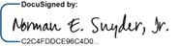 |  | By:
Name: | Norman E. Snyder, Jr. |  | Name:
Title: | CEO |  | Title:

HOLDERS: |  |  | COLLATERAL AGENT:
Whitebox Multi-Strategy Partners, LP |  |  | Wilmington Savings Fund Society, FSB,  solely in its capacity as the Collateral Agent
By: |  |  | By:
Name: | Jacob Mercer |  | Name:
Title: | Authorized Signatory |  | Title:

Whitebox Relative Value Partners, LP
By:
Name: | Jacob Mercer
Title: | Authorized Signatory

Pandora Select Partners, LP
By:
Name: | Jacob Mercer
Title: | Authorized Signatory

Whitebox GT Fund, LP
By:
Name: | Jacob Mercer
Title: | Authorized Signatory

[Signature Page to Option Exercise and Sixth Amendment of the 10% Secured Convertible Notes]

IN WITNESS WHEREOF, this Option Exercise and Sixth Amendment to 10% Secured Convertible Notes has been duly executed and delivered by each of the parties hereto as of the date first above written.

COMPANY: |  |  | HOLDER REPRESENTATIVE:
Reed’s Inc. |  |  | Wilmington Savings Fund Society, FSB,  Solely in its capacity as the Holder Representative
By: |  |  | By:
Name: | Norman E. Snyder, Jr. |  | Name:
Title: | CEO |  | Title:

HOLDERS: |  |  | COLLATERAL AGENT:
Whitebox Multi-Strategy Partners, LP |  |  | Wilmington Savings Fund Society, FSB,  solely in its capacity as the Collateral Agent
By: | 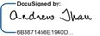 |  | By:
Name: | Andrew Thau |  | Name:
Title: | Authorized Signatory |  | Title:

Whitebox Relative Value Partners, LP
By:
Name: | Andrew Thau
Title: | Authorized Signatory

Pandora Select Partners, LP
By:
Name: | Andrew Thau
Title: | Authorized Signatory

Whitebox GT Fund, LP
By:
Name: | Andrew Thau
Title: | Authorized Signatory

[Signature Page to Option Exercise and Sixth Amendment of the 10% Secured Convertible Notes]

IN WITNESS WHEREOF, this Option Exercise and Sixth Amendment to 10% Secured Convertible Notes has been duly executed and delivered by each of the parties hereto as of the date first above written.

COMPANY: |  |  | HOLDER REPRESENTATIVE:
Reed’s, Inc. |  |  | Wilmington Savings Fund Society, FSB,  Solely in its capacity as the Holder Representative
By: |  |  | By: | 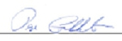
Name: | Norman E. Snyder, Jr. |  | Name: | Raye Goldsborough
Title: | CEO |  | Title: | Vice President

HOLDERS: |  |  | COLLATERAL AGENT:
Whitebox Multi-Strategy Partners, LP |  |  | Wilmington Savings Fund Society, FSB,  solely in its capacity as the Collateral Agent
By: |  |  | By:
Name: | Jacob Mercer |  | Name: | Raye Goldsborough
Title: | Authorized Signatory |  | Title: | Vice President

Whitebox Relative Value Partners, LP
By:
Name: | Jacob Mercer
Title: | Authorized Signatory

Pandora Select Partners, LP
By:
Name: | Jacob Mercer
Title: | Authorized Signatory

Whitebox GT Fund, LP
By:
Name: | Jacob Mercer
Title: | Authorized Signatory

[Signature Page to Option Exercise and Sixth Amendment of the 10% Secured Convertible Notes]

Exhibit A

Form of Fourth Option Note

Purchaser |  | Aggregate Principal Amount of Fourth Option Notes Purchased |  | Aggregate Cash Purchase Price |  | Purchased Third Option Notes Exchanged1
Whitebox Multi-Strategy Partners, LP |  | $3,758.288.95 |  | $808,888.89 |  | Note No. 9 and Note No. 13  $2,949,400.07
Whitebox Relative Value Partners, LP |  | $2,081,513.89 |  | $448,000.00 |  | Note No. 10 and Note No. 14  $1,633,513.88
Pandora Select Partners, LP |  | $346,918.99 |  | $74,666.67 |  | Note No. 11 and Note No. 15  $272,252.32
Whitebox GT Fund, LP |  | $318,099.06 |  | $68,444.44 |  | Note No. 12 and Note No. 16  $$249,564.62
Total |  | $6,504,730.89 |  | $1,400,000.00 |  | $5,104,730.89

1 | Amount listed reflects all aggregate principal amount, accrued and unpaid interest and fees under Section 12(g) of the Purchased Third Option Notes due and owing on the Purchased Third Option Notes.

Exhibit B

Specified Events of Default

1. | The Company’s failure, on or prior to the date hereof and during the Waiver Period (a) to be in good standing as a result of the Company’s failure to pay certain disputed Delaware franchise taxes for calendar year 2013 in an amount not exceeding $225,000 and (b) to prevent any Liens, other than Permitted Liens, as a result of the disputed franchise taxes in clause (a).
2. | The Company’s failure to comply with Section 4(f) of the Notes on or prior to the date hereof.
3. | The Company’s failure to comply with Section 7(w) of the Notes on or prior to the date hereof by maintaining Indebtedness in favor of the ABL Lenders arising under the ABL Debt Documents less than the amount permitted by clause (n) of the definition of Permitted Indebtedness in the Notes.
4. | The Company’s failure to comply with Section 7(w) of the Notes on or prior to the date hereof and during the Waiver Period by maintaining Indebtedness to trade creditors in the ordinary course of business less than the amounts permitted by clause (i) of the definition of Permitted Indebtedness in the Notes; provided that the amount of such Indebtedness does not exceed $3,000,000 in the aggregate at any time after the date hereof.
5. | The Company’s failure to comply with Section 7(kk) of the Notes on or prior to the date hereof.
6. | The Company’s failure to timely pay on or prior to the date hereof (a) the Principal Amount as required by Section 2(a) of each Purchased Third Option Note, (b) any Cash Interest or PIK Interest (including default interest) as required by Section 2 of each Note, and (c) the Principal Amount of any amortization payment pursuant to Section 2(b) of each Note.
7. | The Company’s failure to timely pay on or prior to the date hereof the fees as required under Section 12(g) of the Notes.

Exhibit C

Form of Fourth Option Note

Final Form

THE SECURITIES REPRESENTED HEREBY HAVE NOT BEEN REGISTERED UNDER THE SECURITIES ACT (AS DEFINED HEREIN) OR UNDER ANY STATE SECURITIES LAWS. BY ITS ACQUISITION HEREOF, THE HOLDER AGREES FOR THE BENEFIT OF THE BORROWER (AS DEFINED HEREIN) THAT IT WILL NOT OFFER, SELL, PLEDGE OR OTHERWISE TRANSFER THESE SECURITIES OR ANY BENEFICIAL INTEREST HEREIN, EXCEPT: (A) TO THE BORROWER OR ANY SUBSIDIARY THEREOF; (B) PURSUANT TO A REGISTRATION STATEMENT WHICH HAS BECOME EFFECTIVE UNDER THE SECURITIES ACT; (C) PURSUANT TO AN EXEMPTION FROM REGISTRATION PROVIDED BY RULE 144 UNDER THE SECURITIES ACT; OR (D) PURSUANT TO ANY OTHER EXEMPTION FROM, OR IN A TRANSACTION NOT SUBJECT TO, THE REGISTRATION REQUIREMENTS OF THE SECURITIES ACT AND ANY APPLICABLE STATE SECURITIES LAWS.

PRIOR TO THE REGISTRATION OF ANY TRANSFER IN ACCORDANCE WITH CLAUSE (C) OR (D) ABOVE, THE BORROWER RESERVES THE RIGHT TO REQUIRE THE DELIVERY OF SUCH CERTIFICATIONS, OPINIONS OF COUNSEL OR OTHER EVIDENCE AS MAY REASONABLY BE REQUIRED IN ORDER TO DETERMINE THAT THE PROPOSED TRANSFER IS BEING MADE IN COMPLIANCE WITH THE SECURITIES ACT AND APPLICABLE STATE SECURITIES LAWS. NO REPRESENTATION IS MADE AS TO THE AVAILABILITY OF ANY EXEMPTION FROM THE REGISTRATION REQUIREMENTS OF THE SECURITIES ACT OR ANY APPLICABLE STATE SECURITIES LAWS.

THE PAYMENT OF THIS PROMISSORY NOTE AND THE RIGHTS AND REMEDIES OF HOLDERS OF THIS PROMISSORY NOTE SHALL BE SUBJECT TO THE INTERCREDITOR AGREEMENT (AS DEFINED HEREIN).

THIS NOTE IS ISSUED WITH “ORIGINAL ISSUE DISCOUNT” (WITHIN THE MEANING OF SECTION 1272 OF THE INTERNAL REVENUE CODE) FOR U.S. FEDERAL INCOME TAX PURPOSES. UPON WRITTEN REQUEST, THE COMPANY WILL PROMPTLY MAKE AVAILABLE TO ANY PURCHASER OF THIS NOTE: (1) THE ISSUE PRICE AND DATE OF THE NOTE, (2) THE AMOUNT OF ORIGINAL ISSUE DISCOUNT ON THE NOTE AND (3) THE YIELD TO MATURITY OF THE NOTE.

REED’S, INC.
SECURED PROMISSORY NOTE

$[●] | [●]
 | Note No. [●]

FOR VALUE RECEIVED, the undersigned, REED’S, INC., a Delaware corporation (the “Borrower”), promises to pay to [●], or its registered assigns (the “Holder”), in lawful money of the United States of America and in immediately available funds, the principal sum of [●] (as such amount may, from time to time, be decreased pursuant to the terms hereof, the “Principal Amount”) on the Maturity Date (as defined herein), together with interest as provided herein.

1

This Note is one of a series of secured promissory notes issued by the Borrower at several closings pursuant to that certain Note Purchase Agreement, dated as of May 9, 2022, as amended (the “Purchase Agreement”), by and among the Borrower, Wilmington Savings Fund Society, FSB, in its capacity as representative for the holders of Notes (the “Holder Representative”), the Holder and the other purchasers from time to time party thereto (this Note, together with the other secured promissory notes of the same series issued pursuant to the Purchase Agreement, are collectively referred to as the “Notes”). This Note is also one of a series of secured promissory notes issued on the Original Issuance Date (each, a “Fourth Option Note”, collectively, the “Fourth Option Notes”).

1. Definitions. All terms defined in the Code (as defined herein) and not defined in this Note have the meanings specified therein. As used in this Note, in addition to the terms defined elsewhere in this Note, the following terms shall have the following meanings:

“ABL Debt” means the “Obligations” as defined in the ABL Debt Documents.

“ABL Debt Documents” means that certain Ledgered ABL Agreement dated as of March 28, 2022 between Borrower and ABL Lender, that certain Overadvance Rider to Ledgered ABL Agreement dated as of March 28, 2022 between Borrower and ABL Lender, and that certain Inventory Finance Rider to Purchasing and Security Agreement dated as of dated as of March 28, 2022 between Borrower and ABL Lender.

“ABL Lender” means Alterna Capital Solutions, LLC, a Florida limited liability company.

“Affiliate” means, with respect to a specified Person, another Person that directly, or indirectly through one or more intermediaries, controls or is controlled by or is under common control with the Person specified. For the purposes of this definition, “control,” when used with respect to any specified Person means the power to direct or cause the direction of the management and policies of such Person, directly or indirectly, whether through the ownership of voting securities, by contract or otherwise; and the terms “controlling” and “controlled” have meanings correlative to the foregoing.

“AHYDO Payment” means any payment required to be made pursuant to the terms of any Subordinated Debt instrument after the fifth anniversary of the issuance thereof that is intended to avoid such Subordinated Debt instrument being classified as an “applicable high yield discount obligation” within the meaning of Section 163(i) of the Internal Revenue Code.

“Anti-Corruption Laws” means the United States Foreign Corrupt Practices Act of 1977, the U.K. Bribery Act of 2010, as amended, and all other applicable laws and regulations or ordinances concerning or relating to bribery, money laundering or corruption in any jurisdiction in which any Note Party or any of its Subsidiaries or Affiliates is located or is doing business.

“Anti-Money Laundering Laws” means the applicable laws, statutes, regulations or rules in any jurisdiction in which any Note Party or any of its Subsidiaries or Affiliates is located or is doing business that relates to money laundering, any predicate crime to money laundering, or any financial record keeping and reporting requirements related thereto, including, but not limited to, the Bank Secrecy Act (31 U.S.C. § 5311 et seq.) and the USA Patriot Act.

2

“Bank Services” mean any products, credit services or financial accommodations previously, now or hereafter provided to any Note Party or any of its Subsidiaries by any third party bank, including any cash management services (including merchant services, direct deposit of payroll, business credit cards, and check cashing services), interest rate swap arrangements and foreign exchange services as any such products or services may be identified in such third party bank’s various agreements related thereto.

“Board of Directors” means the board of directors of the Borrower.

“Business Day” means any day other than a Saturday, a Sunday or other day on which commercial banks in New York, New York or Wilmington, Delaware are authorized or required by law or executive order to close or be closed.

“Capital Lease Obligations” of any Person means the obligations of such Person to pay rent or other amounts under any lease of (or other arrangement conveying the right to use) real or personal property, or a combination thereof, which obligations are required to be classified and accounted for as capital leases on a balance sheet of such Person under GAAP (consistently applied), and the amount of such obligations shall be the capitalized amount thereof determined in accordance with GAAP (consistently applied); provided that any lease that would properly be recognized as an “operating lease” by any Note Party as of the date hereof shall continue to be treated as an operating lease and shall not constitute a Capital Lease Obligation for purposes hereof.

“Capital Stock” means, any and all shares, interests, rights to purchase, warrants and options (whether denominated as common stock or preferred stock), equity interests, beneficial, partnership or membership interests, joint venture interests, participations or other ownership or profit interests in or equivalents (regardless of how designated) of or in a Person (other than an individual), whether voting or non-voting.

“Cash Equivalents” means, as to any Person: (a) securities issued or directly and fully and unconditionally guaranteed or insured by the United States or any agency or instrumentality thereof (but only so long as the full faith and credit of the United States is pledged in support thereof) having maturities of not more than twelve months from the date of acquisition; (b) securities issued by any state of the United States or any political subdivision of any such state or any public instrumentality thereof having maturities of not more than 180 days from the date of acquisition and having one of the two highest ratings from either Standard & Poor’s, a division of The McGraw-Hill Companies, Inc., or Moody’s Investors Service, Inc.; (c) certificates of deposit, denominated solely in U.S. Dollars, maturing within twelve months after the date of acquisition, issued by any commercial bank organized under the laws of the United States or any state thereof or the District of Columbia or that is a U.S. subsidiary of a foreign commercial bank; in each of the foregoing cases, solely to the extent that (i) such commercial bank’s short-term commercial paper is rated at least A-1 or the equivalent by Standard & Poor’s, a division of The McGraw-Hill Companies, Inc., or at least P-1 or the equivalent thereof by Moody’s Investors Service, Inc. (any such commercial bank, an “Approved Bank”) or (ii) the par amount of all certificates of deposit acquired from such commercial bank are fully insured by the Federal Deposit Insurance Corporation; or (d) commercial paper issued by any Approved Bank (or by the parent company thereof), in each case maturing not more than twelve months after the date of the acquisition thereof.

3

“CFC” means a “controlled foreign corporation” within the meaning of Section 957 of the Internal Revenue Code in which any Note Party would be treated as a United States shareholder (as defined in Section 951(b)) for purposes of including income under Sections 951(a)(1) or 951A(a) of the Internal Revenue Code.

“CFC Holdco” means any Subsidiary substantially all of the assets of which (directly or indirectly) consist of Capital Stock (including, for this purpose, any debt or other instrument treated as equity for U.S. federal income tax purposes) in, or debt issued by, one or more (a) CFCs or (a) other CFC Holdcos.

“Close of Business” means 5:00 p.m., New York City time.

“Code” means the Uniform Commercial Code as adopted and in effect in the State of New York, as amended from time to time; provided, that, to the extent that the Code is used to define any term herein or in any other Note Document and such term is defined differently in different Articles or Divisions of the Code, the definition of such term contained in Article or Division 9 shall govern; provided further, that in the event that, by reason of mandatory provisions of law, any or all of the attachment, perfection or priority of, or remedies with respect to, the Collateral Agent’s Lien on any Collateral is governed by the Uniform Commercial Code in effect in a jurisdiction other than the State of New York, the term “Code” shall mean the Uniform Commercial Code as enacted and in effect in such other jurisdiction solely for purposes of the provisions thereof relating to such attachment, perfection, priority or remedies and for purposes of definitions relating to such provisions.

“Collateral” means the Article 9 Collateral and the Pledged Collateral, in each case, other than any Excluded Assets.

“Collateral Agent” means Wilmington Savings Fund Society, FSB, in its capacity as collateral agent for the holders of Notes (together with its successors and permitted assigns in such capacity).

“Collateral Pledge Agreements” mean, collectively, any pledge agreement relating to the Capital Stock or evidence of Indebtedness of any Subsidiary owned directly or indirectly by the Borrower or any other Note Party to the extent necessary or useful to perfect the Collateral Agent’s security interest therein under applicable Laws.

“Commission” means the U.S. Securities and Exchange Commission.

“Common Stock” means the Borrower’s Common Stock, par value $0.0001 per share (as such stock may be renamed or reclassified from time to time).

“Common Equity” of any Person means Capital Stock of such Person that is generally entitled (a) to vote in the election of directors of such Person or (b) if such Person is not a corporation, to vote or otherwise participate in the selection of the governing body, partners, managers, trustees or others that will control the management or policies of such Person.

4

“Contingent Obligation” means, as applied to any Person, any direct or indirect liability, contingent or otherwise, of that Person with respect to (a) any indebtedness, lease, dividend, letter of credit or other obligation of another, (b) any obligations with respect to undrawn letters of credit, corporate credit cards, or merchant services issued or provided for the account of that Person and

(c) all obligations arising under any agreement or arrangement designed to protect such Person against fluctuation in interest rates, currency exchange rates or commodity prices; provided, however, that the term “Contingent Obligation” shall not include endorsements for collection or deposit in the ordinary course of business. The amount of any Contingent Obligation shall be deemed to be an amount equal to the stated or determined amount of the primary obligation in respect of which such Contingent Obligation is made or, if not stated or determinable, the maximum liability in respect thereof as determined by the Majority Holders in good faith; provided, however, that such amount shall not in any event exceed the maximum amount of the obligations under the guarantee or other support arrangement.

“Control Agreement” means an agreement, the terms of which are satisfactory to the Majority Holders and the Collateral Agent, as to its rights, duties and obligations (it being agreed that any agreement that shall require the Collateral Agent to indemnify any institution in its individual capacity shall not be satisfactory to the Collateral Agent), which is executed by the Collateral Agent, the applicable Note Party and the applicable financial institution or securities/investment intermediary, and which perfects the Collateral Agent’s (for its benefit and for the benefit of the Holder Representative and the holders of Notes) first priority security interest in such Note Party’s deposit, securities or commodities accounts maintained as such financial institution or securities/investment intermediary.

“Copyright License” means any written agreement, now or hereafter in effect, granting any right to any third party under any Copyright now or hereafter owned by any Note Party or that such Note Party otherwise has the right to license, or granting any right to any Note Party under any copyright now or hereafter owned by any third party, and all rights of such Note Party under any such agreement.

“Copyrights” means any and all copyright rights, copyright applications, copyright registrations and like protections in each work or authorship and derivative work thereof, whether or not filed with the USCO or foreign equivalent.

“Debtor Relief Laws” means Title 11 of the United States Code entitled “Bankruptcy” and all other liquidation, conservatorship, bankruptcy, assignment for the benefit of creditors, moratorium, rearrangement, receivership, insolvency, reorganization or similar debtor relief Laws of the United States or other applicable jurisdictions from time to time in effect and affecting the rights of creditors generally.

“Default” means any event which with the passing of time or the giving of notice or both would become an Event of Default.

“Depositary” means The Depository Trust Company or its successor.

“Disclosure Letter” means the disclosure letter dated as of the date of the Original Issue Notes containing certain information and schedules delivered by the Note Parties to the Holder Representative and the Collateral Agent (as such disclosure letter may be supplemented from time to time in accordance with the terms hereof).

5

“Disqualified Stock” means any Capital Stock that, by its terms (or by the terms of any security into which it is convertible or for which it is exchangeable), or upon the happening of any event, (a) matures (excluding any maturity as the result of an optional redemption by the issuer thereof) or is mandatorily redeemable, pursuant to a sinking fund obligation or otherwise, or is redeemable at the option of the holder thereof, in whole or in part, or requires the payment of any cash dividend or any other scheduled payment constituting a return of capital, in each case at any time on or prior to the date that is one year and one day following the Maturity Date; or (b) is convertible into or exchangeable (unless at the sole option of the issuer thereof) for (i) debt securities or (ii) any Capital Stock referred to in clause (a) above, in each case at any time on or prior to the date that is one year and one day following the Maturity Date.

“ERISA” means the Employee Retirement Income Security Act of 1974, as amended from time to time.

“ERISA Affiliate” means any entity, trade or business (whether or not incorporated) under common control with the Borrower or any of its Affiliates within the meaning of Section 414(b) or (c) of the Internal Revenue Code (and Sections 414(m) and (o) for purposes of provisions relating to Section 412 of the Internal Revenue Code).

“ERISA Event” means: (a) a Reportable Event with respect to a Pension Plan; (b) a withdrawal by any Note Party or any ERISA Affiliate from a Pension Plan subject to Section 4063 of ERISA during a plan year in which it was a substantial employer (as defined in Section 4001(a)(2) of ERISA) or a cessation of operations that is treated as such a withdrawal under Section 4062(e) of ERISA; (c) a complete or partial withdrawal by any Note Party or any ERISA Affiliate from a Multiemployer Plan or notification that a Multiemployer Plan is in reorganization; (d) the filing of a notice of intent to terminate a Pension Plan, the treatment of a Plan amendment as a termination under Section 4041 or 4041A of ERISA, or the commencement of proceedings by the PBGC to terminate a Pension Plan or Multiemployer Plan; (e) an event or condition which constitutes grounds under Section 4042 of ERISA for the termination of, or the appointment of a trustee to administer, any Pension Plan or Multiemployer Plan; or (f) the imposition of any liability under Title IV of ERISA, other than for PBGC premiums due but not delinquent under Section 4007 of ERISA, upon any Note Party or any ERISA Affiliate.

“Exchange Act” means the Securities Exchange Act of 1934, as amended, and the rules and regulations promulgated thereunder.

“Foreign Subsidiary” means any Subsidiary of a Note Party that is organized under the Laws of a jurisdiction other than the United States, any state thereof or the District of Columbia.

“Fundamental Change” means any of the following events:

(A) a “person” or “group” (within the meaning of Section 13(d) of the Exchange Act), other than the Borrower or its Wholly Owned Subsidiaries, or their respective employee benefit plans files a Schedule TO (or any successor schedule, form or report) or any schedule, form or report under the Exchange Act disclosing that such person or group has become the direct or indirect “beneficial owner” (as defined below) of Common Stock (or such other Common Equity into which the Common Stock has been reclassified) representing more than 50% (or 65% in the case of a Permitted Holder so long as such Permitted Holder does not seek to cause the Borrower to cease its ongoing reporting pursuant to Sections 13 and 15 of the Exchange Act) of the voting power of the Common Stock (or such other Common Equity into which the Common Stock has been reclassified);

6

(B) the consummation of (i) any sale, lease or other transfer, in one transaction or a series of transactions, of all or substantially all of the assets of the Borrower and its Subsidiaries, taken as a whole, to any Person other than any of the Borrower’s Wholly Owned Subsidiaries; or (ii) any transaction or series of related transactions in connection with which (whether by means of merger, consolidation, share exchange, combination, reclassification, recapitalization, acquisition, liquidation or otherwise) all of the Common Stock is exchanged for, converted into, acquired for, or constitutes solely the right to receive, other securities, cash or other property; provided, however, that any merger, consolidation, share exchange or combination of the Borrower pursuant to which the Persons that directly or indirectly “beneficially owned” (as defined below) Common Stock (or such other Common Equity into which the Common Stock has been reclassified) immediately before such transaction directly or indirectly “beneficially own,” immediately after such transaction, more than fifty percent (50%) of the Common Stock (or such other Common Equity into which the Common Stock has been reclassified) of the surviving, continuing or acquiring company or other transferee, as applicable, or the parent thereof, in substantially the same proportions vis-à-vis each other as immediately before such transaction will be deemed not to be a Fundamental Change pursuant to this clause (B);

(C) the Borrower’s stockholders approve any plan or proposal for the liquidation or dissolution of the Borrower; or

(D) the Common Stock is listed after the date hereof and subsequently ceases to be listed on any of The New York Stock Exchange, The NASDAQ Capital Market, The NASDAQ Global Market or The NASDAQ Global Select Market (or any of their respective successors);

provided, however, that a transaction or event described in clause (A) or (B) above will not constitute a Fundamental Change if at least ninety percent (90%) of the consideration received or to be received by the holders of Common Stock (excluding cash payments for fractional shares or pursuant to dissenters rights), in connection with such transaction or event, consists of shares of common stock listed on any of The New York Stock Exchange, The NASDAQ Capital Market, The NASDAQ Global Market or The NASDAQ Global Select Market (or any of their respective successors), or that will be so listed when issued or exchanged in connection with such transaction or event.

For the purposes of this definition, (x) any transaction or event described in both clause (A) and in clause (B)(i) or (ii) above (without regard to the proviso in clause (B)) will be deemed to occur solely pursuant to clause (B) above (subject to such proviso); and (y) whether a Person is a “beneficial owner” and whether shares are “beneficially owned” will be determined in accordance with Rule 13d-3 under the Exchange Act.

7

“GAAP” means, as of any date of determination, generally accepted accounting principles as then in effect in the United States of America set forth in the opinions and pronouncements of the Accounting Principles Board of the American Institute of Certified Public Accountants and statements and pronouncements of the Financial Accounting Standards Board.

“guarantee” of or by any Person (the “guarantor”) means any obligation, contingent or otherwise, of the guarantor guaranteeing or having the economic effect of guaranteeing any Indebtedness or other obligation of any other Person (the “primary obligor”) in any manner, whether directly or indirectly, and including any obligation of the guarantor, direct or indirect, (a) to purchase or pay (or advance or supply funds for the purchase or payment of) such Indebtedness or other obligation or to purchase (or to advance or supply funds for the purchase of) any security for the payment thereof, (b) to purchase or lease property, securities or services for the purpose of assuring the owner of such Indebtedness or other obligation of the payment thereof, (c) to maintain working capital, equity capital or any other financial statement condition or liquidity of the primary obligor so as to enable the primary obligor to pay such Indebtedness or other obligation or (d) as an account party in respect of any letter of credit or letter of guaranty issued to support such Indebtedness or obligation; provided that the term “guarantee” shall not include endorsements for collection or deposit in the ordinary course of business.

“Guarantor” means each Subsidiary of the Borrower and their respective successors and assign.

“Guaranty” means, collectively, the guaranty of the Note Obligations by the Guarantors pursuant to this Note.

“Governmental Authority” shall mean the government of the United States of America or any other nation, or of any political subdivision thereof, whether state or local, and any agency, authority, instrumentality, regulatory body, court, central bank or other entity exercising executive, legislative, judicial, taxing, regulatory or administrative powers or functions of or pertaining to government (including any supra-national bodies such as the European Union or the European Central Bank).

“Hedging Agreement” means any interest rate protection agreement, foreign currency exchange agreement, commodity price protection agreement or other interest or currency exchange rate or commodity price hedging arrangement.

“Holder Representative” has the meaning set forth in the first paragraph of this Note (together with its successors and permitted assigns in such capacity).

8

“Indebtedness” of any Person means without duplication (a) all indebtedness created, assumed or incurred in any manner by the Borrower representing money borrowed (including by the issuance of debt securities, notes, bonds, debentures or similar instruments) and all obligations with respect to deposits or advances of any kind, (b) all obligations of such Person or with respect to letters of credit, bankers’ acceptances and other similar extensions of credit whether or not representing obligations for borrowed money, (c) all obligations of such Person upon which interest charges are customarily paid, (d) all obligations of such Person under conditional sale or other title retention agreements relating to property or assets purchased by such Person, including any earn-out obligations, (e) all obligations of such Person issued or assumed as the deferred purchase price of property or services (excluding trade accounts payable and accrued obligations incurred in the ordinary course of business and not more than 90 days past due), (f) all Indebtedness of others secured by (or for which the holder of such Indebtedness has an existing right, contingent or otherwise, to be secured by) any Lien on property owned or acquired by such Person, whether or not the obligations secured thereby have been assumed, (g) all Contingent Obligations of such Person including indebtedness of others, (h) all Capital Lease Obligations and Synthetic Lease Obligations of such Person, (i) obligations in respect of Disqualified Stock and (j) all obligations of such Person in respect of any exchange traded or over the counter derivative transaction, including any Hedging Agreement, in each case, whether entered into for hedging or speculative purposes or otherwise. The amount of any Indebtedness of any Person in respect of a Hedging Agreement shall be the amount determined in respect thereof as of the end of the then most recently ended fiscal quarter of such Person, based on the assumption that such Hedging Agreement had terminated at the end of such fiscal quarter. In making such determination, if any agreement relating to such Hedging Agreement provides for the netting of amounts payable by and to such Person thereunder or if any such agreement provides for the simultaneous payment of amounts by and to such Person, then in each such case, the amount of such obligation shall be the net amount so determined, in each case to the extent that such agreement is legally enforceable in any insolvency proceedings against the applicable counterparty thereof. The Indebtedness of any Person shall include the Indebtedness of any partnership or joint venture in which such Person is a general partner or joint venturer. For the avoidance of doubt, ordinary course operating leases and guarantees thereof shall not constitute Indebtedness.

“Initial Closing Date” shall have the meaning given to such term in the Purchase Agreement.

“Initial Holders” means, together, Whitebox Multi-Strategy Partners, LP, Whitebox Relative Value Partners, LP, Pandora Select Partners, LP and Whitebox GT Fund, LP.

“Insurance/Condemnation Event” means any casualty or other insured damage to, or any taking under the power of eminent domain or by condemnation or similar proceeding of, or any disposition under a threat of such taking of, all or any part of any assets of any Note Party or any Subsidiary thereof.

“Intellectual Property” means all of a Person’s right, title and interest in and to the following: domain names; Copyrights, Trademarks and Patents (including registrations and applications therefor prior to granting, and whether or not filed, recorded or issued); all trade secrets and related rights, including rights to unpatented inventions, know-how and manuals; all design rights; claims for damages by way of past, present and future infringement of any of the rights included above; and all amendments, renewals and extensions of any Copyrights, Trademarks or Patents.

“Intellectual Property Security Agreement” means any short-form Patent Security Agreement, short-form Trademark Security Agreement or short-form Copyright Security Agreement, each in form and substance satisfactory to the Majority Holders for filing with the USPTO or USCO, as applicable.

9

“Intercreditor Agreement” means that certain Collateral Sharing Agreement, dated as of May 9, 2022, among the ABL Lender, the Borrower, the Holder Representative and the Collateral Agent.

“Internal Revenue Code” means the Internal Revenue Code of 1986, as amended from time to time, and the regulations promulgated and rulings issued thereunder.

“Inventory” means “inventory” as defined in the Code, including work in process and finished products intended for sale or lease or to be furnished under a contract of service, of every kind and description now or at any time hereafter owned by or in the custody or possession, actual or constructive, of any Note Party, including such inventory as is temporarily out of its custody or possession or in transit and including any returns upon any accounts or other proceeds, including insurance proceeds, resulting from the sale or disposition of any of the foregoing and any documents of title representing any of the above, and the applicable Note Party’s books and records relating to any of the foregoing.

“Investment” means, as to any Person, all investments by such Person in other Persons (including Affiliates) in the form of loans (including guarantees), advances or capital contributions (other than advances made in the ordinary course of business that would be recorded as accounts receivable on the balance sheet of the specified Person prepared in conformity with GAAP), purchases or other acquisitions for consideration of Indebtedness, Capital Stock or other securities issued by any other Person and the purchase or other acquisition (in one transaction or a series of transactions) of all or substantially all of the property or assets or business of another Person or assets constituting a business unit, line of business or division of such other Person

“Joinder Agreement” means an agreement substantially in the form of Exhibit A.

“Landlord Subordination and Access Agreement” means an agreement between the applicable Note Party’s landlord(s) and the Collateral Agent that provides the Collateral Agent access to the premises that such Note Party leases from such landlord in a form reasonably satisfactory to the Majority Holders and the Collateral Agent, as to its rights, duties and obligations.

“Laws” means, collectively, all international, foreign, Federal, state and local statutes, treaties, rules, guidelines, regulations, ordinances, codes and administrative or judicial precedents or authorities, including the legally binding interpretation or administration thereof by any Governmental Authority charged with the enforcement, interpretation or administration thereof, and all applicable administrative orders, directed duties, legally binding requests, licenses, authorizations and permits of, and agreements with, any Governmental Authority.

“License” means any Patent License, Trademark License, Copyright License or other Intellectual Property license or sublicense agreement to which any Note Party is a party, together with any and all (a) renewals, extensions, amendments, restatements, supplements and continuations thereof, (b) income, fees, royalties, damages, claims and payments now and hereafter due or payable thereunder or with respect thereto including damages and payments for past, present or future breach or violations thereof and (c) rights to sue for past, present and future breach or violations thereof.

10

“Lien” means any pledge, bailment, lease, mortgage, hypothecation, conditional sales and title retention agreement, charge, claim, encumbrance or other lien in favor of any Person.

“Majority Holders” means, with respect to any date, the holders of Notes representing more than 50% of the aggregate principal amount of the Notes outstanding on such date; provided, at any time that any of the Initial Holders continue to hold any of the Notes, (i) for purposes of Section 12, “Majority Holders” must include such Initial Holder(s) and (ii) for all other purposes, “Majority Holders” means the Initial Holders.

“Material Adverse Effect” means a material adverse effect on or material adverse developments with respect to (i) the business, operations, properties, assets, financial condition of the Borrower and its Subsidiaries taken as a whole; (ii) the ability of the Borrower to fully and timely perform its obligations under this Note or (iii) the legality, validity, binding effect or enforceability against the Borrower of this Note.

“Maturity Date” means the earlier of (i) December 15, 2024 (subject to two automatic extensions of 30 calendar days each if the Commission is actively reviewing a registration statement, proxy statement or other filing for a proposed transaction as a result of which the Borrower reasonably believes that its Common Stock will be listed on any of The New York Stock Exchange, The NASDAQ Capital Market, The NASDAQ Global Market or The NASDAQ Global Select Market (or any of their respective successors) upon the completion of such transaction) and (ii) ninety-one (91) days before the scheduled maturity of any unsecured Indebtedness incurred by the Borrower that is junior in right of payment to the Note Obligations.

“MOIC Payment Termination Date” means the date, if any, prior to the Maturity Date or acceleration of this Note when an aggregate of $1,400,000 of the aggregate Principal Amount of the Fourth Option Notes has been repaid by Borrower pursuant to Section 2(c) and/or Section 2(e).

“Mortgage” means a mortgage, deed of trust or deed to secure debt, in form and substance reasonably satisfactory to Majority Holders and the Collateral Agent, as to its rights, duties and obligations, made by a Note Party in favor of the Collateral Agent for the benefit of the Collateral Agent and the holders of Notes, securing the Note Obligations.

“Multiemployer Plan” means any “multiemployer plan” (as defined in Section 4001(a)(3) of ERISA) to which the Borrower, any of its Subsidiaries or any ERISA Affiliate makes or is obligated to make contributions, or during the preceding six years has made or been obligated to make contributions.

“Negotiable Collateral” means all letters of credit of which any Note Party is a beneficiary, notes, drafts, instruments, securities, documents of title, and chattel paper, and any Note Party’s books and records relating to any of the foregoing.

11

“Net Proceeds” means, with respect to any event, the cash (which term, for purposes of this definition, shall include Cash Equivalents) proceeds (including, in the case of any Insurance/Condemnation Event, insurance, condemnation and similar proceeds) received in respect of such event, including any cash and Cash Equivalents received in respect of any non- cash proceeds, but only as and when received, net of (a) all fees and out-of-pocket costs and expenses incurred in connection with such event by any Note Party or any Subsidiary thereof to Persons that are not Affiliates of the Note Parties or their Subsidiaries (including attorneys’, accountants’ and consultants’ fees, investment banking and advisory fees and underwriting discounts and commissions), (b) the amount of all payments (including in respect of principal, accrued interest and premiums) required to be made by any Note Party or any Subsidiary thereof as a result of such event to repay Indebtedness (other than the Notes) secured by the assets subject thereto, (c) the amount of all payments reasonably estimated to be required to be made by any Note Party or any Subsidiary thereof in respect of purchase price adjustment, indemnification and similar contingent liabilities that are directly attributable to such event or in respect of any retained liabilities associated with such event (including pension and other post-employment benefit liabilities and environmental liabilities) and (d) the amount of all Taxes (including transfer taxes, deed or recording taxes and repatriation taxes or any withholding or deduction) paid (or reasonably estimated to be payable) by any Note Party or any Subsidiary thereof in connection with such event.

“Note Collateral Documents” means, collectively, all Intellectual Property Security Agreements, Mortgages, Control Agreements, Notice and Access Agreements, Landlord Subordination and Access Agreements, each other agreement, instrument or document that creates or purports to create a Lien in favor of the Collateral Agent for the benefit of the Collateral Agent and the holders of Notes and all financing statements (or comparable documents now or hereafter filed in accordance with the Code or comparable Law) against any Note Party as debtor in favor of the Collateral Agent for the benefit of the Collateral Agent and the holders of Notes, as secured party, as any of the foregoing may be amended, restated, supplemented or modified from time to time.

“Note Documents” means, collectively, the Notes, the Purchase Agreement, the Registration Rights Agreement (as defined in the Purchase Agreement), the Note Collateral Documents, the Intercreditor Agreement, each Subordination Agreement and any other agreement, document or instrument entered into in connection with the foregoing.

“Note Obligations” means the Obligations of the Borrower and the other obligors (including the Guarantors) under this Note to pay principal, premium, if any, MOIC Deficiency Amount (if any) and interest (including all interest accruing after the commencement of any bankruptcy, insolvency, reorganization or similar proceeding, whether or not a claim for such post- petition interest is allowed or allowable in such proceeding) when due and payable, and all other amounts due or to become due under or in connection with the performance of all other Obligations of the Borrower and the Guarantors under the Note Documents, according to the respective terms thereof.

“Note Party” means the Borrower and each Guarantor.

“Notice and Access Agreement” means an agreement between a third party warehouse, fulfillment center, bailee or similar entity, on the one hand, and the Collateral Agent on the other, that provides the Collateral Agent access to the premises containing a Note Party’s Inventory or other Collateral and otherwise in form and substance reasonably satisfactory to Majority Holders and the Collateral Agent, as to its rights, duties and obligations.

12

“Obligations” means all advances to, and debts, liabilities, obligations, covenants and duties of, any Note Party and its Subsidiaries arising under this Note and any other Note Document or otherwise, whether direct or indirect (including those acquired by assumption), absolute or contingent, due or to become due, now existing or hereafter arising and including interest and fees that accrue after acceleration of the Obligations or after the commencement by or against any Note Party or any Subsidiary of a Note Party of any proceeding under any Debtor Relief Laws naming such Person as the debtor in such proceeding, regardless of whether such interest and fees are allowed claims in such proceeding. Without limiting the generality of the foregoing, the Obligations include the obligation (including guarantee obligations) to pay all principal, interest, penalties, fees, charges, expenses, attorneys’ costs, indemnifications, reimbursements, debts, liabilities and other amounts, and all obligations, covenants, damages and duties of any Note Party and its Subsidiaries arising under any Note Document or otherwise.

“OFAC” means the Office of Foreign Assets Control of the U.S. Treasury Department. “Open of Business” means 9:00 a.m., New York City time.

“Organizational Documents” means (a) with respect to any corporation or company, its certificate or articles of incorporation, organization or association, as amended, and its bylaws, as amended, (b) with respect to any limited partnership, its certificate or declaration of limited partnership, as amended, and its partnership agreement, as amended, (c) with respect to any general partnership, its partnership agreement, as amended, and (d) with respect to any limited liability company, its certificate of formation or articles of organization, as amended, and its operating agreement, as amended.

“Original Issue Date” means [●].

“Patent License” means any written agreement, now or hereafter in effect, granting to any third party any right to make, use or sell any invention or designs on which a Patent, now or hereafter owned by any Note Party or that any Note Party otherwise has the right to license, or granting to any Note Party any right to make, use or sell any invention or designs on which a patent, now or hereafter owned by any third party, is in existence, and all rights of any Note Party under any such agreement.

“Patents” means all patents, patent applications and like protections including improvements, divisions, continuations, renewals, reissues, extensions and continuations-in-part of the same, whether or not filed with the USPTO or any foreign equivalent.

“PBGC” means the Pension Benefit Guaranty Corporation.

“Pension Plan” means any “employee benefit plan” (as such term is defined in Section 3(2) of ERISA), other than a Multiemployer Plan, which is subject to Title IV of ERISA or Sections 412 of the Internal Revenue Code or Section 302 of ERISA, and which is or was, within the preceding six years, maintained by the Borrower, any of its Subsidiaries or any ERISA Affiliate.

“Permitted Holders” means D&D Source of Life Holdings Ltd. and its Affiliates.

13

“Permitted Indebtedness” means the following:

(a) Indebtedness of any Note Party in favor of the Collateral Agent or a holder of Notes arising under the Notes or any other Note Document;

(b) Indebtedness existing on the Initial Closing Date and disclosed in Section 2 of the Disclosure Letter;

(c) Indebtedness consisting of: (i) Permitted Investments allowed pursuant to clause (f) of the definition of “Permitted Investments”; and (ii) purchase money obligations for fixed or capital assets within the limitations set forth in clause (c) of the defined term “Permitted Liens”; provided that such Indebtedness does not exceed the lesser of the cost or fair market value of the equipment and software financed with such Indebtedness;

(d) Indebtedness arising from the honoring by a bank or other financial institution of a check, draft or similar instrument inadvertently (except in the case of daylight overdrafts) drawn against insufficient funds in the ordinary course of business, provided that such Indebtedness is promptly extinguished;

(e) Indebtedness arising in connection with endorsement of instruments for deposit in the ordinary course of business;

(f) Indebtedness of any Note Party or any Subsidiary that may be deemed to exist in connection with agreements providing for warranty obligations entered into in the ordinary course of business;

(g) Indebtedness of any Note Party or any Subsidiary arising from (i) customary credit card charges incurred in the ordinary course of business and (ii) Bank Services provided by any third party bank (in each case, other than Indebtedness for borrowed money);

(h) Indebtedness consisting of the financing of insurance premiums contemplated by clause (o) of the definition of “Permitted Liens”;

(i) unsecured Indebtedness to trade creditors in the ordinary course of business not to exceed at any time outstanding $500,000 individually or $1,000,000 in the aggregate;

(j) Indebtedness of any Note Party or any Subsidiary with respect to performance bonds, surety bonds, appeal bonds or customs bonds required in the ordinary course of business not to exceed in the aggregate more than $100,000 at any time outstanding;

(k) intercompany Indebtedness by and among the Borrower and its Subsidiaries (subject to clause (d) of the definition of “Permitted Investments”);

(l) Subordinated Debt, so long as such Subordinated Debt (x) is on then current market terms (as reasonably determined by the Borrower and the Majority Holders), (y) has no scheduled amortization payments prior to 180 days after the Maturity Date and (z) does not mature prior to the date that is 180 days after the Maturity Date (except in case of clause (y) and (z) above, customary asset sale or change-of-control provisions that provide for the prior repayment in full of the Notes);

14

(m) advances or deposits received in the ordinary course of business from customers or vendors;

(n) Indebtedness in favor of the ABL Lenders arising under the ABL Debt Documents not to exceed in the aggregate at any time outstanding or committed the sum of (i) (x) prior to November 30, 2024, $9,500,000 and (y) on and after November 30, 2024, $6,500,000, if the Borrower has not publicly announced or is not actively pursuing a proposed transaction as a result of which the Borrower reasonably believes that its Common Stock will be listed on any of The New York Stock Exchange, The NASDAQ Capital Market, The NASDAQ Global Market or The NASDAQ Global Select Market (or any of their respective successors) upon the completion of such transaction), or $9,500,000 otherwise, minus (ii) any amounts repaid to the ABL Lenders as contemplated by Section 2(c)(iii) of the Fourth Option Notes (not to exceed $500,000) plus (iii) the aggregate principal amount of Notes voluntarily converted pursuant to the terms of each applicable Note, in each case subject to the terms of the Intercreditor Agreement; provided that the sum of the amounts in clauses (i), (ii) and (ii) above shall not exceed $10,500,000 minus any amounts repaid to the ABL Lenders as contemplated by Section 2(c)(iii) of the Fourth Option Notes (not to exceed $500,000); and

(o) extensions, refinancings, modifications, amendments and restatements of any items of Permitted Indebtedness (b) through (n) above; provided that (i) the principal amount thereof is not increased or the terms thereof are not modified to impose more burdensome or restrictive terms upon any Note Party or any Subsidiary, as the case may be, (ii) the maturity and weighted average life to maturity with respect to any Indebtedness incurred pursuant to clauses (b), (l) and (n) above in this definition is not shortened in connection with any such extensions, refinancings, modifications, amendments and restatements, (iii) no Event of Default shall have occurred and be continuing, (iv) if such Indebtedness being extended, refinanced, modified, amended or restated is subordinated in right of payment to the Obligations, such extension, refinancing, modification, amendment or restatement shall be subordinated in right of payment to the Obligations on terms at least as favorable to the holders of Notes as those contained in the documentation governing the Indebtedness being extended, refinanced, modified, amended or restated, (v) if such Indebtedness being extended, refinanced, modified, amended or restated is unsecured, such extension, refinancing, modification, amendment or restatement shall be unsecured, (vi) to the extent such Indebtedness being extended, refinanced, modified, amended or restated is secured or subject to intercreditor arrangements for the benefit of the holders of Notes, such extension, refinancing, modification, amendment or restatement is either (1) unsecured or (2) secured and, if secured, subject to an intercreditor arrangement in form and substance reasonably acceptable to the Collateral Agent, as to its rights, duties and obligations, and the Majority Holders on terms at least as favorable (including with respect to priority) to the holders of Notes as those contained in the documentation governing the Indebtedness being extended, refinanced, modified, amended or restated, and such extension, refinancing, modification, amendment or restatement is incurred by one or more Persons who is an obligor of the Indebtedness being extended, refinanced, modified, amended or restated and (vii) any such extension, refinancing, modification, amendment or restatement has the same primary obligor and the same (or fewer) guarantors as the Indebtedness being extended, refinanced, modified, amended or restated.

15

“Permitted Investments” means the following:

(a) Investments existing on the Initial Closing Date disclosed in Section 1 of the Disclosure Letter;

(b) Investments constituting cash and Cash Equivalents; provided such cash and Cash Equivalents are in accounts which are subject to a Control Agreement in favor of the Collateral Agent to the extent required under Section 7(ee);

(c) Investments accepted in connection with Permitted Transfers;

(d) Investments among Note Parties;

(e) Investments (including debt obligations) received in connection with the bankruptcy or reorganization of customers or suppliers and in settlement of delinquent obligations of, and other disputes with, customers or suppliers arising in the ordinary course of the Note Parties’ business;

(f) Investments consisting of the purchase of capital assets in an amount not to exceed $750,000 per fiscal year; provided that the aggregate amount of Investments made pursuant to this clause (f) after the Initial Closing Date shall not exceed $1,250,000 at any time outstanding;

(g) Investments consisting of (i) travel advances and employee relocation loans and other employee loans and advances in the ordinary course of business in an aggregate amount not to exceed $50,000 per fiscal year and (ii) loans to employees, officers or directors relating to the purchase of Capital Stock of the Borrower or its Subsidiaries pursuant to employee stock purchase plans or agreements approved by the Board of Directors in an aggregate amount not to exceed $100,000 per fiscal year;

(h) Investments consisting of the endorsement of negotiable instruments for deposit or collection or similar transactions in the ordinary course of business;

(i) Investments in accounts at financial institutions; provided, that such accounts are permitted pursuant to Section 7(ee) and the Collateral Agent has a perfected Lien on the amounts held in such accounts as required pursuant to Section 7(ee);

(j) Investments consisting of notes receivable of, or prepaid royalties and other credit extensions, to customers and suppliers who are not Affiliates of any Note Party or any Subsidiary, in the ordinary course of business, and Investments received in satisfaction or partial satisfaction thereof from financially troubled Account Debtors to the extent reasonably necessary in order to prevent or limit loss; provided that this shall not apply to Investments of any Note Party in any Subsidiary;

16

(k) deposits made to secure the performance of leases, licenses or contracts in the ordinary course of business, and other deposits made in connection with the incurrence of Permitted Liens; and

(l) Investments for fair market value not otherwise permitted hereunder in an amount not to exceed $200,000 per fiscal year.

“Permitted Liens” means the following:

(a) Liens existing on the Initial Closing Date and disclosed in Section 3 of the Disclosure Letter;

(b) Liens for taxes, fees, assessments or other governmental charges or levies that are not delinquent, not to exceed $100,000 in the aggregate at any time, and for which the applicable Note Party maintains adequate reserves in accordance with GAAP;

(c) Liens (i) upon or in any equipment acquired or held by a Note Party or any of its Subsidiaries to secure the purchase price of such equipment incurred solely for the purpose of financing the equipment not to exceed $1,250,000 outstanding at any time, or (ii) existing on such assets at the time of their acquisition; provided that with respect to clauses (i) and (ii), the Lien is confined solely to the property so acquired and improvements thereon, and the proceeds of such assets; provided further that the same have no priority over the Collateral Agent’s Lien in the Collateral (other than with respect to such equipment and related proceeds) and do not encumber the Collateral (other than with respect to such equipment and related proceeds);

(d) Liens incurred in connection with the extension, renewal or refinancing of the indebtedness secured by Liens of the type described in clauses (a) through (c) above; provided that any extension, renewal or replacement Lien (i) shall be limited to the property encumbered by the existing Lien, (ii) shall not exceed the principal amount and interest rate of the indebtedness being extended, renewed or refinanced and (iii) the term for payment, the maturity and weighted average life to maturity with respect to items listed in clause (a) above in this definition shall not decrease in connection with any such extension, renewal or refinancing;

(e) Non-exclusive licenses of Intellectual Property granted to third parties in the ordinary course of the Note Parties’ business;

(f) Liens arising from judgments in circumstances not constituting an Event of Default under Section 12(a)(iv);

(g) Liens in favor of other financial institutions arising in connection with a Note Party’s Deposit Accounts or Securities Accounts held at such institutions to secure standard fees for services charged by, but not financing made available by, such institutions; provided that the Collateral Agent, for its benefit and the benefit of the Holder Representative and the holders of Notes has a perfected security interest in the amounts held in such accounts to the extent required under Section 7(ee);

17

(h) Liens in favor of customs and revenue authorities arising as a matter of Law to secure payments of customs duties in connection with the importation of goods;

(i) Liens on deposits securing obligations with suppliers entered into in the ordinary course of business and deposits to secure the performance of bids, trade contracts and leases (other than Indebtedness), statutory obligations, surety and appeal bonds, performance bonds and other obligations of a like nature incurred in the ordinary course of business;

(j) customary statutory Liens of landlords and Liens of carriers, warehousemen, mechanics and suppliers and other Liens imposed by Law or pursuant to customary reservations or retentions of title arising in the ordinary course of business; provided that such Liens attach only to Inventory and secure only amounts not yet due and payable or, if due and payable, are unfiled and no other action has been taken to enforce the same;

(k) Liens in favor of the ABL Lenders arising under the ABL Debt Documents to secure Permitted Indebtedness under clause (n) of the definition thereof, in each case subject to the terms of the Intercreditor Agreement;

(l) Liens in favor of any third party bank providing Bank Services not to exceed $200,000 in the aggregate for Indebtedness described in clause (g) of the definition of “Permitted Indebtedness”;

(m) Liens arising from the filing of any financing statement on operating leases, to the extent such operating leases are permitted hereunder;

(n) Liens to secure workers’ compensation, employment insurance, old-age pensions, social security and other like obligations incurred in the ordinary course of business; and

(o) Liens on insurance proceeds in favor of insurance companies granted solely as security for financed premiums.

“Person” means an individual, a corporation, a limited liability company, an association, a partnership, a joint venture, a joint stock company, a trust, an unincorporated organization or a government or an agency or a political subdivision thereof.

“Pledged Securities” means the Pledged Equity and Pledged Debt.

“Prohibited Transaction” means a “prohibited transaction” as defined in Section 406 of ERISA and Section 4975(c) of the Internal Revenue Code.

18

“Real Property Deliverables” means each of the following agreements, instruments and other documents in respect of each Facility, each in form and substance reasonably satisfactory to the Majority Holders:

(a) a Mortgage duly executed by the applicable Note Party;

(b) a title insurance policy with respect to each Mortgage;

(c) a current ALTA survey and a surveyor’s certificate, certified to the Collateral Agent and to the issuer of the title insurance policy with respect thereto by a professional surveyor licensed in the state in which such real property is located and reasonably satisfactory to the Majority Holders;

(d) a customary opinion of counsel in the state where such Facility is located with respect to the enforceability of the Mortgage to be recorded; and

(e) to the extent reasonably requested by the Majority Holders an ASTM 1527- 13 Phase I Environmental Site Assessment by an independent firm reasonably satisfactory to Majority Holders with respect to such Facility.

“Registration Rights Agreement” means the Registration Rights Agreement, dated May 9, 2022, as amended, among the Borrower and the several holders signatory thereto.

“Reportable Event” means a reportable event as defined in Section 4043 of ERISA and the regulations issued under such section, with respect to a Pension Plan, excluding, however, such events as to which the PBGC by regulation waived the requirement of Section 4043(a) of ERISA that it be notified within 30 days of the occurrence of such event, provided, however, that a failure to meet the minimum funding standard of Section 412 of the Internal Revenue Code and of Section 302 of ERISA shall be a Reportable Event regardless of the issuance of any such waiver of the notice requirement in accordance with either Section 4043(a) of ERISA or Section 412(d) of the Internal Revenue Code.

“Responsible Officer” means the President, Chief Executive Officer, Chief Financial Officer, Head of Finance or Controller of the Borrower.

“Sanctions” means economic or financial sanctions, requirements or trade embargoes imposed, administered or enforced from time to time by U.S. Governmental Authorities (including, but not limited to, OFAC, the U.S. Department of State and the U.S. Department of Commerce), the United Nations Security Council, the European Union, Her Majesty’s Treasury or any other relevant Governmental Authority.

“Sanctions Target” means any Person: (a) that is the subject or target of any Sanctions; (b) named in any Sanctions-related list maintained by OFAC, the U.S. Department of State, the U.S. Department of Commerce or the U.S. Department of the Treasury, including the OFAC list of “Specially Designated Nationals and Blocked Persons,” or any similar list maintained by the United Nations Security Council, the European Union, Her Majesty’s Treasury or any other relevant Governmental Authority; (c) located, organized or resident in a country, territory or geographical region which is itself the subject or target of any Sanctions (including the Crimea region of Ukraine, Cuba, Iran, North Korea, Syria and, prior to January 1, 2017, Sudan); or (d) owned or controlled by any such Person or Persons described in the foregoing clauses (a) through (c), inclusive.

“Securities Act” means the Securities Act of 1933, as amended, and the rules and regulations promulgated thereunder.

19

“Subordinated Debt” means any unsecured Indebtedness incurred by the Borrower that is subordinated to the Note Obligations pursuant to a Subordination Agreement on terms acceptable to the Majority Holders and the Collateral Agent, as to its rights, duties and obligations.

“Subordination Agreement” means any subordination and intercreditor agreement substantially in the form attached hereto as Exhibit B or otherwise in form and substance satisfactory to the Majority Holders and the Collateral Agent, as to its rights, duties and obligations, entered into between the Collateral Agent and the other creditor.

“Subsidiary” means, with respect to any Person, any corporation, association, partnership or other business entity of which more than 50% of the total voting power of the Common Stock entitled (without regard to the occurrence of any contingency) to vote in the election of directors, managers, general partners or trustees thereof is at the time owned or controlled, directly or indirectly, by (a) such Person; (b) such Person and one or more Subsidiaries of such Person; or (c) one or more Subsidiaries of such Person.

“Synthetic Lease Obligations” means, as to any Person, an amount equal to the capitalized amount of the remaining lease payments under any synthetic lease that would appear on a balance sheet of such Person in accordance with GAAP (consistently applied) if such obligations were accounted for as Capital Lease Obligations.

“Taxes” means taxes, duties, levies, imposts, deductions, assessments, fees, withholdings or similar charges imposed under U.S. federal, state, local or any foreign Law (including additions to tax, penalties and interest).

“Trademark License” means any written agreement, now or hereafter in effect, granting to any third party any right to use any Trademark now or hereafter owned by any Note Party or that any Note Party otherwise has the right to license, or granting to any Note Party any right to use any trademark now or hereafter owned by any third party, and all rights of any Note Party under any such agreement.

“Trademarks” means any trademark and servicemark rights, whether registered or not, applications to register and registrations of the same and like protections, and the entire goodwill of the business of a Person connected with and symbolized by such trademarks, whether or not filed with the USPTO or any foreign equivalent.

“USCO” means the United States Copyright Office of the Library of Congress.

“USPTO” means the United States Patent and Trademark Office.

“Wholly Owned Subsidiary” means, with respect to any Person, any Subsidiary of such Person, except that, solely for purposes of this definition, the reference to “more than 50%” in the definition of “Subsidiary” shall be deemed replaced by a reference to “100%”.

2. Interest and Maturity.

(a) Payment of Principal Amount. The Principal Amount of this Note (including the MOIC Deficiency Amount thereon) shall be due and payable to the Holder on the earlier of (A) the Maturity Date and (B) the date on which the Principal Amount is otherwise accelerated as provided for under this Note; provided however, the MOIC Deficiency Amount shall neither be due nor payable after the MOIC Payment Termination Date. Except as set forth in Section 2(c) or Section 2(e), the Borrower may not prepay or redeem all or any portion of the Principal Amount of this Note without the prior written consent of the Holder.

20

(b) Reserved.

(c) Mandatory Prepayment.

(i) Subject to clause (ii) below, if (A) any Note Party or any Subsidiary thereof Transfers any assets or property (other than any Transfer permitted by clauses (i) through (iv) of Section 7(t)) or (B) any Insurance/Condemnation Event in respect of any assets or property of any Note Party or any Subsidiary thereof occurs, in each case which results in the realization or receipt by a Note Party or any Subsidiary thereof of Net Proceeds, the Borrower shall cause to be prepaid on or prior to the date which is five (5) Business Days after the date of such realization or receipt by such Note Party of such Net Proceeds, an aggregate principal amount of the Notes in an amount equal to 100% of all such Net Proceeds realized or received.

(ii) So long as no Default or Event of Default has occurred and is continuing, with respect to any Net Proceeds realized or received with respect to any Insurance/Condemnation Event, at the option of the Borrower, the applicable Note Party or Subsidiary may reinvest an amount equal to all or any portion of such Net Proceeds to replace the assets or property subject to such Insurance/Condemnation Event (which assets or property may, for the avoidance of doubt, be replaced with assets or property that are substantially similar to such assets or property subject to such Insurance/Condemnation Even) within (A) six (6) months following receipt of such Net Proceeds or (B) if the applicable Note Party or Subsidiary enters into a legally binding commitment to reinvest such Net Proceeds to replace such assets or property within six (6) months following receipt thereof, ninety (90) days after the six (6) month period that follow receipt of such Net Proceeds; provided that if any Net Proceeds are not so reinvested by the deadline specified in clause (A) or (B) above, as applicable, or if any such Net Proceeds are no longer intended to be or cannot be so reinvested, any such Net Proceeds shall be applied to the prepayment of the Notes as set forth in Section 2(c)(i).

(iii) At any time when (A) the Company has, for any calendar month positive net cash flow from operations or (B) any Note Party or any Subsidiary thereof receives swing-lid insurance proceeds or proceeds from employee retention credits, then the Company shall within one (1) Business Days of such Business Day prepay the Obligations under this Note in an amount equal to the amount of such positive net cash flow from operations or by the full amount of such proceeds received as contemplated by clause (B), as applicable; provided however, that no prepayment shall be required under this clause (iii) until the $500,000 of Indebtedness borrowed under the ABL Debt Documents concurrently with the issuance of the Fourth Option Notes shall have been repaid in full.

21

(d) Interest. This Note shall bear interest on the aggregate Principal Amount then outstanding of this Note in arrears at a rate of 11.13% per annum, payable in cash (“Cash Interest”), from the Original Issue Date to, but excluding, the Maturity Date. Interest on this Note is payable in arrears on the Maturity Date.

(e) Optional Prepayment. The Borrower shall have the right at any time and from time to time to prepay the Fourth Option Notes, in whole or in part, at a price equal to 100% of the Principal Amount of the Fourth Option Notes being prepaid plus all accrued and unpaid interest thereon to the date of prepayment. The Borrower shall provide the Holders of the Fourth Option Notes and the Agent with at least five (5) Business Days prior written notice of any election to exercise its right to prepay any portion of the Fourth Option Notes pursuant to this Section 2(e).

(f) Interest and Fee Calculations and Payment Provisions. Interest and fees shall be calculated on the basis of a 360-day year consisting of twelve 30 day months. Interest hereunder will be paid to the initial Holder or, if the Borrower has received notice of any transfer thereof signed by the initial Holder or any successive Holders, to the Person in whose name this Note is registered on the Note Register. All payments made hereunder will be applied first to the repayment of fees and expenses payable under this Note, then to accrued and unpaid interest until all then outstanding accrued and unpaid interest has been paid in full, and then to the repayment of the Principal Amount and other Note Obligations until the Principal Amount and such other Note Obligations have been paid in full. If after all applications of such payments have been made as provided in this paragraph any amounts remain, then the remaining amount of such payments shall be returned to the Borrower. Except as otherwise provided herein, all payments under this Note (including cash interest payments) shall be made in lawful money of the United States of America and in immediately available funds. Each such payment must be received by the Holder not later than 12:00 p.m., New York City time, on the date such payment becomes due and payable. Any payment received by the Holder after such time will be deemed to have been made on the next following Business Day and such extension of time shall be reflected in computing interest or fees, as the case may be. If a payment under this Note otherwise would become due and payable on a Saturday, Sunday or legal holiday, the due date thereof shall be extended to the next day which is not a Saturday, Sunday or legal holiday, and interest shall be payable thereon during such extension. Except as otherwise provided in this Note, all amounts due under this Note shall be payable without defense or counterclaim. All payments under this Note shall be subject to any deduction or withholding as required by applicable law. Each Holder of a Note, if reasonably requested by the Borrower, shall deliver documentation prescribed by applicable law or reasonably requested by the Borrower as will enable the Borrower to determine whether or not and to what extent the Holder is subject to withholding, backup withholding, or information reporting requirements.

22

(g) Ranking.

(i) The Notes shall be pari passu in right of payment with respect to each other. All payments (other than any payments in respect of a conversion of Notes, any Initially Issued Notes Pro Rata Payments or any Fourth Option Notes Pro Rata Payments (collectively, the “Non-Pro Rata Payments”)) to the holders of the Notes (including the Holder) shall be made pro rata among the holders based upon the aggregate unpaid principal amount and accrued interest of the Notes outstanding as of one Business Day immediately prior to any such payment. The Borrower shall not make, and no holder of Notes shall accept, any payment (other than any Non-Pro Rata Payments) except as shall be shared ratably between the holders of the Notes so as to maintain as near as possible the amount of the indebtedness owing under the Notes pro rata according to the holders’ respective proportionate interest in the amount of Notes Obligations owed as of the date immediately prior to such payment or payments. If one holder of the Notes obtains any payment (whether voluntary, involuntary or by offset or otherwise, but not including any Non-Pro Rata Payments) of principal, interest or other amount with respect to the Notes in excess of such holder’s pro rata share of such payments obtained by all holders of the Notes, then the holder receiving such payment in excess of its pro rata share shall return to the Agent, for distribution to each of the other holders, an amount sufficient to cause all holders of the Notes to receive their respective pro rata shares of any payment of principal, interest or other amounts with respect to the Notes.

(ii) Any (A) Amortization Payments made with respect to any Notes dated May 9, 2022 (the “Initially Issued Notes”), (B) payments of Cash Interest with respect to any Initially Issued Notes, (C) compounding of PIK Interest with respect to any Initially Issued Notes, and (D) payments of Principal Amounts in connection with the maturity of any Initially Issued Notes (collectively, the “Initially Issued Notes Pro Rata Payments”) to the holders of the Initially Issued Notes (including, if applicable, the Holder) shall be made pro rata among the holders of the Initially Issued Notes based upon the aggregate unpaid principal amount and accrued interest of the Initially Issued Notes outstanding as of one Business Day immediately prior to any such payment. The Borrower shall not make, and no holder of Initially Issued Notes shall accept, any Initially Issued Notes Pro Rata Payment except as shall be shared ratably between the holders of the Initially Issued Notes so as to maintain as near as possible the amount of the indebtedness owing under the Initially Issued Notes pro rata according to the holders’ respective proportionate interest in the amount of Notes Obligations owed as of the date immediately prior to such payment or payments. If one holder of the Initially Issued Notes obtains any Initially Issued Notes Pro Rata Payment (whether voluntary, involuntary or by offset or otherwise) of principal, interest or other amount with respect to the Initially Issued Notes in excess of such holder’s pro rata share of such payments obtained by all holders of the Initially Issued Notes, then the holder receiving such payment in excess of its pro rata share shall return to the Agent, for distribution to each of the other holders, an amount sufficient to cause all holders of the Initially Issued Notes to receive their respective pro rata shares of such payment.

23

(iii) Any (A) payments of Cash Interest with respect to any the Fourth Option Notes, (B) payments of Principal Amounts in connection with the maturity of any Fourth Option Notes and (C) payments in connection with any mandatory prepayments set forth in Section 2(c)(iii) or an exercise of the optional prepayments rights set forth in Section 2(e) of the Fourth Option Notes (collectively, the “Fourth Option Notes Pro Rata Payments”) to the holders of the Fourth Option Notes (including, if applicable, the Holder) shall de made pro rata among the holders of the Fourth Option Notes based upon the aggregate unpaid principal amount and accrued interest of the Fourth Option Notes outstanding as of one Business Day immediately prior to any such payment. The Borrower shall not make, and no holder of Fourth Option Notes shall accept, any Fourth Option Notes Pro Rata Payment except as shall be shared ratably between the holders of the Fourth Option Notes so as to maintain as near as possible the amount of the indebtedness owing under the Fourth Option Notes pro rata according to the holders’ respective proportionate interest in the amount of Notes Obligations owed as of the date immediately prior to such payment or payments. If one holder of the Fourth Option Notes obtains any Fourth Option Notes Pro Rata Payment (whether voluntary, involuntary or by offset or otherwise) of principal, interest or other amount with respect to the Fourth Option Notes in excess of such holder’s pro rata share of such payments obtained by all holders of the Fourth Option Notes, then the holder receiving such payment in excess of its pro rata share shall return to the Agent, for distribution to each of the other holders, an amount sufficient to cause all holders of the Fourth Option Notes to receive their respective pro rata shares of such payment.

(h) MOIC. Subject to the final sentence of this Section 2(h), payment of any Fourth Option Note on the Maturity Date (or due to an acceleration (whether declared or automatic)) shall be accompanied by an additional amount (such amount, the “MOIC Deficiency Amount”), if any, sufficient to achieve a 1.13:1.00 multiple of invested capital since the Original Issue Date (the “MOIC”) on the aggregate Principal Amount of the Fourth Option Notes being paid. The MOIC Deficiency Amount in connection with any payment of Fourth Option Notes shall be calculated based on (i) the sum of all fees, original issue discount, interest, premiums, principal and other payments received in cash by the applicable Holders in respect of the Fourth Option Notes since the Original Issue Date (excluding any reimbursement of out-of-pocket costs or expenses reimbursed and any indemnification payments made to the applicable Holders in respect of the Fourth Option Notes), as the numerator, and (ii) the aggregate Principal Amount of the Fourth Option Notes on the Original Issue Date, as the denominator. Notwithstanding anything in the Fourth Option Notes to the contrary, no MOIC Deficiency Amount will be due and payable on any date after the MOIC Payment Termination Date.

3. Registration of Transfers and Exchanges.

(a) Different Denominations. This Note is exchangeable for an equal aggregate principal amount of Notes of different authorized denominations, as requested by the Holder surrendering the same. No service charge will be payable for such registration of transfer or exchange.

(b) Reliance on Note Register. The Initial Holders are listed herein. The Borrower shall maintain a copy of each transfer and a register for the recordation of the names and addresses of the applicable holders of the Notes, and the principal amounts (and stated interest) of the Notes held by each holder pursuant to the terms hereof from time to time (the “Note Register”). The Company, the Holder Representative and the holders shall treat each Person whose name is recorded in the Note Register pursuant to the terms hereof as a holder for all purposes of the Notes. The Note Register shall be available for inspection by the Holder Representative and any holder, at any reasonable time and from time to time upon reasonable prior notice. Prior to due presentment for transfer to the Borrower of this Note, the Borrower and any agent of the Borrower may, upon receipt of appropriate signed notice from the Person previously listed on the Note Register as owner hereof, treat the Person in whose name this Note is duly registered on the Note Register as the owner hereof for the purpose of receiving payment as herein provided and for all other purposes, whether or not this Note is overdue, and neither the Borrower nor any such agent shall be affected by notice to the contrary.

24

4. Reserved.

5. Reserved.

6. Repurchase at the Option of the Holder Upon a Fundamental Change.

(a) If a Fundamental Change occurs at any time, the Holder shall have the right, at its option, to require the Borrower to repurchase for cash all or any portion of the Notes, on the date (the “Fundamental Change Repurchase Date”) specified by the Borrower that is not less than twenty (20) Business Day or more than thirty-five (35) Business Day following the date of the Fundamental Change Borrower Notice at a repurchase price equal to 110% of the Principal Amount, plus any accrued and unpaid interest to, but excluding, the Fundamental Change Repurchase Date (the “Fundamental Change Repurchase Price”).

(b) Repurchases under this Section 6 shall be made, at the option of the Holder, upon:

(i) delivery to the Borrower of a duly completed notice (the “Fundamental Change Repurchase Notice”) in the form set forth in Annex C hereto on or before the close of business on the Business Day immediately preceding the Fundamental Change Repurchase Date; and

(ii) if the entire remaining Principal Amount of this Note is being repurchased, delivery of this Note to the Borrower at any time after delivery of the Fundamental Change Repurchase Notice (together with all necessary endorsements for transfer), such delivery being a condition to receipt by the Holder of the Fundamental Change Repurchase Price therefor.

Notwithstanding anything herein to the contrary, the Holder shall have the right to withdraw, in whole or in part, such Fundamental Change Repurchase Notice at any time prior to the Close of Business on the Business Day immediately preceding the Fundamental Change Repurchase Date by delivery of a written notice of withdrawal to the Borrower in accordance with Section 6(c).

25

(c) On or before the twentieth (20th) Business Day after the occurrence of the effective date of a Fundamental Change, the Borrower shall provide to the Holder a notice (the “Fundamental Change Borrower Notice”) of the occurrence of the effective date of the Fundamental Change and of the repurchase right at the option of the Holder arising as a result thereof specifying the following: (i) the events causing the Fundamental Change; (ii) the date of the Fundamental Change; (iii) the last date on which the Holder may exercise the repurchase right pursuant to this Section 6; (iv) the Fundamental Change Repurchase Price; and (v) the Fundamental Change Repurchase Date. No failure of the Borrower to give the foregoing notice and no defect therein shall limit the Holder’s repurchase rights or affect the validity of the proceedings for the repurchase of this Note pursuant to this Section 6.

(d) Notwithstanding the foregoing, no Notes may be repurchased by the Borrower on any date at the option of the Holders upon a Fundamental Change if the principal amount of the Notes has been accelerated, and such acceleration has not been rescinded, on or prior to such date (except in the case of an acceleration resulting from a Default by the Borrower in the payment of the Fundamental Change Repurchase Price with respect to such Notes).

(e) To the extent that, as a result of a change in law occurring after the first date on which this Note is issued, the provisions of any applicable securities laws or regulations conflict with the provisions of this Note relating to the Borrower’s obligations to purchase the Notes upon a Fundamental Change, the Borrower shall comply with the applicable securities laws and regulations and shall not be deemed to have breached its obligations under such provisions of this Note by virtue of such conflict.

(f) A Fundamental Change Repurchase Notice may be withdrawn (in whole or in part) by means of a written notice of withdrawal delivered to the Borrower at any time prior to the Close of Business on the Business Day immediately preceding the Fundamental Change Repurchase Date, specifying the Principal Amount with respect to which such notice of withdrawal is being submitted, and the Principal Amount, if any, that remains subject to the original Fundamental Change Repurchase Notice.

(g) The Borrower will set aside, segregate and hold in trust on or prior to 11:00 a.m., New York City time, on the Fundamental Change Repurchase Date an amount of money, in immediately available funds, sufficient to repurchase all of the Notes to be repurchased at the appropriate Fundamental Change Repurchase Price. Subject to receipt of Notes, payment for Notes surrendered for repurchase (and not withdrawn prior to the close of business on the Business Day immediately preceding the Fundamental Change Repurchase Date) will be made on the Fundamental Change Repurchase Date by mailing checks for the amount payable to the Holders of such Notes entitled thereto as they shall appear in the Note Register.

(h) In connection with any repurchase offer, the Borrower will, if required:

(i) comply with the provisions of Rule 13e-4, Rule 14e-1 and any other tender offer rules under the Exchange Act that may then be applicable; (ii) file a Schedule TO or any other required schedule under the Exchange Act; and (iii) otherwise comply with all federal and state securities laws in connection with any offer by the Borrower to repurchase the Notes; in each case, so as to permit the rights and obligations under this Section 6 to be exercised in the time and in the manner specified in this Section 6.

26

7. Covenants.

(a) Reserved.

(b) Good Standing. Each Note Party shall, and shall cause each of its Subsidiaries to, maintain its organizational existence and good standing in its jurisdiction of organization and maintain qualification in each other material jurisdiction. Each Note Party shall, and shall cause each of its Subsidiaries to, maintain in force all material licenses, approvals and agreements.

(c) Government Compliance. Each Note Party shall, and shall cause each of its Subsidiaries to, comply in all material respects with all applicable federal and state statutes, laws, ordinances and government rules and regulations to which it or its operations is subject.

(d) Financial Statements, Reports, Certificates. Subject to Section 7(jj), the Borrower shall deliver the following to the Holder, and the Holder shall be entitled to rely on the information contained therein: (i) as soon as available, but in any event within thirty (30) days after the end of each calendar month after the Original Issue Date, consolidated financial statements of the Borrower and its Subsidiaries, including a cash flow statement, income statement and balance sheet for the period reported, and certified by a Responsible Officer; (ii) as soon as available, but in any event within ninety (90) days after the end of each fiscal year of the Borrower, audited consolidated financial statements of the Borrower and its Subsidiaries in accordance with GAAP, consistently applied, together with an unqualified opinion on the financial statements from an independent certified public accounting firm reasonably acceptable to the Majority Holders; (iii) as soon as available, but in any event within forty-five (45) days after the end of each fiscal year of the Borrower, an annual operating budget and financial projections (including income statements, balance sheets and cash flow statements) for the subsequent fiscal year, presented in a quarterly format, as approved by the Board of Directors and the Majority Holders (with the Majority Holders’ approval not to be unreasonably withheld); (iv) upon the Holder’s request, within thirty (30) days after the end of any month that ends on the last day of a fiscal quarter, together with the delivery of the financial statements required pursuant to clause (i) above for such month, a management’s discussion and analysis of the important operational and financial developments during such fiscal quarter with a comparison to such period during the prior year; (v) copies of all statements, reports and notices sent or made available generally by the Borrower to its security holders and debt holders, when made available to such holders; (vi) promptly upon receipt of notice thereof, a report of any legal actions pending or threatened against the Borrower or any Subsidiary that could result in damages to the Borrower or any Subsidiary exceeding $100,000, fines, penalties or other sanctions by any Governmental Authority, or claims for injunctive or equitable relief; (vii) promptly upon receipt thereof (but in any event no more than three (3) Business Days thereafter), (A) copies of any amendments, waivers, consents or other modifications to the ABL Debt Documents and (B) notices of default required to be delivered pursuant to the ABL Debt Documents and (viii) other financial information as the Holder may reasonably request from time to time promptly after such request.

(e) Certificates of Compliance. Each time financial statements are required to be furnished pursuant to Section 7(d) above, there shall be delivered to the Holder a certificate signed by a Responsible Officer (each a “Compliance Certificate”) certifying that as of the end of the reporting period for such financial statements, the Note Parties were in full compliance with all of the terms and conditions of the Note Documents, and setting forth such other information as the Holder shall reasonably request.

27

(f) Notice of Defaults. As soon as possible, and in any event within three (3) Business Days after the discovery of a Default or an Event of Default, the Borrower shall notify the Holder Representative, Collateral Agent and the Holder in writing of the facts relating to or giving rise to such Default or Event of Default and the action which the Note Parties propose to take with respect thereto.

(g) Taxes. Each Note Party shall, and shall cause each of its Subsidiaries to, make due and timely payment or deposit of all federal and material state and local Taxes, assessments or contributions required of it by Law or imposed on its income or upon any properties belonging to it, and will, upon request, furnish the Holder with proof satisfactory to the Majority Holders indicating that each Note Party and each Subsidiary thereof has made such payments or deposits; provided that the Note Parties and their Subsidiaries need not make any payment if the amount or validity of such payment is contested in good faith by appropriate proceedings and is fully reserved against by the Note Parties and their Subsidiaries.

(h) Maintenance. Each Note Party, at its expense, shall maintain the Collateral in good condition, normal wear and tear and casualty and condemnation excepted, and will comply in all material respects with all Laws to which the use and operation of the Collateral may be or become subject. Such obligation shall extend to repair and replacement of any partial loss or damage to the Collateral, regardless of the cause, except where the failure to do so would not reasonably be expected to result in a Material Adverse Effect.

(i) Insurance.

(i) Each Note Party shall, and shall cause each of its Subsidiaries to, maintain, at its sole cost and expense, with financially sound and reputable insurance companies not affiliates of the Note Parties or their Subsidiaries, insurance with respect to the Collateral and its and its Subsidiaries’ properties and businesses against loss or damage of the kinds customarily insured against by Persons engaged in the same or similar business, of such types and in such amounts as are customarily carried under similar circumstances by such other Persons. All such policies of insurance shall be in such form, with such companies, and in such amounts as are reasonably satisfactory to the Majority Holders.

(ii) From and after the date that is thirty (30) days after the Initial Closing Date, all such policies of property insurance shall contain a lender’s loss payable endorsement, in a form satisfactory to the Majority Holders, showing the Collateral Agent for its benefit and the benefit of the Holder Representative and the holders of Notes as a loss payee thereof, and all liability insurance policies shall show the Collateral Agent for its benefit and the benefit of the Holder Representative and the holders of Notes as an additional insured and shall specify that the insurer must give at least thirty (30) days’ notice to the Collateral Agent before canceling its policy for any reason (except for nonpayment, which shall be ten (10) days’ prior notice); provided that the Collateral Agent shall have no obligation or duty to obtain or monitor insurance in respect of the Collateral. Each Note Party shall promptly deliver to the Holder its current copy of such policies of insurance, evidence of the payments of all premiums therefor and insurance certificates and related endorsements thereto, it being understood that any time there is a change or renewal of insurance, it is the Note Parties’ obligation to promptly deliver such materials to the Holder.

28

(iii) The Note Parties shall bear the risk of the Collateral being lost, stolen, destroyed, damaged beyond repair, rendered permanently unfit for use, or seized by a Governmental Authority for any reason whatsoever at any time.

(j) Intellectual Property Rights.

(i) With respect to registration or pending application of each item of its Intellectual Property for which such Note Party has standing to do so, each Note Party agrees to take, at its expense, all reasonable steps, including in the USPTO, the USCO and any other Governmental Authority located in the United States, to pursue the registration and maintenance of each material Patent, Trademark, or Copyright registration or application now or hereafter included in the Intellectual Property of such Note Party that is not an Excluded Asset.

(ii) No Note Party shall do or permit any act or knowingly omit to do any act whereby any of its Intellectual Property or Licenses, excluding Excluded Assets, may lapse, be terminated or become invalid or unenforceable or placed in the public domain (or in the case of a trade secret, become publicly known).

(iii) Each Grantor shall take all reasonable steps to preserve and protect each item of its Intellectual Property and Licenses, including maintaining the quality of any and all products or services used or provided in connection with any of its Trademarks, consistent with the quality of the products and services as of the date hereof, and taking reasonable steps necessary to ensure that all licensed users of any of its Trademarks abide by the applicable License’s terms with respect to standards of quality.

(iv) (iv) Concurrently with the delivery of each Compliance Certificate for the months ending March 31, June 30, September 30 and December 31 of each year pursuant to Section 7(e), the Note Parties shall give the Holder written notice of: (A) any registration or filing of any Trademark, Copyright or Patent by any Note Party or any Subsidiary thereof, including the date of such registration or filing, the registration or filing numbers, the location of such registration or filing, and a general description of such registration or filing; (B) any intent-to-use Trademark application of any Note Party that no longer qualifies as an Excluded Asset; (C) any material change to any Note Party’s or any Subsidiary’s Intellectual Property, but excluding changes to source code, operating manuals and the like made in the ordinary course of business and (E) any Note Party’s knowledge of an event that could reasonably be expected to materially and adversely affect the value of its or any Subsidiary’s Intellectual Property. Within five (5) Business Days (or such longer period as the Majority Holders may agree in their reasonable discretion) following the delivery of such Compliance Certificate, the applicable Note Parties shall execute and deliver to the Collateral Agent Intellectual Property Security Agreements containing a description of such Intellectual Property (other than any Excluded Asset) in appropriate form for filing and recording in the USPTO or USCO, as applicable, and shall promptly file and record with the USPTO or USCO, as applicable, and provide evidence thereof to the Collateral Agent. For the avoidance of doubt, the provisions hereof shall automatically apply to such Intellectual Property (other than any Excluded Asset) and such Intellectual Property (other than any Excluded Asset) shall automatically constitute Article 9 Collateral hereunder.

29

(v) The Collateral Agent (as directed by the Majority Holders) or the Holder may audit the Note Parties’ Intellectual Property to confirm compliance with this Section, provided such audit may not occur more often than twice per year, unless an Event of Default has occurred and is continuing. The Collateral Agent and the Holder shall have the right, but not the obligation, to take, at the Note Parties’ sole expense, any actions that any Note Party is required under this Section to take but which such Note Party fails to take, after fifteen (15) days’ notice to the Borrower. The Note Parties shall reimburse and indemnify the Collateral Agent and the Holder for all costs, charges and expenses (including reasonable and documented attorneys’ fees and expenses) incurred in the exercise of its rights under the previous sentence.

(k) Formation or Acquisition of Subsidiaries. Notwithstanding and without limiting the negative covenants contained in Section 7(x) or Section 8, within thirty (30) days of the date that any Note Party forms any direct or indirect Subsidiary or acquires (including by division) any direct or indirect Subsidiary, such Note Party shall (i) cause such new Subsidiary to provide to the Collateral Agent a Joinder Agreement, together with such other Note Documents, all in form and substance satisfactory to the Majority Holders and the Collateral Agent, as to its rights, duties and obligations, as applicable, (including being sufficient to grant the Collateral Agent, for its benefit and for the benefit of the Holder Representative and the holders of Notes, a first priority Lien (subject to Permitted Liens) in and to the assets of such newly formed or acquired Subsidiary), (ii) provide to the Collateral Agent appropriate certificates and powers and financing statements, pledging all of the direct or beneficial ownership interest in such new Subsidiary (to the extent the same constitutes Collateral), in form and substance satisfactory to the Majority Holders and (iii) provide to the Collateral Agent all other documentation in form and substance satisfactory to the Majority Holders that in their opinion is appropriate with respect to the execution and delivery of the applicable documentation referred to above, including all documentation and other information which the Collateral Agent may reasonably request with respect to any new Subsidiary that signs and delivers a Joinder Agreement in order to comply with its ongoing obligations under applicable “know your customer” and anti-money laundering rules and regulations, including the USA PATRIOT ACT, the USA FREEDOM Act, an IRS Form W-9 or other applicable tax forms.

30

(l) Defense of Article 9 Collateral. Each Note Party shall, at its own expense, upon the reasonable request of the Majority Holders, take any and all commercially reasonable actions necessary to defend title to all material amounts of the Article 9 Collateral against all Persons and to defend the Security Interest of the Collateral Agent in the Article 9 Collateral and the priority thereof against any Lien other than Permitted Liens.

(m) Further Assurances. At any time and from time to time, the Note Parties shall, at their own expense, execute, acknowledge, deliver and cause to be duly filed all such further instruments and documents and take all such actions as the Collateral Agent or the Majority Holders may from time to time reasonably request to better assure, preserve, protect and perfect the Security Interest and the rights and remedies created hereby, including the payment of any fees and Taxes required in connection with the execution and delivery of this Note and the other Note Documents, the granting of the Security Interest and the filing of any financing statements or other documents in connection herewith or therewith.

(n) Inventory, Returns. The Note Parties shall keep all Inventory in good and marketable condition, free from all material defects except for Inventory for which adequate reserves have been made. Returns and allowances, if any, as between any Note Party and its Account Debtors shall be on the same basis and in accordance with GAAP, consistently applied, or with the usual customary practices of such Note arty, as they exist at the time of the execution and delivery of this Note. Each Note Party shall promptly notify the Holder of all returns and recoveries and of all disputes and claims, where the return, recovery, dispute or claim involves more than $100,000.

(o) Delivery of Third-Party Agreements.

(i) In the event that any Note Party shall at any time be a party to a lease with respect to any location where $250,000 or more of assets will be located, then such Note Party shall, upon the Holder’s request, within sixty (60) days after the date hereof (or, with respect to any lease entered into after the date hereof, within sixty (60) days after the execution of such lease), use commercially reasonable efforts to obtain and deliver to the Collateral Agent a Landlord Subordination and Access Agreement with respect to such lease, in form and substance reasonably satisfactory to the Majority Holders and the Collateral Agent, as to its rights, duties and obligations.

(ii) Within sixty (60) days following the Holder’s written request, the applicable Note Party shall obtain and deliver to the Collateral Agent a Notice and Access Agreement for any location that contains or any Person that holds greater than $250,000.

(iii) In the event that any Note Party shall at any time own or acquire any fee interest in any real property (wherever located) (each such interest being a “Facility”) with a Current Value (as defined below) in excess of $300,000, the Borrower shall promptly so notify the Collateral Agent, setting forth with reasonable specificity a description of the interest acquired, the location of the real property, any structures or improvements thereon and either an appraisal or such Note Party’s good-faith estimate of the current value of such real property at the time of such acquisition (for purposes of this Section, the “Current Value”). The Collateral Agent (at the direction of the Majority Holders) shall notify the Borrower or the applicable Note Party whether it intends to require a Mortgage (and any other Real Property Deliverables) with respect to any such Facility with a Current Value in excess of $300,000. Upon receipt of such notice requesting a Mortgage (and any other Real Property Deliverables), the applicable Note Party shall promptly furnish the same to the Collateral Agent within ninety (90) days of such Note Party’s receipt of such notice. The Note Parties shall pay all reasonable fees and out-of-pocket expenses, including reasonable and documented attorneys’ fees and expenses, and all customary and reasonable title insurance charges and premiums, in connection with its obligations under this Section 7(o)(iii).

31

(p) Inspections and Rights to Consult with Management. The Collateral Agent or a representative of the Majority Holders (through any of their officers, employees or agents) shall have the right, upon reasonable prior notice, from time to time during the Note Parties’ usual business hours but no more once per 365 consecutive day period at the expense of the Note Parties (unless an Event of Default has occurred and is continuing), to inspect the Note Parties’ books and records and to make copies thereof and to check, test and appraise the Collateral in order to verify the Note Parties’ financial condition or the amount, condition of, or any other matter relating to, the Collateral. In addition, each Note Party shall permit any representative that the Holder or the Collateral Agent authorizes, including attorneys and accountants, to meet, at reasonable times and upon reasonable notice, with management and officers of the Note Parties no more than twice per calendar quarter (unless an Event of Default is continuing, in which case no such restriction on the frequency of meetings shall apply).

(q) Privacy and Data Security. Each Note Party shall, and shall cause each of its Subsidiaries to, at all times, remain in compliance in all material respects with all applicable United States and international privacy and data security laws and regulations, including the European Union General Data Protection Regulation, Regulation (EU) 2016/679 of the European Parliament and of the Council of 27 April 2016 of the European Parliament and the Council of the European Union and all regulations promulgated thereunder.

(r) Deposit Accounts/Securities Accounts. Except with respect to Deposit Accounts permitted without a Control Agreement pursuant to Section 7(ee), prior to opening or acquiring any Deposit Account or Securities Account after the Initial Closing Date, each Note Party shall first notify the Collateral Agent and shall not deposit any funds or securities into such account until such account is subject to a Control Agreement in favor of the Collateral Agent, whereupon, such Note Party shall update the Disclosure Letter to include such new account.

(s) Chief Executive Office; Location of Collateral. No Note Party shall, nor shall any Note Party permit any of its Subsidiaries to, change its jurisdiction of organization, chief executive office or principal place of business or remove or cause to be removed, except in the ordinary course of its business, the Collateral (or any portion thereof) or the records concerning the Collateral (or any portion thereof) from the premises listed in Section 4 of the Disclosure Letter without twenty (20) days’ prior written notice to the Collateral Agent; provided that any such removal of any portion of the Collateral may not be to a location outside of the United States without the Majority Holder’s prior written consent.

32

(t) Disposal of Assets. No Note Party shall, nor shall any Note Party permit any of its Subsidiaries to, convey, sell, lease, license, transfer or otherwise dispose of (collectively, a “Transfer”), or permit any of its Subsidiaries to Transfer, all or any part of its business or property, other than: (i) Inventory in the ordinary course of business (including with respect to consignment arrangements with respect to such Inventory); (ii) Transfers of surplus, worn-out or obsolete Equipment; (iii) uses of cash and Cash Equivalents not prohibited under this Note or the other Note Documents, (iv) Transfers consisting of or made in connection with Permitted Liens and Permitted Investments or (v) other assets of the Borrower or its Subsidiaries that do not in the aggregate exceed $250,000 in any fiscal year for fair market value (collectively, the “Permitted Transfers”).

(u) Restructure. No Note Party shall, nor shall any Note Party permit any of its Subsidiaries to: (i) without providing not less than twenty (20) days’ advance written notice to the Collateral Agent, change its name, identity, type of organization, corporate structure or organizational identification number, (ii) suspend operation of its business (other than in connection with a dissolution permitted pursuant to Section 7(u)(vi)), (iii) engage in any business other than the businesses engaged in by the Note Parties and their Subsidiaries as of the date hereof, and any business substantially similar or reasonably related thereto; (iv) cause, experience or allow a departure of a Responsible Officer, without providing the Collateral Agent a written notice within ten (10) days after the occurrence of such departure; (v) without the Holder’s prior written consent, change the date on which its fiscal year ends or change its accounting policies in any manner that would be material and adverse to the Holder; (vi) permit any Subsidiary to liquidate or dissolve (other than the liquidation or dissolution of Subsidiaries whose assets are transferred to the Borrower or another Note Party at the time of such liquidation or dissolution); or (vii) consummate any transaction or series of related transactions in which the stockholders of such Note Party or such Subsidiary, as applicable, who were not stockholders immediately prior to the first such transaction own more than fifty percent (50%) of the voting Capital Stock of such Note Party or such Subsidiary, as applicable, immediately after giving effect to such transaction or related series of such transactions.

(v) Liens/Negative Pledge. No Note Party shall, nor shall any Note Party permit any of its Subsidiaries to, create, incur, assume or suffer to exist any Lien with respect to any of its property, including Intellectual Property and Inventory held at warehouse or fulfilment centers, or assign or otherwise convey any right to receive income, except for Permitted Liens, or enter into any agreement with any Person other than the holders of Notes or the Collateral Agent that prohibits such Note Party or Subsidiary from granting a security interest in, or otherwise encumbering, any of its property, or from paying dividends or making distributions or payments on account of or in redemption, retirement or purchase of any of its Capital Stock, except for (i) restrictions by reason of customary provisions restricting assignments, subletting, sublicensing, pledging or other transfers contained in leases, subleases or licenses in the ordinary course of business (provided that such restrictions are limited to the agreement itself or the property or assets secured by such Liens or the property or assets subject to such leases, subleases or licenses, as the case may be) and (ii) restrictions set forth in the ABL Debt Documents.

33

(w) Indebtedness. No Note Party shall, nor shall any Note Party permit any of its Subsidiaries to, create, incur, assume or suffer to exist any Indebtedness other than Permitted Indebtedness.

(x) Investments. No Note Party shall, nor shall any Note Party permit any of its Subsidiaries to, make any Investment in any Person other than Permitted Investments.

(y) Distributions. No Note Party shall, nor shall any Note Party permit any of its Subsidiaries to, pay any dividends or make any other distribution or payment on account of or in redemption, retirement or purchase of any of its Capital Stock, except that (i) Subsidiaries may pay dividends or make any other distributions or payments to the Borrower (either directly or indirectly) or any Guarantor that is a Subsidiary of the Borrower, (ii) reserved, (iii) each Note Party may make de minimis payments of cash in lieu of the issuance of fractional Capital Stock and

(iv) each Note Party may pay dividends solely in its Capital Stock.

(z) Payments of Other Indebtedness. No Note Party shall, nor shall any Note Party permit any of its Subsidiaries to prepay, redeem, purchase, defease or otherwise satisfy prior to the scheduled maturity thereof in any manner any Subordinated Debt (it being understood that payments of regularly scheduled interest, AHYDO Payments and mandatory prepayments under any such Subordinated Debt shall not be prohibited by this clause, so long as such payments do not violate the subordination provisions of the Subordination Agreement applicable thereto).

(aa) Transactions with Affiliates. No Note Party shall, nor shall any Note Party permit any of its Subsidiaries to, directly or indirectly enter into or permit to exist any material transaction with any Affiliate of any Note Party after the Initial Closing Date except for (i) ordinary course compensatory agreements (including employment agreements and benefit plans) with officers and directors, (ii) transactions that are in the ordinary course of the Note Parties’ business, on terms no less favorable to the Note Party than would be obtained in an arm’s length transaction with a Person that is not an Affiliate of a Note Party, (iii) transactions between or among Note Parties, (iv) equity financings with the Borrower or its investors (or their Affiliates), as permitted hereunder, and (v) other transactions approved by the Collateral Agent in writing (at the direction of the Majority Holders).

(bb) Amendments or Waivers of Organizational Documents and Certain Agreements. No Note Party shall, nor shall any Note Party permit any of its Subsidiaries to, agree to any amendment, restatement, supplement or other modification to, or waiver of any of its rights under, (i) any Subordinated Indebtedness to the extent such amendment, restatement, supplement, modification or waiver could reasonably be expected to be adverse in any material respect to the Holder or (ii) its Organizational Documents to the extent such amendment, restatement, supplement, modification or waiver could reasonably be expected to be adverse in any material respect to the Holder.

(cc) Stock Certificates. For any Subsidiary for which any Note Party’s ownership interest is not evidenced by a certificate, no Note Party shall allow such Subsidiary to certificate such ownership interest without the Majority Holders’ prior written consent, which consent may be conditioned upon requiring such Subsidiary to execute and deliver a Collateral Pledge Agreement satisfactory to the Majority Holders.

34

(dd) Compliance. No Note Party shall, nor shall any Note Party permit any of its Subsidiaries to, (i) become an “investment company” under the Investment Company Act of 1940 or undertake as one of its important activities extending credit to purchase or carry margin stock, or use the proceeds of the Notes for that purpose; (ii) except as could not be reasonably expected to have a Material Adverse Effect, fail to meet the minimum funding requirements of ERISA with respect to any Pension Plan or permit a Reportable Event (within the meaning of Section 4043(c) of ERISA) or a Prohibited Transaction (as such term is defined in Section 4975 of the Internal Revenue Code) to occur; or (iii) fail to comply in any material respect with the Federal Fair Labor Standards Act or violate any other Law or regulation in any material respect.

(ee) Deposit Accounts and Securities Accounts. From and after the date that is thirty (30) days after the Initial Closing Date, no Note Party shall, nor shall any Note Party permit any of its Subsidiaries to, maintain any Deposit Accounts or Securities Accounts except accounts respecting which the Collateral Agent has obtained a Control Agreement, provided however, that the Borrower may maintain Deposit Accounts established solely as payroll and other zero balance accounts without them being subject to a Control Agreement.

(ff) Inventory. No Note Party shall, nor shall any Note Party permit any of its Subsidiaries to, store Inventory or other tangible Collateral with a bailee, warehouseman or other third party where the aggregate amount of Inventory or other tangible Collateral with such bailee, warehouseman or other third party shall be in excess of 15% of the Borrower’s Inventory for a period of ninety (90) days or longer (other than those entities for which the applicable Note Party has delivered a Notice and Access Agreement pursuant to Section 7(o)(ii)).

(gg) Restrictions on Use of Proceeds. No Note Party shall, nor shall any Note Party permit any of its Subsidiaries to, (i) use the proceeds of any Note or any portion thereof to make any payments to a Sanctions Target, to fund any investments, loans or contributions in, or otherwise make such proceeds available to, a Sanctions Target, to fund any operations, activities or business of a Sanctions Target or in any other manner that would result in a violation of Sanctions applicable to any party hereto or to any other Note Document or (ii) use the proceeds of any Note or any portion thereof in furtherance of an offer, payment, promise to pay or authorization of the payment or giving of money, or anything else of value, to any Person in violation of any Anti-Corruption Laws or Anti-Money Laundering Laws.

(hh) Reserved.

(ii) Weekly Reports. Subject to Section 7(jj), the Borrower shall deliver the following to the Holder weekly reporting regarding consolidated revenue received, any short shipments, consolidated cash flow and past due trade payables, and the Holder shall be entitled to rely on the information contained therein.

(jj) Opt-In Notices. Notwithstanding anything herein or in any other Note Document to the contrary, prior to receipt of an Opt-In Notice and at any time when all Opt-In Notices from the Holder have been revoked, the Borrower shall not deliver to the Holder any information pursuant to any Note Document (other than the occurrence of a Default or an Event of Default under this Note) that would constitute material non-public information regarding the Borrower or any of its Subsidiaries. At any time or from time to time, the Holder may deliver written notice (an “Opt-In Notice”) to the Borrower requesting that the Holder receive from the Borrower any such information required to be delivered that would constitute material non-public information regarding the Borrower or any of its Subsidiaries; provided, however, that the Holder may revoke any such Opt-In Notice in writing at any time. Following receipt of an Opt-In Notice from the Holder, the Borrower shall deliver such information to the Holder until the Opt-In Notice is subsequently revoked. To avoid doubt, prior to the receipt of any Opt-In Notice and at any time when all Opt-In Notices from the Holder have been revoked, the Borrower shall not be required to deliver any financial information pursuant to Section 7(d) of this Note or any weekly reports pursuant to Section 7(ii) of this Note.

35

8. Consolidation, Merger, Sale, Conveyance and Lease.

(a) Borrower May Consolidate, Etc. on Certain Terms. Subject to the provisions of Section 8(b), the Borrower shall not consolidate with, merge with or into, or sell, convey, transfer or lease all or substantially all of its properties and assets to another Person, unless:

(i) the resulting, surviving or transferee Person (the “Successor Borrower”), if not the Borrower, shall be a corporation organized and existing under the laws of the United States of America, any state thereof or the District of Columbia, and the Successor Borrower (if not the Borrower) shall expressly assume all of the obligations of the Borrower under the Notes and the other Note Documents; and

(ii) immediately after giving effect to such transaction, no Default or Event of Default shall have occurred and be continuing.

For purposes of this Section 8(a), the sale, conveyance, transfer or lease of all or substantially all of the properties and assets of one or more Subsidiaries of the Borrower to another Person, which properties and assets, if held by the Borrower instead of such Subsidiaries, would constitute all or substantially all of the properties and assets of the Borrower on a consolidated basis, shall be deemed to be the sale, conveyance, transfer or lease of all or substantially all of the properties and assets of the Borrower to another Person.

(b) Successor Borrower to Be Substituted. In case of any such consolidation, merger, sale, conveyance, transfer or lease and upon the assumption by the Successor Borrower, by supplements or amendments to this Note and the other Note Documents, executed and delivered to the Collateral Agent, the Holder Representative and the holders of Notes, as applicable, satisfactory in form to the Collateral Agent, the Holder Representative (as to their respective rights, duties and obligations, as applicable) and the holders of Notes, of the due and punctual payment of the principal of and any accrued and unpaid interest on all of the Notes and the due and punctual performance of all of the covenants and conditions of this Note and the other Note Documents to be performed by the Borrower, such Successor Borrower (if not the Borrower) shall succeed to and, except in the case of a lease of all or substantially all of the Borrower’s properties and assets, shall be substituted for the Borrower, with the same effect as if it had been named herein as the party of the first part. Such Successor Borrower thereupon may cause to be signed, and may issue either in its own name or in the name of the Borrower any or all of the Notes issuable under the Purchase Agreement which theretofore shall not have been signed and delivered by the Borrower.

36

All the Notes so issued shall in all respects have the same legal rank and benefit under the Purchase Agreement as the Notes theretofore or thereafter issued in accordance with the terms of the Purchase Agreement as though all of such Notes had been issued at the date of the execution of the Purchase Agreement. In the event of any such consolidation, merger, sale, conveyance or transfer (but not in the case of a lease), upon compliance with this Section 8 the Person named as the “Borrower” in the first paragraph of this Note (or any successor that shall thereafter have become such in the manner prescribed in this Section 8) may be dissolved, wound up and liquidated at any time thereafter and, except in the case of a lease, such Person shall be released from its liabilities as obligor and maker of the Notes and from its obligations under the Purchase Agreement and the Notes.

In case of any such consolidation, merger, sale, conveyance, transfer or lease, such changes in phraseology and form (but not in substance) may be made in the Notes thereafter to be issued as may be appropriate.

(c) Opinion of Counsel to Be Given to Holder Representative. No such consolidation, merger, sale, conveyance, transfer or lease shall be effective unless the Holder Representative shall have received an opinion of counsel as conclusive evidence that any such consolidation, merger, sale, conveyance, transfer or lease and any such assumption complies with the provisions of this Section 8.

9. Guarantees.

(a) Subject to this Section 9 each of the Guarantors hereby, as a primary obligor and not merely as surety, jointly and severally, unconditionally guarantees to the Holder and its successors and assigns, irrespective of the validity and enforceability of this Note or the obligations of the Borrower hereunder or thereunder, that:

(i) the principal of, premium, if any, and interest on, this Note and such other Note Obligations will be promptly paid in full in cash when due, whether at maturity, by acceleration, redemption or otherwise, and interest on the overdue principal of and interest on this Note, if any, if lawful, and all other obligations of the Borrower to the Holder hereunder will be promptly paid in full in cash or performed, all in accordance with the terms hereof and thereof; and

(ii) in case of any extension of time of payment or renewal of this Note or any of such other obligations (including Note Obligations), that same will be promptly paid in full in cash when due or performed in accordance with the terms of the extension or renewal, whether at maturity, by acceleration or otherwise.

(b) Failing payment when due of any amount so guaranteed or any performance so guaranteed for whatever reason, the Guarantors will be jointly and severally obligated to pay the same immediately. Each Guarantor agrees that this is a guarantee of payment and not a guarantee of collection.

37

(c) The Guarantors hereby agree that their obligations hereunder are unconditional, irrespective of the validity, regularity or enforceability of this Note, the absence of any action to enforce the same, any amendment, waiver or consent by the Holder with respect to any provisions hereof or thereof, the recovery of any judgment against the Borrower or any other Guarantor, any action to enforce the same or any other circumstance which might otherwise constitute a legal or equitable discharge or defense of a Guarantor. Each Guarantor hereby unconditionally and irrevocably waives and agrees not to assert any claim, defense, setoff or counterclaim based on diligence, promptness, presentment, requirements for any demand or notice hereunder including any of the following: (i) any demand for payment or performance and protest and notice of protest; (ii) any notice of acceptance; (iii) any presentment, demand, protest or further notice or other requirements of any kind with respect to any Note Obligation (including any accrued but unpaid interest thereon) becoming immediately due and payable; and (iv) any other notice in respect of any Note Obligation or any part thereof, and any defense arising by reason of any disability or other defense of the Borrower or any Guarantor. Each Guarantor further unconditionally and irrevocably agrees not to (x) enforce or otherwise exercise any right of subrogation or any right of reimbursement or contribution or similar right against the Borrower or any Guarantor or (y) assert any claim, defense, setoff or counterclaim it may have against the Borrower or any other Guarantor or set off any of its obligations to the Borrower or any other Guarantor against obligations of such Guarantor to the Borrower or such other Guarantor. No obligation of any Guarantor hereunder shall be discharged other than by complete performance. Each Guarantor further waives any right such Guarantor may have under any applicable requirement of law to require the Collateral Agent or the Holder to seek recourse first against the Borrower or any other Person as a condition precedent to enforcing such Guarantor’s liability and obligations under this Section 9.

(d) If the Holder is required by any court or otherwise to return any amount paid by the Borrower or any Guarantor, this Guarantee, to the extent theretofore discharged, will be reinstated in full force and effect.

(e) Each Guarantor agrees that it will not be entitled to any right of subrogation in relation to the Holder in respect of any obligations guaranteed hereby until payment in full in cash of all obligations (including the Note Obligations) guaranteed hereby. Each Guarantor further agrees that, as between the Guarantors, on the one hand, and the Holder and the Collateral Agent, on the other hand, (1) the maturity of the obligations guaranteed hereby may be accelerated as provided in Section 12(b) for the purposes of this Guarantee, notwithstanding any stay, injunction or other prohibition preventing such acceleration in respect of the obligations guaranteed hereby, and (2) in the event of any declaration of acceleration of such obligations as provided in Section 12(b), such obligations (whether or not due and payable) will forthwith become due and payable by the Guarantors for the purpose of this guarantee.

(f) Each Guarantor, and by its acceptance of the Note, the Holder, hereby confirms that it is the intention of all such parties that the guarantee of such Guarantor not constitute a fraudulent transfer or conveyance for purposes of applicable Bankruptcy Law, the Uniform Fraudulent Conveyance Act, the Uniform Fraudulent Transfer Act or any similar federal or state law to the extent applicable to any guarantee. To effectuate the foregoing intention, the Holder and the Guarantors hereby irrevocably agree that the obligations of such Guarantor will be limited to the maximum amount that will, after giving effect to such maximum amount and all other contingent and fixed liabilities of such Guarantor that are relevant under such laws, and after giving effect to any collections from, rights to receive contribution from or payments made by or on behalf of any other Guarantor in respect of the obligations of such other Guarantor under this Section 9, result in the obligations of such Guarantor under its guarantee not constituting a fraudulent transfer or conveyance. Each Guarantor acknowledges that it will receive direct and indirect benefits from the financing arrangements contemplated by this Note and that its Guarantee, and the waivers set forth herein, are knowingly made in contemplation of such benefits.

38

(g) To evidence a guarantee set forth in Section 9(a), this Note will be executed on behalf of each Guarantor by one of its officers or authorized representatives and, with respect to any Guarantors providing a Guarantee after the date hereof, a Joinder Agreement will be executed on behalf of such Guarantor by one of its officers. Each Guarantor hereby agrees that its guarantee set forth in Section 9(a) will remain in full force and effect notwithstanding any failure to endorse on each Note a notation of such guarantee.

(h) Except as otherwise provided in Section 9(i), a Guarantor may not, directly or indirectly, (1) consolidate with or merge with or into, or (2) sell, convey, transfer or lease all or substantially all of its properties and assets to (whether or not such Guarantor is the surviving Person), any other Person, other than the Borrower or another Guarantor, unless.

(i) immediately after giving effect to that transaction, no Default or Event of Default has occurred and is continuing or would be caused thereby; and

(ii) the Person acquiring the property in any such sale or disposition or the Person formed by or surviving any such consolidation or merger (if other than the Borrower or another Guarantor) is an entity organized under the laws of the United States and otherwise reasonably acceptable to the Majority Holders and expressly assumes, by executing and delivering supplements and amendments to this Note and the other Note Documents that are satisfactory in form to the Collateral Agent, the Holder Representative (as to their respective rights, duties and obligations, as applicable) and the Majority Holders, all of the obligations of that Guarantor under its Guaranty, this Note and all other appropriate Note Documents.

In case of any such consolidation, merger, sale, conveyance, transfer or lease and upon the assumption by the successor Person of the Guaranty of such Guarantor and the due and punctual performance of all of the covenants and conditions of this Note and the other Note Documents to be performed by such Guarantor, such successor Person will succeed to and be substituted for the Guarantor with the same effect as if it had been named herein as a Guarantor. Such successor Person thereupon may cause to be signed any or all of the Notes issuable under the Purchase Agreement which theretofore shall not have been signed and delivered by the Borrower; provided, however, that the Guaranty of such successor Person will remain in full force and effect notwithstanding any failure to endorse on each Note a notation of such Guaranty. All the Guaranties so issued will in all respects have the same legal rank and benefit under the Purchase Agreement as the Guaranties theretofore and thereafter issued in accordance with the terms of this Note and the other Note Documents as though all of such Guaranties had been issued at the date of the execution of the Purchase Agreement.

(i) The Guaranty of any Guarantor, and the Collateral Agent’s Lien on the Collateral of such Guarantor, will be automatically released upon the liquidation or dissolution of such Guarantor following the Transfer of all of its assets to the Borrower or another Guarantor as permitted hereunder.

39

If the Guaranty of any Guarantor or all or substantially all of the assets of a Guarantor or the Capital Stock of any Guarantor are sold or disposed of in the manner described in this clause (i), and such Guarantor (or as the context may require, Collateral) is released, the Borrower shall deliver to the Collateral Agent and the Holder Representative a certificate of a Responsible Officer stating and certifying the identity of the released Guarantor (any/or the applicable Collateral), the basis for release in reasonable detail and that such release complies with this Note and the other Note Documents. Upon delivery by the Borrower to the Collateral Agent and the Holder Representative of a certificate of a Responsible Officer and an opinion of counsel to the effect that the conditions precedent to this clause (i) have been met with respect to a Guarantor (or such Collateral) in accordance with the provisions of this Note and the other Note Documents, the Collateral Agent and Holder Representative will execute any documents reasonably requested that are necessary or advisable in order to evidence the release of such Guarantor from its obligations under its Guaranty or the applicable Note Documents. Any Guarantor not released from its obligations under its Guaranty as provided in this Section 9(i) will remain liable for the full amount of principal of and interest and premium, if any, on the Notes and for the other obligations (including the Note Obligations) of any Guarantor under this Note and the other Note Documents as provided in this Section 9 notwithstanding the release of any other Guarantor.

(j) Each Guarantor hereby assumes responsibility for keeping itself informed of the financial condition of the Borrower, each other Guarantor and any other guarantor, maker or endorser of any Note Obligation or any part thereof, and of all other circumstances bearing upon the risk of nonpayment of any Note Obligation or any part thereof that diligent inquiry would reveal, and each Guarantor hereby agrees that the Holder shall not have any duty to advise any Guarantor of information known to it regarding such condition or any such circumstances. In the event the Holder, in its sole discretion, undertakes at any time or from time to time to provide any such information to any Guarantor, then the Holder shall be under no obligation to (a) undertake any investigation not a part of its regular business routine, (b) disclose any information that such Person, pursuant to accepted or reasonable commercial finance or banking practices, wishes to maintain confidential or (c) make any future disclosures of such information or any other information to any Guarantor.

10. Creation of Security Interest.

(a) Grant of Security Interest. To secure prompt payment of any and all of the principal of, premium, if any, and interest on, this Note and all other Note Obligations, and prompt performance by each Note Party of each of its covenants and duties under the Note Documents, each Note Party hereby grants to the Collateral Agent, for its benefit and for the benefit of the Holder Representative and holders of Notes, a continuing security interest (the “Security Interest”) in all of such Note Party’s right, title and interest in or to any and all of the following assets and properties, whether now owned or at any time hereafter created or acquired by such Note Party or in which such Note Party now has or at any time in the future may acquire any right, title or interest, and wherever located (collectively, the “Article 9 Collateral”):

(i) all accounts (including health-care-insurance receivables), cash and Cash Equivalents, chattel paper (including tangible and electronic chattel paper), commercial tort claims, deposit accounts, securities accounts, documents (including negotiable documents), equipment (including all accessions and additions thereto), general intangibles (including payment intangibles, Intellectual Property and Licenses), goods (including fixtures), instruments (including promissory notes), Inventory (including all goods held for sale or lease or to be furnished under a contract of service, and including returns and repossessions), investment property (including securities and securities entitlements), letter-of- credit rights, money, fixtures, all books, records, ledger cards, files, correspondence, computer programs, tapes, disks and related data processing software (owned by such Note Party or in which it has an interest) that at any time evidence or contain information relating to any Article 9 Collateral or as are otherwise necessary or helpful in the collection thereof or realization thereupon;

(ii) all real property interests (including leaseholds, mineral rights, timber, etc.); and

(iii) any and all cash proceeds or noncash proceeds and products of any of the foregoing, including insurance proceeds, and all supporting obligations and the security and guarantees therefor or for any right to payment.

40

Such Security Interest constitutes a valid, first priority security interest in the presently existing Article 9 Collateral, and will constitute a valid, first priority security interest in Article 9 Collateral acquired after the date hereof, in each case, subject to Permitted Liens. This Note is intended by the parties to be a security agreement for purposes of the Code. Neither the Holder Representative nor the Collateral Agent shall be responsible for and make no representation as to the existence, genuineness, value or protection of any Collateral, for the legality, effectiveness or sufficiency of any Note Collateral Document, or for the creation, perfection, priority, sufficiency or protection of any Liens securing the Notes. By its acceptance of the Notes, the Holder will be deemed to accept the terms of, agree to be bound by and authorize and direct each of the Holder Representative and the Collateral Agent, as applicable, to enter into and perform its respective obligations under, the Note Collateral Documents. Neither the Holder Representative nor the Collateral Agent shall be responsible for (A) perfecting, maintaining, monitoring, preserving or protecting the Liens granted under this Note, the Note Collateral Documents or any agreement or instrument contemplated hereby or thereby, (B) the determination, filing, re-filing, recording, re-recording or continuing of any document, financing statement, financing change statement, registration, mortgage, assignment, notice, instrument of further assurance or other instrument in any public office at any time or times or (C) providing, maintaining, monitoring or preserving insurance on or the payment of taxes with respect to the Collateral. The actions described in items (A) through (C) shall be the sole responsibility of the Note Parties, as applicable.

Notwithstanding the foregoing, in no event shall the Article 9 Collateral include: (A) any lease, license, contract, property rights or agreement to which a Note Party is a party or any of its rights or interests thereunder if and for so long as the grant of such Security Interest shall constitute or result in (I) the abandonment, invalidation or unenforceability of any right, title or interest of such Note Party therein or (II) a breach or termination pursuant to the terms of, or a default under, any such lease, license, contract, property rights or agreement (other than to the extent that any such term would be rendered ineffective pursuant to Sections 9406, 9407, 9408 or 9409 of the Code (or any successor provision or provisions) of any relevant jurisdiction or any other applicable Law (including Debtor Relief Laws) or principles of equity); provided that the Article 9 Collateral shall include and such Security Interest shall attach immediately (x) at such time as the condition causing such abandonment, invalidation or unenforceability shall be remedied and to the extent severable, shall attach immediately to any portion of such lease, license, contract, property rights or agreement that does not result in any of the consequences specified in (I) or (II) above and (y) to any all Proceeds, products, accessions, rents and profits of or in respect of any of the foregoing such leases, licenses, contracts, property rights or agreements; (B) any intent-to use Trademark applications prior to the filing of a “Statement of Use”, “Amendment to Allege Use” or similar filing with regard thereto, to the extent and solely during the period in which the grant of a security interest therein may impair the validity or enforceability of any Trademark that may issue from such intent to use Trademark application under applicable Law or (C) vehicles that may only be perfected by notifications on certificates of title (collectively, the “Excluded Assets”).

(b) Authorization to File Financing Statements. Each Note Party hereby irrevocably authorizes the Collateral Agent (but without obligation) for its benefit and the benefit of the Holder Representative and the holders of Notes at any time and from time to time to file, at such Note Party’s expense, in any relevant jurisdiction any financing statements with respect to the Article 9 Collateral or any part thereof and amendments thereto that (i) indicate the Article 9 Collateral as “all assets” whether now owned or hereafter acquired or “all personal property” whether now owned or hereafter acquired of such Note Party or words of similar effect as being of an equal or lesser scope or with greater detail and (ii) contain the information required by Article 9 of the Code or the analogous legislation of each applicable jurisdiction for the filing of any financing statement or amendment, including whether such Note Party is an organization, the type of organization and, if required, any organizational identification number issued to such Note Party. Each Note Party agrees to provide such information to the Collateral Agent promptly upon any reasonable request. Notwithstanding the foregoing or anything to the contrary herein or in any other Note Collateral Document, the Note Parties shall make all filings (including filings of continuation statements and amendments to financing statements that may be necessary to continue the effectiveness of such financing statements) necessary to maintain (at the sole cost and expense of the Note Parties) the security interest created by the Note Collateral Documents in the Collateral as a first priority perfected security interest to the extent perfection is required herein or by the Note Collateral Documents, and promptly provide evidence thereof to the Collateral Agent.

41

(c) No Obligation. The Security Interest is granted as security only and shall not subject the Collateral Agent or any holder of Notes to, or in any way alter or modify, any obligation or liability of any Note Party with respect to or arising out of the Article 9 Collateral.

(d) Intellectual Property Filings. The Collateral Agent is authorized (but without obligation) to file with the USPTO or the USCO (or any successor office) such documents as may be necessary or advisable for the purpose of perfecting, confirming, continuing, enforcing or protecting the Security Interest in United States Intellectual Property of each Note Party in which a security interest has been granted by such Note Party hereunder, with notice to such, and with or without the signature of any, Note Party, and naming any Note Party as debtor and the Collateral Agent as secured party. Notwithstanding the foregoing, such filings shall be the responsibility of the applicable Note Party, and such Note Party agrees to furnish evidence of any such filings and recordings to the Collateral Agent.

(e) Duration of Security Interest; Release.

(i) The Collateral Agent’s Security Interest in the Article 9 Collateral shall continue until the payment in full in cash and the satisfaction of all Note Obligations (other than inchoate indemnity obligations or other obligations that expressly survive termination), whereupon such Security Interest shall terminate and the Collateral Agent shall, at the Note Parties’ sole cost and expense, promptly execute such further documents and take such further actions as may be necessary to effect the release contemplated by this Section 10(e)(i).

(ii) Upon any Transfer by any Note Party of any Collateral that is permitted hereunder and under the other Note Documents (other than a Transfer to another Note Party), the security interest in such Collateral shall be automatically released and the Collateral Agent shall, at the Note Parties’ sole cost and expense, promptly execute such further documents and take such further actions as may be necessary to effect the release contemplated by this Section 10(e)(ii).

(f) Possession of Article 9 Collateral. So long as no Event of Default has occurred and is continuing, the Note Parties shall remain in full possession, enjoyment and control of the Article 9 Collateral (except only as may be otherwise required by the Majority Holders for perfection or protection of the Collateral Agent’s Security Interest therein) and shall be entitled to manage, operate and use the same and each part thereof with all the rights and franchises appertaining thereto; provided, however, that the possession, enjoyment, control and use of the Article 9 Collateral shall at all times be subject to the observance and performance of the terms of this Note and the other Note Documents.

(g) Delivery of Additional Documentation Required. Each Note Party shall from time to time execute and deliver to the Collateral Agent for its benefit and the benefit of the Holder Representative and the holders of Notes all Negotiable Collateral (having a value in excess of $100,000 in the aggregate) and other documents necessary or advisable to perfect and continue the perfection of the Collateral Agent’s Security Interest in the Article 9 Collateral and in order to fully consummate all of the transactions contemplated under the Note Documents. For the avoidance of doubt, if any Note Party acquires a Commercial Tort Claim (which could reasonably be expected to result in damages in excess of $100,000), such Note Party shall promptly notify the Collateral Agent in a writing signed by such Note Party of the general details thereof and such Note Party shall promptly, but in no event more than three (3) Business Days after such notice, agree to an amendment to the definition of Article 9 Collateral or the Code filings to include such Commercial Tort Claim, such amendment to be in form and substance as required by the Collateral Agent (acting at the direction of the Majority Holders). If at any time any Note Party shall take a security interest in any property of an Account Debtor or any other Person the value of which is in excess of $100,000 to secure payment and performance of an Account, such Note Party shall promptly notify the Collateral Agent and assign such security interest to the Collateral Agent for its benefit and the benefit of the holders of Notes. Such assignment need not be filed of public record unless necessary to continue the perfected status of the security interest against creditors of and transferees from the Account Debtor or other Person granting the security interest.

42

(h) Representations and Warranties. Each Note Party represents and warrants, as to itself and the other Note Parties, to the Holder Representative, the Collateral Agent and the Holder that:

(i) Subject to Permitted Liens, each Note Party has good and valid rights in and title (except as otherwise permitted by the Note Documents) to (or the power to transfer rights in) the Article 9 Collateral (except with respect to title to Intellectual Property owned by a third party as to which such Note Party has been granted a License) with respect to which it has purported to grant a Security Interest hereunder, except for minor defects in title that do not materially interfere with its ability to conduct its business or to utilize such properties for their intended purposes and has full power and authority to grant to the Collateral Agent the Security Interest in such Article 9 Collateral pursuant hereto and to execute, deliver and perform its obligations in accordance with the terms of this Note and the other Note Documents, without the consent or approval of any other Person, other than any consent or approval that has been obtained and is in full force and effect.

(ii) The Disclosure Letter has been duly prepared, completed and executed and the information set forth therein is correct and complete in all material respects (except that the information therein with respect to the exact legal name of each Note Party is correct and complete in all respects) as of the date hereof. The UCC financing statements or other appropriate filings, recordings or registrations prepared based upon the information provided to the Collateral Agent in the Disclosure Letter for filing by the Borrower in the applicable filing office, as required by the terms of this Note or the other Note Documents, are all the filings, recordings and registrations that are necessary to establish and preserve a legal, valid and perfected security interest in favor of the Collateral Agent (for its benefit and the benefit of the Holder Representative and the holders of Notes) in respect of all Article 9 Collateral in which the Security Interest may be perfected by filing, recording or registration in the United States (or any political subdivision thereof) and its territories and possessions pursuant to the Code, and no further or subsequent filing, re-filing, recording, rerecording, registration or re-registration is necessary in any such jurisdiction, except as provided under applicable Law with respect to the filing of continuation statements. Sections 5 and 6 of the Disclosure Letter set forth all Securities Accounts and Deposit Accounts maintained as of the date hereof by the Note Parties including (A) in the case of each Deposit Account, the depository bank and (B) in the case of each Securities Account, the Securities Intermediary.

(iii) Each Note Party represents and warrants that Intellectual Property Security Agreements containing a description of all Article 9 Collateral consisting of (A) United States-registered Patents (and Patents for which United States applications are pending), (B) United States-registered Trademarks (and Trademarks for which United States applications for registration are pending) and (C) United States-registered Copyrights, respectively (other than, in each case, any Excluded Assets), in each case, as of the date hereof and listed in Section 9 of the Disclosure Letter, if any, have been prepared for recording by the USPTO and the USCO pursuant to 35 U.S.C. § 261, 15 U.S.C. § 1060 or 17 U.S.C. § 205 and the regulations thereunder, as applicable, in respect of all Article 9 Collateral consisting of United States registrations and applications for Patents, Trademarks and Copyrights. To the extent a security interest may be perfected by filing, recording or registration in the USPTO or USCO under the federal intellectual property laws, then no further or subsequent filing, re-filing, recording, rerecording, registration or re-registration is necessary (other than (x) such filings and actions as are necessary to perfect the Security Interest with respect to any Article 9 Collateral consisting of United States registrations and applications for Patents, Trademarks and Copyrights filed, acquired or developed by any Note Party after the date hereof and (y) the UCC financing and continuation statements contemplated in Section 10(h)(ii)).

43

(iv) The Security Interest constitutes (A) a legal and valid security interest in all the Article 9 Collateral securing the payment and performance in full of the Note Obligations and (B) subject to the filings described in Sections 9(h)(ii) and 10(h)(iii), a perfected security interest in all Article 9 Collateral in which a security interest may be perfected by filing, recording or registering a financing statement or analogous document in the United States (or any political subdivision thereof) and its territories and possessions pursuant to the Code. The Security Interest is prior to any other Lien on any of the Article 9 Collateral, subject to Permitted Liens.

(v) The Article 9 Collateral (except with respect to Intellectual Property owned by a third party as to which a Note Party has been granted a License) is owned by the Note Parties free and clear of any Lien, except for Permitted Liens. None of the Note Parties has filed or consented to the filing of (A) any effective financing statement or analogous document under the Code or any other applicable Laws covering any Article 9 Collateral, (B) any assignment in which any Note Party assigns any Article 9 Collateral or any security agreement or similar instrument covering any Article 9 Collateral with the USPTO or the USCO or (C) any assignment in which any Note Party assigns any Article 9 Collateral or any security agreement or similar instrument covering any Article 9 Collateral with any foreign governmental, municipal or other office, which financing statement or analogous document, assignment, security agreement or similar instrument is still in effect, except, in each case under the foregoing clauses (A), (B) and (C), for Permitted Liens.

(vi) As of the date hereof, no Note Party has any Commercial Tort Claim which could reasonably be expected to result in damages in excess of $100,000, other than the Commercial Tort Claims listed in Section 7 of the Disclosure Letter.

44

11. Pledge of Securities.

(a) Pledge. To secure prompt payment of any and all of the principal of, premium, if any, and interest on, this Note and all other Note Obligations, and prompt performance by each Note Party of each of its covenants and duties under the Note Documents, each Note Party hereby assigns and pledges to the Collateral Agent, for its benefit and for the benefit of the Holder Representative and the holders of Notes, and hereby grants to the Collateral Agent, for its benefit and for the benefit of the Holder Representative and the holders of Notes, a continuing security interest in all of such Note Party’s right, title and interest in, to and under the following, whether now existing or hereafter from time to time acquired:

(i) all Capital Stock held by it that are listed in Section 8 of the Disclosure Letter and any other Capital Stock in any Subsidiary now owned or acquired in the future by such Note Party and all certificates (if any) representing all such Capital Stock (the “Pledged Equity”); provided that the Pledged Equity shall not include Capital Stock in excess of 65% of the issued and outstanding voting Capital Stock or 100% of the issued and outstanding non-voting Capital Stock directly owned by any Note Party in (A) any Subsidiary that is a CFC Holdco or (B) any Subsidiary that is a CFC.

(ii) (A) the Indebtedness owned by it and listed opposite the name of such Note Party in Section 8 of the Disclosure Letter, (B) any other Indebtedness now owned or acquired in the future by such Note Party and (C) the debt securities, promissory notes and any other instruments evidencing such Indebtedness (collectively, the “Pledged Debt”);

(iii) all other property that may be delivered to and held by the Collateral Agent pursuant to the terms of this Section 11(a);

(iv) subject to Section 11(f), all payments of principal or interest, dividends, cash, instruments and other property from time to time received, receivable or otherwise distributed in respect of, in exchange for or upon the conversion of, and all other Proceeds received in respect of, the securities and other property referred to in clauses (i), (ii) and (iii) above;

(v) subject to Section 11(f), all rights and privileges of such Note Party with respect to the securities and other property referred to in clauses (i), (ii), (iii) and (iv) above, including any claims, rights, powers, privileges, authority, options, security interests, liens and remedies (if any) under any corporate bylaws, limited liability company agreement or operating agreement, partnership agreement, or at law or otherwise; and

(vi) all Proceeds of any of the foregoing (the items referred to in clauses (i) through (vi) of this Section 11(a) being collectively referred to as the “Pledged Collateral”);

45

TO HAVE AND TO HOLD the Pledged Collateral, together with all right, title, interest, powers, privileges and preferences pertaining or incidental thereto, subject, however, to the terms, covenants and conditions hereinafter set forth.

(b) Delivery of Pledged Securities.

(i) Each Note Party agrees to deliver or cause to be delivered to the Collateral Agent, for its benefit and the benefit of the Holder Representative and the holders of Notes, on the date hereof, or if acquired after the date hereof, within fifteen (15) calendar days after receipt by such Note Party (or, in each case, such longer period as the Majority Holders may agree in their reasonable discretion), any and all (A) Pledged Equity to the extent consisting of certificated Capital Stock of any Subsidiary directly owned by such Note Party and (B) to the extent required to be delivered pursuant to Section 11(b)(ii), Pledged Debt.

(ii) Each Note Party will cause any Indebtedness for borrowed money having an aggregate principal amount equal to or in excess of $100,000 owed to such Note Party by any Person (other than a Note Party) that is evidenced by a debt security, instrument or promissory note to be delivered to the Collateral Agent, for its benefit and the benefit of the Holder Representative and the holders of Notes, pursuant to the terms hereof.

(iii) Upon delivery to the Collateral Agent, any Pledged Securities shall be accompanied by stock or security powers, as applicable, undated and duly executed in blank or other instruments of transfer reasonably satisfactory to the Majority Holders and by such other instruments and documents as the Majority Holders may reasonably request. Each delivery of Pledged Securities shall be accompanied by a schedule describing the securities, which schedule shall be deemed to supplement Section 8 of the Disclosure Letter and be made a part thereof; provided that failure to supplement such Section shall not affect the validity of such pledge of such Pledged Securities. Each schedule so delivered shall supplement any prior schedules so delivered.

(c) Representations, Warranties and Covenants. Each Note Party represents, warrants and covenants to the Collateral Agent, for its benefit and the benefit of the Holder Representative and the holders of Notes, that:

(i) as of the date hereof, Section 8 of the Disclosure Letter includes all Capital Stock, debt securities, instruments and promissory notes required to be pledged by such Note Party hereunder;

(ii) the Pledged Equity issued by any Subsidiary of any Note Party has been duly and validly issued by the issuers thereof and is fully paid and non- assessable (other than Pledged Equity consisting of limited liability company interests or partnership interests which, pursuant to the relevant organizational or formation documents, cannot be fully paid and non-assessable);

46

(iii) except for the security interests granted hereunder, such Note Party (A) is, subject to any transfers, liquidations or dissolutions made in compliance with the terms of this Note and the other Note Documents, the direct owner, beneficially and of record, of the Pledged Equity indicated on Section 8 of the Disclosure Letter, (B) holds the same free and clear of all Liens, other than Liens created by the Note Documents and other Permitted Liens and (C) will use commercially reasonable efforts to defend its title or interest thereto or therein against any and all Liens (other than Permitted Liens), however arising, of all Persons whomsoever;

(iv) except for restrictions and limitations imposed or permitted by the Note Documents or securities laws generally, the Pledged Collateral is freely transferable and assignable, and none of the Pledged Collateral is subject to any option, right of first refusal, shareholders agreement, charter or by-law provisions or contractual restriction of any nature that would reasonably be expected to prohibit, impair, delay or otherwise affect in any manner material and adverse to the Collateral Agent or the holders of Notes the pledge of such Pledged Collateral hereunder, the sale or disposition thereof pursuant hereto or the exercise by the Collateral Agent or the holders of Notes of rights and remedies hereunder and under the other Note Documents;

(v) no material order, consent, license, authorization, action, notices, validation of, filing, registration with, exemption by or approval of any Governmental Authority, any securities exchange or any other Person was or is necessary for the validity of the pledge effected hereby, except for (A) filings and registrations necessary to perfect the Liens on the Collateral granted by the Note Parties in favor of the Collateral Agent and (B) the orders, consents, licenses, authorizations, actions, notices, validations, filings, registrations, exemptions and approvals that have been duly obtained, taken, given or made and are in full force and effect;

(vi) by virtue of the execution and delivery by each Note Party of this Note, and delivery of certificates (if any) representing the Pledged Equity and delivery of the debt securities, promissory notes and any other instruments (if any) evidencing the Pledged Debt to and continued possession thereof by the Collateral Agent in the State of New York, the Collateral Agent for its benefit and the benefit of the Holder Representative and the holders of Notes has a legal, valid and perfected Lien upon and security interest in such Pledged Securities as security for the payment and performance of the Note Obligations to the extent such perfection is governed by the Code, subject to no prior Lien;

(vii) the pledge effected hereby is effective to vest in the Collateral Agent, for its benefit and the benefit of the Holder Representative and the holders of Notes, the rights of a “secured party” (as defined in the Code) in the Pledged Collateral to the extent intended hereby, except as such enforceability may be limited by applicable bankruptcy, insolvency, reorganization, moratorium or similar laws affecting the enforcement of creditors’ rights generally and by general equitable principles (whether enforcement is sought by proceedings in equity or at law); and

47

(viii) subject to the terms of this Note and to the extent permitted by applicable Law, each Note Party hereby agrees that if an Event of Default shall have occurred and be continuing and the Collateral Agent (acting at the direction of the Majority Holders or otherwise in accordance with the terms of the Note Documents) shall have given the applicable Note Party written notice of its intent to exercise such rights, it will comply with instructions of the Collateral Agent with respect to the Capital Stock in such Note Party that constitute Pledged Equity hereunder that are not certificated without further consent by the applicable owner or holder of such Capital Stock.

(d) Certification of Limited Liability Company and Limited Partnership Interests. No interest in any limited liability company or limited partnership controlled by any Note Party that constitutes Pledged Equity shall be represented by a certificate unless (i) the limited liability company agreement or partnership agreement expressly provides that such interests shall be a “security” within the meaning of Article 8 of the Code of the applicable jurisdiction, (ii) such certificate bears a legend indicating such interest represented thereby is such a “security” and (iii) such certificate shall be delivered to the Collateral Agent in accordance with Section 11(b). Each Note Party further acknowledges and agrees that with respect to any interest in any limited liability company or limited partnership controlled on or after the date hereof by such Note Party and pledged hereunder that is not a “security” within the meaning of Article 8 of the Code, such Note Party shall at no time elect to treat any such interest as a “security” within the meaning of Article 8 of the Code, nor shall such interest be represented by a certificate, unless such election is made and such interest is thereafter represented by a certificate that is promptly delivered to the Collateral Agent pursuant to Sections 10(b)(i) and 10(b)(iii).

(e) Registration in Nominee Name; Denominations. If an Event of Default shall have occurred and be continuing and the Collateral Agent (acting at the direction of the Majority Holders or otherwise in accordance with the terms of the Note Documents) shall have given the applicable Note Party written notice of its intent to exercise such rights, (i) the Collateral Agent, for its benefit and the benefit of the Holder Representative and the holders of Notes, shall have the right to hold the Pledged Securities in its own name as pledgee, the name of its nominee (as pledgee or as sub-agent) or the name of the applicable Note Party, endorsed or assigned in blank or in favor of the Collateral Agent and each Note Party will promptly give to the Collateral Agent copies of any written notices or other written communications received by it with respect to Pledged Equity registered in the name of such Note Party and (ii) the Collateral Agent shall have the right to exchange the certificates representing Pledged Equity for certificates of smaller or larger denominations for any purpose consistent with this Note and the other Note Documents, to the extent permitted by the documentation governing such Pledged Equity.

(i) The parties hereto expressly agree that, unless the Collateral Agent shall become the absolute owner of Pledged Equity consisting of any limited liability company interest or partnership interest pursuant hereto, neither this Note nor the other Note Documents shall be construed as creating a partnership or joint venture among the Collateral Agent, any holder of Notes, any Note Party or any other Person and the Collateral Agent shall have no duty, obligation or responsibility with respect to the Pledged Equity other than to hold the same in accordance with this Note.

48

(ii) The Collateral Agent and the holders of Notes shall not be obligated to perform or discharge any obligation of any Note Parties solely as a result of the pledge effected hereby.

(f) Voting Rights; Dividends and Interest.

(i) Unless and until an Event of Default shall have occurred and be continuing and the Collateral Agent (acting at the direction of the Majority Holders or otherwise in accordance with the terms of the Note Documents) shall have provided written notice to the applicable Note Party in accordance with Section 11(f)(iv) below that the rights of such Note Party under this Section 11(f) are being suspended:

(A) each Note Party shall be entitled to exercise any and all voting or other consensual rights and powers inuring to an owner of Pledged Equity or any part thereof and each Note Party agrees that it shall exercise such rights in a manner not prohibited by the terms of this Note or the other Note Documents;

(B) the Collateral Agent shall promptly (after reasonable advance notice) execute and deliver (at the Note Parties’ sole cost and expense) to each Note Party, or cause to be executed and delivered to such Note Party, all such proxies, powers of attorney and other instruments prepared by such Note Party as such Note Party may reasonably request for the purpose of enabling such Note Party to exercise the voting or consensual rights and powers it is entitled to exercise pursuant to Section 11(f)(i)(A); and

(C) each Note Party shall be entitled to receive and retain any and all dividends, interest, principal and other distributions paid on or distributed in respect of the Pledged Securities to the extent and only to the extent that such dividends, interest, principal and other distributions are permitted by, and otherwise paid or distributed in accordance with, the terms and conditions of this Note, the other Note Documents and applicable Laws; provided that any noncash dividends, interest, principal or other distributions that would constitute Pledged Equity or Pledged Debt, whether resulting from a subdivision, combination or reclassification of the outstanding Capital Stock of the issuer of any Pledged Securities or received in exchange for Pledged Securities or any part thereof, or in redemption thereof, or as a result of any merger, consolidation, acquisition or other exchange of assets to which such issuer may be a party or otherwise, shall be and become part of the Pledged Collateral, and, if received by any Note Party, shall not be commingled by such Note Party with any of its other funds or property but shall be held separate and apart therefrom, shall be held in trust for the benefit of the Collateral Agent and the holders of Notes and shall be promptly (and in any event within five (5) Business Days or such longer period as the Majority Holders may agree in their reasonable discretion) delivered to the Collateral Agent in the same form as so received (with any necessary endorsement reasonably requested by the Majority Holders). So long as no Default or Event of Default has occurred and is continuing, the Collateral Agent shall promptly deliver to each Note Party any Pledged Securities in its possession if requested to be delivered to the issuer thereof in connection with any exchange or redemption of such Pledged Securities permitted by this Note and the other Note Documents in accordance with this Section 11(f)(i)(C).

49

(ii) Upon the occurrence and during the continuance of an Event of Default after the Collateral Agent (acting at the direction of the Majority Holders or otherwise in accordance with the terms of the Note Documents) shall have provided written notice to the applicable Note Party of the suspension of such Note Party’s rights under Section 11(f)(i)(C), then all rights of such Note Party to dividends, interest, principal or other distributions that such Note Party is authorized to receive pursuant to paragraph Section 11(f)(i)(C) shall cease and all such rights shall thereupon become vested in the Collateral Agent (on behalf of the holders of Notes), which shall have the sole and exclusive right and authority to receive and retain such dividends, interest, principal or other distributions in respect of the Pledged Equity. All dividends, interest, principal or other distributions received by any Note Party contrary to the provisions of this Section 11(f) shall be held in trust for the benefit of the Collateral Agent (for the benefit of the holders of Notes), shall be segregated from other property or funds of such Note Party and shall be promptly (and in any event within five (5) Business Days or such longer period as the Majority Holders may agree in their reasonable discretion) delivered to the Collateral Agent upon demand in the same form as so received (with any necessary endorsement reasonably requested by the Collateral Agent). Any and all money and other property paid over to or received by the Collateral Agent pursuant to the provisions of this paragraph (ii) shall be retained by the Collateral Agent in an account to be established by the Collateral Agent upon receipt of such money or other property and shall be applied in accordance with the provisions of Section 11(c). After all Events of Default have been cured or waived and the Collateral Agent has received written notice from the Note Parties of such cure or waiver, the Collateral Agent shall promptly repay to each Note Party (without interest) all dividends, interest, principal or other distributions that such Note Party would otherwise be permitted to retain pursuant to the terms of paragraph Section 11(f)(i)(C) and that remain in such account, and such Note Party’s right to receive and retain any and all dividends, interest, principal and other distributions paid on or distributed in respect of the Pledged Securities shall be automatically reinstated.

50

(iii) Upon the occurrence and during the continuance of an Event of Default, after the Collateral Agent (acting at the direction of the Majority Holders or otherwise in accordance with the terms of the Note Documents) shall have provided the applicable Note Party with written notice of the suspension of such Note Party’s rights under paragraph Section 11(f)(i)(A), then all rights of such Note Party to exercise the voting and consensual rights and powers it is entitled to exercise pursuant to Section 11(f)(i)(A), and the obligations of the Collateral Agent under Section 11(f)(i)(B), shall cease, and all such rights in respect of the Pledged Securities shall thereupon become vested in the Collateral Agent (on behalf of the holders of Notes), which shall have the sole and exclusive right and authority to exercise such voting and consensual rights and powers. After all Events of Default have been cured or waived and the Collateral Agent has received written notice from the Note Parties of such cure or waiver, each Note Party shall immediately have the exclusive right to exercise the voting or consensual rights and powers that such Note Party would otherwise be entitled to exercise pursuant to the terms of Section 11(f)(i)(A) until such time as such rights are again suspended pursuant to this Section 11(f), and the obligations of the Collateral Agent under Section 11(f)(i)(B) shall be immediately reinstated.

(iv) Any notice required to be given by the Collateral Agent to the Note Parties to suspend rights under Section 11(f) (A) shall be given in writing, (B) may be given with respect to one or more Note Parties at the same or different times and (C) may suspend the rights of the Note Parties under Section 11(f)(i)(A) or Section 11(f)(i)(C) in part without suspending all such rights (as specified by the Collateral Agent acting at the direction of the Majority Holders or otherwise in accordance with the terms of the Note Documents) and without waiving or otherwise affecting the Collateral Agent’s rights to give additional notices from time to time suspending other rights so long as an Event of Default has occurred and is continuing.

12. Defaults and Remedies

(a) Events of Default. Each of the following events shall be an “Event of Default” with respect to the Note (each, an “Event of Default”):

(i) default in any payment of interest on this Note when due and payable, and the default continues for a period of thirty (30) days;

(ii) default in the payment of principal of the Note when due and payable on the Maturity Date, upon any required repurchase or redemption, upon declaration of acceleration or otherwise;

(iii) default by any Note Party or any Subsidiary of any Note Party with respect to any mortgage, agreement or other instrument under which there may be outstanding, or by which there may be secured or evidenced, any Indebtedness for money borrowed in excess of $500,000 (or its foreign currency equivalent) in the aggregate of such Note Party or of any such Subsidiary, whether such Indebtedness now exists or shall hereafter be created (but excluding the ABL Debt) (i) resulting in such Indebtedness becoming or being declared due and payable, (ii) enabling or permitting the holder or holders of such Indebtedness or any trustee or agent on its or their behalf to cause any such Indebtedness to become due, or to require the prepayment, repurchase, redemption or defeasance thereof, prior to its scheduled maturity or (iii) constituting a failure to pay the principal of any such debt when due and payable at its stated maturity, upon required repurchase, upon declaration of acceleration or otherwise;

51

(iv) a final judgment or judgments for the payment of $100,000 (or its foreign currency equivalent) or more (excluding any amounts covered by insurance policies issued by insurers reasonably believed by the applicable Note Party in good faith to be credit-worthy) in the aggregate rendered against any Note Party or any Subsidiary of any Note Party, which judgment is not discharged or stayed within sixty (60) calendar days after (i) the date on which the right to appeal thereof has expired if no such appeal has commenced, or (ii) the date on which all rights to appeal have been extinguished;

(v) any Note Party or any Subsidiary of any Note Party shall commence a voluntary case or other proceeding seeking liquidation, reorganization or other relief with respect to such Note Party or any such Subsidiary or its debts under any Debtor Relief Law now or hereafter in effect or seeking the appointment of a trustee, receiver, liquidator, administrator, custodian or other similar official of any Note Party or any such Subsidiary or any substantial part of its property, or shall consent to any such relief or to the appointment of or taking possession by any such official in an involuntary case or other proceeding commenced against it, or shall make a general assignment for the benefit of creditors;

(vi) an involuntary case or other proceeding shall be commenced against any Note Party or any Subsidiary seeking liquidation, reorganization or other relief with respect to such Note Party or such Subsidiary or its debts under any Debtor Relief Law now or hereafter in effect or seeking the appointment of a trustee, receiver, liquidator, administrator, custodian or other similar official of any Note Party or any such Subsidiary or any substantial part of its property, and such involuntary case or other proceeding shall remain undismissed and unstayed for a period of sixty (60) consecutive days;

(vii) any Guaranty ceases to be in full force and effect, other than in accordance with the terms of this Note, or any Guarantor denies or disaffirms its obligations under its Guaranty or gives notice to such effect;

(viii) any material provision of any Note Document, at any time after its execution and delivery and for any reason, other than as expressly permitted hereunder or thereunder or the satisfaction in full of all the Note Obligations, ceases to be in full force and effect, or any Note Party contests in writing the validity or enforceability of any provision of any Note Document or the validity or priority of any Lien as required hereby or thereby on a material portion of the Collateral or any Note Party denies in writing that it has any or further liability or obligation under any Note Document (other than as a result of repayment in full of the Note Obligations), or purports in writing to revoke or rescind any Note Document;

(ix) (A) this Note or any other Note Document shall for any reason (other than pursuant to the terms hereof or thereof) cease to create a valid and perfected Lien, with the priority required hereby or thereby, on and security interest in any material portion of the Collateral purported to be covered thereby, subject to Permitted Liens or (B) any Lien created or purported to be created by this Note or any other Note Document shall cease to have the lien priority established or purported to be established by the applicable Intercreditor Agreement or Subordination Agreement;

52

(x) any provisions of any Subordination Agreement or Intercreditor Agreement or any agreement or instrument governing any Indebtedness thereunder shall for any reason be revoked or invalidated, or otherwise cease to be in full force and effect, or any Person shall contest in any manner the validity or enforceability thereof or deny that it has any further liability or obligation thereunder, or the Note Obligations or the Liens securing the Note Obligations for any reason shall not have the priority contemplated by this Note, the other Note Documents or any such Subordination Agreement or Intercreditor Agreement;

(xi) (A) An ERISA Event occurs with respect to a Pension Plan or a Multiemployer Plan which has resulted or could reasonably be expected to result in liability of any Note Party or any Subsidiary under Title IV of ERISA to the Pension Plan, Multiemployer Plan or the PBGC in an aggregate amount in excess of $100,000 or (B) any Note Party or any ERISA Affiliate fails to pay when due, after the expiration of any applicable grace period, any installment payment with respect to its withdrawal liability under Section 4201 of ERISA under a Multiemployer Plan in an aggregate amount in excess of $100,000.

(xii) the Borrower or the Guarantor fails to observe or perform any other obligation or undertaking given by it under or in relation to this Note or the other Note Documents after written notice of such failure and a thirty (30) day period to cure;

(xiii) a default in the Borrower’s obligations under Section 8;

(xiv) reserved;

(xv) (i) any “Event of Default” (other than a payment default) under the ABL Debt occurs and continues beyond any applicable grace period, (ii) any principal payment “Event of Default” under the ABL Debt occurs or (iii) acceleration of the ABL Debt;

(xvi) the occurrence of an “Event of Default” under any other Note and continuance thereof beyond any applicable grace period; or

(xvii) the aggregate amount of all brokerage, finder’s or other fees or commissions paid by the Borrower or the Guarantor to any broker, financial advisor or consultant, finder, placement agent, investment banker, bank or other Person with respect to any purchase or sale of Option Notes (as defined in the Purchase Agreement, as amended) exceeds $75,000, or the aggregate cash amount of all such fees or commissions paid exceeds $50,000.

53

(b) Remedies. If one or more Events of Default shall have occurred and be continuing (whatever the reason for such Event of Default and whether it shall be voluntary or involuntary or be effected by operation of law or pursuant to any judgment, decree or order of any court or any order, rule or regulation of any administrative or governmental body), then:

(i) in each and every such case (other than an Event of Default specified in Section 12(a)(v) or Section 12(a)(vi) with respect to any Note Party or any of its Subsidiaries), unless the principal of all of the Notes shall have already become due and payable, either the Collateral Agent (at the direction of the Majority Holders) or the Majority Holders, by notice in writing to the Borrower (and to the Collateral Agent if given by the Majority Holders), may declare 100% of the principal of, and any accrued and unpaid interest on, all of the Notes, and all other amounts owing or payable hereunder or under the other Note Documents to be due and payable immediately, and upon any such declaration the same shall become and shall automatically be immediately due and payable, anything contained in this Note to the contrary notwithstanding. If an Event of Default specified in Section 12(a)(v) or Section 12(a)(vi) with respect to any Note Party or any of its Subsidiaries occurs and is continuing, 100% of the principal of, and accrued and unpaid interest, if any, on, all Notes, and all other amount owing or payable hereunder or under the other Notes Documents shall become and shall automatically be immediately due and payable; and

(ii) the Collateral Agent shall, at the request of the Majority Holders, exercise on behalf of itself and the holders of Notes any and all rights and remedies available to it and the holders of Notes under the Note Documents and any and all rights afforded to a “secured party” (as defined in the Code) with respect to the Note Obligations, including the Guaranty, under the Code or other applicable Law and also may (A) require each Note Party to, and each Note Party agrees that it will at its expense and upon request of the Collateral Agent (acting at the direction of the Majority Holders or otherwise in accordance with terms of the Note Documents), promptly assemble all or part of the Collateral as directed by the Collateral Agent and make it available to the Collateral Agent at a place and time to be reasonably designated by the Collateral Agent; (B) upon prior written notice, occupy any premises owned or, to the extent lawful and permitted, leased by any of the Note Parties where the Collateral or any part thereof is assembled or located for a reasonable period in order to effectuate its rights and remedies hereunder or under applicable Law, without obligation to such Note Party in respect of such occupation; (C) exercise any and all rights and remedies of any of the Note Parties under or in connection with the Collateral, or otherwise in respect of the Collateral; (D) subject to the mandatory requirements of applicable Law, sell, assign or otherwise dispose of all or any part of the Collateral, or direct such Note Party to sell, assign or otherwise dispose of all or any part of the Collateral without demand and without notice, advertisement, hearing or process of applicable Law, all of which each Grantor hereby waives to the fullest extent permitted by applicable Law, at any time or any place, at a public or private sale or at any broker’s board or on any securities exchange, for cash, upon credit or for future delivery as the Collateral Agent (acting at the direction of the Majority Holders) shall deem appropriate; and (E) to the extent of the Note Parties’ interest therein, take possession and control over all software and all associated servers, hardware and equipment, including domain name registrations and associated URLs, and each such Note Party shall provide to the Collateral Agent all access codes, transfer codes and verification codes and access to all other security measures and devices used or necessary in connection therewith. The Collateral Agent shall be authorized at any such sale of securities (if it deems it advisable to do so) to restrict the prospective bidders or purchasers to Persons who will represent and agree that they are purchasing the Collateral for their own account for investment and not with a view to the distribution or sale thereof, and upon consummation of any such sale the Collateral Agent shall have the right to assign, transfer and deliver to the purchaser or purchasers thereof the Collateral so sold. Each such purchaser at any sale of Collateral shall hold the property sold absolutely, free from any claim or right on the part of any Note Party, and each Note Party hereby waives (to the extent permitted by applicable Law) all rights of redemption, stay and appraisal that such Note Party now has or may at any time in the future have under any applicable Law now existing or hereafter enacted.

54

To the extent notice to the Note Parties is required under applicable Law, the Collateral Agent shall give the applicable Note Parties ten (10) calendar days’ prior written notice (which each Note Party agrees is reasonable notice within the meaning of Section 9611 of the Code or its equivalent in other jurisdictions) of the Collateral Agent’s intention to make any sale of Collateral. Such notice, in the case of a public sale, shall state the time and place for such sale and, in the case of a sale at a broker’s board or on a securities exchange, shall state the board or exchange at which such sale is to be made and the day on which the Collateral, or portion thereof, will first be offered for sale at such board or exchange. Any such public sale shall be held at such time or times within ordinary business hours and at such place or places as the Collateral Agent (acting at the direction of the Majority Holders or otherwise in accordance with the terms of the Note Documents) may fix and state in the notice (if any) of such sale. At any such sale, the Collateral, or portion thereof, to be sold may be sold in one lot as an entirety or in separate parcels, as the Collateral Agent (acting at the direction of the Majority Holders or otherwise in accordance with the terms of the Note Documents) may determine. The Collateral Agent shall not be obligated to make any sale of any Collateral if the Collateral Agent (acting at the direction of the Majority Holders) shall determine not to do so, regardless of the fact that notice of sale of such Collateral shall have been given. The Collateral Agent (acting at the direction of the Majority Holders or otherwise in accordance with the terms of the Note Documents) may, without notice or publication, adjourn any public or private sale or cause the same to be adjourned from time to time by announcement at the time and place fixed for sale, and such sale may, without further notice, be made at the time and place to which the same was so adjourned. In case any sale of all or any part of the Collateral is made on credit or for future delivery, the Collateral so sold may be retained by the Collateral Agent until the sale price is paid by the purchaser or purchasers thereof, but the Collateral Agent shall not incur any liability in case any such purchaser or purchasers shall fail to take up and pay for the Collateral so sold and, in case of any such failure, such Collateral may be sold again upon like notice. At any public (or, to the extent permitted by applicable Law, private) sale made pursuant to this Note or the other Note Documents, the Collateral Agent or any holder of Notes may bid for or purchase, free (to the extent permitted by applicable Law) from any right of redemption, stay, valuation or appraisal on the part of any Note Party (all said rights being also hereby waived and released to the extent permitted by applicable Law), the Collateral or any part thereof offered for sale and may make payment on account thereof by using any claim then due and payable to the Collateral Agent or such holder of Notes, as applicable, from any Note Party as a credit against the purchase price, and the Collateral Agent or such holder of Notes, as applicable, may, upon compliance with the terms of sale, hold, retain and dispose of such property without further accountability to any Note Party therefor. For purposes hereof, a binding written agreement to purchase the Collateral or any portion thereof shall be treated as a sale thereof, the Collateral Agent shall be free to carry out such sale pursuant to such agreement and no Note Party shall be entitled to the return of the Collateral or any portion thereof subject thereto, notwithstanding the fact that after the Collateral Agent shall have entered into such an agreement all Events of Default shall have been remedied and the Note Obligations paid in full. As an alternative to exercising the power of sale herein conferred upon it, the Collateral Agent (acting at the direction of the Majority Holders or otherwise in accordance with the terms of the Note Documents) may proceed by a suit or suits at Law or in equity to foreclose this Note and the other Note Documents and to sell the Collateral or any portion thereof pursuant to a judgment or decree of a court or courts having competent jurisdiction or pursuant to a proceeding by a court-appointed receiver. Any sale pursuant to, and in accordance with, the provisions of this Section 12(b) shall be deemed to conform to the commercially reasonable standards as provided in Section 9610(b) of the Code or its equivalent in other jurisdictions.

Each Note Party irrevocably makes, constitutes and appoints the Collateral Agent (and all officers, employees or agents designated by the Collateral Agent) as such Note Party’s true and lawful agent (and attorney-in-fact) during the continuance of an Event of Default, for the purpose of (i) making, settling and adjusting claims in respect of Article 9 Collateral under policies of insurance, and endorsing the name of such Note Party on any check, draft, instrument or other item of payment for the proceeds of such policies of insurance, (ii) making all determinations and decisions with respect thereto and (iii) obtaining or maintaining the policies of insurance required hereby of by the other Note Documents or to pay any premium in whole or in part relating thereto; provided that to the extent any of the foregoing actions relate to the exercise of any rights or remedies in connection with the Capital Stock of any Note Party or Subsidiary thereof, including voting rights, the Collateral Agent shall provide written notice to the applicable Note Party. All sums disbursed by the Collateral Agent (for itself and on behalf of any of the Persons who are entitled to payment and reimbursement of costs and expenses under the Note Documents) in connection with this paragraph, including reasonable and documented out-of-pocket attorneys’ fees, court costs, expenses and other charges relating thereto, shall be payable by the Note Parties upon demand and shall be additional Note Obligations secured by the Collateral.

55

Each Note Party recognizes that the Collateral Agent may be unable to effect a public sale of any or all of the Pledged Equity or the Pledged Debt by reason of certain prohibitions contained in the Securities Act and applicable state securities laws or otherwise, and may be compelled to resort to one or more private sales thereof to a restricted group of purchasers which will be obliged to agree, among other things, to acquire such securities for their own account for investment and not with a view to the distribution or resale thereof. Each Note Party acknowledges and agrees that any such private sale may result in prices and other terms less favorable than if such sale were a public sale and, notwithstanding such circumstances, agrees that any such private sale shall be deemed to have been made in a commercially reasonable manner. The Collateral Agent shall be under no obligation to delay a sale of any of the Pledged Equity or the Pledged Debt for the period of time necessary to permit the issuer thereof to register such securities for public sale under the Securities Act or under applicable state securities laws, even if such issuer would agree to do so.

(c) Application of Proceeds. After the exercise of remedies provided for in Section 12(b) (or after the Note Obligations have automatically become immediately due and payable as set forth in Section 12(b)(i)), including in any proceeding under any Debtor Relief Law, any amounts received on account of the Note Obligations (whether as a result of a payment under a guarantee, any realization on the Collateral, any set-off rights, any distribution in connection with any proceeding under any Debtor Relief Law or otherwise and whether received in cash or otherwise, including all proceeds received by the Collateral Agent in respect of any sale, any collection from, or other realization upon all or any part of the Collateral but excluding the payment of current interest or interest paid as a form of adequate protection in any proceeding under any Debtor Relief Law) shall be applied by the Collateral Agent, subject to any Intercreditor Agreement then in effect, in the following order:

First, to payment of that portion of the Note Obligations constituting fees, indemnities, expenses and other amounts payable to the Collateral Agent and the Holder Representative, as applicable, in its capacities as such;

Second, to the payment of that portion of the Note Obligations constituting fees and indemnities (other than unasserted contingent indemnification obligations) and other amounts (other than principal and interest) payable to the holders of Notes, ratably among them in proportion to the respective amounts described in this clause Second payable to them, together with interest on each such amount at the highest rate then in effect under the Note Documents from and after the date such amount is due, owing or unpaid until paid in full;

Third, to the payment of that portion of the Note Obligations constituting accrued and unpaid interest on the Notes and other Note Obligations under the Note Documents (including, for the avoidance of doubt, interest which, but for the filing of a petition in bankruptcy with respect to any Note Party would have accrued on any such Note Obligation, whether or not a claim is allowed or allowable against any Note Party for such interest in the related bankruptcy proceeding), ratably among the holders of Notes in proportion to the respective amounts described in this clause Third payable to them;

56

Fourth, to the payment of that portion of the Note Obligations constituting unpaid principal of the Notes, ratably among the holders of Notes in proportion to the respective amounts described in this clause Fourth held by them;

Fifth, to the payment of all other Note Obligations that are due and payable to the Collateral Agent and the holders of Notes on such date, ratably based upon the respective amounts described in this clause Fifth payable to them on such date; and

Last, the balance, if any, after all of the Note Obligations have been indefeasibly paid in full, to the Note Parties or as otherwise required by Law.

The Collateral Agent (acting at the direction of the Majority Holders or otherwise in accordance with the terms of the Note Documents) shall have absolute discretion as to the time of application of any such proceeds, moneys or balances in accordance with this Note and the other Note Documents. Upon any sale of Collateral by the Collateral Agent (including pursuant to a power of sale granted by statute or under a judicial proceeding), the receipt of the Collateral Agent or of the officer making the sale shall be a sufficient discharge to the purchaser or purchasers of the Collateral so sold and such purchaser or purchasers shall not be obligated to see to the application of any part of the purchase money paid over to the Collateral Agent or such officer or be answerable in any way for the misapplication thereof.

The Collateral Agent shall have no liability to any holder of Notes for actions taken in reliance on information supplied to it as to the amounts of unpaid principal and interest and other amounts outstanding with respect to the Note Obligations. All distributions made by the Collateral Agent pursuant to this Section 12(c) shall be (subject to any decree of any court of competent jurisdiction) final (absent manifest error).

(d) Grant of License to Use Intellectual Property. For the exclusive purpose of enabling the Collateral Agent to exercise rights and remedies under this Note and the other Note Documents at such time as the Collateral Agent shall be lawfully entitled to exercise such rights and remedies at any time after the occurrence and during the continuance of an Event of Default, each Note Party hereby grants to the Collateral Agent a non-exclusive, royalty-free, limited license (until the waiver or cure of all Events of Default) to use, license or sublicense any of the Intellectual Property and Licenses included in the Article 9 Collateral now owned or hereafter acquired by such Note Party, and wherever the same may be located, and including in such license reasonable access to all media in which any of the licensed items may be recorded or stored and to all computer software and programs used for the compilation or printout thereof to the extent of the applicable Note Party’s interest therein; provided, however, that (i) all of the foregoing rights of the Collateral Agent to use (to the extent permitted by the terms of such licenses and sublicenses) such licenses and sublicenses shall expire immediately upon the waiver or cure of all Events of Default and written notice by the applicable Note Party to the Collateral Agent of such waiver or cure, and shall be exercised by the Collateral Agent solely during the continuance of an Event of Default, and nothing in this Section 12(d) shall require the Note Parties to grant any license that is prohibited by any rule of Law or is prohibited by, or constitutes a breach or default under or results in the termination of, any contract, license, agreement, instrument or other document evidencing, giving rise to or theretofore granted, to the extent permitted by the Note Documents, with respect to, such property or otherwise unreasonably prejudices the value thereof to the relevant Note Party and (ii) such license and all of the foregoing rights related thereto shall automatically terminate upon the payment in full of all Note Obligations. Under the licenses to be granted by each Note Party under this Section 12(d), both (A) the use of the Intellectual Property and Licenses included in the Article 9 Collateral by the Collateral Agent and (B) the licenses granted by the Collateral Agent to a third party shall (1) with respect to Trademarks, be subject to the maintenance of reasonable quality standards with respect to the goods and services on which such Trademarks are used sufficient to preserve the validity of such Trademarks; (2) with regard to trade secrets, be subject to the requirement that the secret status of the trade secrets be maintained and reasonable steps are taken to ensure that they are maintained; (3) with regard to Patents, be subject to the obligation to maintain the existence and enforceability of such Patents; (4) be subject to the use of reasonable patent, trademark, copyright and proprietary notices; and (5) be subject to the Collateral Agent having no greater rights than those of any such Note Party under any such license or sublicense; provided, however, that with respect to any uses, licenses, form licenses, or any other agreements or activities in effect on or prior to the occurrence of such Event of Default the requirements set forth in the foregoing clauses (1) through (5) shall be deemed satisfied. For the avoidance of doubt, the use of such license by the Collateral Agent (acting at the direction of the Majority Holders or otherwise in accordance with the terms of the Note Documents) may be exercised only during the continuation of an Event of Default and until such time as all such Events of Default have been cured or waived in writing by the requisite holders of Notes in accordance with the Note Documents. Upon the occurrence and during the continuance of an Event of Default, the Collateral Agent (acting at the direction of the Majority Holders or otherwise in accordance with the terms of the Note Documents) may also exercise the rights afforded under Section 12(b)(ii) with respect to Intellectual Property and Licenses contained in the Article 9 Collateral.

57

(e) Certain Rights on Acceleration. It is understood and agreed that if this Note is accelerated or otherwise becomes due prior to its stated maturity and prior to the MOIC Payment Termination Date, in each case, as a result of an Event of Default (including an Event of Default specified in Section 12(a)(v) or Section 12(a)(vi) (including the acceleration of any portion of the Indebtedness evidenced by the Notes by operation of law)), the MOIC Deficiency Amount, if any, shall also be due and payable in cash and shall constitute part of the Note Obligations in view of the impracticability and difficulty of ascertaining actual damages and by mutual agreement of the parties as to a reasonable calculation of each Holder’s lost profits as a result thereof. If the MOIC Deficiency Amount becomes due and payable, it shall accrue interest at a rate of 11.13% per annum from and after the applicable triggering event, including in connection with an Event of Default specified in Section 12(a)(v) or Section 12(a)(vi). Any amounts payable above shall be presumed to be liquidated damages sustained by each Holder as the result of the acceleration of this Note and the Borrower and each Guarantor agrees that it is reasonable under the circumstances currently existing. The MOIC Deficiency Amount shall also be payable in the event this Note is satisfied, released or discharged through foreclosure, whether by judicial proceeding, deed in lieu of foreclosure or by any other means. THE BORROWER AND EACH GUARANTOR EXPRESSLY WAIVES (TO THE FULLEST EXTENT THEY MAY LAWFULLY DO SO) THE PROVISIONS OF ANY PRESENT OR FUTURE STATUTE OR LAW THAT PROHIBITS OR MAY PROHIBIT THE COLLECTION OF THE FOREGOING PREMIUM IN CONNECTION WITH ANY SUCH ACCELERATION. The Borrower and each Guarantor expressly agree (to the fullest extent it may lawfully do so) that: (A) the MOIC Deficiency Amount is reasonable and is the product of an arm’s length transaction between sophisticated business entities ably represented by counsel; (B) the MOIC Deficiency Amount shall be payable notwithstanding the then prevailing market rates at the time acceleration occurs; (C) there has been a course of conduct between the Holder and the Borrower and each Guarantor giving specific consideration in this transaction for such agreement to pay the MOIC Deficiency Amount; and (D) the Borrower and each Guarantor shall be estopped hereafter from claiming differently than as agreed to in this paragraph. The Borrower and each Guarantor expressly acknowledge that their agreement to pay the MOIC Deficiency Amount to holders as herein described is a material inducement to the Holder to purchase this Note.

58

(f) Rights not Exclusive. The rights and remedies provided for in this Note and the other Note Documents are cumulative and are not exclusive of any other rights, powers, privileges or remedies provided by Law or in equity, or under any other instrument, document or agreement now existing or hereafter arising.

(g) Reserved.

13. Miscellaneous Provisions.

(a) This Note and any provisions herein may be modified, amended and waived only with the written consent of the Borrower, the Majority Holders and the acknowledgement of the Holder Representative and the Collateral Agent, and any such modification, amendment or waiver shall be binding on the Holder and all holders of other Notes with respect to all the Notes. Notwithstanding the foregoing, no modification, amendment or waiver shall be made that affects the rights, duties or immunities of the Holder Representative and/or the Collateral Agent without its written consent, as applicable. Neither this Note nor any of the other Notes forming a series with this Note may be modified or amended, and no provisions of such other Notes may be waived, unless such modification, amendment or waiver applies to all of the Notes in the series. Notwithstanding the foregoing, (i) the terms of the Initially Issued Notes may be modified or amended despite being part of the same series as all other Notes; provided, however that no Initially Issued Note may be modified or amended, and no provisions of such Initially Issued Note may be waived, unless such modification, amendment or waiver applies to all of the Initially Issued Notes, and (ii) the terms of the Fourth Option Notes may be modified or amended despite being part of the same series as all other Notes; provided, however that no Fourth Option Note may be modified or amended, and no provisions of such Fourth Option Note may be waived, unless such modification, amendment or waiver applies to all of the Fourth Option Notes.

(b) After the date hereof, the Borrower agrees to pay all reasonable and documented fees, costs and expenses, including reasonable attorneys’ fees and expenses, incurred by the Majority Holders in collecting or attempting to collect the Obligations, whether or not any action or proceeding is commenced. None of the provisions hereof and none of the Holder’s rights or remedies under this Note on account of any past or future defaults shall be deemed to have been waived by the Collateral Agent’s or the Holder’s acceptance of any past due installments or by any indulgence granted by the Collateral Agent or the Holder to the Borrower.

59

(c) The Borrower hereby waives presentment, demand, diligence, protest and notice of every kind, and agrees that it shall remain liable for all amounts due under this Note notwithstanding any delay or failure by the Collateral Agent or the Holder to exercise any rights under this Note. Borrower hereby waives the right to plead any and all statutes of limitation as a defense to a demand under this Note to the full extent permitted by law.

(d) All notices, requests, demands, consents, instructions and other communications which are required or may be given under this Note shall be in writing and shall be deemed to have been duly given when received if personally delivered; when transmitted if transmitted by confirmed facsimile or other electronic transmission (including e-mail), except that, if not given during normal business hours for the recipient, shall be deemed to have been given at the opening of business on the next Business Day for the recipient; the Business Day after it is sent if sent for next day delivery to a domestic address by recognized overnight delivery service (e.g. Federal Express); and five (5) Business Days after the date mailed by certified or registered mail, postage prepaid, if sent by certified or registered mail, return receipt requested. In each case notice shall be sent to:

If to the Holder Representative on behalf of the Holder, addressed to:

Wilmington Savings Fund Society, FSB, as Holder Representative
WSFS Bank Center
500 Delaware Avenue, 11th Floor
Wilmington, DE 19801
Attn: Global Capital Markets – Reed’s Inc
E-Mail: rgoldsborough@wsfsbank.com

With a copy (which shall not constitute notice) to:

Chapman and Cutler LLP
1270 Avenue of the Americas
New York, NY 10020
Telephone: 212.655.2525
Attn: Bart Pisella
E-Mail: bpisella@chapman.com

If to the Borrower, addressed to:

Reed’s, Inc.
201 Merritt 7 Corporate Park,
Norwalk, CT 06851
Attn: Norman E. Snyder, Jr, CEO
E-Mail: nsnyder@reedsinc.com

With a copy to (which will not constitute notice):

Barton LLP
100 Wilshire Boulevard, Suite 1300
Santa Monica, CA 90401
Attn: Ruba Qashu
E-Mail: rqashu@bartonesq.com

or to such other place and with such other copies as each party may designate as to itself by written notice to the others.

60

(e) The Holder hereby confirms the appointment of Wilmington Savings Fund Society, FSB as the Holder Representative and as the Collateral Agent for the benefit of the Holder under this Note and the other Note Documents to serve from the date hereof until the termination of this Note.

(i) Each Holder hereby irrevocably authorizes the Holder Representative and the Collateral Agent to take such action and to exercise such powers hereunder as provided herein or as requested in writing by the Holder or the Majority Holders, in accordance with the terms hereof, together with such powers as are reasonably incidental thereto and authorizes and directs the Collateral Agent to enter into each of the applicable Note Documents and perform its obligation and exercise its rights thereunder in accordance therewith, subject to the indemnification and other rights of the Collateral Agent set forth herein. Anything herein to the contrary notwithstanding, whenever reference is made in this Note to any action by, consent, designation, specification, requirement or approval of, notice, request or other communication from, or other direction given or action to be undertaken or to be (or not to be) suffered or omitted by the Collateral Agent or to any election, decision, opinion, acceptance, use of judgment, expression of satisfaction or other exercise of discretion, rights or remedies to be made (or not to be made) by the Collateral Agent, it is understood that in all cases the Collateral Agent shall be acting, giving, withholding, suffering, omitting, taking or otherwise undertaking and exercising the same (or shall not be undertaking and exercising the same) as directed by the Majority Holders. Each of the Holder Representative and the Collateral Agent may execute any of its duties hereunder by or through agents or employees and shall be entitled to request and act in reliance upon the advice of counsel concerning all matters pertaining to its duties hereunder and shall not be liable for any action taken or omitted to be taken by it in good faith in accordance therewith. Neither the Holder Representative nor the Collateral Agent will incur any liability of any kind with respect to any action or omission by the Holder Representative or the Collateral Agent, as applicable, in connection with its services pursuant to this Note and the other Note Documents, except in the event of liability directly resulting from its gross negligence or willful misconduct. The Holder will indemnify, defend and hold harmless the Holder Representative and the Collateral Agent from and against any and all losses, liabilities, damages, claims, penalties, fines, forfeitures, actions, fees, costs and expenses (including the fees and expenses of counsel and experts and their staffs and all expense of document location, duplication and shipment) and including the event of nonpayment by the Borrower under the Purchase Agreement (collectively, “Representative Losses”) arising out of or in connection with the Holder Representative’s or the Collateral Agent’s, as applicable, execution and performance of this Note and any other Note Documents, and the exercise or performance of their respective powers or duties hereunder (including any removal or remedial actions or other environmental claims), or in connection with any actual or alleged presence of hazardous materials in the air, surface water or groundwater or on the surface or subsurface of any real property at any time owned, leased or operated by the Borrower, the generation, storage, transportation, handling or disposal of hazardous materials by the Borrower or any of its Subsidiaries at any location, whether or not owned, leased or operated by the Borrower or any of its Subsidiaries, the non-compliance by the Borrower or any of its Subsidiaries with any environmental laws, or any environmental claim asserted against the Borrower, any of its Subsidiaries or any real property at any time owned, leased or operated by the Borrower or any of its Subsidiaries, in each case as such Representative Loss is suffered or incurred, including the enforcement of this Section 13(e)(i); provided, that no such indemnification shall be provided in the event that any such Representative Loss is finally adjudicated to have been directly caused by the gross negligence or willful misconduct of the Holder Representative or the Collateral Agent, as applicable.

61

(ii) Each of the Holder Representative and the Collateral Agent may resign at any time upon 10 days’ notice to the Borrower, the Holder and the other holders of Notes, and the Majority Holders may remove or replace the Holder Representative or the Collateral Agent at any time upon 10 days’ notice by notifying the Borrower and the holders of the Notes. Upon any such resignation or replacement, the Majority Holders shall have the right to appoint a successor holder representative or collateral agent, as applicable, in consultation with the Borrower. Upon the acceptance of its appointment as Holder Representative or Collateral Agent, as applicable, hereunder by a successor, such successor shall succeed to and become vested with all the rights, powers, privileges and duties of the retiring Holder Representative or Collateral Agent, as applicable, and the retiring, replaced or removed Holder Representative or Collateral Agent, as applicable, shall be discharged from its duties and obligations hereunder. If no successor Holder Representative or Collateral Agent, as applicable, shall have been appointed and shall have accepted such appointment, then on such 10th day (a) the retiring Holder Representative’s or Collateral Agent’s, as applicable, resignation, replacement or removal shall become effective, (b) the retiring, replaced or removed Holder Representative or Collateral Agent, as applicable, shall thereupon be discharged from its duties and obligations hereunder and (c) the Majority Holders shall thereafter perform all duties of the Holder Representative or the Collateral Agent, as applicable, hereunder and under the other Note Documents until such time, if any, as the Majority Holders appoint a successor Holder Representative or Collateral Agent, as applicable, in consultation with the Borrower. The Holder Representative and Collateral Agent, as applicable, shall have no liability or responsibility for any action or inaction of any successor Holder Representative or successor Collateral Agent, as applicable. Notwithstanding replacement of the Holder Representative or the Collateral Agent, as applicable, pursuant to this Section 13(e)(ii), the Holder’s obligations under Section 13(e)(i) hereof will continue for the benefit of the retiring Holder Representative or Collateral Agent, as applicable.

62

(iii) The Holder agrees that any action taken by the Collateral Agent in accordance with the provision of this Note and the Note Collateral Documents, and the exercise by the Collateral Agent of any rights or remedies set forth herein and therein shall be authorized and binding upon the Holder. Notwithstanding any provision to the contrary contained elsewhere in this Note and the Note Collateral Documents, the duties of the Collateral Agent shall be ministerial and administrative in nature, and the Collateral Agent shall not have any duties or responsibilities, except those expressly set forth herein and in the other documents to which the Collateral Agent is a party, nor shall the Collateral Agent have or be deemed to have any trust or other fiduciary relationship with the Holder Representative, any Holder or any Note Party, and no implied covenants, functions, responsibilities, duties, obligations or liabilities shall be read into this Note and the Note Collateral Documents or otherwise exist against the Collateral Agent, and the Collateral Agent shall not have any duty to take any discretionary action or exercise any discretionary powers, except discretionary rights and powers expressly contemplated hereby or by the other Note Collateral Documents that the Collateral Agent is required to exercise as directed in writing by the Majority Holders. Without limiting the generality of the foregoing sentence, the use of the term “agent” in this Note with reference to the Collateral Agent is not intended to connote any fiduciary or other implied (or express) obligations arising under agency doctrine of any applicable law regardless of whether an Event of Default has occurred and is continuing. Instead, such term is used merely as a matter of market custom and is intended to create or reflect only an administrative relationship between independent contracting parties.

(iv) The parties hereto and the Holder hereby agree and acknowledge that the Collateral Agent shall not assume, be responsible for or otherwise be obligated for any liabilities, claims, causes of action, suits, losses, allegations, requests, demands, penalties, fines, settlements, damages (including foreseeable and unforeseeable), judgments, expenses and costs (including but not limited to, any remediation, corrective action, response, removal or remedial action, or investigation, operations and maintenance or monitoring costs, for personal injury or property damages, real or personal) of any kind whatsoever, pursuant to any environmental law as a result of this Note, the Note Collateral Documents or any actions taken pursuant hereto or thereto. Further, the parties hereto and the Holder hereby agree and acknowledge that in the exercise of its rights under this Note and the Note Collateral Documents, the Collateral Agent may hold or obtain indicia of ownership primarily to protect the security interest of the Collateral Agent in the Collateral and that any such actions taken by the Collateral Agent shall not be construed as or otherwise constitute any participation in the management of such Collateral.

(v) No provision of this Note or any Note Collateral Document shall require the Collateral Agent to expend or risk its own funds or otherwise incur any financial liability in the performance of any of its duties hereunder or thereunder or to take or omit to take any action hereunder or thereunder or take any action at the request or direction of the holders of Notes unless it shall have received indemnity satisfactory to the Collateral Agent against potential costs and liabilities incurred by the Collateral Agent relating thereto. Notwithstanding anything to the contrary contained in this Note or the Note Collateral Documents, in the event the Collateral Agent is entitled or required to commence an action to foreclose or otherwise exercise its remedies to acquire control or possession of the Collateral, the Collateral Agent shall not be required to commence any such action or exercise any remedy or to inspect or conduct any studies of any property under the Mortgages or take any such other action if the Collateral Agent has determined that the Collateral Agent may incur personal liability as a result of the presence at, or release on or from, the Collateral or such property, of any hazardous materials. The Collateral Agent shall at any time be entitled to cease taking any action described in this clause if it no longer reasonably deems any indemnity, security or undertaking from the Note Parties or the Holder to be sufficient.

63

(f) In the event that any one or more provisions of this Note shall be held to be illegal, invalid or otherwise unenforceable, the same shall not affect any other provision of this Note and the remaining provisions of this Note shall remain in full force and effect.

(g) Neither this Note nor any beneficial interest in this Note may be assigned or transferred by the Borrower; provided, this Note shall be transferrable by the Holder upon prior written notice to the Collateral Agent and the Borrower and subject to applicable securities laws and completion and execution of the Assignment and Assumption Agreement in the form attached to the Purchase Agreement.

(h) All questions concerning the construction, validity, enforcement and interpretation of the Note Documents shall be governed by and construed and enforced in accordance with the internal laws of the State of New York, without regard to the principles of conflicts of law thereof. Each party agrees that all legal Proceedings (as defined in the Purchase Agreement) concerning the interpretations, enforcement and defense of the transactions contemplated by the Notes and any other Note Documents (whether brought against a party hereto or its respective affiliates, directors, officers, shareholders, partners, members, employees or agents) shall be commenced exclusively in the state and federal courts sitting in the City of New York. Each party hereby irrevocably submits to the exclusive jurisdiction of the state and federal courts sitting in the City of New York, Borough of Manhattan for the adjudication of any dispute hereunder or in connection herewith or with any transaction contemplated hereby or discussed herein (including with respect to the enforcement of any of the Note Documents), and hereby irrevocably waives, and agrees not to assert in any Action (as defined in the Purchase Agreement) or Proceeding, any claim that it is not personally subject to the jurisdiction of any such court, that such Action or Proceeding is improper or is an inconvenient venue for such Proceeding. Each party hereby irrevocably waives personal service of process and consents to process being served in any such Action or Proceeding by mailing a copy thereof via registered or certified mail or overnight delivery (with evidence of delivery) to such party at the address in effect for notices to it under this Agreement and agrees that such service shall constitute good and sufficient service of process and notice thereof. Nothing contained herein shall be deemed to limit in any way any right to serve process in any other manner permitted by law. If any party shall commence an Action or Proceeding to enforce any provisions of the Note Documents, then, in addition to the obligations of the Borrower under Section 4.7 of the Purchase Agreement, the prevailing party in such Action or Proceeding shall be reimbursed by the non-prevailing party for its reasonable attorneys’ fees and other costs and expenses incurred with the investigation, preparation and prosecution of such Action or Proceeding.

64

(i) IN ANY ACTION, SUIT, OR PROCEEDING IN ANY JURISDICTION BROUGHT BY ANY PARTY AGAINST ANY OTHER PARTY, THE PARTIES EACH KNOWINGLY AND INTENTIONALLY, TO THE GREATEST EXTENT PERMITTED BY APPLICABLE LAW, HEREBY ABSOLUTELY, UNCONDITIONALLY, IRREVOCABLY AND EXPRESSLY WAIVES FOREVER TRIAL BY JURY.

(j) The headings herein are for convenience only, do not constitute a part of this Note and shall not be deemed to limit or affect any of the provisions hereof. Unless the context otherwise requires, any reference in this Note to a “Section” or “clause” refers to a Section or clause, as the case may be, of this Note, and the words “herein,” “hereof” and “hereunder” and other words of similar import refer to this Note as a whole and not to any particular Section or other subdivision. Unless the context otherwise requires, any reference to a statute, rule or regulation refers to the same (including any successor statute, rule or regulation thereto) as it may be amended from time to time, and the word “including” shall be deemed to be followed by the words “without limitation.”

(k) THE BORROWER MAY, TO THE EXTENT PERMITTED BY LAW, AND DIRECTLY OR INDIRECTLY (REGARDLESS OF WHETHER SUCH NOTES ARE SURRENDERED TO THE BORROWER), REPURCHASE NOTES OR PORTIONS OF INDEBTEDNESS OUTSTANDING UNDER THE NOTES IN THE OPEN MARKET OR OTHERWISE, WHETHER BY THE BORROWER OR ITS SUBSIDIARIES. THE BORROWER SHALL CAUSE ANY SUCH NOTES OR PORTIONS OF INDEBTEDNESS OUTSTANDING UNDER THE NOTES SO REPURCHASED TO BE CANCELLED AND SUCH NOTES SHALL NO LONGER BE CONSIDERED OUTSTANDING UPON THEIR REPURCHASE.

(l) In no event shall the Holder Representative or the Collateral Agent be responsible or liable for any failure or delay in the performance of their respective obligations hereunder arising out of or caused by, directly or indirectly, forces beyond their respective control, including, without limitation, strikes, work stoppages, accidents, acts of war or terrorism, civil or military disturbances, nuclear or natural catastrophes or acts of God, epidemics and pandemics, and interruptions, loss or malfunctions of utilities, communications or computer (software and hardware) services; it being understood that the Holder Representative or Collateral Agent shall use reasonable efforts which are consistent with accepted practices in the banking industry to resume performance as soon as practicable under the circumstances.

(m) The parties hereto acknowledge that in accordance with Section 326 of the

U.S.A. PATRIOT Act, the Holder Representative and the Collateral Agent, like all financial institutions and in order to help fight the funding of terrorism and money laundering, is required to obtain, verify, and record information that identifies each person or legal entity that establishes a relationship or opens an account with the Holder Representative and the Collateral Agent. The parties to this Note agree that they will provide the Holder Representative and the Collateral Agent with such information as it may request in order for the Holder Representative and the Collateral Agent to satisfy the requirements of the U.S.A. PATRIOT Act.

[Signature Page Follows]

65

IN WITNESS WHEREOF, Borrower and each Guarantor has caused this Note to be duly executed the day and year first above written.

REED’S, INC., as Borrower
a Delaware corporation
By:
Name:
Title:

[Signature Page to Promissory Note]

AGREED AND ACCEPTED:
HOLDER REPRESENTATIVE
Wilmington Savings Fund Society, FSB,
solely in its capacity as the Holder Representative
By:
Name:
Title

COLLATERAL AGENT
Wilmington Savings Fund Society, FSB,
solely in its capacity as the Collateral Agent
By:
Name:
Title

Date:

[Signature Page to Promissory Note]

EXHIBIT A

Form of Guaranty Joinder [see attached]

JOINDER AGREEMENT

Reference is made to that series of Secured Promissory Notes (as amended, amended and restated, supplemented or otherwise modified from time to time, the “Notes”), issued by Reed’s, Inc., a Delaware corporation (the “Borrower”), and agreed and accepted to by Wilmington Savings Fund Society, FSB, as holder representative and collateral agent (in such capacities, the “Agent”). Capitalized terms used but not otherwise defined herein shall have the meanings assigned to such terms in the Notes.

This Joinder Agreement supplements each Note and is delivered by each of the undersigned (collectively, the “New Guarantors” and each a “New Guarantor” and, collectively, the “New Guarantors”), pursuant to Section 9(g) of each Note. Each New Guarantor hereby agrees to be bound as a Guarantor party to each such Note by all of the terms, covenants and conditions set forth therein to the same extent that it would have been bound if it had been a signatory to the Note on the date of the issuance of such Note. Without limiting the generality of the foregoing, each New Guarantor hereby jointly and severally, unconditionally guarantees to each Holder, and their respective successors, endorsees, transferees and assigns, the prompt payment (whether at stated maturity, by acceleration or otherwise) and performance of the Note Obligations of the Borrower in accordance with the terms of each Note and expressly assumes all obligations and liabilities of a Guarantor under such Note. Each New Guarantor hereby makes each of the representations and warranties and agrees to each of the covenants applicable to the Guarantors contained in each Note.

The Agent makes no representation or warranty as to the validity or sufficiency of this Joinder Agreement or the New Guarantors’ guarantee hereunder. Additionally, the Agent shall not be responsible in any manner whatsoever for or with respect to any of the recitals or statements contained herein, all of which recitals or statements are made solely by the Borrower and the New Guarantors, and the Agent makes no representation with respect to any such matters.

This Joinder Agreement and any amendments, waivers, consents or supplements hereto may be executed in any number of counterparts and by different parties hereto in separate counterparts, each of which when so executed and delivered shall be deemed to be an original, but all such counterparts together shall constitute one and the same agreement.

THIS JOINDER AGREEMENT SHALL BE GOVERNED BY, AND SHALL BE CONSTRUED AND ENFORCED IN ACCORDANCE WITH, THE LAW OF THE STATE OF NEW YORK.

IN WITNESS WHEREOF, each New Guarantor has caused this Joinder Agreement to be executed and delivered by its duly authorized officer as of the date first above written.

[______________]

By:
Name:
Title:

EXHIBIT B

Form of Subordination Agreement [see attached]

ANNEX A

FUNDAMENTAL CHANGE REPURCHASE NOTICE

REED’S INC.

Secured Promissory Notes

Subject to the terms of the Notes, by executing and delivering this Fundamental Change Repurchase Notice, the undersigned Holder of the Note identified below is exercising its Fundamental Change Repurchase Right with respect to (check one):

☐ the entire principal amount of

☐ $ __________* aggregate principal amount of the

Note identified by Certificate No. _____________.

The undersigned acknowledges that this Note, duly endorsed for transfer, must be delivered to the Paying Agent before the Fundamental Change Repurchase Price will be paid.

Date:
(Legal Name of Holder)

By:
Name:
Title:

Exhibit 10.2

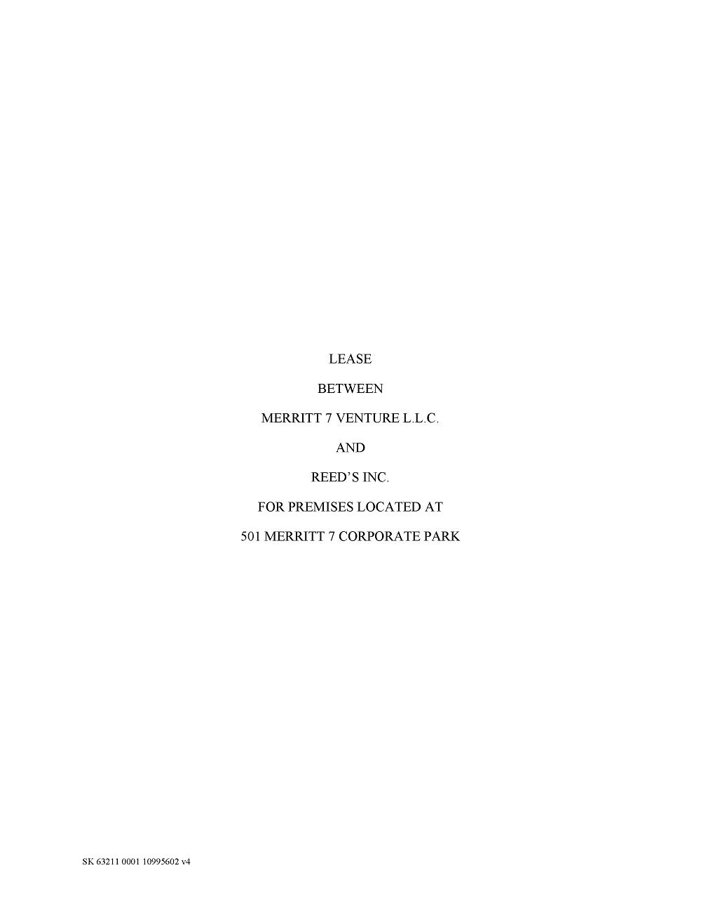

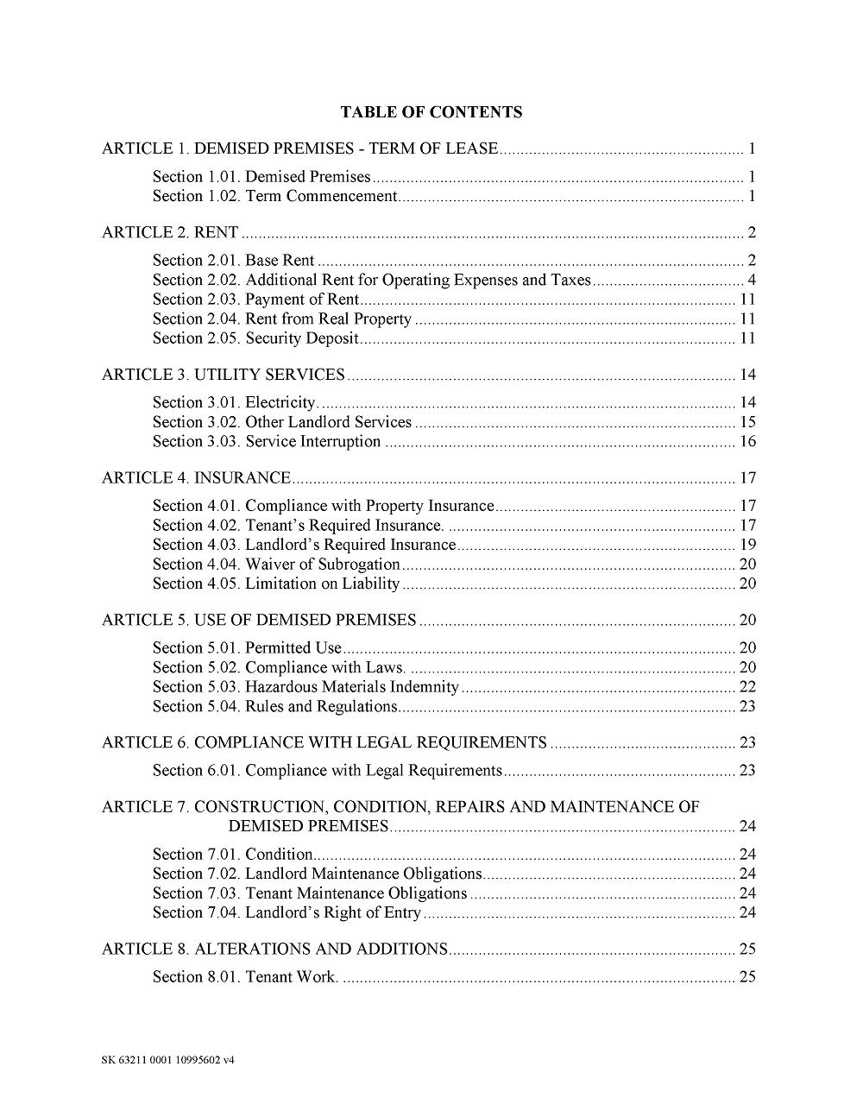

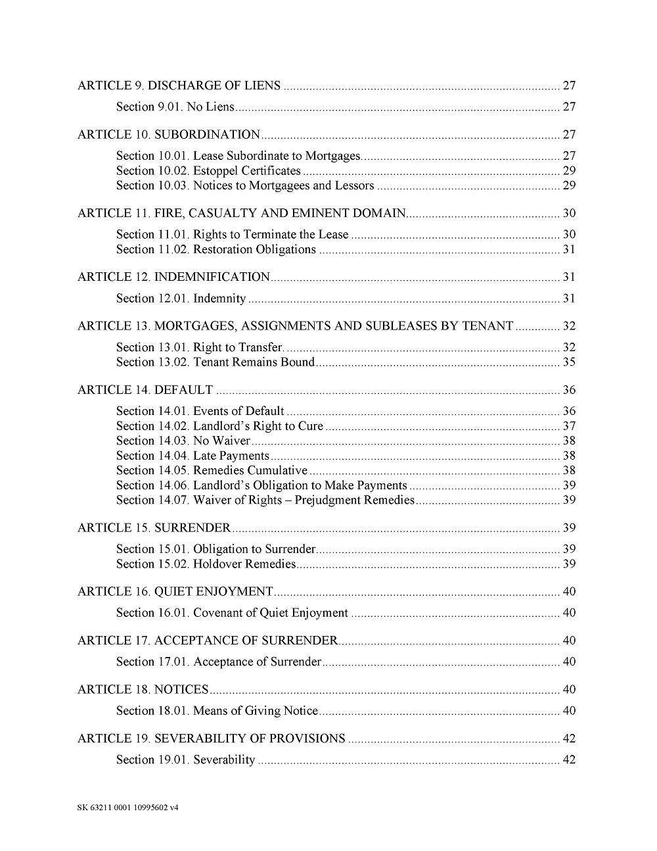

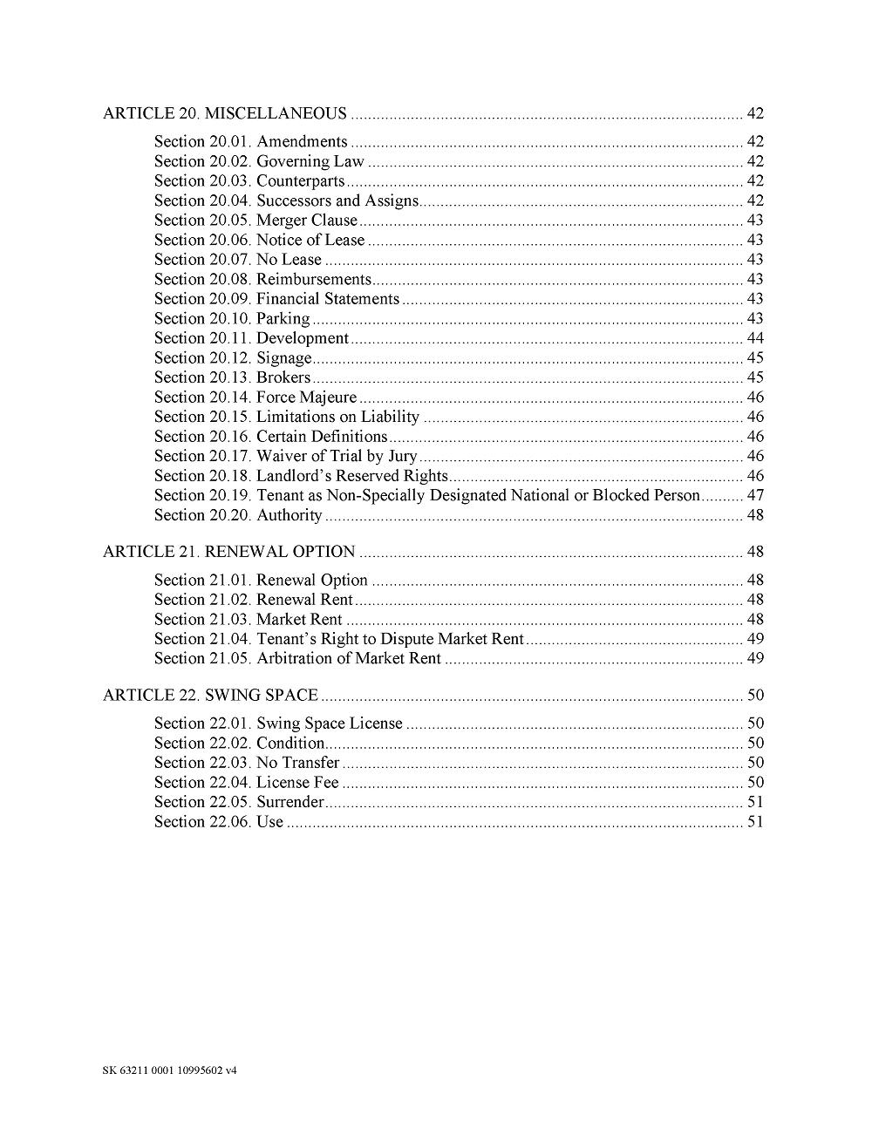



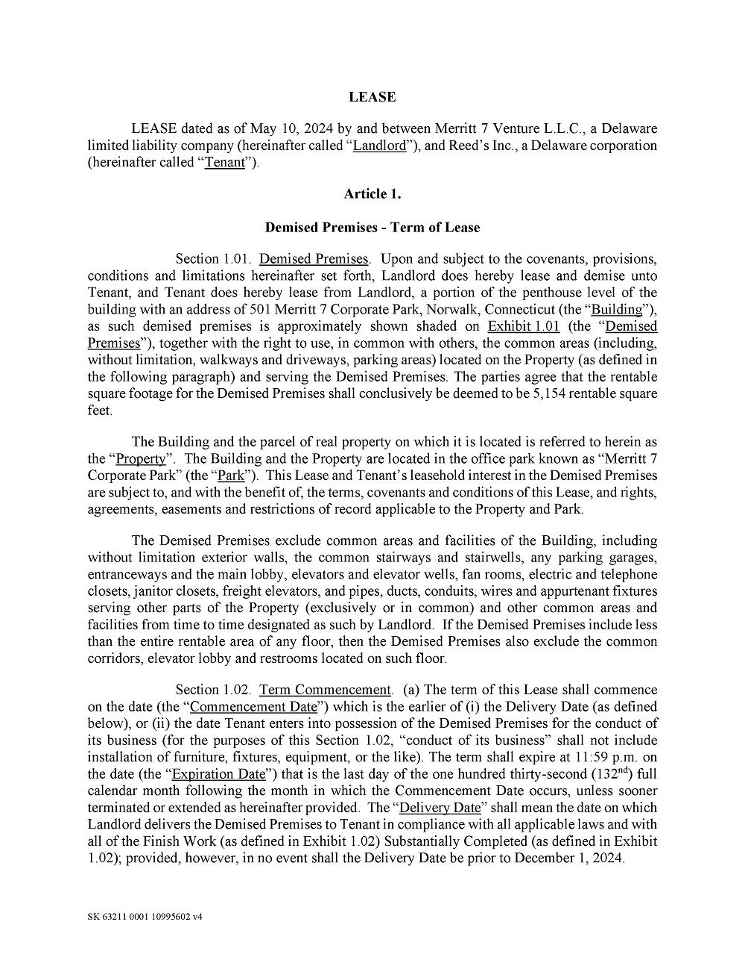

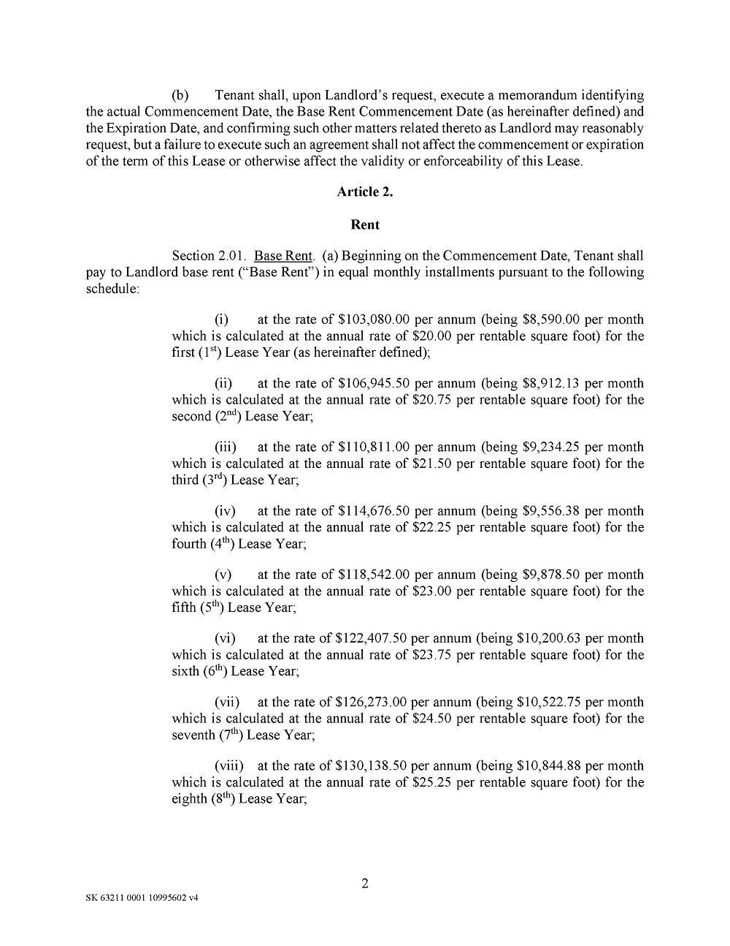

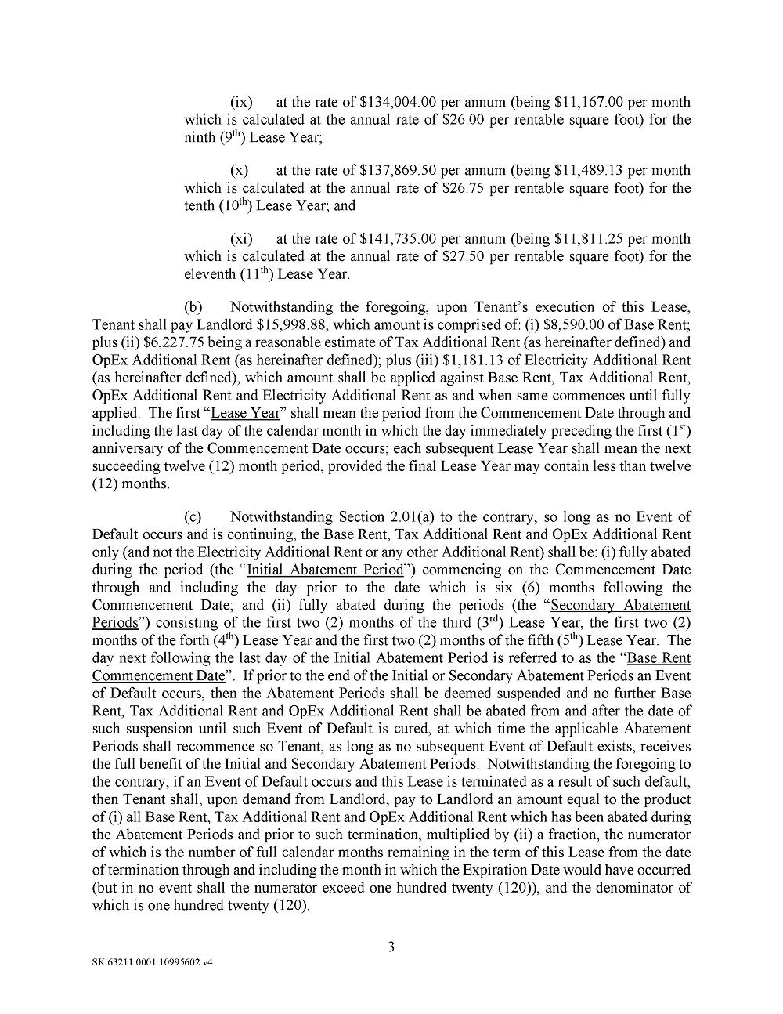

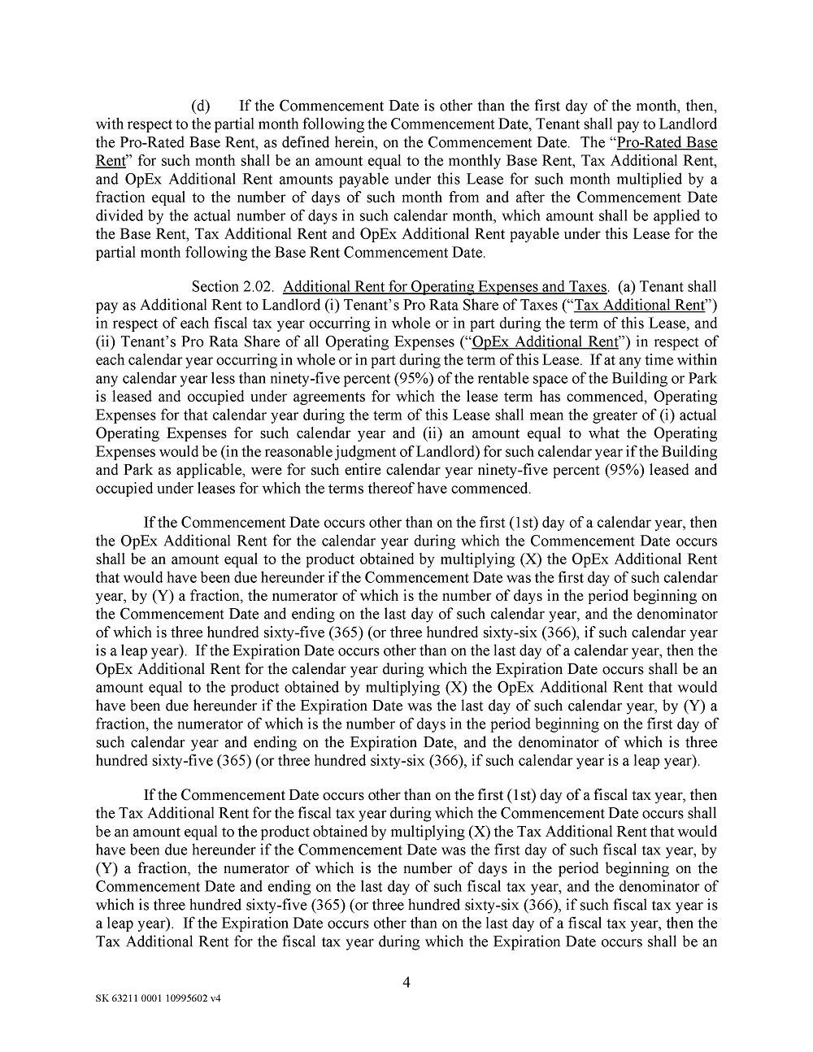

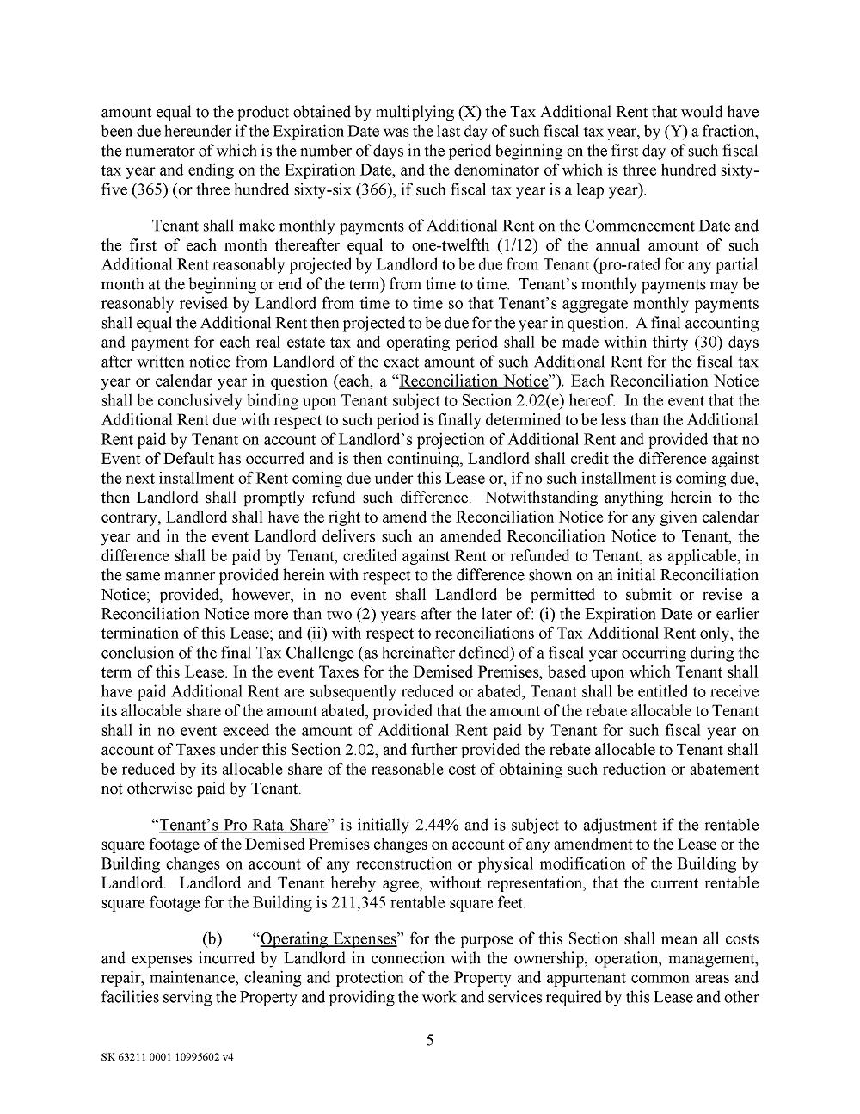



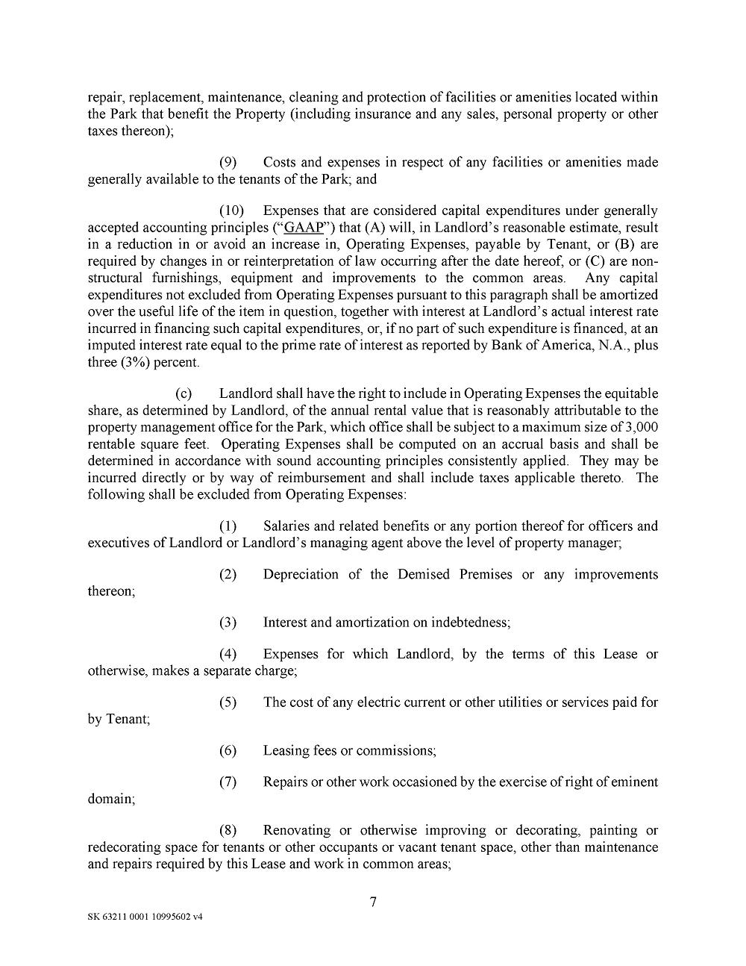

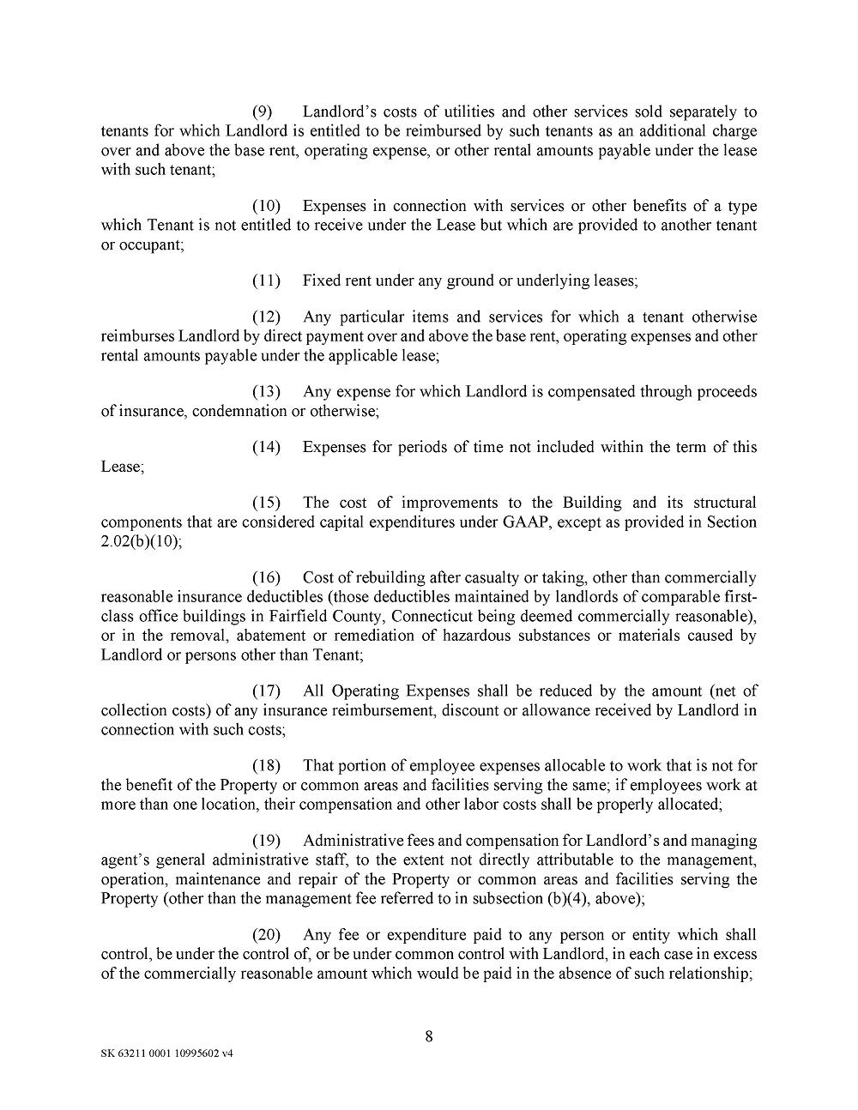

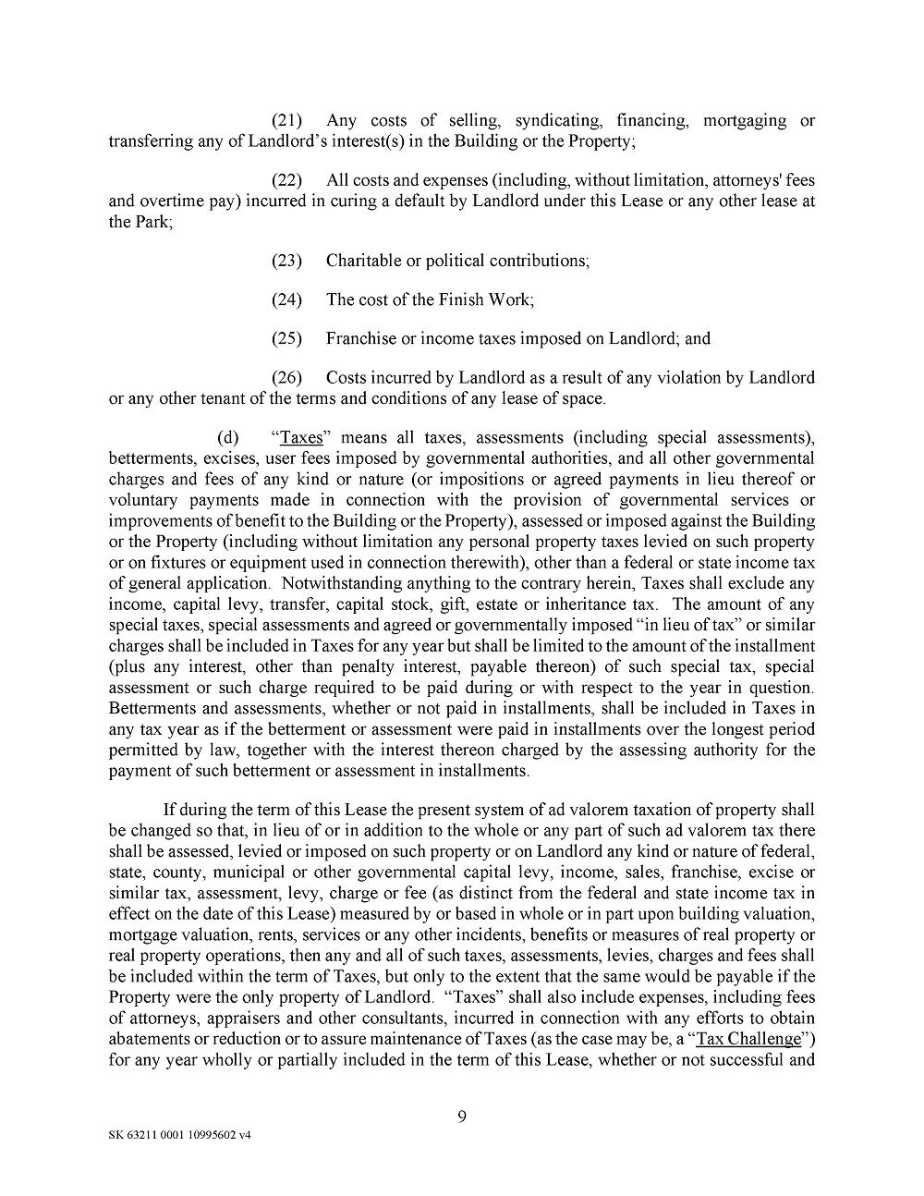

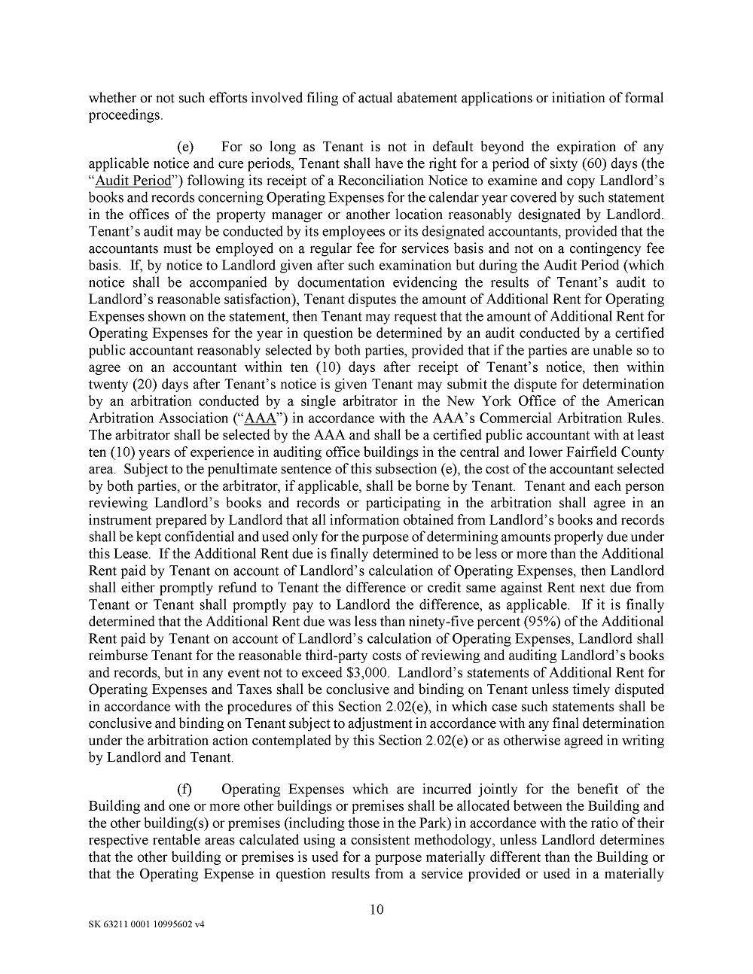

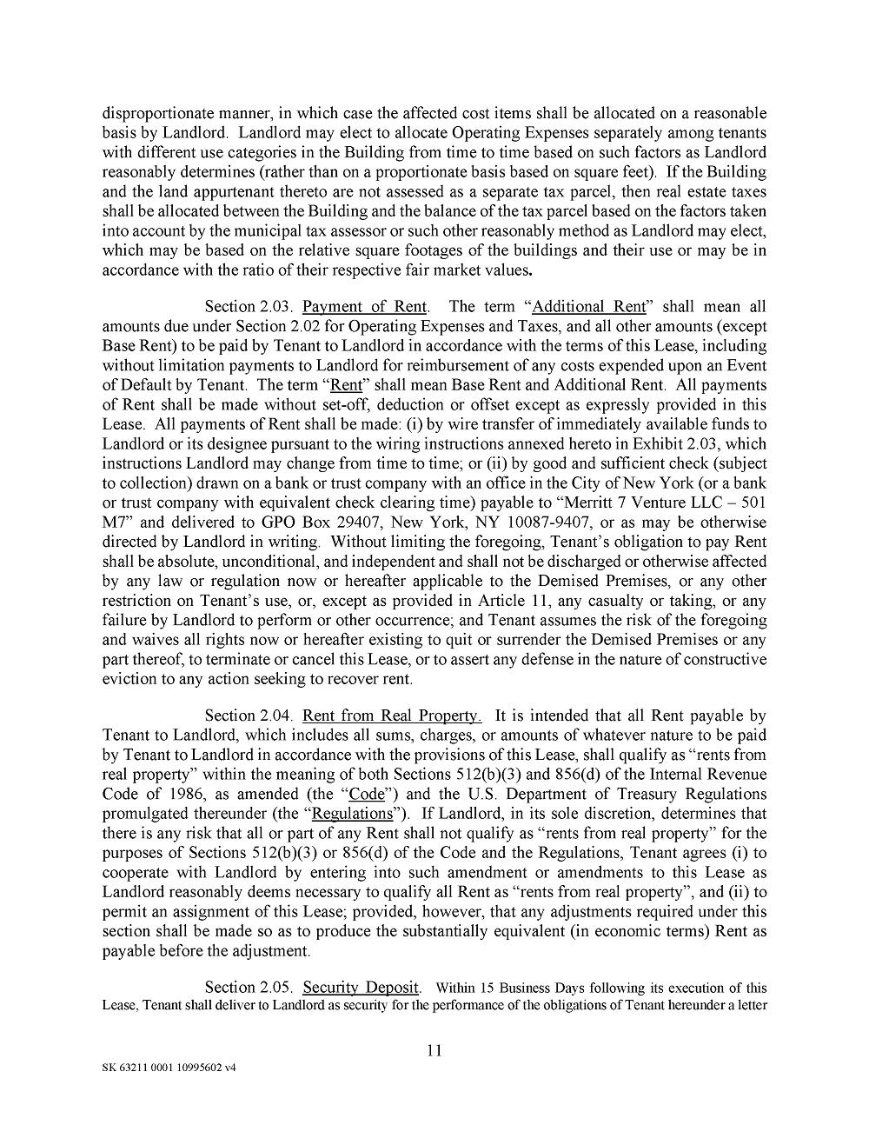

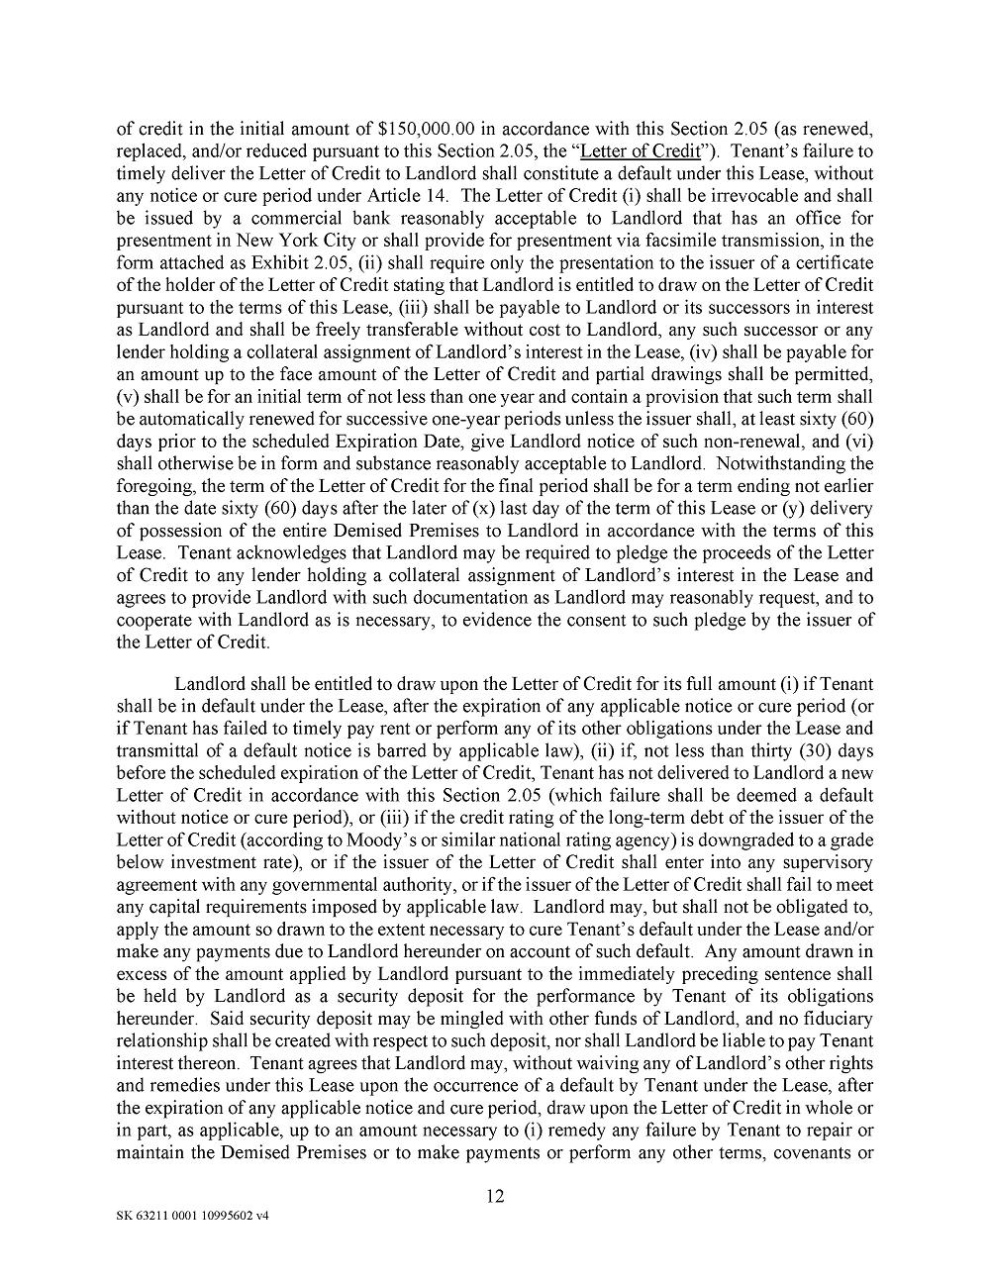

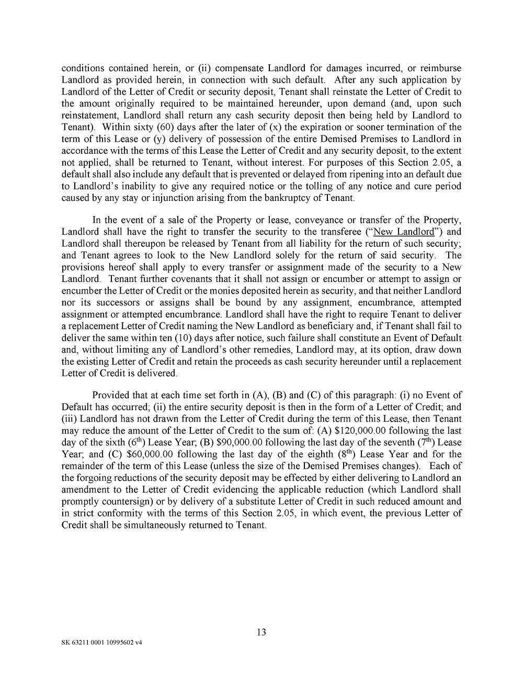

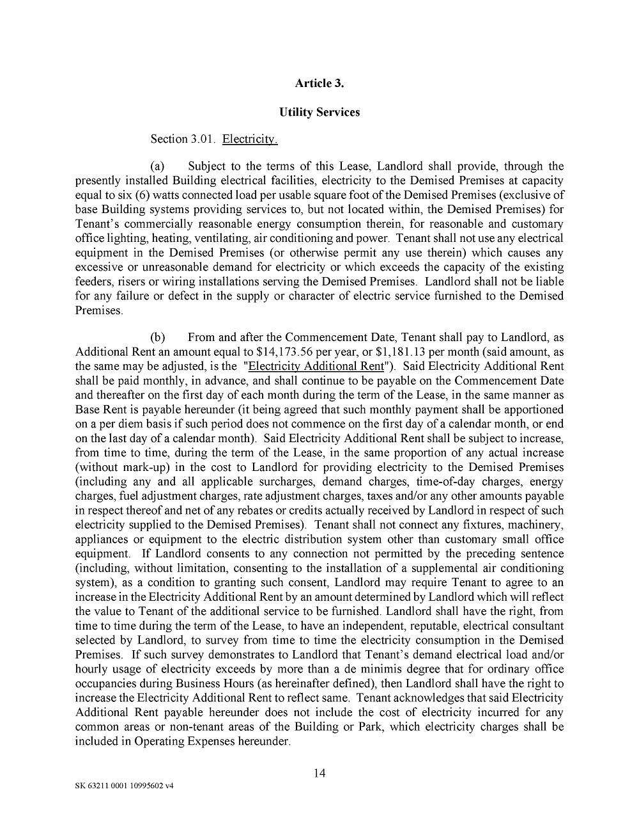

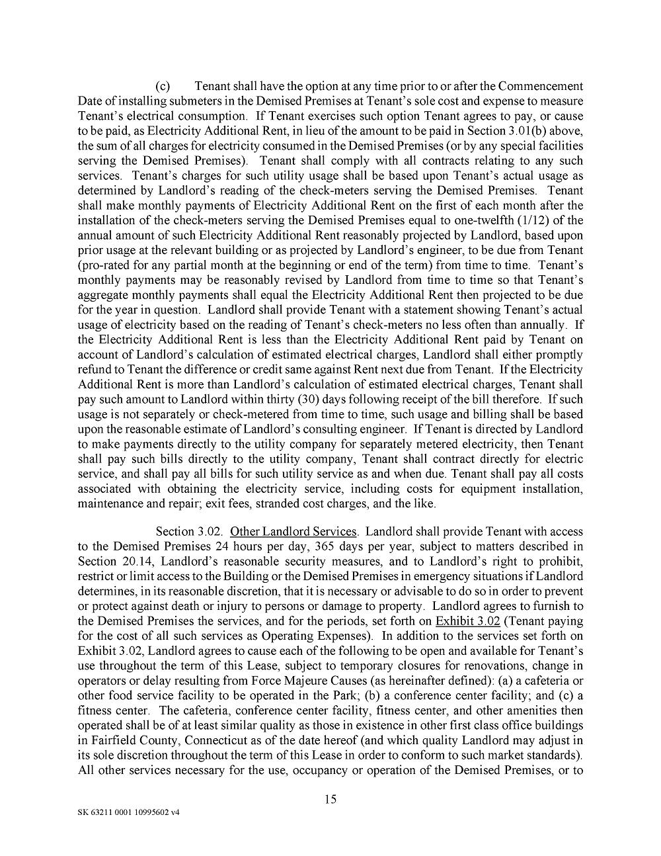

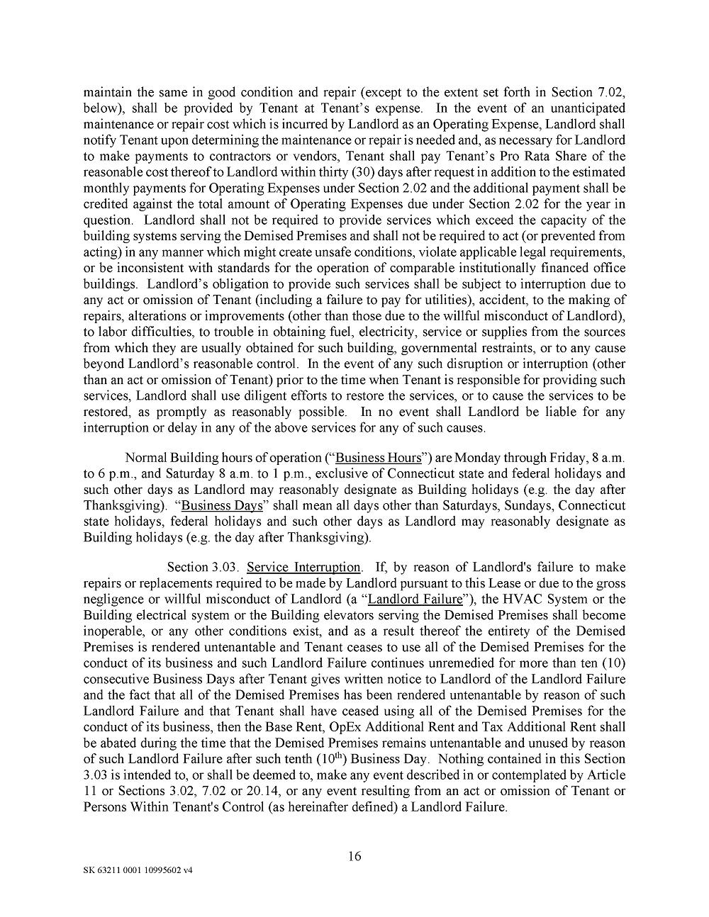

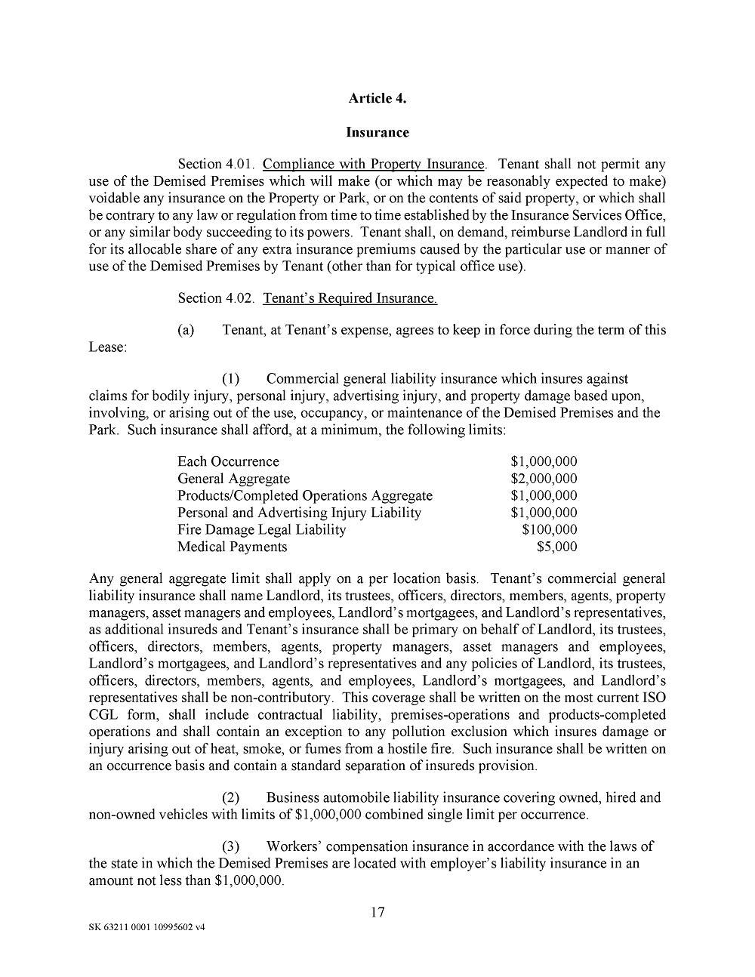

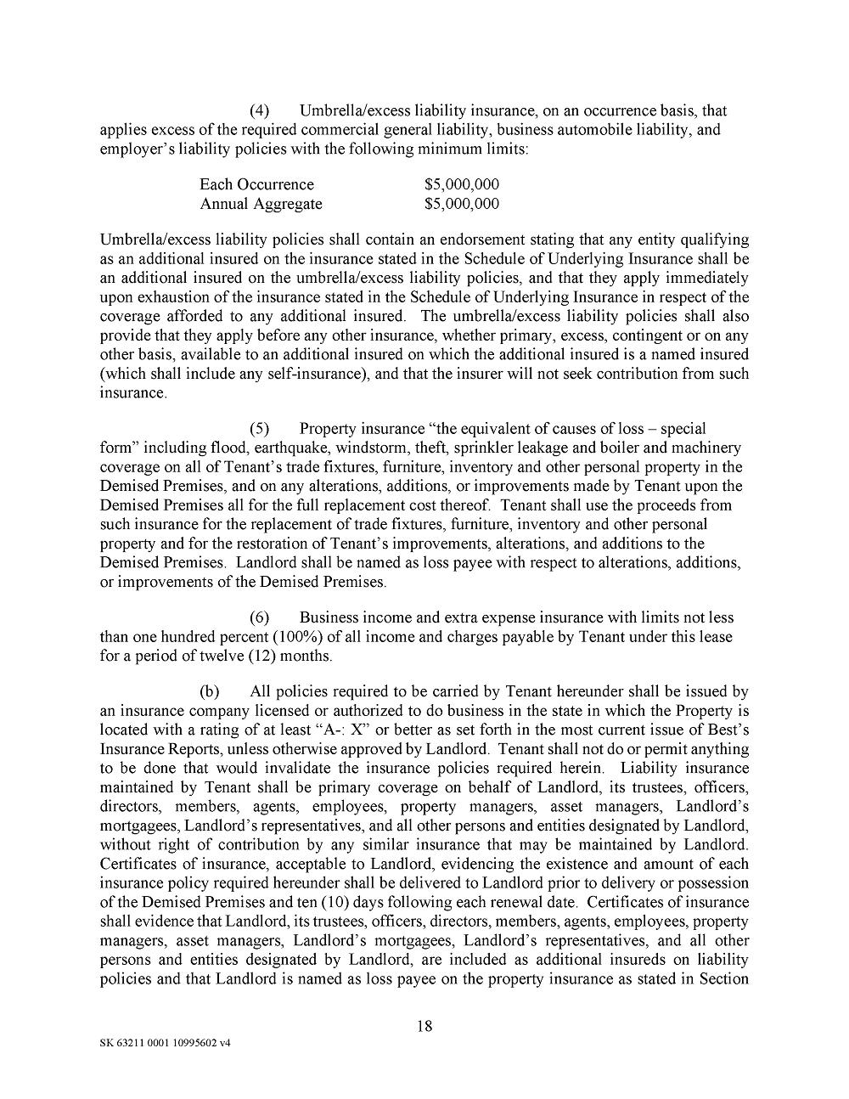

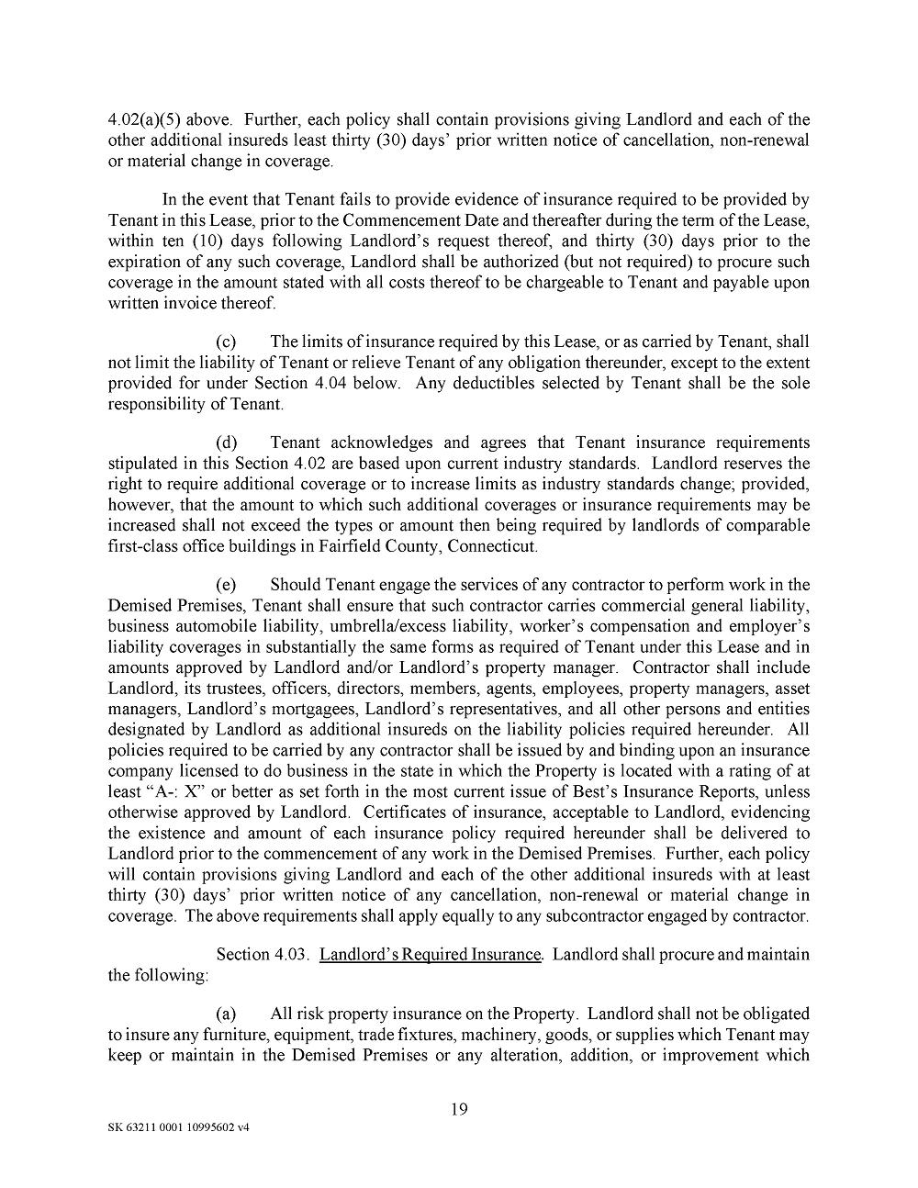

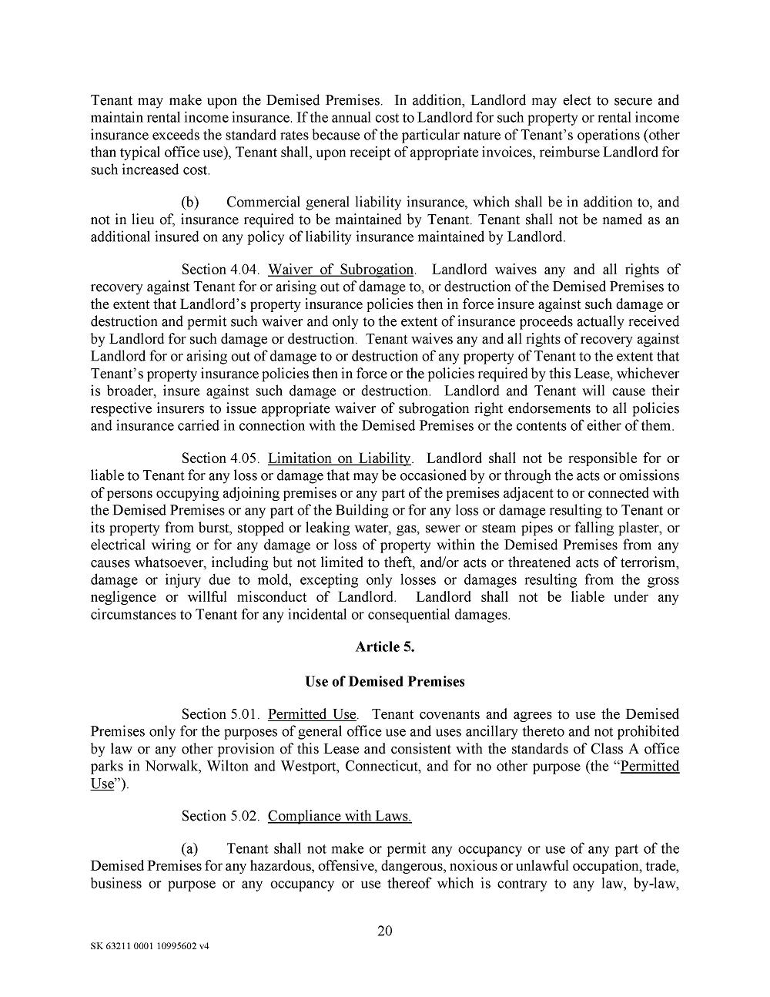

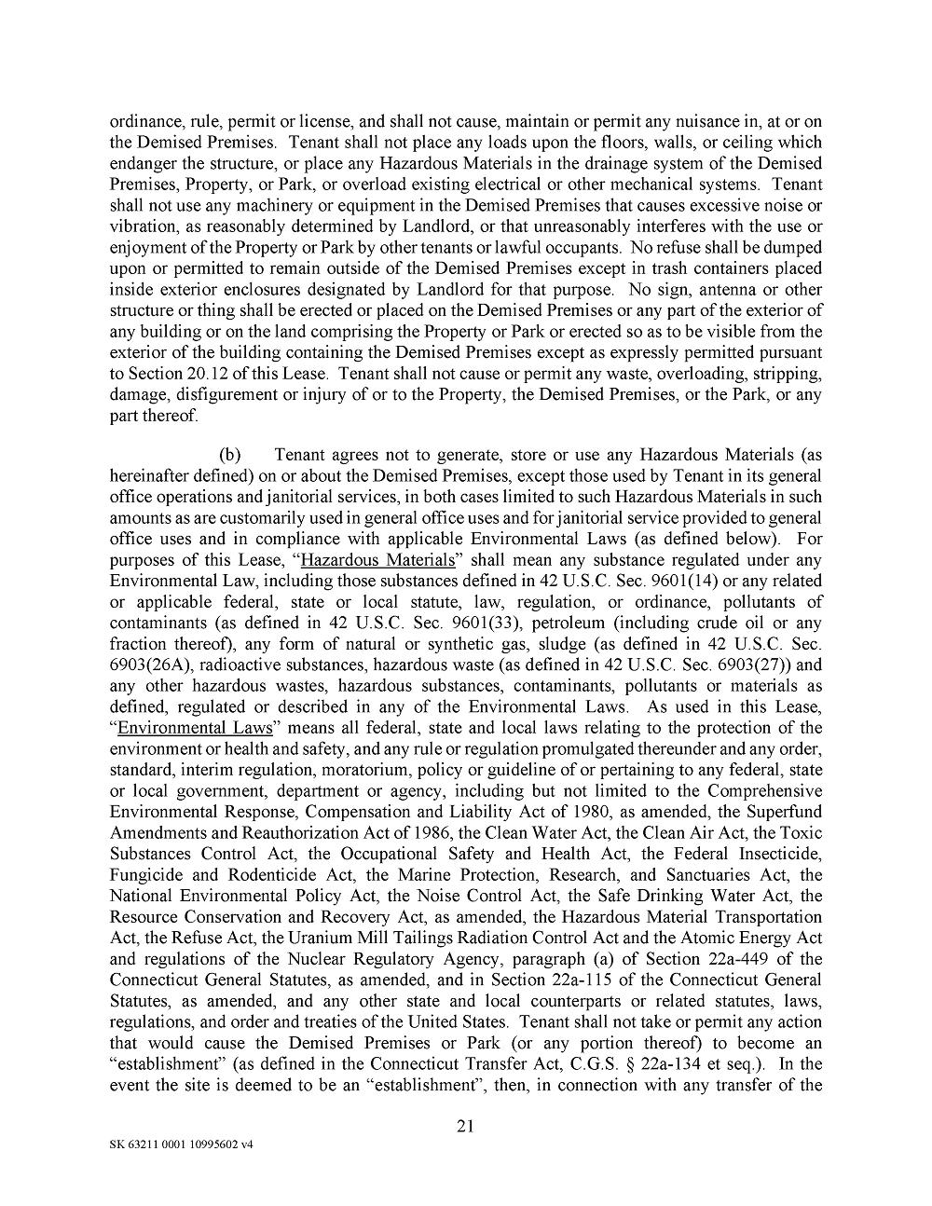

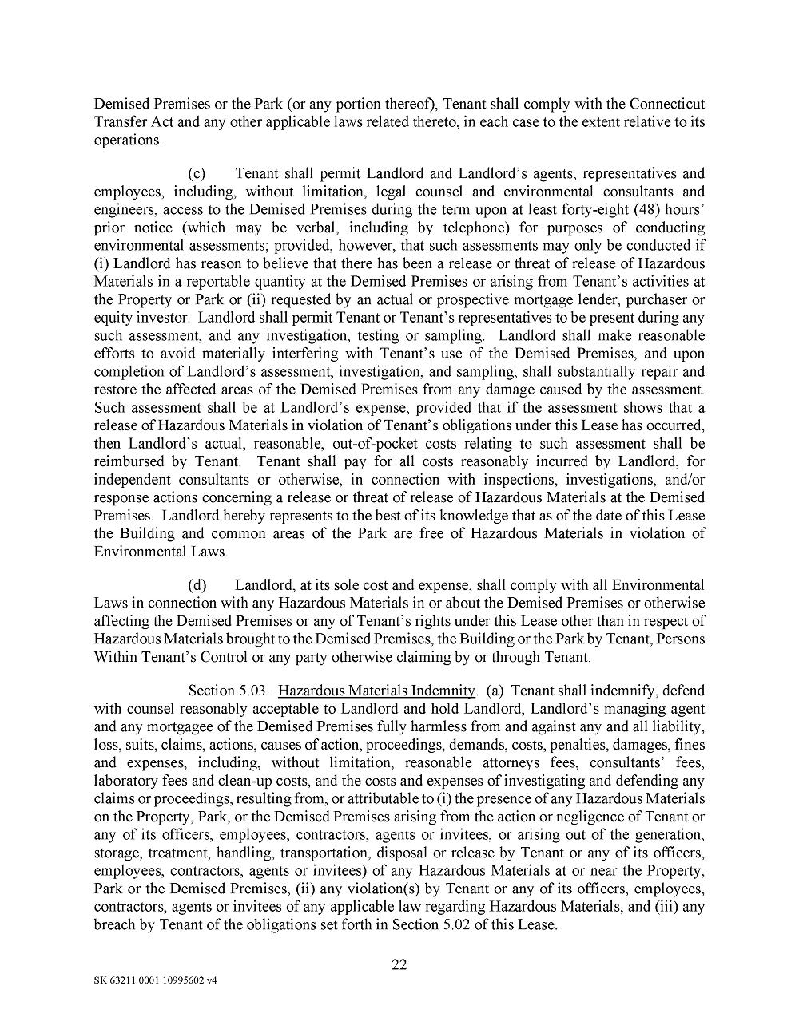

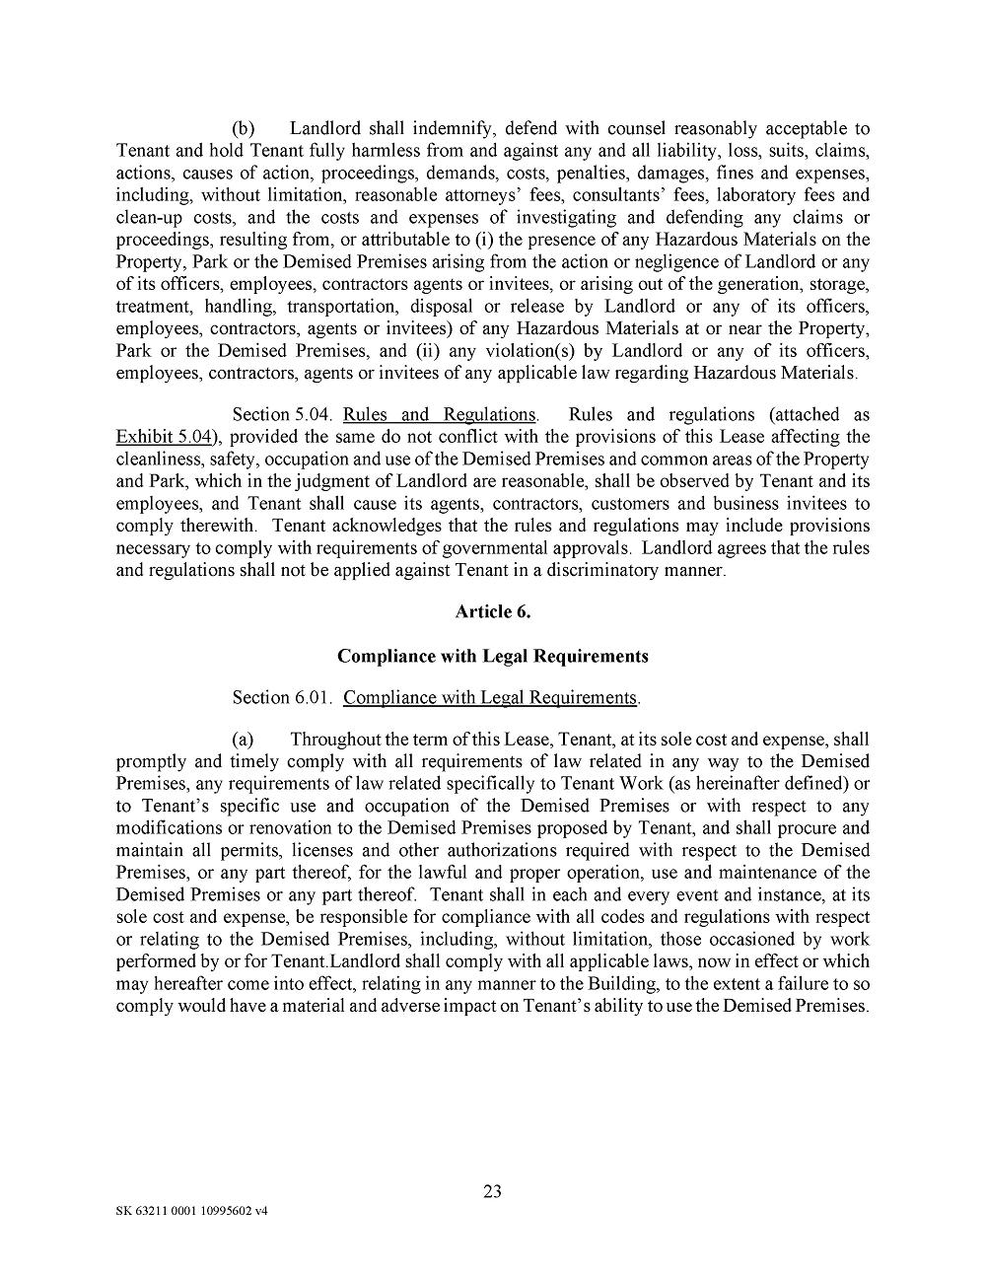

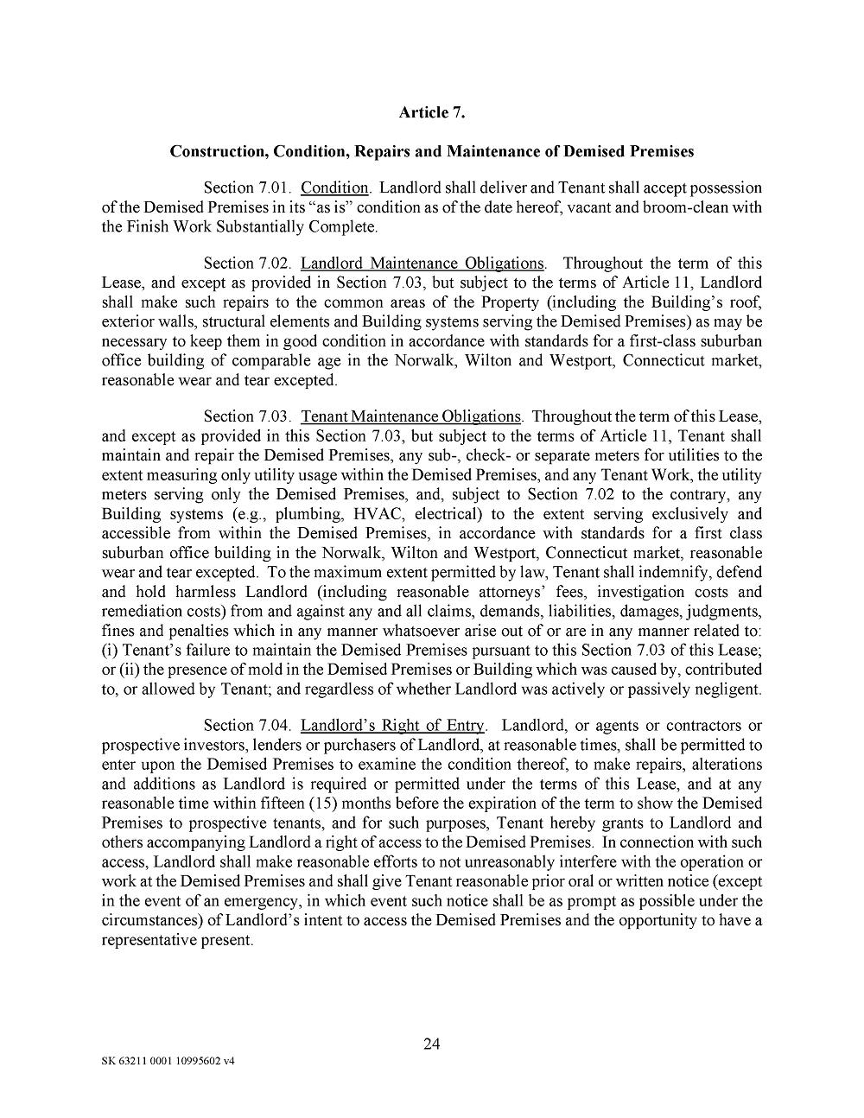

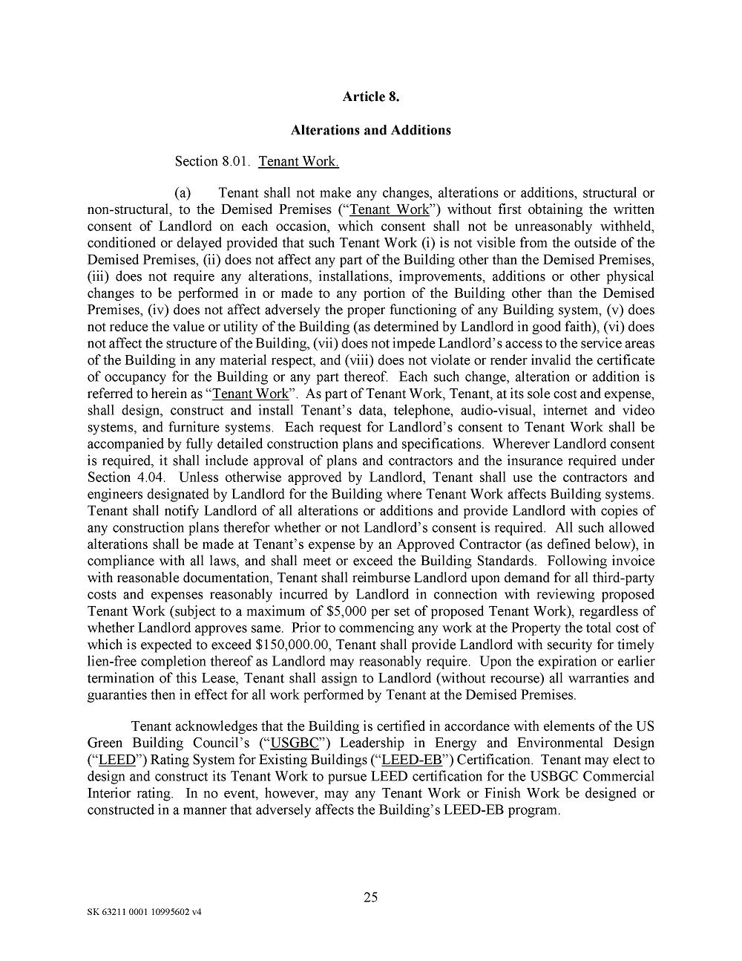

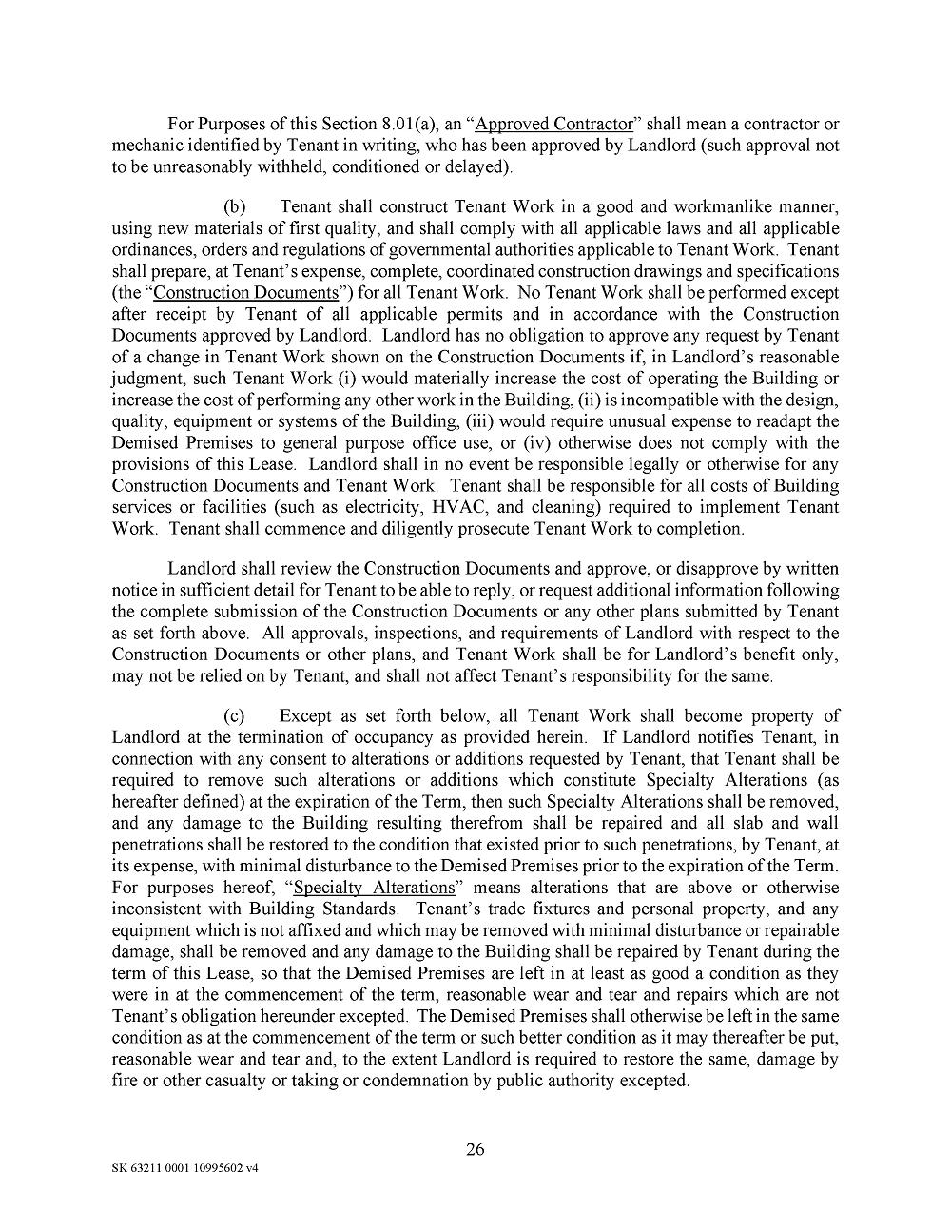

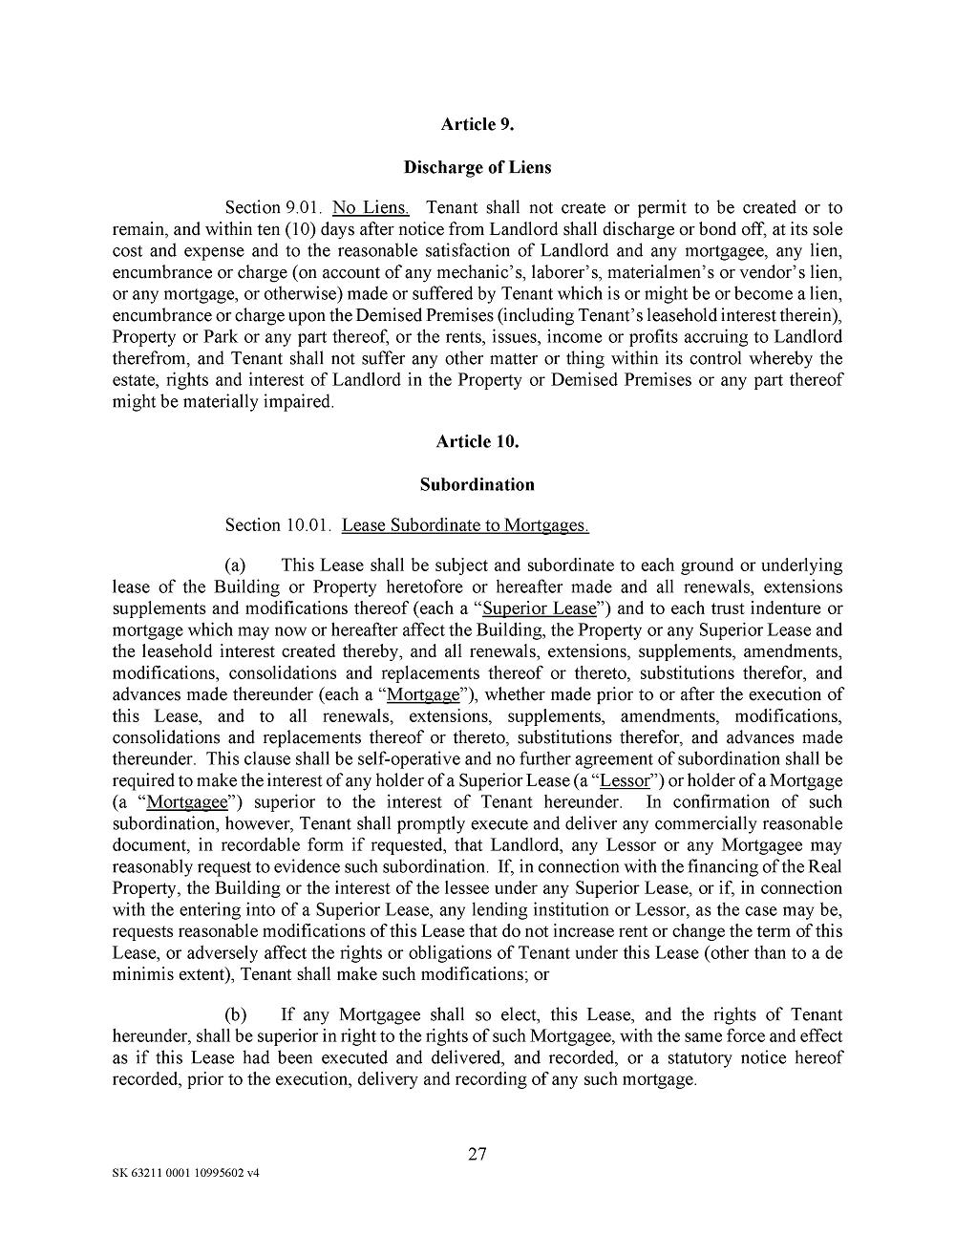

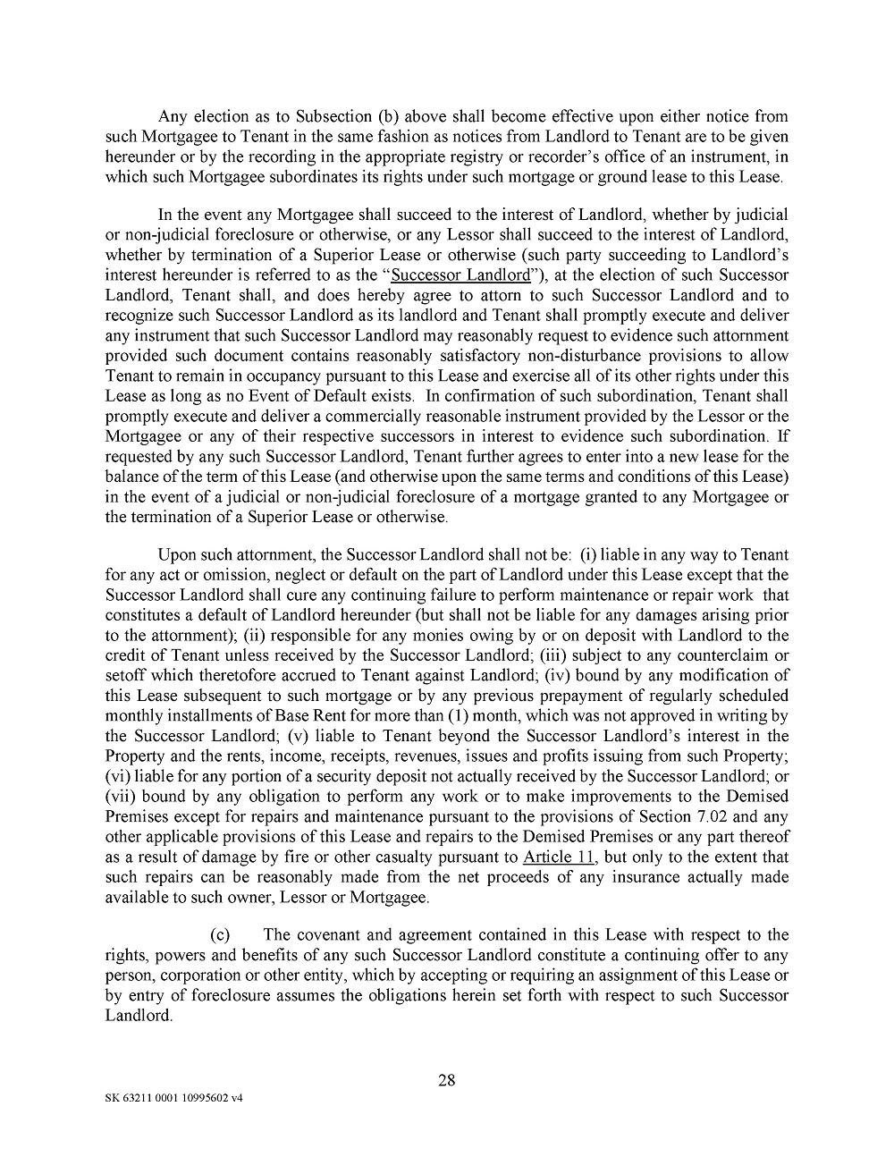

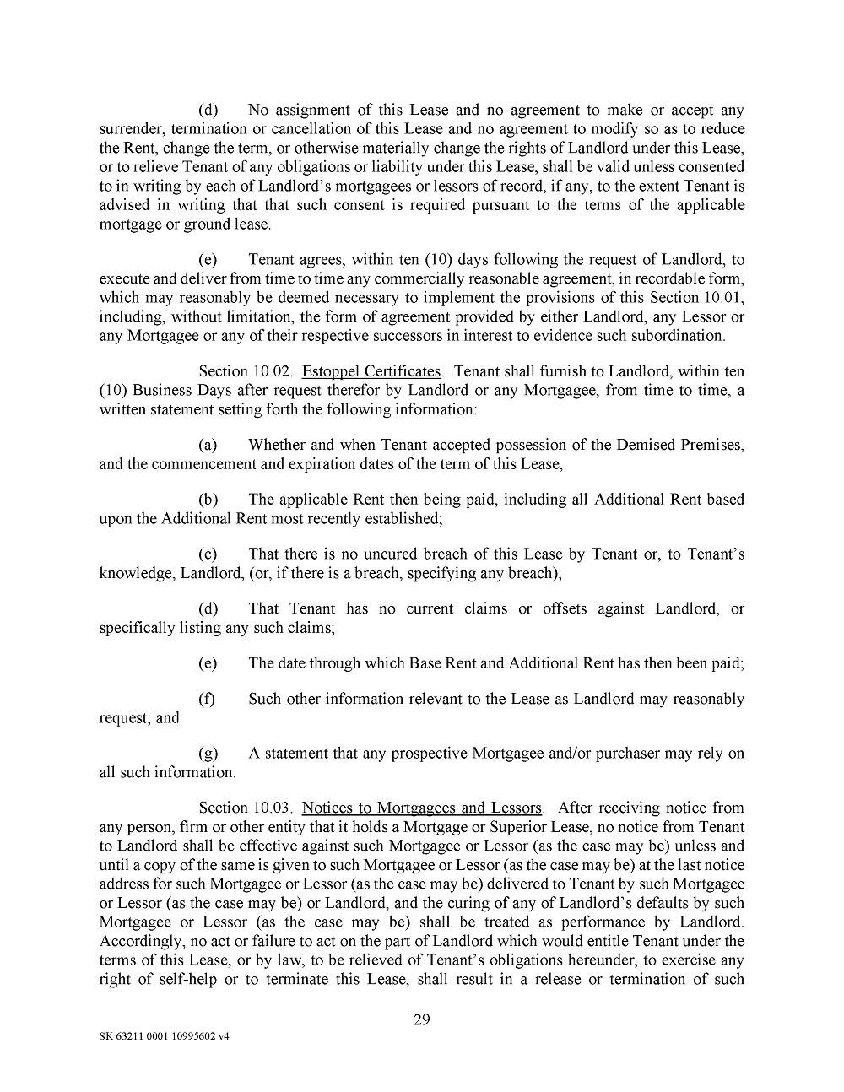

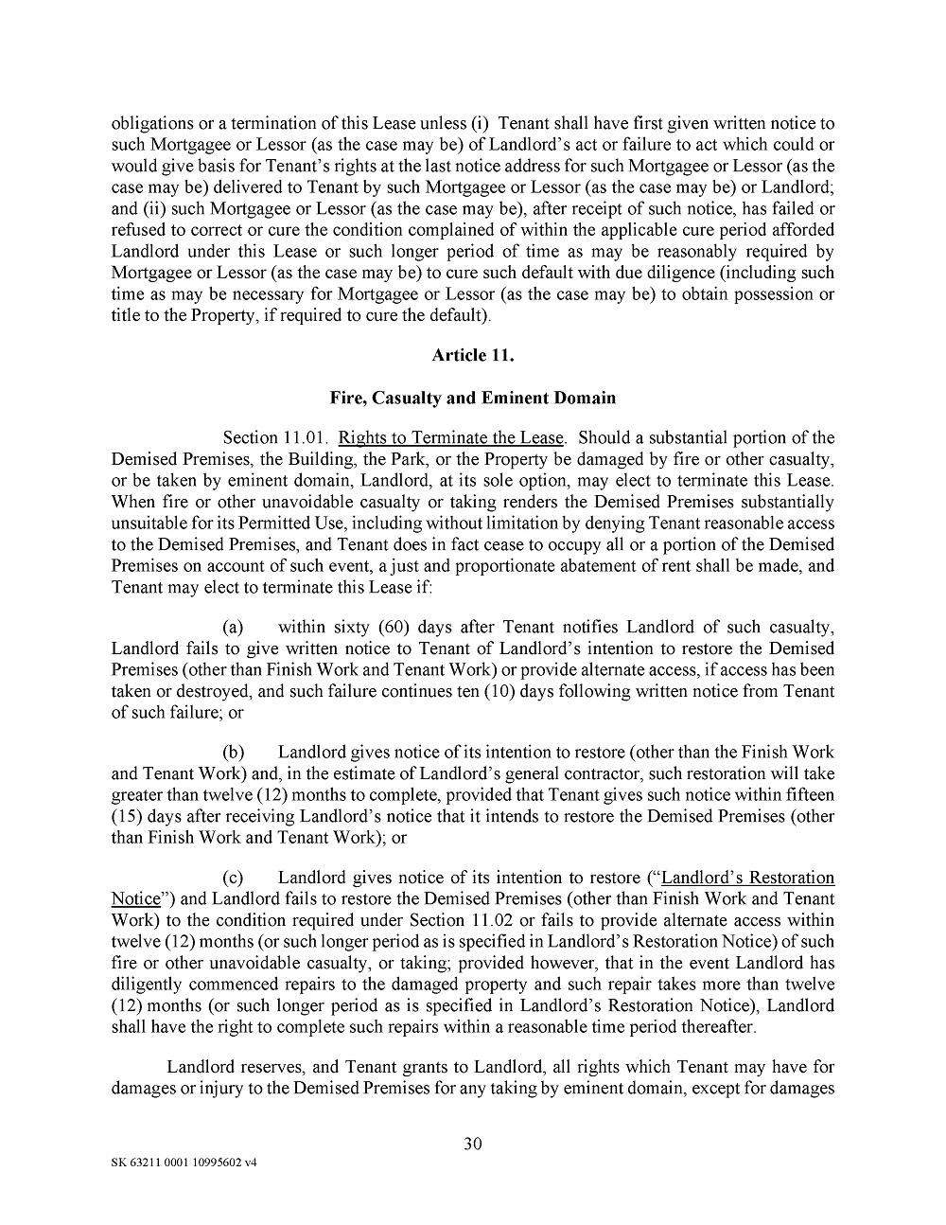

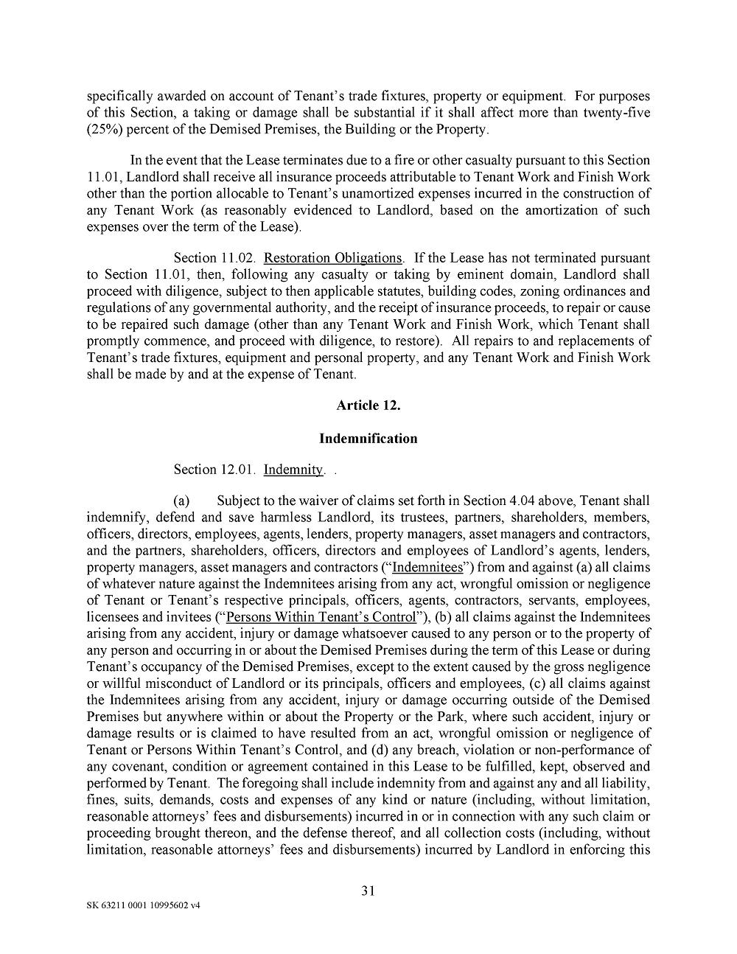

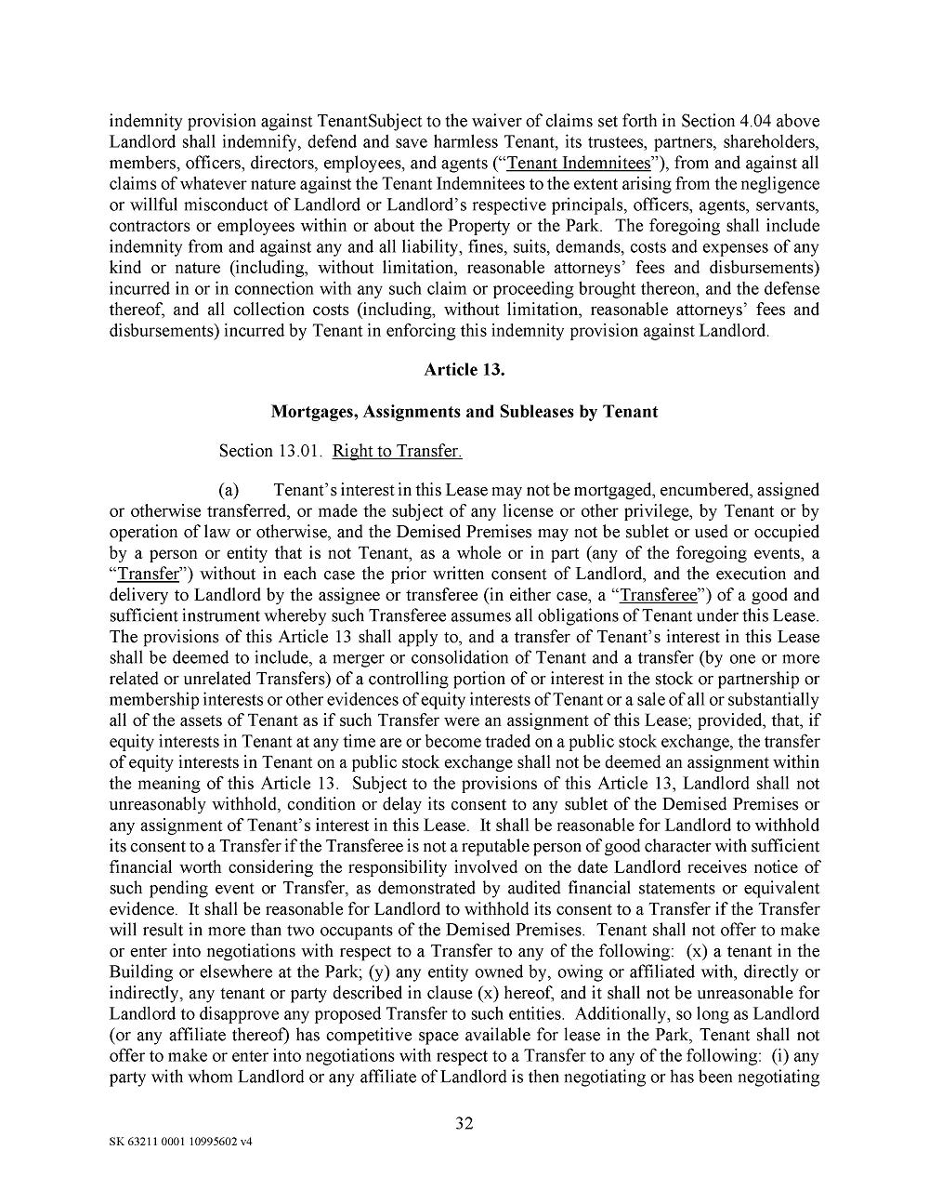

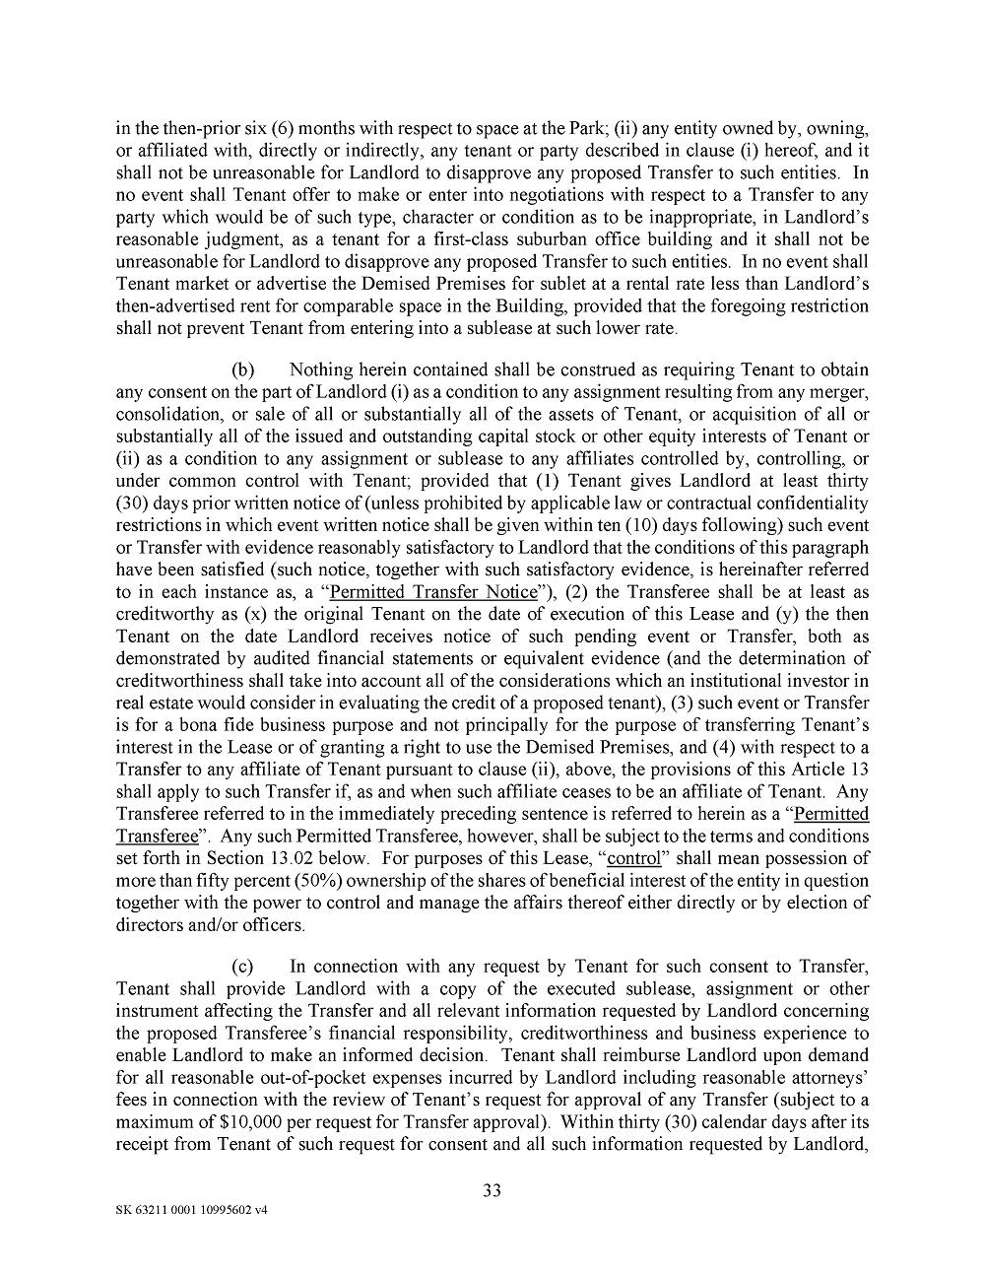

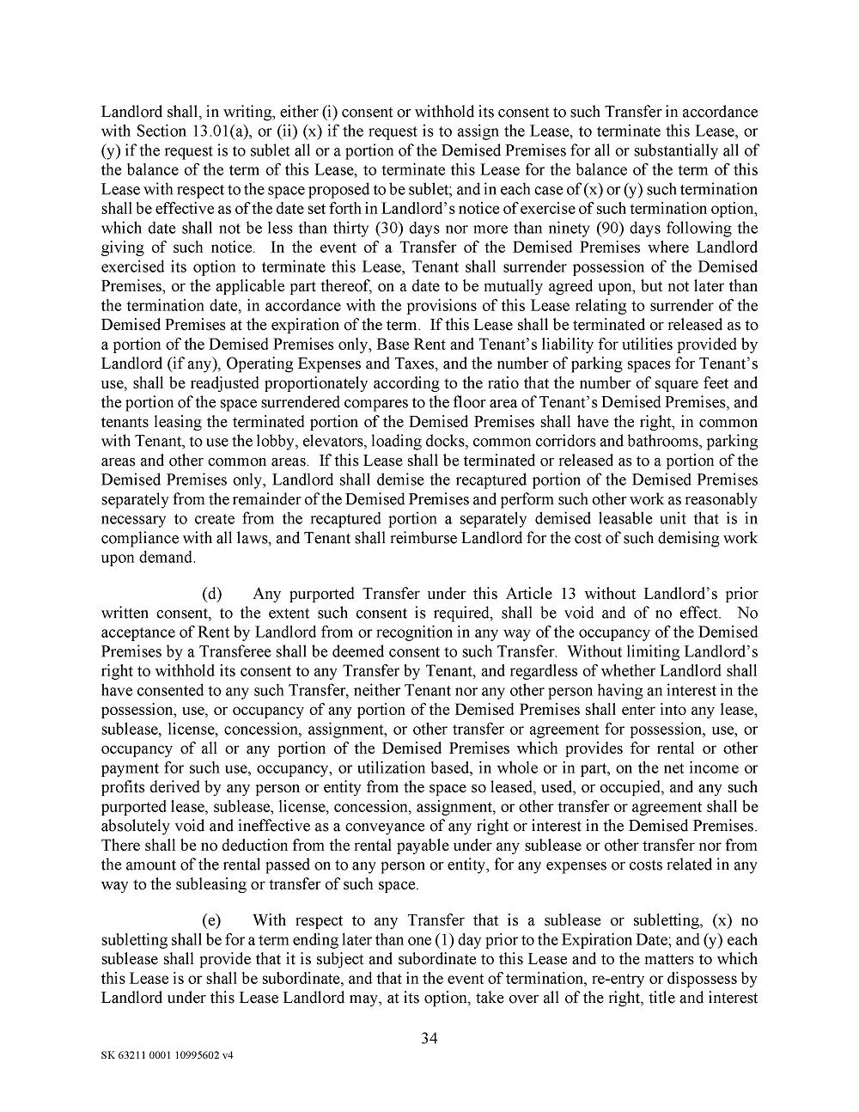

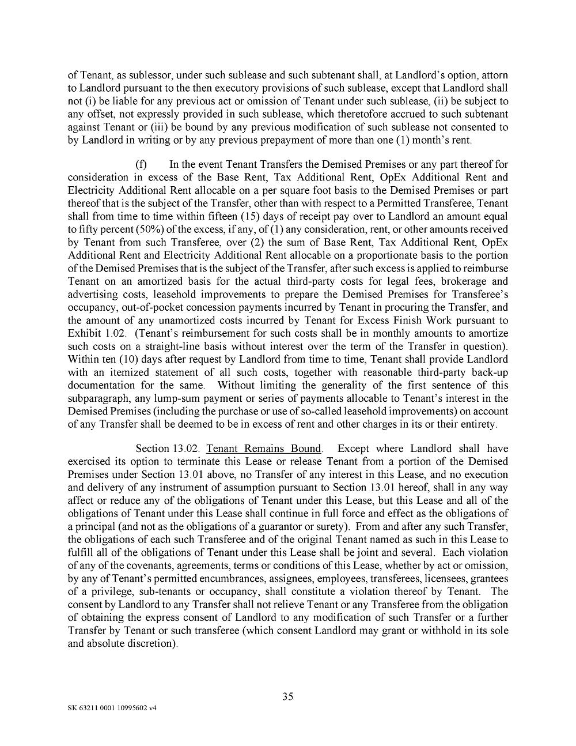

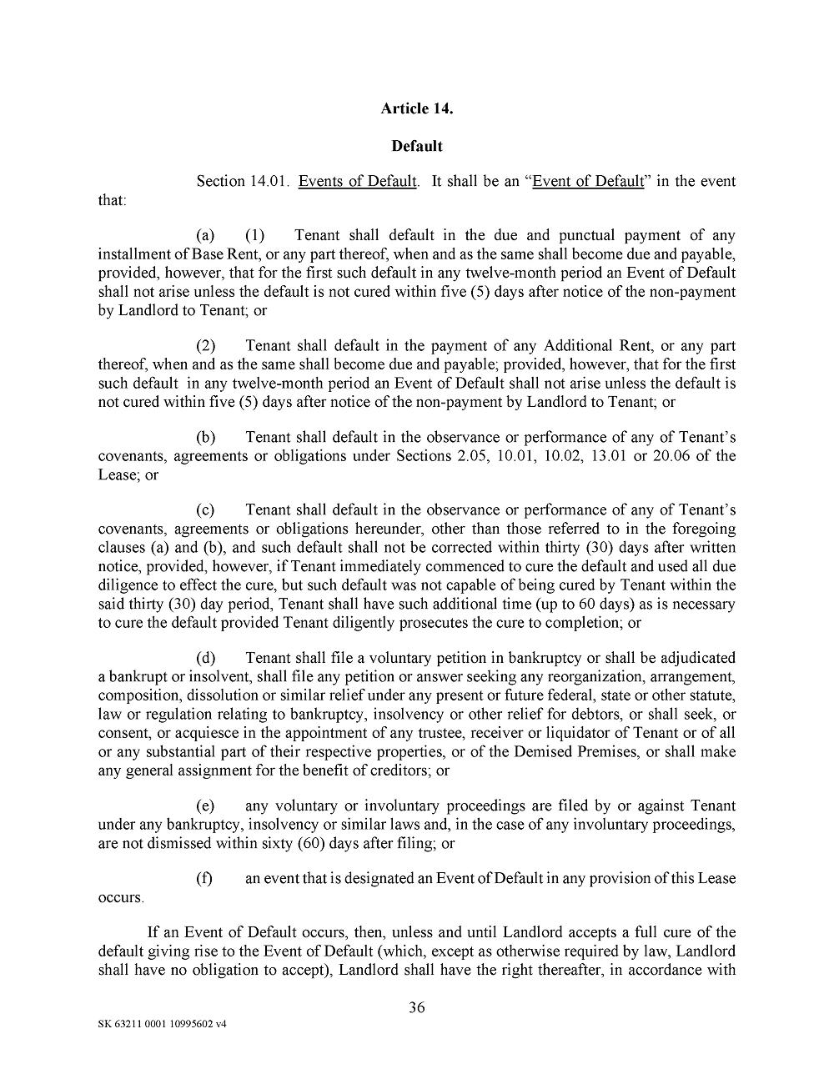

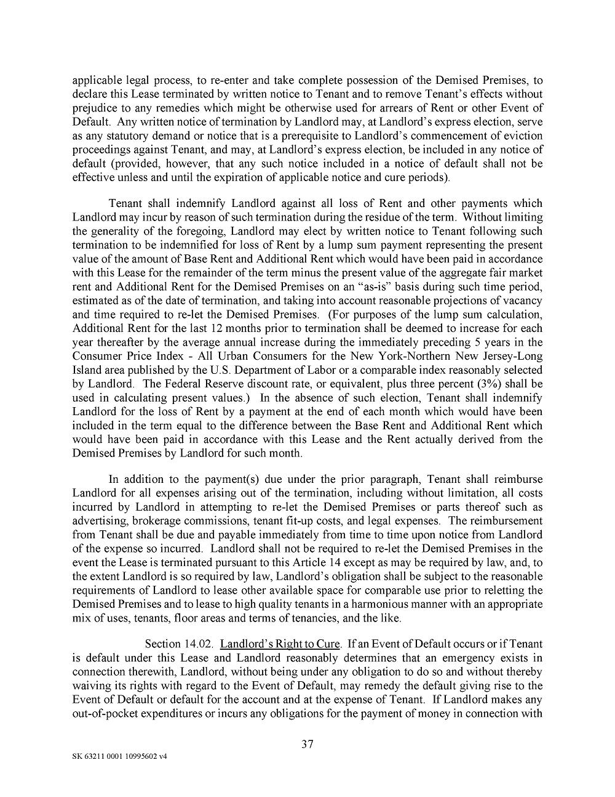

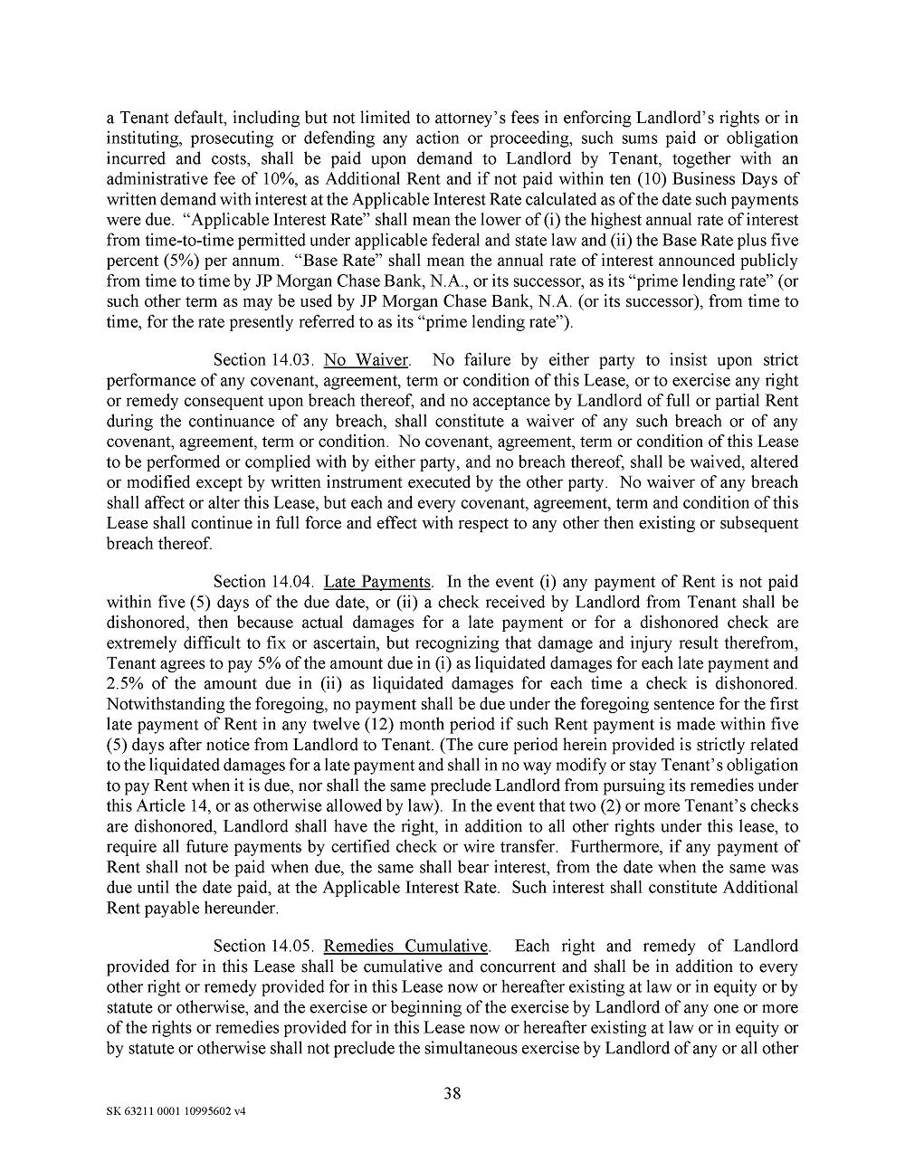

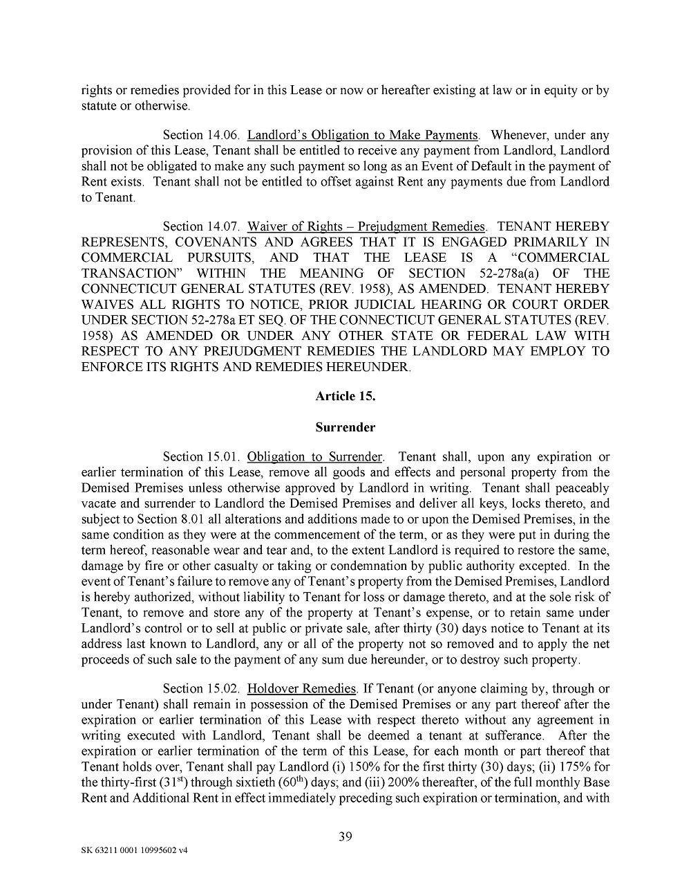

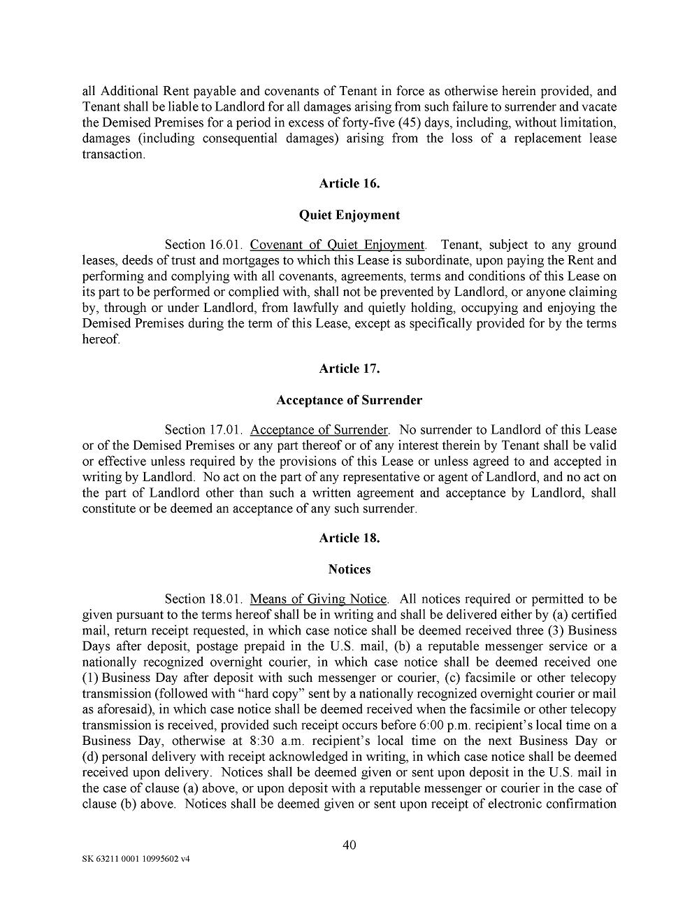

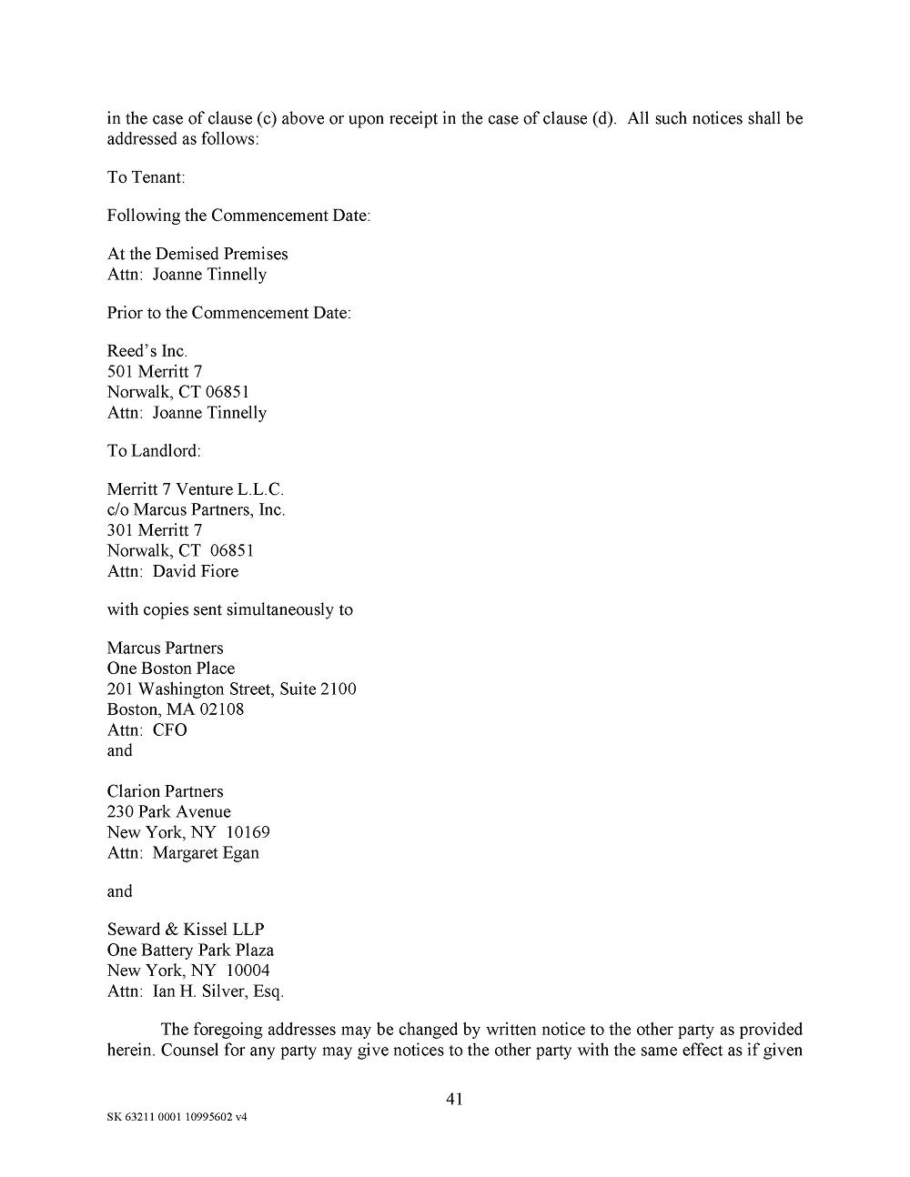

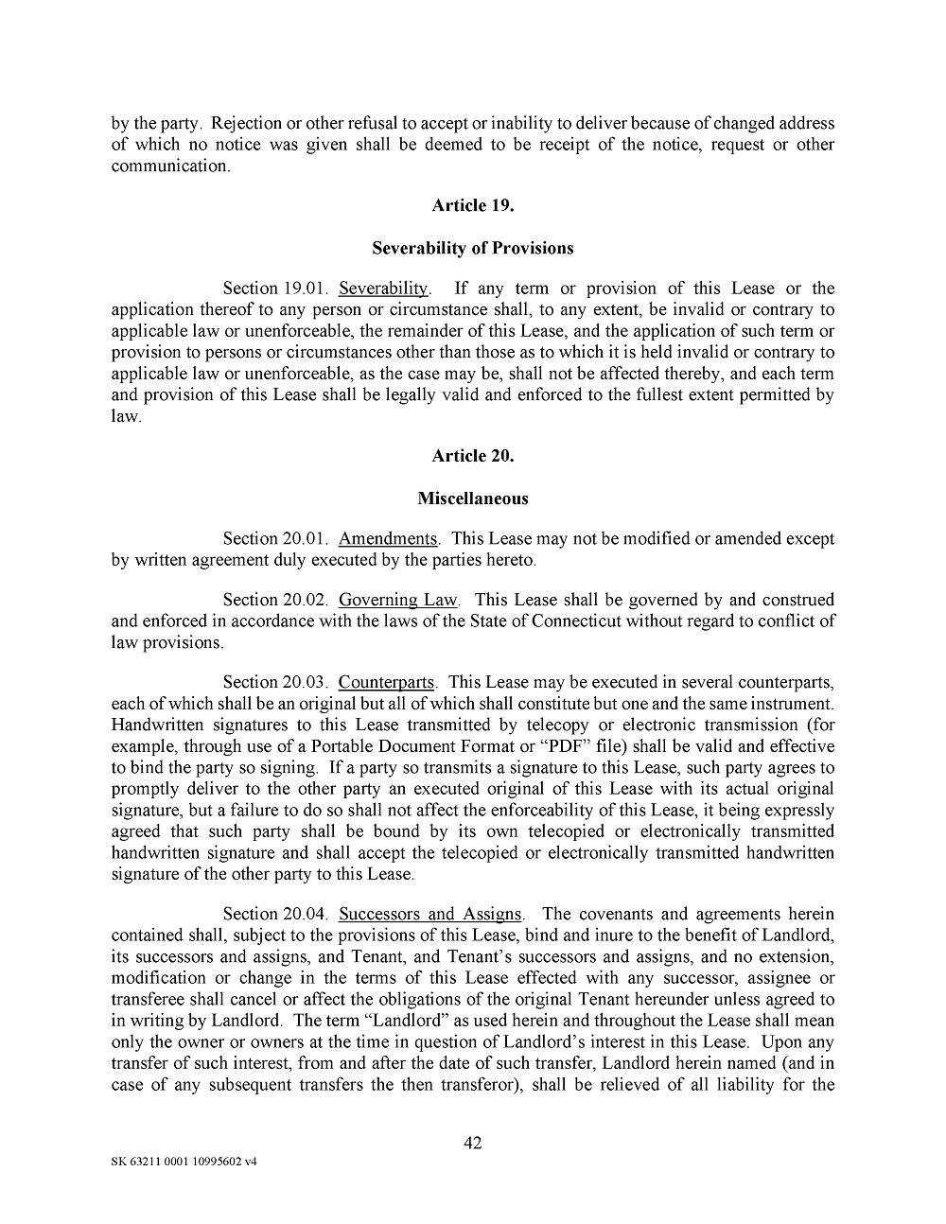

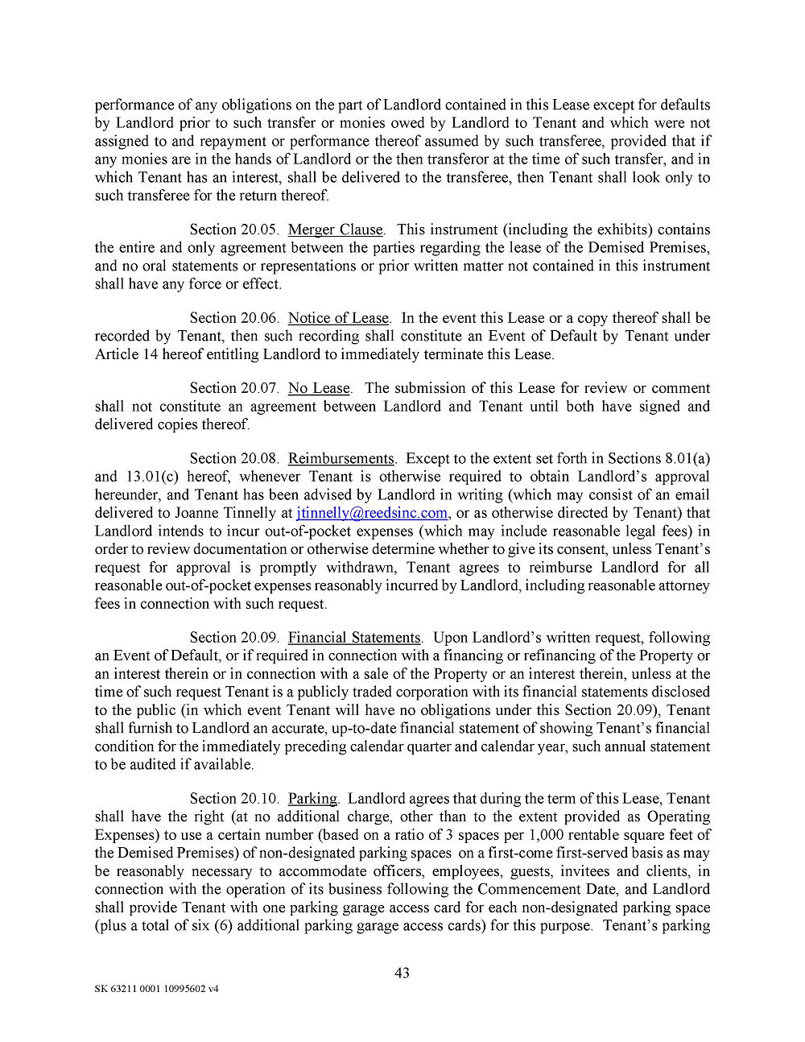

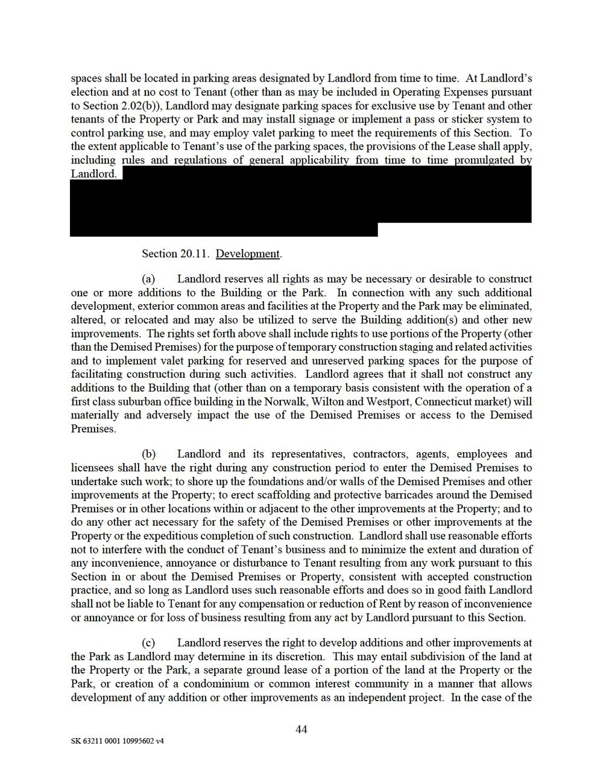

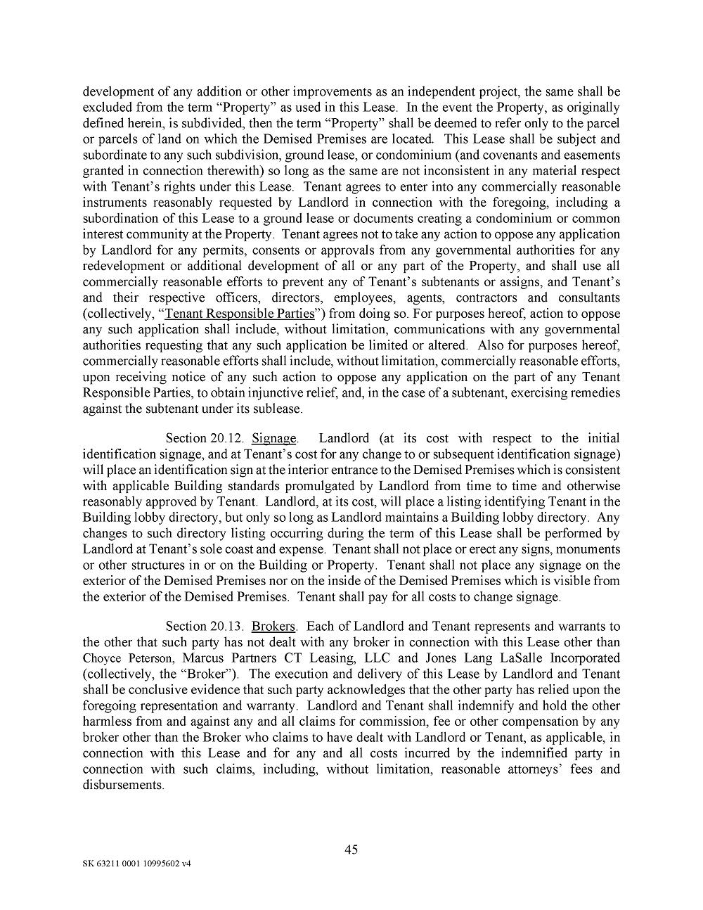

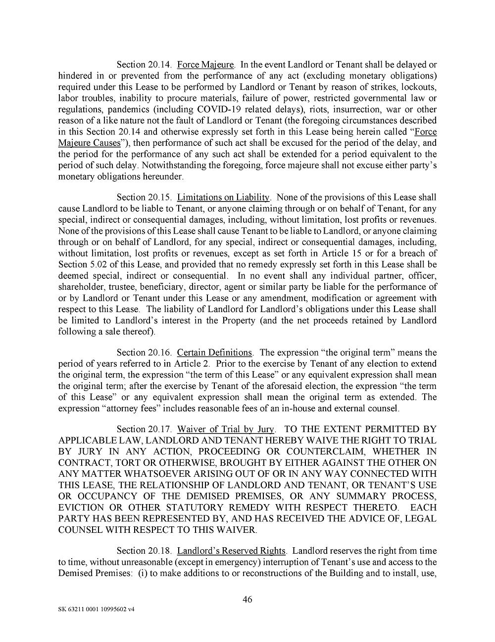

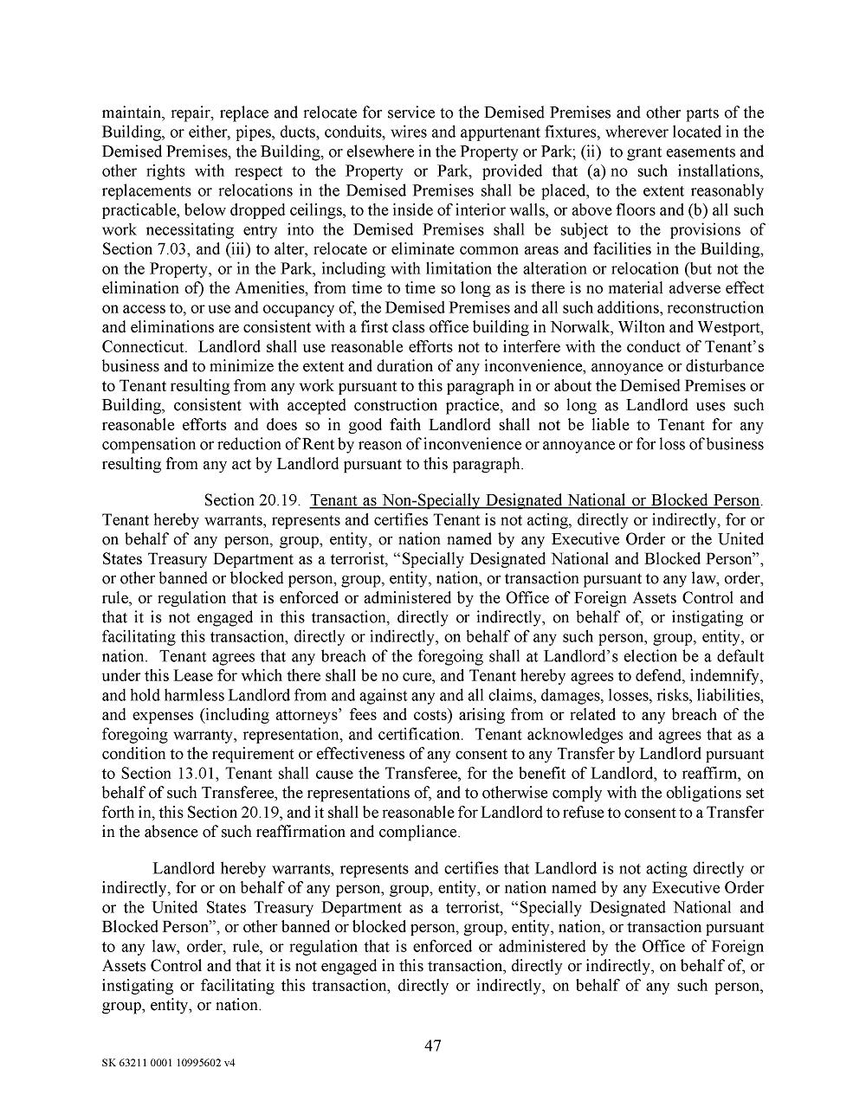

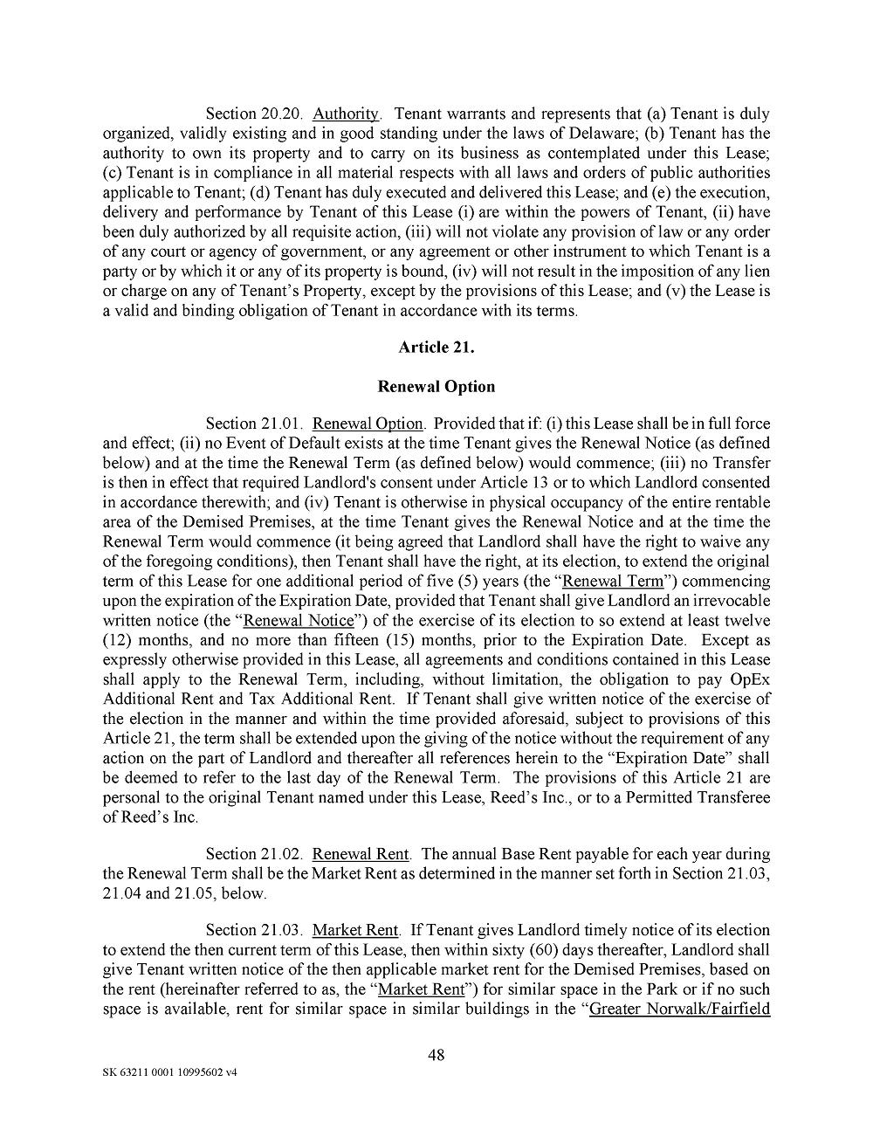

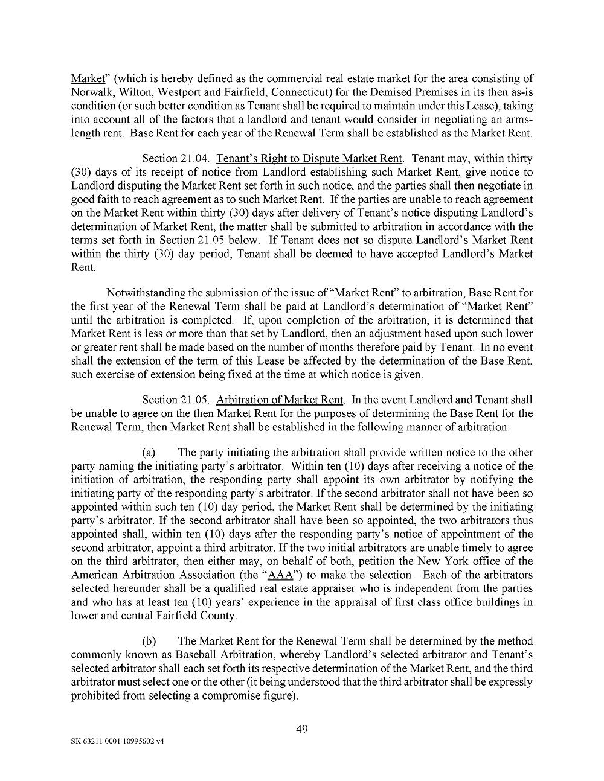

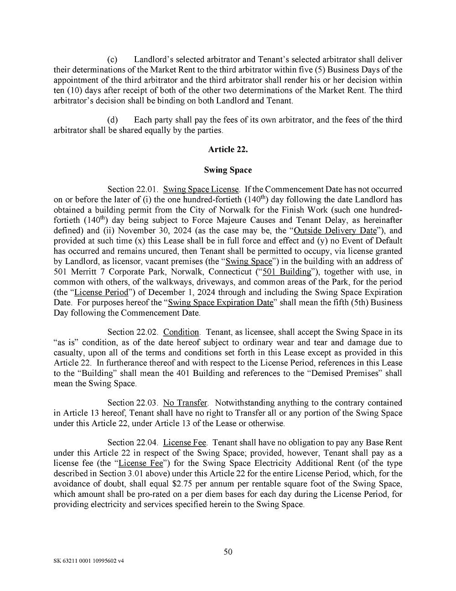

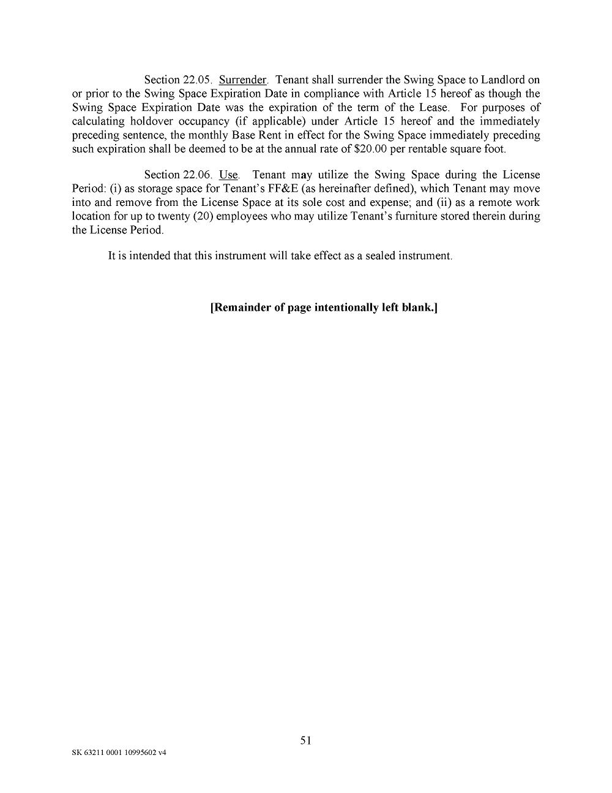

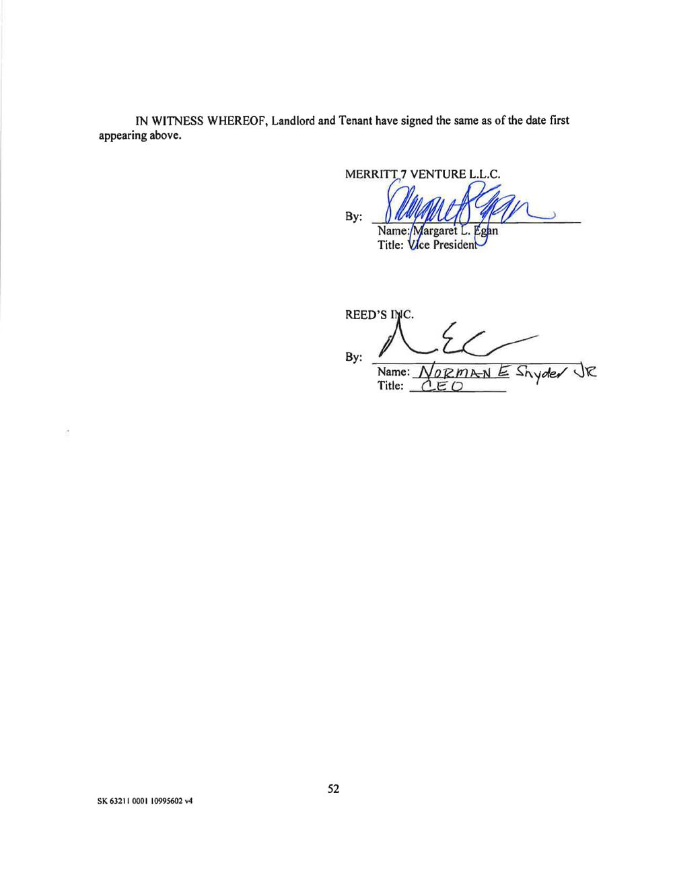

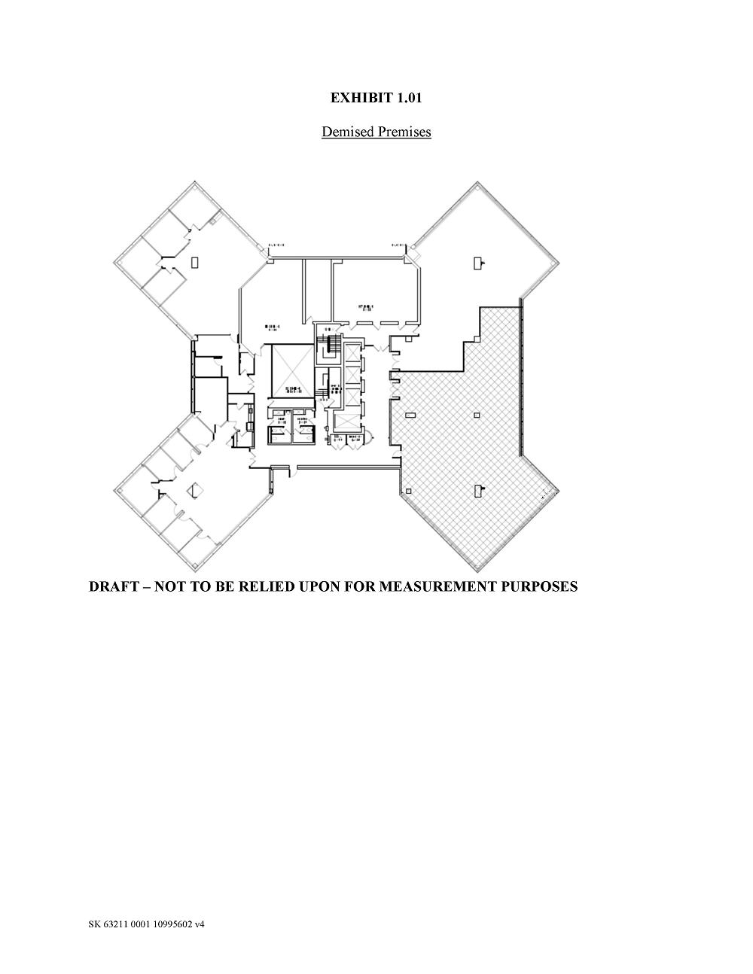

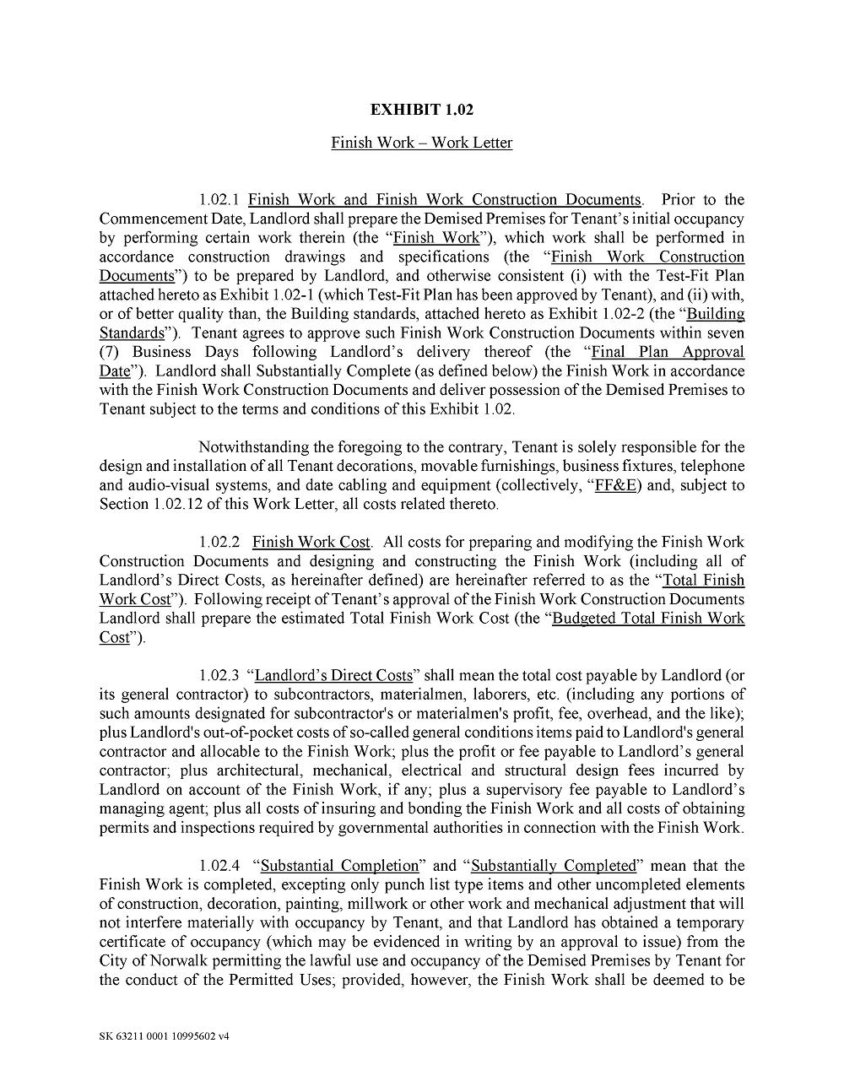

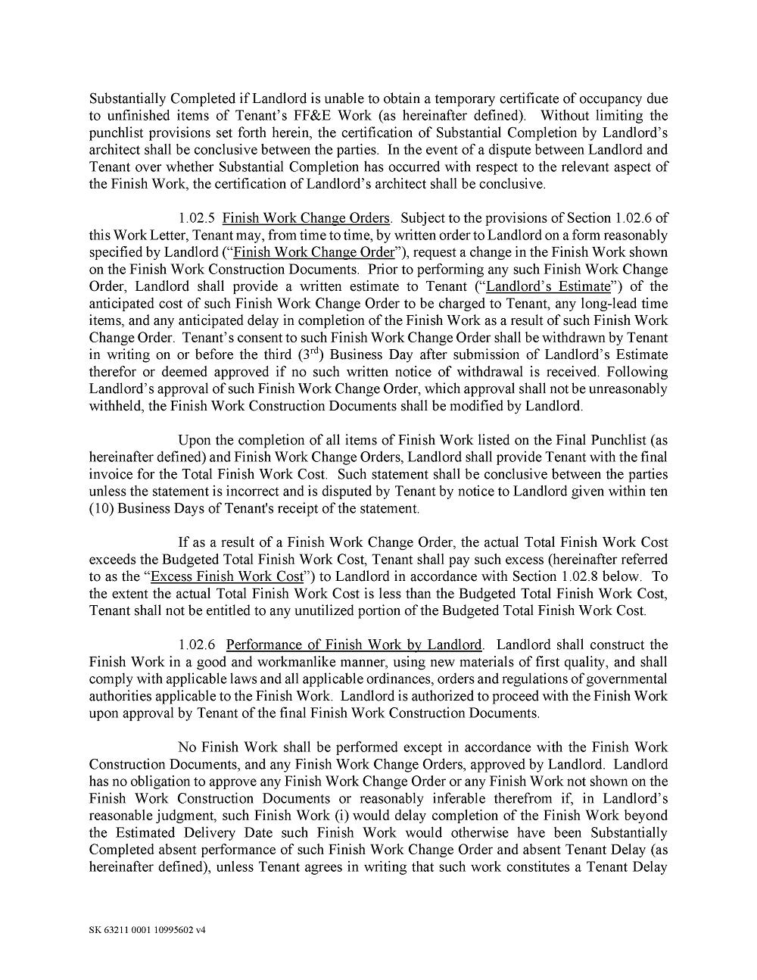

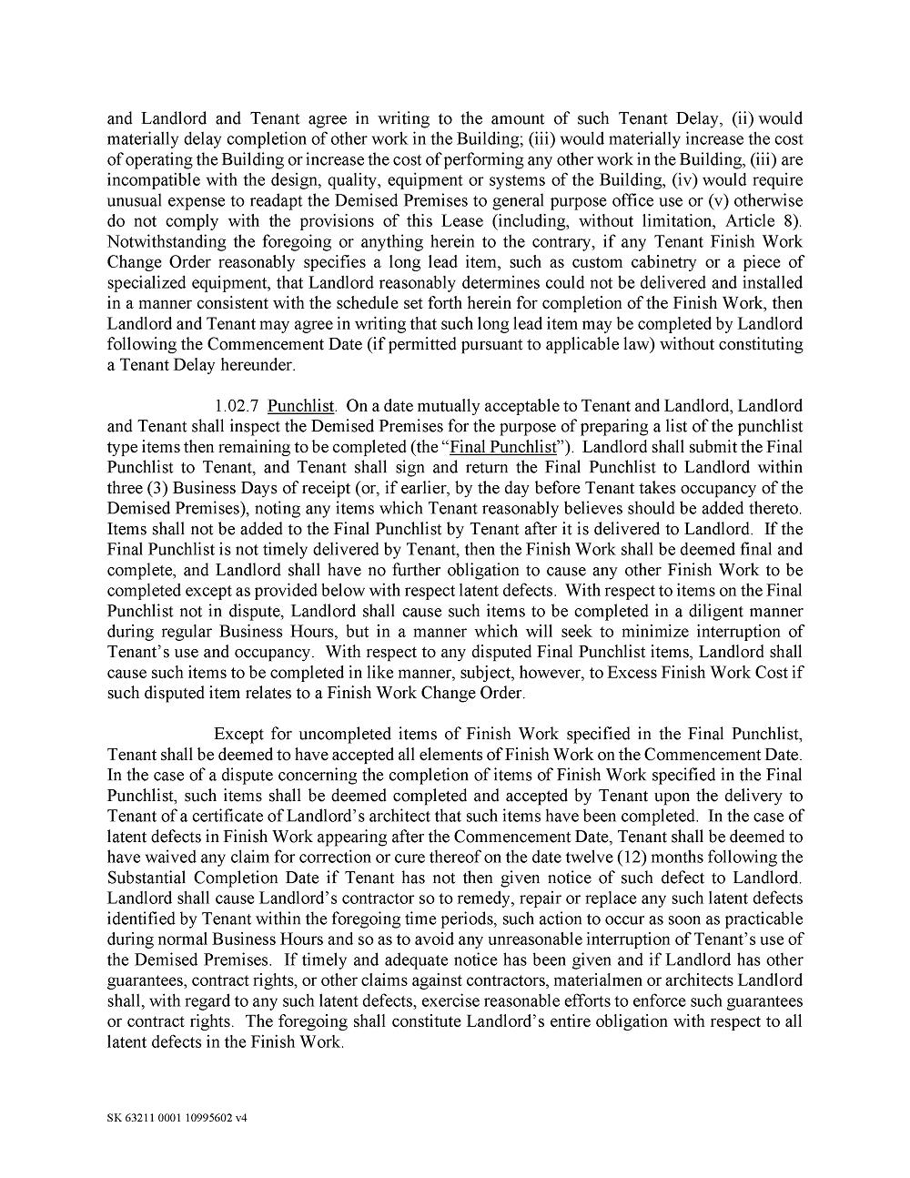

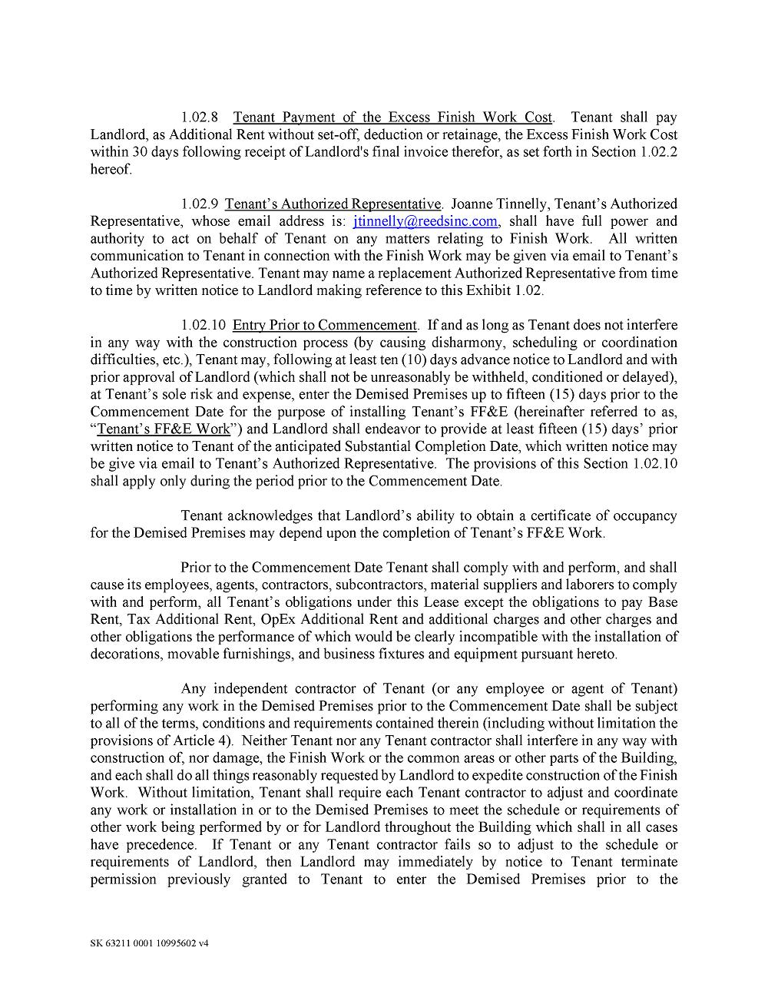

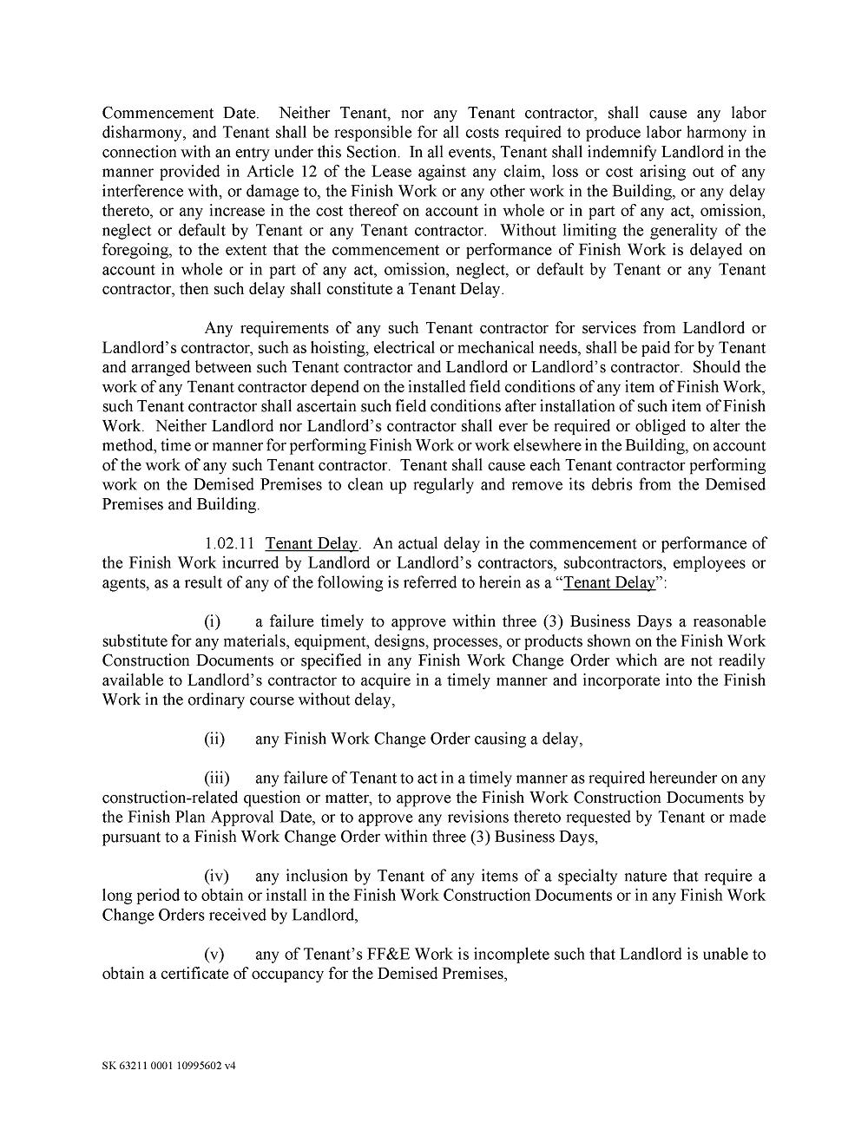

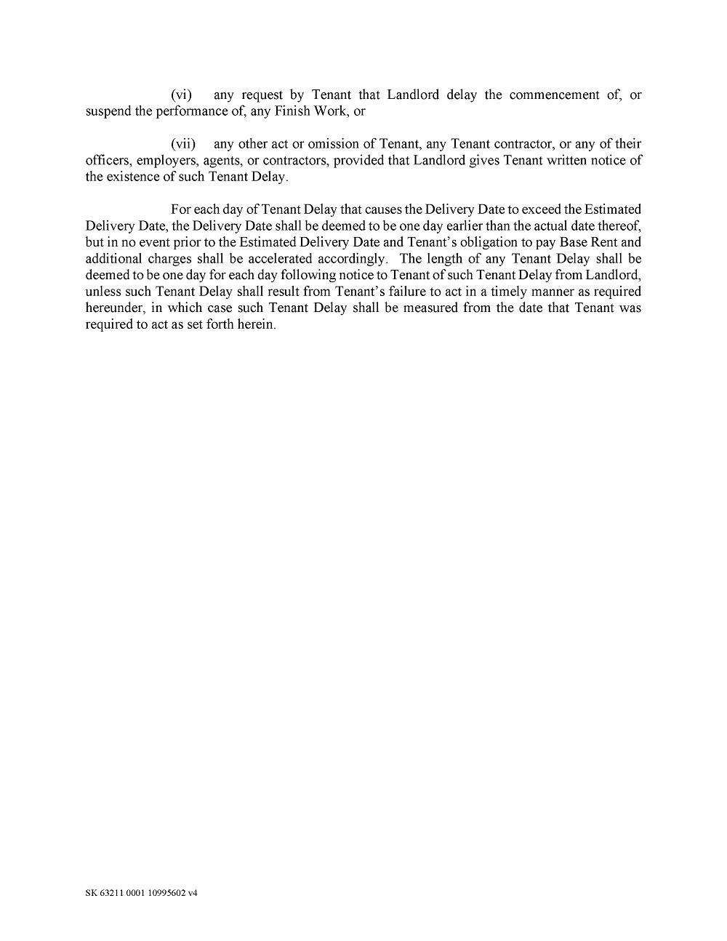

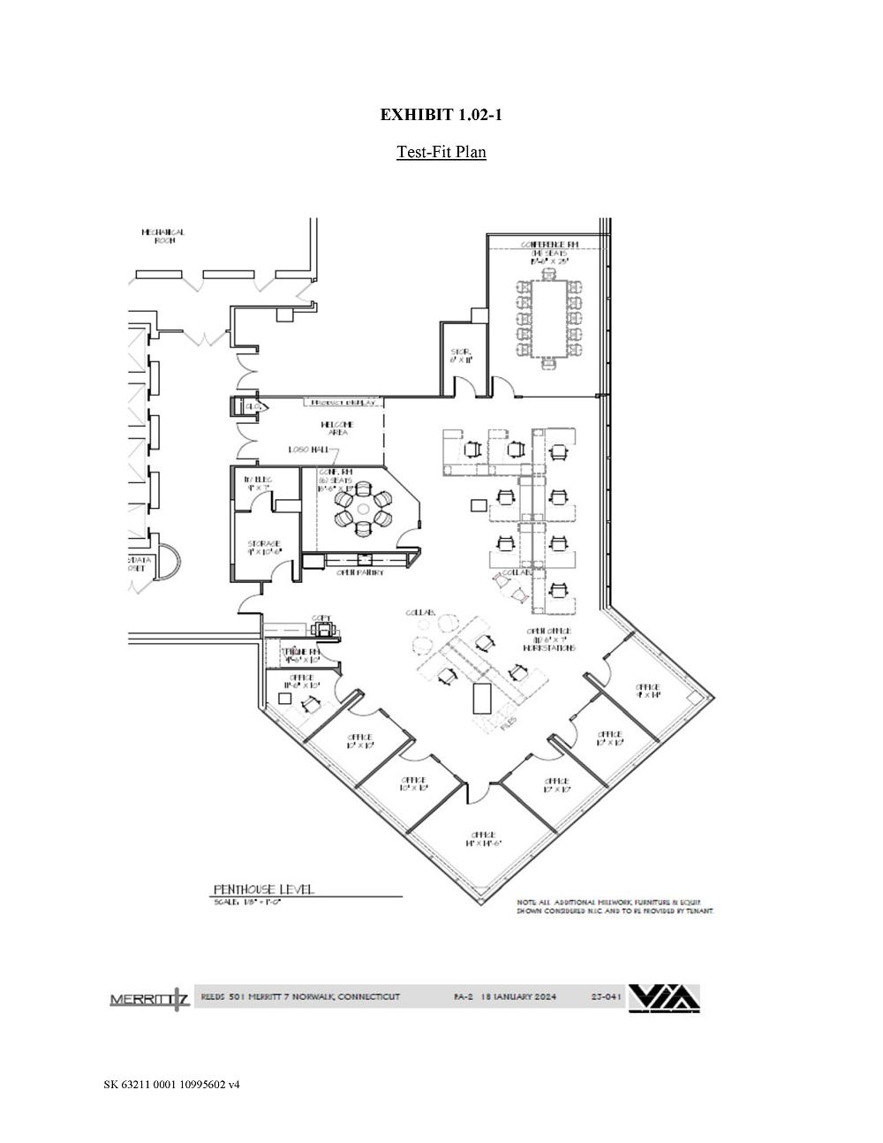



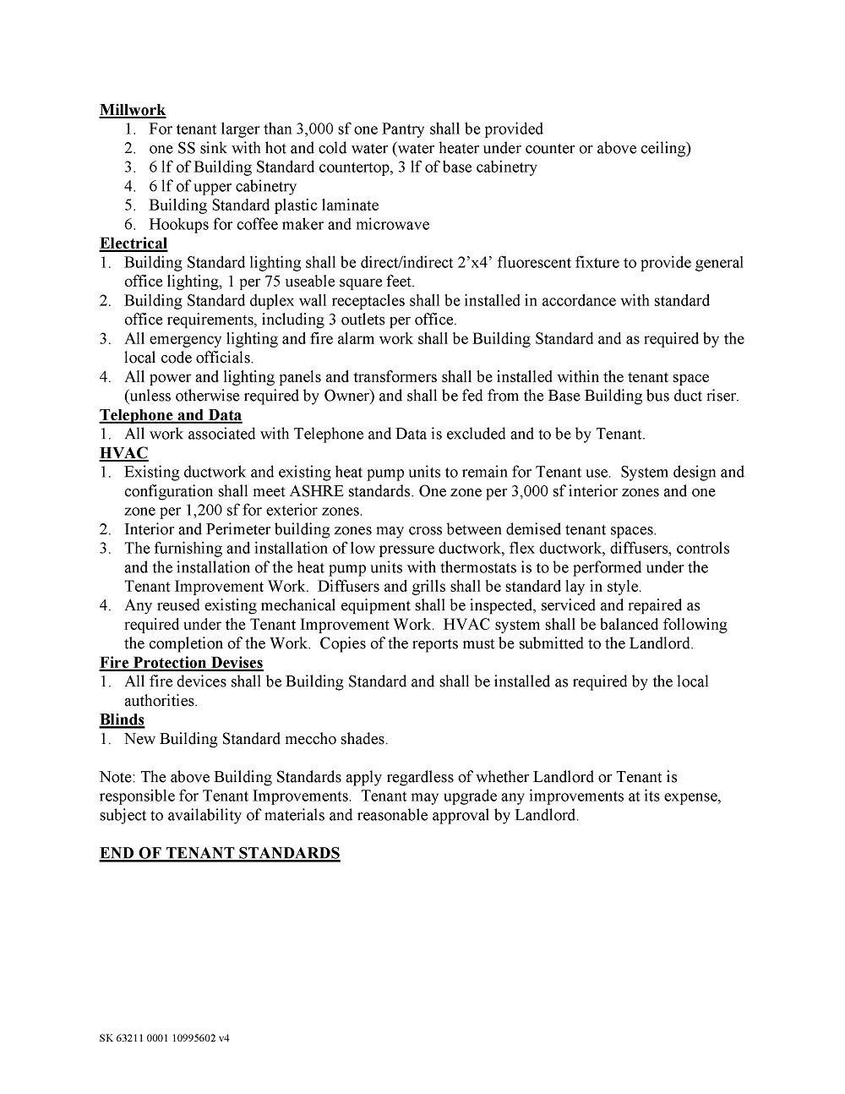

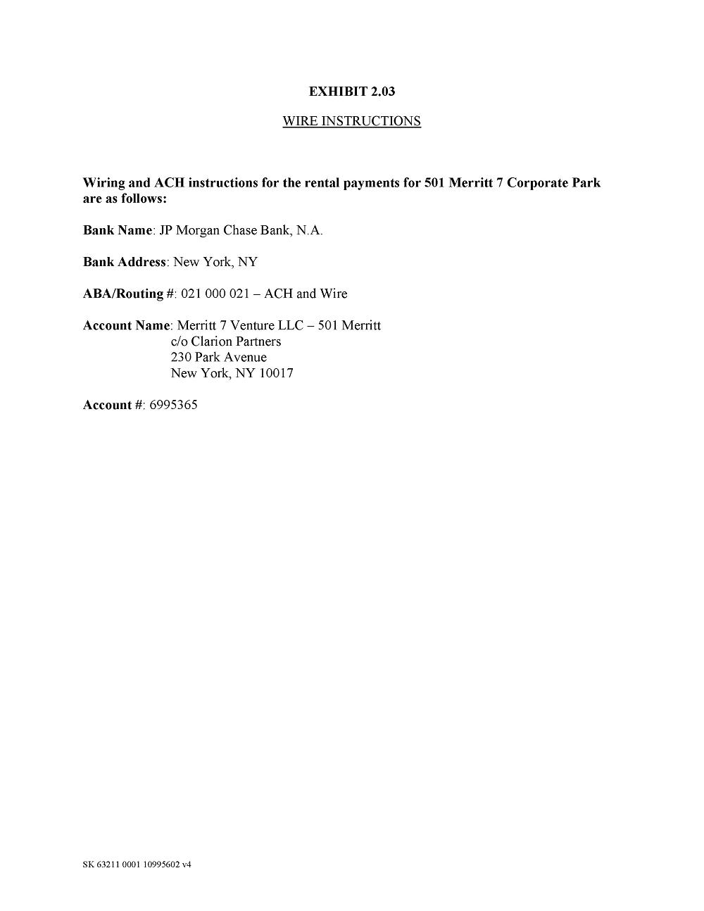

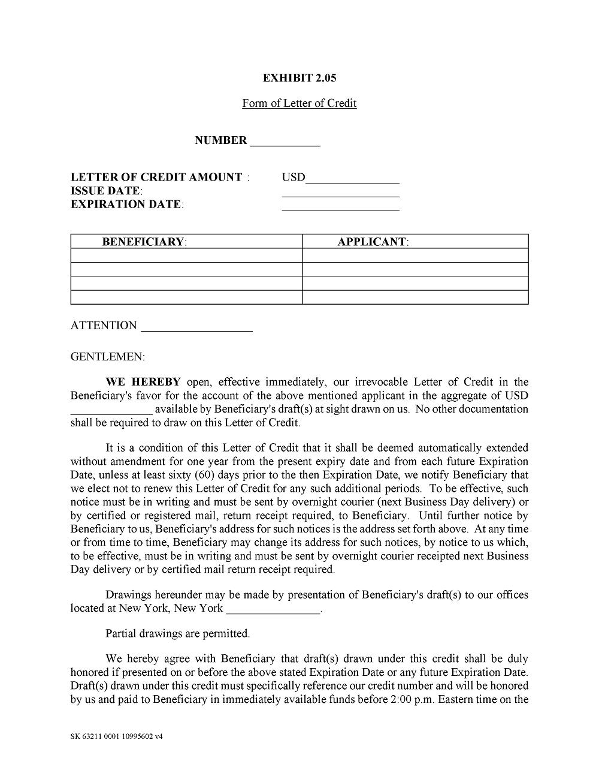

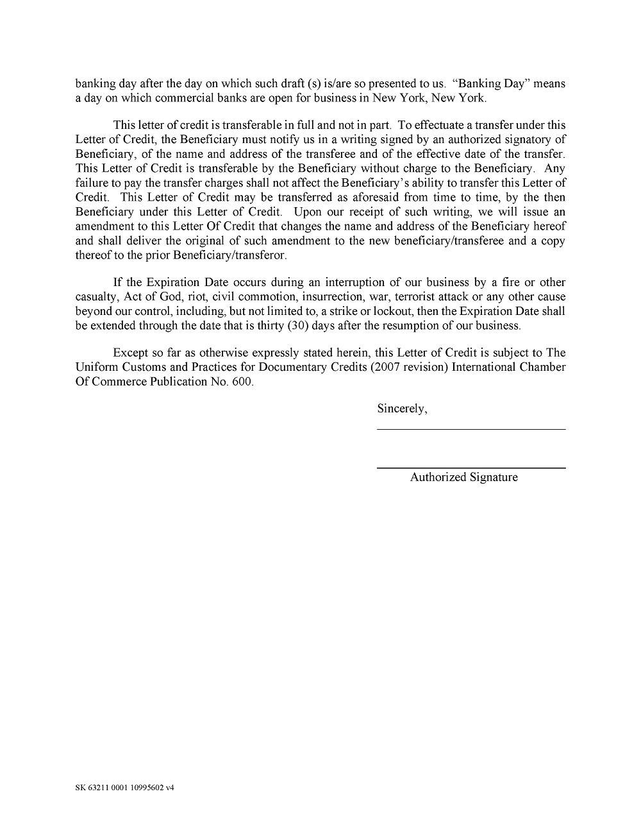

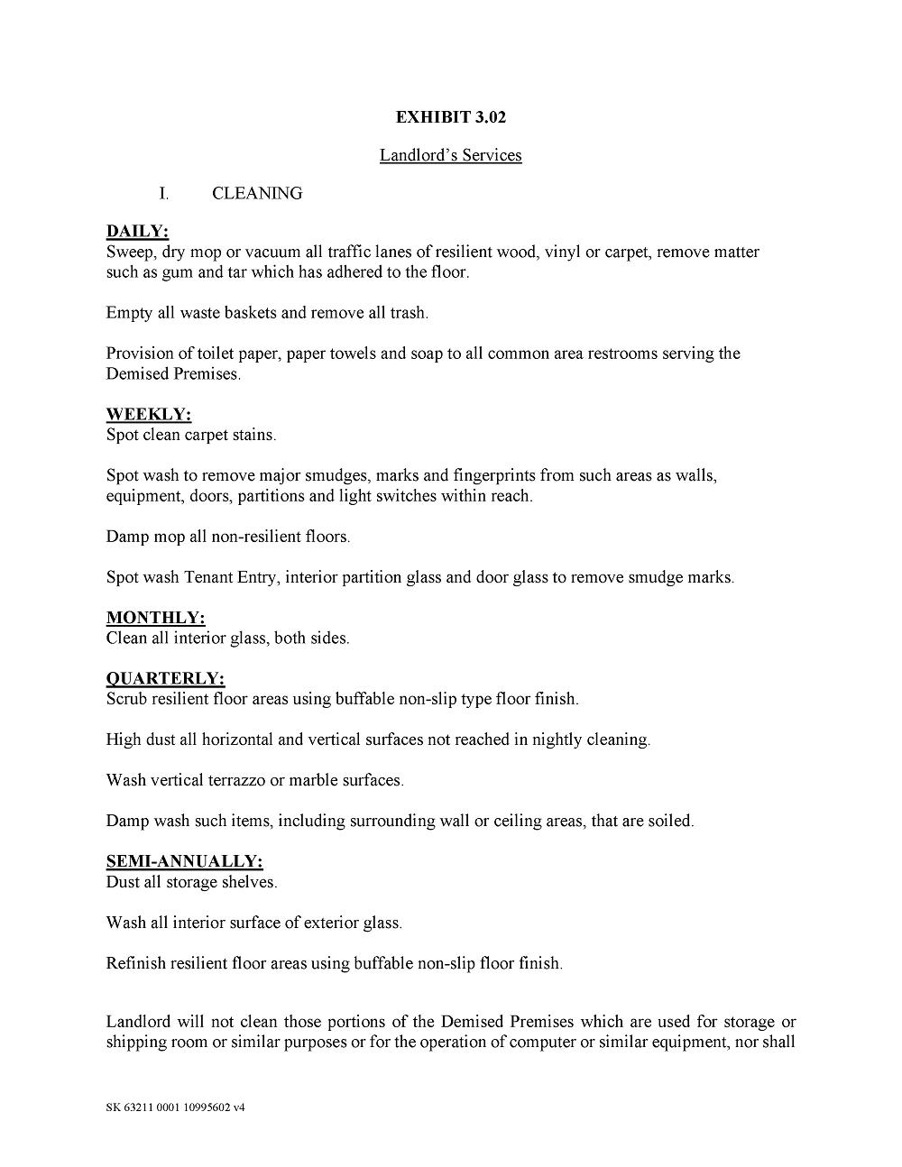

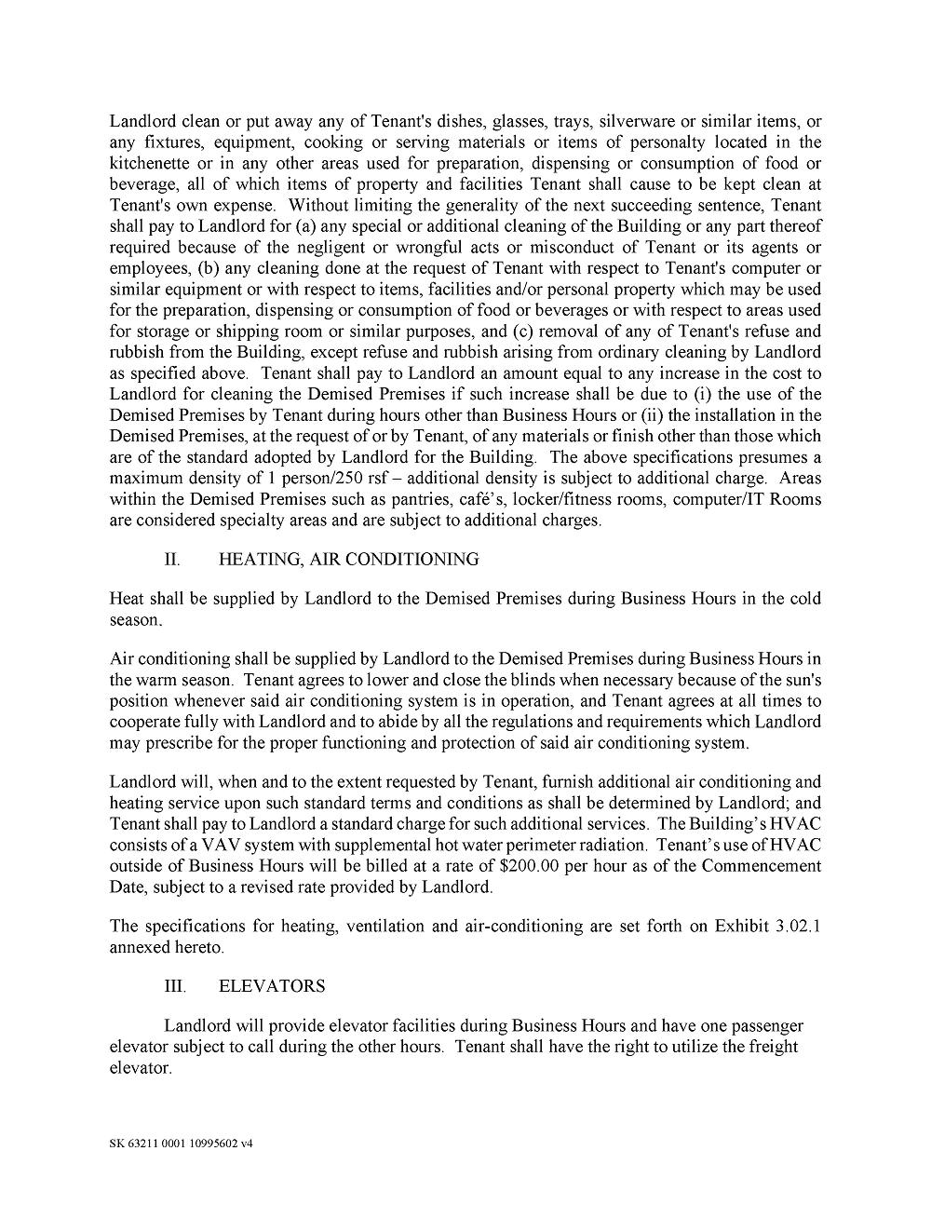





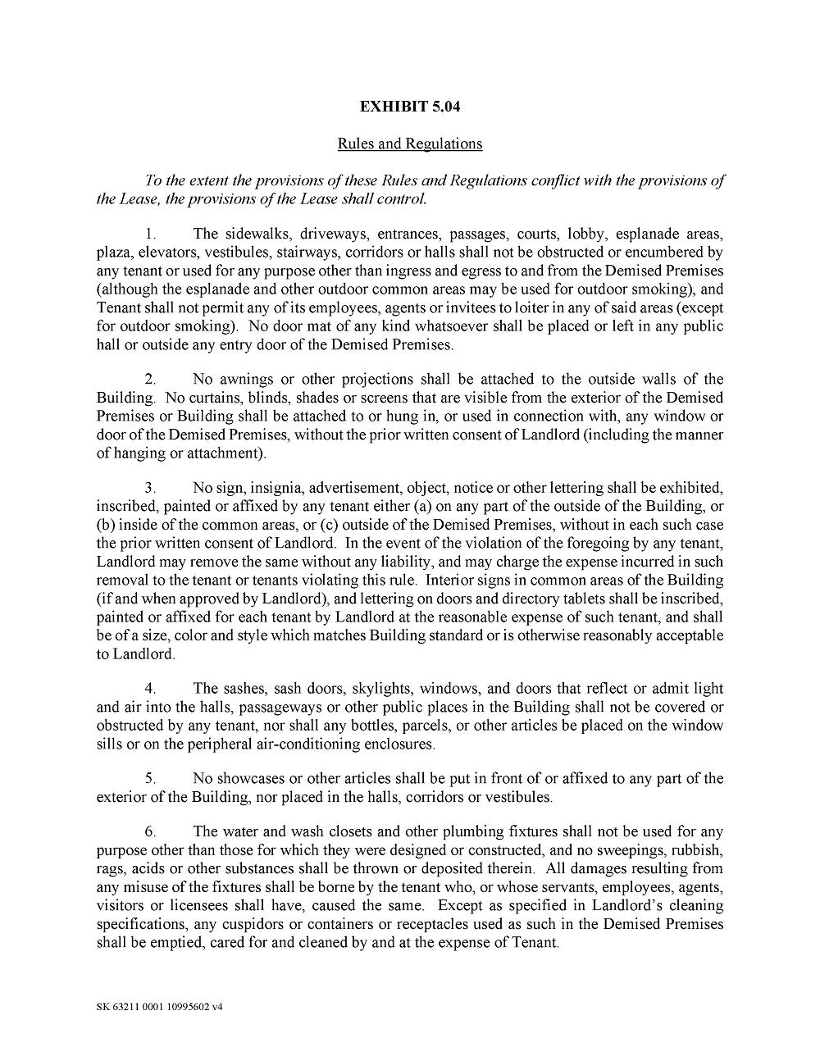



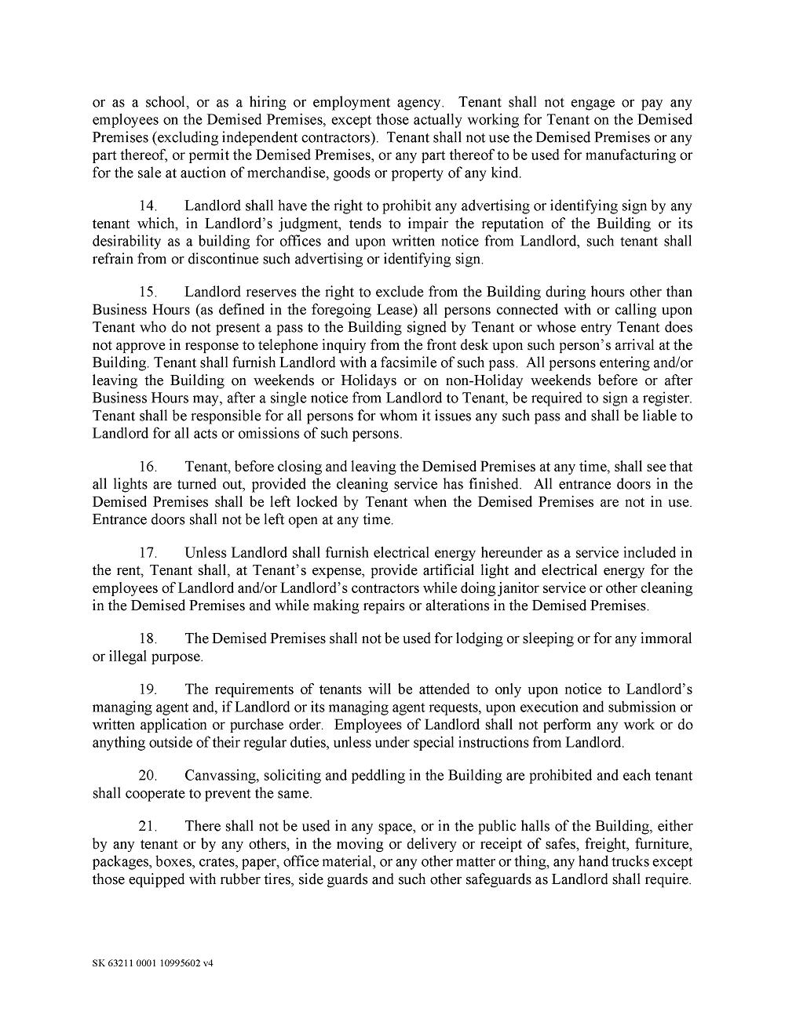

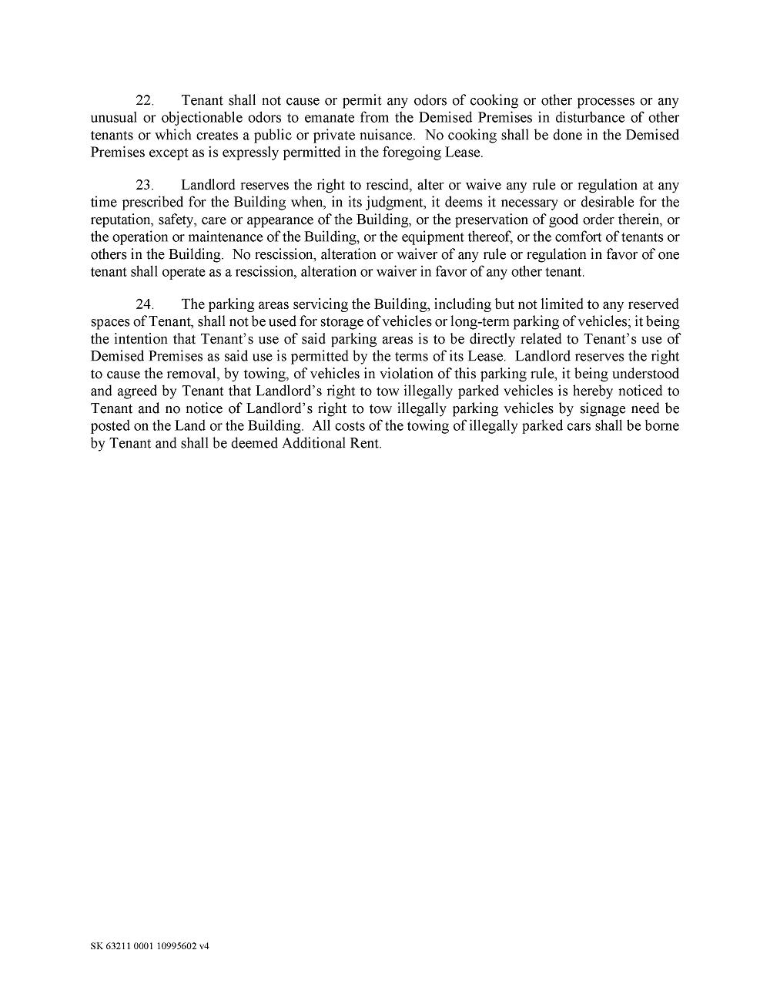

EXHIBIT 31

Certification of Principal Executive Officer

I, Norman E. Snyder, Jr., certify that:

1. I have reviewed this Quarterly Report on Form 10-Q of Reed’s, Inc.;

2. Based on my knowledge, this report does not contain any untrue statement of a material fact or omit to state a material fact necessary to make the statements made, in light of the circumstances under which such statements were made, not misleading with respect to the period covered by this report;

3. Based on my knowledge, the financial statements, and other financial information included in this report, fairly present in all material respects the financial condition, results of operations and cash flows of the registrant as of, and for, the periods presented in this report;

4. The registrant’s other certifying officer and I are responsible for establishing and maintaining disclosure controls and procedures (as defined in Exchange Act Rules 13a-15(e) and 15d-15(e)) and internal control over financial reporting (as defined in Exchange Act Rules 13a-15(f) and 15d-15(f)) for the registrant and have:

(a) Designed such disclosure controls and procedures, or caused such disclosure controls and procedures to be designed under our supervision, to ensure that material information relating to the registrant, including its consolidated subsidiaries, is made known to us by others within those entities, particularly during the period in which this report is being prepared;

(b) Designed such internal control over financial reporting, or caused such internal control over financial reporting to be designed under our supervision, to provide reasonable assurance regarding the reliability of financial reporting and the preparation of financial statements for external purposes in accordance with generally accepted accounting principles;

(c) Evaluated the effectiveness of the registrant’s disclosure controls and procedures and presented in this report our conclusions about the effectiveness of the disclosure controls and procedures, as of the end of the period covered by this report based on such evaluation; and

(d) Disclosed in this report any change in the registrant’s internal control over financial reporting that occurred during the registrant’s first fiscal quarter that has materially affected, or is reasonably likely to materially affect, the registrant’s internal control over financial reporting; and

5. The registrant’s other certifying officer and I have disclosed, based on our most recent evaluation of internal control over financial reporting, to the registrant’s auditors and the audit committee of the registrant’s board of directors (or persons performing the equivalent functions):

(a) All significant deficiencies and material weaknesses in the design or operation of internal control over financial reporting which are reasonably likely to adversely affect the registrant’s ability to record, process, summarize and report financial information; and

(b) Any fraud, whether or not material, that involves management or other employees who have a significant role in the registrant’s internal control over financial reporting.

Date: August 13, 2024

 | /s/ Norman E. Snyder, Jr.
 | Name: | Norman E. Snyder, Jr.
 | Title: | Chief Executive Officer  (Principal Executive Officer)

Certification of Principal Financial Officer

I, Joann Tinnelly, certify that:

1. I have reviewed this Quarterly Report on Form 10-Q of Reed’s, Inc.;

2. Based on my knowledge, this report does not contain any untrue statement of a material fact or omit to state a material fact necessary to make the statements made, in light of the circumstances under which such statements were made, not misleading with respect to the period covered by this report;

3. Based on my knowledge, the financial statements, and other financial information included in this report, fairly present in all material respects the financial condition, results of operations and cash flows of the registrant as of, and for, the periods presented in this report;

4. The registrant’s other certifying officer and I are responsible for establishing and maintaining disclosure controls and procedures (as defined in Exchange Act Rules 13a-15(e) and 15d-15(e)) and internal control over financial reporting (as defined in Exchange Act Rules 13a-15(f) and 15d-15(f)) for the registrant and have:

(a) Designed such disclosure controls and procedures, or caused such disclosure controls and procedures to be designed under our supervision, to ensure that material information relating to the registrant, including its consolidated subsidiaries, is made known to us by others within those entities, particularly during the period in which this report is being prepared;

(b) Designed such internal control over financial reporting, or caused such internal control over financial reporting to be designed under our supervision, to provide reasonable assurance regarding the reliability of financial reporting and the preparation of financial statements for external purposes in accordance with generally accepted accounting principles;

(c) Evaluated the effectiveness of the registrant’s disclosure controls and procedures and presented in this report our conclusions about the effectiveness of the disclosure controls and procedures, as of the end of the period covered by this report based on such evaluation; and

(d) Disclosed in this report any change in the registrant’s internal control over financial reporting that occurred during the registrant’s first fiscal quarter that has materially affected, or is reasonably likely to materially affect, the registrant’s internal control over financial reporting; and

5. The registrant’s other certifying officer and I have disclosed, based on our most recent evaluation of internal control over financial reporting, to the registrant’s auditors and the audit committee of the registrant’s board of directors (or persons performing the equivalent functions):

(a) All significant deficiencies and material weaknesses in the design or operation of internal control over financial reporting which are reasonably likely to adversely affect the registrant’s ability to record, process, summarize and report financial information; and

(b) Any fraud, whether or not material, that involves management or other employees who have a significant role in the registrant’s internal control over financial reporting.

Date: August 13, 2024

 | /s/ Joann Tinnelly
 | Name: | Joann Tinnelly
 | Title: | Chief Financial Officer  (Principal Financial Officer)

EXHIBIT 32

Certification of Principal Executive Officer Pursuant to 18 U.S.C. Section 1350 as Adopted Pursuant to Section 906 of the Sarbanes-Oxley Act of 2002

Pursuant to 18 U.S.C. Section 1350, as adopted pursuant to Section 906 of the Sarbanes-Oxley Act of 2002, I, Norman E. Snyder, Jr., the Chief Executive Officer of Reed’s, Inc. (the “Company”), hereby certify, that, to my knowledge:

1. The Quarterly Report on Form 10-Q for the quarterly period ended June 30, 2024 (the “Report”) of the Company fully complies with the requirements of Section 13(a) of the Securities Exchange Act of 1934; and

2. The information contained in the Report fairly presents, in all material respects, the financial condition and results of operations of the Company.

Date: August 13, 2024

 | /s/ Norman E. Snyder, Jr.
 | Name: | Norman E. Snyder, Jr.
 | Title: | Chief Executive Officer  (Principal Executive Officer)

Certification of Principal Financial Officer Pursuant to 18 U.S.C. Section 1350 as Adopted Pursuant to Section 906 of the Sarbanes-Oxley Act of 2002

Pursuant to 18 U.S.C. Section 1350, as adopted pursuant to Section 906 of the Sarbanes-Oxley Act of 2002, I, Joann Tinnelly, the Chief Financial Officer of Reed’s, Inc. (the “Company”), hereby certify, that, to my knowledge:

1. The Quarterly Report on Form 10-Q for the quarterly period ended June 30, 2024 (the “Report”) of the Company fully complies with the requirements of Section 13(a) of the Securities Exchange Act of 1934; and

2. The information contained in the Report fairly presents, in all material respects, the financial condition and results of operations of the Company.

Date: August 13, 2024

 | /s/ Joann Tinnelly
 | Name: | Joann Tinnelly
 | Title: | Chief Financial Officer  (Principal Financial Officer)

