UNITED STATES
SECURITIES AND EXCHANGE COMMISSION
Washington, D.C. 20549

FORM 10-K

☒ ANNUAL REPORT PURSUANT TO SECTION 13 OR 15(d) OF THE SECURITIES EXCHANGE ACT OF 1934

For the fiscal year ended December 31, 2020

☐ TRANSITION REPORT PURSUANT TO SECTION 13 OR 15(d) OF THE SECURITIES EXCHANGE ACT OF 1934

For the transition period from _______ to _______

Commission File Number: 001-32501

REED’S, INC.
(Exact name of registrant as specified in its charter)

Delaware |  | 35-2177773
(State of incorporation) |  | (I.R.S. Employer Identification No.)

201 Merritt 7, Norwalk, CT |  | 06851
(Address of principal executive offices) |  | (Zip Code)

(800) 997-3337

(Registrant’s telephone number, including area code)

(Former name, former address and former fiscal year, if changed since last report)

Securities registered pursuant to Section 12(b) of the Act

Title of each class |  | Trading Symbol(s) |  | Name of each exchange on which registered
Common Stock |  | REED |  | The NASDAQ Stock Market LLC

Indicate by check mark if the registrant is a well-known seasoned issuer, as defined in Rule 405 of the Securities Act. Yes ☐ No ☒

Indicate by check mark if the registrant is not required to file reports pursuant to Section 13 or 15(d) of the Act. Yes ☐ No ☒

Indicate by check mark whether the registrant (1) has filed all reports required to be filed by Section 13 or 15(d) of the Securities Exchange Act of 1934 during the preceding 12 months (or for such shorter period that the registrant was required to file such reports), and (2) has been subject to such filing requirements for the past 90 days. Yes ☒ No ☐

Indicate by check mark whether the registrant has submitted electronically every Interactive Data File required to be submitted pursuant to Rule 405 of Regulation S-T (§232.405 of this chapter) during the preceding 12 months (or for such shorter period that the registrant was required to submit such files). Yes ☒ No ☐

Indicate by check mark whether the registrant is a large accelerated filer, an accelerated filer, a non-accelerated filer, smaller reporting company, or an emerging growth company. See the definitions of “large accelerated filer,” “accelerated filer,” “smaller reporting company,” and “emerging growth company” in Rule 12b-2 of the Exchange Act.

Large accelerated filer ☐ |  | Accelerated filer ☐
Non-accelerated filer ☒ |  | Smaller reporting company ☒
 |  | Emerging growth company ☐

If an emerging growth company, indicate by check mark if the registrant has elected not to use the extended transition period for complying with any new or revised financial accounting standards provided pursuant to Section 13(a) of the Exchange Act. ☐

Indicate by check mark whether the registrant has filed a report on and attestation to its management’s assessment of the effectiveness of its internal control over financial reporting under Section 404(b) of the Sarbanes-Oxley Act (15 U.S.C. 7262(b)) by the registered public accounting firm that prepared or issued its audit report. ☐

Indicate by check mark whether the registrant is a shell company (as defined in Rule 12b-2 of the Exchange Act). Yes ☐ No ☒

The aggregate market value of the voting and non-voting common equity held by non-affiliates (excluding voting shares held by officers and directors) as of June 30, 2020 was $55,025,154.

Indicate the number of shares outstanding of each of the issuer’s classes of common stock, as of the latest practicable date. There were a total of 86,403,321 shares of Common Stock outstanding as of March 22, 2021.

TABLE OF CONTENTS

PART I | 5
Item 1. Business | 5
Item 1A. Risk Factors | 13
Item 1B. Unresolved Staff Comments | 31
Item 2. Properties | 31
Item 3. Legal Proceedings | 31
Item 4. Mine Safety Disclosures | 31
PART II | 32
Item 5. Market for Registrant’s Common Equity, Related Stockholder Matters and Issuer Purchases of Equity Securities | 32
Item 6. Selected Financial Data | 33
Item 7. Management’s Discussion and Analysis of Financial Condition and Results of Operations | 33
Item 7A. Quantitative and Qualitative Disclosures About Market Risk | 40
Item 8. Financial Statements and Supplementary Data | 41
Item 9. Changes in and Disagreements with Accountants on Accounting and Financial Disclosure | 42
Item 9A. Controls and Procedures | 42
Item 9B. Other Information | 42
PART III | 43
Item 10. Directors, Executive Officers and Corporate Governance | 43
Item 11. Executive Compensation | 47
Item 12. Security Ownership of Certain Beneficial Owners and Management and Related Stockholder Matters | 51
Item 13. Certain Relationships and Related Transactions, and Director Independence | 52
Item 14. Principal Accountant Fees and Services | 54
PART IV | 55
Item 15. Exhibits, Financial Statement Schedules | 55
Item 16. Form 10-K Summary | 55

2

CAUTIONARY STATEMENT REGARDING FORWARD-LOOKING STATEMENTS AND INFORMATION

This Annual Report on Form 10-K (“Annual Report”), the other reports, statements, and information that we have previously filed or that we may subsequently file with the Securities and Exchange Commission (“SEC”) and public announcements that we have previously made or may subsequently make include, may include, incorporate by reference or may incorporate by reference certain statements that may be deemed to be forward-looking statements. The forward-looking statements included or incorporated by reference in this Annual Report and those reports, statements, information and announcements address activities, events or developments that Reed’s, Inc. (hereinafter referred to as “we,” “us,” “our” or “Reed’s”) expects or anticipates will or may occur in the future. Any statements in this document about expectations, beliefs, plans, objectives, assumptions or future events or performance are not historical facts and are forward-looking statements. These statements are often, but not always, made through the use of words or phrases such as “may,” “should,” “could,” “predict,” “potential,” “believe,” “will likely result,” “expect,” “will continue,” “anticipate,” “seek,” “estimate,” “intend,” “plan,” “projection,” “would” and “outlook” and similar expressions. Accordingly, these statements involve estimates, assumptions and uncertainties, which could cause actual results to differ materially from those expressed in them. Any forward-looking statements are qualified in their entirety by reference to the factors discussed throughout this document. All forward-looking statements concerning economic conditions, rates of growth, rates of income or values as may be included in this document are based on information available to us on the dates noted, and we assume no obligation to update any such forward-looking statements.

The risk factors referred to in this Annual Report beginning on page 14 could cause actual results or outcomes to differ materially from those expressed in any forward-looking statements made by us, and you should not place undue reliance on any such forward-looking statements. Any forward-looking statement speaks only as of the date on which it is made, and we do not undertake any obligation to update any forward-looking statement or statements to reflect events or circumstances after the date on which such statement is made or to reflect the occurrence of unanticipated events. New factors emerge from time to time, and it is not possible for us to predict which will arise. In addition, we cannot assess the impact of each factor on our business or the extent to which any factor, or combination of factors, may cause actual results to differ materially from those contained in any forward-looking statements.

Management cautions that these statements are qualified by their terms and/or important factors, many of which are outside of our control, involve a number of risks, uncertainties and other factors that could cause actual results and events to differ materially from the statements made, including, but not limited to, the following risk factors:

● Our ability to generate sufficient cash flow to support marketing and product development plans and general operating activities,

● Decreased demand for our products resulting from changes in consumer preferences,

● Competitive products and pricing pressures and our ability to gain or maintain our share of sales in the marketplace,

● The introduction of new products,

● Our being subject to a broad range of evolving federal, state and local laws and regulations including those regarding the labeling and safety of food products, establishing ingredient designations and standards of identity for certain foods, environmental protections, as well as worker health and safety. Changes in these laws and regulations could have a material effect on the way in which we produce and market our products and could result in increased costs,

● Changes in the cost and availability of raw materials and the ability to maintain our supply arrangements and relationships and procure timely and/or adequate production of all or any of our products,

3

● Our ability to penetrate new markets and maintain or expand existing markets,

● Maintaining existing relationships and expanding the distributor network of our products,

● Decline in global financial markets and economic downturn resulting from the coronavirus COVID-19 global pandemic,

● Business interruptions resulting from the coronavirus COVID-19 global pandemic,

● Our ability to remediate weaknesses we identified in our disclosure controls and procedures and our internal control over financial reporting in a timely enough manner to eliminate the risks posed by such material weaknesses in future periods,

● Maintaining the listing of our common stock on the Nasdaq Capital Market or other national securities exchange,

● The marketing efforts of distributors of our products, most of whom also distribute products that are competitive with our products,

● Decisions by distributors, grocery chains, specialty chain stores, club stores and other customers to discontinue carrying all or any of our products that they are carrying at any time,

● The availability and cost of capital to finance our working capital needs and growth plans,

● The effectiveness of our advertising, marketing and promotional programs,

● Changes in product category consumption,

● Economic and political changes,

● Consumer acceptance of new products, including taste test comparisons,

● Possible recalls of our products, and

● Whether or not we will be entitled to forgiveness of our Paycheck Protection Program loan.

Although we believe that the expectations reflected in the forward-looking statements are reasonable, we cannot guarantee future results, levels of activity, performance, or achievements.

4

PART I

Item 1. Business

Overview

Reed’s Inc., a Delaware corporation (“Reed’s”, the “Company,” “we,” or “us” throughout this report) owns a leading portfolio of handcrafted, all-natural beverages that is sold in over 40,000 outlets nationwide (including the natural and specialty food channel, grocery stores, mass merchants, drug stores, convenience stores, club stores and on-premise locations including bars and restaurants). Reed’s two core brands are Reed’s Craft Ginger Beer and Reed’s Real Ginger Ale and Virgil’s Handcrafted soda. Reed’s Craft Ginger Beers are unique due to the proprietary process of using fresh ginger root combined with a Jamaican inspired recipe of natural spices, honey and fruit juices. Reed’s uses this same handcrafted approach in its Reed’s Real Ginger Ale and Virgil’s line of great tasting, bold flavored craft sodas, including its award-winning Virgil’s Root Beer.

Reed’s is the leading ginger beer in the US; Virgil’s is the leading independent (not aligned with Coca-Cola, Pepsi or Keurig Dr. Pepper) all-natural full line craft soda and is ranked fourth in the craft soda category.

Historical Development

Reed’s Original Ginger Brew, created in 1987 by Christopher J. Reed, our founder, and current Chief Innovation Officer and director, was introduced to the market in Southern California stores in 1989. By 1990, we began marketing our products through United Natural Foods Inc. (“UNFI”) and other natural food distributors and moved our production to a larger facility in Boulder, Colorado.

In 1991, we incorporated our business operations in the state of Florida under the name of Original Beverage Corporation and moved all production to a co-pack facility in Pennsylvania. Throughout the 1990’s, we continued to develop and launch new Ginger Brew varieties. Reed’s Ginger Brews reached broad placement in natural and gourmet foods stores nationwide through UNFI and other major specialty, natural/gourmet and mainstream food and beverage distributors.

In 1997, we began licensing the products of China Cola and eventually acquired the rights to that product in 2000. In 1999, we purchased the Virgil’s Root Beer brand from the Crowley Beverage Company. In 2000, we moved into an 18,000-square foot warehouse property, the Brewery, in Los Angeles, California, to headquarters. In 2001, pursuant to a reincorporation merger, we changed our state of incorporation to Delaware and also changed our name to “Reed’s, Inc.”

In September 2018, we completed the relocation of its headquarters to Norwalk, Connecticut. In December 2018, after a lengthy marketing and bidding process, we sold the Brewery to a company owned by Christopher J. Reed, our founder. The sale of the Brewery marked a fundamental shift in the nature of our operations and effectively eliminated our costs associated with excess manufacturing capacity.

Industry Overview

Reed’s offers its portfolio of natural hand-crafted beverages in the craft specialty foods industry as natural alternatives to the $32 billion mainstream carbonated soft drinks (“CSD”) market in the United States as measured by IRI Multi Outlet scan data. Reed’s products are sold across the country and internationally in the following major channels: natural food, specialty food, grocery, mass merchant, convenience, club, drug, and on-premise locations (bars and restaurants).

Even after a year of the pandemic, overall sales growth of natural food and beverage products continues to outpace sales growth for conventional products across all retail channels. We see ample opportunity to scale our natural beverage business and grow our distribution in these channels.

Carbonated Soft Drink Industry Overview

The retail CSD category has rallied during the pandemic. This past year, after 13 years of declines, the retail CSD category grew 13%. The ginger ale segment grew even faster at 15.4% and is now a $1.1 billion dollar market. Ginger ale growth, we believe, is driven primarily by a consumer perception of ginger ale as a healthier alternative to other sodas. Our new line of ginger ales made with real ginger deliver on this perception and are poised to breakout in the segment.

In the wake of COVID-19, consumers are shifting consumption to better-for-you products. We believe there is significant growth potential from consumers switching away from mainstream beverages that contain artificial ingredients and preservatives towards great-tasting, natural alternatives.

5

Consumer Trends Driving Growth for Our Products

The following is a list of consumer trends that are accelerating as we exit the pandemic, and which support our brands.

 | ● | Natural: Interest in all-natural products has gone mainstream.
 | ● | Clean Label: 62% of Americans are avoiding at least one ingredient.
 | ● | Reduced Sugar: A favorable trend for our zero-sugar beverages, 77% of consumers say they are reducing their sugar intake.
 | ● | Functionality: Right before the pandemic, 65% of consumers looked for function in what they eat and drink. This accelerating trend will drive growth for our ginger-based beverages.
 | ● | Craft: Appeal continues to grow of higher-quality, independent, and more authentic brands.
 | ● | Premiumization: A trend towards embracing quality has accelerated during the pandemic with consumers splurging on premium beverages at retail, including premium mixers.
 | ● | Better-for-you Mocktails: More consumers are seeking non-alcoholic alternatives with bold and unique flavors.
 | ● | Ready-to-Drink Cocktails: Category is exploding alongside hard seltzer as people seek novelty and variety, which puts our RTD Mules in a great position to succeed.

Our strategies will remain responsive to these macro consumer trends as we concentrate our efforts on developing the Company’s sales and marketing functions.

Our Products

We make our hand-crafted beverages with only premium, natural ingredients. Our products are free of genetically modified organisms (“GMOs”) and artificial preservatives. Over the years, Reed’s has developed several product offerings. In 2019, we streamlined our focus to our core categories of Reed’s Ginger Beverages and Virgil’s Craft Sodas. In April 2020, we launched our new line of Reed’s Real Ginger Ales, in both Full Sugar and Zero Sugar versions, made with 2,000mg of fresh organic ginger.

Reed’s Craft Ginger Beer

Reed’s Craft Ginger Beer is set apart from other ginger beers by its proprietary process of brewing fresh ginger root, its exclusive use of all-natural ingredients, and its authentic Jamaican-inspired recipe. We do not use artificial preservatives, artificial flavors, or colors, and Reed’s Ginger Beer is certified kosher. We offer different levels of fresh ginger content, ranging from our lightest-spiced Original, to our medium-spiced Extra, and finally to our spiciest Strongest. We also offer three sweetener options: one with cane sugar, honey and fruit juices; one with honey and pineapple juice; and another without sugar (Zero Sugar) made from an innovative blend of natural sweeteners (developed in 2018 and commercialized in 2019).

6

As of the end of 2020, the Reed’s Craft Ginger Beer line included five major varieties:

Reed’s Original Ginger Beer – Our first to market product uses a Jamaican-inspired recipe that calls for fresh ginger root, lemon, lime, honey, raw cane sugar, pineapple, herbs and spices.

Reed’s Premium Ginger Beer – Our Original Ginger Beer sweetened with honey and pineapple juice. (No cane sugar added.)

Reed’s Extra Ginger Beer – Contains 100% more fresh ginger than Reed’s Original recipe for extra spice.

Reed’s Strongest Ginger Beer – Contains 200% more fresh ginger than Reed’s Original for the strongest spice.

Reed’s Zero Sugar Extra Ginger Beer – launched in 2019 in bottles and cans, it uses a proprietary natural sweetening system for a zero-calorie version of our Reed’s Extra Ginger Beer.

Reed’s Real Ginger Ale

Reed’s Real Ginger Ale is unique for the category because it combines real fresh ginger with the classic, refreshing taste that consumers love. It contains nothing artificial and is Non-GMO project verified. We offer two sweetener options: one with cane sugar and the other with our zero-calorie, all-natural sweetener blend.

NEW! Reed’s Real Ginger Ale – launched in April 2020 in standard and slim cans. It is the only mass market ginger ale made with organic fresh ginger.

NEW! Reed’s Zero Sugar Real Ginger Ale – also launched in April 2020 in standard and slim cans. It uses our all-natural sweetener blend to match the great taste of the cane sugar version in a zero-calorie drink.

Other New Ginger Beverages under the Reed’s brand

NEW! Reed’s Wellness Ginger Shots – launched in February 2020 offered in two varieties: Daily Ginger and Ginger Energize. These convenient, shelf-stable shots provide a ginger boost on the go.

NEW! Reed’s Zero Sugar Classic Mule – launched in June 2020 containing 7% ABV (Alcohol By Volume), is the ultimate mule, made with fresh ginger root, to be enjoyed anytime, anywhere.

Virgil’s Handcrafted Sodas

Virgil’s is a premium handcrafted soda that uses only all-natural ingredients to create bold renditions of classic flavors. We don’t use any artificial preservatives, any artificial colors, or any GMO-sourced ingredients, and our Virgil’s line is certified kosher.

The Virgil’s line includes the following products:

Handcrafted Line: Virgil’s first Handcrafted soda was launched in 1994. It began as one man’s passion to create the finest root beer ever produced and has since won numerous awards. Virgil’s difference is using all-natural ingredients to craft bold, classic soda flavors. Virgil’s Handcrafted line includes Root Beer, Vanilla Cream, Black Cherry, and Orange Cream.

Zero Sugar Line: Virgil’s launched a new line of Zero Sugar, Zero Calorie craft sodas in 2019. Each Zero Sugar soda is sweetened with a proprietary blend of natural sweeteners with no added sugars. This all-natural line of Zero Sugar flavors includes Root Beer, Cola, Black Cherry, Vanilla Cream, Orange Cream and Lemon-Lime. The product has recently been certified Keto compliant.

2021 Product Launches

During the second quarter of 2021, Reed’s will launch the below:

 | ● | Reed’s Real Ginger Ale Zero Sugar Line Extensions: Shirley Tempting and Transfusion
 | ● | Reed’s Real Ginger Ale and Virgil’s 20 oz Bottles for the Convenience Channel
 | ● | Virgil’s Zero Sugar Line Extensions: Dr. Better, Grapefruit, and Ginger Ale
 | ● | Limited Edition Swing Lid Bottles 0.5 liter: Virgil’s Bavarian Nutmeg Root Beer and Flying Cauldron Butterscotch Beer
 | ● | Reed’s Craft Stormy Mule

7

Our Primary Markets

We target a smaller segment of the estimated $32 billion mainstream carbonated and non-carbonated soft drink markets in the United States. Our brands are generally considered premium and natural, with upscale packaging. They are loosely defined as the craft specialty bottled carbonated soft drink category.

We have an experienced and geographically diverse sales force promoting our products, with senior sales representatives strategically placed in multiple regions across the country, supported by local Reed’s sales staff. Additionally, we have sales managers handling national accounts for natural, specialty, grocery, mass, club, drug and convenience channels. Our sales managers are responsible for all activities related to the sales, distribution, and marketing of our brands to our entire retail partner and distributor network in North America. The Company not only employs an internal sales force but has partnered with independent sales brokers and outside representatives to promote our products in specific channels and key targeted accounts.

We sell to well-known popular natural food and gourmet retailers, large grocery store chains, mass merchants, club stores, convenience and drug stores, liquor stores, industrial cafeterias (corporate feeders), and to on-premise bars and restaurants nationwide and in some international markets. We also sell our products and promotional merchandise directly to consumers via the Internet through our Amazon storefront which can be accessed through our company web site www.drinkreeds.com.

Some of our representative key customers include:

 | ● | Natural stores: Whole Foods Market, Sprouts, Natural Grocers by Vitamin Cottage, Fresh Thyme Farmers Market
 | ● | Gourmet & specialty stores: Trader Joe’s, Bristol Farms, Lazy Acres, The Fresh Market, Central Market
 | ● | Grocery and mass chains: Kroger (and all Kroger banners), Safeway, Albertson’s, Publix, Food Lion, Stop & Shop, H.E.B., Wegmans, Target, Walmart
 | ● | Club stores: BJ’s
 | ● | Liquor stores: BevMo!, Total Wine & More, Spec’s
 | ● | Convenience & drug stores: Circle K, CVS Health, Rite Aid

Our Distribution Network

Our products are brought to market through an extremely flexible and fluid hybrid distribution model, which is a mix of direct-store-delivery, customer warehouse, and distributor networks. The distribution system used depends on customer needs, product characteristics, and local trade practices.

Our product reaches the market in the following ways:

Direct to Natural & Specialty Wholesale Distributors

Our natural and specialty distributor partners operate a distribution network delivering thousands of SKUs of natural and gourmet products to thousands of small, independent, natural retail outlets around the U.S., along with national chain customers, both conventional and natural. This system of distribution allows our brands far reaching access to some of the most remote parts of North America. During the past year we expanded, and will continue to expand, in this distribution network.

Direct to Store Distribution (“DSD”) Through Non-Alcoholic Beverage Distributor Network

Our independent distributor partners operate DSD systems which deliver primarily beverages, foods, and snacks directly to retail stores where the products are merchandised by their route sales and field sales employees. DSD enables us to merchandise with maximum visibility and appeal. DSD is especially well-suited to products frequently restocked and responds to in-store promotion and merchandising. We are primarily focused on expanding our DSD network on a national basis.

8

Direct to Store Warehouse Distribution

Some of our products are delivered from our co-packers and warehouses directly to customer warehouses. Some retailers mandate we deliver directly to them, as it is more cost effective and allows them to pass savings along to their customers. Other retailers may not mandate direct delivery, but they recommend and prefer it as they have the capability to self-distribute and can realize significant savings with direct delivery.

Wholesale Distribution

Our Wholesale Distributor network handles the wholesale shipments of our products. These distributors have a warehouse and distribution center, and ship Reed’s and Virgil’s products directly to the retailer (or to customers who opt for drop shipping).

International Distribution

We presently export Reed’s and Virgil’s brands throughout international markets via US based exporters. International markets where our brands are present are France, UK, South Africa, portions of the Caribbean, Canada, Spain, Philippines, Israel and Australia. In the UK, our Virgil’s brands can be found at Pizza Hut, Tesco Supermarket and Sainsbury.

International sales to some areas of the world are cost prohibitive, except for some specialty sales, since our premium sodas were historically packed in glass, which drives substantial freight costs when shipping overseas. Despite these cost challenges, we believe there are good opportunities to expand internationally, and we are increasing our marketing focus on these areas by adding freight friendly packages such as aluminum cans. We are open to exporting and co-packing internationally and expanding our brands into foreign markets, and we have held preliminary discussions with trading companies and import/export companies for the distribution of our products throughout Asia, Europe, Australia, and South America. We believe these areas are a natural fit for Reed’s ginger products because of the popularity and importance of ginger in international markets, especially the Asian market, where ginger is a significant part of the local diet and nutrition.

We believe the strength of our brands, innovation, and marketing, coupled with the quality of our products and flexibility of our distribution network, allows us to compete effectively.

Distribution Agreements

We have entered into agreements with some of our distributors that commit us to “termination fees” if we terminate our agreements early or without cause. These agreements provide for our distributor partners to have the right to distribute our products to a defined type of retailer within a defined geographic region. As is customary in the beverage industry, if we should terminate the agreement or not automatically renew the agreement, we would be obligated to make certain payments to our distributor partners. We constantly review our distribution agreements with our partners across North America.

Some of our outside distributors are not bound by written agreements with us and may discontinue their relationship with us on short notice. Most distributors handle a number of competitive products. In addition, our products are sometimes a small part of our distributors’ businesses.

Manufacturing Our Products

All of Reed’s products are produced by our co-pack partners, which assemble our products and charge us a fee, generally by the case, for the products produced. We have a long-standing relationship with two co-packers in Pennsylvania. Additionally, in conjunction with the sale of our plant, we entered into a three-year co-packing agreement with CCB, whereby CCB will produce Reed’s Inc. beverages in glass bottles at prevailing West Coast market rates. In 2019, we entered into a co-packing agreement with Sonoma Beverage Company on the West Coast. We recently engaged an additional co-packer on the East Coast, Clinton’s Ditch, and another on the West Coast, Noel Canning. We are in discussions and negotiations with additional co-packers to secure added capability for future production needs. We periodically review our co-packing relationships to ensure that they are optimal with respect to quality of production, cost and location.

9

Warehousing and Logistics are a significant portion of the Company’s operational costs. In order to drive efficiency and reduce costs, on February 1, 2019 we entered into a strategic partnership with Veritiv Logistics Solutions to manage all freight movement for the Company. Veritiv is one of the largest distribution service providers in North America and has expertise that will provide a competitive advantage in the movement of raw materials and finished goods. This partnership will support planning and execution of all inventory movement, assessment of storage needs and cost management.

We follow a “fill as needed” model to the best of our ability and have no significant order backlog.

New Product Development

While we have simplified our business and have streamlined a significant number of SKUs in order to further our primary objective of accelerating the growth of the Reed’s and Virgil’s core product offerings, we believe significant opportunity remains in the all-natural beverage space.

Healthier alternatives will be the future for carbonated soft drinks. We will continue to drive product development in the all-natural, no and low sugar offerings in the “better for you” beverage categories. In addition, we believe there are powerful consumer trends that will help propel the growth of our brand portfolio including the increased consumption of ginger as a recognized superfood, the growing use of ginger beer in today’s popular cocktail drinks, and consumers’ increased demand for higher quality, all-natural handcrafted beverages.

Christopher J. Reed, the Company’s founder and Chief Innovation Officer continues to support our new product development efforts in 2020. Mr. Reed possesses thirty plus years of product development and innovation experience. Recent innovations include our compelling line of full flavor, all-natural, zero sugar, zero calorie sodas. Reed’s has also begun to expand and broaden its product development capabilities by engaging and working with larger, experienced beverage flavor houses and innovative ingredient research and supply companies.

We believe our new business model enhances our ability to be nimble and innovative, producing category leading new products in a short period of time.

Competition

Nonalcoholic Beverages

The nonalcoholic beverage segment of the commercial beverage industry is highly competitive, consisting of numerous companies ranging from small or emerging to very large and well established. The principal areas of competition include pricing, packaging, development of new products and flavors, and marketing campaigns. Our products compete with a wide range of drinks produced by a relatively large number of manufacturers. Many of these brands have enjoyed broad, well-established national recognition for years, through well-funded ad and other branding campaigns. Competitors in the ginger beer category include Goslings, Fever Tree, Bundaberg, Cock ‘n Bull and Q Tonic; in the craft soda category we compete with brands such as Stewart’s, IBC, Zevia, Blue Sky, Hansen’s, Henry Weinhard’s, Boylan, and Jones Soda; In the Ginger Ale category we compete with Canada Dry, Schweppes, Seagram’s and Zevia.

Important factors affecting our ability to compete successfully include the taste and flavor of products, trade and consumer promotions, rapid and effective development of new, unique cutting-edge products, attractive and different packaging, branded product advertising, and pricing. We also compete for distributors who will concentrate on marketing our products over those of our competitors, provide stable and reliable distribution, and secure adequate shelf space in retail outlets. Competitive pressures in the soft drink category could also cause our products to be unable to gain or even lose market share, or we could experience price erosion.

10

Despite our products having a relatively high price for a craft premium beverage product, minimal mass media advertising to date, and a small but growing presence in the mainstream market compared to many of our competitors, we believe our all-natural innovative beverage recipes, packaging, use of premium ingredients, and a proprietary ginger processing formula provide us with a competitive advantage. Our commitments to the highest quality standards and brand innovation are keys to our success.

Shot Category

Our Reed’s Wellness Ginger Shot was introduced during 2020. The shot category is very competitive and a few mainstream companies dominate the category, but there is room for an all-natural alternative. Competition for market share and acceptance of new products is significant. Main competitors are 5-Hour Energy, Ginger Time, and Rescue Ginger Shots.

Candy

Reed’s Craft Crystallized Ginger and Reed’s Ginger Chews restaged their product line up in 2020 and we will be working with a new distribution partner in 2021. The category is small and there is not a significant number of entrants. Key competitors are Chimes and Gin Gins.

Raw Materials

Substantially all of the raw materials used in the preparation, bottling and packaging of our products are purchased by Reed’s or by our contract packers in accordance with our specifications.

Generally, the raw materials used in our products are obtained from domestic and foreign suppliers and many of the materials have multiple reliable suppliers. This provides a level of protection against a major supply constriction or adverse cost or supply impacts. Since our raw materials are common ingredients and supply is easily accessible, we have few long-term contracts in place with our suppliers.

Glass Bottles and Aluminum Cans

A significant component of our product cost is the purchase of glass bottles and aluminum cans. In December 2017, we entered into an exclusive strategic partnership with Owens-Illinois (glass), and in February 2018 we entered into a strategic partnership with Crown Cork & Seal for aluminum cans. Both suppliers provide expertise in emerging package and material innovation that can be leveraged to further expand marketing and package offerings.

Working Capital Practices

Historically, we have financed our operations through public and private sales of common stock, issuance of preferred and common stock, convertible debt instruments, term loans and credit lines from financial institutions, and cash generated from operations. We have taken decisive action to improve our margins, including fully outsourcing our manufacturing process, streamlining our product portfolio, negotiating improved vendor contracts and restructuring our selling prices.

Licensing

During 2020 we entered into a licensing agreement with Full Sail Brewery headquartered in Hood River, Oregon to manufacture and sell our new line of Reed’s Alcoholic Moscow Mule in 4 pack, 12 pack, and 16 ounce cans. Full Sail manages all aspects of production and distribution.

11

Seasonality

Sales of our nonalcoholic beverages are somewhat seasonal with a higher than average volume in the warmer months. The volume of sales in the beverage business may be affected by weather conditions.

Proprietary Rights

We own copyrights, trademarks and trade secrets relating to our products and the processes for their production; the packages used for our products; and the design and operation of various processes and equipment used in our business. Some of our proprietary rights are licensed to our co-packers and suppliers and other parties. Reed’s ginger processing and brewing process, finished beverage products and concentrate formulas are among its most valuable trade secrets.

We own trademarks in the United States that we consider material to our business. Trademarks in the United States are valid as long as they are in use and/or their registrations are properly maintained. Pursuant to our manufacturing and bottling agreements, we authorize our bottlers to use applicable Reed’s trademarks in connection with their manufacture, sale and distribution of our products. We have registered and intend to obtain additional trademarks in international markets as may become necessary.

We use confidentiality and non-disclosure agreements with employees, manufacturers and distributors to protect our proprietary rights. Mr. Reed is also subject to an intellectual property agreement with Reed’s restricting competition consistent with his fiduciary obligations to Reed’s.

Regulation

General

The production, distribution and sale in the United States of many of our products are subject to the Federal Food, Drug, and Cosmetic Act, the Federal Trade Commission Act, the Lanham Act, state consumer protection laws, competition laws, federal, state and local workplace health and safety laws, various federal, state and local environmental protection laws, and various other federal, state and local statutes and regulations applicable to the production, transportation, sale, safety, advertising, labeling and ingredients of such products. Outside the United States, the distribution and sale of our many products and related operations are also subject to numerous similar and other statutes and regulations.

A California law known as Proposition 65 requires a specific warning to appear on any product containing a component listed by the state as having been found to cause cancer or birth defects. The state maintains lists of these substances and periodically adds other substances to these lists. Proposition 65 exposes all food and beverage producers to the possibility of having to provide warnings on their products in California because it does not provide for any generally applicable quantitative threshold below which the presence of a listed substance is exempt from the warning requirement. Consequently, the detection of even a trace amount of a listed substance can subject an affected product to the requirement of a warning label. However, Proposition 65 does not require a warning if the manufacturer of a product can demonstrate that the use of that product exposes consumers to a daily quantity of a listed substance that is:

 | ● | below a “safe harbor” threshold that may be established;
 | ● | naturally occurring;
 | ● | the result of necessary cooking; or
 | ● | subject to another applicable exemption.

No Company beverages produced for sale in California are currently required to display warnings under this law. We are unable to predict whether a component found in a Company product might be added to the California list in the future, although the state has initiated a regulatory process in which caffeine and other natural occurring substances will be evaluated for listing. Furthermore, we are also unable to predict when or whether the increasing sensitivity of detection methodology may become applicable under this law and related regulations as they currently exist, or as they may be amended, might result in the detection of an infinitesimal quantity of a listed substance in a beverage of ours produced for sale in California.

12

Bottlers of our beverage products presently offer and use non-refillable, recyclable containers in the United States. Some of these bottlers also offer and use refillable containers, which are also recyclable. Legal requirements apply in various jurisdictions in the United States and overseas requiring deposits or certain taxes or fees be charged for the sale, marketing and use of certain non-refillable beverage containers. The precise requirements imposed by these measures vary. Other types of beverage container-related deposit, recycling, tax and/or product stewardship statutes and regulations also apply in various jurisdictions in the United States and overseas. We anticipate additional, similar legal requirements may be proposed or enacted in the future at local, state and federal levels, both in the United States and elsewhere.

All of our facilities and other operations in the United States are subject to various environmental protection statutes and regulations, including those relating to the use of water resources and the discharge of wastewater. Our policy is to comply with all such legal requirements. Compliance with these provisions has not had, and we do not expect such compliance to have, any material adverse effect on our capital expenditures, net income or competitive position.

Environmental Matters

Our primary cost pertaining to environmental compliance activity is in recycling fees and redemption values. We are required to collect redemption values from our customers and remit those redemption values to the state, based upon the number of bottles or cans of certain products sold in the state.

Human Capital Resources

As of December 31, 2020, we have 34 full-time equivalent employees on our corporate staff. We employ additional people on a part-time basis as needed. We have never participated in a collective bargaining agreement. We believe relations with our employees are good.

Available Information

We are subject to the reporting requirements of the Exchange Act and, accordingly, we file annual reports, quarterly reports and other information with the Securities and Exchange Commission, or SEC. Access to copies of our Annual Reports on Form 10-K, Quarterly Reports on Form 10-Q, Current Reports on Form 8-K and other filings with the SEC, including amendments to such filings, may be obtained free of charge from our website, http://www.reedsinc.com. These filings are available promptly after we file them with, or furnish them to, the SEC. We are not incorporating our website or any information from the website into this annual report. The SEC also maintains a website, http://www.sec.gov, that contains our Annual Reports on Form 10-K, Quarterly Reports on Form 10-Q, Current Report on Form 8-K and other filings with the SEC. Access to these filings is free of charge.

Item 1A. Risk Factors

The following are some of the risks and uncertainties that could cause our actual results to differ materially from those presented in our forward-looking statements. The risks and uncertainties described below are not the only ones we face but do represent those risks and uncertainties that we believe are material to us. Additional risks and uncertainties not presently known to us or that we currently deem immaterial may also harm our business. All forward-looking statements in this document are based on information available to us as of the date hereof, and we assume no obligations to update any such forward-looking statements.

Summary of Material Risk Factors

● We have a history of operating losses. If we continue to suffer losses from operations, our working capital may be insufficient to support our ability to expand our business operations as rapidly as we would deem necessary at any time, unless we are able to obtain additional financing.

13

● We may need additional financing in the future, which may not be available when needed or may be costly and dilutive.

● Our secured credit facility with Rosenthal and Rosenthal, Inc. contains financial covenants that, if breached, could trigger default.

● The recent global coronavirus outbreak could harm our business and results of operations.

● Disruption within our supply chain, contract manufacturing or distribution channels could have an adverse effect on our business, financial condition and results of operations.

● Increased market spending may not drive volume growth.

● Increases in costs of packaging, ingredients and contract manufacturing tolling fees may have an adverse impact on our gross margin.

● If we do not adequately manage our inventory levels, our operating results could be adversely affected.

● It is difficult to predict the timing and amount of our sales because our distributors are not required to place minimum orders with us.

Risk Factors Related to our recently received Paycheck Protection Program Loan

We may not be entitled to forgiveness of our recently received Paycheck Protection Program Loan, and our application for the Paycheck Protection Program Loan could in the future be determined to have been impermissible.

On April 20, 2020, we were granted a Paycheck Protection Program loan (the “PPP Loan”) under the Coronavirus Aid, Relief, and Economic Security Act (the “CARES Act”) administered by the U.S. Small Business Administration (the “SBA”) in the aggregate amount of $770,000 pursuant to the Paycheck Protection Program (the “PPP”) under the CARES Act. The PPP Loan agreement is dated April 20, 2020, matures on April 20, 2022, bears interest at a rate of 1% per annum, with the first six months of interest deferred, is payable monthly commencing on November 2020, and is unsecured and guaranteed by the U.S. Small Business Administration. The loan term may be extended to April 20, 2025, if mutually agreed to by the Company and lender. The PPP Loan may be prepaid at any time prior to maturity with no prepayment penalties. Under the CARES Act, as amended in June 2020, loan forgiveness is generally available for the sum of documented payroll costs, covered rent payments, covered mortgage interest and covered utilities during the “Covered Period”, which is 8 weeks or 24 weeks (at the election of the Company) beginning on the date of the first disbursement of the PPP Loan. We will be required to repay any portion of the outstanding principal that is not forgiven, along with accrued interest, and we cannot provide any assurance that we will be eligible for loan forgiveness, that we will apply for forgiveness, or that any amount of the PPP Loan will ultimately be forgiven by the SBA. In order to apply for the PPP Loan, we were required to certify, among other things, that the current economic uncertainty made the PPP Loan request necessary to support our ongoing operations. We made this certification in good faith after analyzing, among other things, the maintenance of our workforce, our need for additional funding to continue operations, and our ability to access alternative forms of capital in the current market environment to offset the effects of the COVID-19 pandemic. Following this analysis, we believe that we satisfied all eligibility criteria for the PPP Loan, and that our receipt of the PPP Loan is consistent with the broad objectives of the CARES Act. The certification described above is subject to interpretation. On April 23, 2020, the SBA issued guidance stating that it is unlikely that a public company with substantial market value and access to capital markets will be able to make the required certification in good faith. The lack of clarity regarding loan eligibility under the Paycheck Protection Program has resulted in significant media coverage and controversy with respect to public companies applying for and receiving loans. If, despite our good-faith belief that given our circumstances we satisfied all eligible requirements for the PPP Loan, we are later determined to have not been in compliance with these requirements or it is otherwise determined that we were ineligible to receive the PPP Loan, we may be required to repay the PPP Loan in its entirety and/or be subject to additional penalties. Should we be audited or reviewed by federal or state regulatory authorities as a result of filing an application for forgiveness of the PPP Loan or otherwise, such audit or review could result in the diversion of management’s time and attention and the incurrence of additional costs. Any of these events could have a material adverse effect on our business, results of operations and financial condition.

14

Risk Factors Relating to Our Business

We have a history of operating losses.

For the year ended December 31, 2020, the Company recorded a net loss of $10,177 and used cash in operations of $9,496. As of December 31, 2020, we had a cash balance of $595 with borrowing capacity of $5,166, stockholders’ equity of $10,404 and a working capital of $9,528, compared to a cash balance of $913, stockholder’s equity of $1,147 and working capital of $4,885 at December 31, 2019.

During the years ended December 31, 2020 and 2019, the Company experienced significant financing shortages and engaged in two separate transactions to raise capital in 2020. Recently, the Company received net proceeds of $5,310 from an underwritten offering of common stock in April 2020, and $11,254 from an underwritten offering of common stock in November 2020.

If we continue to suffer losses from operations, our working capital may be insufficient to support our ability to expand our business operations as rapidly as we would deem necessary at any time, unless we are able to obtain additional financing. There can be no assurance that we will be able to obtain such financing on acceptable terms, or at all. If adequate funds are not available or are not available on acceptable terms, we may not be able to pursue our business objectives and would be required to reduce our level of operations, including reducing infrastructure, promotions, sales and marketing programs, personnel and other operating expenses. These events could adversely affect our business, results of operations and financial condition. If adequate funds are not available or if they are not available on acceptable terms, our ability to fund the growth of our operations, take advantage of opportunities, develop products or services or otherwise respond to competitive pressures, could be significantly limited.

We may need additional financing in the future, which may not be available when needed or may be costly and dilutive.

We may require additional financing to support our working capital needs in the future. The amount of additional capital we may require, the timing of our capital needs and the availability of financing to fund those needs will depend on a number of factors, including our strategic initiatives and operating plans, the performance of our business and the market conditions for debt or equity financing. Additionally, the amount of capital required will depend on our ability to meet our case sales goals and otherwise successfully execute our operating plan. We believe it is imperative to meet these sales objectives in order to lessen our reliance on external financing in the future. Although we believe various debt and equity financing alternatives will be available to us to support our working capital needs, financing arrangements on acceptable terms may not be available to us when needed. Additionally, these alternatives may require significant cash payments for interest and other costs or could be highly dilutive to our existing shareholders. Any such financing alternatives may not provide us with sufficient funds to meet our long-term capital requirements. If necessary, we may explore strategic transactions that we consider to be in the best interest of the Company and our shareholders, which may include, without limitation, public or private offerings of debt or equity securities, and other strategic alternatives; however, these options may not ultimately be available or feasible.

15

Our indebtedness and liquidity needs could restrict our operations and make us more vulnerable to adverse economic conditions.

Our existing indebtedness may adversely affect our operations and limit our growth, and we may have difficulty making debt service payments on such indebtedness as payments become due. We may also experience the occurrence of events of default or breach of financial covenants. If market or other economic conditions deteriorate, our ability to comply with these covenants may be impaired. If we violate any of the restrictions or covenants, a significant portion of our indebtedness may become immediately due and payable, our lenders’ commitment to make further loans to us may terminate. We might not have, or be able to obtain, sufficient funds to make these accelerated payments.

Our secured credit facility with Rosenthal and Rosenthal, Inc. contains financial covenants that, if breached, could trigger default.

Pursuant to our Financing Agreement with Rosenthal & Rosenthal, Inc. (“Rosenthal”) dated October 4, 2018 for our secured credit facility, we are required to maintain at the end of each of our fiscal quarters, tangible net worth in an amount not less than negative $1,500,000 and working capital of not less than negative $2,500,000. We met these requirements for the fiscal year ended December 31, 2020, and 2019. Any breach that is not waived by Rosenthal could trigger default.

The recent global coronavirus outbreak could harm our business and results of operations.

In March 2020 the World Health Organization declared coronavirus COVID-19 a global pandemic. This contagious disease outbreak, which has continued to spread, and any related adverse public health developments, has adversely affected workforces, customers, economies, and financial markets globally, potentially leading to an economic downturn. It has also disrupted the normal operations of many businesses, including ours. This outbreak could decrease spending, adversely affect demand for our product and harm our business and results of operations. It is not possible for us to predict the duration or magnitude of the adverse results of the outbreak and its effects on our business or results of operations at this time.

The COVID-19 pandemic and mitigation measures has had an adverse impact on global economic conditions, including disruption of stock markets and may impact on our ability to obtain financing on terms acceptable to us, if at all.

In February and March 2020, the financial markets significantly declined as the reality of the COVID-19 pandemic came into focus. The extent to which the COVID-19 pandemic continues to impact our results will depend on future developments that are highly uncertain and cannot be predicted at this time, including new information that may emerge concerning the severity of the virus and its variants and the actions to contain its impact. Disruption of stock markets had an impact on the cost of capital in 2020 and may, in the future, impact on our ability to obtain financing on terms acceptable to us, if at all.

Disruption within our supply chain, contract manufacturing or distribution channels could have an adverse effect on our business, financial condition and results of operations.

Our ability, through our suppliers, business partners, contract manufacturers, independent distributors and retailers, to produce, transport, distribute and sell products is critical to our success.

Damage or disruption to our suppliers or to manufacturing or distribution capabilities due to weather, natural disaster, fire or explosion, terrorism, pandemics such as COVD-19 and influenza, labor strikes or other reasons, could impair the manufacture, distribution and sale of our products. Many of these events are outside of our control. Failure to take adequate steps to protect against or mitigate the likelihood or potential impact of such events, or to effectively manage such events if they occur, could adversely affect our business, financial condition and results of operations.

16

Our reliance on distributors, retailers and brokers could affect our ability to efficiently and profitably distribute and market our products, maintain our existing markets and expand our business into other geographic markets.

Our ability to maintain and expand our existing markets for our products, and to establish markets in new geographic distribution areas, is dependent on our ability to establish and maintain successful relationships with reliable distributors, retailers and brokers strategically positioned to serve those areas. Most of our distributors, retailers and brokers sell and distribute competing products and our products may represent a small portion of their businesses. The success of this network will depend on the performance of the distributors, retailers and brokers of this network. There is a risk that the mentioned entities may not adequately perform their functions within the network by, without limitation, failing to distribute to sufficient retailers or positioning our products in localities that may not be receptive to our product. Our ability to incentivize and motivate distributors to manage and sell our products is affected by competition from other beverage companies who have greater resources than we do. To the extent that our distributors, retailers and brokers are distracted from selling our products or do not employ sufficient efforts in managing and selling our products, including re-stocking the retail shelves with our products, our sales and results of operations could be adversely affected. Furthermore, such third-parties’ financial position or market share may deteriorate, which could adversely affect our distribution, marketing and sales activities.

Our ability to maintain and expand our distribution network and attract additional distributors, retailers and brokers will depend on a number of factors, some of which are outside our control. Some of these factors include:

 | ● | the level of demand for our brands and products in a particular distribution area;
 | ● | our ability to price our products at levels competitive with those of competing products; and
 | ● | our ability to deliver products in the quantity and at the time ordered by distributors, retailers and brokers.

We may not be able to successfully manage all or any of these factors in any of our current or prospective geographic areas of distribution. Our inability to achieve success with regards to any of these factors in a geographic distribution area will have a material adverse effect on our relationships in that particular geographic area, thus limiting our ability to maintain or expand our market, which will likely adversely affect our revenues and financial results.

We incur significant time and expense in attracting and maintaining key distributors.

Our marketing and sales strategy depends in large part on the availability and performance of our independent distributors. We currently do not have, nor do we anticipate in the future that we will be able to establish, long-term contractual commitments from some of our distributors. We may not be able to maintain our current distribution relationships or establish and maintain successful relationships with distributors in new geographic distribution areas. Moreover, there is the additional possibility that we may have to incur additional expenditures to attract and maintain key distributors in one or more of our geographic distribution areas in order to profitably exploit our geographic markets.

If we lose any of our key distributors or national retail accounts, our financial condition and results of operations could be adversely affected.

We depend in large part on distributors to distribute our beverages and other products. Some of our outside distributors are not bound by written agreements with us and may discontinue their relationship with us on short notice. Some distributors handle a number of competitive products. In addition, our products are a small part of our distributors’ businesses.

We continually seek to expand distribution of our products by entering into distribution arrangements with regional bottlers or other direct store delivery distributors having established sales, marketing and distribution organizations. Many of our distributors are affiliated with and manufacture and/or distribute other soda and non-carbonated brands and other beverage products. In many cases, such products compete directly with our products.

The marketing efforts of our distributors are important for our success. If our brands prove to be less attractive to our existing distributors and/or if we fail to attract additional distributors, and/or our distributors do not market and promote our products above the products of our competitors, our business, financial condition and results of operations could be adversely affected.

17

It is difficult to predict the timing and amount of our sales because our distributors are not required to place minimum orders with us.

Our independent distributors and national accounts are not required to place minimum monthly or annual orders for our products. In order to reduce their inventory costs, independent distributors typically order products from us on a “just in time” basis in quantities and at such times based on the demand for the products in a particular distribution area. Accordingly, we cannot predict the timing or quantity of purchases by any of our independent distributors or whether any of our distributors will continue to purchase products from us in the same frequencies and volumes as they may have done in the past. Additionally, our larger distributors and partners may make orders that are larger than we have historically been required to fill. Shortages in inventory levels, supply of raw materials or other key supplies could negatively affect us.

If we do not adequately manage our inventory levels, our operating results could be adversely affected.

We need to maintain adequate inventory levels to be able to deliver products to distributors on a timely basis. Our inventory supply depends on our ability to correctly estimate demand for our products. Our ability to estimate demand for our products is imprecise, particularly for new products, seasonal promotions and new markets. If we materially underestimate demand for our products or are unable to maintain sufficient inventory of raw materials, we might not be able to satisfy demand on a short-term basis. If we overestimate distributor or retailer demand for our products, we may end up with too much inventory, resulting in higher storage costs, increased trade spending and the risk of inventory spoilage. If we fail to manage our inventory to meet demand, we could damage our relationships with our distributors and retailers and could delay or lose sales opportunities, which would unfavorably impact our future sales and adversely affect our operating results. In addition, if the inventory of our products held by our distributors and retailers is too high, they will not place orders for additional products, which would also unfavorably impact our sales and adversely affect our operating results.

Our dependence on independent contract manufacturers could make management of our manufacturing and distribution efforts inefficient or unprofitable.

We are expected to arrange for our contract manufacturing needs sufficiently in advance of anticipated requirements, which is customary in the contract manufacturing industry for comparably sized companies. Based on the cost structure and forecasted demand for the particular geographic area where our contract manufacturers are located, we continually evaluate which of our contract manufacturers to use. To the extent demand for our products exceeds available inventory or the production capacity of our contract manufacturing arrangements, or orders are not submitted on a timely basis, we will be unable to fulfill distributor orders on demand. Conversely, we may produce more product inventory than warranted by the actual demand for it, resulting in higher storage costs and the potential risk of inventory spoilage. Our failure to accurately predict and manage our contract manufacturing requirements and our inventory levels may impair relationships with our independent distributors and key accounts, which, in turn, would likely have a material adverse effect on our ability to maintain effective relationships with those distributors and key accounts.

Increases in costs of packaging, ingredients and contract manufacturing tolling fees may have an adverse impact on our gross margin.

Over the past few years, costs of organic and natural ingredients have increased due to increased demand and required the Company to obtain these ingredients from a wider population of qualified vendors. Packaging costs such as paper and aluminum cans have experienced industry wide price increases in the past and there is always the risk that the company’s co-packers increase their toll rates based on increases in their fixed and variable costs. If the Company is unable to pass on these costs, the gross margin will be significantly impacted.

Increased market spending may not drive volume growth

The Company’s marketing efforts in the past have been limited. The current increase in marketing spending may not generate an increase in sales volume resulting in a net decrease in gross revenue.

18

Increases in costs of energy and freight may have an adverse impact on our gross and operating margins.

Over the past few years, volatility in the global oil markets has resulted in high fuel prices, which many shipping companies have passed on to their customers by way of higher base pricing and increased fuel surcharges. With recent declines in fuel prices, some companies have been slow to pass on decreases in their fuel surcharges. If fuel prices increase again, we expect to experience higher shipping rates and fuel surcharges, as well as energy surcharges on our raw materials. It is hard to predict what will happen in the fuel markets in 2021. Due to the price sensitivity of our products, we may not be able to pass such increases on to our customers.

If we are unable to attract and retain key personnel, our efficiency and operations would be adversely affected.

Our success depends on our ability to attract and retain highly qualified employees in such areas as sales, marketing, product development, supply chain, finance and accounting. In general, we compete to hire new employees, and, in some cases, must train them and develop their skills and competencies. Our operating results could be adversely affected by increased costs due to increased competition for employees, higher employee turnover or increased employee benefit costs. Any unplanned turnover, particularly involving our key personnel, could negatively impact our operations, financial condition and employee morale.

If we fail to protect our trademarks and trade secrets, we may be unable to successfully market our products and compete effectively.

We rely on a combination of trademark and trade secrecy laws, confidentiality procedures and contractual provisions to protect our intellectual property rights. Failure to protect our intellectual property could harm our brand and our reputation, and adversely affect our ability to compete effectively. Further, enforcing or defending our intellectual property rights, including our trademarks, copyrights, licenses and trade secrets, could result in the expenditure of significant financial and managerial resources. We regard our intellectual property, particularly our trademarks and trade secrets, to be of considerable value and importance to our business and our success, and we actively pursue the registration of our trademarks in the United States and internationally. However, the steps taken by us to protect these proprietary rights may not be adequate and may not prevent third parties from infringing or misappropriating our trademarks, trade secrets or similar proprietary rights. In addition, other parties may seek to assert infringement claims against us, and we may have to pursue litigation against other parties to assert our rights. Any such claim or litigation could be costly. In addition, any event that would jeopardize our proprietary rights or any claims of infringement by third parties could have a material adverse effect on our ability to market or sell our brands, profitably exploit our products or recoup our associated research and development costs.

Litigation or legal proceedings could expose us to significant liabilities and damage our reputation.

We may become party to litigation claims and legal proceedings. Litigation involves significant risks, uncertainties and costs, including distraction of management attention away from our business operations. We evaluate litigation claims and legal proceedings to assess the likelihood of unfavorable outcomes and to estimate, if possible, the amount of potential losses. Based on these assessments and estimates, we establish reserves and disclose the relevant litigation claims or legal proceedings, as appropriate. These assessments and estimates are based on the information available to management at the time and involve a significant amount of management judgment. Actual outcomes or losses may differ materially from those envisioned by our current assessments and estimates. Our policies and procedures require strict compliance by our employees and agents with all U.S. and local laws and regulations applicable to our business operations, including those prohibiting improper payments to government officials. Nonetheless, our policies and procedures may not ensure full compliance by our employees and agents with all applicable legal requirements. Improper conduct by our employees or agents could damage our reputation or lead to litigation or legal proceedings that could result in civil or criminal penalties, including substantial monetary fines, as well as disgorgement of profits.

We are subject to risks inherent in sales of products in international markets.

Our operations outside of the United States contribute to our revenue and profitability, and we believe that developing and emerging markets present important future growth opportunities for us. However, there can be no assurance that existing or new products that we manufacture, distribute or sell will be accepted or be successful in any particular foreign market, due to local or global competition, product price, cultural differences, consumer preferences or otherwise. Here are many factors that could adversely affect demand for our products in foreign markets, including our inability to attract and maintain key distributors in these markets; volatility in the economic growth of certain of these markets; changes in economic, political or social conditions, imposition of new or increased labeling, product or production requirements, or other legal restrictions; restrictions on the import or export of our products or ingredients or substances used in our products; inflationary currency, devaluation or fluctuation; increased costs of doing business due to compliance with complex foreign and U.S. laws and regulations. If we are unable to effectively operate or manage the risks associated with operating in international markets, our business, financial condition or results of operations could be adversely affected.

19

Changes in accounting standards and subjective assumptions, estimates and judgments by management related to complex accounting matters could significantly affect our financial results.

The United States generally accepted accounting principles and related pronouncements, implementation guidelines and interpretations with regard to a wide variety of matters that are relevant to our business, such as, but not limited to, stock-based compensation, trade spend and promotions, and income taxes are highly complex and involve many subjective assumptions, estimates and judgments by our management. Changes to these rules or their interpretation or changes in underlying assumptions, estimates or judgments by our management could significantly change our reported results.

If we are unable to build and sustain proper information technology infrastructure, our business could suffer.

We depend on information technology as an enabler to improve the effectiveness of our operations and to interface with our customers, as well as to maintain financial accuracy and efficiency. If we do not allocate and effectively manage the resources necessary to build and sustain the proper technology infrastructure, we could be subject to transaction errors, processing inefficiencies, the loss of customers, business disruptions, or the loss of or damage to intellectual property through security breaches.

We could be subject to cybersecurity attacks.

Cybersecurity attacks are evolving and include malicious software, attempts to gain unauthorized access to data, and other electronic security breaches that could lead to disruptions in business processes, unauthorized release of confidential or otherwise protected information and corruption of data. Such unauthorized access could subject us to operational interruption, damage to our brand image and private data exposure, and harm our business.

20

Risks Factors Relating to Our Industry

The current aluminum shortage can harm our ability to meet consumer demand.

As a craft beverage company, we do not meet volume requirements to have a contract in place with our aluminum can supplier. Craft beverage companies such as us are facing an aluminum can shortage. We anticipate we will continue to see supply issues with all sizes of aluminum cans. This aluminum can shortage can harm our ability to timely produce enough product to meet consumer demand.

We may experience a reduced demand for some of our products due to health concerns (including obesity) and legislative initiatives against sweetened beverages.

Consumers are concerned about health and wellness; public health officials and government officials are increasingly vocal about obesity and its consequences. There has been a trend among some public health advocates and dietary guidelines to recommend a reduction in sweetened beverages, as well as increased public scrutiny, potential new taxes on sugar-sweetened beverages, and additional governmental regulations concerning the marketing and labeling/packing of the beverage industry. Additional or revised regulatory requirements, whether labeling, tax or otherwise, could have a material adverse effect on our financial condition and results of operations. Further, increasing public concern with respect to sweetened beverages could reduce demand for our beverages and increase desire for more low-calorie soft drinks, water, enhanced water, coffee-flavored beverages, tea, and beverages with natural sweeteners. We are continuously working to launch new products that round out our diversified portfolio.

Legislative or regulatory changes that affect our products could reduce demand for products or increase our costs.

Taxes imposed on the sale of certain of our products by federal, state and local governments in the United States, Canada or other countries in which we operate could cause consumers to shift away from purchasing our beverages. Several municipalities in the United States have implemented or are considering implementing taxes on the sale of certain “sugared” beverages, including non-diet soft drinks, fruit drinks, teas and flavored waters to help fund various initiatives. These taxes could materially affect our business and financial results.

Additional taxes levied on us could harm our financial results.

Recent legislative proposals to reform U.S. taxation of non-U.S. earnings could have a material adverse effect on our financial results by subjecting a significant portion of our non-U.S. earnings to incremental U.S. taxation and/or by delaying or permanently deferring certain deductions otherwise allowed in calculating our U.S. tax liabilities.

We compete in an industry that is brand-conscious, so brand name recognition and acceptance of our products are critical to our success.

Our business is substantially dependent upon awareness and market acceptance of our products and brands by our targeted consumers. In addition, our business depends on acceptance by our independent distributors of our brands as beverage brands that have the potential to provide incremental sales growth rather than reduce distributors’ existing beverage sales. Although we believe that we have been relatively successful towards establishing our brands as recognizable brands in the all-natural “better for you” beverage industry, it may be too early in the product life cycle of these brands to determine whether our products and brands will achieve and maintain satisfactory levels of acceptance by independent distributors, retail customers and consumers. We believe that the success of our brands will also be substantially dependent upon acceptance of our product name brands. Accordingly, any failure of our brands to maintain or increase acceptance or market penetration would likely have a material adverse effect on our revenues and financial results.

Competition from traditional non-alcoholic beverage manufacturers may adversely affect our distribution relationships and may hinder development of our existing markets, as well as prevent us from expanding our markets.

We target a niche in the estimated $32 billion carbonated and non-carbonated soft drink markets in the US, Canada and international markets. Our brands are generally regarded as premium and natural, with upscale packaging and are loosely defined as the artisanal (craft), premium bottled carbonated soft drink category. The soft drink industry is highly fragmented, and the craft soft drink category consists of such competitors as IBC, Stewart’s, Zevia, Henry Weinhard’s, Hansen’s, Izze, Boylan and Jones Soda, to name a few. These brands have the advantage of being seen widely in the national market and being commonly known for years through well-funded ad campaigns. Our products have a relatively high price for an artisanal premium beverage product, minimal mass media advertising to date and a small but growing presence in the mainstream market compared to some of our larger competitors.

21

The beverage industry is highly competitive. We compete with other beverage companies not only for consumer acceptance but also for shelf space in retail outlets and for marketing focus by our distributors, all of which also distribute other beverage brands. Our products compete with a wide range of drinks produced by a relatively large number of manufacturers, most of which have substantially greater financial, marketing and distribution resources than ours. Some of these competitors are placing pressure on independent distributors not to carry competitive sparkling brands such as ours. We also compete with regional beverage producers and “private label” soft drink suppliers.

Increased competitor consolidations, market-place competition, particularly among branded beverage products, and competitive product and pricing pressures could impact our earnings, market share and volume growth. If, due to such pressure or other competitive threats, we are unable to sufficiently maintain or develop our distribution channels, we may be unable to achieve our current revenue and financial targets. As a means of maintaining and expanding our distribution network, we intend to introduce new, innovative products and packages. We may not be successful in doing this and other companies may be more successful in this regard over the long term. Competition, particularly from companies with greater financial and marketing resources than ours, could have a material adverse effect on our existing markets, as well as on our ability to expand the market for our products.

We compete in an industry characterized by rapid changes in consumer preferences and public perception, so our ability to continue developing new products to satisfy our consumers’ changing preferences will determine our long-term success.

Failure to introduce new products or product extensions into the marketplace as current ones mature and to meet our consumers’ changing preferences could prevent us from gaining market share and achieving long-term profitability. Product lifecycles can vary, and consumers’ preferences and loyalties change over time. Although we try to anticipate these shifts and innovate new products to introduce to our consumers, we may not succeed. Customer preferences also are affected by factors other than taste, such as health and nutrition considerations and obesity concerns, shifting consumer needs, changes in consumer lifestyles, increased consumer information and competitive product and pricing pressures. Sales of our products may be adversely affected by the negative publicity associated with these issues. If we do not adequately anticipate or adjust to respond to these and other changes in customer preferences, we may not be able to maintain and grow our brand image and our sales may be adversely affected.

Global economic conditions may continue to adversely impact our business and results of operations.

The beverage industry, and particularly those companies selling premium beverages, can be affected by macro-economic factors, including changes in national, regional, and local economic conditions, unemployment levels and consumer spending patterns, which together may impact the willingness of consumers to purchase our products as they adjust their discretionary spending. Adverse economic conditions may negatively impact the ability of our distributors to obtain the credit necessary to fund their working capital needs, which could negatively impact their ability or desire to continue to purchase products from us in the same frequencies and volumes as they have done in the past. If we experience adverse economic conditions in the future, sales of our products could be adversely affected, collectability of accounts receivable may be compromised, and we may face obsolescence issues with our inventory, any of which could have a material adverse impact on our operating results and financial condition.

If we encounter product recalls or other product quality issues, our business may suffer.

Product quality issues, real or imagined, or allegations of product contamination, even when false or unfounded, could tarnish our image and could cause consumers to choose other products. In addition, because of changing government regulations or implementation thereof, or allegations of product contamination, we may be required from time to time to recall products entirely or from specific markets. Product recalls could affect our profitability and could negatively affect brand image.

22

We could be exposed to product liability claims.

Although we have product liability and basic recall insurance, insurance coverage may not be sufficient to cover all product liability claims that may arise. To the extent our product liability coverage is insufficient, a product liability claim would likely have a material adverse effect upon our financial condition. In addition, any product liability claim brought against us may materially damage the reputation and brand image of our products and business.

Our business is subject to many regulations and noncompliance is costly.

The production, marketing and sale of our beverages, including contents, labels, caps and containers, are subject to the rules and regulations of various federal, provincial, state and local health agencies. If a regulatory authority finds that a current or future product or production run is not in compliance with any of these regulations, we may be fined, or production may be stopped, which would adversely affect our financial condition and results of operations. Similarly, any adverse publicity associated with any noncompliance may damage our reputation and our ability to successfully market our products. Furthermore, the rules and regulations are subject to change from time to time and while we closely monitor developments in this area, we cannot anticipate whether changes in these rules and regulations will impact our business adversely. Additional or revised regulatory requirements, whether labeling, environmental, tax or otherwise, could have a material adverse effect on our financial condition and results of operations.

Significant additional labeling or warning requirements may inhibit sales of affected products.

Various jurisdictions may seek to adopt significant additional product labeling or warning requirements relating to the chemical content or perceived adverse health consequences of certain of our products. These types of requirements, if they become applicable to one or more of our products under current or future environmental or health laws or regulations, may inhibit sales of such products. In California, a law requires that a specific warning appear on any product that contains a component listed by the state as having been found to cause cancer or birth defects. This law recognizes no generally applicable quantitative thresholds below which a warning is not required. If a component found in one of our products is added to the list, or if the increasing sensitivity of detection methodology that may become available under this law and related regulations as they currently exist, or as they may be amended, results in the detection of an infinitesimal quantity of a listed substance in one of our beverages produced for sale in California, the resulting warning requirements or adverse publicity could affect our sales.

We may not be able to develop successful new beverage products, which are important to our growth.

An important part of our strategy is to increase our sales through the development of new beverage products. We cannot provide assurance that we will be able to continue to develop, market and distribute future beverage products that will enjoy market acceptance. The failure to continue to develop new beverage products that gain market acceptance could have an adverse impact on our growth and materially adversely affect our financial condition. We may have higher obsolescent product expense if new products fail to perform as expected due to the need to write off excess inventory of the new products.

Our results of operations may be impacted in various ways by the introduction of new products, even if they are successful, including the following:

 | ● | sales of new products could adversely impact sales of existing products;
 | ● | we may incur higher cost of goods sold and selling, general and administrative expenses in the periods when we introduce new products due to increased costs associated with the introduction and marketing of new products, most of which are expensed as incurred; and
 | ● | when we introduce new platforms and package sizes, we may experience increased freight and logistics costs as our co-packers adjust their facilities for the new products.

23

The growth of our revenues is dependent on acceptance of our products by mainstream consumers.

We have dedicated significant resources to introduce our products to the mainstream consumer. As such, we have increased our sales force and executed agreements with distributors who, in turn, distribute to mainstream consumers at grocery stores and other retailers. If our products are not accepted by the mainstream consumer, our business could suffer.

Our failure to accurately estimate demand for our products could adversely affect our business and financial results.

We may not correctly estimate demand for our products. Our ability to estimate demand for our products is imprecise, particularly with new products, and may be less precise during periods of rapid growth, particularly in new markets. If we materially underestimate demand for our products or are unable to secure sufficient ingredients or raw materials including, but not limited to, glass, cans, cartons, labels, flavors or packing arrangements, we might not be able to satisfy demand on a short-term basis. Furthermore, industry-wide shortages of certain juice concentrates and sweeteners have been and could, from time to time in the future, be experienced, which could interfere with and/or delay production of certain of our products and could have a material adverse effect on our business and financial results. We do not use hedging agreements or alternative instruments to manage this risk.

The loss of our largest customers would substantially reduce revenues.

Our customers are material to our success. If we are unable to maintain good relationships with our existing customers, our business could suffer.

During the year ended December 31, 2020, the Company had two broker/distributors that accounted for approximately 25% and 12% of its sales, respectively; and during the year ended December 31, 2019, the Company had two broker/distributors that accounted for 12% and 11% of its sales, respectively. These two broker/distributors serve hundreds if not thousands of various retail chains and end customers.

No other customer exceeded 10% of sales for either period.

The loss of our largest vendors would substantially reduce revenues.

Our vendors are important to our success. If we are unable to maintain good relationships with our existing vendors, our business could suffer.

During the year ended December 31, 2020, the Company’s largest two vendors accounted for approximately 12%, and 11% of its purchases, respectively. During the year ended December 31, 2019, the Company’s largest three vendors accounted for approximately 12%, 11%, and 10% of its purchases, respectively.

As of December 31, 2020, the Company’s largest two vendors accounted for 12% and 10% of the total accounts payable, respectively. As of December 31, 2019, the Company’s largest three vendors accounted for 19%, 15% and 14% of the total accounts payable, respectively.

No other account was more than 10% of the balance of accounts payable in either period.

The loss of our third-party distributors could impair our operations and substantially reduce our financial results.

We depend in large part on distributors to distribute our beverages and other products. Some of our outside distributors are not bound by written agreements with the Company and may discontinue their relationship with us on short notice. Some distributors handle a number of competitive products. In addition, our products are a small part of our distributors’ businesses.

We continually seek to expand distribution of our products by entering into distribution arrangements with regional bottlers or other direct store delivery distributors having established sales, marketing and distribution organizations. Many of our distributors are affiliated with and manufacture and/or distribute other soda and non-carbonated brands and other beverage products. In many cases, such products compete directly with our products.

24

The marketing efforts of our distributors are important for our success. If our brands prove to be less attractive to our existing distributors and/or if we fail to attract additional distributors, and/or our distributors do not market and promote our products above the products of our competitors, our business, financial condition and results of operations could be adversely affected.

Price fluctuations in, and unavailability of, raw materials and packaging that we use could adversely affect us.

We do not enter into hedging arrangements for raw materials. Although the prices of raw materials that we use have not increased significantly in recent years, our results of operations would be adversely affected if the price of these raw materials were to rise and we were unable to pass these costs on to our customers.

We depend upon an uninterrupted supply of the ingredients for our products, a significant portion of which we obtain overseas, principally from Peru, Fiji and Indonesia. Any decrease in the supply of these ingredients or increase in the prices of these ingredients as a result of any adverse weather conditions, pests, crop disease, interruptions of shipment or political considerations, among other reasons, could substantially increase our costs and adversely affect our financial performance.

We also depend upon an uninterrupted supply of packaging materials, such as glass, cans and paper items. We obtain bottles both domestically and internationally. Any decrease in supply of these materials or increase in the prices of the materials, as a result of decreased supply or increased demand, could substantially increase our costs and adversely affect our financial performance.

The loss of any of our co-packers could impair our operations and substantially reduce our financial results.

We rely on third parties, called co-packers in our industry, to produce our beverages.

During the years ended December 31, 2020 and 2019, the Company had utilized six and four, respectively, separate US based co-packers for most its production needs. Although there are other packers that could produce the Company’s beverages, a change in packers may cause a delay in the production process, which could ultimately affect operating results.

Our co-packing arrangements with other companies are on a short-term basis and such co-packers may discontinue their relationship with us on short notice. Our co-packing arrangements expose us to various risks, including:

 | ● | if any of those co-packers were to terminate our co-packing arrangement or have difficulties in producing beverages for us, our ability to produce our beverages would be adversely affected until we were able to make alternative arrangements; and
 | ● | our business reputation would be adversely affected if any of the co-packers were to produce inferior quality.

We believe that we have substantially reduced this risk by reducing our reliance upon any single co-packer. We are in discussion and negotiation with additional co-packers to ensure added capability for future production needs.

We compete in an industry characterized by rapid changes in consumer preferences and public perception, so our ability to continue to market our existing products and develop new products to satisfy our consumers’ changing preferences will determine our long-term success.

Consumers are seeking greater variety in their beverages. Our future success will depend, in part, upon our continued ability to develop and introduce different and innovative beverages. In order to retain and expand our market share, we must continue to develop and introduce different and innovative beverages and be competitive in the areas of quality and health, although there can be no assurance of our ability to do so. There is no assurance that consumers will continue to purchase our products in the future. Additionally, many of our products are considered premium products and to maintain market share during recessionary periods, we may have to reduce profit margins, which would adversely affect our results of operations. In addition, there is increasing awareness and concern for the health consequences of obesity. This may reduce demand for our non-diet beverages, which could affect our profitability. Product lifecycles for some beverage brands and/or products and/or packages may be limited to a few years before consumers’ preferences change. The beverages we currently market are in varying stages of their lifecycles and there can be no assurance that such beverages will become or remain profitable for us. The beverage industry is subject to changing consumer preferences and shifts in consumer preferences may adversely affect us if we misjudge such preferences. We may be unable to achieve volume growth through product and packaging initiatives. We also may be unable to penetrate new markets. If our revenues decline, our business, financial condition and results of operations will be materially and adversely affected.

25

Our quarterly operating results may fluctuate because of the seasonality of our business.

Our highest revenues occur during the summer and fall, the third and fourth quarters of each fiscal year. These seasonality issues may cause our financial performance to fluctuate. In addition, beverage sales can be adversely affected by sustained periods of bad weather.

Our manufacturing process is not patented.

None of the manufacturing processes used in producing our products are subject to a patent or similar intellectual property protection. Our only protection against a third party using our recipes and processes is confidentiality agreements with the companies that produce our beverages and with our employees who have knowledge of such processes. If our competitors develop substantially equivalent proprietary information or otherwise obtain access to our knowledge, we will have greater difficulty in competing with them for business, and our market share could decline.

If we are not able to retain the full-time services of our management team, it will be more difficult for us to manage our operations and our operating performance could suffer.

Our business is dependent, to a large extent, upon the services of our management team. We do have a written employment agreement with two of five members of our management team. In addition, we do not maintain key person life insurance on any of our management team. Therefore, in the event of the loss or unavailability of any member of the management team to us, there can be no assurance that we would be able to locate in a timely manner or employ qualified personnel to replace him or her. The loss of the services of any member of our management team or our failure to attract and retain other key personnel over time would jeopardize our ability to execute our business plan and could have a material adverse effect on our business, results of operations and financial condition.

The price of our common stock may be volatile, and a shareholder’s investment in our common stock could suffer a decline in value.

There has been significant volatility in the volume and market price of our common stock, and this volatility may continue in the future. In addition, factors such as quarterly variations in our operating results, litigation involving us, general trends relating to the beverage industry, actions by governmental agencies, national economic and stock market considerations as well as other events and circumstances beyond our control could have a significant impact on the future market price of our common stock and the relative volatility of such market price.

A prolonged decline in the price of our common stock could result in a reduction in the liquidity of our common stock and a reduction in our ability to raise capital. If we are unable to raise the funds required for all of our planned operations and key initiatives, we may be forced to allocate funds from other planned uses, which may negatively impact our business and operations, including our ability to develop new products and continue our current operations.

Many factors that are beyond our control may significantly affect the market price of our shares. These factors include:

 | ● | price and volume fluctuations in the stock markets;
 | ● | changes in our revenues and earnings or other variations in operating results;

26

 | ● | any shortfall in revenue or increase in losses from levels expected by us or securities analysts;
 | ● | changes in regulatory policies or law;
 | ● | operating performance of companies comparable to us; and
 | ● | general economic trends and other external factors.

Even if an active market for our common stock is established, stockholders may have to sell their shares at prices substantially lower than the price they paid for them or might otherwise receive than if a broad public market existed.

There has been a very limited public trading market for our securities and the market for our securities may continue to be limited, and be sporadic and highly volatile.

There is currently a limited public market for our common stock. Holders of our common stock may, therefore, have difficulty selling their shares, should they decide to do so. In addition, there can be no assurances that such markets will continue or that any shares which may be purchased, may be sold without incurring a loss. Any such market price of our shares may not necessarily bear any relationship to our book value, assets, past operating results, financial condition or any other established criteria of value, and may not be indicative of the market price for the shares in the future.

Future financings could adversely affect common stock ownership interest and rights in comparison with those of other security holders.

Our board of directors has the power to issue additional shares of common or preferred stock up to the amounts authorized in our certificate of incorporation without stockholder approval, subject to restrictive covenants contained in the Company’s contracts. If additional funds are raised through the issuance of equity or convertible debt securities, the percentage ownership of our existing stockholders will be reduced, and these newly issued securities may have rights, preferences or privileges senior to those of existing stockholders. If we issue any additional common stock or securities convertible into common stock, such issuance will reduce the proportionate ownership and voting power of each other stockholder. In addition, such stock issuances might result in a reduction of the book value of our common stock. Any increase of the number of authorized shares of common stock or preferred stock would require board and shareholder approval and subsequent amendment to our certificate of incorporation.

Risk Factors Related to Distribution of Alcoholic Beverages

Demand for our products may be adversely affected by many factors, including changes in consumer preferences and trends.

Consumer preferences may shift due to a variety of factors including changes in demographic and social trends, public health initiatives, product innovations, changes in vacation or leisure activity patterns and a downturn in economic conditions, which may reduce consumers’ willingness to purchase distilled spirits or cause a shift in consumer preferences away from ginger beer based cocktails toward beer, wine or non-alcoholic beverages. Our success depends in part on fulfilling available opportunities to meet consumer needs and anticipating changes in consumer preferences with successful new products and product innovations. The competitive position of our brands could also be affected adversely by any failure to achieve consistent, reliable quality in the product or in service levels to customers.

We face substantial competition in our industry and many factors may prevent us from competing successfully.

We compete based on product taste and quality, brand image, price, service and ability to innovate in response to consumer preferences. The global spirits industry is highly competitive and is dominated by several large, well-funded international companies. It is possible that our competitors may either respond to industry conditions or consumer trends more rapidly or effectively or resort to price competition to sustain market share, which could adversely affect our sales and profitability.

27

Adverse public opinion about alcohol could reduce demand for our products.

Anti-alcohol groups have, in the past, advocated successfully for more stringent labeling requirements, higher taxes and other regulations designed to discourage alcohol consumption. More restrictive regulations, negative publicity regarding alcohol consumption and/or changes in consumer perceptions of the relative healthfulness or safety of beverage alcohol could decrease sales and consumption of alcohol and thus the demand for our products. This could, in turn, significantly decrease both our revenues and our revenue growth, causing a decline in our results of operations.

Class action or other litigation relating to alcohol abuse or the misuse of alcohol could adversely affect our business.

Companies in the beverage alcohol industry are, from time to time, exposed to class action or other litigation relating to alcohol advertising, product liability, alcohol abuse problems or health consequences from the misuse of alcohol. It is also possible that governments could assert that the use of alcohol has significantly increased government funded health care costs. Litigation or assertions of this type have adversely affected companies in the tobacco industry, and it is possible that we, as well as our suppliers, could be named in litigation of this type.

Also, lawsuits have been brought in a number of states alleging that beverage alcohol manufacturers and marketers have improperly targeted underage consumers in their advertising. Plaintiffs in these cases allege that the defendants’ advertisements, marketing and promotions violate the consumer protection or deceptive trade practices statutes in each of these states and seek repayment of the family funds expended by the underage consumers. While we have not been named in these lawsuits, we could be named in similar lawsuits in the future. Any class action or other litigation asserted against us could be expensive and time-consuming to defend against, depleting our cash and diverting our personnel resources and, if the plaintiffs in such actions were to prevail, our business could be harmed significantly.

Regulatory decisions and legal, regulatory and tax changes could limit our business activities, increase our operating costs and reduce our margins.

Our business is subject to extensive regulation in all of the countries in which we operate. This may include regulations regarding production, distribution, marketing, advertising and labeling of beverage alcohol products. We are required to comply with these regulations and to maintain various permits and licenses. We are also required to conduct business only with holders of licenses to import, warehouse, transport, distribute and sell beverage alcohol products. We cannot assure you that these and other governmental regulations applicable to our industry will not change or become more stringent. Moreover, because these laws and regulations are subject to interpretation, we may not be able to predict when and to what extent liability may arise. Additionally, due to increasing public concern over alcohol-related societal problems, including driving while intoxicated, underage drinking, alcoholism and health consequences from the abuse of alcohol, various levels of government may seek to impose additional restrictions or limits on advertising or other marketing activities promoting beverage alcohol products. Failure to comply with any of the current or future regulations and requirements relating to our industry and products could result in monetary penalties, suspension or even revocation of our licenses and permits. Costs of compliance with changes in regulations could be significant and could harm our business, as we could find it necessary to raise our prices to maintain profit margins, which could lower the demand for our products and reduce our sales and profit potential.

Also, the distribution of beverage alcohol products is subject to extensive taxation both in the U.S. and internationally (and, in the U.S., at both the federal and state government levels), and beverage alcohol products themselves are the subject of national import and excise duties in most countries around the world. An increase in taxation or in import or excise duties could also significantly harm our sales revenue and margins, both through the reduction of overall consumption and by encouraging consumers to switch to lower-taxed categories of beverage alcohol.

28

Risk Factors Related to Our Common Stock

If we are not able to achieve our objectives for our business, the value of an investment in our Company could be negatively affected.

In order to be successful, we believe that we must, among other things:

 | ● | increase the volume for our products
 | ● | continue to find savings in our cost of goods (co-packer fees, packaging and ingredients);
 | ● | expand the number of co-packers for our core and innovation products;
 | ● | continue to recruit and retain top talent;
 | ● | drive increased awareness through our brand pull campaigns, and trial and repeat purchase of our core brands;
 | ● | drive increased SKU placement on shelf, and open new outlets of retail distribution through our investment in sales resources, partnerships and trade marketing support;
 | ● | manage our operating expenses to sufficiently support operating activities and
 | ● | avoid significant increases in variable costs relating to production, marketing and distribution.

We may not be able to meet these objectives, which could have a material adverse effect on our results of operations. We have incurred significant operating expenses in the past and may do so again in the future and, as a result, will need to increase revenues in order to improve our results of operations. Our ability to increase sales volume will depend primarily on success in marketing initiatives with industry brokers, improving our distribution base with DSD companies, introducing new no sugar brands, and focusing on the existing core brands in the market. Our ability to successfully enter new distribution areas and obtain national accounts will, in turn, depend on various factors, many of which are beyond our control, including, but not limited to, the continued demand for our brands and products in target markets, the ability to price our products at competitive levels, the ability to establish and maintain relationships with distributors in each geographic area of distribution and the ability in the future to create, develop and successfully introduce one or more new brands, products, and product extensions.

Anti-takeover provisions in our charter documents and under Delaware law could make an acquisition of us more difficult, limit attempts by our stockholders to replace or remove our current management and limit the market price of our common stock.

Provisions in our certificate of incorporation and bylaws may have the effect of delaying or preventing a change of control or changes in our management. Our amended and restated certificate of incorporation and amended and restated bylaws include provisions that:

 | ● | authorize our board of directors to issue, without further action by the stockholders, shares of undesignated preferred stock;
 | ● | specify that special meetings of our stockholders can be called only upon the request of a majority of our board of directors or our Chief Executive Officer;
 | ● | establish an advance notice procedure for stockholder proposals to be brought before an annual meeting, including proposed nominations of persons for election to our board of directors; and
 | ● | prohibit cumulative voting in the election of directors.

29

These provisions may frustrate or prevent any attempts by our stockholders to replace or remove our current management by making it more difficult for stockholders to replace members of our board of directors, which is responsible for appointing the members of our management, and may discourage, delay or prevent a transaction involving a change of control of our Company that is in the best interest of our minority stockholders. Even in the absence of a takeover attempt, the existence of these provisions may adversely affect the prevailing market price of our common stock if they are viewed as discouraging future takeover attempts.

Furthermore, we are subject to the provisions of Section 203 of the Delaware General Corporation Law. In general, Section 203 prohibits a publicly held Delaware corporation from engaging in a “business combination” with an “interested stockholder” for a three-year period following the time that this stockholder becomes an interested stockholder, unless the business combination is approved in a prescribed manner. A “business combination” includes, among other things, a merger, asset or stock sale or other transaction resulting in a financial benefit to the interested stockholder. An “interested stockholder” is a person who, together with affiliates and associates, owns, or did own within three years prior to the determination of interested stockholder status, 15% or more of the corporation’s voting stock. Under Section 203, a business combination between a corporation and an interested stockholder is prohibited unless it satisfies one of the following conditions:

 | ● | before the stockholder became interested, the board of directors approved either the business combination or the transaction which resulted in the stockholder becoming an interested stockholder;
 | ● | upon consummation of the transaction which resulted in the stockholder becoming an interested stockholder, the interested stockholder owned at least 85% of the voting stock of the corporation outstanding at the time the transaction commenced, excluding for purposes of determining the voting stock outstanding, shares owned by persons who are directors and also officers, and employee stock plans, in some instances; or
 | ● | at or after the time the stockholder became interested, the business combination was approved by the board of directors of the corporation and authorized at an annual or special meeting of the stockholders by the affirmative vote of at least two-thirds of the outstanding voting stock which is not owned by the interested stockholder.

The existence of this provision may have an anti-takeover effect with respect to transactions the Company’s board of directors does not approve in advance. Section 203 may also discourage attempts that might result in a premium over the market price for the shares of Common Stock held by stockholders.

These provisions of Delaware law and the Certificate of Incorporation could have the effect of discouraging others from attempting hostile takeovers and, as a consequence, they may also inhibit temporary fluctuations in the market price of the Company’s common stock that often result from actual or rumored hostile takeover attempts. These provisions may also have the effect of preventing changes in the Company’s management. It is possible that these provisions could make it more difficult to accomplish transactions that stockholders may otherwise deem to be in their best interests.

Collectively, members of our board of directors and our executive officers hold approximately 8% of the Company’s outstanding common stock, beneficially own approximately 10% of our common stock and may greatly influence the outcome of all matters on which stockholders vote.

Collectively, members of our board of directors and our executive officers hold approximately 8% of our outstanding common stock and beneficially own approximately 10% of our common stock. Members of our board of directors and our executive officers may influence the outcome of certain matters on which stockholders vote. (Beneficial ownership is calculated pursuant to Section 13d-3 of the Securities Exchange Act of 1934, as amended, and includes shares underlying derivative securities which may be exercised or converted within 60 days.)

30

If securities analysts or industry analysts downgrade our shares, publish negative research or reports, or do not publish reports about our business, our share price and trading volume could decline.

The trading market for our common stock will be influenced by the research and reports that industry or securities analysts publish about us, our business and our industry. If one or more analysts adversely change their recommendation regarding our shares or our competitors’ stock, our share price would likely decline. If one or more analysts cease coverage of us or fail to regularly publish reports on us, we could lose visibility in the financial markets, which in turn could cause our share price or trading volume to decline. As a result, the market price for our common stock may decline.

We have the ability to issue additional shares of our common stock and shares of preferred stock without asking for stockholder approval, which could cause your investment to be diluted.

Our Articles of Incorporation authorize the Board of Directors to issue up to 120,000,000 shares of common stock and up to 500,000 shares of preferred stock. The power of the Board of Directors to issue shares of common stock, preferred stock or warrants or options to purchase shares of common stock or preferred stock is generally not subject to stockholder approval. Accordingly, any additional issuance of our common stock, or preferred stock that may be convertible into common stock, may have the effect of diluting your investment, and the new securities may have rights, preferences and privileges senior to those of our common stock.

Substantial sales of our stock may impact the market price of our common stock.

Future sales of substantial amounts of our common stock, including shares that we may issue upon exercise of options and warrants, could adversely affect the market price of our common stock. Further, if we raise additional funds through the issuance of common stock or securities convertible into or exercisable for common stock, the percentage ownership of our stockholders will be reduced, and the price of our common stock may fall.

Our common stock is thinly traded, and investors may be unable to sell some or all of their shares at the price they would like, or at all, and sales of large blocks of shares may depress the price of our common stock.

Our common stock has historically been sporadically or “thinly-traded,” meaning that the number of persons interested in purchasing shares of our common stock at prevailing prices at any given time may be relatively small or nonexistent. As a consequence, there may be periods of several days or more when trading activity in shares of our common stock is minimal or non-existent, as compared to a seasoned issuer that has a large and steady volume of trading activity that will generally support continuous sales without an adverse effect on share price. This could lead to wide fluctuations in our share price. Investors may be unable to sell their common stock at or above their purchase price, which may result in substantial losses. Also, as a consequence of this lack of liquidity, the trading of relatively small quantities of shares by our stockholders may disproportionately influence the price of shares of our common stock in either direction. The price of shares of our common stock could, for example, decline precipitously in the event a large number of shares of our common shares are sold on the market without commensurate demand, as compared to a seasoned issuer that could better absorb those sales without adverse impact on its share price.

We do not intend to pay any cash dividends on our shares of common stock in the near future, so our shareholders will not be able to receive a return on their shares unless they sell their shares.

We intend to retain any future earnings to finance the development and expansion of our business. We do not anticipate paying any cash dividends on our common stock in the foreseeable future. There is no assurance that future dividends will be paid, and if dividends are paid, there is no assurance with respect to the amount of any such dividend. Unless we pay dividends, our shareholders will not be able to receive a return on their shares unless they sell such shares.

Item 1B. Unresolved Staff Comments

Not applicable.

Item 2. Property

The Company leases 8,620 square feet of office space in Norwalk, Connecticut, which serves as our principal executive offices. The lease commenced September 1, 2018 and continues in effect for a period of 6.5 years.

Item 3. Legal Proceedings

From time to time, we are a party to ordinary, routine litigation incidental to our business. Our management evaluates our exposure to these claims and proceedings individually and in the aggregate and provides for potential losses on such litigation if the amount of the loss is estimable and the loss is probable.

We are not party to any material pending legal proceedings (including environmental proceedings), other than ordinary, routine litigation incidental to the business at the current time. Although the results of such litigation matters and claims cannot be predicted with certainty, we believe that the final outcome of ordinary, routine litigation will not have a material adverse impact on our financial position, liquidity, or results of operations.

Item 4. Mine Safety Disclosures

Not applicable.

31

PART II

Item 5. Market for Common Equity and Related Stockholder Matters and Issuer Purchases of Equity Securities

We voluntarily withdrew the principal listing of our common stock, par value $0.0001 per share from the NYSE American, LLC and transferred the listing to The Nasdaq Stock Market, LLC. The listing and trading of our common stock on the NYSE American, LLC ended at market close on May 9, 2019 and that trading began on the Nasdaq Capital Market at market open on May 10, 2019 under the stock symbol “REED”.

On December 21, 2020, our shareholders approved an increase in the number of authorized shares of common stock from 100 million to 120 million. As of December 31, 2020, there were approximately 5,000 holders of record of the common stock (including only non-objecting beneficial owners of record) and 86,317,096 outstanding shares of common stock.

We currently have no expectation to pay cash dividends to holders of our common stock in the foreseeable future.

Unregistered Sales of Equity Securities

During the year ended December 31, 2020, we paid dividends on Series A Preferred Stock through the issuance of 4,530 shares of common stock. These equity securities were not registered under the Securities Act.

Equity Compensation Plans

Pursuant to the SEC’s Regulation S-K Compliance and Disclosure Interpretation 106.01, the information required by this Item pursuant to Item 201(d) of Regulation S-K relating to securities authorized for issuance under the Corporation’s equity compensation plans is located in Item 12 of Part III of this Annual Report and is incorporated herein by reference.

32

Item 6. Selected Financial Data

As a smaller reporting company, Reed’s is not required to provide the information required by this Item 6.

Item 7. Management’s Discussion and Analysis of Financial Condition and Results of Operations

The following discussion and analysis of our financial condition and results of operations should be read in conjunction with our financial statements and the related notes appearing elsewhere in this Annual Report. This discussion and analysis may contain forward-looking statements based on assumptions about our future business. Our actual results could differ materially from those anticipated in these forward-looking statements as a result of certain factors, including but not limited to those set forth under “Risk Factors” and elsewhere in this Annual Report.

Amounts presented in the discussion below are in thousands, except share and per share amounts.

Results of Operations

Overview

During the year ended December 31, 2020, the Company fully utilized its expanded network of co-packers and implemented an upgraded set of quality protocols. In addition to our traditional sales channels, the Company is utilizing its ecommerce platform that includes their branded web sites and Amazon to offer its line of shots, ginger candy and drinks packaged in cans.

Two public equity offerings which closed during the year ended December 31, 2020, provided the Company with funds for working capital and general corporate purposes. These funds enabled us to initiate the implementation of our 2020 strategy that included driving growth while strategically reducing operating costs.

The Company remains focused on driving sales growth and improving margin. The sales growth focus is on channel expansion, new product introduction and improved sales execution. The margin enhancement initiative is driven by co-packer upgrades, better leveraged purchasing and improved efficiency. Underpinning these initiatives is a focus on strategically reducing operating costs.

33

COVID-19 Considerations

During the year ended December 31, 2020, the COVID-19 pandemic did not have a material net impact on our operating results. In the future, the pandemic may cause reduced demand for our products if, for example, the pandemic results in a recessionary economic environment which negatively effects the consumers who purchase our products. Based on the recent increase in demand for our products, we believe that over the long term, there will continue to be strong demand for our products.

Our ability to operate without significant negative operational impact from the COVID-19 pandemic will in part depend on our ability to protect our employees and our supply chain. The Company has endeavored to follow the recommended actions of government and health authorities to protect our employees. Since the inception of the COVID-19 pandemic and through the year ended December 31, 2020, we maintained the consistency of our operations during the onset of the COVID-19 pandemic. We will continue to innovate in managing our business, coordinating with our employees and suppliers to do our part in the infection prevention and remain flexible in responding to our customers and suppliers. However, the uncertainty resulting from the pandemic could result in an unforeseen disruption to our workforce and supply chain (for example an inability of a key supplier or transportation supplier to source and transport materials) that could negatively impact our operations.

Through December 31, 2020, the COVID-19 pandemic has not negatively impacted the Company’s liquidity position as of such date. Net sales for the year ended December 31, 2020 were up 23% from the prior year period. Through December 31, 2020, we continue to generate cash flows to meet our short-term liquidity needs, and we expect to maintain access to the capital markets. We have also not observed any material impairments of our assets or a significant change in the fair value of our assets due to the COVID-19 pandemic.

For additional information on risk factors related to the pandemic or other risks that could impact our results, please refer to “Risk Factors” in Part I, Item 1A of this Form 10-K.

Results of Operations – Year Ended December 31, 2020

The following table sets forth key statistics for the years ended December 31, 2020 and 2019, in thousands:

 |  | Year Ended December 31, |  |  |  |  |  |  |  | Pct.
 |  | 2020 |  |  |  | 2019 |  |  |  | Change
Gross sales (A) |  | $ | 46,801 |  |  | $ | 39,300 |  |  |  | 19 | %
Less: Promotional and other allowances (B) |  |  | 5,186 |  |  |  | 5,480 |  |  |  | -5 | %
Net sales |  | $ | 41,615 |  |  | $ | 33,820 |  |  |  | 23 | %
Cost of goods produced (C) |  |  | 28,849 |  |  |  | 25,635 |  |  |  | 13 | %
% of Gross sales |  |  | 62 | % |  |  | 65 | %
% of Net sales |  |  | 69 | % |  |  | 76 | %
Cost of goods sold – idle capacity (D) |  |  | - |  |  |  | 309 |  |  |  | -100 | %
% of Net sales |  |  | - | % |  |  | 1 | %
Gross profit |  | $ | 12,766 |  |  | $ | 7,876 |  |  |  | 62 | %
% of Net sales |  |  | 31 | % |  |  | 23 | %
Expenses
Delivery and handling |  | $ | 6,856 |  |  | $ | 5,993 |  |  |  | 14 | %
% of Net sales |  |  | 16 | % |  |  | 18 | %
Dollar per case ($) |  |  | 2.76 |  |  |  | 2.83
Selling and marketing |  |  | 7,503 |  |  |  | 9,188 |  |  |  | -18 | %
% of Net sales |  |  | 18 | % |  |  | 27 | %
General and administrative |  |  | 7,023 |  |  |  | 7,551 |  |  |  | -7 | %
% of Net sales |  |  | 17 | % |  |  | 22 | %
Total Operating expenses |  |  | 21,382 |  |  |  | 22,732 |  |  |  | -6 | %
Loss from operations |  | $ | (8,616 | ) |  | $ | (14,856 | ) |  |  | -42 | %
Interest expense and other expense |  | $ | (1,561 | ) |  | $ | (1,256 | ) |  |  | 24 | %
Net loss |  | $ | (10,177 | ) |  | $ | (16,112 | ) |  |  | -37 | %
Loss per share – basic and diluted |  | $ | (0.17 | ) |  | $ | (0.46 | ) |  |  | -63 | %
Weighted average shares outstanding - basic & diluted |  |  | 60,644,842 |  |  |  | 35,058,004 |  |  |  | 73 | %

34

(A) Gross sales are used internally by management as an indicator of and to monitor operating performance, including sales performance of particular products, salesperson performance, product growth or declines and overall Company performance. The use of gross sales allows evaluation of sales performance before the effect of any promotional items, which can mask certain performance issues. We therefore believe that the presentation of gross sales provides a useful measure of our operating performance. Gross sales are not a measure that is recognized under GAAP and should not be considered as an alternative to net sales, which is determined in accordance with GAAP, and should not be used alone as an indicator of operating performance in place of net sales. Additionally, gross sales may not be comparable to similarly titled measures used by other companies, as gross sales have been defined by our internal reporting practices. In addition, gross sales may not be realized in the form of cash receipts as promotional payments and allowances may be deducted from payments received from certain customers.

(B) Although the expenditures described in this line item are determined in accordance with GAAP and meet GAAP requirements, the disclosure thereof does not conform to GAAP presentation requirements. Additionally, our definition of promotional and other allowances may not be comparable to similar items presented by other companies. Promotional and other allowances primarily include consideration given to the Company’s distributors or retail customers including, but not limited to the following: (i) reimbursements given to the Company’s distributors for agreed portions of their promotional spend with retailers, including slotting, shelf space allowances and other fees for both new and existing products; (ii) the Company’s agreed share of fees given to distributors and/or directly to retailers for in-store marketing and promotional activities; (iii) the Company’s agreed share of slotting, shelf space allowances and other fees given directly to retailers; (iv) incentives given to the Company’s distributors and/or retailers for achieving or exceeding certain predetermined sales goals; and (v) discounted or free products. The presentation of promotional and other allowances facilitates an evaluation of their impact on the determination of net sales and the spending levels incurred or correlated with such sales. Promotional and other allowances constitute a material portion of our marketing activities. The Company’s promotional allowance programs with its numerous distributors and/or retailers are executed through separate agreements in the ordinary course of business. These agreements generally provide for one or more of the arrangements described above and are of varying durations, ranging from one week to one year.

(C) Cost of goods produced: Cost of goods produced consists of the costs of raw materials and packaging utilized in the manufacture of products, co-packing fees, repacking fees, in-bound freight charges, inventory adjustments, as well as certain internal transfer costs. Cost of goods produced is used internally by management to measure the direct costs of goods sold, aside from unallocated plant costs. Cost of goods produced is not a measure that is recognized under GAAP and should not be considered as an alternative to cost of goods sold, which is determined in accordance with GAAP, and should not be used alone as an indicator of operating performance in place of cost of goods sold.

(D) Cost of goods sold – idle capacity: Cost of goods sold – idle capacity consists of direct production costs in excess of charges allocated to our finished goods in production. Plant costs in excess of production allocations are expensed in the period incurred rather than added to the cost of finished goods produced. Plant costs include labor costs, production supplies, repairs and maintenance, and inventory write-off. Our charges for labor and overhead allocated to our finished goods are determined on a market cost basis, which is lower than our actual costs incurred. Cost of goods sold – idle capacity is not a measure that is recognized under GAAP and should not be considered as an alternative to cost of goods sold, which is determined in accordance with GAAP, and should not be used alone as an indicator of operating performance in place of cost of goods sold.

35

Sales, Cost of Sales, and Gross Margins

The following chart sets forth key statistics for the transition of the Company’s top line activity through the years ended December 31, 2020.

 |  | Total |  |  |  | Total |  |  |  |  |  |  |  | Per Case |  |  |  | Per Case
 |  | 2020 |  |  |  | 2019 |  |  |  | vs PY |  |  |  | 2020 |  |  |  | 2019 |  |  |  | vs PY
Cases:
Reed’s |  |  | 1,254 |  |  |  | 970 |  |  |  | 29 | %
Virgil’s |  |  | 1,204 |  |  |  | 1,083 |  |  |  | 11 | %
Total Core |  |  | 2,458 |  |  |  | 2,053 |  |  |  | 20 | %
Non Core |  |  | 2 |  |  |  | 33 |  |  |  | -94 | %
Candy |  |  | 26 |  |  |  | 34 |  |  |  | -24 | %
Total |  |  | 2,486 |  |  |  | 2,120 |  |  |  | 17 | %
Gross Sales:
Core |  | $ | 45,324 |  |  | $ | 37,769 |  |  |  | 20 | % |  | $ | 18.4 |  |  | $ | 18.4 |  |  |  | 0 | %
Non Core |  |  | 556 |  |  |  | 560 |  |  |  | -1 | % |  |  | 278.0 |  |  |  | 16.9 |  |  |  | 1,548 | %
Candy |  |  | 921 |  |  |  | 971 |  |  |  | -5 | % |  |  | 35.4 |  |  |  | 28.6 |  |  |  | 24 | %
Total |  | $ | 46,801 |  |  | $ | 39,300 |  |  |  | 19 | % |  |  | 18.8 |  |  |  | 18.5 |  |  |  | 2 | %
Discounts: Total |  | $ | (5,186 | ) |  | $ | (5,480 | ) |  |  | -5 | % |  | $ | (2.1 | ) |  | $ | (2.6 | ) |  |  | -19 | %
COGS:
Core |  | $ | (28,139 | ) |  | $ | (24,286 | ) |  |  | 16 | % |  | $ | (11.4 | ) |  | $ | (11.8 | ) |  |  | -3 | %
Non Core |  |  | (110 | ) |  |  | (678 | ) |  |  | -84 | % |  |  | (55.0 | ) |  | $ | (20.5 | ) |  |  | 168 | %
Candy |  |  | (600 | ) |  |  | (671 | ) |  |  | -11 | % |  |  | (23.1 | ) |  | $ | (19.8 | ) |  |  | 16 | %
Idle Plant |  |  | - |  |  |  | (309 | ) |  |  | -100 | % |  |  | - |  |  |  | (0.1 | ) |  |  | -100 | %
Total |  | $ | (28,849 | ) |  | $ | (25,944 | ) |  |  | 11 | % |  | $ | (11.6 | ) |  | $ | (12.2 | ) |  |  | -5 | %
Gross Margin: |  | $ | 12,766 |  |  | $ | 7,876 |  |  |  | 62 | % |  | $ | 5.1 |  |  | $ | 3.7 |  |  |  | 38 | %
as % Net Sales |  |  | 31 | % |  |  | 23 | %

As part of the Company’s ongoing initiative to simplify and streamline operations by reducing the number of SKUs, the Company has identified core products on which to place its strategic focus. These core products consist of Reed’s and Virgil’s branded beverages. Beginning in 2020, our Wellness Shots are captured in Non-core products. Non-core products for 2019 consist primarily of slower selling discontinued Reed’s and Virgil’s SKUs.

As a result of our decision to focus on the core Reed’s and Virgil’s beverage brands and simplify operations by reducing the overall number of SKUs that we offer, the Company’s core beverage volume for the year ended December 31, 2020, represents 98% of all beverage volume.

Sales

Core brand gross revenue increased by 20% to $45,324 compared to the same period last year, driven by Reed’s volume growth of 29%. The result is an increase in total gross revenue of 19%, to $46,801 in the year ended December 31, 2020, from $39,300 during the same period last year. Price on our core brands remained flat from the prior year, while volume grew 20% as compared to the same period last year.

Discounts as a percentage of gross sales decreased to 11% from 14% in the same period last year. As a result, net sales revenue grew 23% in the year ended December 31, 2020 to $41,615, compared to $33,820 in the same period last year.

36

Cost of Goods Sold and Produced

Cost of goods sold increased $2,905 during the year ended December 31, 2020 as compared to the same period last year. As a percentage of net sales, cost of goods sold in the year ended December 31, 2020 improved to 69% as compared to 77% for the same period last year.

The total cost of goods per case decreased to $11.60 per case in the year ended December 31, 2020 from $12.24 per case for the same period last year. The cost of goods sold per case on core brands was $11.45 during the year ended December 31, 2020, compared to $11.83 for the same period last year. Improvements in COGS have been driven by cost savings initiatives on core brands.

Gross Margin

Gross margin increased to 31% for the year ended December 31, 2020, compared to 23% for the same period last year. The improvements in gross margin have been driven by reduced discount spend and cost savings initiatives.

Operating Expenses

Delivery and Handling Expenses

Delivery and handling expenses consist of delivery costs to customers and warehousing costs incurred for handling our finished goods after production. Delivery and handling expenses increased by $863 in the year ended December 31, 2020 to $6,856 from $5,993 in the same period last year, driven by increased volumes. Delivery costs in the year ended December 31, 2020 were 16% of net sales and $2.76 per case, compared to 18% of net sales and $2.83 per case during the same period last year. The improvement was driven by a reduction in cross country shipments but this savings was negatively impacted by increasing freight rates due to Covid-19.

Selling and Marketing Expenses

Marketing expenses consist of direct marketing, marketing labor, and marketing support costs. Selling expenses consist of all other selling-related expenses including personnel and contractor support.

Total selling and marketing expenses were $7,503 during the year ended December 31, 2020, compared to $9,188 during the same period last year. As a percentage of net sales, selling and marketing costs decreased to 18% during the year ended December 31, 2020, as compared to 27% during the same period last year. The decrease was driven by the lapping of the “Fooled Your Mom” campaign from 2019, and reduced expenditures on trade shows and sponsorships, partially offset by an increase in stock compensation and market research.

General and Administrative Expenses

General and administrative expenses consist primarily of the cost of executive, administrative, and finance personnel, as well as professional fees. General and administrative expenses decreased in the year ended December 31, 2020 to $7,023 from $7,551, a decrease of $528 over the same period last year. The decrease was driven by a $638 decrease in severance expense, and a $147 decrease in professional and consulting fees, partially offset by a $76 increase in stock option expense and $181 increase in other general and administrative expenses.

Loss from Operations

The loss from operations was $8,616 for the year ended December 31, 2020, as compared to a loss of $14,856 in the same period last year driven by increased gross profit and reductions in operating expenses discussed above.

Interest and Other Expense

Interest and other expense for the year ended December 31, 2020, consisted of $262 loss on extinguishment of debt, $1,307 of interest expense offset by the change in fair value of our warrant liability of $8. During the same period last year, interest and other expense consisted of $1,286 of interest expense offset by the change in fair value of our warrant liability of $30.

37

Modified EBITDA

In addition to our GAAP results, we present Modified EBITDA as a supplemental measure of our performance. However, Modified EBITDA is not a recognized measurement under GAAP and should not be considered as an alternative to net income, income from operations or any other performance measure derived in accordance with GAAP, or as an alternative to cash flow from operating activities as a measure of liquidity. We define Modified EBITDA as net income (loss), plus interest expense, depreciation and amortization, stock-based compensation, changes in fair value of warrant expense, and one-time restructuring-related costs including employee severance and asset impairment.

Management considers our core operating performance to be that which our managers can affect in any particular period through their management of the resources that affect our underlying revenue and profit generating operations during that period. Non-GAAP adjustments to our results prepared in accordance with GAAP are itemized below. You are encouraged to evaluate these adjustments and the reasons we consider them appropriate for supplemental analysis. In evaluating Modified EBITDA, you should be aware that in the future we may incur expenses that are the same as or similar to some of the adjustments in this presentation. Our presentation of Modified EBITDA should not be construed as an inference that our future results will be unaffected by unusual or non-recurring items.

Set forth below is a reconciliation of net loss to Modified EBITDA for the year ended December 31, 2020 and 2019 (in thousands):

 |  | Year Ended December 31,
 |  | 2020 |  |  |  | 2019
Net loss |  | $ | (10,177 | ) |  | $ | (16,112 | )
Modified EBITDA adjustments:
Depreciation and amortization |  |  | 204 |  |  |  | 152
Interest expense |  |  | 1,307 |  |  |  | 1,286
Stock option and other noncash compensation |  |  | 1,592 |  |  |  | 1,296
Loss on extinguishment of debt |  |  | 262 |  |  |  | -
Change in fair value of warrant liability |  |  | (8 | ) |  |  | (30 | )
Impairment and severance costs |  |  | 5 |  |  |  | 643
Total EBITDA adjustments |  | $ | 3,362 |  |  | $ | 3,347
Modified EBITDA |  | $ | (6,815 | ) |  | $ | (12,765 | )

We present Modified EBITDA because we believe it assists investors and analysts in comparing our performance across reporting periods on a consistent basis by excluding items that we do not believe are indicative of our core operating performance. In addition, we use Modified EBITDA in developing our internal budgets, forecasts and strategic plan; in analyzing the effectiveness of our business strategies in evaluating potential acquisitions; making compensation decisions; and in communications with our board of directors concerning our financial performance. Modified EBITDA has limitations as an analytical tool, which includes, among others, the following:

 | ● | Modified EBITDA does not reflect our cash expenditures, or future requirements, for capital expenditures or contractual commitments;
 | ● | Modified EBITDA does not reflect changes in, or cash requirements for, our working capital needs;
 | ● | Modified EBITDA does not reflect future interest expense, or the cash requirements necessary to service interest or principal payments, on our debts; and
 | ● | Although depreciation and amortization are non-cash charges, the assets being depreciated and amortized will often have to be replaced in the future, and Modified EBITDA does not reflect any cash requirements for such replacements.

38

Liquidity and Capital Resources

The accompanying financial statements have been prepared under the assumption that the Company will continue as a going concern. Such assumption contemplates the realization of assets and satisfaction of liabilities in the normal course of business.

For the year ended December 31, 2020, the Company recorded a net loss of $10,177 and used cash in operations of $9,496. As of December 31, 2020, we had a cash balance of $595 with borrowing capacity of $5,166, stockholders’ equity of $10,404 and a working capital of $9,528, compared to a cash balance of $913, stockholders’ equity of $1,147 and working capital of $4,885 at December 31, 2019. Notwithstanding the loss for 2020, management projects adequate cash from operations and available line of credit in 2021 to ensure continuation of the Company as a going concern.

In April 2020, the Company conducted a public offering of 15,333,334 shares of its common shares at a public offering price of $0.375 per share. The net proceeds to the Company from this offering are $5,310, after deducting underwriting discounts and commissions and other offering expenses.

In November 2020, the Company conducted a public offering of 21,562,500 shares of its common shares at a public offering price of $0.523 per share. The net proceeds to the Company from this offering are $11,254, after deducting underwriting discounts and commissions and other offering expenses.

Historically, we have financed our operations through public and private sales of common stock, issuance of preferred and common stock, convertible debt instruments, term loans and credit lines from financial institutions, and cash generated from operations. We have taken decisive action to improve our margins, including fully outsourcing our manufacturing process, streamlining our product portfolio, negotiating improved vendor contracts and restructuring our selling prices.

Critical Accounting Policies and Estimates

Use of Estimates and Assumptions. The preparation of financial statements in conformity with generally accepted accounting principles requires management to make estimates and assumptions that affect the reported amounts of assets and liabilities, disclosures of contingent assets and liabilities at the date of the financial statements, and the reported amounts of revenues and expenses during the reporting period. Actual results could differ from those estimates. Those estimates and assumptions include estimates for reserves of uncollectible accounts receivables, assumptions used in valuing inventories at net realizable value, impairment testing of recorded long-term tangible and intangible assets, the valuation allowance for deferred tax assets, accruals for potential liabilities, assumptions made in valuing stock instruments issued for services, and assumptions used in valuing warrant liabilities, and assumptions used in the determination of the Company’s liquidity.

Accounts Receivable. Accounts receivable are recorded at the invoiced amounts. The Company evaluates the collectability of its trade accounts receivable based on a number of factors. In circumstances where the Company becomes aware of a specific customer’s inability to meet its financial obligations to the Company, a specific reserve for bad debts is estimated and recorded, which reduces the recognized receivable to the estimated amount the Company believes will ultimately be collected. In addition to specific customer identification of potential bad debts, bad debt charges are recorded based on the Company’s historical losses and an overall assessment of past due trade accounts receivable outstanding.

39

Inventory. Inventory is stated at the lower of cost or net realizable value. We regularly review our inventory quantities on hand and record a provision for excess and obsolete inventory based primarily on our estimated forecast of product demand and our ability to sell the product(s) concerned. Demand for our products can fluctuate significantly. Factors that could affect demand for our products include unanticipated changes in consumer preferences, general market conditions or other factors, which may result in cancellations of advance orders or a reduction in the rate of reorders placed by customers. Additionally, our management’s estimates of future product demand may be inaccurate, which could result in an understated or overstated provision required for excess and obsolete inventory.

Revenue Recognition. Revenue and costs of sales are recognized when control of the products transfers to our customer, which generally occurs upon shipment from our facilities. The Company’s performance obligations are satisfied at that time. The Company does not have any significant contracts with customers requiring performance beyond delivery, and contracts with customers contain no incentives or discounts that could cause revenue to be allocated or adjusted over time. Shipping and handling activities are performed before the customer obtains control of the goods and therefore represent a fulfillment activity rather than a promised service to the customer.

Stock Compensation Expense. The Company periodically issues stock options and restricted stock awards to employees and non-employees in non-capital raising transactions for services and for financing costs. The Company accounts for such grants issued and vesting based on ASC 718, Compensation-Stock Compensation whereby the value of the award is measured on the date of grant and recognized as compensation expense on the straight-line basis over the vesting period. The Company recognizes the fair value of stock-based compensation within its Statements of Operations with classification depending on the nature of the services rendered.

Recent Accounting Pronouncements

See Note 2 of the financial statements for a discussion of recent accounting pronouncements.

Item 7A. Quantitative and Qualitative Disclosures about Market Risk

As a smaller reporting company, Reed’s is not required to provide the information required by this Item 7A.

40

Item 8. Financial Statements

Report of Independent Registered Public Accounting Firm | F-1
Financial Statements:
Balance Sheets as of December 31, 2020 and December 31, 2019 | F-2
Statements of Operations for the years ended December 31, 2020 and 2019 | F-3
Statements of Changes in Stockholders’ Equity for the years ended December 31, 2020 and 2019 | F-4
Statements of Cash Flows for the years ended December 31, 2020 and 2019 | F-5
Notes to Financial Statements for the years ended December 31, 2020 and 2019 | F-6

41

REPORT OF INDEPENDENT REGISTERED PUBLIC ACCOUNTING FIRM

To the Stockholders and Board of Directors of Reed’s, Inc.

Opinion on the Financial Statements

We have audited the accompanying balance sheets of Reed’s, Inc. (the “Company”) as of December 31, 2020 and 2019, the related statements of operations, changes in stockholders’ equity (deficit), and cash flows for the years then ended, and the related notes (collectively referred to as the “financial statements”). In our opinion, the financial statements present fairly, in all material respects, the financial position of the Company as of December 31, 2020 and 2019, and the results of its operations and its cash flows for the years then ended, in conformity with accounting principles generally accepted in the United States of America.

Basis for Opinion

These financial statements are the responsibility of the Company’s management. Our responsibility is to express an opinion on the Company’s financial statements based on our audits. We are a public accounting firm registered with the Public Company Accounting Oversight Board (United States) (“PCAOB”) and are required to be independent with respect to the Company in accordance with the U.S. federal securities laws and the applicable rules and regulations of the Securities and Exchange Commission and the PCAOB.

We conducted our audits in accordance with the standards of the PCAOB. Those standards require that we plan and perform the audit to obtain reasonable assurance about whether the financial statements are free of material misstatement, whether due to error or fraud. The Company is not required to have, nor were we engaged to perform, an audit of its internal control over financial reporting. As part of our audits we are required to obtain an understanding of internal control over financial reporting but not for the purpose of expressing an opinion on the effectiveness of the Company’s internal control over financial reporting. Accordingly, we express no such opinion.

Our audits included performing procedures to assess the risks of material misstatement of the financial statements, whether due to error or fraud, and performing procedures that respond to those risks. Such procedures included examining, on a test basis, evidence regarding the amounts and disclosures in the financial statements. Our audits also included evaluating the accounting principles used and significant estimates made by management, as well as evaluating the overall presentation of the financial statements. We believe that our audits provide a reasonable basis for our opinion.

Critical Audit Matters

The critical audit matters communicated below are matters arising from the current period audit of the financial statements that was communicated or required to be communicated to the audit committee and that (1) relate to accounts or disclosures that are material to the financial statements and (2) involved our especially challenging, subjective, or complex judgments. The communication of critical audit matters does not alter in any way our opinion on the financial statements, taken as a whole, and we are not, by communicating the critical audit matters below, providing separate opinions on the critical audit matters or on the accounts or disclosures to which they relate.

Inventory Reserves

As described in Notes 2 and 3 to the financial statements, the Company’s inventories are valued at the lower of cost or net realizable value, determined on first-in, first-out (“FIFO”) basis. The Company also determines a reserve for slow moving and potentially obsolete inventory equal to the difference between the cost of the inventory and the estimated net realizable value of the inventory based on estimated reserve percentages, which consider historical usage, known trends, inventory age, and market conditions. At December 31, 2020, the balance of inventory and inventory reserves were $11.3 million and $0.2, respectively

We identified the reserve for slow moving and potentially obsolete inventory as a critical audit matter, because of the significant judgment by management in estimating the slow moving and potentially obsolete inventory reserve, and the high degree of auditor judgment, subjectivity and effort in performing procedures and evaluating the reasonableness of the significant assumptions used in developing the reserve.

The primary procedures we performed to address this critical audit matter included:

 | ● | We evaluated the reasonableness of the significant assumptions used by management including those related to forecasted inventory usage by considering historic sales activity and sales forecast
 | ● | We tested the completeness, accuracy, and relevance of the underlying data used in management’s estimates of slow-moving and potentially obsolete inventory.
 | ● | We tested the calculations and application of management’s methodologies related to the valuation estimates of slow-moving and potentially obsolete inventory.
 | ● | We developed an independent expectation of the excess and potentially obsolete inventory reserve using historic inventory activity and compared our independent expectation to the amount recorded in the financial statements.
 | ● | We evaluated management’s ability to accurately estimate the reserve by comparing actual write-off activity in the current year to the excess and potentially obsolete reserve estimated by the Company in the prior year.
 | ● | We tested inventory write-off activity subsequent to December 31, 2020 to discern whether there were any indications that the reserve for excess and potentially obsolete inventory may be understated.

Evaluation of Liquidity

As described in Note 1 to the financial statements, Management believes, based on the Company’s operating plan, that projected cash from operations and available line of credit financing is sufficient to fund operations for at least one year from the date the Company’s December 31, 2020, financial statements are issued.

We identified management’s evaluation of the Company’s liquidity as a critical audit matter due to the significant judgments required by management in developing assumptions in preparing the Company’s forecasted cash flows. Addressing the matter involved especially challenging auditor judgment and effort in performing procedures and evaluating evidence supporting management’s funding requirements.

The primary procedures we performed to address this critical audit matter included:

 | ● | Consideration of positive and negative evidence impacting management’s forecasts, including market and industry trends.
 | ● | Consideration of the Company’s historical ability to raise capital.
 | ● | Testing the completeness and accuracy of the underlying data used by management in preparing the forecasted cash flows by comparison to prior period forecasts to actual results.
 | ● | Evaluating the sufficiency of the Company’s liquidity disclosure.

We have served as the Company’s auditor since 2004.

/s/ Weinberg & Company, P.A.
Los Angeles, California
March 30, 2021

F-1

REED’S INC.
BALANCE SHEETS
(Amounts in thousands, except share amounts)

 |  | December 31, 2020 |  |  |  | December 31, 2019
ASSETS
Current assets:
Cash |  | $ | 595 |  |  | $ | 913
Accounts receivable, net of allowance of $234 and $375, respectively |  |  | 4,718 |  |  |  | 2,099
Receivable from related party |  |  | 682 |  |  |  | 356
Inventory, net of reserve for obsolescence of $194 and $646, respectively |  |  | 11,119 |  |  |  | 10,508
Prepaid expenses and other current assets |  |  | 1,341 |  |  |  | 420
Total current assets |  |  | 18,455 |  |  |  | 14,296
Property and equipment, net of accumulated depreciation of $361 and $482, respectively |  |  | 920 |  |  |  | 1,053
Equipment held for sale, net of impairment reserves of $96 and $96, respectively |  |  | 67 |  |  |  | 67
Intangible assets |  |  | 615 |  |  |  | 576
Total assets |  | $ | 20,057 |  |  | $ | 15,992
LIABILITIES AND STOCKHOLDERS’ EQUITY
Current liabilities:
Accounts payable |  | $ | 6,746 |  |  | $ | 5,357
Payable to related party |  |  | 557 |  |  |  | 182
Accrued expenses |  |  | 895 |  |  |  | 646
Revolving line of credit |  |  | - |  |  |  | 3,177
Current portion of note payable |  |  | 599 |  |  |  | -
Current portion of lease liabilities |  |  | 130 |  |  |  | 49
Total current liabilities |  |  | 8,927 |  |  |  | 9,411
Lease liabilities, less current portion |  |  | 555 |  |  |  | 737
Note payable, less current portion |  |  | 171
Convertible note to a related party |  |  | - |  |  |  | 4,689
Warrant liability |  |  | - |  |  |  | 8
Total liabilities |  |  | 9,653 |  |  |  | 14,845
Stockholders’ equity:
Series A Convertible Preferred stock, $10 par value, 500,000 shares authorized, 9,411 shares issued and outstanding |  |  | 94 |  |  |  | 94
Common stock, $.0001 par value, 120,000,000 and 100,000,000 shares authorized, respectively; 86,317,096 and 47,595,206 shares issued and outstanding, respectively |  |  | 9 |  |  |  | 5
Additional paid in capital |  |  | 97,031 |  |  |  | 77,596
Accumulated deficit |  |  | (86,730 | ) |  |  | (76,548 | )
Total stockholders’ equity |  |  | 10,404 |  |  |  | 1,147
Total liabilities and stockholders’ equity |  | $ | 20,057 |  |  | $ | 15,992

The accompanying notes are an integral part of these financial statements.

F-2

REED’S, INC.
STATEMENTS OF OPERATIONS
For the Years Ended December 31, 2020 and 2019
(Amounts in thousands, except share and per share amounts)

 |  | 2020 |  |  |  | 2019
 |  | Year Ended December 31,
 |  | 2020 |  |  |  | 2019
Net Sales |  | $ | 41,615 |  |  | $ | 33,820
Cost of goods sold |  |  | 28,849 |  |  |  | 25,944
Gross profit |  |  | 12,766 |  |  |  | 7,876
Operating expenses:
Delivery and handling expense |  |  | 6,856 |  |  |  | 5,993
Selling and marketing expense |  |  | 7,503 |  |  |  | 9,188
General and administrative expense |  |  | 7,023 |  |  |  | 7,551
Total operating expenses |  |  | 21,382 |  |  |  | 22,732
Loss from operations |  |  | (8,616 | ) |  |  | (14,856 | )
Loss on extinguishment of debt |  |  | (262 | ) |  |  | -
Interest expense |  |  | (1,307 | ) |  |  | (1,286 | )
Change in fair value of warrant liability |  |  | 8 |  |  |  | 30
Net loss |  |  | (10,177 | ) |  |  | (16,112 | )
Dividends on Series A Convertible Preferred Stock |  |  | (5 | ) |  |  | (5 | )
Net loss attributable to common stockholders |  | $ | (10,182 | ) |  | $ | (16,117 | )
Loss per share – basic and diluted |  | $ | (0.17 | ) |  | $ | (0.46 | )
Weighted average number of shares outstanding – basic and diluted |  |  | 60,644,842 |  |  |  | 35,058,004

The accompanying notes are an integral part of these financial statements.

F-3

REED’S, INC.
STATEMENTS OF CHANGES IN STOCKHOLDERS’ EQUITY (DEFICIT)
For the Years Ended December 31, 2020 and 2019
(Amounts in thousands except share amounts)

 |  | Shares |  |  |  | Amount |  |  |  | Shares |  |  |  | Amount |  |  |  | Capital |  |  |  | Deficit |  |  |  | Total
 |  | Common Stock |  |  |  |  |  |  |  | Preferred Stock |  |  |  |  |  |  |  | Additional Paid In |  |  |  | Accumulated |  |  |  | Total Stockholders’ Equity
 |  | Shares |  |  |  | Amount |  |  |  | Shares |  |  |  | Amount |  |  |  | Capital |  |  |  | Deficit |  |  |  | (Deficit)
Balance, December 31, 2018 |  |  | 25,729,461 |  |  | $ | 3 |  |  |  | 9,411 |  |  | $ | 94 |  |  | $ | 53,591 |  |  | $ | (60,431 | ) |  | $ | (6,743 | )
Fair value of vested options |  |  | - |  |  |  | - |  |  |  | - |  |  |  | - |  |  |  | 790 |  |  |  | - |  |  |  | 790
Fair value of vested restricted shares granted to Directors for services |  |  | 46,035 |  |  |  | - |  |  |  | - |  |  |  | - |  |  |  | 132 |  |  |  | - |  |  |  | 132
Fair value of vested restricted shares granted to a former officer for services |  |  | 442,002 |  |  |  | - |  |  |  | - |  |  |  | - |  |  |  | 374 |  |  |  | - |  |  |  | 374
Fair value of vested restricted shares granted to Directors and officers for services
Fair value of vested restricted shares granted to Directors and officers for services, shares
Dividends on Series A Convertible Preferred Stock |  |  | 4,254 |  |  |  | - |  |  |  | - |  |  |  | - |  |  |  | 5 |  |  |  | (5 | ) |  |  | -
Common shares issued pursuant to the rights offerings, net of offering costs |  |  | 21,150,417 |  |  |  | 2 |  |  |  | - |  |  |  | - |  |  |  | 22,339 |  |  |  | - |  |  |  | 22,341
Exercise of warrants |  |  | 223,037 |  |  |  | - |  |  |  | - |  |  |  | - |  |  |  | 365 |  |  |  | - |  |  |  | 365
Fair value of warrants issued on extinguishment of debt
Common shares issued on conversion of note payable
Common shares issued on conversion of note payable, shares
Exercise of options
Exercise of options, shares
Net Loss |  |  | - |  |  |  | - |  |  |  | - |  |  |  | - |  |  |  | - |  |  |  | (16,112 | ) |  |  | (16,112 | )
Balance, December 31, 2019 |  |  | 47,595,206 |  |  |  | 5 |  |  |  | 9,411 |  |  |  | 94 |  |  |  | 77,596 |  |  |  | (76,548 | ) |  |  | 1,147
Balance, December 31, 2019 |  |  | 47,595,206 |  |  |  | 5 |  |  |  | 9,411 |  |  |  | 94 |  |  |  | 77,596 |  |  |  | (76,548) |  |  |  | 1,147
Fair value of vested options |  |  | - |  |  |  | - |  |  |  | - |  |  |  | - |  |  |  | 1,176 |  |  |  | - |  |  |  | 1,176
Fair value of vested restricted shares granted to Directors and officers for services |  |  | 444,740 |  |  |  | - |  |  |  | - |  |  |  | - |  |  |  | 416 |  |  |  | - |  |  |  | 416
Fair value of warrants issued on extinguishment of debt |  |  | - |  |  |  | - |  |  |  | - |  |  |  | - |  |  |  | 402 |  |  |  | - |  |  |  | 402
Dividends on Series A Convertible Preferred Stock |  |  | 4,530 |  |  |  | - |  |  |  | - |  |  |  | - |  |  |  | 5 |  |  |  | (5 | ) |  |  | -
Common shares issued pursuant to the rights offerings, net of offering costs |  |  | 36,895,834 |  |  |  | 4 |  |  |  | - |  |  |  | - |  |  |  | 16,560 |  |  |  | - |  |  |  | 16,564
Common shares issued on conversion of note payable |  |  | 1,339,286 |  |  |  |  |  |  |  |  |  |  |  |  |  |  |  | 857 |  |  |  |  |  |  |  | 857
Exercise of options |  |  | 37,500 |  |  |  | - |  |  |  | - |  |  |  | - |  |  |  | 19 |  |  |  | - |  |  |  | 19
Net Loss |  |  | - |  |  |  | - |  |  |  | - |  |  |  | - |  |  |  | - |  |  |  | (10,177 | ) |  |  | (10,177 | )
Balance, December 31, 2020 |  |  | 86,317,096 |  |  | $ | 9 |  |  |  | 9,411 |  |  | $ | 94 |  |  | $ | 97,031 |  |  | $ | (86,730 | ) |  | $ | 10,404

The accompanying notes are an integral part of these financial statements.

F-4

REED’S, INC.
STATEMENTS OF CASH FLOWS
For the Years Ended December 31, 2020 and 2019
(Amounts in thousands)

 |  | December 31, 2020 |  |  |  | December 31, 2019
Cash flows from operating activities:
Net loss |  | $ | (10,177 | ) |  | $ | (16,112 | )
Adjustments to reconcile net loss to net cash used in operating activities:
Depreciation |  |  | 88 |  |  |  | 61
Gain on sale of property & equipment |  |  | - |  |  |  | (45 | )
Loss on termination of leases |  |  | - |  |  |  | 8
Loss on extinguishment of debt |  |  | 262
Amortization of debt discount |  |  | 452 |  |  |  | 323
Amortization of right of use assets |  |  | 116 |  |  |  | 91
Fair value of vested options |  |  | 1,176 |  |  |  | 790
Fair value of vested restricted shares granted to directors and officers for services |  |  | 416 |  |  |  | 506
Decrease in accounts receivable allowance |  |  | (141 | ) |  |  | (248 | )
Increase (decrease) in inventory reserve |  |  | (452 | ) |  |  | 449
Decrease in fair value of warrant liability |  |  | (8 | ) |  |  | (30 | )
Accrual of interest on convertible note to a related party |  |  | 558 |  |  |  | 528
Lease liability |  |  | (28 | ) |  |  | -
Changes in operating assets and liabilities:
Accounts receivable |  |  | (2,478 | ) |  |  | 757
Inventory |  |  | (159 | ) |  |  | (3,575 | )
Prepaid expenses and other assets |  |  | (759 | ) |  |  | (645 | )
Accounts payable |  |  | 1,390 |  |  |  | (182 | )
Accrued expenses |  |  | 248 |  |  |  | (837 | )
Net cash used in operating activities |  |  | (9,496 | ) |  |  | (18,161 | )
Cash flows from investing activities:
Intangible asset trademark costs |  |  | (39 | )
Proceeds from sale of property and equipment |  |  | - |  |  |  | 45
Purchase of property and equipment |  |  | (122 | ) |  |  | (322 | )
Net cash used in investing activities |  |  | (161 | ) |  |  | (277 | )
Cash flows from financing activities:
Borrowings under revolving line of credit |  |  | 50,975 |  |  |  | 54,831
Repayments of revolving line of credit |  |  | (54,636 | ) |  |  | (58,827 | )
Capitalization of financing costs |  |  | (130 | ) |  |  | (130 | )
Proceeds from loan payable |  |  | 770 |  |  |  | -
Amounts from related party |  |  | 49 |  |  |  | 195
Repayment of convertible note payable |  |  | (4,250 | ) |  |  | -
Principal repayments on finance lease obligation |  |  | (22 | ) |  |  | (48 | )
Exercise of options |  |  | 19 |  |  |  | -
Exercise of warrants |  |  | - |  |  |  | 365
Proceeds from sale of common stock |  |  | 16,564 |  |  |  | 22,341
Net cash provided by financing activities |  |  | 9,339 |  |  |  | 18,727
Net increase (decrease) in cash |  |  | (318 | ) |  |  | 289
Cash at beginning of period |  |  | 913 |  |  |  | 624
Cash at end of period |  | $ | 595 |  |  | $ | 913
Supplemental disclosures of cash flow information:
Cash paid for interest |  | $ | 1,740 |  |  | $ | 498
Non-cash investing and financing activities:
Offset accounts receivable related party and accounts payable related party |  | $ | 153 |  |  | $ | -
Dividends on Series A Convertible Preferred Stock |  | $ | 5 |  |  | $ | 5

The accompanying notes are an integral part of these financial statements.

F-5

REED’S, INC.
NOTES TO FINANCIAL STATEMENTS
For the Years Ended December 31, 2020 and 2019
(In thousands, except share and per share amounts)

1. Operations and Liquidity

Reed’s Inc. (the “Company”) is the owner and maker of both Reed Craft Ginger Beer and Reed’s Real Ginger Ale and Virgil’s Handcrafted Sodas. Established in 1989, Reed’s is America’s best-selling Ginger Beer brand and has been the leader and innovator in the ginger beer category for decades. Virgil’s is America’s best-selling independent, full line of natural craft sodas. The Reed’s Inc. portfolio is sold in over 40,000 retail stores nationwide. Reed’s Ginger Beers are unique due to the proprietary process of using fresh ginger root combined with a Jamaican inspired recipe of natural spices and fruit juices. Reed’s uses this same handcrafted approach in its Reed’s Real Ginger Ale and Virgil’s line of great tasting, bold flavored craft sodas, including its award-winning Virgil’s Root Beer.

COVID-19 Considerations

During the year ended December 31, 2020, the COVID-19 pandemic did not have a material net impact on our operating results. In the future, the pandemic may cause reduced demand for our products if, for example, the pandemic results in a recessionary economic environment which negatively effects the consumers who purchase our products. Based on the recent increase in demand for our products, we believe that over the long term, there will continue to be strong demand for our products.

Our ability to operate without significant negative operational impact from the COVID-19 pandemic will in part depend on our ability to protect our employees and our supply chain. The Company has endeavored to follow the recommended actions of government and health authorities to protect our employees. Since the inception of the COVID-19 pandemic and through the year ended December 31, 2020, we maintained the consistency of our operations during the onset of the COVID-19 pandemic. We will continue to innovate in managing our business, coordinating with our employees and suppliers to do our part in the infection prevention and remain flexible in responding to our customers and suppliers. However, the uncertainty resulting from the pandemic could result in an unforeseen disruption to our workforce and supply chain (for example an inability of a key supplier or transportation supplier to source and transport materials) that could negatively impact our operations.

Through December 31, 2020, the COVID-19 pandemic has not negatively impacted the Company’s liquidity position as of such date. Net sales for the year ended December 31, 2020 were up 23% from the prior year period. Through December 31, 2020, we continue to generate cash flows to meet our short-term liquidity needs, and we expect to maintain access to the capital markets. We have also not observed any material impairments of our assets or a significant change in the fair value of our assets due to the COVID-19 pandemic.

Liquidity

The accompanying financial statements have been prepared under the assumption that the Company will continue as a going concern. Such assumption contemplates the realization of assets and satisfaction of liabilities in the normal course of business. For the year ended December 31, 2020, the Company recorded a net loss of $10,177 and used cash in operations of $9,496. As of December 31, 2020, we had a cash balance of $595 with borrowing capacity of $5,166, stockholders’ equity of $10,404 and a working capital of $9,528. Notwithstanding the net loss for 2020, management projects adequate cash from operations and available line of credit in 2021 to ensure continuation of the Company as a going concern for at least one year from the date the Company’s 2020 financial statements are issued.

During 2020, the Company conducted public offerings and sold 36.9 million of its common shares and received net proceeds of $16,564 (see Note 11).

Historically, we have financed our operations through public and private sales of common stock, issuance of preferred and common stock, convertible debt instruments, term loans and credit lines from financial institutions, and cash generated from operations. We have taken decisive action to improve our margins, including fully outsourcing our manufacturing process, streamlining our product portfolio, negotiating improved vendor contracts and restructuring our selling prices.

F-6

2. Significant Accounting Policies

Use of Estimates

The preparation of financial statements in conformity with generally accepted accounting principles requires management to make estimates and assumptions that affect the reported amounts of assets and liabilities, disclosures of contingent assets and liabilities at the date of the financial statements, and the reported amounts of revenues and expenses during the reporting period. Actual results could differ from those estimates. Those estimates and assumptions include estimates for reserves of uncollectible accounts receivables, assumptions used in valuing inventories at net realizable value, impairment testing of recorded long-term tangible and intangible assets, the valuation allowance for deferred tax assets, accruals for potential liabilities, assumptions made in valuing stock instruments issued for services, and assumptions used in valuing warrant liabilities, and assumptions used in the determination of the Company’s liquidity.

Accounts Receivable

Accounts receivable are generally recorded at the invoiced amounts net of an allowance for expected losses. The Company evaluates the collectability of its trade accounts receivable based on a number of factors. In circumstances where the Company becomes aware of a specific customer’s inability to meet its financial obligations to the Company, a specific reserve for bad debts is estimated and recorded, which reduces the recognized receivable to the estimated amount the Company believes will ultimately be collected. In addition to specific customer identification of potential bad debts, bad debt charges are recorded based on the Company’s historical losses and an overall assessment of past due trade accounts receivable outstanding.

The allowance for accounts receivable is established through a provision reducing the carrying value of receivables. At December 31, 2020 and 2019, the allowance was $234 and $375, respectively.

Inventory

Inventory is stated at the lower of cost or net realizable value, with cost determined on a first-in, first-out (“FIFO”) basis. We regularly review our inventory quantities on hand and record a provision for excess and obsolete inventory based primarily on our estimated forecast of product demand and our ability to sell the product(s) concerned. Demand for our products can fluctuate significantly. Factors that could affect demand for our products include unanticipated changes in consumer preferences, general market conditions or other factors, which may result in cancellations of advance orders or a reduction in the rate of reorders placed by customers. Additionally, our management’s estimates of future product demand may be inaccurate, which could result in an understated or overstated provision required for excess and obsolete inventory. At December 31, 2020 and 2019, the reserve for inventory obsolescence aggregated $194 and $646, respectively.

Property and Equipment

Property and equipment is stated at cost. Expenditures for major renewals and improvements that extend the useful lives of property and equipment or increase production capacity are capitalized, and expenditures for repairs and maintenance are charged to expense as incurred. Depreciation is calculated using accelerated and straight-line methods over the estimated useful lives of the assets as follows:
Schedule of Estimated Useful Lives of Property and Equipment and Related Depreciation
Property and Equipment Type |  | Years of Depreciation
Computer hardware and software |  | 3-7 years
Machinery and equipment |  | 5 years

F-7

Management assesses the carrying value of property and equipment whenever events or changes in circumstances indicate that the carrying value may not be recoverable. If there is indication of impairment, management prepares an estimate of future cash flows expected to result from the use of the asset and its eventual disposition. If these cash flows are less than the carrying amount of the asset, an impairment loss is recognized to write down the asset to its estimated fair value. For the years ended December 31, 2020 and 2019, the Company determined there were no indicators of impairment of its property and equipment.

Intangible Assets

Intangible assets are comprised of indefinite-lived brand names acquired, so classified because we anticipate that these brand names will contribute cash flows to the Company perpetually. Indefinite-lived intangible assets are not amortized but are assessed for impairment annually, or more frequently if events or circumstances indicate that assets might be impaired, and evaluated annually to determine whether the indefinite useful life is appropriate. As part of our impairment test, we first assess qualitative factors to determine whether it is more likely than not the asset is impaired. If further testing is necessary, we compare the estimated fair value of our asset with its book value. If the carrying amount of the asset exceeds its fair value, as determined by its discounted cash flows, an impairment loss is recognized in an amount equal to that excess. For the years ended December 31, 2020 and 2019, the Company determined there was no impairment of its indefinite-lived brand names.

Warrant Liabilities

Various stock sales made by the Company to finance operations have been accompanied by the issuance of warrants. Some of these warrant agreements contain fundamental transaction provisions which may give rise to an obligation of the Company to pay cash to the warrant holders in the event that a fundamental transaction occurs (such as a merger or change in control of the Company) and such cash payment is elected by the holder. For accounting purposes, in accordance with ASC 480, Distinguishing Liabilities from Equity, those warrants with fundamental transaction terms are accounted for as liabilities given the terms may give rise to an obligation of the Company to the warrant holders. These liabilities are measured at fair value at each reporting period and the change in the fair value is recognized in earnings in the accompanying Statements of Operations.

Fair value is estimated using the Black-Scholes-Merton Option Pricing model, which uses certain assumptions related to risk-free interest rates, expected volatility, expected life of the stock options or restricted stock, and future dividends. Expense is recorded based upon the value derived from the Black-Scholes-Merton Option Pricing model and based on actual experience. The assumptions used in the Black-Scholes-Merton Option Pricing model could materially affect the amount of expense recorded in future periods.

Revenue Recognition

The Company recognizes revenue in accordance with Accounting Standards Codification (ASC) 606, Revenue from Contracts with Customers (“ASC 606”). The underlying principle of ASC 606 is to recognize revenue to depict the transfer of goods or services to customers at the amount expected to be collected. ASC 606 creates a five-step model that requires entities to exercise judgment when considering the terms of contract(s), which include (1) identifying the contract or agreement with a customer, (2) identifying our performance obligations in the contract or agreement, (3) determining the transaction price, (4) allocating the transaction price to the separate performance obligations, and (5) recognizing revenue as each performance obligation is satisfied.

F-8

Revenue and costs of sales are recognized when control of the products transfers to our customer, which generally occurs upon shipment from our facilities. The Company’s performance obligations are satisfied at that time. The Company does not have any significant contracts with customers requiring performance beyond delivery, and contracts with customers contain no incentives or discounts that could cause revenue to be allocated or adjusted over time. Shipping and handling activities are performed before the customer obtains control of the goods and therefore represent a fulfillment activity rather than a promised service to the customer.

All of the Company’s products are offered for sale as finished goods only, and there are no performance obligations required post-shipment for customers to derive the expected value from them.

The Company does not allow for returns, except for damaged products when the damage occurred pre-fulfillment. Damaged product returns have historically been insignificant. Because of this, the stand-alone nature of our products, and our assessment of performance obligations and transaction pricing for our sales contracts, we do not currently maintain a contract asset or liability balance for obligations. We assess our contracts and the reasonableness of our conclusions on a quarterly basis.

Cost of Goods Sold

Cost of goods sold is comprised of the costs of raw materials and packaging utilized in the manufacture of products, co-packing fees, repacking fees, in-bound freight charges, as well as certain internal transfer costs. Additionally, cost of goods sold includes direct production costs in excess of charges allocated to finished goods in production. Plant costs include labor costs, production supplies, repairs and maintenance, depreciation, direct inventory write-off charges and adjustments to the inventory reserve. Charges for labor and overhead allocated to finished goods are determined on a market cost basis, which may be lower than the actual costs incurred. Plant costs in excess of production allocations are expensed in the period incurred rather than added to the cost of finished goods produced. Expenses not related to the production of our products are classified as operating expenses.

Delivery and Handling Expense

Shipping and handling costs are comprised of purchasing and receiving, inspection, warehousing, transfer freight, and other costs associated with product distribution after manufacture and are included as part of operating expenses.

Advertising Costs

Advertising costs are expensed as incurred and are included in selling and marketing expense. Advertising costs aggregated $1,518 and $2,570 for the years ended December 31, 2020 and 2019, respectively.

Stock Compensation Expense

The Company periodically issues stock options and restricted stock awards to employees and non-employees in non-capital raising transactions for services and for financing costs. The Company accounts for such grants issued and vesting based on ASC 718, Compensation-Stock Compensation whereby the value of the award is measured on the date of grant and recognized for employees as compensation expense on the straight-line basis over the vesting period. Recognition of compensation expense for non-employees is in the same period and manner as if the Company had paid cash for the services. The Company recognizes the fair value of stock-based compensation within its Statements of Operations with classification depending on the nature of the services rendered.

The fair value of the Company’s stock options is estimated using the Black-Scholes-Merton Option Pricing model, which uses certain assumptions related to risk-free interest rates, expected volatility, expected life of the stock options or restricted stock, and future dividends. Compensation expense is recorded based upon the value derived from the Black-Scholes-Merton Option Pricing model and based on actual experience. The assumptions used in the Black-Scholes-Merton Option Pricing model could materially affect compensation expense recorded in future periods.

F-9

Income Taxes

The Company uses an asset and liability approach for accounting and reporting for income taxes that allows recognition and measurement of deferred tax assets based upon the likelihood of realization of tax benefits in future years. Under the asset and liability approach, deferred taxes are provided for the net tax effects of temporary differences between the carrying amounts of assets and liabilities for financial reporting purposes and the amounts used for income tax purposes. A valuation allowance is provided for deferred tax assets if it is more likely than not these items will either expire before the Company is able to realize their benefits, or that future deductibility is uncertain. The Company’s policy is to recognize interest and/or penalties related to income tax matters in income tax expense.

Loss per Common Share

Basic earnings (loss) per share is computed by dividing the net income (loss) applicable to common stockholders by the weighted average number of shares of common stock outstanding during the year. Diluted earnings (loss) per share is computed by dividing the net income applicable to common stockholders by the weighted average number of common shares outstanding plus the number of additional common shares that would have been outstanding if all dilutive potential common shares had been issued, using the treasury stock method. Potential common shares are excluded from the computation when their effect is antidilutive.

For the years ended December 31, 2020 and 2019, the calculations of basic and diluted loss per share are the same because potential dilutive securities would have had an anti-dilutive effect. The potentially dilutive securities consisted of the following:
Schedule of Potentially Dilutive Securities
 |  | December 31,  2020 |  |  |  | December 31,  2019
Convertible note to a related party |  |  | - |  |  |  | 2,266,667
Warrants |  |  | 3,362,241 |  |  |  | 6,413,782
Common stock equivalent of Series A Convertible Preferred Stock |  |  | 37,644 |  |  |  | 37,644
Unvested restricted common stock |  |  | 150,000 |  |  |  | -
Options |  |  | 9,417,898 |  |  |  | 3,265,580
Total |  |  | 12,967,783 |  |  |  | 11,983,673

The Series A Convertible Preferred Stock is convertible into Common shares at the rate of 1:4.

Fair Value of Financial Instruments

The Company uses various inputs in determining the fair value of its financial assets and liabilities and measures these assets on a recurring basis. Financial assets recorded at fair value are categorized by the level of subjectivity associated with the inputs used to measure their fair value. Accounting Standards Codification Section 820 defines the following levels of subjectivity associated with the inputs:

Level 1—Quoted prices in active markets for identical assets or liabilities.
Level 2—Inputs, other than the quoted prices in active markets, that are observable either directly or indirectly.
Level 3—Unobservable inputs based on the Company’s assumptions.

The carrying amounts of financial assets and liabilities, such as cash and cash equivalents, accounts receivable, short-term bank loans, accounts payable, notes payable and other payables, approximate their fair values because of the short maturity of these instruments. The carrying values of capital lease obligations and long-term financing obligations approximate their fair values because interest rates on these obligations are based on prevailing market interest rates.

As of December 31, 2020, and 2019, the Company’s balance sheets included Level 2 liabilities comprised of the fair value of warrant liabilities aggregating $0 and $8, respectively (see Note 10).

Segments

The Company operates in one segment for the manufacture and distribution of our products. In accordance with the “Segment Reporting” Topic of the ASC, the Company’s chief operating decision maker has been identified as the Chief Executive Officer and President, who reviews operating results to make decisions about allocating resources and assessing performance for the entire Company. Existing guidance, which is based on a management approach to segment reporting, establishes requirements to report selected segment information quarterly and to report annually entity-wide disclosures about products and services, major customers, and the countries in which the entity holds material assets and reports revenue. All material operating units qualify for aggregation under “Segment Reporting” due to their similar customer base and similarities in: economic characteristics; nature of products and services; and procurement, manufacturing and distribution processes. Since the Company operates in one segment, all financial information required by “Segment Reporting” can be found in the accompanying financial statements.

F-10

Concentrations

The Company’s cash balances on deposit with banks are guaranteed by the Federal Deposit Insurance Corporation (FDIC) up to $250. Generally, the Company’s policy is to minimize borrowing costs by immediately applying cash receipts to borrowings against its credit facility. From time to time, however, the Company may be exposed to risk for the amounts of funds held in bank accounts in excess of the FDIC limit. To minimize the risk, the Company’s policy is to maintain cash balances with high quality financial institutions.

Gross sales. During the year ended December 31, 2020, the Company’s largest two customers accounted for 25% and 12% of gross sales, respectively. During the year ended December 31, 2019, the Company’s largest two customers accounted for 12% and 11% of gross sales, respectively.

Accounts receivable. As of December 31, 2020, the Company had accounts receivable from one customer which comprised 23% of its gross accounts receivable. As of December 31, 2019, the Company had accounts receivable from one customer which comprised 14% of its gross accounts receivable.

During the years ended December 31, 2020 and 2019, respectively, the Company utilized six and four, respectively, separate, co-packers for most its production and bottling of beverage products in the United States. With the December 31, 2018 sale of its manufacturing plant, the Company no longer conducts a manufacturing operation, accordingly it utilizes co-packers to produce 100% of its products as of those dates. The Company has long-standing relationships with two different co-packers, and in conjunction with the sale of its manufacturing plant we entered into a third co-packing agreement with California Custom Beverage LLC (“CCB”), the purchaser of the plant (see Note 15). CCB is 100% owned by Chris Reed, founder of the Company and current Chief Information Officer and director. Although there are other packers, a change in co-packers may cause a delay in the production process, which could ultimately affect operating results.

Purchases from vendors. During the year ended December 31, 2020, the Company’s largest two vendors accounted for approximately 12% and 11% of all purchases, respectively. During the year ended December 31, 2019, the Company’s largest three vendors accounted for approximately 12%, 11%, and 10% of all purchases, respectively.

Accounts payable. As of December 31, 20120 the Company’s largest two vendors accounted for 12% and 10% of the total accounts payable, respectively. As of December 31, 2019, the Company’s largest three vendors accounted for 19%, 15% and 14% of the total accounts payable, respectively.

Recent Accounting Pronouncements

In June 2016, the FASB issued ASU 2016-13, Measurement of Credit Losses on Financial Instruments. ASU 2016-13 requires entities to use a forward-looking approach based on current expected credit losses (“CECL”) to estimate credit losses on certain types of financial instruments, including trade receivables. This may result in the earlier recognition of allowances for losses. ASU 2016-13 is effective for the Company beginning January 1, 2023, and early adoption is permitted. The Company does not believe the potential impact of the new guidance and related codification improvements will be material to its financial position, results of operations and cash flows.

In August 2020, the FASB issued ASU No. 2020-06 (“ASU 2020-06”) “Debt—Debt with Conversion and Other Options (Subtopic 470-20) and Derivatives and Hedging—Contracts in Entity’s Own Equity (Subtopic 815-40): Accounting for Convertible Instruments and Contracts in an Entity’s Own Equity.” ASU 2020-06 will simplify the accounting for convertible instruments by reducing the number of accounting models for convertible debt instruments and convertible preferred stock. Limiting the accounting models will result in fewer embedded conversion features being separately recognized from the host contract as compared with current GAAP. Convertible instruments that continue to be subject to separation models are (1) those with embedded conversion features that are not clearly and closely related to the host contract, that meet the definition of a derivative, and that do not qualify for a scope exception from derivative accounting and (2) convertible debt instruments issued with substantial premiums for which the premiums are recorded as paid-in capital. ASU 2020-06 also amends the guidance for the derivatives scope exception for contracts in an entity’s own equity to reduce form-over-substance-based accounting conclusions. ASU 2020-06 will be effective for the Company January 1, 2024. Early adoption is permitted, but no earlier than January 1, 2021, including interim periods within that year. Management is currently evaluating the effect of the adoption of ASU 2020-06 on the financial statements, but currently does not believe ASU 2020-06 will have a significant impact on the Company’s accounting for its convertible debt instruments. The effect will largely depend on the composition and terms of the financial instruments at the time of adoption.

F-11

Other recent accounting pronouncements issued by the FASB, its Emerging Issues Task Force, the American Institute of Certified Public Accountants, and the Securities and Exchange Commission did not or are not believed by management to have a material impact on the Company’s present or future financial statements.

3. Inventory

Inventory is valued at the lower of cost (first-in, first-out) or net realizable value, and net of reserves is comprised of the following (in thousands):
Schedule of Inventory
 |  | December 31,  2020 |  |  |  | December 31,  2019
Raw materials and packaging |  | $ | 6,793 |  |  | $ | 4,261
Finished products |  |  | 4,326 |  |  |  | 6,247
Total |  | $ | 11,119 |  |  | $ | 10,508

The Company has recorded a reserve for slow moving and potentially obsolete inventory. The reserve at December 31, 2020 and 2019 was $194 and $646, respectively.

4. Property and Equipment

Property and equipment is comprised of the following (in thousands):
Schedule of Property and Equipment
 |  | December 31,  2020 |  |  |  | December 31,  2019
Right-of-use assets under operating leases |  | $ | 724 |  |  | $ | 730
Right-of-use assets under finance leases |  |  | 54 |  |  |  | 179
Computer hardware and software |  |  | 400 |  |  |  | 543
Machinery and equipment |  |  | 103 |  |  |  | 83
Total cost |  |  | 1,281 |  |  |  | 1,535
Accumulated depreciation and amortization |  |  | (361 | ) |  |  | (482 | )
Net book value |  | $ | 920 |  |  | $ | 1,053

Depreciation expense for the years ended December 31, 2020 and 2019 was $88 and $24, respectively, and amortization of right-of-use assets for the years ended December 31, 2020 and 2019 was $116 and $91, respectively. During the year ended December 31, 2020, the Company disposed of right-of-use assets under finance leases with a net book value of $51 and terminated $51 of related finance leases (see Note 9). Additionally, during the year ended December 31, 2020, the Company reclassified $6 of right-of-use assets under operating leases to right-of-use assets under finance leases and disposed of fully depreciated computer hardware and software of $244 with zero net book value.

Equipment held for sale consists of the following (in thousands):
Schedule of Equipment Held for Sale
 |  | December 31,  2020 |  |  |  | December 31,  2019
Equipment held for sale |  | $ | 163 |  |  | $ | 163
Reserve |  |  | (96 | ) |  |  | (96 | )
Net book value |  | $ | 67 |  |  | $ | 67

The balance as of December 31, 2020 and 2019 consists of residual manufacturing equipment, at estimated net realizable value, which management anticipates selling during 2021.

F-12

5. Intangible Assets

Intangible assets are comprised of brand names acquired, specifically Virgil’s, and costs related to trademarks. They have been assigned an indefinite life, as we currently anticipate that they will contribute cash flows to the Company perpetually. These indefinite-lived intangible assets are not amortized but are assessed for impairment annually and evaluated annually to determine whether the indefinite useful life remains appropriate. We first assess qualitative factors to determine whether it is more likely than not that the asset is impaired. If further testing is necessary, we compare the estimated fair value of our asset with its book value. If the carrying amount of the asset exceeds its fair value, as determined by the discounted cash flows expected to be generated by the asset, an impairment loss is recognized in an amount equal to that excess. Based on management’s assessment, there were no indications of impairment at December 31, 2020.

During the year ended December 31, 2020, the Company capitalized costs of $39 pertaining to legal and other fees incurred in applying for international trademarks for Reeds and Virgil’s brands.

Intangible assets consist of the following (in thousands):
Summary of Intangible Assets
 |  | December 31,  2020 |  |  |  | December 31,  2019
Brand names |  | $ | 576 |  |  | $ | 576
Trademarks |  |  | 39 |  |  |  | -
Total |  | $ | 615 |  |  | $ | 576

6. Line of Credit

Amounts outstanding under the Company’s credit facilities are as follows (in thousands):
Schedule of Amount Outstanding Under Credit Facilities
 |  | December 31,  2020 |  |  |  | December 31,  2019
Line of Credit |  | $ | - |  |  | $ | 3,661
Capitalized finance costs |  |  | - |  |  |  | (484 | )
Net balance |  | $ | - |  |  | $ | 3,177

On October 4, 2018, the Company entered into a financing agreement with Rosenthal & Rosenthal, Inc. The financing agreement provides a maximum borrowing capacity of $13,000. Borrowings are based on a formula of eligible accounts receivable and inventories (the “permitted borrowings”) plus advances (an “over-advance” of up to $4,000) in excess of permitted borrowings. At December 31, 2020, the unused borrowing capacity under the financing agreement was $5,166. The line of credit matures on March 30, 2021, with automatic yearly renewals thereafter until terminated.

Borrowings under the Rosenthal financing agreement bear interest at the greater of prime or 4.75%, plus an additional 2.0% to 3.5% depending on whether the borrowing is based upon receivables, inventory or is an over-advance. Additionally, the line of credit is subject to monthly facility and administration fees, and aggregate minimum monthly fees (including interest) of $4.

The line of credit is secured by substantially all of the assets, excluding intellectual property, of the Company. The over-advance is secured by all of Reed’s intellectual property collateral. Additionally, any over-advance is guaranteed by an irrevocable stand-by letter of credit in the amount of $1,500, issued by Daniel J. Doherty III and the Daniel J. Doherty, III 2002 Family Trust, affiliates of Raptor/Harbor Reeds SPV LLC (“Raptor”). As of December 31, 2020, Raptor beneficially owns 7.4% of the Company’s outstanding common stock. In the event of a default under the financing agreement, Raptor has a put option to purchase from Rosenthal the entire amount of any outstanding over-advance plus accrued interest, prior to Rosenthal declaring an event of default under the financing agreement.

The financing agreement with Rosenthal includes customary restrictions that limit our ability to engage in certain types of transactions, including our ability to utilize tangible and intangible assets as collateral for other indebtedness. Additionally, the agreement contains a financial covenant that requires us to meet certain minimum working capital and tangible net worth thresholds as of the end of each quarter. We were in compliance with the terms of our agreement with Rosenthal as of December 31, 2020.

F-13

The Company annually incurs an additional $130 of fees from the bank, which is equal to 1% of the $13,000 borrowing limit. These costs have been capitalized and recorded as a debt discount and are amortized over the remaining life of the Rosenthal agreement. Amortization of debt discount was $452 and $323 for the year ended December 31, 2020 and 2019, respectively. On December 31, 2020, the remaining unamortized debt discount of $162 is included in prepaid expense and other current assets on the balance sheet.

7. Convertible Note to a Related Party

The Convertible Note to a Related Party consists of the following (in thousands):
Schedule of Convertible Notes
 |  | December 31,  2020 |  |  |  | December 31,  2019
12% Convertible Note Payable |  | $ | - |  |  | $ | 3,400
Accrued Interest |  |  | - |  |  |  | 1,289
Total obligation |  | $ | - |  |  | $ | 4,689

On April 21, 2017, pursuant to a Securities Purchase Agreement, the Company issued a secured, convertible, subordinated, non-redeemable note in the principal amount of $3,400 (the “Raptor Note”) and warrants to purchase 1,416,667 shares of common stock.

The Raptor Note bears interest at a rate of 12% per annum, compounded monthly. It is secured by the Company’s assets, subordinate to the first priority security interest of Rosenthal & Rosenthal (see Note 6). The note may not be prepaid and matures on April 21, 2021. It may be converted, at any time and from time to time, into shares of common stock of the Company, at a revised conversion price of $1.50.

The warrant will expire on April 21, 2022 and has an adjusted exercise price of $1.50 per share. The note and warrant contain customary anti-dilution provisions, and the shares of common stock issuable upon conversion of the note and exercise of the warrant have been registered on Form S-3. The investor was also granted the right to participate in future financing transactions of the Company for a term of two years.

On December 11, 2020, the Company entered into a Satisfaction, Settlement and Release Agreement with Raptor satisfying all of its obligations to Raptor as its junior secured lender. In full satisfaction of the Raptor Note, including release of collateral, and termination of related junior lender documentation, the Company (a) paid Raptor $4,250 in cash, (b) issued to Raptor a 5-year warrant with a fair value of $402 to purchase 1,000,000 shares of the Company common stock with an exercise price of $0.644 per share, and (c) issued to Raptor 1,339,286 shares of Common Stock with a fair value of $857 upon conversion of $750 of the Raptor Note at a reduced per share conversion price of $0.56 per share. The aggregate amount of the cash paid, the fair value of the warrants issued, and the fair value of shares issued upon conversion of the Raptor Note was approximately $5,509. The carrying amount of the balance of the Raptor note, including accrued interest, was approximately $5,247, resulting in a loss on extinguishment of debt of $262 recorded on the statements of operations during the year ended December 31, 2020.

8. Note Payable

On April 20, 2020, the Company was granted a loan (the “PPP loan”) from City National Bank in the aggregate amount of $770, pursuant to the Paycheck Protection Program (the “PPP”) under the CARES Act. At December 31, 2020, the note payable balance was $770, of which $599 was reflected as the current portion of note payable.

The PPP loan agreement is dated April 20, 2020, matures on April 20, 2022, bears interest at a rate of 1% per annum, with the first six months of interest deferred, is payable monthly commencing on November 2020, and is unsecured and guaranteed by the U.S. Small Business Administration. We applied ASC 470, Debt, to account for the PPP loan. Funds from the PPP loan may only be used for qualifying expenses as described in the CARES Act, including qualifying payroll costs, qualifying group health care benefits, qualifying rent and debt obligations, and qualifying utilities. The Company believes it used the entire loan amount for qualifying expenses. Under the terms of the PPP, certain amounts of the loan may be forgiven if they are used for qualifying expenses. The Company was in compliance with the terms of the PPP loan as of December 31, 2020.

F-14

If the conditions outlined in the PPP loan program are adhered to by the Company, all or part of such loan could be forgiven. The Company believes that all or a substantial portion of the PPP loan is eligible for forgiveness. The Company applied for full forgiveness of the PPP loan on March 17, 2021. As for the potential loan forgiveness, once the PPP loan is, in part or wholly, forgiven and a legal release is received, the liability would be reduced by the amount forgiven and a gain on extinguishment would be recorded. However, the Company cannot provide any assurance whether the PPP loan will ultimately be forgiven by the SBA.

9. Leases Liabilities

The Company determines whether a contract is, or contains, a lease at inception. Right-of-use assets represent the Company’s right to use an underlying asset during the lease term, and lease liabilities represent the Company’s obligation to make lease payments arising from the lease. Right-of-use assets and lease liabilities are recognized at lease commencement based upon the estimated present value of unpaid lease payments over the lease term. The Company leases its headquarters office, and certain office equipment and automobiles. Leases with an initial term of 12 months or less are not included on the balance sheets.

During the years ended December 31, 2020 and 2019, lease costs totaled $181 and $181, respectively.

As of December 31, 2018, lease liabilities totaled $852, made up of finance leases liabilities of $133 and operating lease liabilities of $719. During the year ended December 31, 2019, the Company made payments of $44 towards its finance lease liability and $22 towards its operating lease liability. As of December 31, 2019, the Company’s lease liabilities totaled $786, made up of finance lease liabilities of $89 and operating lease liabilities of $697. During the year ended December 31, 2020, the Company terminated $51 of finance leases, and made payments of $22 towards its finance lease liability and $28 towards its operating lease liability. As of December 31, 2020, lease liabilities totaled $685, made up of finance lease liabilities of $16 and operating lease liabilities of $669.

As of December 31, 2020, the weighted average remaining lease terms for operating lease and finance lease are 4.00 years and 0.28 years, respectively. As of December 31, 2020, the weighted average discount rate for operating lease is 12.60% and 6.03% for finance lease.

Future minimum lease payments under the leases are as follows (in thousands):
Schedule of Future Minimum Lease Payments Under Leases
 |  |  | Dec 31, 2020
Years Ending December 31,
2021 |  | $ | 209
2022 |  |  | 222
2023 |  |  | 226
2024 |  |  | 221
2025 |  |  | -
Total payments |  |  | 878
Less: Amount representing interest |  |  | (193 | )
Present value of net minimum lease payments |  |  | 685
Less: Current portion |  |  | (130 | )
Non-current portion |  | $ | 555

F-15

10. Warrant Liability

Various sales of common stock made by the Company to finance operations have been accompanied by the issuance of warrants. Some of these warrant agreements contain fundamental transaction provisions which may give rise to an obligation of the Company to pay cash to the warrant holders. For accounting purposes, in accordance with ASC 480, Distinguishing Liabilities from Equity, those warrants with fundamental transaction terms are accounted for as liabilities given the terms may give rise to an obligation of the Company to the warrant holders. These liabilities are measured at fair value at each reporting period and the change in the fair value is recognized in earnings in the accompanying Statements of Operations.

The fair value of the warrant liability was determined using the Black-Scholes-Merton option pricing model at December 31, 2020 and December 31, 2019, using the following assumptions:
Schedule of Warrant Liability Using Assumptions
 |  | December 31,  2020 |  |  |  | December 31,  2019
Stock Price |  | $ | 0.59 |  |  | $ | 0.91
Risk free interest rate |  |  | 0.48 | % |  |  | 1.95 | %
Expected volatility |  |  | 76.35 | % |  |  | 83.36 | %
Expected life in years |  |  | 0.42 |  |  |  | 1.42
Expected dividend yield |  |  | 0 | % |  |  | 0 | %
Number of Warrants containing fundamental transaction provisions |  |  | 138,762 |  |  |  | 138,762
Fair Value of Warrants |  | $ | - |  |  | $ | 8

The risk-free interest rate is based on rates established by the Federal Reserve Bank. The Company uses the historical volatility of its common stock to estimate its future volatility. The expected life of the warrant is based upon its remaining contractual life. The expected dividend yield reflects that the Company has not paid dividends to its common stockholders in the past and does not expect to do so in the foreseeable future.

The following table sets forth a summary of the changes in the estimated fair value of the warrant liability during the year ended December 31, 2020 and 2019:
Schedule of Warrant Liability
 |  | December 31,  2020 |  |  |  | December 31,  2019
Beginning Balance |  | $ | 8 |  |  | $ | 38
Change in fair value |  |  | (8 | ) |  |  | (30 | )
Ending balance |  | $ | - |  |  | $ | 8

11. Stockholders’ Equity

Series A Convertible Preferred Stock

Series A Convertible Preferred Stock (the “Preferred Stock”) consists of $10 par value, 5% non-cumulative, non-voting, participating preferred stock, with a liquidation preference of $10.00 per share. 500,000 shares are authorized. As of December 31, 2020, and 2019, there were 9,411 shares outstanding. Each share of Preferred Stock can be converted into four shares of the Company’s common stock.

Dividends are payable at the rate of 5% annually, pro-rata and non-cumulative. The dividend can be paid in cash or, at the discretion of our board of directors, in shares of common stock based on its then fair market value. The Company cannot declare or pay any dividend on shares of our common stock until the holders of the Preferred Stock have received their annual dividend. In addition, the holders of the Preferred Stock are entitled to receive pro rata distributions of dividends on an “as converted” basis with the holders of our common stock.

F-16

In the event of any liquidation, dissolution or winding up of the Company, or if there is a change of control event as defined, the holders of the Preferred Stock are entitled to receive, prior to distributions to the holders of common stock, $10.00 per share plus all accrued and unpaid dividends. Thereafter, all remaining assets are distributed pro rata among all security holders. Since June 30, 2008, the Company has the right, but not the obligation, to redeem all or any portion of the Preferred Stock at $10.00 per share, the original issue price, plus all accrued and unpaid dividends.

The Preferred Stock may be converted at any time, at the option of the holder, into four shares of common stock, subject to adjustment in the event of stock splits, reverse stock splits, stock dividends, recapitalization, reclassification, and similar transactions. The Company is obligated to reserve authorized but unissued shares of common stock sufficient to affect the conversion of all outstanding shares of Preferred Stock.

Except as provided by law, the holders of the Preferred Stock do not have the right to vote on any matters, including the election of directors. However, so long as any shares of Preferred Stock are outstanding, the Company shall not, without the approval of a majority of the preferred stockholders, authorize or issue any equity security having a preference over the Preferred Stock with respect to dividends, liquidation, redemption or voting, including any other security convertible into or exercisable for any senior preferred stock.

During the years ended December 31, 2020 and 2019, the Company paid dividends on the Preferred Stock through the issuance of 4,530 and 4,254 shares of its common stock, respectively, which based upon the then-current market price of the stock equated to dividends of $5 in each of the years. No shares of Series A preferred stock were converted into common stock in 2020 and 2019.

Common Stock

The Company’s common stock has a par value of $.0001. On December 21, 2020, our shareholders approved an increase in the authorized number of common shares from 100,000,000 to 120,000,000. As of December 31, 2020, there were 120,000,000 shares authorized with 86,317,096 outstanding. As of December 31, 2019, there were 100,000,000 shares authorized, and 47,595,206 shares of common stock outstanding.

Common Stock Issuance

In November 2020, the Company conducted a public offering of 21,562,500 shares of its common shares at a public offering price of $0.56 per share. The net proceeds to the Company from this offering are $11,254, after deducting underwriting discounts and commissions and other offering expenses.

In April 2020, the Company conducted a public offering of 15,333,334 shares of its common shares at a public offering price of $0.375 per share. The net proceeds to the Company from this offering are $5,310, after deducting underwriting discounts and commissions and other offering expenses.

In October 2019, the Company conducted a public offering of 13,416,667 shares of its common shares at a public offering price of $0.60 per share. The net proceeds to the Company from this offering are $7,474, after deducting underwriting discounts and commissions and other offering expenses.

In February 2019, the Company conducted a public offering of 7,733,750 shares of its common shares at a public offering price of $2.10 per share. The net proceeds to the Company from this offering are $14,867, after deducting underwriting discounts and commissions and other offering expenses.

12. Share-Based Payments

Management believes that the ability to issue equity compensation, in order to incentivize performance by employees, directors, and consultants, is essential to the Company’s growth strategy.

On September 29, 2017, the 2017 Compensation Plan (the “2017 Plan”) was approved by our shareholders. Initially it provided for the issuance of up to 3,000,000 shares. On December 13, 2018 our shareholders approved a 3,500,000 share increase in the number of shares issuable under the 2017 Plan. Options issued and forfeited under the 2017 Plan contain an Evergreen provision and cannot be re-priced without shareholder approval. As of December 31, 2020 and 2019, shares issuable under the 2017 Plan were 1,168,258 and 3,436,864, respectively. With the shareholder approval of the 2020 Equity Incentive Plan on December 21, 2020, no further shares will be issued from the 2017 Compensation Plan.

F-17

On December 21, 2020, the 2020 Equity Incentive Plan (the “2020 Plan”) was approved by our shareholders. The 2020 Plan provides for the issuance of up to 8,500,000 shares. Options issued and forfeited under the 2020 plan contain an Evergreen provision and cannot be re-priced without shareholder approval. As of December 31, 2020, shares issuable under the 2020 Plan were 3,874,048.

The 2020 Plan permits the grant of options and stock awards to our employees, directors and consultants. The options may constitute either “incentive stock options” within the meaning of Section 422 of the Internal Revenue Code or “non-qualified stock options”. The Plan is currently administered by the board of directors. The exercise price of an option granted under the plan cannot be less than 100% of the fair market value per share of common stock on the date of the grant of the option. Options may not be granted under the plan on or after the tenth anniversary of the adoption of the plan. Incentive stock options granted to a person owning more than 10% of the combined voting power of the common stock cannot be exercisable for more than five years. When an option is exercised, the purchase price of the underlying stock is received in cash, except that the plan administrator may permit the exercise price to be paid in any combination of cash, shares of stock having a fair market value equal to the exercise price, or as otherwise determined by the plan administrator.

Restricted common stock

The following table summarizes restricted stock activity during the years ended December 31, 2020 and 2019:
Summary of Non-vested Restricted Stock Activity
 |  | Unvested  Shares |  |  |  | Issuable  Shares |  |  |  | Fair Value  at Date of  Issuance |  |  |  | Weighted  Average  Grant Date  Fair Value
Balance, December 31, 2018 |  |  | 598,370 |  |  |  | - |  |  | $ | 592 |  |  | $ | 1.63
Granted |  |  | 46,035 |  |  |  | - |  |  |  | 132 |  |  |  | 2.88
Vested |  |  | (488,037 | ) |  |  | 488,037 |  |  |  | - |  |  |  | -
Forfeited |  |  | (156,368 | ) |  |  | - |  |  |  | (218 | ) |  |  | 1.60
Issued |  |  | - |  |  |  | (488,037 | ) |  |  | (506 | ) |  |  | -
Balance, December 31, 2019 |  |  | - |  |  |  | - |  |  |  | - |  |  |  | -
Balance, December 31, 2019 |  |  | - |  |  |  | - |  |  |  | - |  |  |  | -
Granted |  |  | 594,740 |  |  |  | - |  |  |  | 508 |  |  |  | 0.85
Vested |  |  | (444,740 | ) |  |  | 444,740 |  |  |  | - |  |  |  | -
Issued |  |  | - |  |  |  | (444,740 | ) |  |  | (416 | ) |  |  | -
Balance, December 31, 2020 |  |  | 150,000 |  |  |  | - |  |  | $ | 92 |  |  | $ | 0.89

During the year ended December 31, 2020, the Company issued 594,740 shares of restricted stock to a director and two executive employees. 350,000 of these shares vested immediately, 94,740 shares vested in increments of 47,370 each over a two-month period of October and November 2020, 75,000 shares will vest in increments of 18,750 each over four years from the date of grant, and 75,000 shares will vest over four years based on performance criteria determined by the Board of Directors or Compensation Committee. Unvested shares remain subject to forfeiture if vesting conditions are not met. The aggregate fair value of the stock awards was $508 based on the market price of our common stock price which ranged from $0.81 to $0.95 per share on the dates of grants and is amortized as shares vest. The total fair value of restricted common stock vesting during the year ended December 31, 2020 and 2019 was $416 and $506, respectively, and is included in general and administrative expenses in the accompanying statements of operations. As of December 31, 2020, the amount of unvested compensation related to issuances of restricted common stock was $92, which will be recognized as an expense in future periods as the shares vest. When calculating basic loss per share, these shares are included in weighted average common shares outstanding from the time they vest. When calculating diluted net income per share, these shares are included in weighted average common shares outstanding as of their grant date.

F-18

In 2018, the Company awarded an aggregate of 784,004 shares of restricted common stock to Valentin Stalowir, former Chief Executive Officer of the Company, pursuant to his employment agreement with the Company. The 784,004 restricted shares had an aggregate fair value of $1,291 based on the market price of our common stock on the dates of grant. Of the 784,004 restricted shares, 185,634 shares vested and were issued during 2018. On October 31, 2019, the Company entered into a Separation, Settlement and Release of Claims Agreement with Mr. Stalowir in connection with his resignation as Chief Executive Officer and the subsequent termination of his employment. As part of the Agreement, 442,002 shares of restricted common stock issued in 2018 vested and were issued, and the balance of 156,368 unvested shares of restricted common stock issued to Mr. Stalowir in 2018 were forfeited. During the year ended December 31, 2019, the Company recognized $374 as compensation expense related to the fair value of vested restricted shares.

During the year ended December 31, 2019, the Company issued 46,035 shares of restricted stock to members of the board of directors. 17,652 shares vested immediately and the balance of 28,383 shares vested throughout 2019. The aggregate fair value of the stock awards was $132 based on the market price of our common stock on the dates of grant. During the year ended December 31, 2019, the total of 46,035 shares vested and were issued, and $132 was recognized as compensation expense.

During the year ended December 31, 2019, the Company recognized a total $506 as compensation expense related to vesting of shares of restricted common stock.

Stock Options

As of December 31, 2020, the Company has issued stock options to purchase an aggregate of 9,417,898 shares of common stock. The Company’s stock option activity during the years ended December 31, 2020 and 2019 is as follows:
Schedule of Stock Option Activity
 |  | Shares |  |  |  | Weighted-  Average  Exercise Price |  |  |  | Weighted-  Average  Remaining  Contractual  Terms (Years) |  |  |  | Aggregate  Intrinsic  Value
Outstanding at December 31, 2018 |  |  | 3,674,286 |  |  | $ | 2.16 |  |  |  | 8.53 |  |  | $ | 1,026
Granted |  |  | 1,431,840 |  |  |  | 2.48
Exercised |  |  | - |  |  |  | -
Unvested forfeited or expired |  |  | (1,571,794 | ) |  |  | 2.25
Vested forfeited or expired |  |  | (268,702 | ) |  |  | 3.07
Outstanding at December 31, 2019 |  |  | 3,265,630 |  |  | $ | 2.19 |  |  |  | 7.09 |  |  | $ | 6
Outstanding at December 31, 2019 |  |  | 3,265,630 |  |  | $ | 2.19 |  |  |  | 7.09 |  |  |  | 6
Granted |  |  | 6,893,752 |  |  |  | 0.87
Exercised |  |  | (37,500 | ) |  |  | 0.50
Unvested forfeited or expired |  |  | (515,941 | ) |  |  | 2.10
Vested forfeited or expired |  |  | (188,043 | ) |  |  | 4.20
Outstanding at December 31, 2020 |  |  | 9,417,898 |  |  | $ | 1.19 |  |  |  | 8.55 |  |  | $ | 78
Exercisable at December 31, 2020 |  |  | 2,266,440 |  |  | $ | 1.45 |  |  |  | 6.09 |  |  | $ | 78

During the year ended December 31, 2020, the Company approved options exercisable into 4,625,952 shares to be issued pursuant to Reed’s 2020 Equity Incentive Plan, and 2,267,800 shares to be issued pursuant to Reed’s 2017 Incentive Compensation Plan. 6,558,752 options were issued to employees including 3,279,376 options that vest annually over a four-year vesting period, and 3,279,376 options that will vest based on performance criteria to be established by the board. In addition, 335,000 options granted to consultants, board members, and former employees vest over various periods.

F-19

The stock options are exercisable at a weighted average price $0.87 per share and expire in ten years. The total fair value of these options at grant date was approximately $3,561, which was determined using a Black-Scholes-Merton option pricing model with the following average assumption: average stock price of $0.87 per share, weight average expected term of 5.91 years, weighted average volatility ranging from 76%, dividend rate of 0%, and weighted average risk-free interest rate of 0.48%. The fair value of the options of $3,561 will be amortized as the options vest over a weighted average period of 2.67 years.

During the year ended December 31, 2019, the Company approved options to be issued pursuant to Reed’s 2017 Incentive Compensation Plan to certain current employees totaling 1,258,000 shares. One half of these options vest annually over a four-year vesting period; the other half of these options will vest based on performance criteria to be established by the board. In addition, during the year ended December 31, 2019, the Company granted options to purchase 113,330 shares of common stock to new board members. Options granted to consultants, former employees, and board members vest at various periods. On September 11, 2019, the Company granted options to purchase 60,510 shares of common stock to certain consultants. None of the options granted to the consultants to purchase 60,510 shares of common stock vested and were forfeited, resulting in no compensation expense.

The stock options are exercisable at a price ranging from $2.33 to $3.37 per share and expire in ten years. Total fair value of these options at grant date was approximately $911, which was determined using the Black-Scholes-Merton option pricing model with the following average assumption: stock price ranging from $2.33 to $3.37 per share, expected term of seven years, volatility of 61%, dividend rate of 0% and risk-free interest rate ranging from 1.39% to 2.60%.

In the measurement of stock options granted in 2020 and 2019, the expected term represents the weighted-average period of time that share option awards granted are expected to be outstanding giving consideration to vesting schedules and historical participant exercise behavior; the expected volatility is based upon historical volatility of the Company’s common stock; the expected dividend yield is based on the fact that the Company has not paid dividends in the past and does not expect to pay dividends in the future; and the risk-free interest rate is based on the U.S. Treasury yield curve in effect at the time of measurement corresponding with the expected term of the share option award.

During the year ended December 31, 2020 and 2019, the Company recognized $1,176 and $790 of compensation expense relating to vested stock options. As of December 31, 2020, the aggregate amount of unvested compensation related to stock options was approximately $3,561 which will be recorded as an expense in future periods as the options vest.

As of December 31, 2020, the outstanding options have an intrinsic value of $78. The aggregate intrinsic value was calculated as the difference between the closing market price as of December 31, 2020, which was $0.59, and the exercise price of the outstanding stock options.

Additional information regarding options outstanding and exercisable as of December 31, 2020, is as follows:
Schedule of Information Regarding Stock Options
 |  |  |  | Options Outstanding |  |  |  |  |  |  |  |  |  |  |  | Options Exercisable
Range of Exercise Price |  |  |  | Number of  Shares  Outstanding |  |  |  | Weighted  Average  Exercise  Price |  |  |  | Weighted  Average  Remaining  Contractual  Life (years) |  |  |  | Number of  Shares  Exercisable |  |  |  | Weighted  Average  Exercise  Price
$0.50 - $0.88 |  |  |  |  | 1,860,300 |  |  | $ | 0.66 |  |  |  | 9.05 |  |  |  | 860,300 |  |  | $ | 0.50
$0.89 - $1.34 |  |  |  |  | 4,975,952 |  |  |  | 0.95 |  |  |  | 9.70 |  |  |  | - |  |  |  | -
$2.49 - $3.74 |  |  |  |  | 1,899,605 |  |  |  | 1.74 |  |  |  | 5.96 |  |  |  | 1,060,240 |  |  |  | 1.72
$2.49 - $3.74 |  |  |  |  | 582,091 |  |  |  | 2.78 |  |  |  | 6.92 |  |  |  | 245,950 |  |  |  | 2.69
$5.01 - $5.01 |  |  |  |  | 99,950 |  |  |  | 3.74 |  |  |  | 1.05 |  |  |  | 99,950 |  |  |  | 3.74
 |  |  |  |  | 9,417,898 |  |  | $ | 1.19 |  |  |  | 8.55 |  |  |  | 2,266,440 |  |  | $ | 1.45

F-20

13. Stock Warrants

As of December 31, 2020, the Company has issued warrants to purchase an aggregate of 3,362,241 shares of common stock. The Company’s warrant activity during the years ended December 31, 2020 and 2019 is as follows:
Schedule of Warrant Activity
 |  | Shares |  |  |  | Weighted  -Average Exercise Price |  |  |  | Weighted-Average Remaining Contractual Terms (Years) |  |  |  | Aggregate Intrinsic Value
Outstanding at December 31, 2018 |  |  | 6,897,277 |  |  | $ | 2.06 |  |  |  | 2.42 |  |  | $ | 1,447
Granted |  |  | - |  |  |  | -
Exercised |  |  | (283,495 | ) |  |  | 2.09
Forfeited or expired |  |  | (200,000 | ) |  |  | 5.60
Outstanding at December 31, 2019 |  |  | 6,413,782 |  |  |  | 2.06 |  |  |  | 1.52 |  |  | $ | -
Outstanding at December 31, 2019 |  |  | 6,413,782 |  |  |  | 2.06 |  |  |  | 1.52 |  |  | $ | -
Granted |  |  | 1,000,000 |  |  |  | 0.64
Exercised |  |  | - |  |  |  | -
Forfeited or expired |  |  | (4,051,541 | ) |  |  | 2.03
Outstanding at December 31, 2020 |  |  | 3,362,241 |  |  | $ | 1.56 |  |  |  | 2.49 |  |  | $ | -
Exercisable at December 31, 2020 |  |  | 3,362,241 |  |  | $ | 1.56 |  |  |  | 2.49 |  |  | $ | -

On December 11, 2020, the Company issued to Raptor a 5-year warrant to purchase 1,000,000 shares of the Company common stock with an exercise price of $0.64 (see Note 7). The fair value of the warrants granted was determined to be $402. The fair value of the warrant was calculated using the Black-Scholes option pricing model using the following assumptions – stock price of $0.64; exercise price of $0.64; expected life of 5 years; volatility of 79%; dividend rate of 0% and discount rate of 0.51%. During the year ended December 31, 2020, warrants to acquire 4,051,541 shares of common stock expired. As of December 31, 2020, the outstanding warrants have no intrinsic value.

During the year ended December 31, 2019, a total of 283,495 warrants were exercised, including 87,485 warrants that were exercised on a cashless basis, resulting in the issuance of 223,037 shares of our common stock. Aggregate proceeds to the Company were $365. During the year ended December 31, 2019, warrants to acquire 200,000 shares of common stock expired.

Additional information regarding warrants outstanding and exercisable as of December 31, 2020, is as follows:
Schedule of Warrants Outstanding and Exercisable
 |  |  |  | Warrants Outstanding |  |  |  |  |  |  |  |  |  |  |  | Warrants Exercisable
Range of Exercise Price |  |  |  | Number of  Shares  Outstanding |  |  |  | Weighted  Average  Exercise  Price |  |  |  | Weighted  Average  Remaining  Contractual  Life (years) |  |  |  | Number of  Shares  Exercisable |  |  |  | Weighted  Average  Exercise  Price
$0.64 - $1.55 |  |  |  |  | 2,560,194 |  |  | $ | 1.17 |  |  |  | 2.92 |  |  |  | 2,560,194 |  |  | $ | 1.17
$2.00 - $4.25 |  |  |  |  | 802,047 |  |  |  | 2.82 |  |  |  | 1.11 |  |  |  | 802,047 |  |  |  | 2.82
 |  |  |  |  | 3,362,241 |  |  | $ | 1.56 |  |  |  | 2.49 |  |  |  | 3,362,241 |  |  | $ | 1.56

14. Income Taxes

At December 31, 2020 and 2019, the Company had available Federal and state net operating loss carryforwards (“NOL”s) to reduce future taxable income. For Federal purposes the amounts available were approximately $66,000 and $58,000, respectively. For state purposes approximately $42,000 and $34,000 was available at December 31, 2020 and 2019, respectively. The Federal carryforward for NOLs arising in years prior to 2018 is approximately $33,000, which expires on various dates through 2037. NOLs for 2018, 2019 and 2020 of approximately 33,000, can be carried forward indefinitely, but are only able to offset 80% of taxable income in future years. The state carryforward expires on various dates through 2040. Given the Company’s history of net operating losses, management has determined that it is more likely than not that the Company will not be able to realize the tax benefit of the carryforwards. Accordingly, the Company has not recognized a deferred tax asset for this benefit.

F-21

Due to restrictions imposed by Internal Revenue Code Section 382 regarding substantial changes in ownership of companies with loss carryforwards, the utilization of the Company’s NOL may be limited as a result of changes in stock ownership. NOLs incurred subsequent to the latest change in control are not subject to the limitation.

The Company recognizes tax benefits from uncertain tax positions only if it is more likely than not that the tax position will be sustained on examination by the taxing authorities, based on the technical merits of the position. The tax benefits recognized in the financial statements from such a position is measured based on the largest benefit that has a greater than fifty percent likelihood of being realized upon ultimate settlement. As of December 31, 2020 and 2019, the Company did not have a liability for unrecognized tax benefits.

The Company recognizes as income tax expense, interest and penalties on uncertain tax provisions. As of December 31, 2020 and 2019, the Company has not accrued interest or penalties related to uncertain tax positions. Tax years 2016 through 2020 remain open to examination by the major taxing jurisdictions to which the Company is subject.

Upon the attainment of taxable income by the Company, management will assess the likelihood of realizing the tax benefit associated with the use of the NOLs and will recognize the appropriate deferred tax asset at that time.

Significant components of the Company’s deferred tax assets and liabilities are as follows:
Schedule of Deferred Income Tax Assets
 |  | December 31, 2020 |  |  |  | December 31, 2019
Deferred income tax asset:
Net operating loss carryforwards |  | $ | 15,641 |  |  | $ | 12,776
Disqualified corporate interest expense |  |  | 857 |  |  |  | 581
Stock-based compensation |  |  | 1,260 |  |  |  | 942
Accounts receivable allowances |  |  | 61 |  |  |  | 98
Inventory reserves |  |  | 51 |  |  |  | 168
Operating lease liability |  |  | 179 |  |  |  | 181
Reserve for asset impairment |  |  | 58 |  |  |  | 58
Gross deferred tax assets |  |  | 18,107 |  |  |  | 14,804
Valuation allowance |  |  | (17,903 | ) |  |  | (14,488 | )
Total deferred tax assets |  |  | 203 |  |  |  | 316
Deferred tax liabilities:
Operating lease right-of-use asset |  |  | (203 | ) |  |  | (190 | )
Deferred finance costs |  |  | - |  |  |  | (126 | )
Total deferred tax liabilities |  |  | (203 | ) |  |  | (316 | )
Net deferred tax asset (liability) |  | $ | - |  |  | $ | -

Reconciliation of the effective income tax rate to the U.S. statutory rate is as follows:
Schedule of Reconciliation of Effective Income Tax Rate to U.S. Statutory Rate
 |  | December 31, 2020 |  |  |  | December 31, 2019
Federal statutory tax rate |  |  | (21 | )% |  |  | (21 | )%
State rate, net of federal benefit |  |  | (5 | )% |  |  | (5 | )%
 |  |  | (26 | )% |  |  | (26 | )%
Effect of change in tax rate |  |  | - | % |  |  | - | %
Valuation allowance |  |  | 26 | % |  |  | 26 | %
Effective tax rate |  | $ | - |  |  | $ | -

F-22

15. Related Party Transactions

On December 31, 2018, the Company completed the sale of its Los Angeles manufacturing plant to California Custom Beverage, LLC (“CCB”), an entity owned by Christopher J. Reed, a related party, and CCB assumed the monthly payments on our lease obligation for the Los Angeles manufacturing plant. Our release from the obligation by the lessor, however, is dependent upon CCB’s deposit of $1,200 of security with the lessor. The deposit is secured by Mr. Reed’s pledge of common stock to the lessor and guaranteed personally by Mr. Reed and his wife. As of December 31, 2020, $800 has been deposited with the lessor and Mr. Reed has placed approximately 363,000 pledged shares valued at $338 that remain in escrow with the lessor.

Beginning in 2019, we are to receive a 5% royalty on CCB’s private label sales to existing customers for three years and a 5% referral fee on CCB’s private label sales to referred customers for three years. During the year ended December 31, 2020 and 2019, the Company recorded royalty revenue from CCB of $98 and $128, respectively.

At December 31, 2019, the Company had royalty revenue receivable from CCB of $128. In addition, at December 31, 2019, the Company has outstanding receivable from CCB of $228 consisting of inventory advances to CCB. The aggregate receivable from CCB at December 31, 2019 was $356. During the year ended December 31, 2020, the Company recorded royalty revenue receivable of $98, advanced inventory and equipment of $381, and reduced CCB receivable by $153 by offsetting CCB payable of $153, leaving an aggregate receivable balance of $682 at December 31, 2020.

At December 31, 2020 and December 31, 2019, the Company had accounts payable due to CCB of $557 and $182, respectively.

Lindsay Martin, daughter of a director of the Company, was employed as Vice President of Marketing during the years ended December 31, 2020 and 2019. Ms. Martin was paid approximately $215 and $161, respectively, for her services during the years ended December 31, 2020 and 2019, respectively.

16. Commitments and Contingencies

From time to time, we are a party to claims and legal proceedings arising in the ordinary course of business. Our management evaluates our exposure to these claims and proceedings individually and in the aggregate and provides for potential losses on such litigation if the amount of the loss is estimable and the loss is probable.

We believe that there are no material litigation matters at the current time. Although the results of such litigation matters and claims cannot be predicted with certainty, we believe that the final outcome of such claims and proceedings will not have a material adverse impact on our financial position, liquidity, or results of operations.

17. Subsequent Events

On March 11, 2021, the Company entered into an amendment to that certain Financing Agreement (see Note 6) dated October 4, 2018, as amended or supplemented with its senior secured lender, Rosenthal & Rosenthal, Inc. (“Rosenthal”) releasing that irrevocable standby letter of credit by Daniel J. Doherty, III and Daniel J. Doherty, III 2002 Family Trust in the amount of $1.5 million, which served as financial collateral for certain obligations of Reed’s under the Rosenthal credit facility, with a $2 million dollar pledge of securities to Rosenthal by John J. Bello and Nancy E. Bello, as Co-Trustees of The John and Nancy Bello Revocable Living Trust, under trust agreement dated December 3, 2012, evidenced by that certain Pledge Agreement to Rosenthal (the “Bello Pledge”).

John Bello, current Chairman and former Interim Chief Executive Officer of Reed’s, is a related party. He is also a greater than 5% beneficial owner of Reed’s common stock. As consideration for the Bello Pledge, Mr. Bello received 400,000 shares of Reed’s restricted stock.

The Nasdaq Listing Qualifications Department notified the Company on December 2, 2020 that the bid price of our common stock has closed at less than $1 per share over the previous 30 consecutive business days, and, as a result, did not comply with Listing Rule 5550(a)(2) (“Bid Price Rule”). On February 22, 2021, Nasdaq Listing Qualifications notified the Company, that for 10 consecutive business days, from February 5, 2021 to February 19, 2021, the closing bid price of Reed’s common stock was $1.00 per share or greater. Accordingly, Reed’s regained compliance with Listing Rule 550(a)(2) and the matter is now closed.

On January 26, 2021, the board of directors of Reed’s, pursuant to a joint recommendation from its governance and compensation committees, set the cash compensation of its non-employee directors at $50,000 for fiscal 2021, payable quarterly in accordance with the company’s policies for non-employee director compensation and granted Restricted Stock Awards consisting of 49,180 shares of common stock to each of its non-employee directors. The Restricted Stock Awards will vest in four equal increments on a quarterly basis on each of February 1, 2021, May 1, 2021, August 1, 2021 and November 1, 2021, in accordance with the company’s policies for non-employee director compensation.

Subsequent to December 31, 2020, the Company issued 86,225 shares of common comprised of 6,000 shares issued on the exercise of stock options, 61,475 shares of restricted stock issued to directors, and 18,750 shares of restricted stock issued to an executive on vesting.

F-23

Item 9. Changes in and Disagreements with Accountants on Accounting and Financial Disclosure

None.

Item 9A. Controls and Procedures

Evaluation of Disclosure Controls and Procedures

Under the supervision and with the participation of our management, including our Chief Executive Officer and our Chief Financial Officer, we conducted an evaluation of our disclosure controls and procedures (as defined in Rules 13a-15(e) and 15d-15(e) under the Securities Exchange Act of 1934, as amended (the “Exchange Act”). Based on this evaluation, our Chief Executive Officer and our Chief Financial Officer concluded that the Company’s disclosure controls and procedures were effective as of December 31, 2020 to provide reasonable assurance that information required to be disclosed in the reports that we file or submit under the Exchange Act is recorded, processed, summarized and reported within the time periods specified in the SEC’s rules and forms, and that such information is accumulated and communicated to our management, including our Chief Executive Officer and Chief Financial Officer, as appropriate, to allow timely decisions regarding required disclosures.

Management’s Annual Report on Internal Control over Financial Reporting

Our management is responsible for establishing and maintaining adequate internal control over financial reporting (as defined in Rules 13a-15(f) and 15d-15(f) under the Exchange Act). Our management, with the participation of our Chief Executive Officer and Chief Financial Officer and the oversight of our audit committee, has evaluated the effectiveness of our internal control over financial reporting as of December 31, 2020. In assessing the effectiveness of our internal control over financial reporting, our management used the framework established in Internal Control Integrated Framework (2013) issued by the Committee of Sponsoring Organizations of the Treadway Commission (COSO). Based on that evaluation, our management has concluded that our internal control over financial reporting was effective as of December 31, 2020.

This Annual Report does not contain an attestation report of our independent registered public accounting firm related to internal control over financial reporting because the rules for smaller reporting companies provide an exemption from the attestation requirement.

Remediation of Previously Identified Material Weaknesses

As disclosed in Part II, Item 9A., “Controls and Procedures,” in our Annual Report on Form 10-K for fiscal year ended December 31, 2019, management identified the following control deficiencies during fiscal 2019 that constituted material weaknesses: (1) we did not have controls designed to assess the design and operation of internal controls pertaining to these outsourced information technology service providers over the period of reliance and (2) we did not maintain effective policies to ensure adequate segregation of duties within its accounting processes.

To remediate these previously identified material weaknesses, our management, with oversight from our audit committee, implemented a remediation plan, we designed and implemented controls related to the periodic monitoring and review of outsourced information technology service providers, and we implemented procedures and independent reconciliations of significant accounts to mitigate the lack of segregation of duties.

Based on the actions taken, management determined that our newly designed and enhanced controls were in place and operated effectively for a sufficient period of time to enable us to conclude that the material weaknesses were remediated as of December 31, 2020.

Changes in Internal Control over Financial Reporting

Other than as described above in the section “Remediation Efforts on Previously Identified Material Weakness,” there were no other changes in our internal control over financial reporting during the quarter ended December 31, 2020, that have materially affected, or are reasonably likely to materially affect, our internal control over financial reporting.

Inherent Limitations on Effectiveness of Controls

An effective internal control system, no matter how well designed, has inherent limitations, including the possibility of human error or overriding of controls, and, therefore, can provide only reasonable assurance with respect to reliable financial reporting. Because of its inherent limitations, our internal control over financial reporting may not prevent or detect all misstatements, including the possibility of human error, the circumvention or overriding of controls, or fraud. Effective internal controls can provide only reasonable assurance with respect to the preparation and fair presentation of financial statements.

Item 9B. Other Information

None.

42

PART III

Item 10. Directors, Executive Officers, and Corporate Governance.

General

Reed’s current directors have terms which will end at the next annual meeting of the stockholders or until their successors are elected and qualify, subject to their death, resignation or removal. The following table sets forth certain information with respect to our current directors and executive officers as of December 31, 2020:

Name |  | Position |  | Age
Norman E. Snyder, Jr. |  | Chief Executive Officer, Director |  | 59
Thomas J. Spisak |  | Chief Financial Officer |  | 53
Neal Cohane |  | Chief Sales Officer |  | 59
Richard H. Hubli |  | Vice President, Operations |  | 63
Christopher J. Reed |  | Chief Innovation Officer |  | 62
John J. Bello |  | Chairman of the Board |  | 74
Lewis Jaffe |  | Director, Chairman of Governance Committee, member of Audit, Operations and Compensation Committees |  | 63
James C. Bass |  | Director, Chairman of the Audit Committee and member of Compensation Committee |  | 68
Scott R. Grossman |  | Director, Chairman of the Compensation Committee and member of Audit and Governance Committees |  | 42
Louis Imbrogno, Jr. |  | Director |  | 75

Business Experience of Directors and Executive Officers

Norman E. Snyder, Jr. was appointed as Chief Executive Officer and director of Reed’s effective March 1, 2020. Prior to his promotion, Mr. Snyder served as Chief Operating Officer of Reed’s from September 2019 through February 29, 2020. Prior to joining Reed’s, Mr. Snyder served as President and Chief Executive Office for Avitae USA, LLC, an emerging premium new age beverage company that markets and sells a line of ready-to-drink caffeinated waters. Prior to Avitae, he served as the President and Chief Operating Officer for Adina For Life, Inc., President and Chief Executive Officer of High Falls Brewing Company, and Chief Financial Officer, and later Chief Operating Officer of South Beach Beverage Company, known as SoBe. In prior experience, Mr. Snyder served as Controller for National Football League Properties, Inc., and in various roles at PriceWaterhouseCoopers during an eight-year tenure. Mr. Snyder earned a B.S. in Accounting from the State University of New York at Albany.

Thomas J. Spisak has served as Chief Financial Officer of Reed’s since December 2019. Prior to joining Reed’s, Mr. Spisak provided financial leadership, including extensive expertise over a broad range of finance functions during his 26 year tenure in the North America region of Diageo, a multinational alcoholic beverage company with net sales over UK £12.9 billion (U.S. $16 billion). Mr. Spisak held numerous positions in multiple divisions of Diageo, most recently serving as Vice President of Finance and Controller of North America. Previously, he held positions of Vice President of Commercial Finance, Director of Business Performance and Senior Finance Director of Marketing and Innovation Decision Support, as well as other roles in finance. Prior to Diageo, Mr. Spisak served at International Masters Publishers, Inc., a private company with publishing activities in 35 countries. Mr. Spisak holds an MBA in International Business from Fairfield University and a Bachelor of Science in Finance from the University of Rhode Island.

Neal Cohane has served as Reed’s Chief Sales Officer since March of 2008 and previously as Vice President of Sales since August 2007. From March 2001 until August 2007, Mr. Cohane served in various senior-level sales and executive positions for PepsiCo, most recently as Senior National Accounts Manager, Eastern Division. In this capacity, Mr. Cohane was responsible for all business development and sales activities within the Eastern Division. From March 2001 until November 2002, Mr. Cohane served as Business Development Manager, Non-Carbonated Division within PepsiCo where he was responsible for leading the non-carbonated category build-out across the Northeast Territory. From 1998 to March 2001, Mr. Cohane spent three years at South Beach Beverage Company, most recently as Vice President of Sales, Eastern Region. From 1986 to 1998, Mr. Cohane spent approximately twelve years at Coca-Cola of New York where he held various senior-level sales and managerial positions, most recently as General Manager New York. Mr. Cohane holds a B.S. degree in Business Administration from Merrimack College in North Andover, Massachusetts.

Richard H. Hubli was appointed Vice President of Operations effective September 28, 2020. Mr. Hubli has nearly four decades of diversified experience in supply chain and operations management. From January 2015 to the present, he owned and operated Rockhouse Services, LLC, a consultancy focused on operations & supply chain improvement. From July 2014 to January 2015, he served as SVP of Operations for Harvest Hill Beverage Company. Prior, from August 2012 to July 2014, he served as VP of Operations for High Ridge Brands with end-to-end operations accountability of a copacker based supply chain plus new product delivery & quality. From March 2009 to July 2012, he served as VP of Operations of Kozy Shack Enterprises. From March 2008 to March 2009, Mr. Hubli was the VP of Operations for Fuze Beverages leading, directing S&OP; managing all operations/supply chain activities while integrating the business unit into Coca-Cola. From 2000 to 2007, he served as a VP of Operations Strategy Development at Cadbury Schweppes Americas Beverages where he created the long-term operations strategy. From 1991 to 2000, Mr. Hubli worked for the North American division of Colgate Palmolive initially as Director of Technology and later as Director of Supply Chain Development. In these roles he ran new product delivery across all business categories and spearheaded supply chain re-engineering initiatives. At Nestle Foods, where he worked from 1987 to 1991, he held the positions of Manager Coffee/Tea Industrial Engineering and Marketing Manager for the Nescafe brand. Mr. Hubli began his five-year tenure with PepsiCo R&D in 1982 as Program Manager and subsequently became Manager, Concentrate Operations leading copack production of aseptic juices for the Slice brand. He began his career as Logistics Analyst for Maxwell House Coffee, then a division of General Foods, in 1980. Mr. Hubli earned a BS in Industrial Engineering and an MBA, both in 1979 from the University of Rhode Island.

43

Christopher J. Reed founded our company in 1987. Since inception, Mr. Reed has served in the roles of Chairman, President, and Chief Executive Officer, and is currently the company’s Chief Innovation Officer. Mr. Reed has been a non-independent Director since our incorporation in 1991. Mr. Reed also served as Chief Financial Officer during fiscal year 2007 until October 1, 2007 and again from April 17, 2008 to January 19, 2010. Mr. Reed remains a Director of the company with the election of John Bello as Chairman of the Board by fellow Board members. Mr. Reed has been responsible for our design and products, including the original product recipes, the proprietary brewing process and the packaging and marketing strategies. Mr. Reed received a B.S. in Chemical Engineering in 1980 from Rensselaer Polytechnic Institute in Troy, New York.

John J. Bello is Reed’s Chairman and sales and marketing expert. Since 2001, Mr. Bello has been the Managing Director of JoNa Ventures, a family venture fund. From 2004 to 2012 Mr. Bello also served as Principal and General Partner at Sherbrooke Capital, a venture capital group dedicated to investing in leading, early stage health and wellness companies. Mr. Bello is the founder and former CEO of South Beach Beverage Company, the maker of nutritionally enhanced teas and juices marketed under the brand name SoBe. The company was sold to PepsiCo in 2001 for $370 million and in the same year Ernst and Young named Mr. Bello National Entrepreneur of the Year in the consumer products category for his work with SoBe. Before founding SoBe, Mr. Bello spent fourteen years at National Football League Properties, the marketing arm of the NFL and served as its President from 1986 to 1993. As the President, Mr. Bello has been credited for building NFL Properties into a sports marketing leader and creating the model by which every major sports league now operates. Prior to working for the NFL, Mr. Bello served in marketing and strategic planning capacities at the Pepsi Cola Division of PepsiCo Inc. and in product management roles for General Foods Corporation on the Sanka and Maxwell House brands. As a board chair, Mr. Bello has also worked with IZZE in brand building, marketing and strategic planning capacities. That brand was also sold to PepsiCo.

Mr. Bello earned his BA from Tufts University, cum laude, and received his MBA from the Tuck School of business at Dartmouth College as an Edward Tuck Scholar. Mr. Bello is extensively involved in non-profit work and currently serves as a Tufts University Trustee and advisory board member (athletics) and the Veteran Heritage Project in Scottsdale, Arizona. Mr. Bello also serves on the board of Rockford Fosgate, a seller of OEM audio equipment, and is executive director of Eye Therapies which has licensed its technology to Bausch and Lomb, who markets a redness reduction eye drop under the Lumify brand name.

James C. Bass has served as a director since September 29, 2017, is Chairman of the Audit Committee and member of the Compensation Committee. Mr. Bass is retired from the position of Chief Financial Officer and Senior Vice President of Sony Interactive Entertainment America LLC, commonly referred to as the PlayStation business of Sony where he joined in 1995 as Vice President of Finance. Mr. Bass has more than thirty-five years of financial and international management experience and was responsible for all of Sony’s financial operations and controls including general accounting and financial reporting, planning, analysis and systems, treasury and risk management, internal audit, and federal, state and local income taxes. Prior experience includes holding several senior management positions encompassing fourteen years with Bristol-Myers Squibb Company, gaining international experience running operations in parts of Asia and Europe.

44

Mr. Bass also spent two years at Wang Laboratories as a Divisional Controller. He started his career in New York at the public accounting firm, Haskins and Sells, now Deloitte & Touche. Mr. Bass received a Bachelor of Business Administration degree in accounting and finance from Pace University, New York City. He is a Certified Public Accountant and a member of the American Institute of Certified Public Accountants.

Lewis Jaffe has served as a director since October 19, 2016, is Chairman of the Governance Committee and a member of the Audit and Compensation Committees. Since August 2014, Mr. Jaffe is an Executive-in-Residence and Clinical Faculty at the Fred Kiesner Center for Entrepreneurship, Loyola Marymount University. He is also a technology futurist, Executive Coach and Public Speaker. Since January 2010 Mr. Jaffe has served on the board of FitLife Brands Inc. (FTLF:OTCBB) and serves on its audit, compensation and governance committees. Since 2006 he has served on the board of directors of York Telecom, a private company, and serves on its compensation and governance committees. From 2006 to 2008 Mr. Jaffe was Interim Chief Executive Officer and President of Oxford Media, Inc. Mr. Jaffe has also served in executive management positions with Verso Technologies, Inc., Wireone Technologies, Inc., Picturetel Corporation, and he was also previously a Managing Director of Arthur Andersen. Mr. Jaffe was the co-founder of MovieMe Network. Mr. Jaffe also served on the Board of Directors of Benihana, Inc. as its lead independent director from 2004 to 2012.

Mr. Jaffe is a graduate of the Stanford Business School Executive Program, holds a Bachelor of Science from LaSalle University and holds a Masters Professional Director Certification from the American College of Corporate Directors, a public company director education and credentialing program.

Scott R. Grossman has served as a director since September 29, 2017, serves as Chairman of the Compensation Committee and is also a member of the Audit and Governance Committees. Mr. Grossman has nearly two decades of investing and advisory experience in both public and private companies undergoing significant change. Mr. Grossman is the founder and CEO of Vindico Capital LLC, a value-oriented investment firm that invests in public company transformations in partnership with management. Prior to Vindico, Mr. Grossman was a Senior Portfolio Manager at Magnetar Capital, a $13 billion multi-strategy alternative asset manager, which he first joined in 2006. Prior to Magnetar, Mr. Grossman worked at Soros Fund Management in its Private Equity division and Merrill Lynch in its investment banking group. In addition, Mr. Grossman is a non-operating partner and current Board Member at Zeitguide. Mr. Grossman received an MBA from the Stanford Graduate School of Business and a BA from Columbia University where he majored in economics.

Louis Imbrogno, Jr. has served as a director since August 2019. He served a 40-year tenure at PepsiCo, bringing extensive expertise in beverage supply chain and management. At PepsiCo he served in a variety of field operating assignments and staff positions including the role of Senior Vice President of Worldwide Technical Operations. In this role he was responsible for Pepsi-Cola’s worldwide beverage quality, concentrate operations, research & development and contract manufacturing, reporting directly to the heads of Pepsi-Cola North America and PepsiCo Beverages International. Since Imbrogno’s retirement from PepsiCo, he has consulted for multiple companies including PepsiCo.

Legal Proceedings

In 2014, Louis Imbrogno Jr. served as Chief Executive Officer of Constar International, Inc. for a six-month period during a bankruptcy proceeding and subsequent sale in a court administered public auction. He was not an executive officer of the company prior to the initiation of the bankruptcy proceedings.

Except as described above, to the best of our knowledge, none of our executive officers or directors are parties to any material proceedings adverse to Reed’s, have any material interest adverse to Reed’s or have, during the past ten years been subject to legal or regulatory proceedings required to be disclosed hereunder.

Family Relationships

There are no family relationships between any of our executive officers and directors.

45

Corporate Governance

Audit Committee of the Board

The Audit Committee was formed in January 2007. The board has determined that each member of our Audit Committee is an “independent director” as defined by Rule 5605(a)(2) of The NASDAQ Stock Market Rules and that members of the Audit Committee are independent under the additional requirements of Rule 10A-3(b)(1) under the Securities Exchange Act of 1934 (the “Exchange Act”). The board has determined James C. Bass meets SEC requirements of an “audit committee financial expert” within the meaning of the Sarbanes Oxley Act of 2002, Section 407(b). In addition, the board determined that (i) none of the Audit Committee members have participated in the preparation of the financial statements of the company at any time during the past three years and (2) Audit Committee members are able to read and understand fundamental financial statements. Additionally, we intend to continue to have at least one member of the Audit Committee whose experience or background results in the individual’s financial sophistication. The Audit Committee charter is posted on our website at www.reedsinc.com.

46

Code of Ethics

Our Chief Executive Officer and all senior financial officers, including the Chief Financial Officer, are bound by a Code of Ethics that complies with Item 406 of Regulation S-B of the Exchange Act. Our Code of Ethics is posted on our website at http://investor.reedsinc.com.

Compliance with Section 16(a) of the Exchange Act

Section 16(a) of the Securities Exchange Act of 1934, as amended (the “Exchange Act”) requires our directors and executive officers and beneficial holders of more than 10% of our common stock to file with the SEC initial reports of ownership and reports of changes in ownership of our equity securities.

To our knowledge, based solely upon a review of Forms 3 and 4 and amendments thereto furnished to Reed’s under 17 CFR 240.16a-3(e) during our fiscal year ended December 31, 2020 the following individuals each filed one late Form 4 representing one transaction (unless otherwise noted): Thomas J. Spisak, Norman E. Snyder, Jr., John Bello, Neal Cohane. None of our officers or directors filed Form 5.

Stockholder Director Nomination Procedures

There have not been any material changes to the procedures by which stockholders may recommend nominees to the our board of directors.

Item 11. Executive Compensation

The following table summarizes all compensation for fiscal years 2020 and 2019 earned by our “Named Executive Officers” during the reported periods:

Name and Principal Position |  | Year |  |  | Salary |  |  |  | Bonus |  |  |  | Stock  Awards  (1) |  |  |  | All Other  Compensation  (2) |  |  |  | Total
Norman E. Snyder, Jr. |  | 2019 |  |  | $ | 59,776 |  |  |  | - |  |  |  | - |  |  | $ | 62,610 |  |  | $ | 122,386
Chief Executive Officer (Former Chief Operating Officer) |  | 2020 |  |  | $ | 308,782 |  |  | $ | 157,500 |  |  | $ | 121,500 |  |  | $ | 14,353 |  |  | $ | 602,135
John J. Bello |  | 2019 |  |  |  |  |  |  |  |  |  |  | $ | 127,200 |  |  | $ | 104,167 |  |  | $ | 231,367
(Former Interim Chief Executive Officer, Chairman) (3) |  | 2020 |  |  |  |  |  |  |  |  |  |  | $ | 177,758 |  |  | $ | 104,167 |  |  | $ | 281,925
Thomas J. Spisak |  | 2019 |  |  | $ | 20,833 |  |  | $ | - |  |  |  | - |  |  | $ | - |  |  | $ | 20,833
Chief Financial Officer |  | 2020 |  |  | $ | 253,847 |  |  | $ | 67,500 |  |  |  | - |  |  | $ | 3,488 |  |  | $ | 324,835
Neal Cohane |  | 2019 |  |  | $ | 210,000 |  |  |  |  |  |  |  |  |  |  | $ | 3,000 |  |  | $ | 213,000
Chief Sales Officer |  | 2020 |  |  | $ | 213,231 |  |  | $ | 66,150 |  |  |  |  |  |  | $ | 11,656 |  |  | $ | 291,037

47

(1) The amounts represent the fair value for share-based payment awards issued during the year. The award is calculated on the date of grant in accordance with Financial Accounting Standards.
(2) Other compensation includes both cash payments and the estimated value of the use of company assets.
(3) Mr. Bello served as Interim Chief Executive Officer from September 30, 2019 through February 29, 2020. His director compensation was suspended during the period as his service as Interim Chief Executive Officer. Director compensation of $37,500 and consulting fees of $66,667. Mr. Bello was issued 200,000 RSAs as compensation for his services as Interim Chief Executive Officer on February 25, 2020 for his service from September 30, 2019 through February 29, 2020. Pro-rata portion of this award earned during 2019 is included in this table. Mr. Bello’s 2020 Director fees and compensation are also reported under the Director Compensation Table.

Employment Agreements

Norman E. Snyder, Jr.

The board appointed Mr. Snyder to the office of Chief Operating Officer, effective March 1, 2020. Mr. Snyder succeeded John J. Bello who served as Interim Chief Executive Officer from September 30, 2019 through February 29, 2020. The board granted Mr. Snyder a one-time bonus of 150,000 RSAs vesting March 1, 2020, subject to the conditions and limitations of Reed’s Second Amended and Restated 2017 Incentive Compensation Plan, in conjunction with his promotion. Pursuant his employment agreement, on February 25, 2020, he received an equity award of 446,000 stock options, one-half scheduled to vest in equal increments on an annual basis for four years and remainder to vest based on performance criteria to be determined by the board of directors (or compensation committee of the board). Mr. Snyder’s performance-based cash bonus was set at a target amount of 30% of base salary for the term of his service as Chief Operating Officer. The agreement provided for acceleration of equity grants triggered by a “change of control”, as defined in the agreement and contains confidentiality, invention assignment and non-solicitation covenants. Mr. Snyder is also eligible to participate in the company’s benefit plans available to its executive officers.

On June 24, 2020, we entered into an amended and restated employment agreement with Norman E. Snyder, Jr. reflecting his promotion to Chief Executive Officer on March 1, 2020. The term of the agreement continues through March 1, 2023 and will automatically renew for an additional one-year term, unless earlier terminated or unless notice of non-renewal is submitted by either party 90 days in advance. Pursuant to the agreement, Mr. Snyder’s base salary of $300,000 per year increased to $350,000 on September 30, 2020 based on satisfaction of certain objectives and to $360,500 on March 1, 2021. Mr. Snyder is also eligible to receive a performance-based cash bonus at a target amount of 50% of his base salary in effect. He is also eligible to participate in Reed’s other benefit plans available to its executive officers. The agreement provides for acceleration of equity grants triggered by a “change of control”, as defined in the agreement and contains customary, non-competition, confidentiality, invention assignment and non-solicitation covenants. Mr. Snyder is also entitled to six months’ severance benefits in the event of termination without cause by Reed’s or for good reason by Mr. Snyder, subject to execution of a release.

48

John J. Bello

On February 19, 2020 the board of directors granted John Bello 200,000 RSAs, vesting March 1, 2020, as compensation for his services as Interim Chief Executive from September 30, 2019 through February 29, 2020.

Thomas J. Spisak

We entered into an at-will employment agreement with Thomas J. Spisak to serve as the Chief Financial Officer of Reed’s, effective December 2, 2019. The agreement may be terminated by the Company or Mr. Spisak, with or without notice and with or without cause, pursuant to the terms of the agreement. Mr. Spisak’s base annual base salary was increased to $257,500 from $250,000 effective March 1, 2020. Mr. Spisak is also eligible to receive performance-based cash bonus at a target amount of 30% of his base salary. Pursuant to his employment agreement, Mr. Spisak received an initial equity award of 150,000 incentive stock options and 150,000 restricted stock awards on March 3, 2020, one-half of the award (75,000 options and 75,000 restricted stock awards) vesting in equal increments on an annual basis for four years and the remainder (75,000 options and 75,000 restricted stock awards) vesting based on performance criteria to be determined by the board of directors or compensation committee. Mr. Spisak is also eligible to participate in Reed’s other benefit plans available to its executive officers. The agreement contains customary confidentiality, non-competition and invention assignment covenants.

Current Salary Arrangements of Other Executive Officers

Neal Cohane receives an annual salary which increased from $210,000 to $250,000 on March 1, 2021 with a 30% bonus target, and he is eligible to participate in benefits offered by the company to its executive officers.

Richard H. Hubli receives an annual salary of $200,000 with a 30% bonus target, and he is eligible to participate in benefits offered by the company to its executive officers.

Christopher J. Reed receives an annual salary of $113,500.

Change-in-Control Provisions

It is our general policy that awards that vest over a term greater one-year include provisions for acceleration upon a change-in-control.

Our 2017 Plan provides the consequences of a change-in-control provisions may be set forth in individual award agreements. For purposes of the 2020 Plan, a “change in control” generally includes (a) the acquisition of more than 50% of the company’s common stock, (b) the acquisition within a twelve-month period of 30% or more of the Company’s common stock, (c) the replacement of a majority of the board of directors, within a twelve-month period, by directors whose election was not endorsed by the incumbent board, or (d) the acquisition of all or substantially all of the Company’s assets.

49

Outstanding Equity Awards at Year-End

The following table sets forth information regarding unexercised options and equity incentive plan awards for each Named Executive Officer outstanding as of December 31, 2020:

Name and Position |  | Number of  Securities  Underlying  Unexercised  Options (#)  Exercisable |  |  |  | Number of  Securities  Underlying  Unexercised  Options (#) Exercisable |  |  |  | Equity Incentive Plan Awards:  Number of Securities  Underlying  Unexercised  Unearned  Options |  |  |  | Option  Exercise  Price |  |  |  | Option  Expiration  Date |  | Number of Shares or Units of Stock That Have Not Vested (#) |  |  |  | Market Value of Shares or Units of Stock That Have Not Vested ($) |  |  |  | Equity Incentive Plan Awards: Number of Unearned Shares, Units or Other Rights That Have Not Vested (#) |  |  |  | Equity Incentive Plan Awards: Market or Payout Value of Unearned Shares, Units or Other Rights That Have Not Vested ($)
Norman E. Snyder, Jr.
(Chief Executive Officer, Former Chief Operating Officer) |  |  | 110,324 |  |  |  | 167,250 |  |  |  | 162,362 |  |  | $ | 0.88 |  |  | 2/25/2030
 |  |  | 25,000 |  |  |  | - |  |  |  | - |  |  | $ | 0.50 |  |  | 3/25/2030
 |  |  | 55,291 |  |  |  | 93,750 |  |  |  | 98,288 |  |  | $ | 0.70 |  |  | 5/20/2030
 |  |  | 90,675 |  |  |  | 403,000 |  |  |  | 302,250 |  |  | $ | 0.95 |  |  | 9/16/2030
John Bello
Former Interim Chief Executive Officer, Chairman |  |  | 50,000 |  |  |  | - |  |  |  | - |  |  | $ | 3.74 |  |  | 9/30/2021 |  |  | 24,590 |  |  | $ | 14,508
 |  |  | 50,000 |  |  |  | - |  |  |  | - |  |  | $ | 0.50 |  |  | 3/25/2030
Thomas J. Spisak  (Chief Financial Officer) |  |  | 36,827 |  |  |  | 56,250 |  |  |  | 54,914 |  |  | $ | 0.89 |  |  | 3/2/2030 |  |  | 56,250 |  |  | $ | 33,188 |  |  |  | 54,914 |  |  | $ | 32,399
 |  |  | 10,000 |  |  |  | - |  |  |  | - |  |  | $ | 0.50 |  |  | 3/25/2030
 |  |  | 84,263 |  |  |  | 374,500 |  |  |  | 280,875 |  |  | $ | 0.95 |  |  | 9/16/2030
Neal Cohane
(Chief Sales Officer) |  |  | 175,781 |  |  |  | 46,875 |  |  |  | 46,875 |  |  | $ | 1.60 |  |  | 3/28/2028
 |  |  | 44,233 |  |  |  | 75,000 |  |  |  | 78,630 |  |  | $ | 0.70 |  |  | 5/20/2030
 |  |  | 46,294 |  |  |  | 205,752 |  |  |  | 154,314 |  |  | $ | 0.95 |  |  | 9/16/2030

 | (A) | These options will vest in 2021.
 | (B) | These options vest 25% per year beginning in 2021.
 | (C) | These options vest in accordance with performance criteria established by the board of directors.

Director Compensation

The following table summarizes the compensation paid to our non-employee directors for the year ended December 31, 2020:

Name |  | Fees Earned or  Paid in Cash |  |  |  | Stock Awards (1) |  |  |  | Option  Awards |  |  |  | Non-Equity  Incentive Plan  Compensation |  |  |  | All Other  Compensation |  |  |  | Total
John J. Bello(2) |  | $ | 104,167 |  |  | $ | 177,758 |  |  |  | - |  |  |  | - |  |  |  | - |  |  | $ | 281,925
Lewis Jaffe |  | $ | 37,500 |  |  | $ | 15,158 |  |  |  | - |  |  |  | - |  |  |  | - |  |  | $ | 52,658
Daniel J. Doherty, III (3) |  | $ | 37,500 |  |  | $ | 15,158 |  |  |  | - |  |  |  | - |  |  |  | - |  |  | $ | 52,658
James C. Bass |  | $ | 37,500 |  |  | $ | 15,158 |  |  |  | - |  |  |  | - |  |  |  | - |  |  | $ | 52,658
Scott R. Grossman |  | $ | 37,500 |  |  | $ | 15,158 |  |  |  | - |  |  |  | - |  |  |  | - |  |  | $ | 52,658
Louis Imbrogno, Jr. |  | $ | 37,500 |  |  | $ | 15,158 |  |  |  | - |  |  |  | - |  |  |  | - |  |  | $ | 52,658

 | (1) | The amounts represent the fair value of restricted stock awards granted during the year. The award is calculated on the date of grant in accordance with Financial Accounting Standards, excluding any impact of assumed forfeiture rates.
 | (2) | Mr. Bello’s 2020 director fees and awards are also reported under the Executive Compensation Table.
 | (3) | Daniel J. Doherty, III resigned from his position as director effective December 31, 2020.

50

Item 12. Security Ownership of Certain Beneficial Owners, Management and Related Stockholder Matters

The following table sets forth certain information regarding our shares of common stock beneficially owned as of March 22, 2021 for (i) each Named Executive Officer and director, and (ii) all Named Executive officers and directors as a group and (iii) each stockholder known to be the beneficial owner of 5% or more of our outstanding shares of common stock. A person is considered to beneficially own any shares (i) over which such person, directly or indirectly, exercises sole or shared voting or investment power or (ii) of which such person has the right to acquire beneficial ownership at any time within 60 days through an exercise of stock options or warrants or otherwise. Unless otherwise indicated, voting and investment power relating to the shares shown in the table for our directors and executive officers is exercised solely by the beneficial owner or shared by the owner and the owner’s spouse or children.

For purposes of this table, a person or group of persons is deemed to have “beneficial ownership” of any shares of common stock that such person has the right to acquire within 60 days of March 22, 2021. For purposes of computing the percentage of outstanding shares of our common stock held by each person or group of persons named above, any shares that such person or persons has the right to acquire within 60 days of March 22, 2021 is deemed to be outstanding but is not deemed to be outstanding for the purpose of computing the percentage ownership of any other person. The inclusion herein of any shares listed as beneficially owned does not constitute an admission of beneficial ownership. Except as otherwise indicated below, the persons named in the table have sole voting and investment power with respect to all shares of common stock held by them. Unless otherwise indicated, the principal address of each listed executive officer and director is 201 Merritt 7 Corporate Park, Norwalk, Connecticut 06851.

Named Beneficial Owner  Directors and Named Executive Officers |  | Number of Shares  Beneficially Owned |  |  |  | Percentage of  Shares Beneficially  Owned (1)
John J. Bello (2) |  |  | 5,466,895 |  |  |  | 6.3 | %
Norman E. Snyder, Jr. (3) |  |  | 903,908 |  |  |  | 1.0 | %
Neal Cohane (4) |  |  | 542,585 |  |  |  | 0.6 | %
James C. Bass (5) |  |  | 451,947 |  |  |  | 0.5 | %
Lewis Jaffe (6) |  |  | 294,634 |  |  |  | 0.3 | %
Thomas J. Spisak (7) |  |  | 284,584 |  |  |  | 0.3 | %
Scott R. Grossman (8) |  |  | 221,529 |  |  |  | 0.3 | %
Louis Imbrogno (9) |  |  | 205,151 |  |  |  | 0.1 | %
Directors and Named Executive Officers as a group (8 persons) |  |  | 8,352,484 |  |  |  | 9.5 | %
5% or greater stockholders
Raptor/ Harbor Reed SPV LLC (10) |  |  | 6,619,600 |  |  |  | 7.4 | %
Union Square Park Partners |  |  | 6,936,672 |  |  |  | 8.0 | %
Polar Asset Management Partners Inc |  |  | 5,315,917 |  |  |  | 6.2 | %

* Less than 1%
(1) Based on 86,317,096 shares outstanding as of December 31, 2020.
(2) Includes 100,000 shares issuable upon exercise of currently-exercisable options, 24, 590 RSAs from 2021 Board Compensation, 400,000 shares of restricted common stock, and warrants of 133,201.
(3) Includes 256,290 shares issuable upon exercise of currently-exercisable options.
(4) Includes 341,308 shares issuable upon exercise of currently-exercisable options.
(5) Includes 80,000 shares issuable upon exercise of currently-exercisable options and 24,590 RSAs from 2021 Board Compensation.
(6) Includes 80,000 shares issuable upon exercise of currently-exercisable options and 24,590 RSAs from 2021 Board Compensation.
(7) Includes 167,917 shares issuable upon exercise of currently-exercisable options.
(8) Includes 80,000 shares issuable upon exercise of currently-exercisable options and 24,590 RSAs from 2021 Board Compensation.
(9) Includes 69,950 shares issuable upon exercise of currently-exercisable options and 24,950 RSAs from 2021 Board Compensation
(10) Principal address is 280 Congress Street, 12th Floor Boston, Massachusetts 02210. Includes 2,810,000 shares of common stock issuable upon exercise of currently-exercisable warrants.

Securities Authorized for Issuance under Equity Compensation Plans

On September 29, 2017, the 2017 Incentive Compensation Plan for 3,000,000 shares was approved by our shareholders. On December 13, 2018 the Amended and Restated 2017 Incentive Compensation Plan was approved by our shareholders increasing the number of shares issuable by 3,500,000 to 6,500,000. On December 16, 2019, the Second Amended and Restated 2017 Incentive Compensation Plan (“2017 Plan”) was approved by our shareholders, increasing the number of shares issuable by 1,000,000 to 7,500,000. On December 21, 2020, the 2020 Equity Incentive Plan (“2020 Plan”) for 8,500,000 shares was approved by our shareholders. The 2020 Plan replaced the 2017 Plan, which will expire by its terms on September 30, 2027. We have discontinued the 2017 Plan and all plans that preceded the 2017 Plan and will not issue any new awards under these prior plans, although awards granted under these plans will remain in effect.

The following table provides information, as of December 31, 2020, with respect to equity securities authorized for issuance under compensation plans:

 |  | Number of Securities to be Issued Upon Exercise of Outstanding Options, Warrants and Rights |  |  |  | Weighted-Average Exercise Price of Outstanding Options, Warrants and Rights |  |  |  | Number of Securities Remaining Available for Future Issuance Under Equity Compensation Plans (excluding securities  reflected in
Plan Category |  | (a) |  |  |  | (b) |  |  |  | Column (a)
Equity compensation plans approved by security holders |  |  | 9,417,898 |  |  | $ | 1.19 |  |  |  | 3,874,048
Equity compensation plans not approved by security holders |  |  | - |  |  | $ | - |  |  |  | -
TOTAL |  |  | 9,417,898 |  |  | $ | 1.19 |  |  |  | 3,874,048

51

Item 13. Certain Relationships and Related Transactions, and Director Independence

Certain Relationships and Related Transactions

Our board of directors has adopted written policies and procedures for the review of any transaction, arrangement or relationship between Reed’s and one of our executive officers, directors, director nominees or 5% or greater stockholders (or their immediate family members), each of whom we refer to as a “related person,” in which such related person has a direct or indirect material interest.

If a related person proposes to enter into such a transaction, arrangement or relationship, defined as a “related party transaction,” the related party must report the proposed related party transaction to our Chief Financial Officer. The policy calls for the proposed related party transaction to be reviewed and, if deemed appropriate, approved by the Governance Committee. Our Governance Committee is comprised of John Bello, Lewis Jaffe and Scott R. Grossman. Mr. Jaffe serves as Chairman. The board of directors has determined all of the members of the Governance Committee are independent under the rules of the Nasdaq Stock Market, LLC. If practicable, the reporting, review and approval will occur prior to entry into the transaction. If advance review and approval is not practicable, the Governance Committee will review, and, in its discretion, may ratify the related party transaction. Any related party transactions that are ongoing in nature will be reviewed annually at a minimum. The related party transactions listed below were reviewed by the full board of directors. Prior to August 2005, we did not have independent directors on our board to review and approve related party transactions. The Governance Committee shall review future related party transactions.

The following includes a summary of transactions since the beginning of fiscal 2019 or any currently proposed transaction, in which we were or are to be a participant and the amount involved exceeded or exceeds the lesser of $120,000 or one percent of the average of our total assets at year-end for the last two completed fiscal years and in which any related person had or will have a direct or indirect material interest (other than compensation described under “Executive Compensation”). We believe the terms obtained or consideration that we paid or received, as applicable, in connection with the transactions described below were comparable to or better than terms available or the amounts that would be paid or received, as applicable, in arm’s-length transactions.

Transactions with California Custom Beverage, LLC (“CCB”)

On December 31, 2018, after completion of bidding process, Reed’s sold its beverage manufacturing equipment and private label beverage business for a purchase price of $1.25 million pursuant to an asset purchase agreement of the same date with California Custom Beverage, LLC (“CCB”), an entity owned by Christopher J. Reed, founder, Chief Innovation Officer and director of Reed’s. Mr. Reed obtained debt financing from a commercial bank, PMC Financial Services, LLC, in the amount of $1,050,000. In addition, in support of the transaction, a group of current Reed’s stockholders, including Chairman John J. Bello and certain institutional investors, purchased 350,000 shares of common stock of REED from Christopher J. Reed at $2.00 per share, in a private transaction exempt from the registration requirements of the Securities Act of 1933. The pricing was based on the higher of $2.00 per share or a 10% discount to the 5-day volume weighted average price ending December 28, 2018.

As part of the transaction, CCB assumed the monthly payments on our lease obligation for the Los Angeles manufacturing plant. Our release from the obligation by the lessor, however, is dependent upon CCB’s deposit of $1.2 million of security with the lessor. The deposit is secured by Mr. Reed’s pledge of common stock to the lessor and guaranteed personally by Mr. Reed and his wife. As of December 31, 2020, $800 has been deposited with the lessor and Mr. Reed has placed approximately 363,000 pledged shares valued at $338 that remain pledged in in escrow in favor of lessor.

The plant equipment was sold to CCB on an “as-is, where is” basis. In addition, the parties entered into a 3-year co-packing contract for the production of Reed’s beverages in glass bottles at prevailing West Coast market rates. Certain transitional services were provided by Reed’s to CCB for 30 days. The transaction documents also contain customary protections for intellectual property, indemnification and non-competition provisions.

52

Beginning in 2019, we began receiving a 5% royalty on CCB’s private label sales to existing customers for three years and a 5% referral fee on CCB’s private label sales to referred customers for three years. During the year ended December 31, 2020, the Company recorded royalty revenue from CCB of $98. During the year ended December 31, 2019, the Company recorded royalty revenue from CCB of $128.

At December 31, 2019, the Company had royalty revenue receivable from CCB of $128. In addition, at December 31, 2019, the Company has outstanding receivable from CCB of $228 consisting of inventory advances to CCB. The aggregate receivable from CCB at December 31, 2019 was $356. During the year ended December 31, 2020, the Company recorded royalty revenue receivable of $98, advanced inventory and equipment of $381, and reduced CCB receivable by $153 and reducing CCB payable of $153, leaving an aggregate receivable balance of $682 at December 31, 2020.

At December 31, 2020 and December 31, 2019, the Company had accounts payable due to CCB of $557 and $182, respectively.

Settlement of Secured Convertible Subordinated Non-redeemable Note with Raptor/ Harbor Reeds SPV, LLC

On December 11, 2020, we entered into a Satisfaction, Settlement and Release Agreement (“Satisfaction Agreement”) with Raptor/ Harbor Reeds SPV, LLC (“Raptor”) satisfying all of our obligations to Raptor as our junior secured lender. Raptor is a related party. Daniel J. Doherty III, a former director of Reed’s, is a principal and member of Raptor. The transaction was completed on December 15, 2020.

Prior to this transaction, our obligation under that certain Senior Secured Amended and Restated Subordinated Convertible Non-Redeemable Secured Note (“Subordinated Note”) dated October 4, 2018 in favor of Raptor, including accrued and unpaid interest through maturity on April 21, 2021, was approximately $5.5 million.

In full satisfaction of the Subordinated Note, including release of collateral, and termination of related junior lender documentation, we (a) paid Raptor $4,250,000 in cash, (b) issued to Raptor a 5-year warrant to purchase 1,000,000 shares of common stock, $0.0001 par value, of Reed’s (“Common Stock”) with an exercise price of $0.644 (“Satisfaction Warrant”), and (c) issued to Raptor 1,339,286 shares of Common Stock upon conversion of $750,000.00 of the Subordinated Note at the reduced per share conversion price of $0.56.

The Satisfaction Agreement includes a mutual release of liability. The Satisfaction Warrant contains customary protection for stock splits, dividends and reclassifications and provides certain rights in the event of a “Fundamental Transaction” as therein defined. Pursuant to a Registration Rights Agreement (“RRA”) dated December 11, 2020, the company also agreed to file a registration statement registering shares of Common Stock underlying the warrant for resale, provided however, sales under the registration statement may not commence until the 6th trading day after Reed’s files its Annual Report on Form 10-K for the period ending December 31, 2020 with the Securities Exchange Commission.

Reed’s senior lender, Rosenthal & Rosenthal Inc. (“Rosenthal”), a New York corporation consented to the settlement transaction subject to pay-down by Reed’s of senior credit line obligation to zero, in compliance with terms of existing financing documents, release of collateral securing the Subordinated Note and other customary requirements.

Amendment to Financing Agreement

On March 11, 2021, we entered into an amendment (“Amendment”) to that certain Financing Agreement dated October 4, 2018, as amended or supplemented with our senior secured lender, Rosenthal & Rosenthal, Inc. (“Rosenthal”) releasing that irrevocable standby letter of credit by Daniel J. Doherty, III and Daniel J. Doherty, III 2002 Family Trust in the amount of $1.5 million (“LC”), which served as financial collateral for certain obligations of Reed’s under the Rosenthal credit facility, with a two million dollar ($2,000,000) pledge of securities to Rosenthal by John J. Bello and Nancy E. Bello, as Co-Trustees of THE JOHN AND NANCY BELLO REVOCABLE LIVING TRUST, under trust agreement dated December 3, 2012, evidenced by that certain Pledge Agreement to Rosenthal, and as to which Rosenthal has a first and only perfected security interest by the Securities Account Control Agreement held by securities broker (“Bello Pledge”).

53

John J. Bello, current Chairman and former Interim Chief Executive Officer of Reed’s, is a related party. He is also a greater than 5% beneficial owner of Reed’s common stock. As consideration for the collateral support, Mr. Bello received 400,000 shares of Reed’s restricted stock.

Other

Lindsay Martin, daughter of a director of the Company, was employed as Vice President of Marketing during the years ended December 31, 2020 and 2019. Ms. Martin was paid approximately $215 and $161, respectively, for her services during the years ended December 31, 2020 and 2019, respectively.

Director Independence

As of the date of this Annual Report, our board has seven directors and the following four standing committees: an Audit Committee, a Compensation Committee, a Governance Committee and an Operations Committee. The board, upon recommendation from the Compensation Committee, determined through 2020, each of John J. Bello, Lewis Jaffe, James C. Bass, Scott R. Grossman and Louis Imbrogno is an “independent director” as defined by Rule 5605(a)(2) of The NASDAQ Stock Market Rules (the “NASDAQ Rules”). Independence of board members is re-evaluated by the board annually. The board determined affirmatively that John J. Bello’s service as Interim Chief Executive Officer and the compensation received for such service would not interfere with his ability to exercise independent judgment as a director. Subsequently, in March of 2021, the board, upon recommendation from the Compensation Committee, determined that John J. Bello is no longer an “independent director” due to collateral support he now provides on behalf of the Company to the Company’s senior secured lender, Rosenthal & Rosenthal, Inc. We intend to maintain at least a majority of independent directors on our board in the future.

Item 14. Principal Accounting Fees and Services

Weinberg & Company, P.A. (“Weinberg”) was our independent registered public accounting firm for the years ended December 31, 2020 and 2019.

The following table shows the fees paid or accrued by us for the audit and other services provided by Weinberg for the years ended December 31, 2020 and 2019:

 |  | 2020 |  |  |  | 2019
Audit Fees |  | $ | 161,597 |  |  | $ | 267,184
Audit-Related Fees |  |  | - |  |  |  | -
Tax Fees |  |  | 36,169 |  |  |  | 63,561
All Other Fees |  |  | 93,548 |  |  |  | 83,670
Total |  | $ | 291,314 |  |  | $ | 414,415

As defined by the SEC, (i) “audit fees” are fees for professional services rendered by our principal accountant for the audit of our annual financial statements and review of financial statements included in our Form 10-K, or for services that are normally provided by the accountant in connection with statutory and regulatory filings or engagements for those fiscal years; (ii) “audit-related fees” are fees for assurance and related services by our principal accountant that are reasonably related to the performance of the audit or review of our financial statements and are not reported under “audit fees;” (iii) “tax fees” are fees for professional services rendered by our principal accountant for tax compliance, tax advice, and tax planning; and (iv) “all other fees” are fees for products and services provided by our principal accountant, other than the services reported under “audit fees,” “audit-related fees,” and “tax fees.”

Audit Fees

Weinberg provided services for the audits of our financial statements included in Annual Reports on Form 10-K and limited reviews of the financial statements included in Quarterly Reports on Form 10-Q.

Audit Related Fees

Weinberg did not provide any professional services which would be considered “audit related fees.”

Tax Fees

Weinberg prepared our 2019 and 2018 Federal and state income tax returns.

All Other Fees

Services provided by Weinberg with respect to the filing of various registration statements made throughout the year are considered “all other fees.”

Audit Committee Pre-Approval Policies and Procedures

Under the SEC’s rules, the Audit Committee is required to pre-approve the audit and non-audit services performed by the independent registered public accounting firm in order to ensure that they do not impair the auditors’ independence. The SEC’s rules specify the types of non-audit services that an independent auditor may not provide to its audit client and establish the Audit Committee’s responsibility for administration of the engagement of the independent registered public accounting firm.

Consistent with the SEC’s rules, the Audit Committee Charter requires that the Audit Committee review and pre-approve all audit services and permitted non-audit services provided by the independent registered public accounting firm to us or any of our subsidiaries. The Audit Committee may delegate pre-approval authority to a member of the Audit Committee and if it does, the decisions of that member must be presented to the full Audit Committee at its next scheduled meeting. Accordingly, 100% of audit services and non-audit services described in this Item 14 were pre-approved by the Audit Committee.

There were no hours expended on the principal accountant’s engagement to audit the registrant’s financial statements for the most recent fiscal year that were attributed to work performed by persons other than the principal accountant’s full-time, permanent employees.

54

PART IV

Item 15. Exhibits and Financial Statements

(a) 1. Financial Statements

See Index to Financial Statements in Item 8 of this Annual Report on Form 10-K, which is incorporated herein by reference.

2. Financial Statement Schedules

All other financial statement schedules have been omitted because they are either not applicable or the required information is shown in the financial statements or notes thereto.

3. Exhibits

See the Exhibit Index, which follows the signature page of this Annual Report on Form 10-K, which is incorporated herein by reference.

(b) Exhibits

See Item 15(a) (3) above.

(c) Financial Statement Schedules

See Item 15(a) (2) above.

Item 16. Form 10K Summary

Not applicable.

55

SIGNATURES

In accordance with Section 13 or 15(d) of the Exchange Act, the registrant caused this Report to be signed on its behalf by the undersigned, thereunto duly authorized.

Date: March 30, 2021 | REED’S, INC.
 | a Delaware corporation
 | By: | /s/ Norman E. Snyder, Jr.
 |  | Norman E. Snyder, Jr.
 |  | Chief Executive Officer

In accordance with the Exchange Act, this Report has been signed below by the following persons on behalf of the registrant and in the capacities and on the dates indicated.

Signature |  | Title |  | Date
/s/ Norman E. Snyder, Jr. |  | Chief Executive Officer, |  | March 30, 2021
Norman E. Snyder, Jr. |  | (Principal Executive Officer), Director
/s/ Thomas J. Spisak |  | Chief Financial Officer |  | March 30, 2021
Thomas J. Spisak |  | (Principal Financial Officer)
/s/ John J. Bello |  | Chairman of the Board |  | March 30, 2021
John J. Bello
/s/ Christopher J. Reed |  | Chief Innovation Officer, Director |  | March 30, 2021
Christopher J. Reed
/s/ Lewis Jaffe |  | Director |  | March 30, 2021
Lewis Jaffe
/s/ James C. Bass |  | Director |  | March 30, 2021
James C. Bass
/s/ Scott R. Grossman |  | Director |  | March 30, 2021
Scott R. Grossman
/s/ Louis Imbrogno, Jr. |  | Director |  | March 30, 2021
Louis Imbrogno, Jr.

56

EXHIBIT INDEX

Exhibit |  |  |  | Filed |  | Incorporated by Reference
No. |  | Exhibit Title |  | Herewith |  | Form |  | Exhibit |  | File No. |  | Date Filed
3 (i) |  | Certificate of Incorporation of Reed’s Inc., as amended |  | X
3 (ii) |  | Amended and Restated Bylaws of Reed’s, Inc. |  |  |  | 10-KA |  | 3.8 |  | 001-32501 |  | 04/08/2020
4.1 |  | Form of common stock certificate |  |  |  | SB-2 |  | 4.1 |  | 333-120451
4.2 |  | Form of series A preferred stock certificate |  |  |  | SB-2 |  | 4.2 |  | 333-120451
4.3 |  | Form of common stock purchase warrant issued to investors on June 2, 2016 |  |  |  | 8-K |  | 4.1 |  | 001-32501 |  | 6/03/2016
4.4 |  | Form of common stock purchase warrant issued to Maxim Group LLC on June 2, 2016 |  |  |  | 8-K |  | 4.2 |  | 001-32501 |  | 6/03/2016
4.5 |  | Form of common stock purchase warrant issued to PMC Financial Services Group, LLC on November 9, 2015 |  |  |  | 10-Q |  | 10.1 |  | 001-32501 |  | 5/11/2016
4.6 |  | Form of 2017-1 common stock purchase warrant |  |  |  | 8-K |  | 4.1 |  | 001-32501 |  | 4/24/2017
4.7 |  | Form of 2017-2 common stock purchase warrant |  |  |  | 8-K |  | 4.2 |  | 001-32501 |  | 4/24/2017
4.8 |  | Form of 2017-3 common stock purchase warrant |  |  |  | 8-K |  | 4.1 |  | 001-32501 |  | 7/14/2017
4.9 |  | Form of 2017-4 common stock purchase warrant |  |  |  | 8-K |  | 4.2 |  | 001-32501 |  | 7/14/2017
4.10 |  | Form of common stock purchase Warrant issued to Raptor/ Harbor Reed’s SPV on December 11, 2020 |  | X
4 (vi) |  | Description of registrant’s common stock |  | X
10.1 |  | Satisfaction Settlement and Release Agreement by and between Reed’s, Inc. and Raptor/ Harbor Reeds SPV, dated December 11, 2020 |  | X
10.2 |  | Registration Rights Agreement by and between Reed’s, Inc. and Raptor/ Harbor Reeds SPV, dated December 11, 2020 |  | X
10.3 |  | Amendment dated March 11, 2021 to Financing Agreement dated October 4, 2018 by and between Reed’s Inc. and Rosenthal & Rosenthal, Inc. |  | X
10.4 |  | Registration Rights Agreement by and between Reed’s Inc. and purchasers signatory thereto dated May 26, 2016 |  |  |  | 8-K |  | 10.3 |  | 001-32501 |  | 6/03/2016
10.5 |  | Form of Registration Rights Agreement by and between Reed’s Inc. and Raptor/Harbor Reeds SPV LLC dated April 21, 2017 |  |  |  | 8-K |  | 10.3 |  | 001-32501 |  | 4/24/2017
10.6* |  | Reed’s, Inc. 2017 Incentive Compensation Plan |  |  |  | 8-K |  | 4.2 |  | 333-222741
10.7* |  | Reed’s, Inc. 2020 Equity Incentive Plan |  |  |  | S-8 |  | 4.2 |  | 333-252140 |  | 1/15/2021
10.8 |  | Amendment dated December 23, 2020 to Financing Agreement dated October 4, 2018 between Reed’s, Inc. and Rosenthal & Rosenthal, Inc. |  | X
10.9 |  | Inventory Security Agreement by and between Reed’s Inc. and Rosenthal & Rosenthal Inc. dated October 4, 2018 |  |  |  | 10-Q |  | 10.2 |  | 001-32501 |  | 11/14/2018
10.10 |  | Intellectual Property Security Agreement by and between Reed’s, Inc. and Rosenthal & Rosenthal Inc. dated October 4, 2018 |  |  |  | 10-Q |  | 10.3 |  | 001-32501 |  | 11/14/2018
10.11 |  | Security Interest (short form) by Reed’s, Inc. in favor of Rosenthal & Rosenthal Inc. dated October 4, 2018 |  |  |  | 10-Q |  | 10.4 |  | 001-32501 |  | 11/14/2018
10.12 |  | Termination Agreement by and between Rosenthal & Rosenthal Inc. and Raptor/Harbor Reeds SPV LLC dated October 4, 2018 |  | X
10.13 |  | Sublease Agreement by and between Reed’s, Inc., Merritt 7 Venture L.L.C., and GE Capital US Holdings, Inc., dated September 1, 2018 |  |  |  | 10-Q |  | 10.7 |  | 001-32501 |  | 11/14/2018
10.14 |  | Asset Purchase Agreement by and between Reed’s, Inc. and California Custom Beverage LLC dated December 31, 2018 |  |  |  | 8-K |  | 10.1 |  | 001-32501 |  | 12/31/2018

57

10.15 |  | Assignment and Assumption of Lease and Consent of Lessor by and between Reed’s, Inc. and California Custom Beverage LLC dated December 31, 2018 |  |  |  | 8-K |  | 10.2 |  | 001-32501 |  | 12/31/2018
10.16 |  | Transition Services Agreement by and between Reed’s, Inc. and California Custom Beverage LLC dated December 31, 2018 |  |  |  | 8-K |  | 10.4 |  | 001-32501 |  | 12/31/2018
10.17 |  | Referral Agreement by and between Reed’s Inc. and California Custom Beverage LLC dated December 31, 2018 |  |  |  | 8-K |  | 10.4 |  | 001-32501 |  | 12/31/2018
10.18 |  | Form of Indemnification Agreement by and between Reed’s, Inc. and officers and directors |  |  |  | 10-K |  | 10.31 |  | 001-32501 |  | 4/01/2019
10.19* |  | Executive Employment Agreement by and between Reed’s Inc. and Thomas J. Spisak dated December 2, 2019 |  |  |  | 10-KA |  | 10.38 |  | 001-32501 |  | 4/08/2020
10.20* |  | Form of Non-Employee Director Nonstatutory Stock Option Agreement |  |  |  | 8-K |  | 10.1 |  | 001-32501
10.21* |  | Form of Executive Incentive Stock Option Agreement |  |  |  | 10-K |  |  |  | 001-32501 |  | 8/10/2020
10.22* |  | Amended and Restated Employment Agreement by and between Reed’s Inc. and Norman E. Snyder, Jr. dated June 24, 2020 |  |  |  | 10-Q |  | 10.1 |  | 001-32501 |  | 8/10/2020
10.23 |  | Form of Reed’s, Inc. Promissory Note, in the principal amount of $769,816 in favor of City National Bank, dated April 20, 2020. |  |  |  | 8-K |  | 10.1 |  | 001-32501 |  | 5/01/2020
10.24 |  | Manufacturing and Distribution Agreement by and between Reed’s, Inc. and B C Marketing Concepts Inc., dba Full Sail Brewing Company dated October 11, 2019 |  |  |  | 10-Q |  | 10.3 |  | 001-32501 |  | 11/13/2019
10.25 |  | Recipe Development Agreement Reed’s, Inc. and B C Marketing Concepts Inc., dba Full Sail Brewing Company dated October 11, 2019 |  |  |  | 10-Q |  | 10.4 |  | 001-32501 |  | 11/13/2019
10.26 |  | Financing Agreement by and between Reed’s Inc. and Rosenthal & Rosenthal Inc. dated October 4, 2018 |  |  |  | 10-Q |  | 10.1 |  | 001-32501 |  | 11/14/2018
14.1 |  | Code of Ethics |  |  |  | SB-2 |  | 14.1 |  | 333-157359
21 |  | Subsidiaries of Reed’s, Inc. |  | X
22(ii) |  | Affiliate Guarantor |  | X
23.1 |  | Consent of Weinberg & Co., PA |  | X
31.1 |  | Certification of Chief Executive Officer pursuant to Section 302 of the Sarbanes-Oxley Act of 2002, filed herewith. |  | X
31.2 |  | Certification of Chief Financial Officer pursuant to Section 302 of the Sarbanes-Oxley Act of 2002, filed herewith. |  | X
32.1 |  | Certification of Chief Executive Officer pursuant to 18 U.S.C. Section 1350, as adopted pursuant to Section 906 of the Sarbanes-Oxley Act of 2002 filed herewith. |  | X
32.2 |  | Certification of Chief Financial Officer pursuant to 18 U.S.C. Section 1350, as adopted pursuant to Section 906 of the Sarbanes-Oxley Act of 2002 filed herewith. |  | X
101.INS |  | XBRL Instance Document |  | X
101.SCH |  | XBRL Taxonomy Extension Schema Document |  | X
101.CAL |  | XBRL Taxonomy Extension Calculation Linkbase Document |  | X
101.DEF |  | XBRL Taxonomy Extension Label Linkbase Document |  | X
101.LAB |  | XBRL Taxonomy Extension Presentation Linkbase Document |  | X
101.PRE |  | XBRL Taxonomy Extension Label Linkbase Document |  | X

* Indicates a management contract or compensatory plan or arrangement.

58

Exhibit 3.(i)

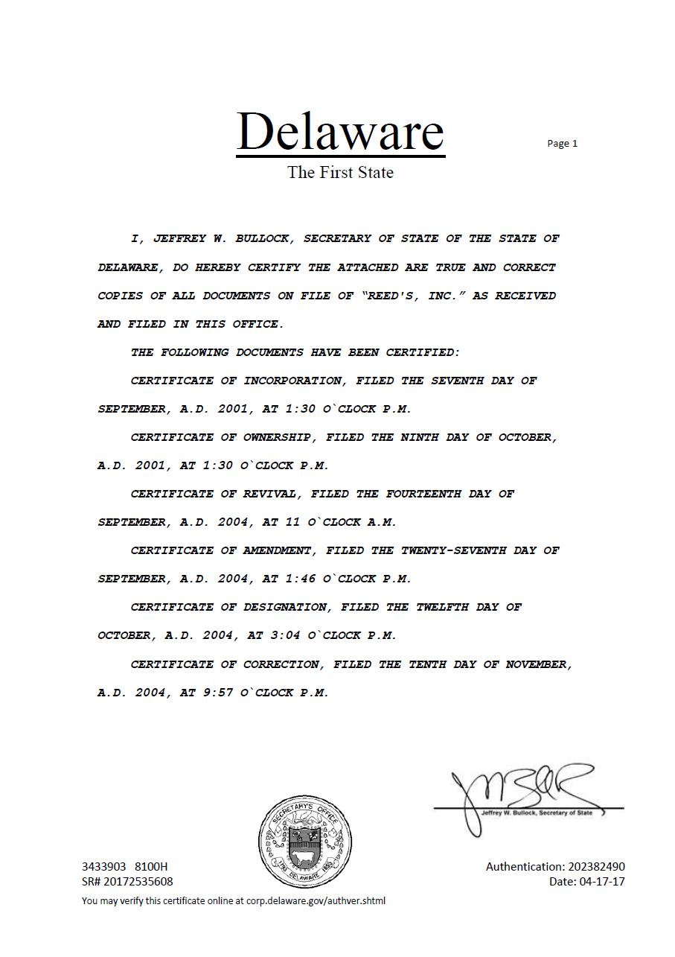

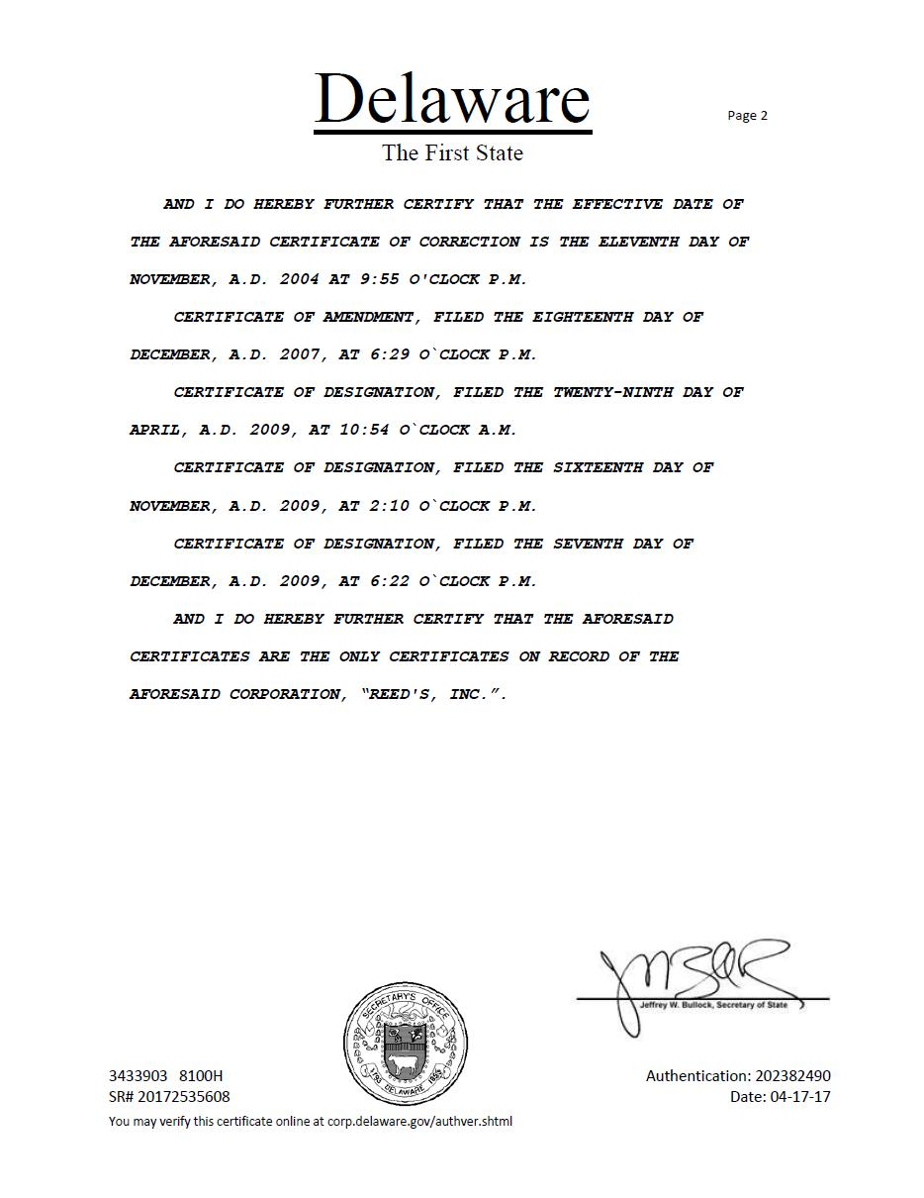

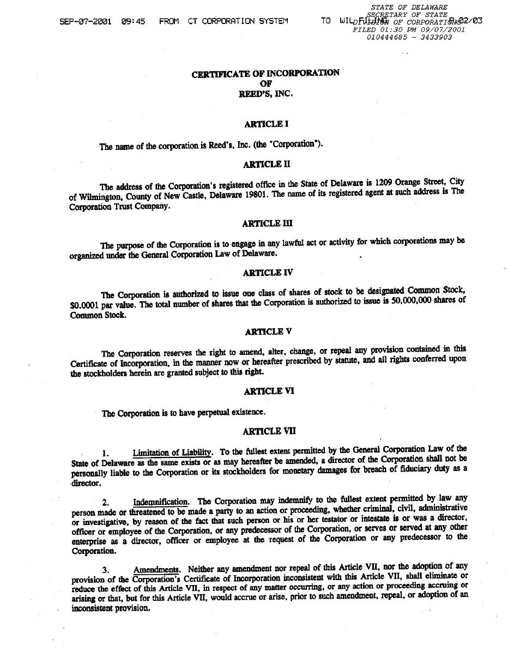

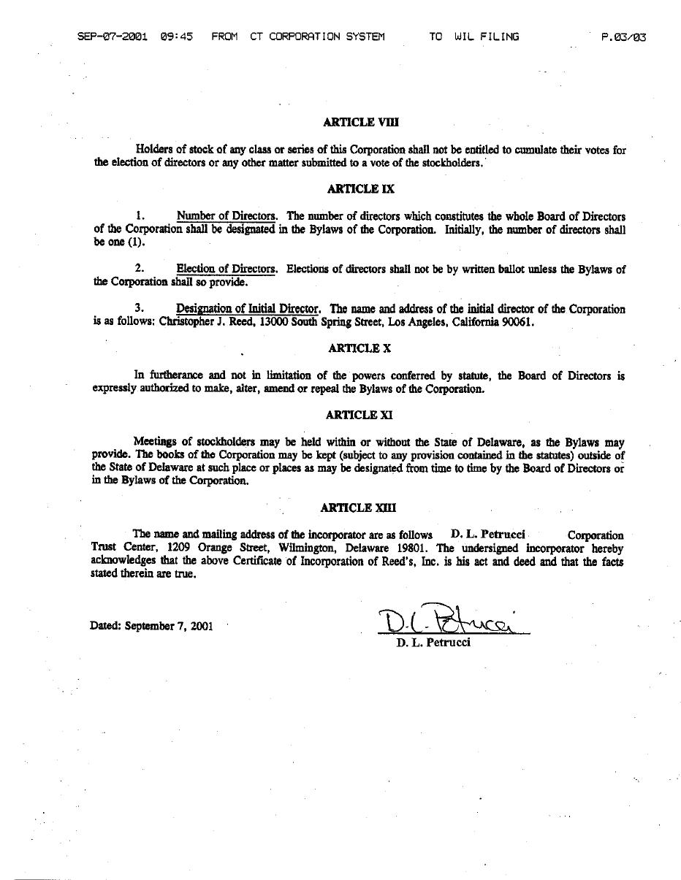

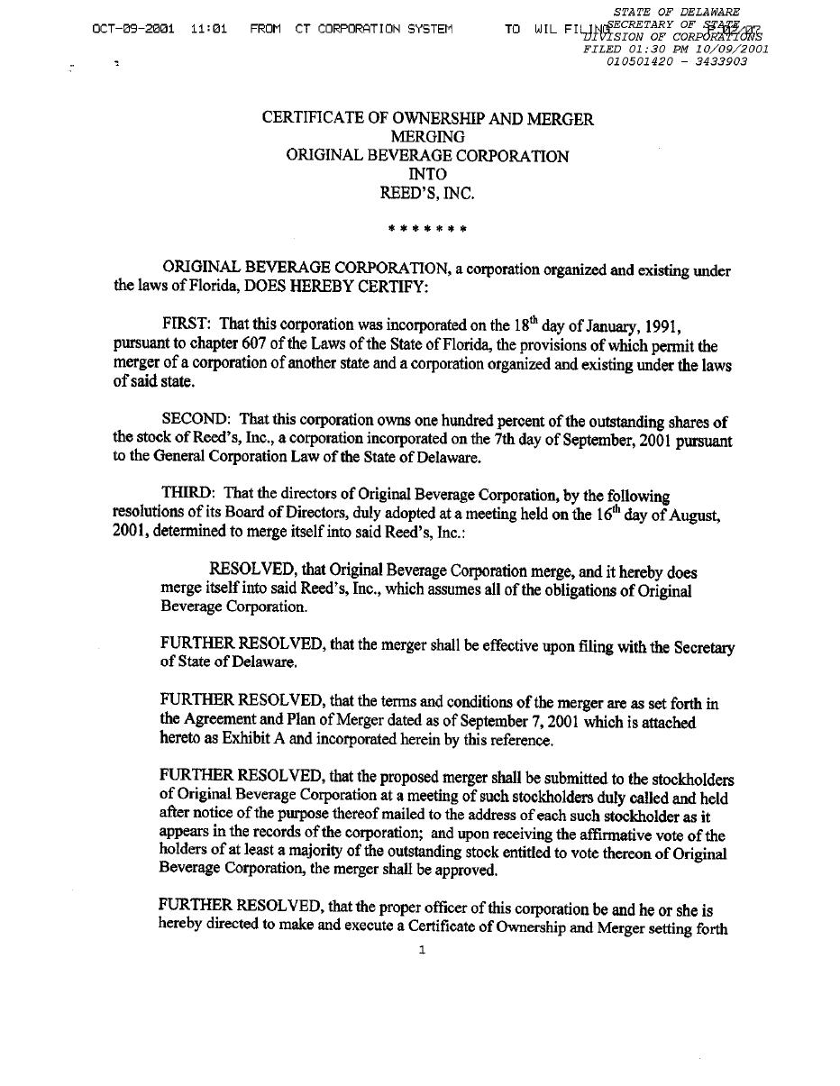

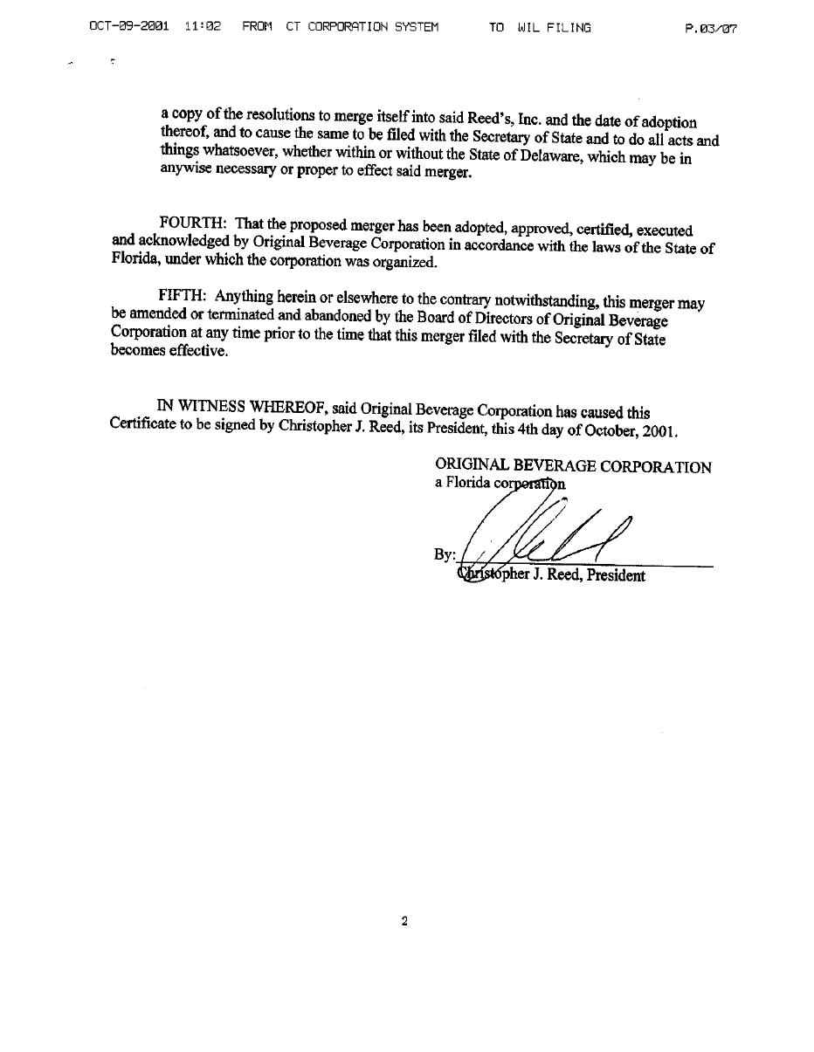

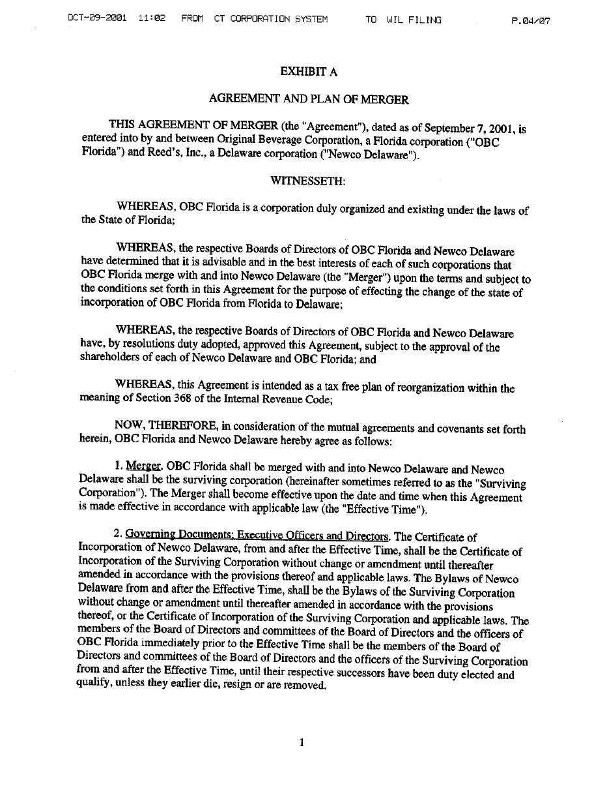

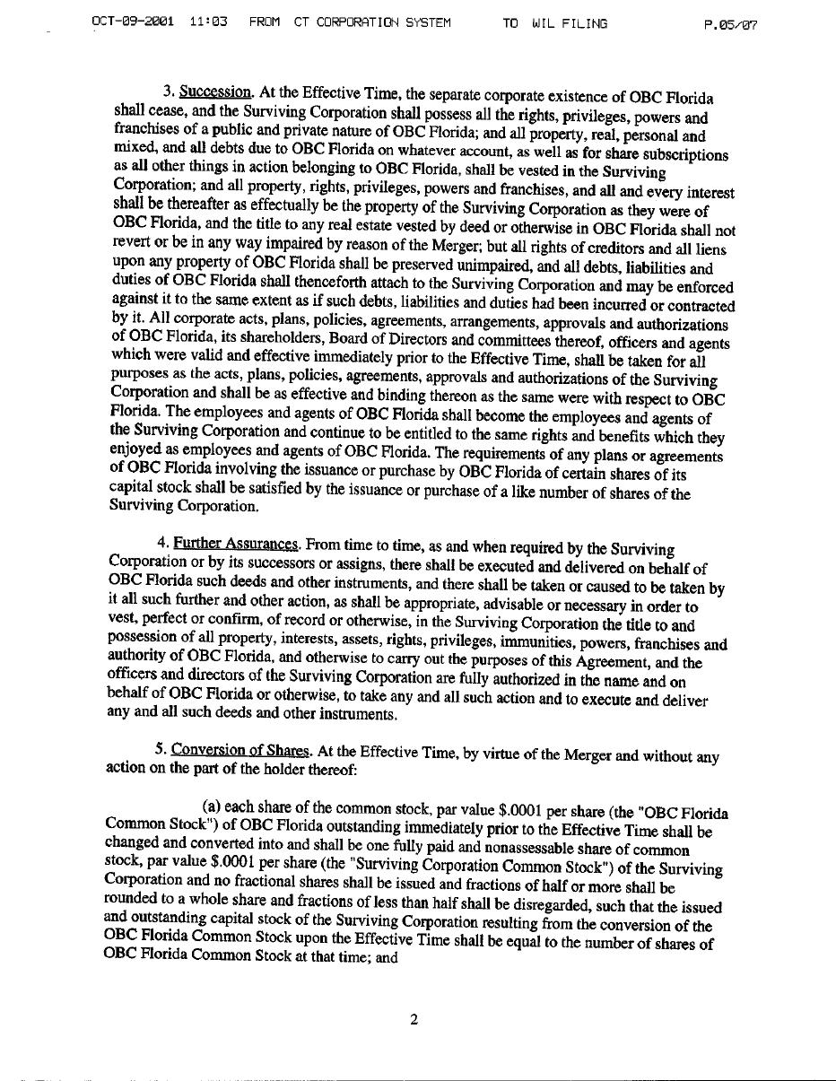

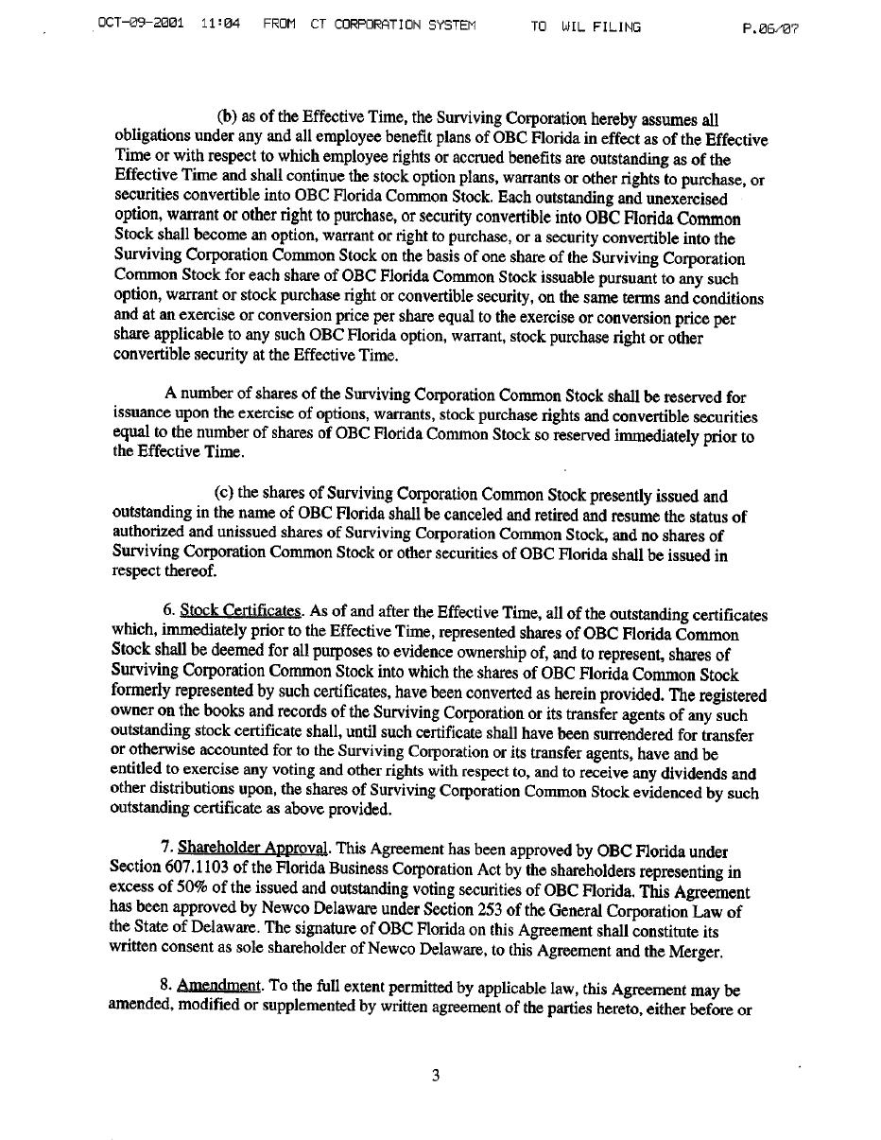

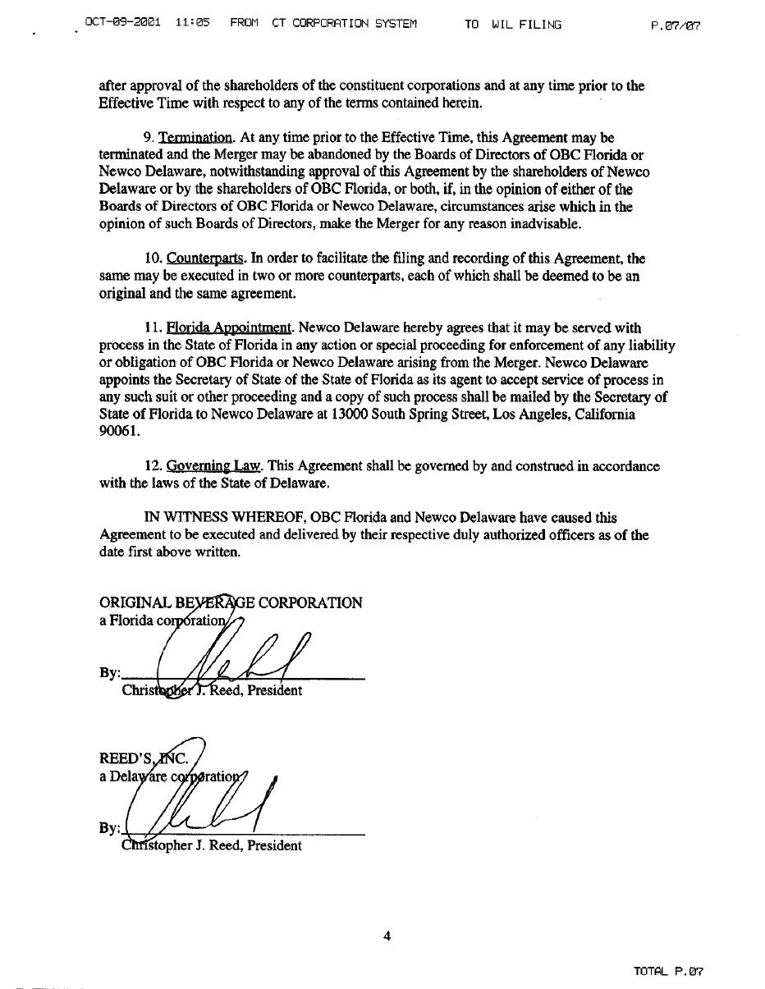

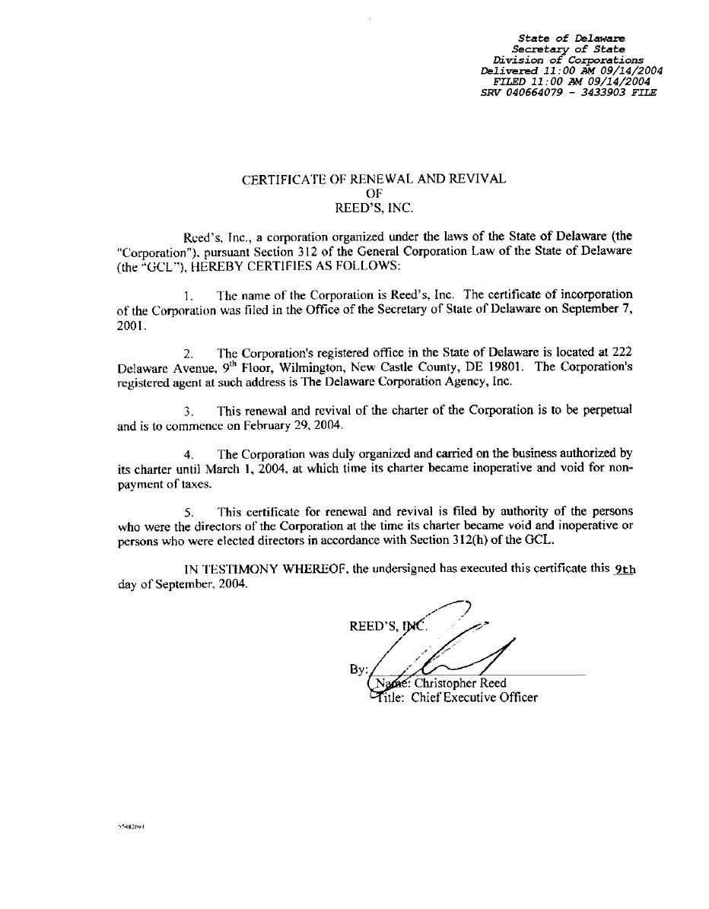

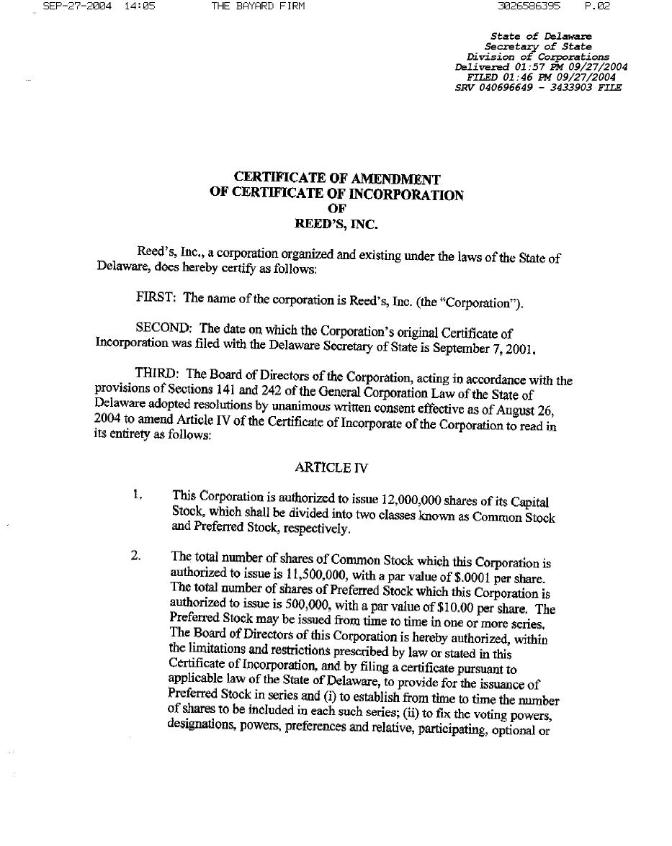

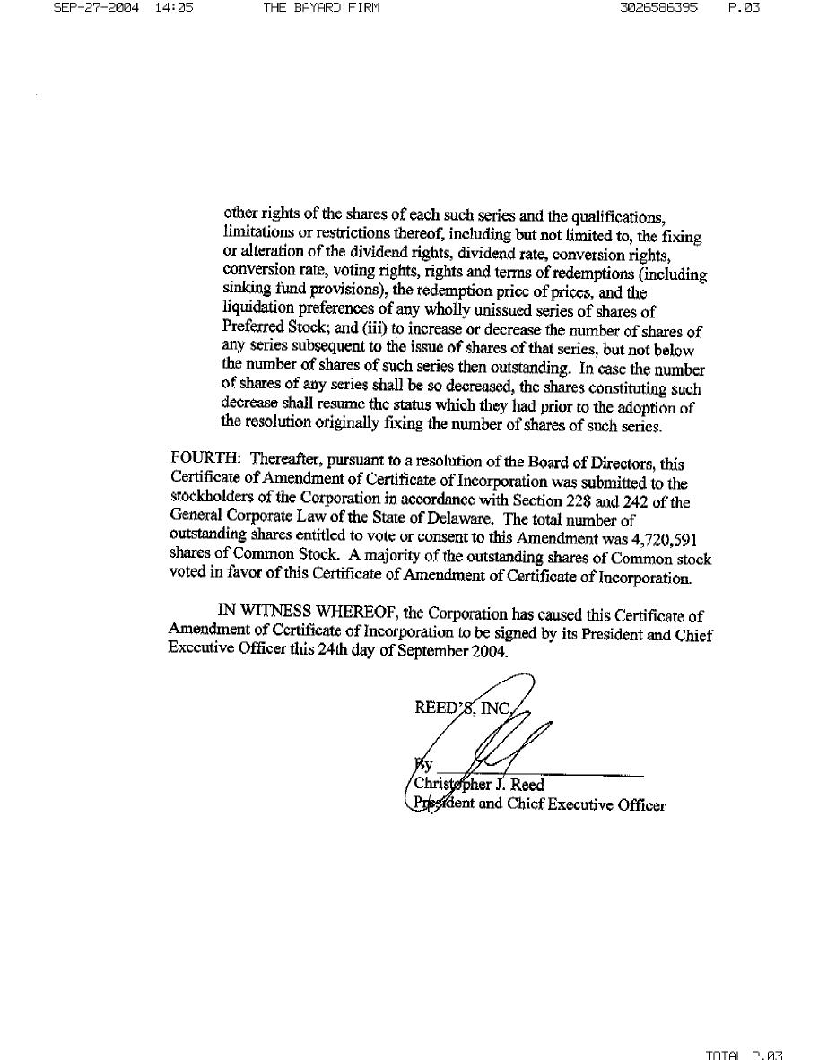

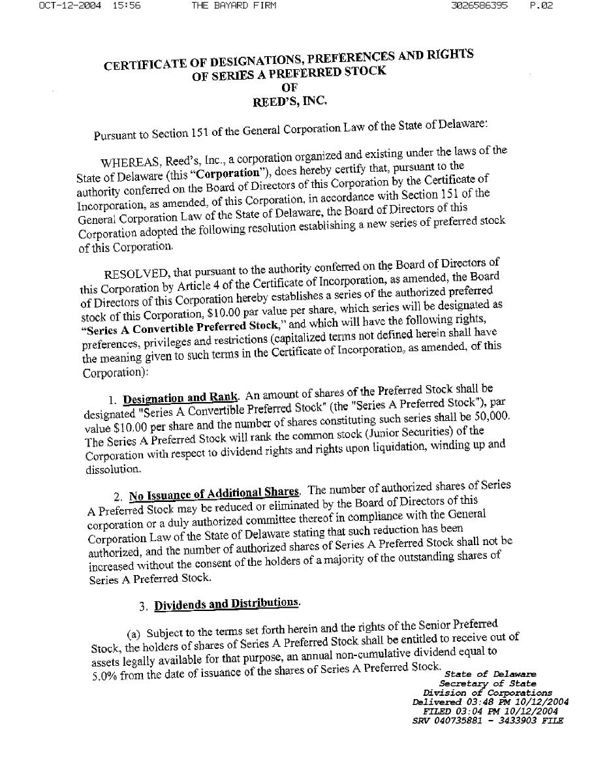

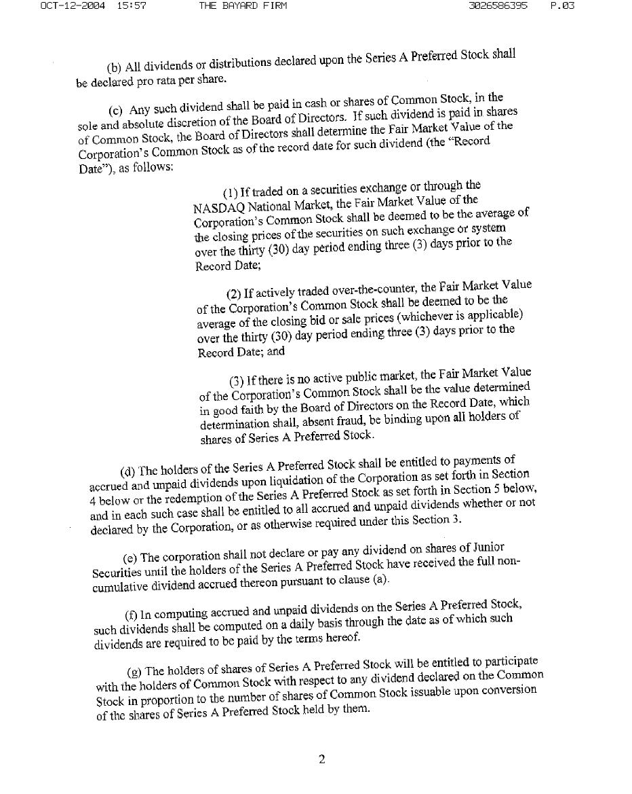

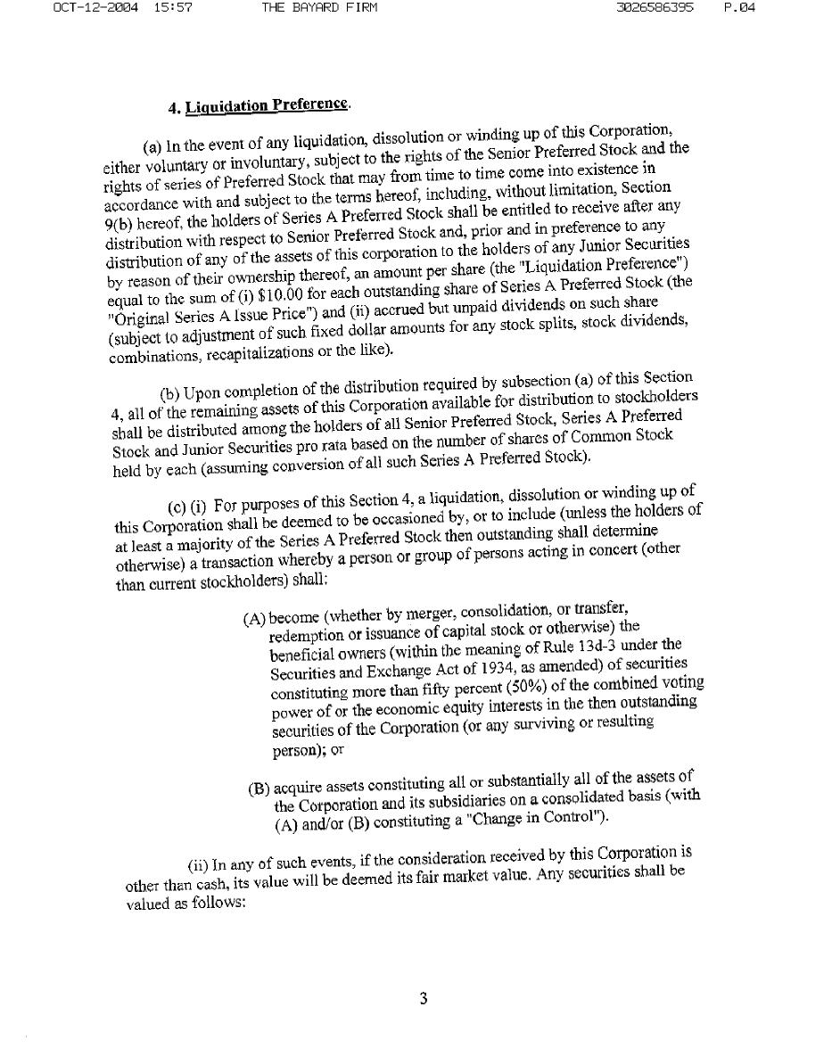

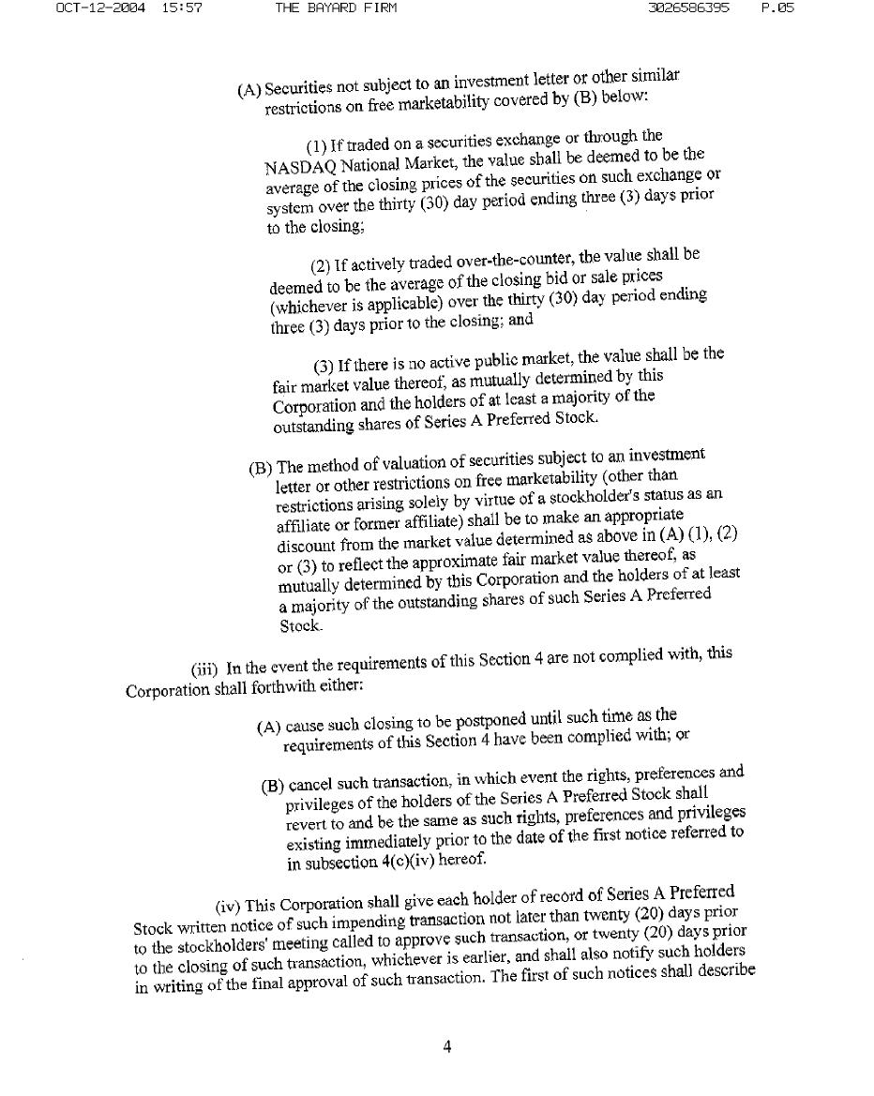

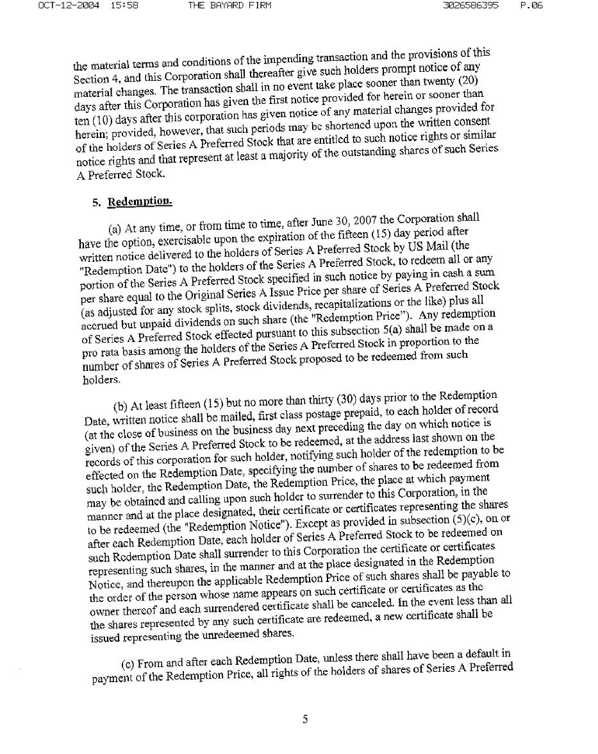

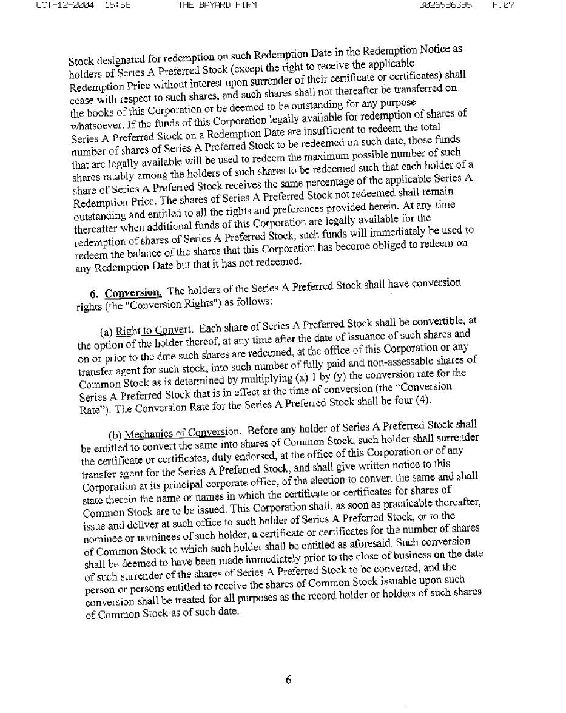

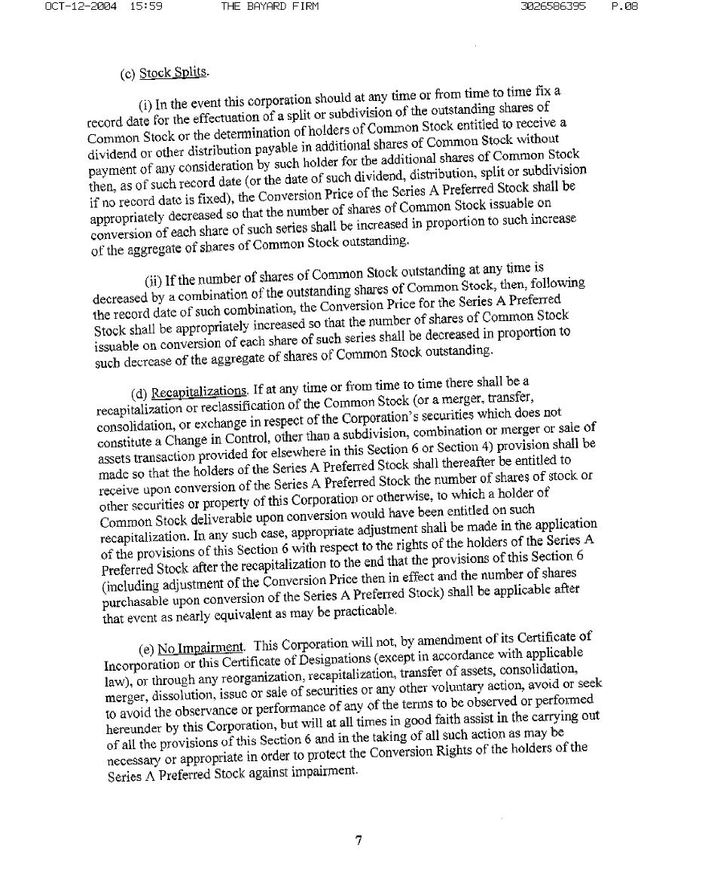

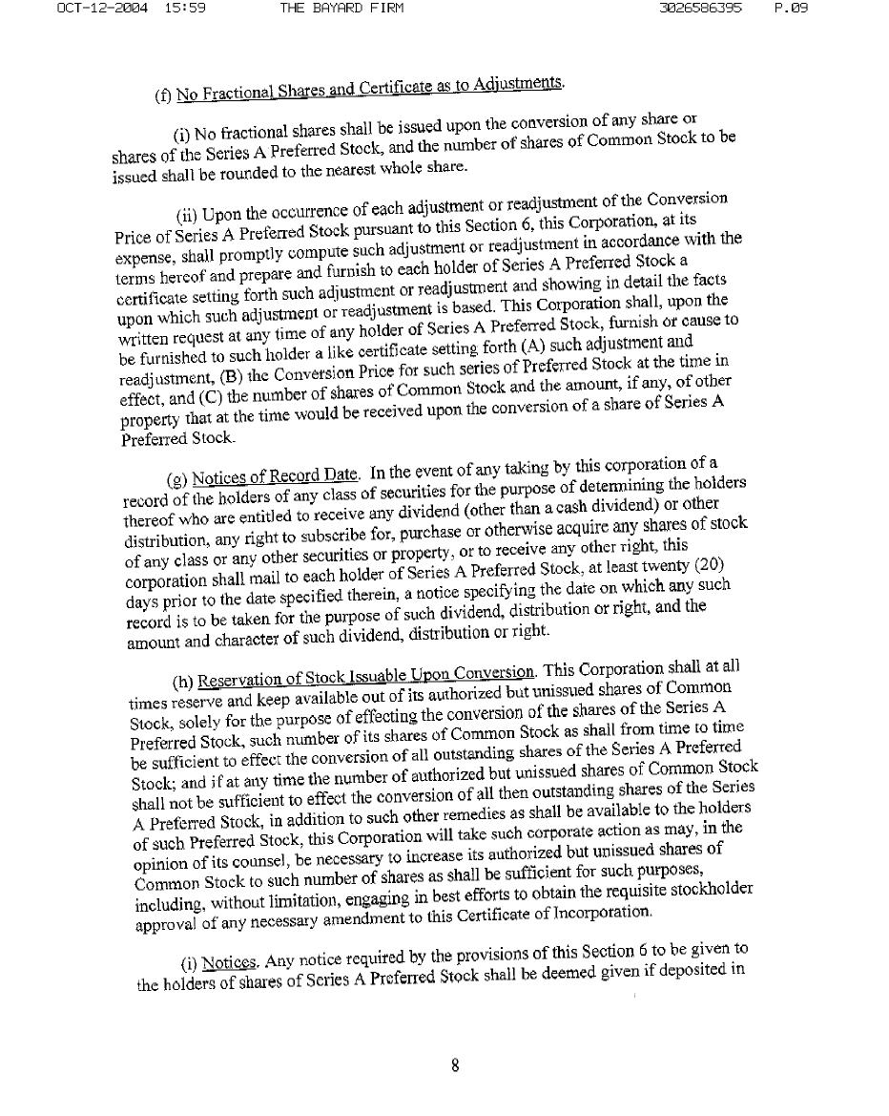

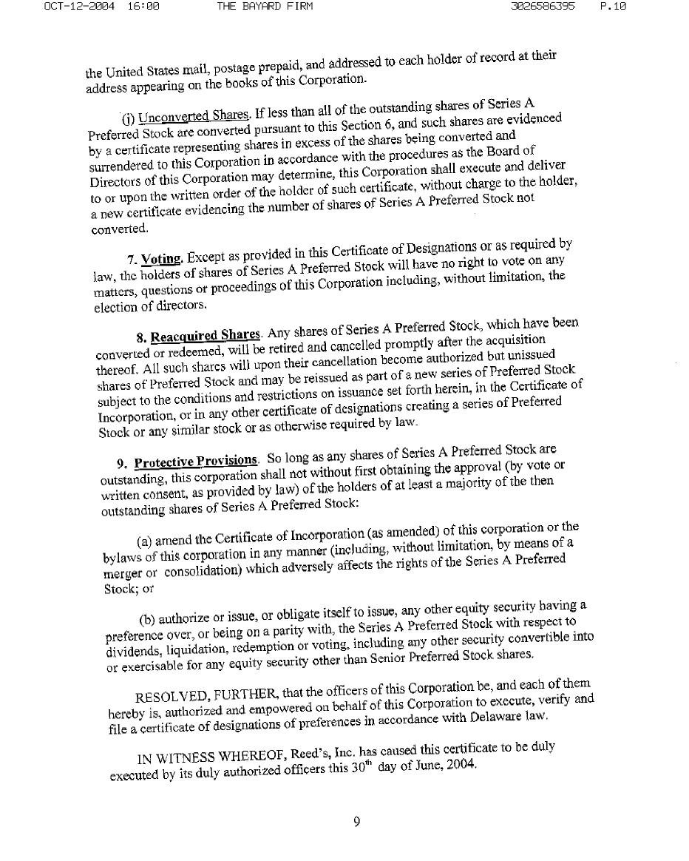



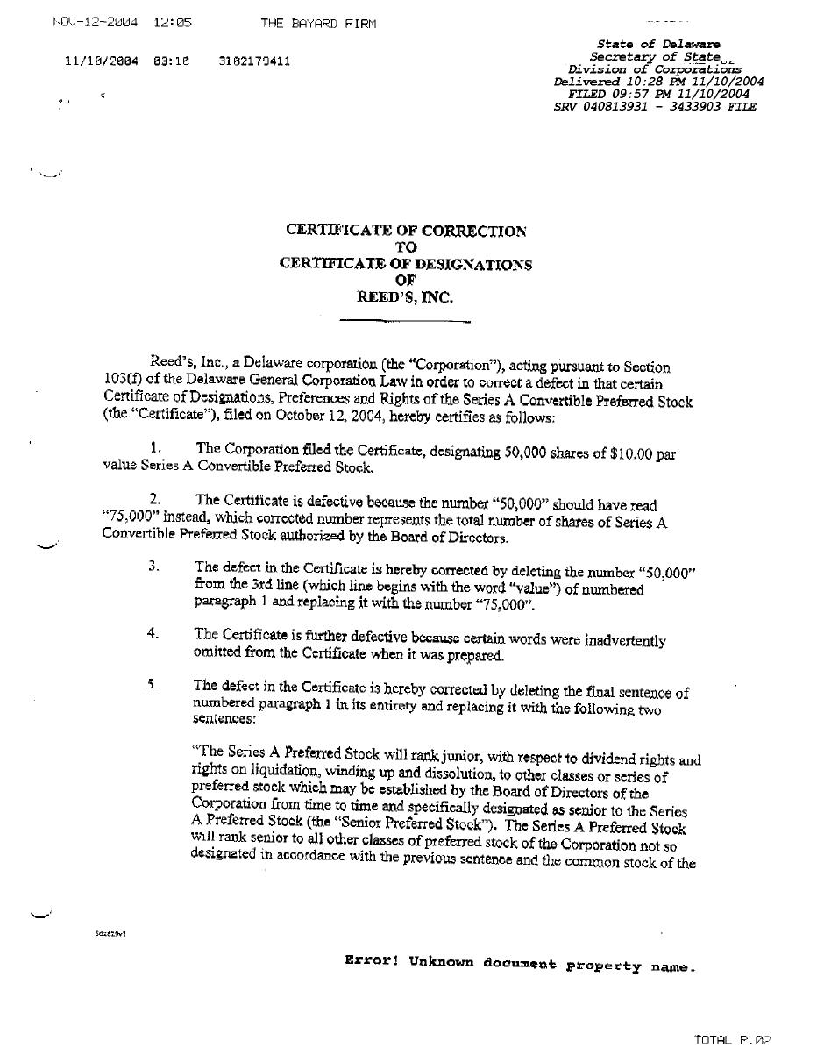

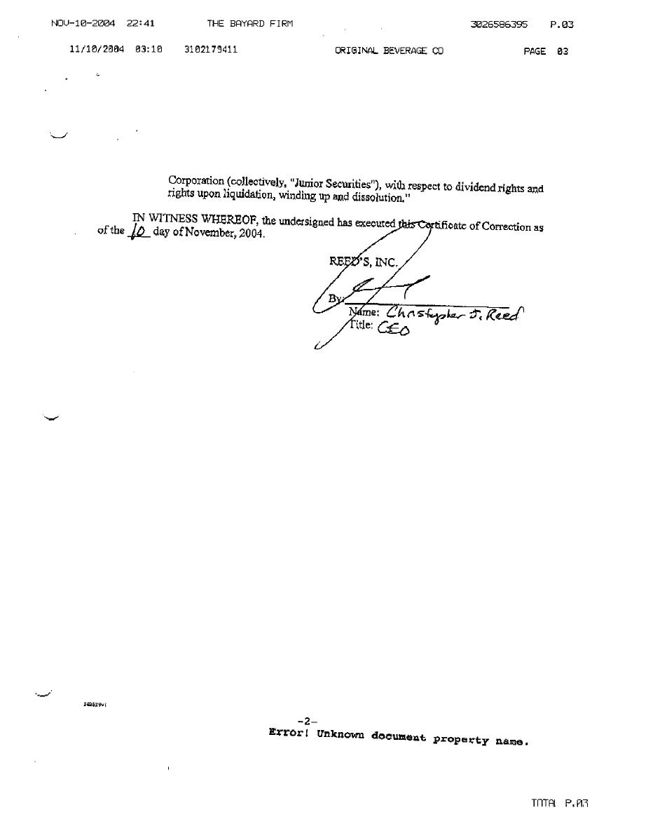

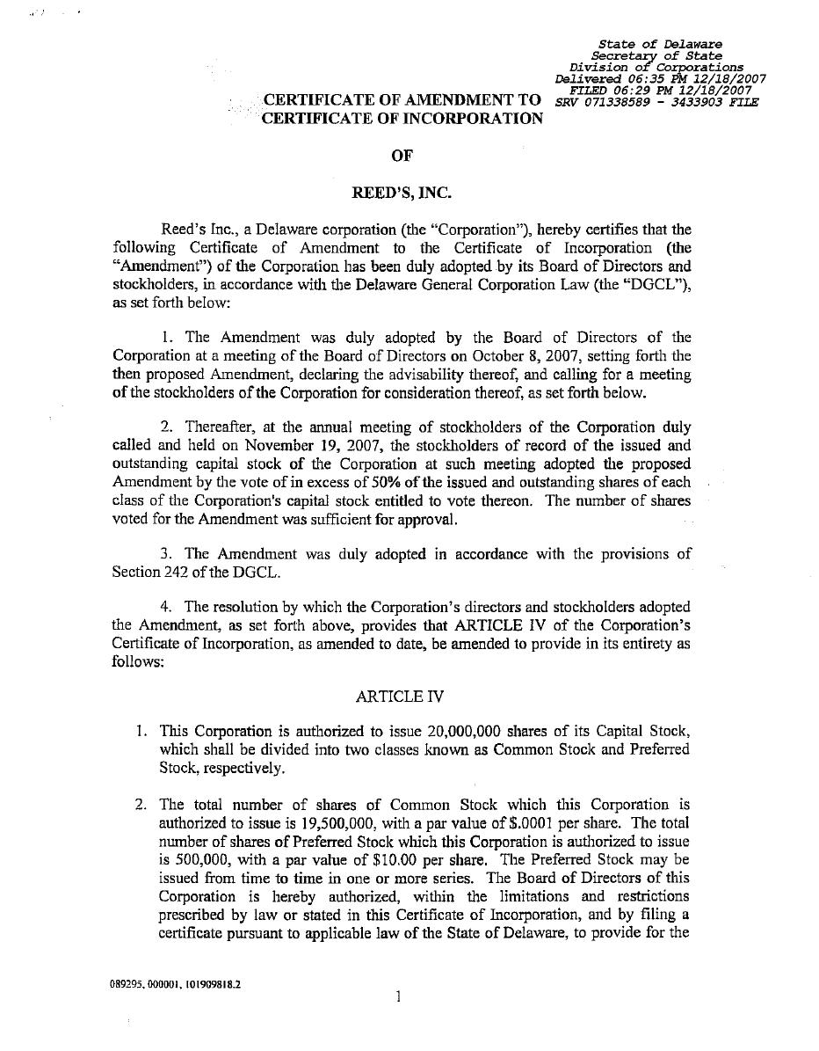

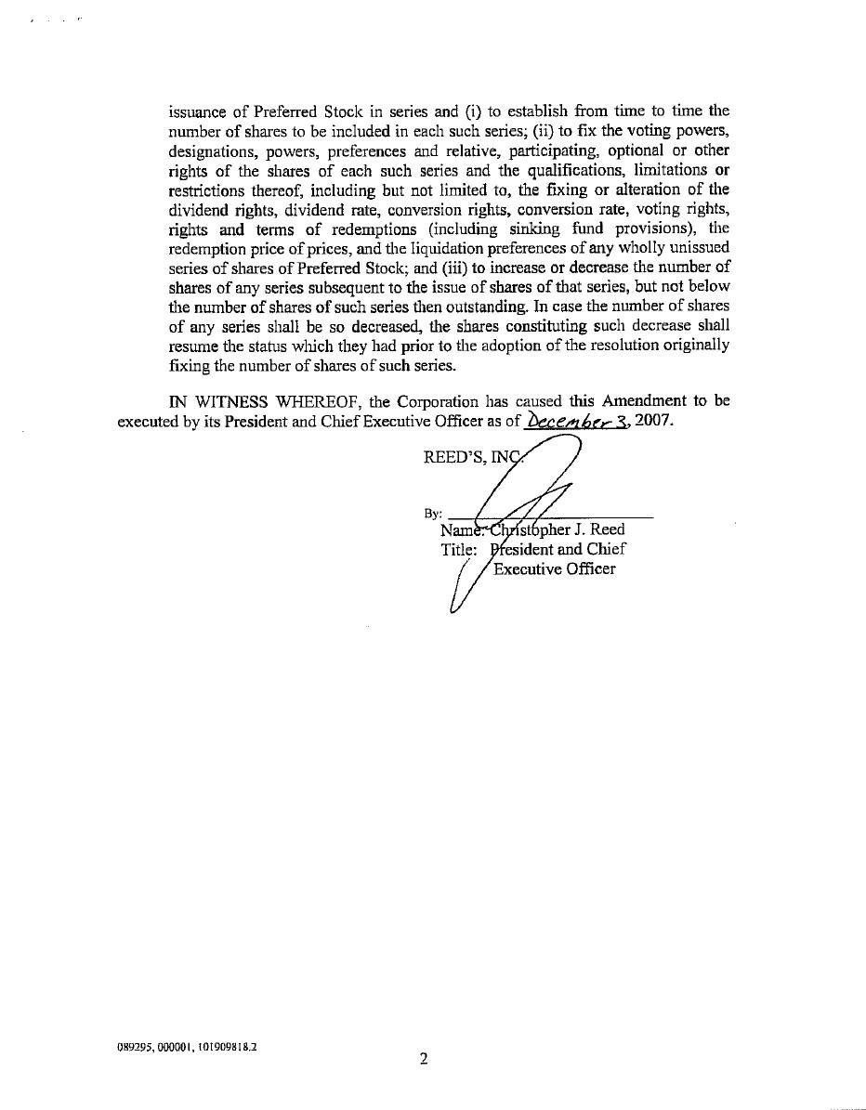

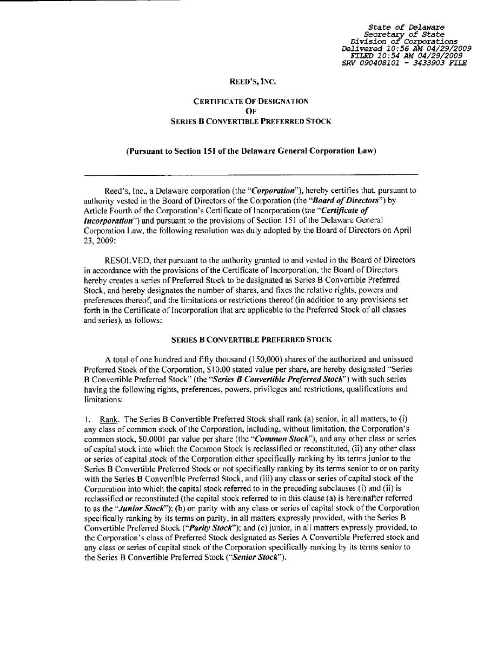

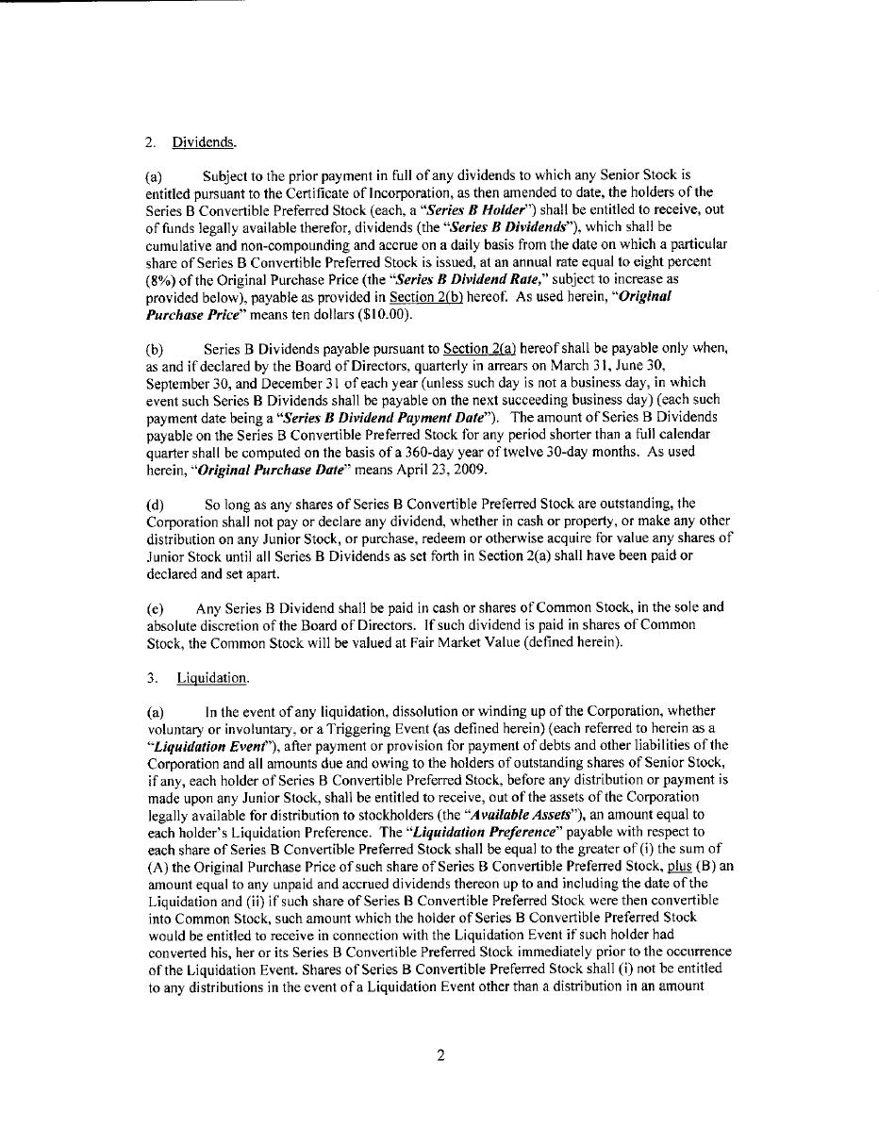

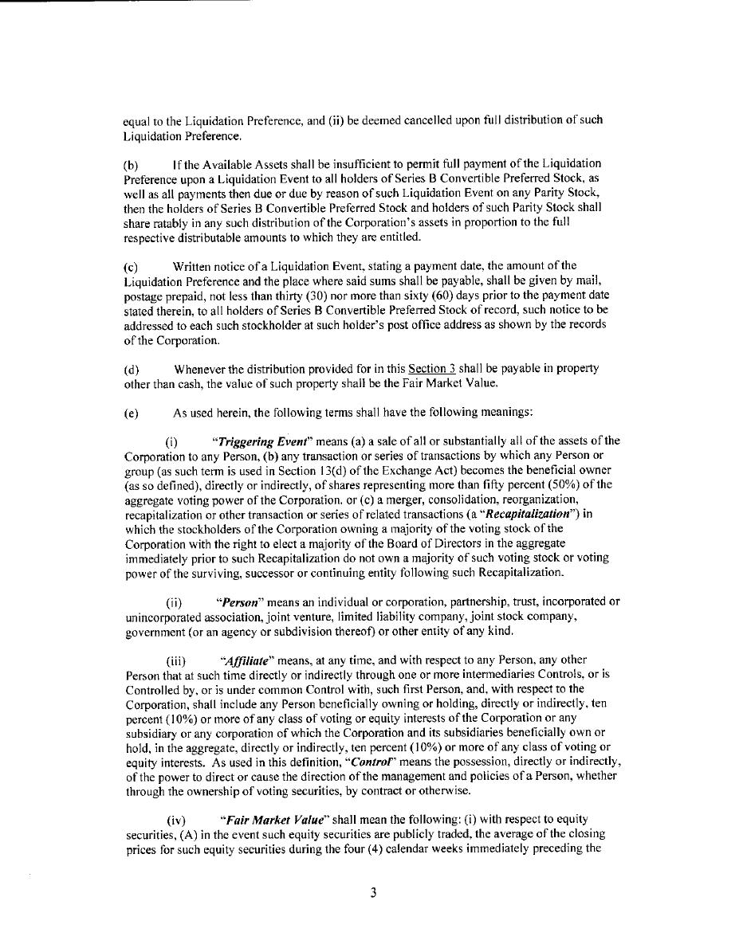

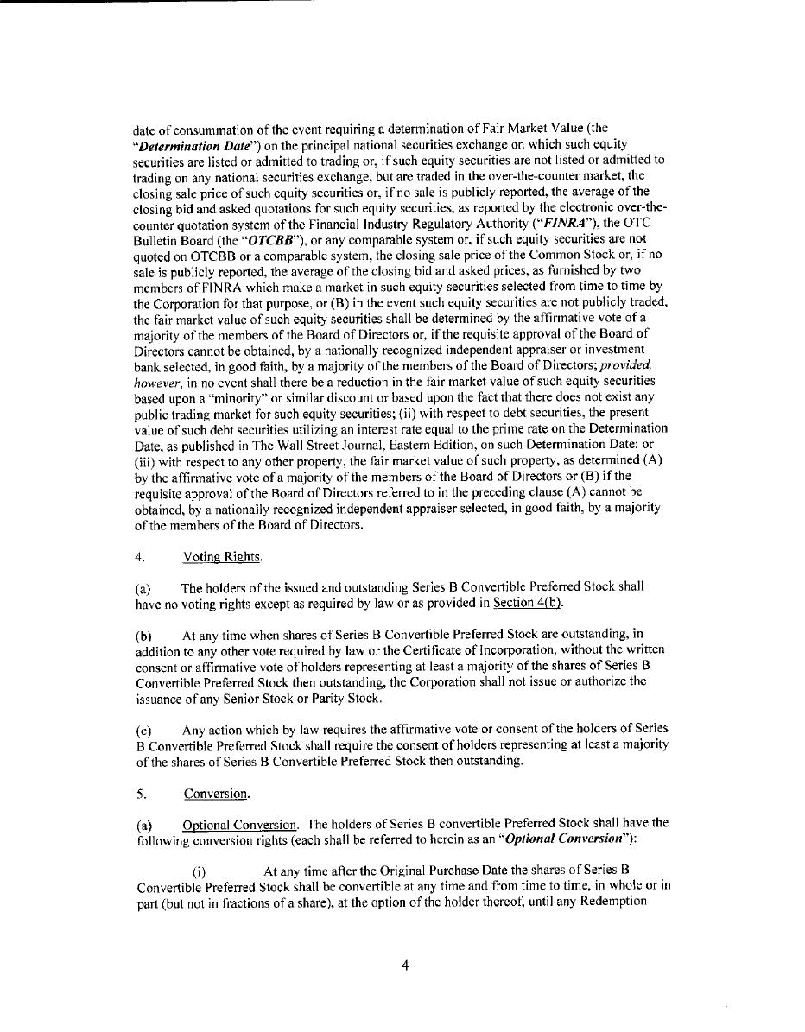

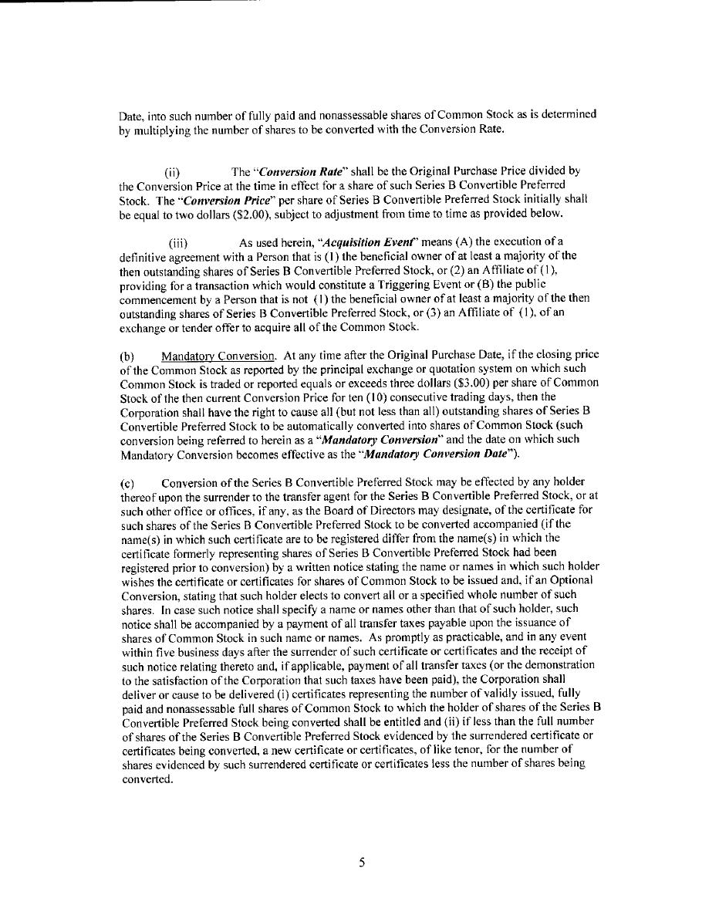

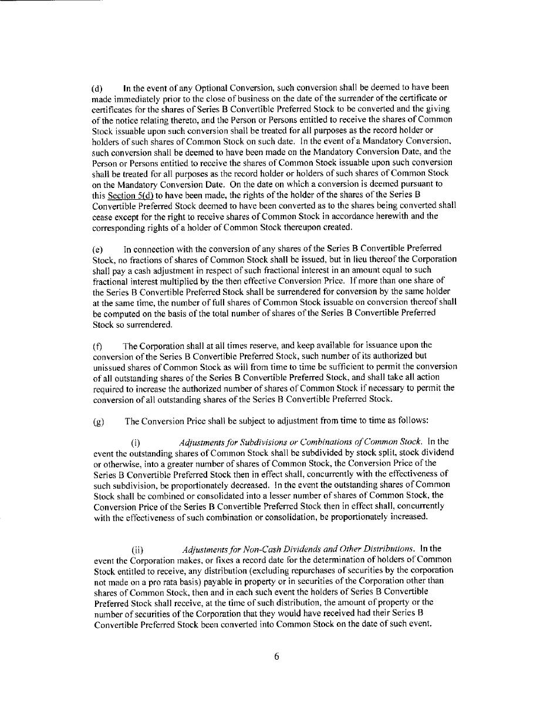

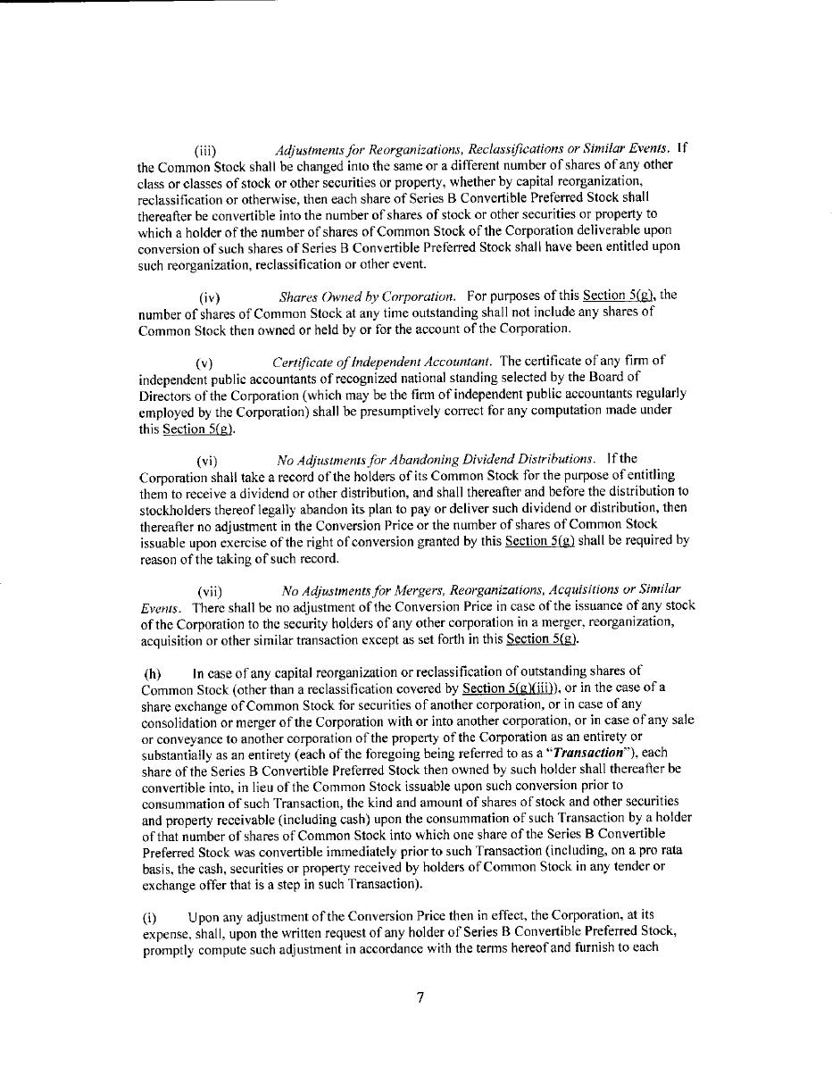

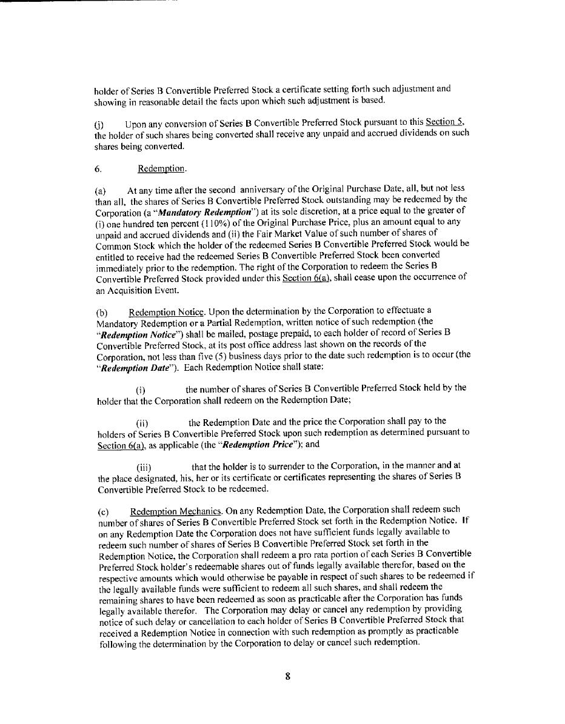

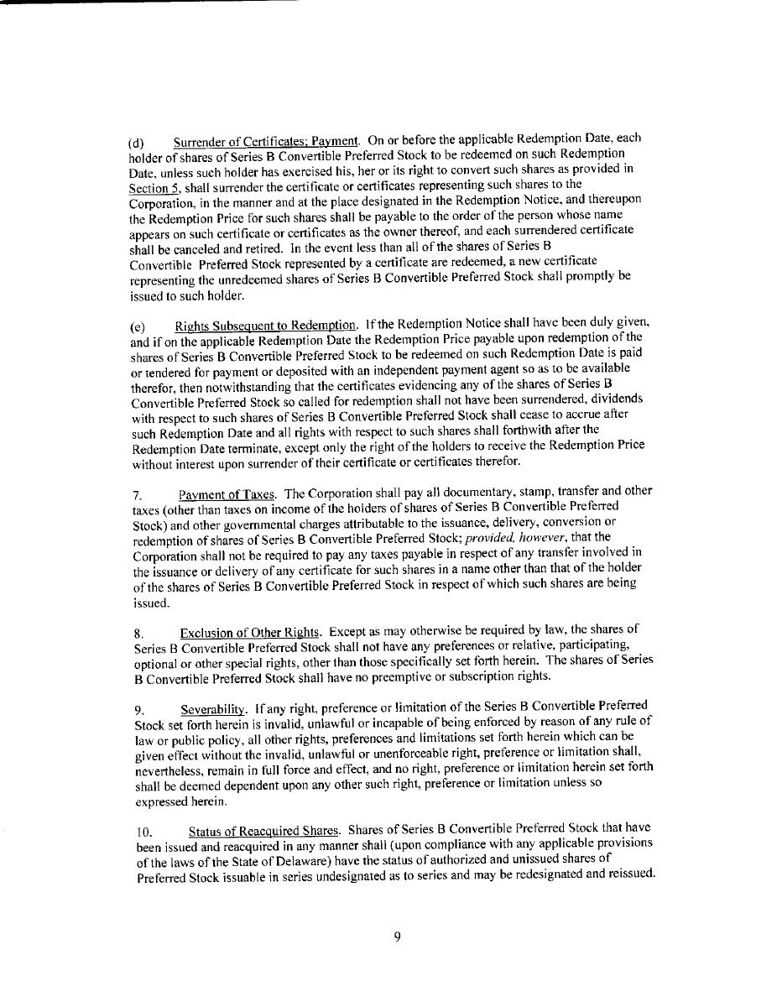

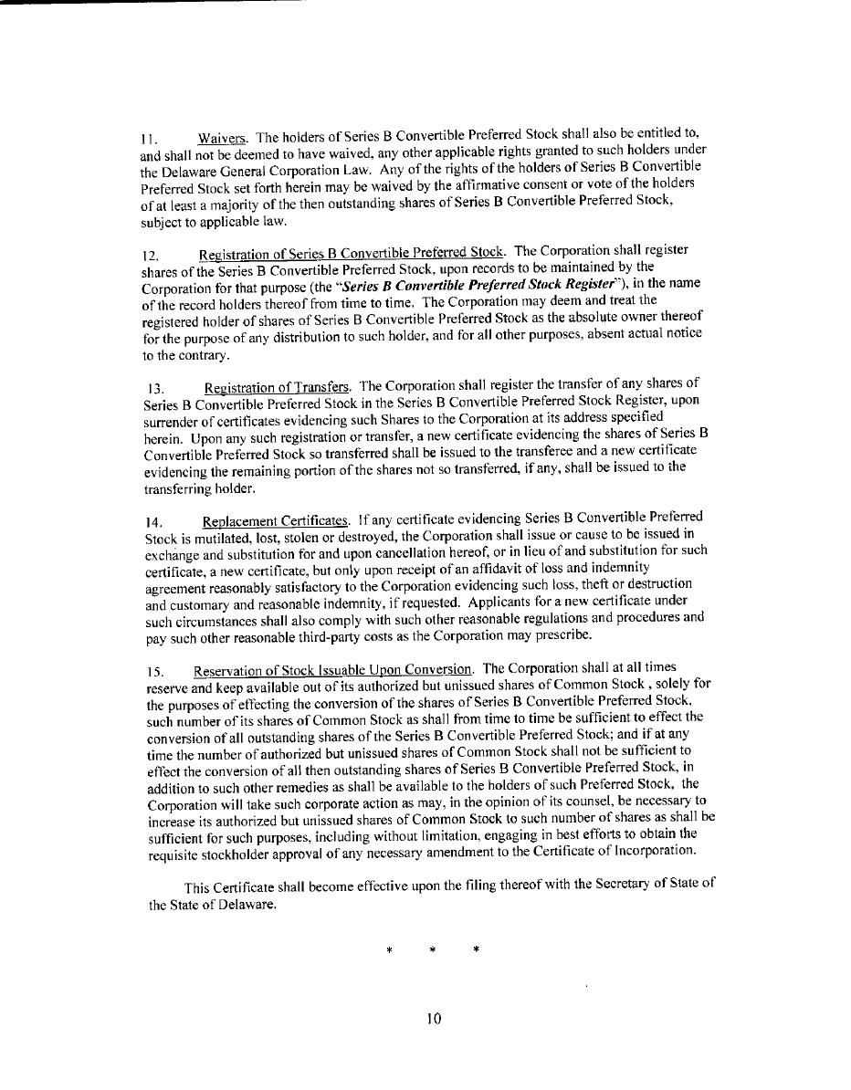

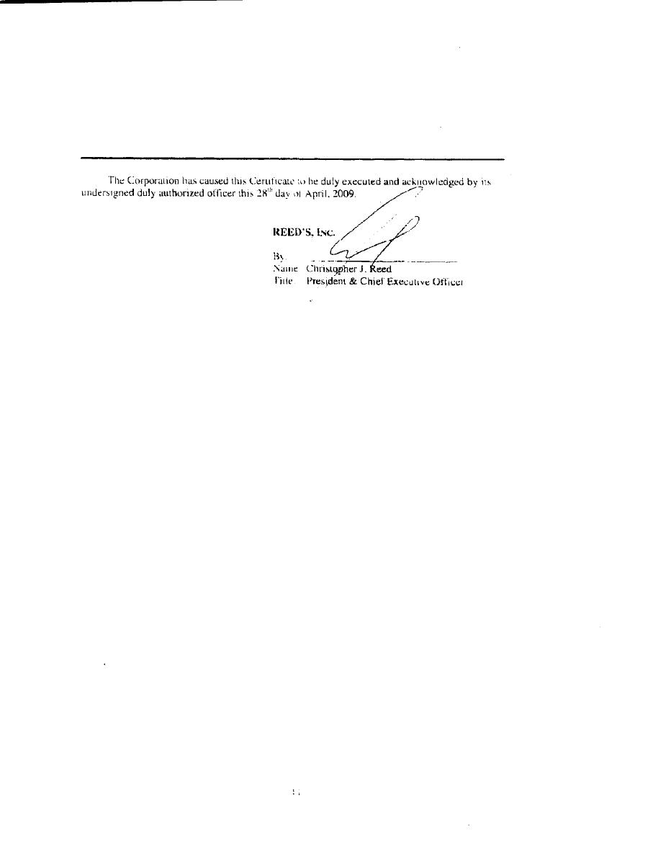

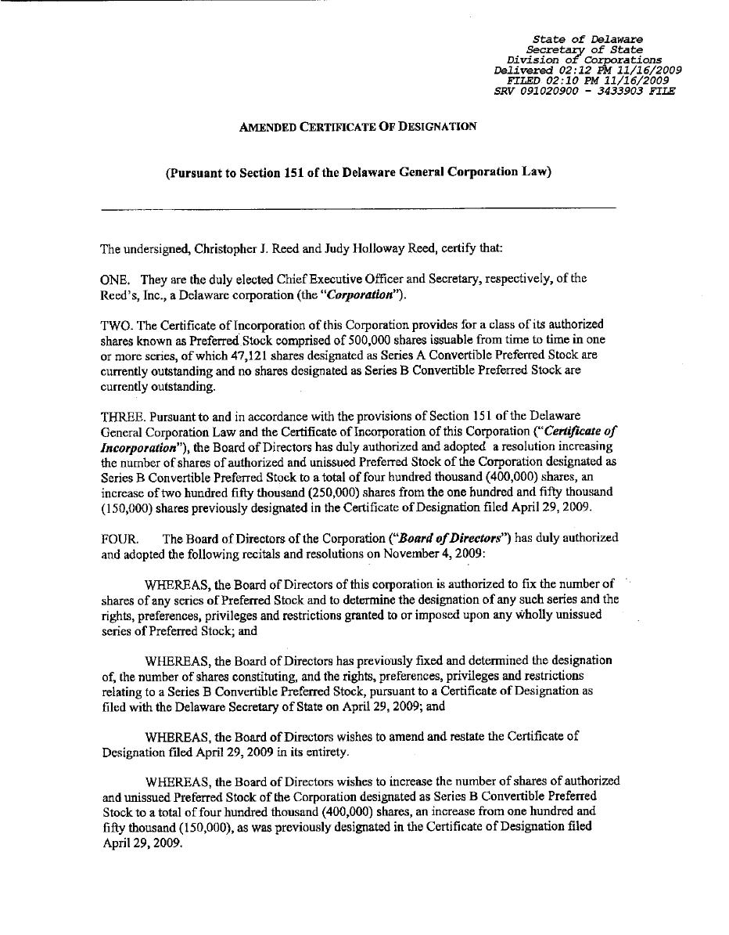

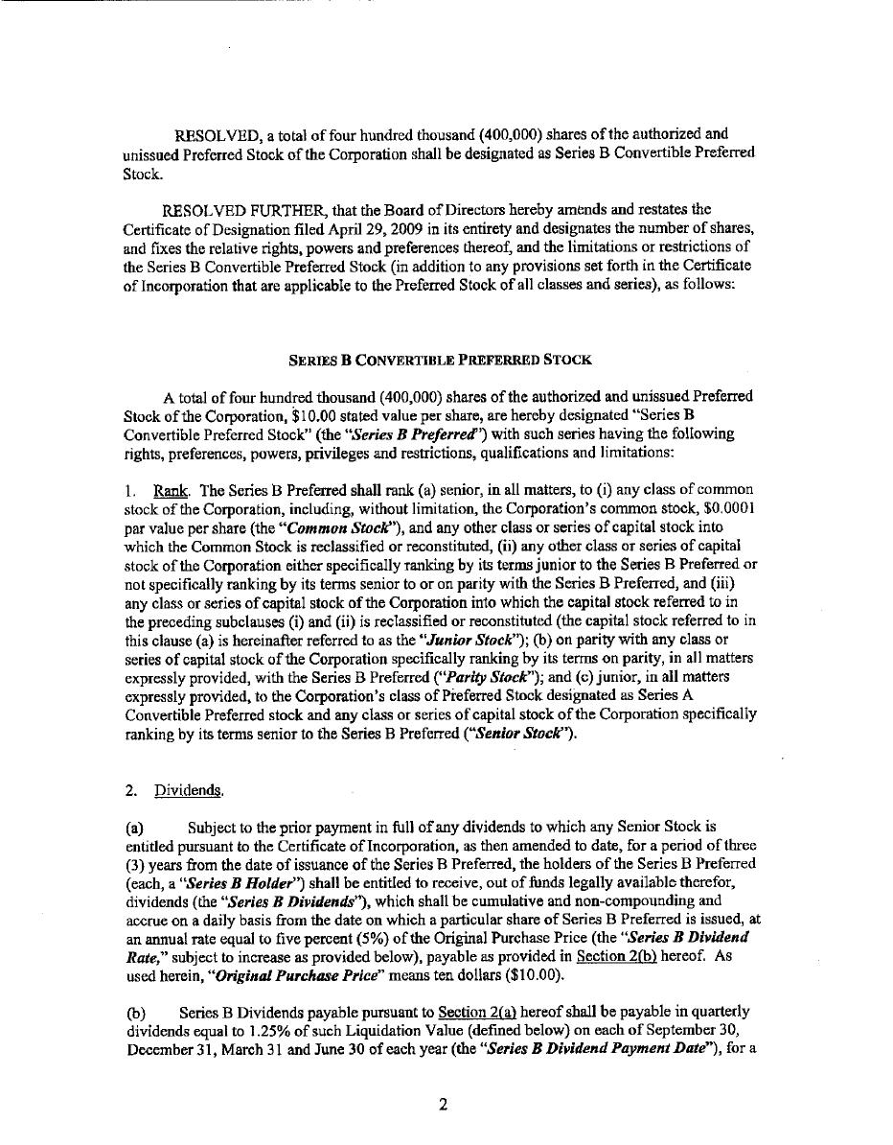

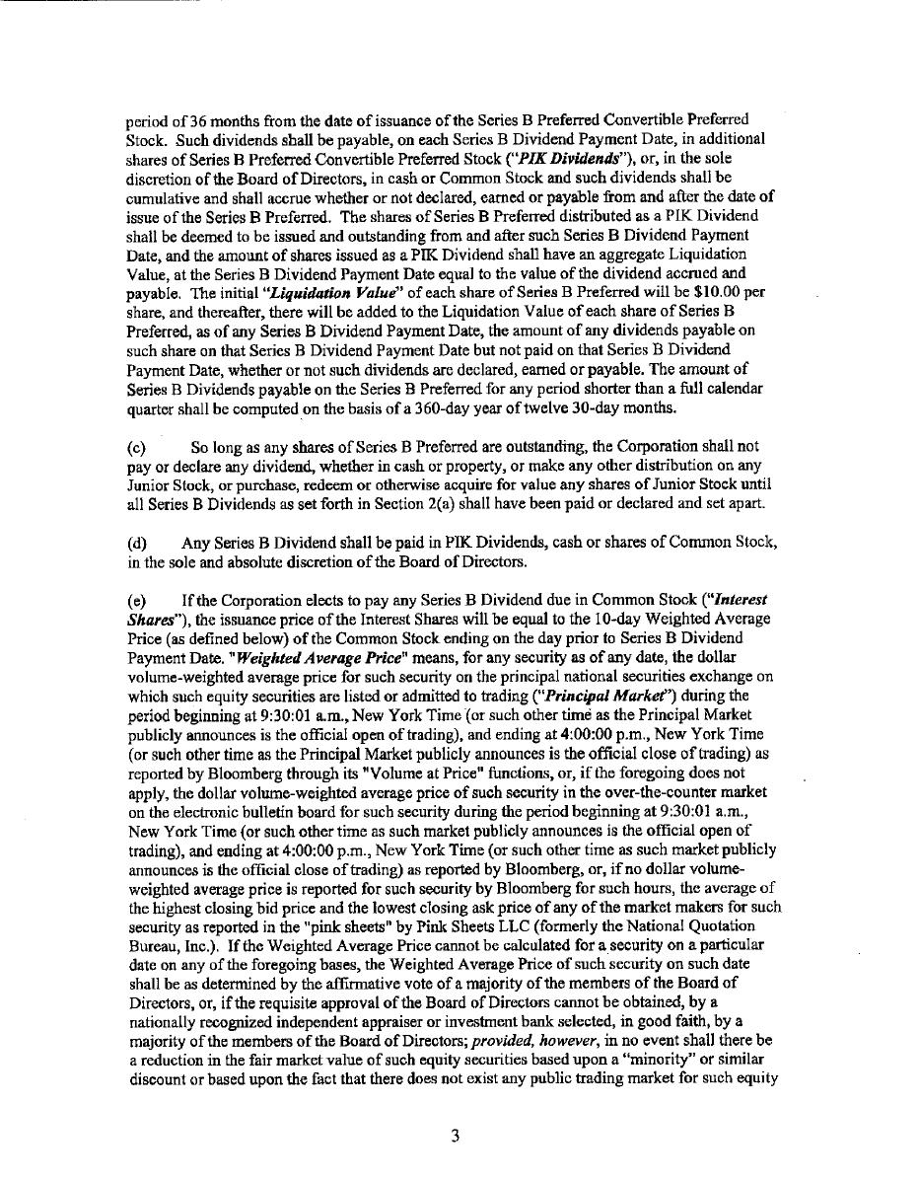

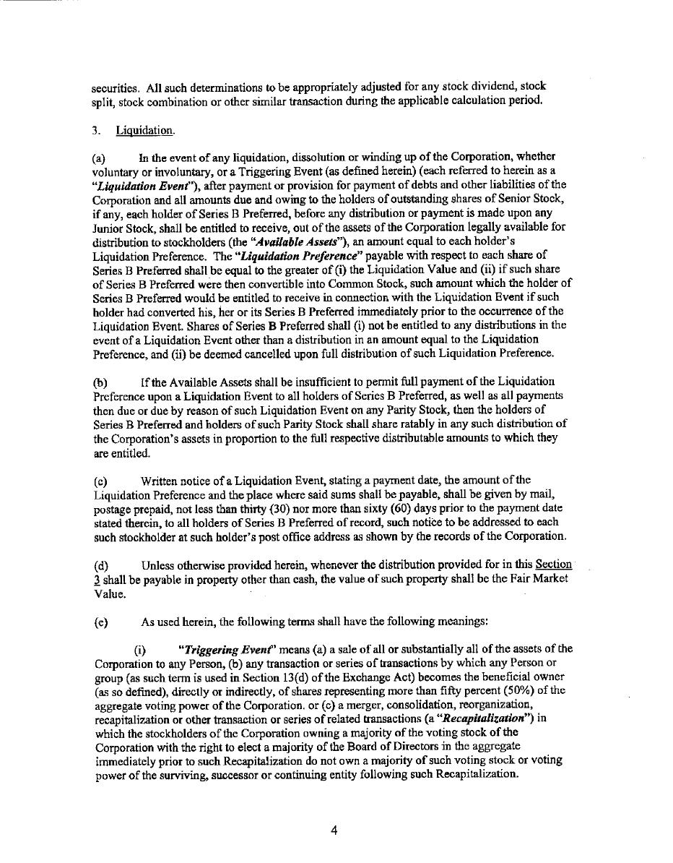

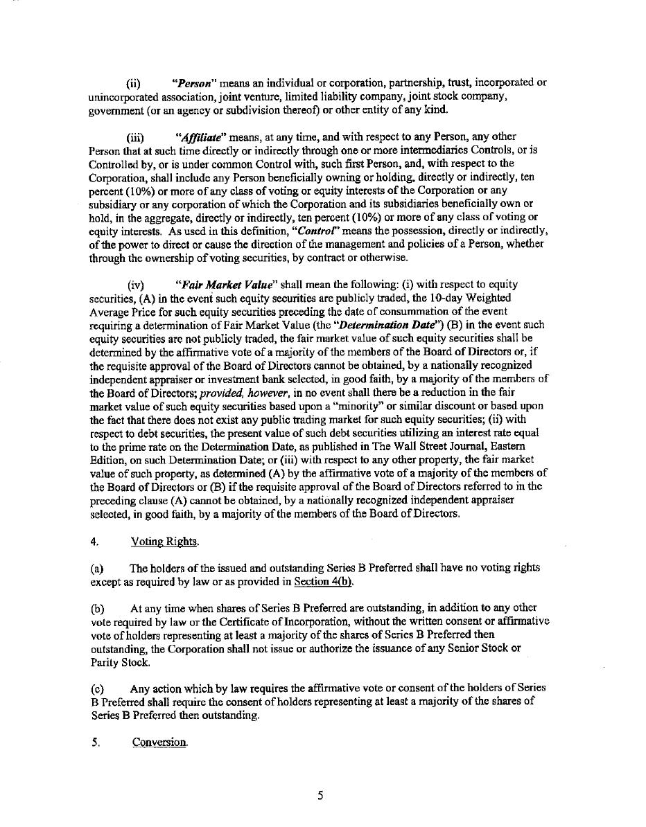

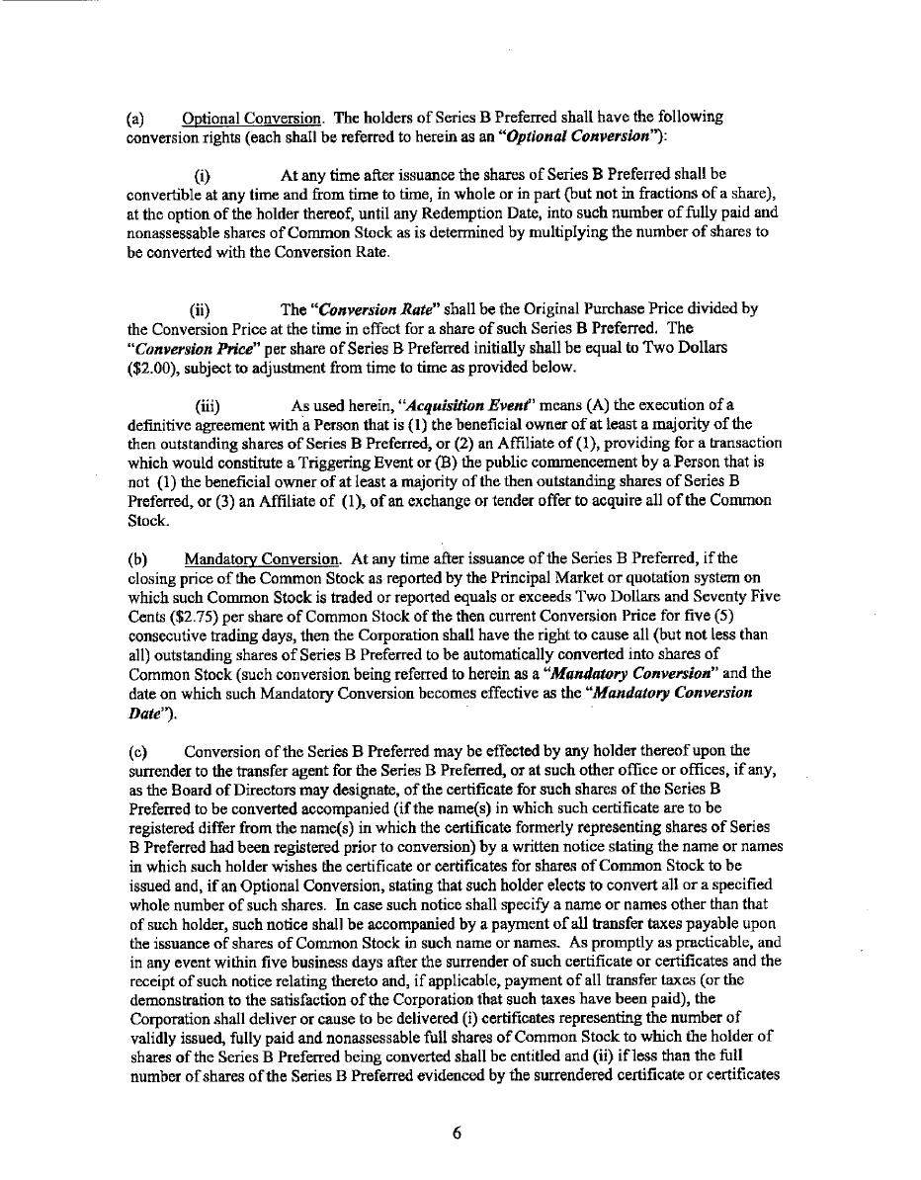

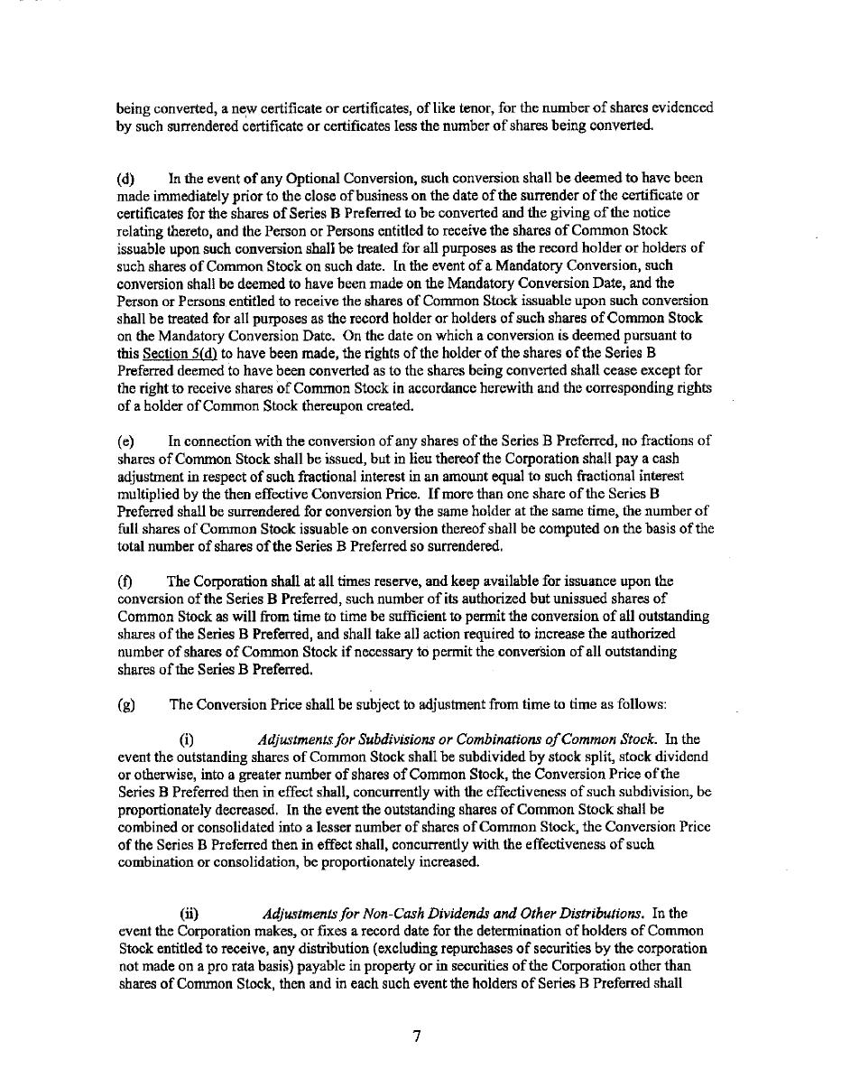

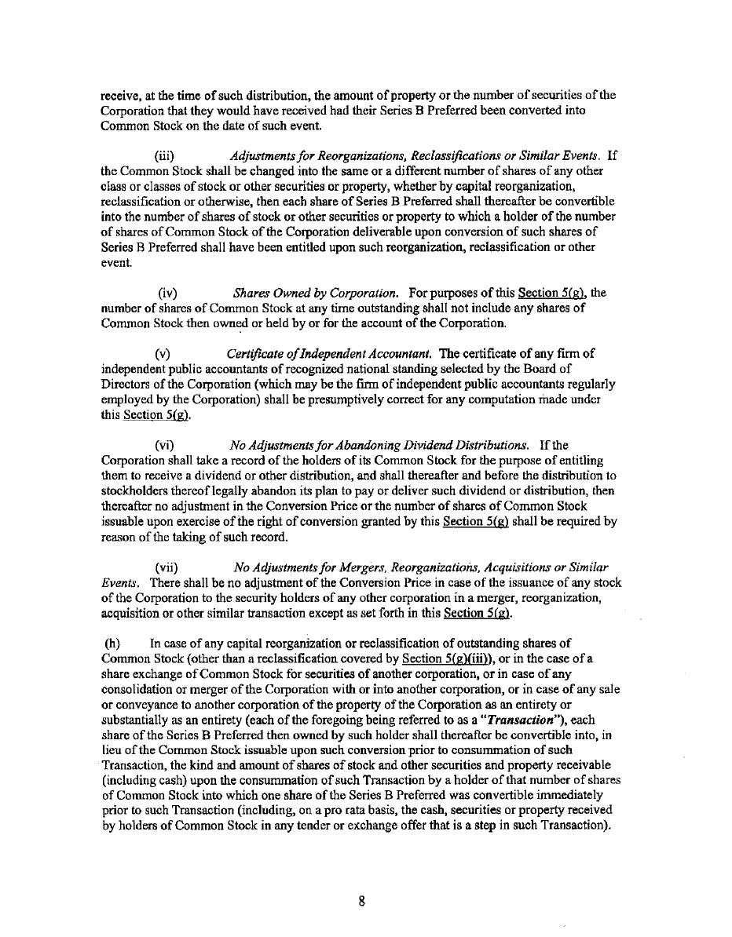

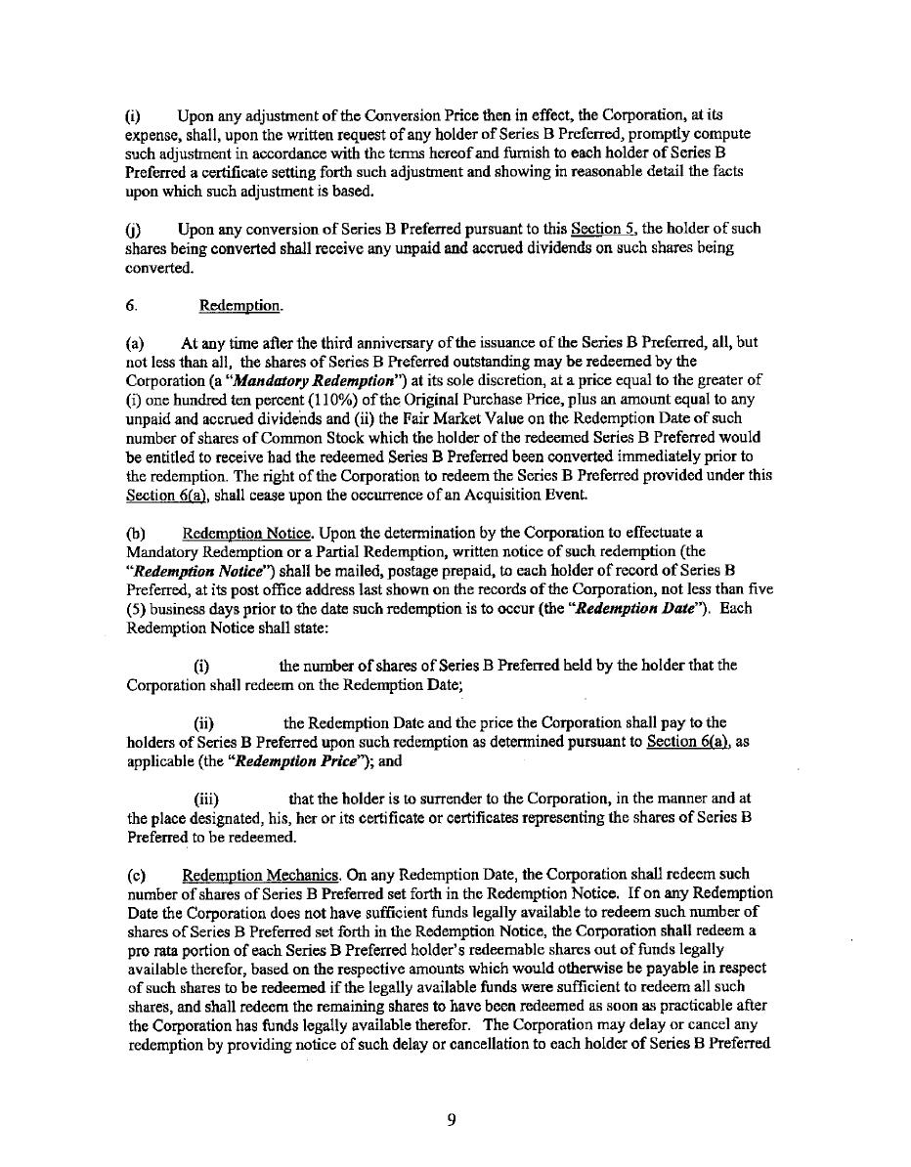

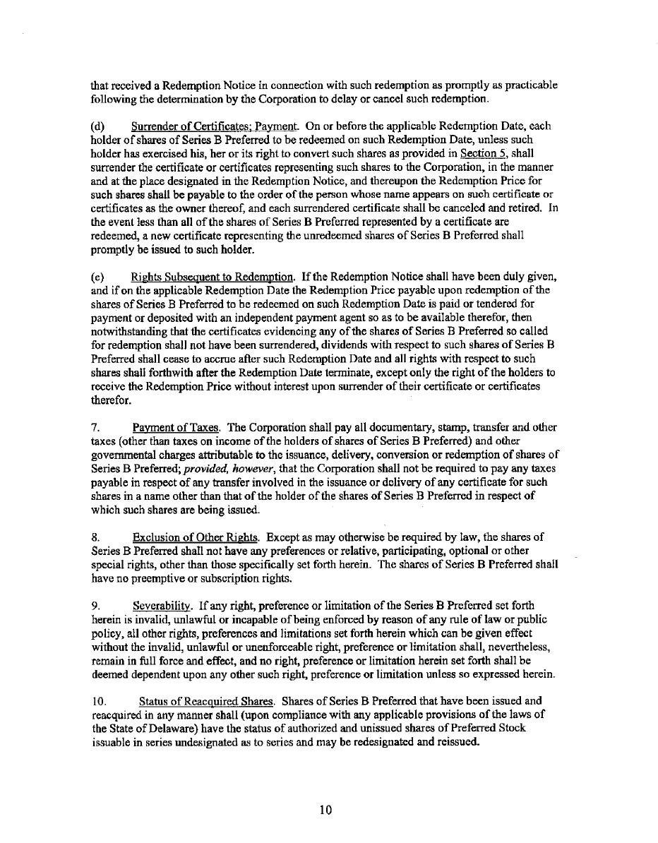

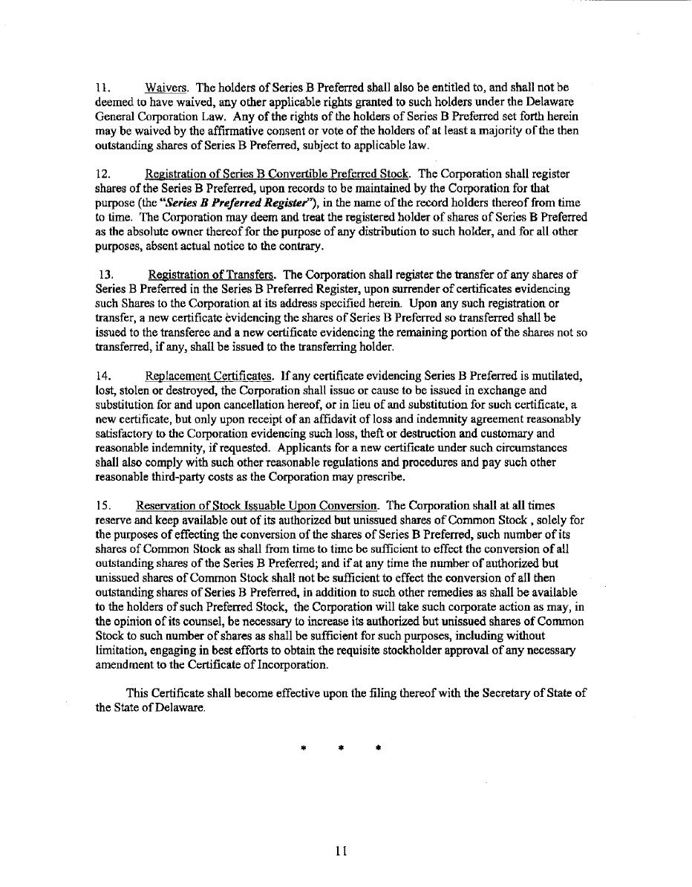

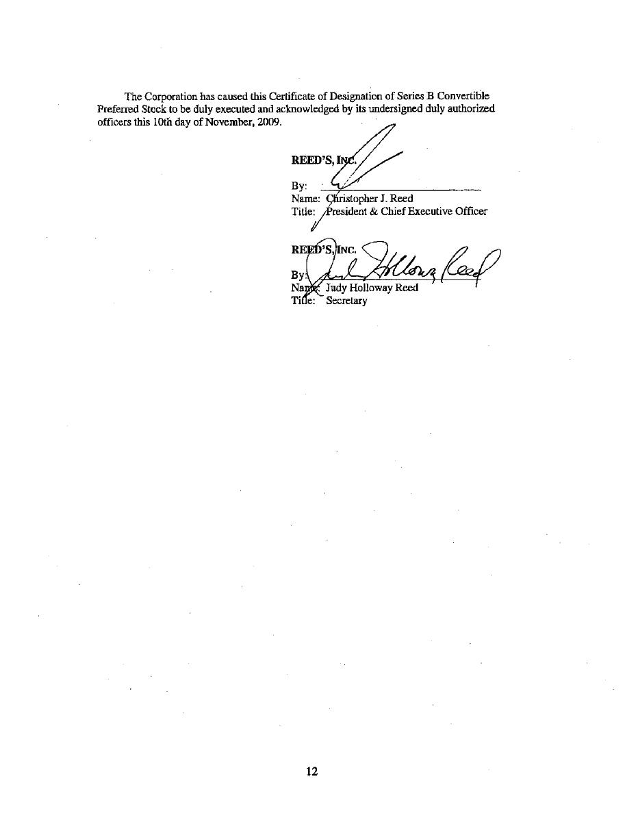

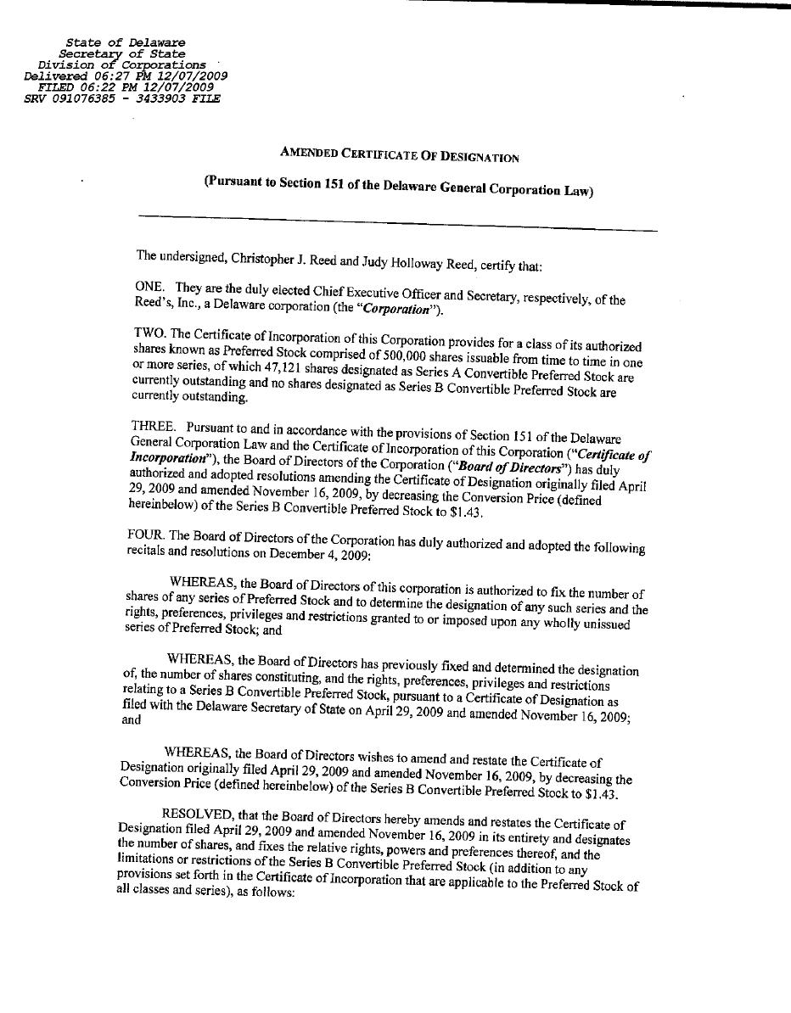

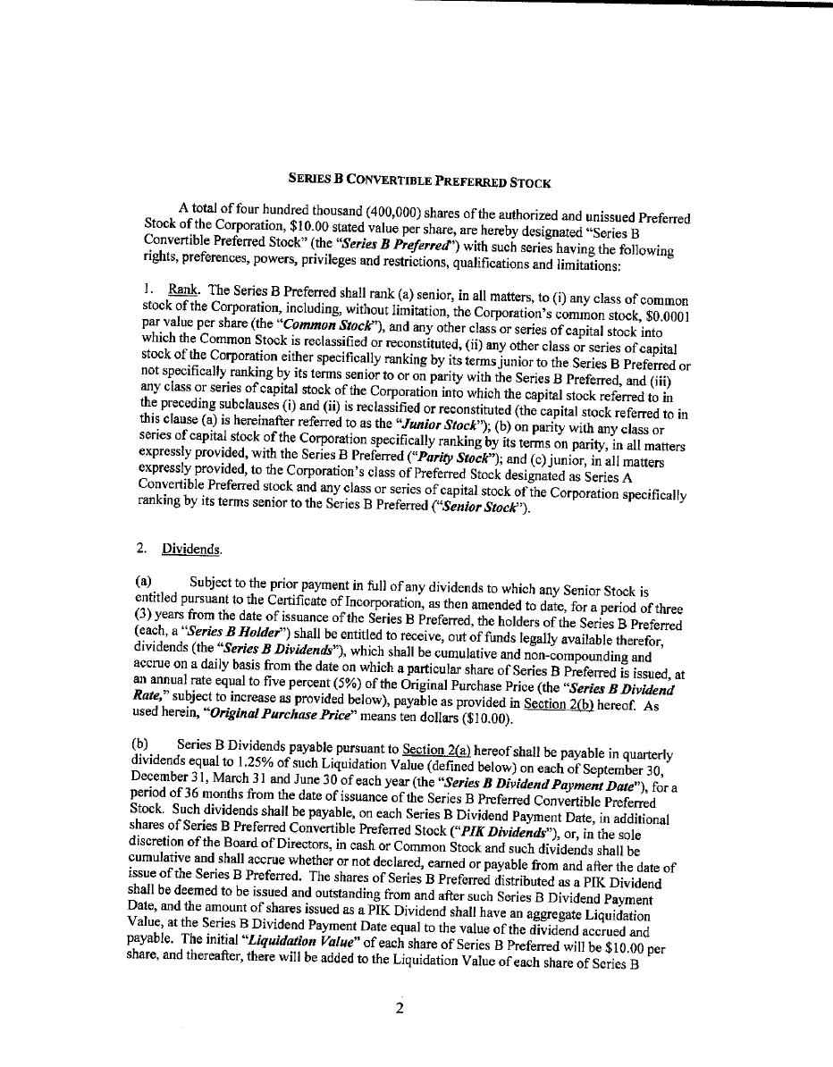

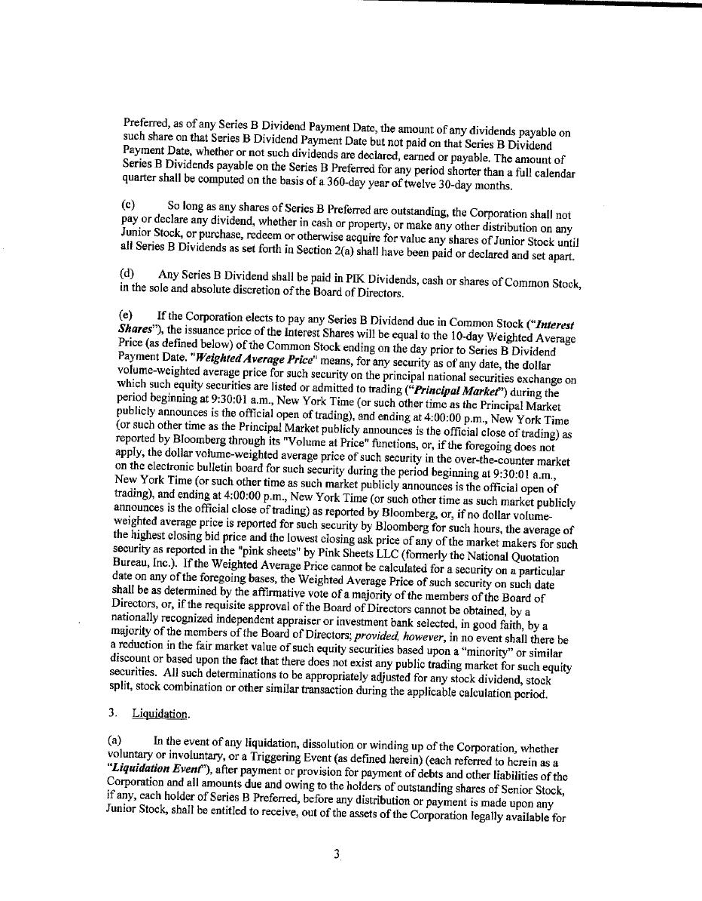

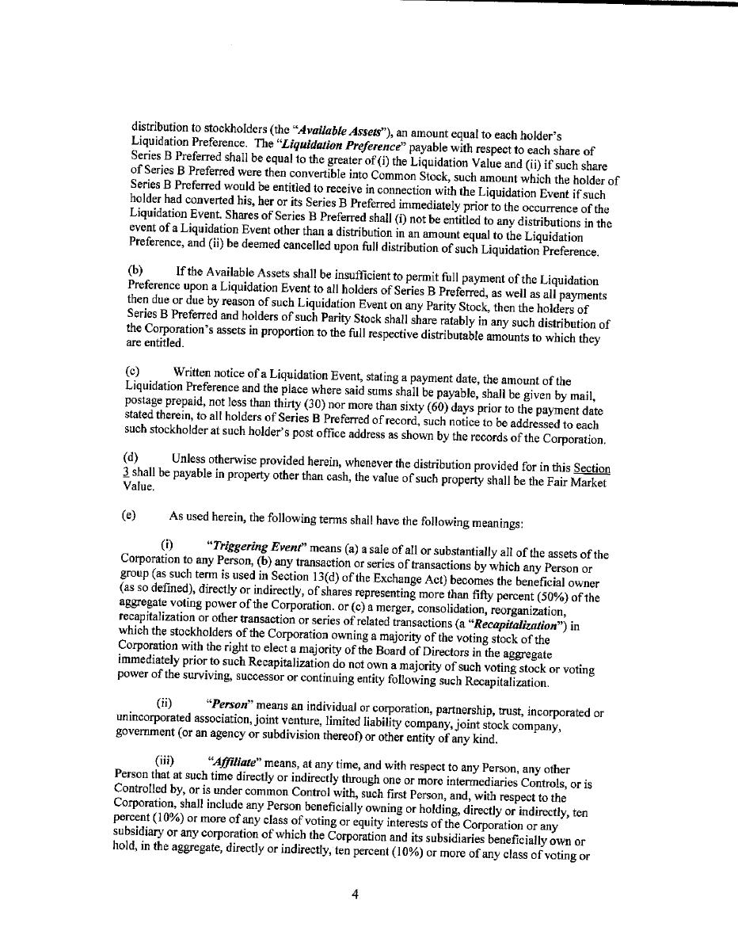

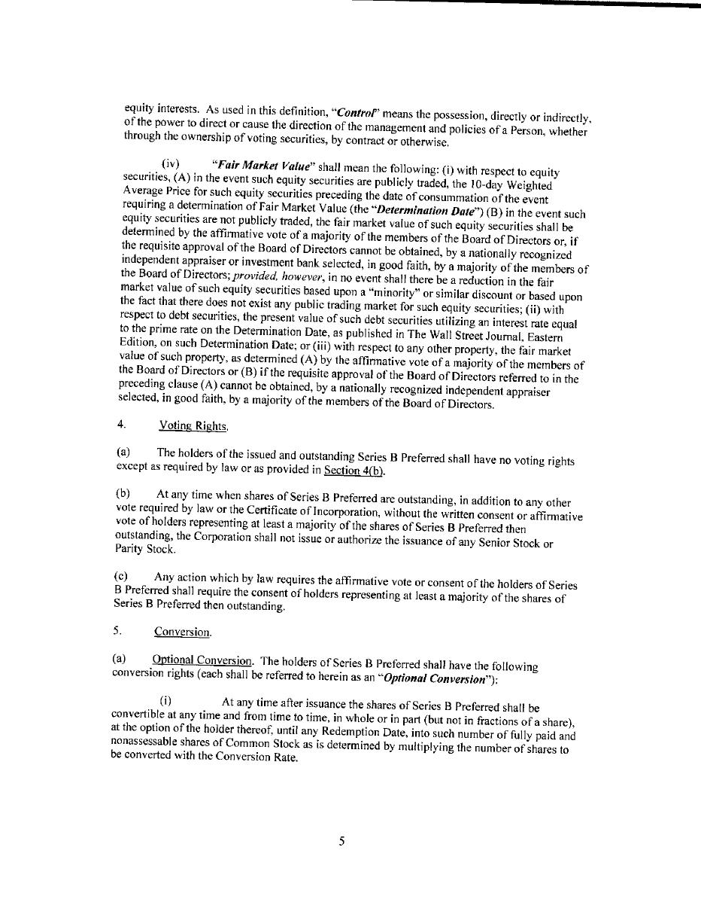

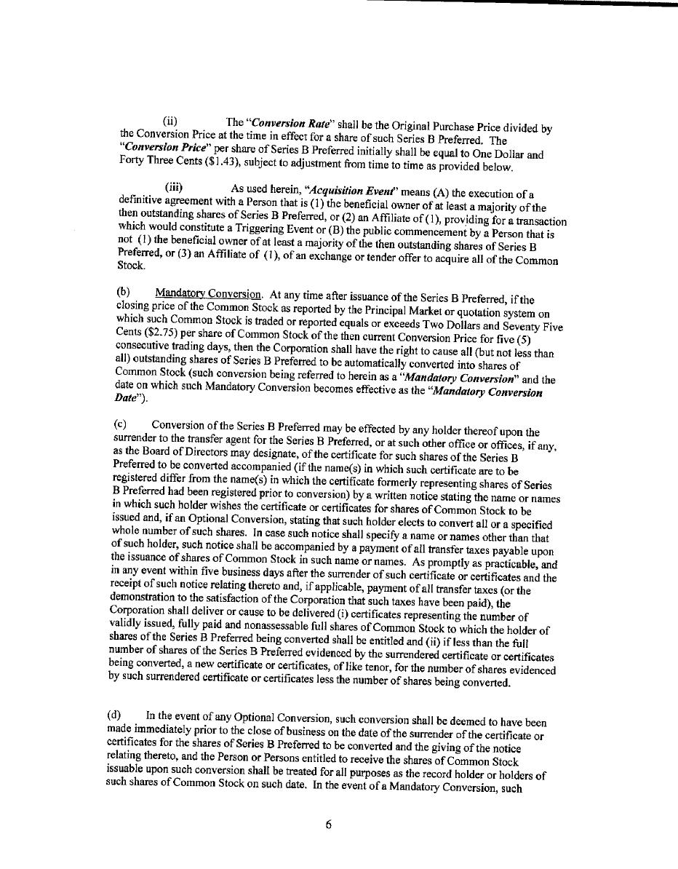

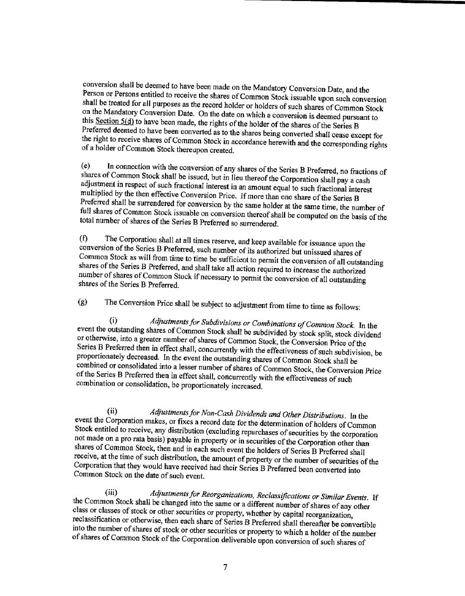

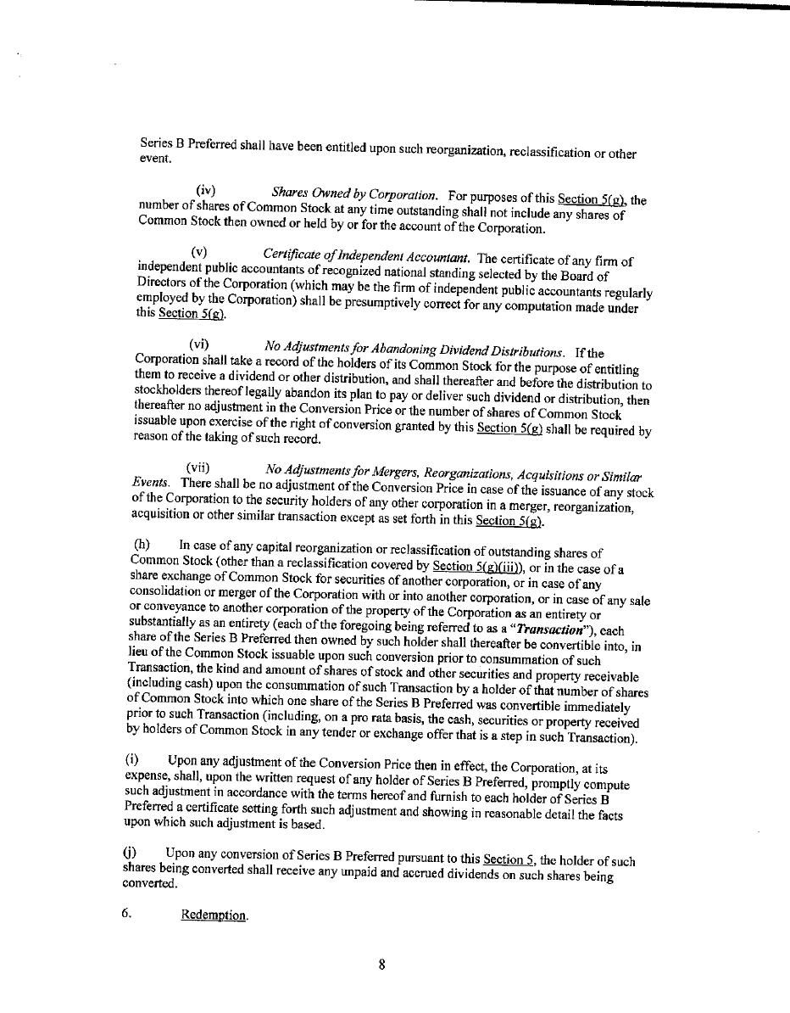

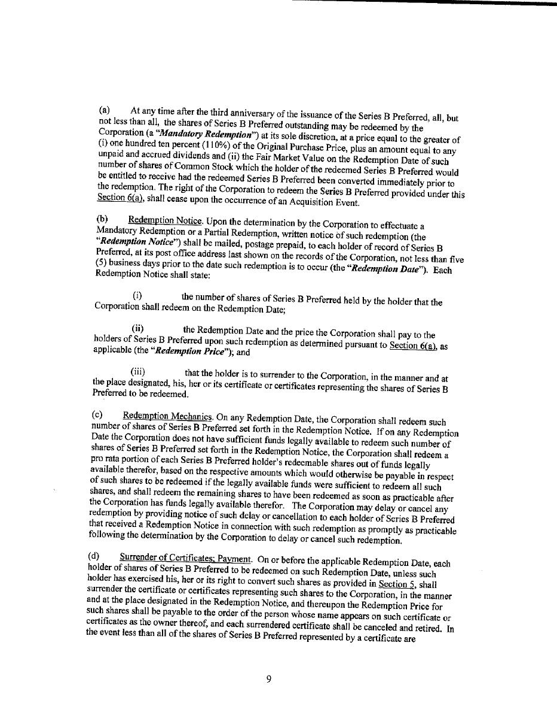

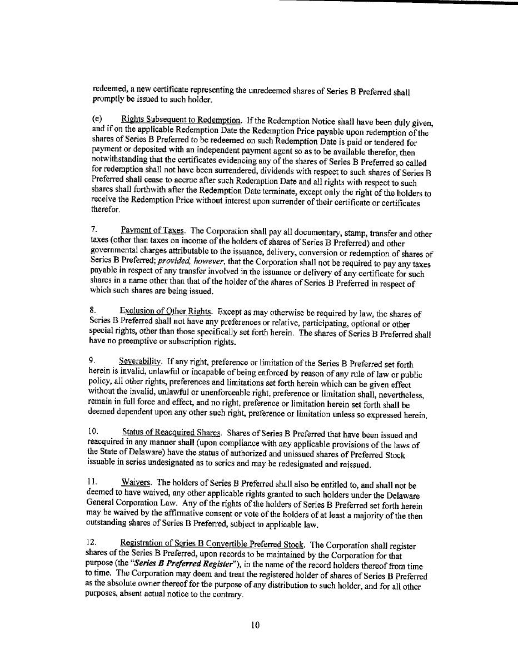

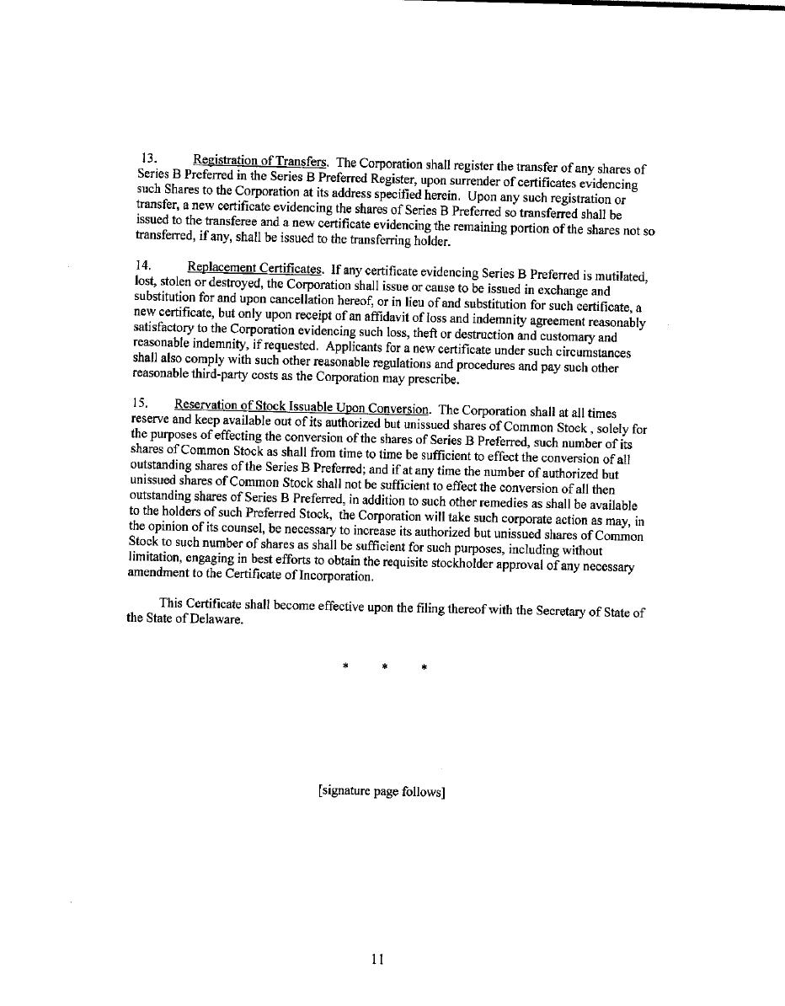

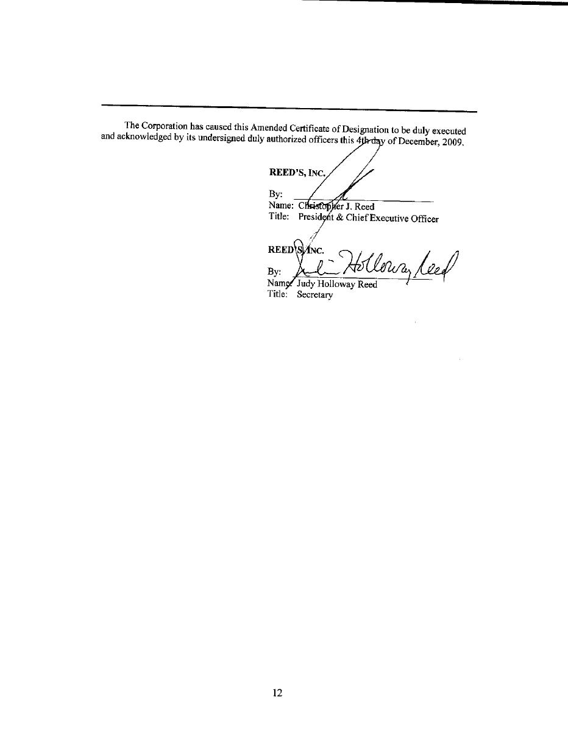

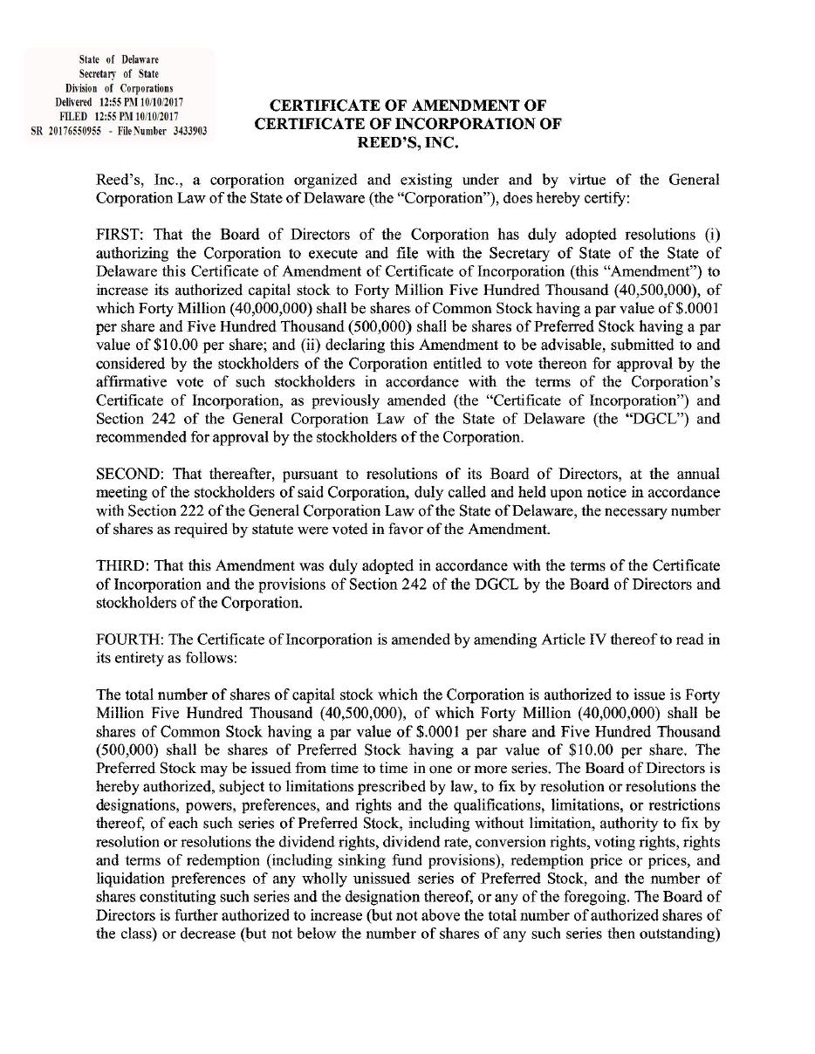

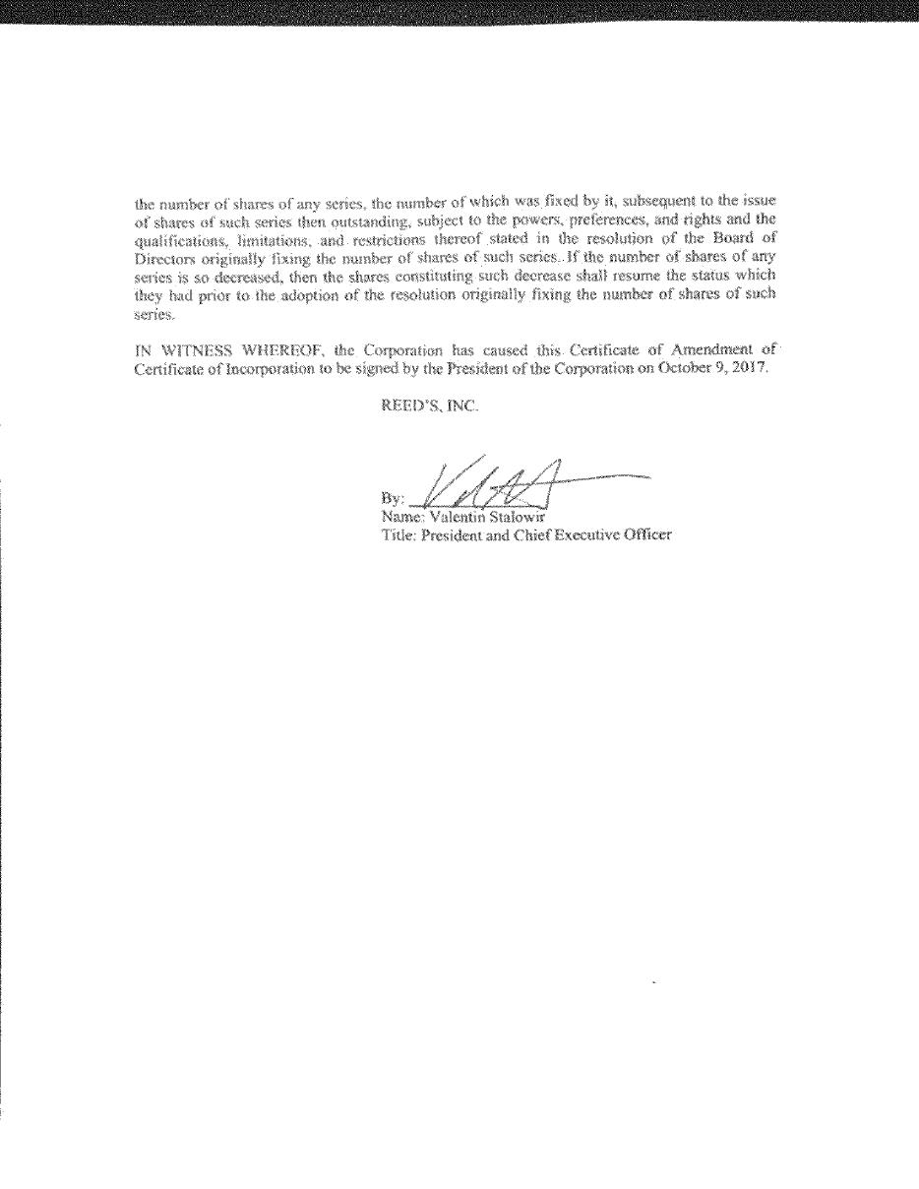

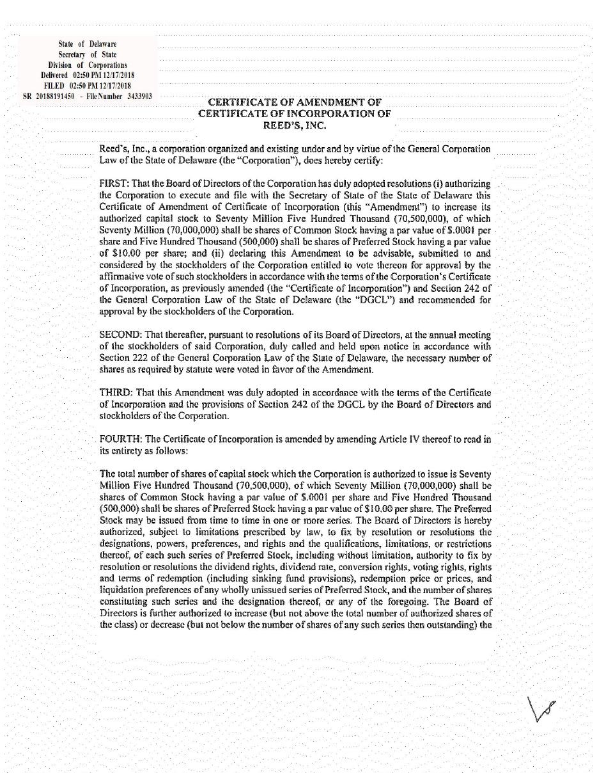

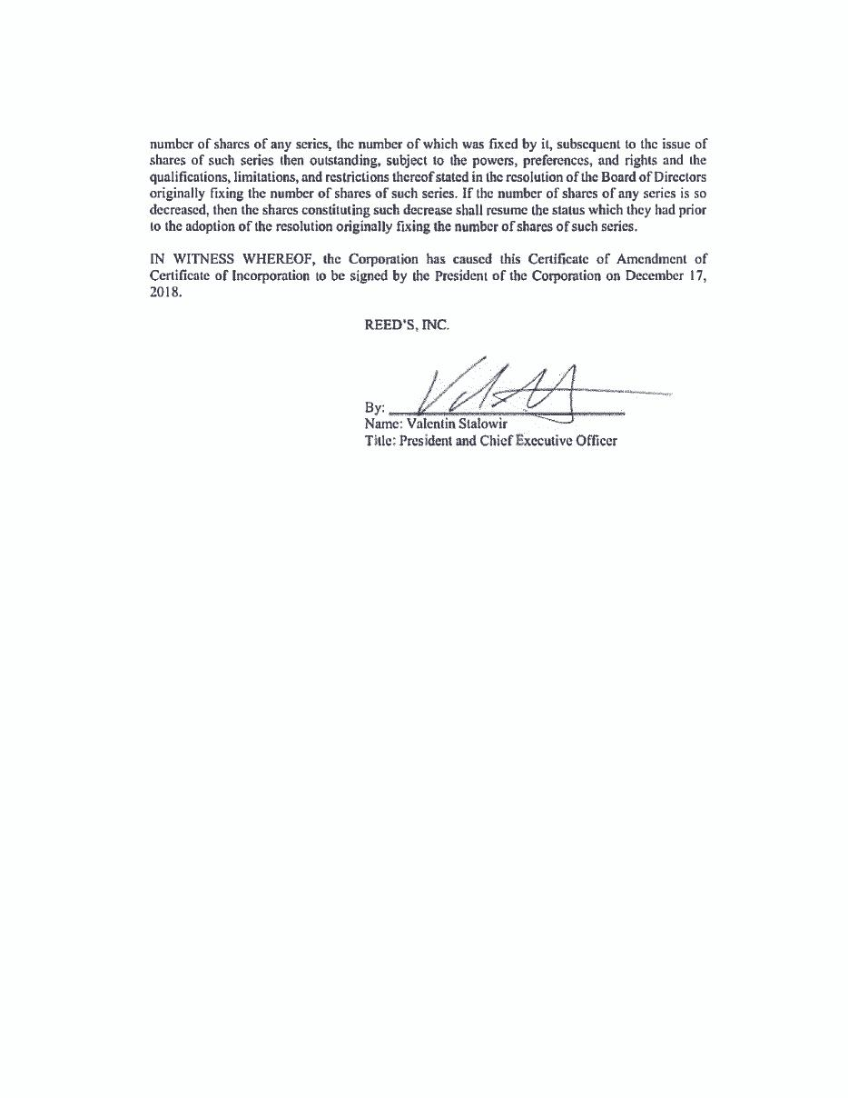

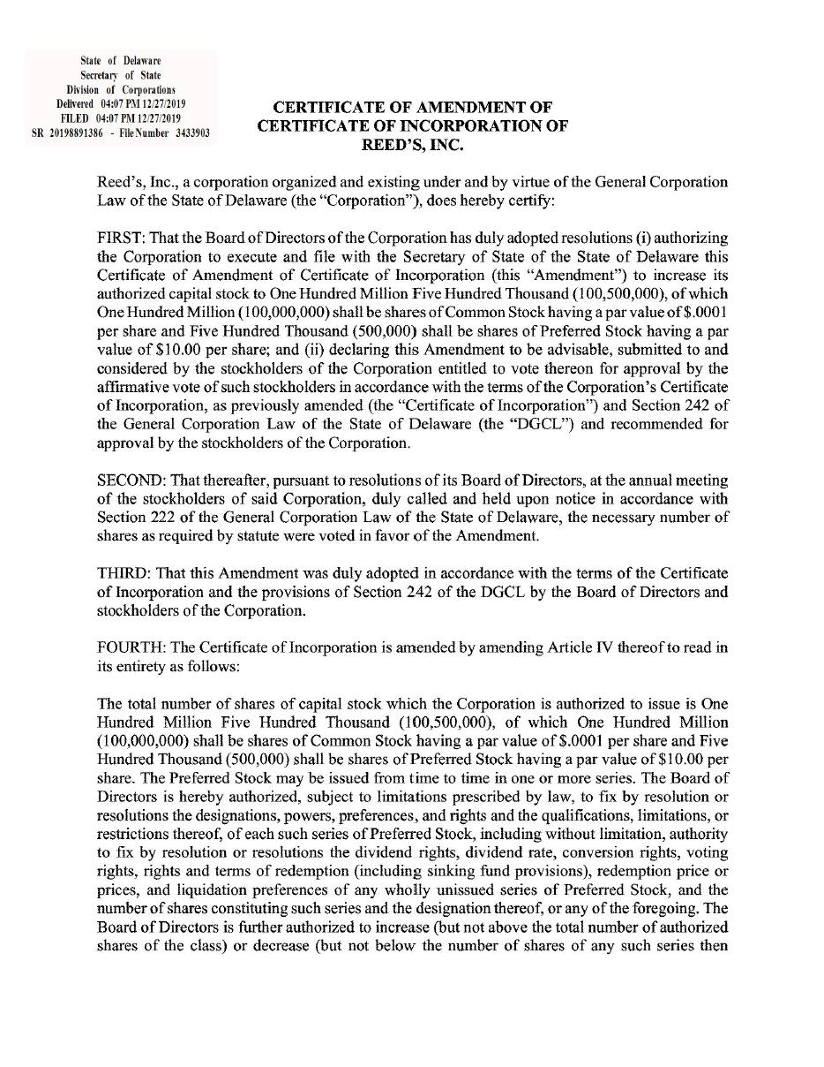

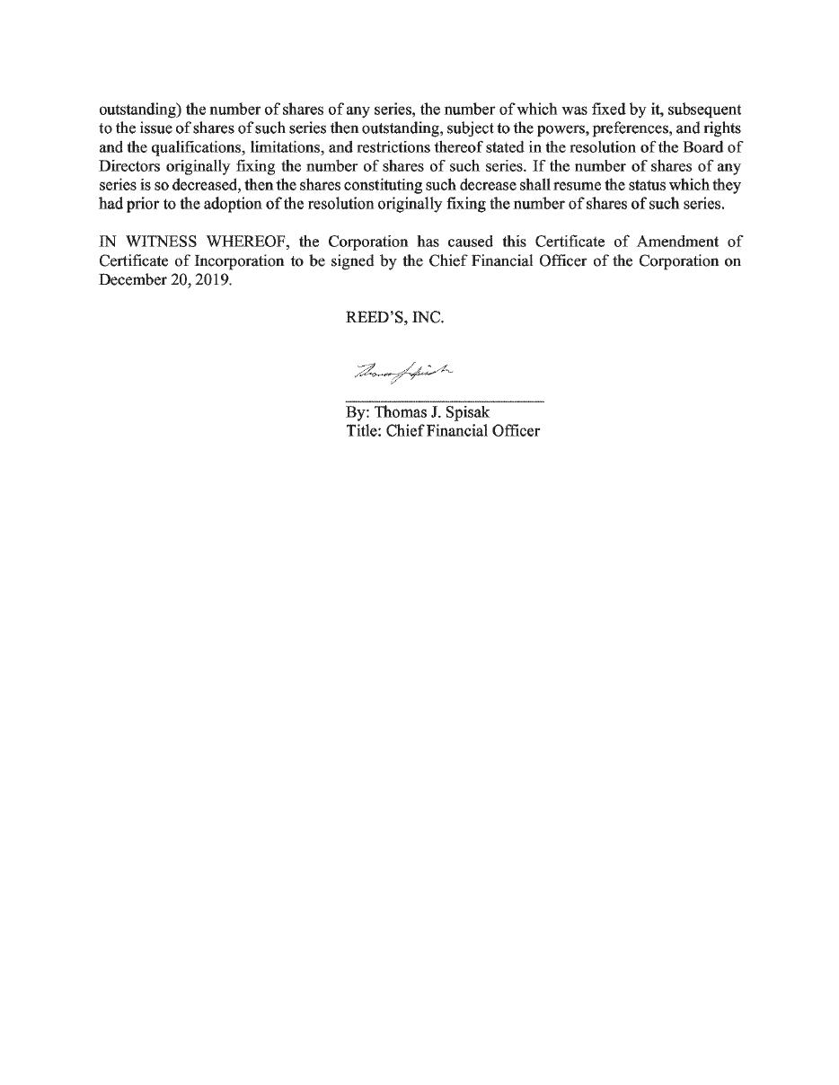

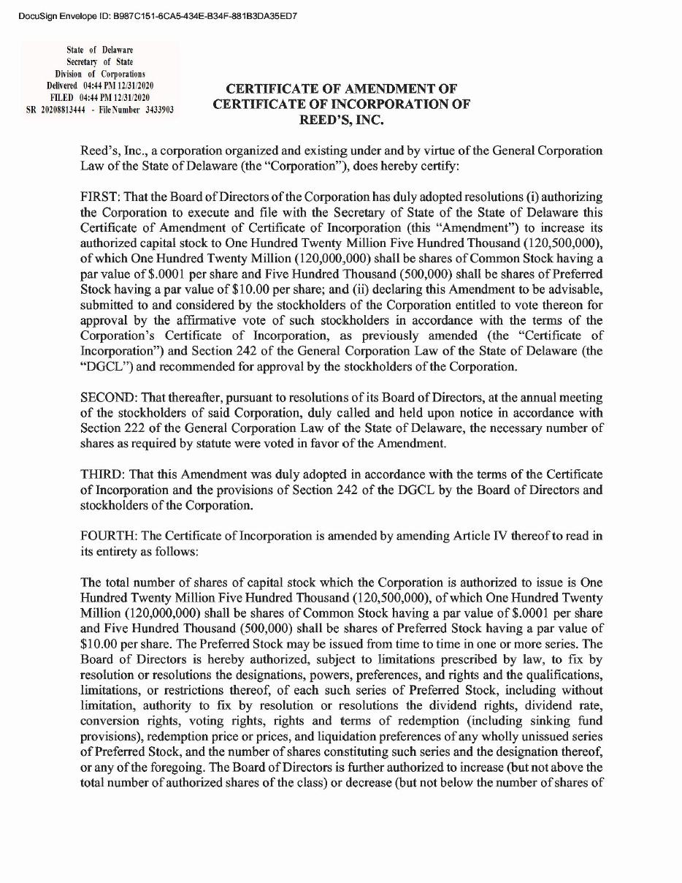

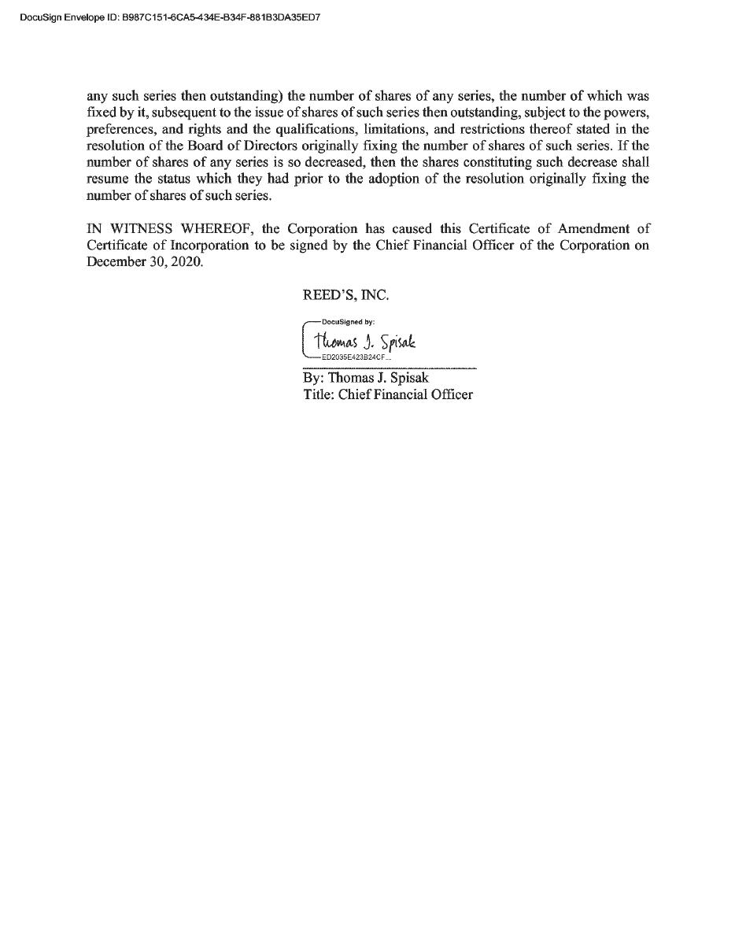

Exhibit 4.10

EXERCISABLE HAVE BEEN REGISTERED WITH THE SECURITIES AND EXCHANGE COMMISSION OR THE SECURITIES COMMISSION OF ANY STATE IN RELIANCE UPON AN EXEMPTION FROM REGISTRATION UNDER THE SECURITIES ACT OF 1933, AS AMENDED (THE “SECURITIES ACT”), AND, ACCORDINGLY, MAY NOT BE OFFERED OR SOLD EXCEPT PURSUANT TO AN EFFECTIVE REGISTRATION STATEMENT UNDER THE SECURITIES ACT OR PURSUANT TO AN AVAILABLE EXEMPTION FROM, OR IN A TRANSACTION NOT SUBJECT TO, THE REGISTRATION REQUIREMENTS OF THE SECURITIES ACT AND IN ACCORDANCE WITH APPLICABLE STATE SECURITIES LAWS. THIS SECURITY AND THE SECURITIES ISSUABLE UPON EXERCISE OF THIS SECURITY MAY BE PLEDGED IN CONNECTION WITH A BONA FIDE MARGIN ACCOUNT OR OTHER LOAN SECURED BY SUCH SECURITIES.

COMMON STOCK PURCHASE WARRANT

REEDS, INC.

Warrant Shares: 1,000,000 | Initial Issuance Date: December 11, 2020
No. S-1

THIS COMMON STOCK PURCHASE WARRANT (the “Warrant”) certifies that, for value received, Raptor/Harbor Reeds SPV LLC, a Delaware limited liability company or its assigns (the “Holder”) is entitled, upon the terms and subject to the limitations on exercise and the conditions hereinafter set forth, at any time on or after the Initial Issuance Date (the “Initial Exercise Date”) and on or prior to the close of business on December 11, 2025 (the “Termination Date”) but not thereafter, to subscribe for and purchase from Reeds, Inc., a Delaware corporation (the “Company”), up to ONE MILLION (1,000,000) shares (as subject to adjustment hereunder, the “Warrant Shares”) of Common Stock. The purchase price of one share of Common Stock under this Warrant shall be equal to the Exercise Price, as defined in Section 2(b). This Warrant is issued pursuant to that certain Satisfaction, Settlement and Release of Claims by and between the Holder and the Company dated December 11, 2020 (the “Satisfaction Agreement”).

Section 1. Definitions. Capitalized terms used and not otherwise defined herein shall have the meanings set forth in the Satisfaction Agreement.

 | a) | “Business Day” means any day except any Saturday, any Sunday, any day which is a federal legal holiday in the United States or any day on which banking institutions in the State of New York are authorized or required by law or other governmental action to close.
 | b) | “Commission” means the United States Securities and Exchange Commission.

1

 | c) | “Common Stock” means the common stock of the Company, par value $0.0001 per share, and any other class of securities into which such securities may hereafter be reclassified or changed.
 | d) | “Common Stock Equivalents” means any securities of the Company or the Subsidiaries which would entitle the holder thereof to acquire at any time Common Stock, including, without limitation, any debt, preferred stock, right, option, warrant or other instrument that is at any time convertible into or exercisable or exchangeable for, or otherwise entitles the holder thereof to receive, Common Stock.
 | e) | “Person” means an individual or corporation, partnership, trust, incorporated or unincorporated association, joint venture, limited liability company, joint stock company, government (or an agency or subdivision thereof) or other entity of any kind.
 | f) | “Rule 144” means Rule 144 promulgated by the Commission pursuant to the Securities Act, as such Rule may be amended or interpreted from time to time, or any similar rule or regulation hereafter adopted by the Commission having substantially the same purpose and effect as such Rule.
 | g) | “Securities Act” means the Securities Act of 1933, as amended, and the rules and regulations promulgated thereunder.
 | h) | “Subsidiary” means any subsidiary of the Company as set forth in the SEC Reports, and shall, where applicable, also include any direct or indirect subsidiary of the Company formed or acquired after the date hereof.
 | i) | “Trading Day” means a day on which the principal Trading Market is open for trading.
 | j) | “Trading Market” means any of the following markets or exchanges on which the Common Stock is listed or quoted for trading on the date in question: the NYSE MKT, the Nasdaq Capital Market, the Nasdaq Global Market, the Nasdaq Global Select Market, the New York Stock Exchange, OTCQB or OTCQX (or any successors to any of the foregoing).
 | k) | “Transfer Agent” means Transfer Online, the current transfer agent of the Company, with a mailing address of 317 SW Alder St # 200, Portland, Oregon 97204, and any successor transfer agent of the Company.

2

Section 2. Exercise.

a) Exercise of Warrant. Exercise of the purchase rights represented by this Warrant may be made, in whole or in part, at any time or times on or after the Initial Exercise Date and on or before the Termination Date by delivery to the Company (or such other office or agency of the Company as it may designate by notice in writing to the registered Holder at the address of the Holder appearing on the books of the Company) of a duly executed and completed facsimile copy (or e-mail attachment) of the Notice of Exercise in the form annexed hereto and, within three (3) Trading Days of the date of said Notice of Exercise is delivered to the Company, payment of the aggregate Exercise Price of the shares thereby purchased by wire transfer or cashier’s check drawn on a United States bank or, if available, pursuant to the cashless exercise procedure specified in Section 2(c) below is specified in the applicable Notice of Exercise. No ink-original Notice of Exercise shall be required, nor shall any medallion guarantee (or other type of guarantee or notarization) of any Notice of Exercise form be required. Notwithstanding anything herein to the contrary, the Holder shall not be required to physically surrender this Warrant to the Company until the Holder has purchased all of the Warrant Shares available hereunder and the Warrant has been exercised in full, in which case, the Holder shall surrender this Warrant to the Company for cancellation within three (3) Trading Days of the date the final Notice of Exercise is delivered to the Company. Partial exercises of this Warrant resulting in purchases of a portion of the total number of Warrant Shares available hereunder shall have the effect of lowering the outstanding number of Warrant Shares purchasable hereunder in an amount equal to the applicable number of Warrant Shares purchased. The Holder and the Company shall maintain records showing the number of Warrant Shares purchased and the date of such purchases. The Company shall deliver any objection to any Notice of Exercise within two (2) Business Days of receipt of such notice. The Holder and any assignee, by acceptance of this Warrant, acknowledge and agree that, by reason of the provisions of this paragraph, following the purchase of a portion of the Warrant Shares hereunder, the number of Warrant Shares available for purchase hereunder at any given time may be less than the amount stated on the face hereof.

b) Exercise Price. The exercise price per share of the Common Stock under this Warrant shall be $0.644, subject to adjustment hereunder (the “Exercise Price”).

c) Cashless Exercise. This Warrant may also be exercised, in whole or in part, at such time by means of a “cashless exercise” in which the Holder shall be entitled to receive a number of Warrant Shares equal to the quotient obtained by dividing [(A-B) (X)] by (A), where:

 | (A) = | the last VWAP immediately preceding the time of delivery of the Notice of Exercise giving rise to the applicable “cashless exercise”, as set forth in the applicable Notice of Exercise (to clarify, the “last VWAP” will be the last VWAP as calculated over an entire Trading Day such that, in the event that this Warrant is exercised at a time that the Trading Market is open, the prior Trading Day’s VWAP shall be used in this calculation);
 | (B) = | the Exercise Price of this Warrant, as adjusted hereunder; and
 | (X) = | the number of Warrant Shares that would be issuable upon exercise of this Warrant in accordance with the terms of this Warrant if such exercise were by means of a cash exercise rather than a cashless exercise.

If Warrant Shares are issued in such a cashless exercise, the parties acknowledge and agree that in accordance with Section 3(a)(9) of the Securities Act, the Warrant Shares shall take on the characteristics of the Warrants being exercised, and the holding period of the Warrant Shares being issued may be tacked on to the holding period of this Warrant. The Company agrees not to take any position contrary to this Section 2(c).

3

“VWAP” means, for any date, the price determined by the first of the following clauses that applies: (a) if the Common Stock is then listed or quoted on a Trading Market, the daily volume weighted average price of the Common Stock for such date (or the nearest preceding date) on the Trading Market on which the Common Stock is then listed or quoted as reported by Bloomberg L.P. (based on a Trading Day from 9:30 a.m. (New York City time) to 4:02 p.m. (New York City time)), (b) if OTCQB or OTCQX is not a Trading Market, the volume weighted average price of the Common Stock for such date (or the nearest preceding date) on OTCQB or OTCQX as applicable, (c) if the Common Stock is not then listed or quoted for trading on OTCQB or OTCQX and if prices for the Common Stock are then reported in the “Pink Sheets” published by OTC Markets Group, Inc. (or a similar organization or agency succeeding to its functions of reporting prices), the most recent bid price per share of the Common Stock so reported, or (d) in all other cases, the fair market value of a share of Common Stock as determined by an independent appraiser selected in good faith by the Purchasers of a majority in interest of the Securities then outstanding and reasonably acceptable to the Company, the fees and expenses of which shall be paid by the Company.

d) Mechanics of Exercise.

i. Delivery of Warrant Shares Upon Exercise. The Company shall cause the Transfer Agent to transmit the Warrant Shares purchased hereunder to the Holder by (a) crediting the account of the Holder’s or its designee’s balance account with The Depository Trust Company through its Deposit or Withdrawal at Custodian system (“DWAC”) if the Company is then a participant in such system and either (A) there is an effective registration statement permitting the issuance of the Warrant Shares to or resale of the Warrant Shares by the Holder or (B) the Warrant Shares are eligible for resale by the Holder without volume or manner-of- sale limitations pursuant to Rule 144 or (b) otherwise by physical delivery of a certificate, registered in the Company’s share register in the name of the Holder or its designee, for the number of Warrant Shares to which the Holder is entitled pursuant to such exercise to the address specified by the Holder in the Notice of Exercise by the date that is one (1) Trading Day after the delivery to the Company of the Notice of Exercise (such date, the “Warrant Share Delivery Date”). For purposes of Rule 200 under Regulation SHO of the Securities Act, the Warrant Shares shall be deemed to have been issued, and Holder shall be deemed for all such purposes to have become the holder of record of the Warrant Shares with respect to which this Warrant has been exercised upon delivery of the Notice of Exercise, irrespective of the date of delivery of the Warrant Shares; provided payment of the aggregate Exercise Price (other than in the case of a Cashless Exercise) is received within three Trading Days of delivery of the Notice of Exercise. The Company agrees to maintain a transfer agent that is a participant in the FAST Automated Securities Transfer program so long as this Warrant remains outstanding and exercisable.

4

ii. Delivery of New Warrants Upon Exercise. If this Warrant shall have been exercised in part, the Company shall, at the request of a Holder and upon surrender of this Warrant certificate, at the time of delivery of the Warrant Shares, deliver to the Holder a new Warrant evidencing the rights of the Holder to purchase the unpurchased Warrant Shares called for by this Warrant, which new Warrant shall in all other respects be identical with this Warrant.

iii. Rescission Rights. If the Company fails to cause the Transfer Agent to transmit to the Holder the Warrant Shares pursuant to Section 2(d)(i) by the Warrant Share Delivery Date, subject to receipt of the aggregate exercise price for the applicable exercise (other than in the case of a Cashless Exercise), then the Holder will have the right to rescind such exercise.

iv. Compensation for Buy-In on Failure to Timely Deliver Warrant Shares Upon Exercise. If the Company fails to cause the Transfer Agent to transmit to the Holder the Warrant Shares in accordance with the provisions of Section 2(d)(i) above pursuant to an exercise on or before the Warrant Share Delivery Date (subject to receipt of the aggregate Exercise Price for the applicable exercise (other than in the case of a Cashless Exercise)), and if after such date the Holder is required by its broker to purchase (in an open market transaction or otherwise) or the Holder’s brokerage firm otherwise purchases, shares of Common Stock to deliver in satisfaction of a sale by the Holder of the Warrant Shares which the Holder anticipated receiving upon such exercise (a “Buy-In”), then the Company shall (A) pay in cash to the Holder the amount, if any, by which (x) the Holder’s total purchase price (including brokerage commissions, if any) for the shares of Common Stock so purchased exceeds (y) the amount obtained by multiplying (1) the number of Warrant Shares that the Company was required to deliver to the Holder in connection with the exercise at issue times (2) the price at which the sell order giving rise to such purchase obligation was executed, and (B) at the option of the Holder, either reinstate the portion of the Warrant and equivalent number of Warrant Shares for which such exercise was not honored (in which case such exercise shall be deemed rescinded) or deliver to the Holder the number of shares of Common Stock that would have been issued had the Company timely complied with its exercise and delivery obligations hereunder. For example, if the Holder purchases Common Stock having a total purchase price of $11,000 to cover a Buy- In with respect to an attempted exercise of shares of Common Stock with an aggregate sale price giving rise to such purchase obligation of $10,000, under clause (A) of the immediately preceding sentence the Company shall be required to pay the Holder $1,000. The Holder shall provide the Company written notice indicating the amounts payable to the Holder in respect of the Buy-In and, upon request of the Company, evidence of the amount of such loss. Nothing herein shall limit a Holder’s right to pursue any other remedies available to it hereunder, at law or in equity including, without limitation, a decree of specific performance and/or injunctive relief with respect to the Company’s failure to timely deliver shares of Common Stock upon exercise of the Warrant as required pursuant to the terms hereof.

5

v. No Fractional Shares or Scrip. No fractional shares or scrip representing fractional shares shall be issued upon the exercise of this Warrant. As to any fraction of a share which the Holder would otherwise be entitled to purchase upon such exercise, the Company shall, at its election, either pay a cash adjustment in respect of such final fraction in an amount equal to such fraction multiplied by the Exercise Price or round up to the next whole share.

vi. Charges, Taxes and Expenses. Issuance of Warrant Shares shall be made without charge to the Holder for any issue or transfer tax or other incidental expense in respect of the issuance of such Warrant Shares, all of which taxes and expenses shall be paid by the Company, and such Warrant Shares shall be issued in the name of the Holder or in such name or names as may be directed by the Holder; provided, however, that in the event that Warrant Shares are to be issued in a name other than the name of the Holder, this Warrant when surrendered for exercise shall be accompanied by the Assignment Form attached hereto duly executed by the Holder and the Company may require, as a condition thereto, the payment of a sum sufficient to reimburse it for any transfer tax incidental thereto. The Company shall pay all Transfer Agent fees required for same-day processing of any Notice of Exercise and all fees to the Depository Trust Company (or another established clearing corporation performing similar functions) required for same-day electronic delivery of the Warrant Shares.

vii. Closing of Books. The Company will not close its stockholder books or records in any manner which prevents the timely exercise of this Warrant, pursuant to the terms hereof.

Section 3. Certain Adjustments.

a) Stock Dividends and Splits. If the Company, at any time while this Warrant is outstanding: (i) pays a stock dividend or otherwise makes a distribution or distributions on shares of its Common Stock or any other equity or equity equivalent securities payable in shares of Common Stock (which, for avoidance of doubt, shall not include any shares of Common Stock issued by the Company upon exercise of this Warrant), (ii) subdivides outstanding shares of Common Stock into a larger number of shares, (iii) combines (including by way of reverse stock split) outstanding shares of Common Stock into a smaller number of shares or (iv) issues by reclassification of shares of the Common Stock any shares of capital stock of the Company, then in each case the Exercise Price shall be multiplied by a fraction of which the numerator shall be the number of shares of Common Stock (excluding treasury shares, if any) outstanding immediately before such event and of which the denominator shall be the number of shares of Common Stock outstanding immediately after such event, and the number of shares issuable upon exercise of this Warrant shall be proportionately adjusted such that the aggregate Exercise Price of this Warrant shall remain unchanged. Any adjustment made pursuant to this Section 3(a) shall become effective immediately after the record date for the determination of stockholders entitled to receive such dividend or distribution and shall become effective immediately after the effective date in the case of a subdivision, combination or re-classification.

6

b) [RESERVED]

c) Subsequent Rights Offerings. In addition to any adjustments pursuant to Section 3(a) above, if at any time the Company grants, issues or sells any Common Stock Equivalents or rights to purchase stock, warrants, securities or other property pro rata to all the record holders of any class of shares of Common Stock (the “Purchase Rights”), then the Holder will be entitled to acquire, upon the terms applicable to such Purchase Rights, the aggregate Purchase Rights which the Holder could have acquired if the Holder had held the number of shares of Common Stock acquirable upon complete exercise of this Warrant (without regard to any limitations on exercise hereof, including without limitation, the Beneficial Ownership Limitation) immediately before the date on which a record is taken for the grant, issuance or sale of such Purchase Rights, or, if no such record is taken, the date as of which the record holders of shares of Common Stock are to be determined for the grant, issue or sale of such Purchase Rights (provided, however, to the extent that the Holder’s right to participate in any such Purchase Right would result in the Holder exceeding the Beneficial Ownership Limitation, then the Holder shall not be entitled to participate in such Purchase Right to such extent (or beneficial ownership of such shares of Common Stock as a result of such Purchase Right to such extent) and such Purchase Right to such extent shall be held in abeyance for the Holder until such time, if ever, as its right thereto would not result in the Holder exceeding the Beneficial Ownership Limitation).

d) Pro Rata Distributions. During such time as this Warrant is outstanding, if the Company shall declare or make any dividend or other distribution of its assets (or rights to acquire its assets) to holders of shares of Common Stock as a class, by way of return of capital or otherwise (including, without limitation, any distribution of cash, stock or other securities, property or options by way of a dividend, spin off, reclassification, corporate rearrangement, scheme of arrangement or other similar transaction) (a “Distribution”), at any time after the issuance of this Warrant, then, in each such case, the Holder shall be entitled to participate in such Distribution to the same extent that the Holder would have participated therein if the Holder had held the number of shares of Common Stock acquirable upon complete exercise of this Warrant (without regard to any limitations on exercise hereof, including without limitation, the Beneficial Ownership Limitation) immediately before the date of which a record is taken for such Distribution, or, if no such record is taken, the date as of which the record holders of shares of Common Stock are to be determined for the participation in such Distribution (provided, however, to the extent that the Holder’s right to participate in any such Distribution would result in the Holder exceeding the Beneficial Ownership Limitation, then the Holder shall not be entitled to participate in such Distribution to such extent (or in the beneficial ownership of any shares of Common Stock as a result of such Distribution to such extent) and the portion of such Distribution shall be held in abeyance for the benefit of the Holder until such time, if ever, as its right thereto would not result in the Holder exceeding the Beneficial Ownership Limitation). To the extent that this Warrant has not been partially or completely exercised at the time of such Distribution, such portion of the Distribution shall be held in abeyance for the benefit of the Holder until the Holder has exercised this Warrant.

7

e) Fundamental Transaction. If, at any time while this Warrant is outstanding, (i) the Company, directly or indirectly, in one or more related transactions effects any merger or consolidation of the Company with or into another Person, (ii) the Company, directly or indirectly, effects any sale, lease, license, assignment, transfer, conveyance or other disposition of all or substantially all of its assets in one or a series of related transactions, (iii) any, direct or indirect, purchase offer, tender offer or exchange offer (whether by the Company or another Person) is completed pursuant to which holders of Common Stock are permitted to sell, tender or exchange their shares for other securities, cash or property and has been accepted by the holders of 50% or more of the outstanding Common Stock, (iv) the Company, directly or indirectly, in one or more related transactions effects any reclassification, reorganization or recapitalization of the Common Stock or any compulsory share exchange pursuant to which the Common Stock is effectively converted into or exchanged for other securities, cash or property, or (v) the Company, directly or indirectly, in one or more related transactions consummates a stock or share purchase agreement or other business combination (including, without limitation, a reorganization, recapitalization, spin-off or scheme of arrangement) with another Person or group of Persons whereby such other Person or group acquires more than 50% of the outstanding shares of Common Stock (not including any shares of Common Stock held by the other Person or other Persons making or party to, or associated or affiliated with the other Persons making or party to, such stock or share purchase agreement or other business combination) (each a “Fundamental Transaction”), then, upon any subsequent exercise of this Warrant, the Holder shall have the right to receive, for each Warrant Share that would have been issuable upon such exercise immediately prior to the occurrence of such Fundamental Transaction, at the option of the Holder, the number of shares of Common Stock of the successor or acquiring corporation or of the Company, if it is the surviving corporation, and any additional consideration (the “Alternate Consideration”) receivable as a result of such Fundamental Transaction by a holder of the number of shares of Common Stock for which this Warrant is exercisable immediately prior to such Fundamental Transaction. For purposes of any such exercise, the determination of the Exercise Price shall be appropriately adjusted to apply to such Alternate Consideration based on the amount of Alternate Consideration issuable in respect of one share of Common Stock in such Fundamental Transaction, and the Company shall apportion the Exercise Price among the Alternate Consideration in a reasonable manner reflecting the relative value of any different components of the Alternate Consideration. If holders of Common Stock are given any choice as to the securities, cash or property to be received in a Fundamental Transaction, then the Holder shall be given the same choice as to the Alternate Consideration it receives upon any exercise of this Warrant following such Fundamental Transaction. Notwithstanding anything to the contrary, in the event of a Fundamental Transaction (other than a Fundamental Transaction not approved by the Company’s Board of Directors) the Company or any Successor Entity (as defined below) shall, at the Holder’s option, exercisable at any time concurrently with, or within 30 days after, the consummation of the Fundamental Transaction (or, if later, the date of the public announcement of the applicable Fundamental Transaction), purchase this Warrant from the Holder by paying to the Holder an amount of cash equal to the Black Scholes Value of the remaining unexercised portion of this Warrant on the date of the consummation of such Fundamental Transaction; provided, however, that for the avoidance of doubt, if the Fundamental Transaction is not approved by the Company’s Board of Directors, Holder shall not have the option to require the Company to purchase this Warrant. “Black Scholes Value” means the value of this Warrant based on the Black and Scholes Option Pricing Model obtained from the “OV” function on Bloomberg, L.P. (“Bloomberg”) determined as of the day of consummation of the applicable Fundamental Transaction for pricing purposes and reflecting (A) a risk-free interest rate corresponding to the U.S. Treasury rate for a period equal to the time between the date of the public announcement of the applicable Fundamental Transaction and the Termination Date, (B) an expected volatility equal to the greater of 100% and the 100 day volatility obtained from the HVT function on Bloomberg as of the Trading Day immediately following the public announcement of the applicable Fundamental Transaction, (C) the underlying price per share used in such calculation shall be the sum of the price per share being offered in cash, if any, plus the value of any non- cash consideration, if any, being offered in such Fundamental Transaction and (D) a remaining option time equal to the time between the date of the public announcement of the applicable Fundamental Transaction and the Termination Date. The payment of the Black Scholes Value will be made by wire transfer of immediately available funds within five Business Days of the Holder’s election (or, if later, on the effective date of the Fundamental Transaction). The Company shall cause any successor entity in a Fundamental Transaction in which the Company is not the survivor (the “Successor Entity”) to assume in writing all of the obligations of the Company under this Warrant and the other Transaction Documents in accordance with the provisions of this Section 3(e) pursuant to written agreements in form and substance reasonably satisfactory to the Holder and approved by the Holder (without unreasonable delay) prior to such Fundamental Transaction and shall, at the option of the Holder, deliver to the Holder in exchange for this Warrant a security of the Successor Entity evidenced by a written instrument substantially similar in form and substance to this Warrant which is exercisable for a corresponding number of shares of capital stock of such Successor Entity (or its parent entity) equivalent to the shares of Common Stock acquirable and receivable upon exercise of this Warrant (without regard to any limitations on the exercise of this Warrant) prior to such Fundamental Transaction, and with an exercise price which applies the exercise price hereunder to such shares of capital stock (but taking into account the relative value of the shares of Common Stock pursuant to such Fundamental Transaction and the value of such shares of capital stock, such number of shares of capital stock and such exercise price being for the purpose of protecting the economic value of this Warrant immediately prior to the consummation of such Fundamental Transaction), and which is reasonably satisfactory in form and substance to the Holder. Upon the occurrence of any such Fundamental Transaction, the Successor Entity shall succeed to, and be substituted for, the Company (so that from and after the date of such Fundamental Transaction, the provisions of this Warrant and the other Transaction Documents referring to the “Company” shall refer instead to the Successor Entity), and the Successor Entity may exercise every right and power of the Company and shall assume all of the obligations of the Company under this Warrant and the other Transaction Documents with the same effect as if such Successor Entity had been named as the Company herein. Notwithstanding anything to the contrary contained in the Warrant, and without limiting the buy-in provision in Section 2(d)(iv), in the event that the Company does not have an effective registration statement registering, or the prospectus contained therein is not available for the issuance of, the Warrant Shares to the Holder, there is no circumstance that would require the Company to net cash settle the Warrant.

8

f) Calculations. All calculations under this Section 3 shall be made to the nearest cent or the nearest 1/100th of a share, as the case may be. For purposes of this Section 3, the number of shares of Common Stock deemed to be issued and outstanding as of a given date shall be the sum of the number of shares of Common Stock (excluding treasury shares, if any) issued and outstanding.

g) Notice to Holder.

i. Adjustment to Exercise Price. Whenever the Exercise Price is adjusted pursuant to any provision of this Section 3, the Company shall promptly deliver to the Holder by facsimile or email a notice setting forth the Exercise Price after such adjustment and any resulting adjustment to the number of Warrant Shares and setting forth a brief statement of the facts requiring such adjustment.

ii. Notice to Allow Exercise by Holder. If (A) the Company shall declare a dividend (or any other distribution in whatever form) on the Common Stock, (B) the Company shall declare a special nonrecurring cash dividend on or a redemption of the Common Stock, (C) the Company shall authorize the granting to all holders of the Common Stock rights or warrants to subscribe for or purchase any shares of capital stock of any class or of any rights, (D) the approval of any stockholders of the Company shall be required in connection with any reclassification of the Common Stock, any consolidation or merger to which the Company is a party, any sale or transfer of all or substantially all of the assets of the Company, or any compulsory share exchange whereby the Common Stock is converted into other securities, cash or property, or (E) the Company shall authorize the voluntary or involuntary dissolution, liquidation or winding up of the affairs of the Company, then, in each case, the Company shall cause to be delivered by facsimile or email to the Holder at its last facsimile number or email address as it shall appear upon the Warrant Register of the Company, at least 30 calendar days prior to the applicable record or effective date hereinafter specified, a notice stating (x) the date on which a record is to be taken for the purpose of such dividend, distribution, redemption, rights or warrants, or if a record is not to be taken, the date as of which the holders of the Common Stock of record to be entitled to such dividend, distributions, redemption, rights or warrants are to be determined or (y) the date on which such reclassification, consolidation, merger, sale, transfer or share exchange is expected to become effective or close, and the date as of which it is expected that holders of the Common Stock of record shall be entitled to exchange their shares of the Common Stock for securities, cash or other property deliverable upon such reclassification, consolidation, merger, sale, transfer or share exchange; provided that the failure to deliver such notice or any defect therein or in the delivery thereof shall not affect the validity of the corporate action required to be specified in such notice. To the extent that any notice provided in this Warrant constitutes, or contains, material, non-public information regarding the Company or any of the Subsidiaries, the Company shall simultaneously file such notice with the Commission pursuant to a Current Report on Form 8-K. The Holder shall remain entitled to exercise this Warrant during the period commencing on the date of such notice to the effective date of the event triggering such notice except as may otherwise be expressly set forth herein.

9

Section 4. Transfer of Warrant.

a) Transferability. Subject to compliance with any applicable securities laws and the conditions set forth in Section 4(d) hereof and to the provisions of Sections 4(f), 4(g) and 4(h) hereof, this Warrant and all rights hereunder (including, without limitation, any registration rights) are transferable, in whole or in part, upon surrender of this Warrant at the principal office of the Company or its designated agent, together with a written assignment of this Warrant substantially in the form attached hereto duly executed by the Holder or its agent or attorney and funds sufficient to pay any transfer taxes payable upon the making of such transfer. Upon such surrender and, if required, such payment, the Company shall execute and deliver a new Warrant or Warrants in the name of the assignee or assignees, as applicable, and in the denomination or denominations specified in such instrument of assignment, and shall issue to the assignor a new Warrant evidencing the portion of this Warrant not so assigned, and this Warrant shall promptly be cancelled. Notwithstanding anything herein to the contrary, the Holder shall not be required to physically surrender this Warrant to the Company unless the Holder has assigned this Warrant in full, in which case, the Holder shall surrender this Warrant to the Company within three (3) Trading Days of the date the Holder delivers an assignment form to the Company assigning this Warrant full. The Warrant, if properly assigned in accordance herewith, may be exercised by a new holder for the purchase of Warrant Shares without having a new Warrant issued.

b) New Warrants. This Warrant may be divided or combined with other Warrants upon presentation hereof at the aforesaid office of the Company, together with a written notice specifying the names and denominations in which new Warrants are to be issued, signed by the Holder or its agent or attorney. Subject to compliance with Section 4(a), as to any transfer which may be involved in such division or combination, the Company shall execute and deliver a new Warrant or Warrants in exchange for the Warrant or Warrants to be divided or combined in accordance with such notice. All Warrants issued on transfers or exchanges shall be dated the original issuance date and shall be identical with this Warrant except as to the number of Warrant Shares issuable pursuant thereto.

10

c) Warrant Register. The Company shall register this Warrant, upon records to be maintained by the Company for that purpose (the “Warrant Register”), in the name of the record Holder hereof from time to time. The Company may deem and treat the registered Holder of this Warrant as the absolute owner hereof for the purpose of any exercise hereof or any distribution to the Holder, and for all other purposes, absent actual notice to the contrary.

d) Transfer Restrictions. If, at the time of the surrender of this Warrant in connection with any transfer of this Warrant, the transfer of this Warrant shall not be either (i) registered pursuant to an effective registration statement under the Securities Act and under applicable state securities or blue sky laws or (ii) eligible for resale without volume or manner-of-sale restrictions or current public information requirements pursuant to Rule 144, the Company may require, as a condition of allowing such transfer, that the Holder or transferee of this Warrant, as the case may be, comply with the provisions of Sections 4(f), 4(g) and 4(h) hereof.

e) Representation by the Holder. The Holder, by the acceptance hereof, represents and warrants that it is acquiring this Warrant and, upon any exercise hereof, will acquire the Warrant Shares issuable upon such exercise, for its own account and not with a view to or for distributing or reselling such Warrant Shares or any part thereof in violation of the Securities Act or any applicable state securities law, except pursuant to sales registered or exempted under the Securities Act.

f) The Warrant Shares may only be disposed of in compliance with state and federal securities laws. In connection with any transfer of Warrant Shares other than pursuant to an effective registration statement or Rule 144, to the Company or to an affiliate of Holder, the Company shall, upon the request of the transferor and at the expense of the Company, provide an opinion of counsel selected by the transferor and reasonably acceptable to the Company effect that registration of such Warrant Shares shall not be required under the Securities Act. As a condition of transfer, in the event that such transfer is not made (i) in accordance with Rule 144, (ii) pursuant to an effective registration statement or (iii) in a transfer not involving a change in beneficial ownership, any such transferee shall agree in writing to be bound by the terms of this Agreement and the Registration Rights Agreement; provided, however, that notwithstanding the other provisions of this sentence, if the transfer does not satisfy parts (i) and (ii) of this sentence but satisfies part (iii) of this sentence, the transferee shall agree in writing to be bound by the terms of this Warrant and the Registration Rights Agreement. If such conditions are satisfied, such transferee shall have the rights and obligations of the Holder under this Warrant and the Registration Rights Agreement

11

g) Certificates evidencing the Warrant Shares shall not contain any legend (i) if sold pursuant to a registration statement covering the resale of such security that is effective under the Securities Act, (ii) in connection with a sale, assignment or other transfer, in which a holder of the Warrant Shares provides the Company with an opinion of counsel, the form and substance of which opinion shall be reasonably acceptable to the Company, that the sale, assignment or transfer of the Warrant Shares may be made without registration under the applicable requirements of the Securities Act, (iii) following any sale of such Warrant Shares pursuant to Rule 144, (iv) if such Warrant Shares are eligible for sale under Rule 144, without the requirement for the Company to be in compliance with the current public information required under Rule 144 as to such Warrant Shares and without volume or manner-of-sale restrictions, or (v) if such legend is not required under applicable requirements of the Securities Act (including judicial interpretations and pronouncements issued by the staff of the Commission). The Company shall cause its counsel to issue a legal opinion to the Transfer Agent promptly after the Effective Date (but no later than 3 Business Days after the Effective Date) if required by the Transfer Agent to effect the removal of the legend in accordance with the provisions of this Warrant, at Company’s expense. If all or any portion of this Warrant is exercised at a time when there is an effective registration statement to cover the resale of the Warrant Shares, or if such Warrant Shares may be sold under Rule 144 and the Company is then in compliance with the current public information required under Rule 144, or if the Warrant Shares may be sold under Rule 144 without the requirement for the Company to be in compliance with the current public information required under Rule 144 as to such Warrant Shares or if such legend is not otherwise required under applicable requirements of the Securities Act (including judicial interpretations and pronouncements issued by the staff of the Commission) then such Warrant Shares shall be issued free of all legends. The Company agrees that following the Effective Date or at such time as such legend is no longer required, it will, no later than three (3) Trading Days following the delivery by the Holder to the Company or the Transfer Agent of a certificate representing Warrant Shares, as the case may be, issued with a restrictive legend (such third Trading Day, the “Legend Removal Date”), deliver or cause to be delivered to such Purchaser a certificate representing such shares that is free from all restrictive and other legends. The Company may not make any notation on its records or give instructions to the Transfer Agent that enlarge the restrictions on transfer set forth in this Section 4. Certificates for Warrant Shares subject to legend removal hereunder shall be transmitted by the Transfer Agent to the Purchaser by crediting the account of the Holder’s prime broker with the Depository Trust Company System as directed by the Holder.

h) Holder agrees with the Company that such Holder will sell any Warrant Shares pursuant to either the registration requirements of the Securities Act, including any applicable prospectus delivery requirements, or an exemption therefrom, and that if Warrant Shares are sold pursuant to a registration statement, they will be sold in compliance with the plan of distribution set forth therein, and acknowledges that the removal of any restrictive legend from certificates representing Warrant Shares is predicated upon the Company’s reliance upon this understanding.

Section 5. Miscellaneous.

a) No Rights as Stockholder Until Exercise. This Warrant does not entitle the Holder to any voting rights, dividends or other rights as a stockholder of the Company prior to the exercise hereof as set forth in Section 2(d)(i), except as expressly set forth in Section 3.

12

b) Loss, Theft, Destruction or Mutilation of Warrant. The Company covenants that upon receipt by the Company of evidence reasonably satisfactory to it of the loss, theft, destruction or mutilation of this Warrant or any stock certificate relating to the Warrant Shares, and in case of loss, theft or destruction, of indemnity or security reasonably satisfactory to it (which, in the case of the Warrant, shall not include the posting of any bond), and upon surrender and cancellation of such Warrant or stock certificate, if mutilated, the Company will make and deliver a new Warrant or stock certificate of like tenor and dated as of such cancellation, in lieu of such Warrant or stock certificate.

c) Saturdays, Sundays, Holidays, etc. If the last or appointed day for the taking of any action or the expiration of any right required or granted herein shall not be a Business Day, then, such action may be taken or such right may be exercised on the next succeeding Business Day.

d) Authorized Shares.

The Company covenants that it has reserved and, during the period the Warrant is outstanding, it will reserve and keep available at all times, its authorized and unissued Common Stock, free of preemptive rights, a sufficient number of shares to provide for the issuance of the Warrant Shares upon the exercise of this Warrant. If at any time the number of authorized but unissued shares of Common Stock shall not be sufficient to effect the conversion of the Warrants, the Company shall take such corporate act as may, in the opinion of its counsel, be necessary to increase its authorized but unissued shares of Common Stock to such number as shall be sufficient for such purposes. The Company further covenants that its issuance of this Warrant shall constitute full authority to its officers who are charged with the duty of issuing the necessary Warrant Shares upon the exercise of the purchase rights under this Warrant. The Company will take all such reasonable action as may be necessary to assure that such Warrant Shares may be issued as provided herein without violation of any applicable law or regulation, or of any requirements of the Trading Market upon which the Common Stock may be listed. The Company covenants that all Warrant Shares which may be issued upon the exercise of the purchase rights represented by this Warrant will, upon exercise of the purchase rights represented by this Warrant and payment for such Warrant Shares in accordance herewith, be duly authorized, validly issued, fully paid and nonassessable and free from all taxes, liens and charges created by the Company in respect of the issue thereof (other than taxes in respect of any transfer occurring contemporaneously with such issue).

Except and to the extent as waived or consented to by the Holder, the Company shall not by any action, including, without limitation, amending its articles of incorporation or through any reorganization, transfer of assets, consolidation, merger, dissolution, issue or sale of securities or any other voluntary action, avoid or seek to avoid the observance or performance of any of the terms of this Warrant, but will at all times in good faith assist in the carrying out of all such terms and in the taking of all such actions as may be necessary or appropriate to protect the rights of Holder as set forth in this Warrant against impairment. Without limiting the generality of the foregoing, the Company will (i) not increase the par value of any Warrant Shares above the amount payable therefor upon such exercise immediately prior to such increase in par value, (ii) take all such action as may be necessary or appropriate in order that the Company may validly and legally issue fully paid and nonassessable Warrant Shares upon the exercise of this Warrant and (iii) use commercially reasonable efforts to obtain all such authorizations, exemptions or consents from any public regulatory body having jurisdiction thereof, as may be, necessary to enable the Company to perform its obligations under this Warrant.

13

Before taking any action which would result in an adjustment in the number of Warrant Shares for which this Warrant is exercisable or in the Exercise Price, the Company shall obtain all such authorizations or exemptions thereof, or consents thereto, as may be necessary from any public regulatory body or bodies having jurisdiction thereof.

e) Jurisdiction. All questions concerning the construction, validity, enforcement and interpretation of this Warrant shall be governed by and construed and enforced in accordance with the internal laws of the State of New York, without regard to the principles of conflicts of law thereof. Each party agrees that all legal proceedings concerning the interpretations, enforcement and defense of the transactions contemplated by this Warrant (whether brought against a party hereto or its respective affiliates, directors, officers, shareholders, partners, members, employees or agents) shall be commenced exclusively in the state and federal courts sitting in the City of New York. Each party hereby irrevocably submits to the exclusive jurisdiction of the state and federal courts sitting in the City of New York, Borough of Manhattan for the adjudication of any dispute hereunder or in connection herewith or with any transaction contemplated hereby or discussed herein (including with respect to the enforcement of any of the Warrant), and hereby irrevocably waives, and agrees not to assert in any suit, action or proceeding, any claim that it is not personally subject to the jurisdiction of any such court, that such suit, action or proceeding is improper or is an inconvenient venue for such proceeding. Each party hereby irrevocably waives personal service of process and consents to process being served in any such suit, action or proceeding by mailing a copy thereof via registered or certified mail or overnight delivery (with evidence of delivery) to such party at the address in effect for notices to it under this Warrant and agrees that such service shall constitute good and sufficient service of process and notice thereof. Nothing contained herein shall be deemed to limit in any way any right to serve process in any other manner permitted by law. If either party shall commence an action or proceeding to enforce any provisions of the Warrant, then the prevailing party in such action, suit or proceeding shall be reimbursed by the other party for its reasonable attorneys’ fees and other costs and expenses incurred with the investigation, preparation and prosecution of such action or proceeding.

f) Restrictions. The Holder acknowledges that the Warrant Shares acquired upon the exercise of this Warrant, if not registered, will have restrictions upon resale imposed by state and federal securities laws.

14

g) Nonwaiver and Expenses. No course of dealing or any delay or failure to exercise any right hereunder on the part of Holder shall operate as a waiver of such right or otherwise prejudice the Holder’s rights, powers or remedies, notwithstanding the fact that all rights hereunder terminate on the Termination Date. If the Company willfully and knowingly fails to comply with any provision of this Warrant, which results in any material damages to the Holder, the Company shall pay to the Holder such amounts as shall be sufficient to cover any costs and expenses including, but not limited to, reasonable attorneys’ fees, including those of appellate proceedings, incurred by the Holder in collecting any amounts due pursuant hereto or in otherwise enforcing any of its rights, powers or remedies hereunder.

h) Notices. Any and all notices or other communications or deliveries required or permitted to be provided hereunder shall be in writing and shall be deemed given and effective on the earliest of: (a) the date of transmission, if such notice or communication is delivered via facsimile or e-mail at the facsimile number or e-mail address set forth on the signature pages attached hereto at or prior to 5:30 p.m. (New York City time) on a ***Trading Day, (b) the next Trading Day after the date of transmission, if such notice or communication is delivered via facsimile or e-mail at the facsimile number or e-mail address set forth on the signature pages attached hereto on a day that is not a Trading Day or later than 5:30 p.m. (New York City time) on any Trading Day, (c) the second (2nd) Trading Day following the date of mailing, if sent by U.S. nationally recognized overnight courier service or (d) upon actual receipt by the party to whom such notice is required to be given. The address for such notices and communications shall be as set forth on the signature pages attached hereto. To the extent that any notice provided pursuant to any Transaction Document constitutes, or contains, material, non-public information regarding the Company or any Subsidiaries, the Company shall simultaneously file such notice with the Commission pursuant to a Current Report on Form 8-K.

i) Limitation of Liability. No provision hereof, in the absence of any affirmative action by the Holder to exercise this Warrant to purchase Warrant Shares, and no enumeration herein of the rights or privileges of the Holder, shall give rise to any liability of the Holder for the purchase price of any Common Stock or as a stockholder of the Company, whether such liability is asserted by the Company or by creditors of the Company.

j) Remedies. The Holder, in addition to being entitled to exercise all rights granted by law, including recovery of damages, will be entitled to specific performance of its rights under this Warrant. The Company agrees that monetary damages would not be adequate compensation for any loss incurred by reason of a breach by it of the provisions of this Warrant and hereby agrees to waive and not to assert the defense in any action for specific performance that a remedy at law would be adequate.

k) Successors and Assigns. Subject to applicable securities laws, this Warrant and the rights and obligations evidenced hereby shall inure to the benefit of and be binding upon the successors and permitted assigns of the Company and the successors and permitted assigns of Holder. The provisions of this Warrant are intended to be for the benefit of any Holder from time to time of this Warrant and shall be enforceable by the Holder or holder of Warrant Shares.

15

l) Amendment. This Warrant may be modified or amended or the provisions hereof waived with the written consent of the Company and each Holder.

m) Severability. Wherever possible, each provision of this Warrant shall be interpreted in such manner as to be effective and valid under applicable law, but if any provision of this Warrant shall be prohibited by or invalid under applicable law, such provision shall be ineffective to the extent of such prohibition or invalidity, without invalidating the remainder of such provisions or the remaining provisions of this Warrant.

n) Headings. The headings used in this Warrant are for the convenience of reference only and shall not, for any purpose, be deemed a part of this Warrant.

o) Acceptance. Receipt of this Warrant by the Holder shall constitute acceptance of and agreement to all of the terms and conditions contained herein.

p) Governing Law. This Warrant shall be construed and enforced in accordance with, and all questions concerning the construction, validity, interpretation and performance of this Warrant shall be governed by, the internal laws of the State of New York, without giving effect to any choice of law or conflict of law provision or rule (whether of the State of New York or any other jurisdictions) that would cause the application of the laws of any jurisdictions other than the State of New York. The Company hereby irrevocably submits to the exclusive jurisdiction of the state and federal courts sitting in The City of New York, Borough of Manhattan, for the adjudication of any dispute hereunder or in connection herewith or with any transaction contemplated hereby or discussed herein, and hereby irrevocably waives, and agrees not to assert in any suit, action or proceeding, any claim that it is not personally subject to the jurisdiction of any such court, that such suit, action or proceeding is brought in an inconvenient forum or that the venue of such suit, action or proceeding is improper. Nothing contained herein shall be deemed to limit in any way any right to serve process in any manner permitted by law. In the event that any provision of this Warrant is invalid or unenforceable under any applicable statute or rule of law, then such provision shall be deemed inoperative to the extent that it may conflict therewith and shall be deemed modified to conform with such statute or rule of law. Any such provision which may prove invalid or unenforceable under any law shall not affect the validity or enforceability of any other provision of this Warrant. Nothing contained herein shall be deemed or operate to preclude the Holder from bringing suit or taking other legal action against the Company in any other jurisdiction to collect on the Company’s obligations to the Holder to realize on any collateral or any other security for such obligations or to enforce a judgment or other court ruling in favor of the Holder. THE COMPANY HEREBY IRREVOCABLY WAIVES ANY RIGHT IT MAY HAVE TO, AND AGREES NOT TO REQUEST, A JURY TRIAL FOR THE ADJUDICATION OF ANY DISPUTE HEREUNDER OR IN CONNECTION WITH OR ARISING OUT OF THIS WARRANT OR ANY TRANSACTION CONTEMPLATED HEREBY.

********************

(Signature Page Follows)

16

IN WITNESS WHEREOF, the Company has caused this Warrant to be executed by its officer thereunto duly authorized as of the date first above indicated.

 | REEDS, INC.
 | By:
 | Name: | Norman E. Snyder, Jr.
 | Title: | Chief Executive Officer

17

NOTICE OF EXERCISE

TO: | REEDS, INC.

(1) The undersigned hereby elects to purchase ____________ Warrant Shares of the Company pursuant to the terms of the attached Warrant (only if exercised in full), and tenders herewith payment of the exercise price in full, together with all applicable transfer taxes, if any.

(2) Payment shall take the form of (check applicable box):

[ ] in lawful money of the United States; or

[ ] [if permitted the cancellation of such number of Warrant Shares as is necessary, in accordance with the formula set forth in subsection 2(c), to exercise this Warrant with respect to the maximum number of Warrant Shares purchasable pursuant to the cashless exercise procedure set forth in subsection 2(c).

(3) Please issue said Warrant Shares in the name of the undersigned or in such other name as is specified below:

The Warrant Shares shall be delivered to the following DWAC Account Number:

(4) Accredited Investor. The undersigned is an “accredited investor” as defined in Regulation D promulgated under the Securities Act of 1933, as amended.

[SIGNATURE OF HOLDER]

Name of Investing Entity: ___________________________________________________________________________
Signature of Authorized Signatory of Investing Entity: _____________________________________________________
Name of Authorized Signatory: _______________________________________________________________________
Title of Authorized Signatory: ________________________________________________________________________
Date: ___________________________________________________________________________________________

EXHIBIT B

ASSIGNMENT FORM

(To assign the foregoing Warrant, execute this form and supply required information. Do not use this form to purchase shares.)

FOR VALUE RECEIVED, the foregoing Warrant and all rights evidenced thereby are hereby assigned to

Name:
(Please Print)
Address:
(Please Print)
Phone Number:
Email Address:
Dated: __________________, _________
Holder’s Signature: _________________________
Holder’s Address: __________________________

Exhibit 4(vi)

DESCRIPTION OF THE REGISTRANT’S SECURITIES
REGISTERED PURSUANT TO SECTION 12 OF THE
SECURITIES EXCHANGE ACT OF 1934

As of December 31, 2020, Reed’s, Inc.’s (“Reed’s,” the “Company,” “we,” “our,” “us”) common stock, par value $0.0001 per share (“Common Stock”) was registered under Section 12(b) of the Securities Exchange Act of 1934, as amended (the “Exchange Act”) and listed on The Nasdaq Capital Market under the symbol “REED”.

DESCRIPTION OF CAPITAL STOCK

The following is a summary of the material terms of our common stock. This summary does not purport to be exhaustive and is qualified in its entirety by reference to our certificate of incorporation, as amended (“Certificate”) and our amended and restated bylaws, as further amended (“Bylaws”) and to the applicable provisions of Delaware law.

We are authorized to issue 120,000,000 shares of common stock, $0.0001 par value. Holders of common stock are each entitled to cast one vote for each share held of record on all matters presented to shareholders. Cumulative voting is not authorized; the holders of a majority of our outstanding shares of common stock may elect all directors. Holders of common stock are entitled to receive such dividends as may be declared by our board out of funds legally available and, in the event of liquidation, to share pro rata in any distribution of our assets after payment of liabilities. Our directors are not obligated to declare a dividend. It is not anticipated that dividends will be paid in the foreseeable future. Holders of common stock do not have preemptive rights to subscribe to any additional shares we may issue in the future. There are no conversion, redemption, sinking fund or similar provisions regarding the common stock. All outstanding shares of common stock are fully paid and nonassessable.

As of December 31, 2020, we had 86,317,096 shares of common stock issued and outstanding.

Anti-Takeover Effects of Certain Provisions of Delaware Law and Our Certificate and Bylaws

We are subject to the provisions of Section 203 of the Delaware General Corporation Law (the “DGCL”), an anti-takeover law. Subject to certain exceptions, the statute prohibits a publicly held Delaware corporation from engaging in a “business combination” with an “interested stockholder” for a period of three years after the date of the transaction in which the person became an interested stockholder unless:

 | ● | prior to such date, the board of directors of the corporation approved either the business combination or the transaction which resulted in the stockholder becoming an interested stockholder;
 | ● | upon consummation of the transaction which resulted in the stockholder becoming an interested stockholder, the interested stockholder owned at least 85% of the voting stock of the corporation outstanding at the time the transaction commenced, excluding for purposes of determining the number of shares outstanding those shares owned (1) by persons who are directors and also officers and (2) by employee stock plans in which employee participants do not have the right to determine confidentially whether shares held subject to the plan will be tendered in a tender or exchange offer; or
 | ● | on or after such date, the business combination is approved by the board of directors and authorized at an annual or special meeting of stockholders, and not by written consent, by the affirmative vote of at least 66 2/3% of the outstanding voting stock that is not owned by the interested stockholder.

For purposes of Section 203, a “business combination” includes a merger, asset sale or other transaction resulting in a financial benefit to the interested stockholder, and an “interested stockholder” is a person who, together with affiliates and associates, owns, or within three years prior to the date of determination whether the person is an “Interested Stockholder” did own, 15% or more of the corporation’s voting stock.

In addition, our authorized but unissued shares of common stock are available for our board to issue without stockholder approval. We may use these additional shares for a variety of corporate purposes, including future public or private offerings to raise additional capital, corporate acquisitions and employee benefit plans. The existence of our authorized but unissued shares of common stock could render more difficult or discourage an attempt to obtain control of our company by means of a proxy contest, tender offer, merger or other transaction. Our authorized but unissued shares may be used to delay, defer or prevent a tender offer or takeover attempt that a stockholder might consider in its best interest, including those attempts that might result in a premium over the market price for the shares held by our stockholders. The board of directors is also authorized to adopt, amend or repeal our Bylaws (provided, however, that no such adoption, amendment, or repeal shall be valid with respect to bylaw provisions which have been adopted, amended, or repealed by the stockholders; and further provided, that bylaw provisions adopted or amended by the board of directors and any powers thereby conferred may be amended, altered, or repealed by the stockholders) which could delay, defer or prevent a change in control.

We are subject to the laws of Delaware on corporate matters, including their indemnification provisions. Section 102 of the DGCL permits a corporation to eliminate the personal liability of directors of a corporation to the corporation or its stockholders for monetary damages for a breach of fiduciary duty as a director, except where the director breached his duty of loyalty, failed to act in good faith, engaged in intentional misconduct or knowingly violated a law, authorized the payment of a dividend or approved a stock repurchase in violation of Delaware corporate law or obtained an improper personal benefit.

Section 145 of the DGCL, as the same exists or may hereafter be amended, provides that a Delaware corporation may indemnify any persons who were, or are threatened to be made, parties to any threatened, pending or completed action, suit or proceeding, whether civil, criminal, administrative or investigative (other than an action by or in the right of such corporation), by reason of the fact that such person is or was an officer, director, employee or agent of such corporation, or is or was serving at the request of such corporation as a director, officer, employee or agent of another corporation or enterprise. The indemnity may include expenses (including attorneys’ fees), judgments, fines and amounts paid in settlement actually and reasonably incurred by such person in connection with such action, suit or proceeding, provided such person acted in good faith and in a manner he or she reasonably believed to be in or not opposed to the corporation’s best interests and, with respect to any criminal action or proceeding, had no reasonable cause to believe that his or her conduct was illegal. A Delaware corporation may indemnify any persons who are, were or are threatened to be made, a party to any threatened, pending or completed action or suit by or in the right of the corporation by reason of the fact that such person was a director, officer, employee or agent of such corporation, or is or was serving at the request of such corporation as a director, officer, employee or agent of another corporation or enterprise. The indemnity may include expenses (including attorneys’ fees) actually and reasonably incurred by such person in connection with the defense or settlement of such action or suit, provided such person acted in good faith and in a manner he or she reasonably believed to be in or not opposed to the corporation’s best interests, provided that no indemnification is permitted without judicial approval if the officer, director, employee or agent is adjudged to be liable to the corporation. Where an officer, director, employee, or agent is successful on the merits or otherwise in the defense of any action referred to above, the corporation must indemnify him or her against the expenses which such officer or director has actually and reasonably incurred.

Section 145 of the DGCL further authorizes a corporation to purchase and maintain insurance on behalf of any person who is or was a director, officer, employee or agent of the corporation, or is or was serving at the request of the corporation as a director, officer, employee or agent of another corporation or enterprise, against any liability asserted against him or her and incurred by him or her in any such capacity, arising out of his or her status as such, whether or not the corporation would otherwise have the power to indemnify him or her under Section 145 of the DGCL.

Our Certificate provides that, to the fullest extent permitted by Delaware law, as it may be amended from time to time, none of our directors will be personally liable to us or our stockholders for monetary damages resulting from a breach of fiduciary duty as a director. Our Certificate also provides discretionary indemnification for the benefit of our directors, officers and employees, to the fullest extent permitted by Delaware law, as it may be amended from time to time. Pursuant to our Bylaws, we are required to indemnify our directors, officers, employees and agents, and we have the discretion to advance his or her related expenses, to the fullest extent permitted by law.

We do currently provide liability insurance coverage for our directors and officers. We also have entered into indemnification agreements with certain of our officers and directors.

Insofar as indemnification for liabilities arising under the Securities Act of 1933, as amended (the “Securities Act”) may be permitted to our directors, officers and controlling persons pursuant to the foregoing provisions, or otherwise, we have been advised that in the opinion of the SEC such indemnification is against public policy as expressed in the Securities Act and is, therefore, unenforceable.

Transfer Agent and Registrar; Market Listing

The transfer agent for the Company’s common stock is Transfer Online, Inc., telephone (503) 227-2950. Our common stock is listed on The Nasdaq Capital Market under the symbol “REED.”

Exhibit 10.1

Satisfaction, Settlement and Release of Claims

THIS SATISFACTION Settlement and Release of Claims dated December 11, 2020 (this “Agreement”) is made by and between Reed’s Inc., a Delaware corporation (“Reed’s”) and Raptor/Harbor Reeds SPV LLC, a Delaware limited liability company (“Raptor”). Raptor and Reed’s are each referred to herein as a “Party”, and collectively, the “Parties”.

WHEREAS, Raptor and Reed’s are parties to that certain Securities Purchase Agreement dated April 21, 2017 (“SPA”) and that certain Second Lien Security Agreement dated April 21, 2017 (“Second Lien Security Agreement”);

WHEREAS, Raptor and Reed’s are parties to that certain First Amendment to Securities Purchase Agreement and Transaction Documents dated as of October 4, 2018 (“First Amendment”), which amended the SPA and the Second Lien Security Agreement;

WHEREAS, Raptor is holder of that certain Amended and Restated Subordinated Convertible Non-Redeemable Secured Note (“Subordinated Note”) dated October 4, 2018 in the maximum principal amount of Seven Million Four Hundred Thousand and 00/100 Dollars ($7,400,000.00), issued by Reed’s;

WHEREAS, Reed’s and Rosenthal & Rosenthal Inc., a New York corporation (“Rosenthal”) are parties to that certain Financing Agreement dated October 4, 2018 pursuant to which Rosenthal makes certain loans and other financial accommodations available to Reed’s;

WHEREAS, Raptor, the “Junior Lender”, and Rosenthal, the “Senior Lender”, are parties to that certain Subordination Agreement dated October 4, 2018 (“Subordination Agreement”);

WHEREAS, Raptor and Reed’s desire to settle and release their claims related to the “Junior Lender Indebtedness” (as defined in the Subordination Agreement), including but not limited to termination of the Subordinated Note, Note Purchase Agreement, First Amendment and Second Lien Security Agreement (“Junior Lender Transaction Documents”);

WHEREAS, Rosenthal has consented to and waived as an “Event of Default” (as defined in the Financing Agreement) the payment by Reed’s to Raptor of consideration set forth herein as payment in full of Junior Lender Indebtedness subject to terms set forth herein.

AGREEMENT

NOW THEREFORE, in consideration of the mutual covenants and promises contained herein, and other good and valuable consideration, the receipt and sufficiency of which are hereby acknowledged, and intending to be legally bound, the parties hereto agree as follows:

1. Incorporation of Recitals. The Recitals set forth above are incorporated into this Agreement by this reference.

2. Pay-Off Consideration. In full and complete satisfaction of the Junior Lender Indebtedness and termination of the Junior Lender Transaction Documents, with no further obligations or liabilities to Raptor, Reed’s hereby agrees to pay and issue to Raptor the following consideration ((a) through (c) collectively referred to herein as the “Pay-Off Consideration”)):

(a) $4,250,000 in cash proceeds received from Reed’s recently completed public offering, which closed on or about November 24, 2020, payable only after “Senior Lender Indebtedness” (as defined in the Subordination Agreement) is reduced to a zero balance;

Page 2

(b) 5-year warrant to purchase 1,000,000 shares of common stock, $0.0001 par value, of Reed’s (“Common Stock”) with an exercise price of $0.644, in the form set forth on Exhibit A, attached hereto and incorporated herein by this reference (the “Warrant”), which Common Stock shall be subject to resale pursuant to a registration statement meeting the requirements set forth in the Registration Rights Agreement in the form set forth on Exhibit B, attached hereto and incorporated herein by this reference (the “Registration Rights Agreement”); and

(c) 1,339,286 unrestricted shares of Common Stock to be issued upon conversion of $750,000.00 of the Subordinated Note at the Offering Price of $0.56 (“Conversion Shares”). The Conversion Shares are registered on an effective Registration Statement on Form S-3 (Registration No. 333-212206) (the “Registration Statement”) and shall be delivered to First Republic Securities Company LLC in accordance with the instructions set forth on Exhibit C.

The Pay-Off Consideration shall be due and payable no later than December 11, 2020, and the Company shall deliver the Registration Rights Agreement, duly executed by the Company, concurrent with the payment of the Pay-Off Consideration.

3. Termination of Junior Lender Transaction Documents. The Junior Lender Transaction Documents are hereby terminated and neither Party has any obligations or liabilities to the other Party arising under the Junior Lender Transaction Documents; provided that, notwithstanding anything to the contrary herein, the Junior Lender Transaction Documents shall be reinstated if (and to the extent) after receipt of the Pay-Off Consideration, any such payment or part thereof is subsequently invalidated, declared to be fraudulent or preferential, set aside, and/or required to be repaid to a trustee, receiver, or any similar official in respect of Reed’s under any bankruptcy law, any other state or federal law, common law, or any equitable cause, then, to the extent of such recovery, the obligation or part thereof originally intended to be satisfied, and all security interests, liens, rights, and remedies therefor or related thereto, shall be revived and continued in full force and effect as if such payment or payments had not been made or such enforcement or setoff had not occurred.

4. Termination of UCC Financing Statement. Upon receipt of the Pay-Off Consideration, Raptor agrees to promptly terminate Financing Statement No. 20172660931 filed April 24, 2017 at the office of the Delaware Secretary of State, evidencing release of Raptor’s security interest in Reed’s intellectual property.

5. Release. Raptor and Reed’s do hereby release, cancel, and forever discharge the other Party, including but not limited to, its directors, officers, employees, subsidiaries, affiliates, agents, and representatives from any and all claims, complaints, causes of action, demands, damages, obligations, liabilities, losses, promises, agreements, controversies, penalties, expenses, and executions of any kind or nature whatsoever, whether known or unknown, actual or potential, whether arising in law or in equity, which each Party may have, may have had, or may in the future obtain, arising out of or relating out of the acts, omissions, agreements, or events relating in any manner to the Junior Lender Indebtedness and Junior Lender Transaction Documents (the “Release”). Each Party represents and warrants that it has not filed any action or initiated any other proceeding with any court or government authority against or involving the other Party that may constitute a claim or provide the basis for any liability that is excluded from the Release provide for in this Section 5. Each Party also represents and warrants that it is not aware of any action by the other Party that could result in a claim filed or initiated in another proceeding with any court or government authority against or involving the other Party that may provide the basis for any liability that is excluded from the Release provided for in this Section 5.

6. Consideration. Each of Raptor and Reed’s acknowledges and agrees that it has received good, valuable and sufficient consideration for making the Release. In particular, upon execution of and compliance with this Agreement by Raptor, Reed’s shall pay and issue, and Raptor shall receive the Pay-Off Consideration. Raptor acknowledges and agrees that it will not be entitled to and shall not assert any claim for any additional amount from Reed’s, other than the aforementioned Pay-Off Consideration. Raptor agrees that it will not seek anything further, directly or indirectly, for itself or any person, corporation, partnership or other entity, including any other payment or consideration, with respect to the Junior Lender Indebtedness and Junior Lender Transaction Documents and the claims released pursuant to this Agreement. Raptor shall be solely responsible for all taxes and withholdings that may be owed to any federal, state, or local taxing authority as a result of the Pay-Off Consideration received under this Agreement.

Page 3

7. Effect. This Agreement and the Release is intended to be a general release in the broadest form. It is understood and agreed that the Parties hereby expressly waive any and all laws and statutes, of all jurisdictions whatsoever, which may provide that a general release does not extend to claims not known or suspected to exist at the time of executing a release which if known would have materially affected the decision to give said release. It is expressly intended and agreed that this Agreement and the Release does, in fact, extend to such unknown and unsuspected claims related to anything which has happened to the date hereof which is covered by this Agreement and the Release, even if knowledge thereof would have materially affected the decision to give the Release. Each Party further represents and warrants that it has not assigned any of its rights with respect to the Junior Lender Indebtedness or the Junior Lender Transaction Documents to any other party. In addition, the Parties warrant and represent to the other that the execution and delivery of this Agreement and the Release does not, and with the passage of time will not, violate any obligation of the Party to any third party.

8. Rosenthal Waiver and Consent. The Parties acknowledge and agree that Rosenthal consented to and waived as an Event of Default the payment by Reed’s to Raptor of the Pay-Off Consideration as payment in full of Junior Lender Indebtedness.

9. No Admission. Raptor and Reed’s expressly agree and acknowledge that this Agreement represents the final settlement and compromise of the Junior Lender Indebtedness and the Junior Lender Transaction Documents, and that by entering into this Agreement, neither Party hereto admits or acknowledges the existence of any liability, obligation, or wrongdoing on its part. Each Party expressly denies any and all liability or wrongdoing with respect to the Junior Lender Indebtedness and the Junior Lender Transaction Documents.

10. Independent Legal Counsel. The Parties acknowledge that they have had an opportunity to consult with independent legal counsel of their choosing regarding the legal effect of this Agreement and the Release and that each Party freely and voluntarily enters into this Agreement.

11. Who Is Bound. Each Party intends to be legally bound by this Agreement. Any person or corporation, partnership or other entity which succeeds to a Party’s rights and responsibilities is also bound. This Agreement is made for the benefit of the Parties, their past, present and future officers, directors, shareholders, employees, and agents, and the Parties’ affiliates and subsidiaries, and all who succeed to their rights and responsibilities, as well as any successors and assigns of the Parties.

12. Governing Law; Venue. This Agreement shall be governed by and construed in accordance with the laws of the State of New York, notwithstanding its choice of law provisions. The Parties agree that any claims or legal actions by one Party against the other to enforce the terms of this Agreement or concerning any rights under this Agreement shall be commenced and maintained in any state or federal court located in the State of New York, Borough of Manhattan.

13. Confidentiality. The Parties agree to keep confidential all negotiations and discussions leading up to this Agreement.

14. Fees and Expenses. Each Party hereto shall bear its own fees and expenses (including attorneys’ fees) incurred in connection with this Agreement and the consummation of the transactions contemplated hereby.

15. Counterparts. This Agreement may be executed in one or more counterparts, each of which will be deemed to be an original, but all of which together will constitute one and the same instrument, without necessity of production of the others. An executed signature page delivered via facsimile transmission or electronic signature shall be deemed as effective as an original executed signature page.

Page 4

16. Waiver. No waiver of any term or right in this Agreement shall be effective unless in writing, signed by an authorized representative of the waiving Party. The failure of either Party to enforce any provision of this Agreement shall not be construed as a waiver or modification of such provision, or impairment of its right to enforce such provision or any other provision of this Agreement thereafter.

17. Construction. The headings/captions appearing in this Agreement have been inserted for the purposes of convenience and ready reference, and do not purport to and shall not be deemed to define, limit or extend the scope or intent of the provisions to which they appertain. This Agreement shall not be construed more strongly against either Party regardless of which Party is more responsible for its preparation.

18. Entire Agreement. This Agreement and the Warrant set forth the entire and complete understanding and agreement between the Parties regarding the subject matter hereof including, but not limited to the settlement of all disputes and claims with respect to the Junior Lender Indebtedness and the Junior Lender Transaction Documents and supersede any and all other prior agreements or discussions, whether oral, written, electronic or otherwise, relating to the subject matter hereunder. Any additions or modifications to this Agreement must be made in writing and signed by authorized representatives of both Parties. The Parties acknowledge and agree that they are not relying upon any representations or statements made by the other Party or the other Party’s employees, agents, representatives or attorneys regarding this Agreement, except to the extent such representations are expressly set forth herein.

19. Severability. In the event that any term of this Agreement is deemed to be invalid, illegal, or otherwise unenforceable (a) the Parties shall use all reasonable efforts to negotiate in good faith to amend the term to eliminate any such invalidity, illegality, or unenforceability to the extent practically possible, taking into full account their original intent when entering into this Agreement in the first instance, and (b) the remaining provisions hereof shall continue in full force and effect.

20. Authority to Bind. By signing below the Parties represent that the signatories are authorized to execute this Agreement on behalf of themselves and/or their respective corporations and that the execution and delivery of this Agreement are the duly authorized and binding acts of their respective corporations.

[Signature page follows]

Page 5

IN WITNESS WHEREOF, the Parties hereto have executed this Satisfaction, Settlement and Release of Claims effective as of the date set forth above.

RaPTOR/HARBOR REEDS SPV LLC, |  |  | REED’S INC., a Delaware corporation
a Delaware limited liability company
By: | Raptor Holdco gp llc, its manager
/s/ Robert Needham |  |  | /s/ Norman E. Snyder, Jr.
By: | Robert Needham |  | By: | Norman E. Snyder, Jr.
Its: | Chief Financial Officer |  | Its: | Chief Executive Officer

Exhibit 10.2

REGISTRATION RIGHTS AGREEMENT

This Registration Rights Agreement (this “Agreement”) is made and entered into as of December 11, 2020, between Reeds, Inc., a Delaware corporation (the “Company”) and the purchaser signatory hereto (the “Purchaser”).

This Agreement is made pursuant to the Satisfaction, Settlement and Release of Claims, dated as of the date hereof, between the Company and the Purchaser (the “Settlement Agreement”).

The Company and Purchaser hereby agree as follows:

 | 1. | Definitions

Capitalized terms used and not otherwise defined herein that are defined in the Settlement Agreement shall have the meanings given such terms in the Settlement Agreement. As used in this Agreement, the following terms shall have the following meanings:

“Advice” shall have the meaning set forth in Section 6(c).

“Effectiveness Date” means, with respect to the Initial Registration Statement required to be filed hereunder, the 90th calendar day following the date hereof (or, in the event of a “full review” by the Commission, the 120th calendar day following the date hereof) and with respect to any additional Registration Statements which may be required pursuant to Section 2(c) or Section 3(c), the 60th calendar day following the date on which an additional Registration Statement is required to be filed hereunder (or, in the event of a “full review” by the Commission, the 90th calendar day following the date such additional Registration Statement is required to be filed hereunder); provided, however, that in the event the Company is notified by the Commission that one or more of the above Registration Statements will not be reviewed or is no longer subject to further review and comments, the Effectiveness Date as to such Registration Statement shall be the fifth Trading Day following the date on which the Company is so notified if such date precedes the dates otherwise required above, provided, further, if such Effectiveness Date falls on a day that is not a Trading Day, then the Effectiveness Date shall be the next succeeding Trading Day.

“Effectiveness Period” shall have the meaning set forth in Section 2(a). “Event” shall have the meaning set forth in Section 2(d).
“Event Date” shall have the meaning set forth in Section 2(d).

“Filing Date” means, with respect to the Initial Registration Statement required hereunder, the 30th calendar day following the date hereof and, with respect to any additional Registration Statements which may be required pursuant to Section 2(c) or Section 3(c), the earliest practical date on which the Company is permitted by SEC Guidance to file such additional Registration Statement related to the Registrable Securities.

“Holder” or “Holders” means the holder or holders, as the case may be, from time to time of Registrable Securities.

“Indemnified Party” shall have the meaning set forth in Section 5(c).

“Indemnifying Party” shall have the meaning set forth in Section 5(c)

“Initial Registration Statement” means the initial Registration Statement filed pursuant to this Agreement.

“Losses” shall have the meaning set forth in Section 5(a).

“Plan of Distribution” shall have the meaning set forth in Section 2(a).

“Prospectus” means the prospectus included in a Registration Statement (including, without limitation, a prospectus that includes any information previously omitted from a prospectus filed as part of an effective registration statement in reliance upon Rule 430A promulgated by the Commission pursuant to the Securities Act), as amended or supplemented by any prospectus supplement, with respect to the terms of the offering of any portion of the Registrable Securities covered by a Registration Statement, and all other amendments and supplements to the Prospectus, including post-effective amendments, and all material incorporated by reference or deemed to be incorporated by reference in such Prospectus.

“Registrable Securities” means, as of any date of determination, (a) all Warrant Shares then issued or issuable upon exercise of the Warrant (assuming on such date the Warrant is exercised in full without regard to any exercise limitations therein) and (c) any securities issued or then issuable upon any stock split, dividend or other distribution, recapitalization or similar event with respect to the foregoing; provided, however, that any such Registrable Securities shall cease to be Registrable Securities (and the Company shall not be required to maintain the effectiveness of any, or file another, Registration Statement hereunder with respect thereto) upon the earlier of (i) the fifth anniversary of the date hereof or such time that (i) a Registration Statement with respect to the sale of such Registrable Securities is declared effective by the Commission under the Securities Act and such Registrable Securities have been disposed of by the Holder in accordance with such effective Registration Statement, (iii) such Registrable Securities have been previously sold in accordance with Rule 144, or (iv) such securities become eligible for resale without volume or manner-of-sale restrictions and without current public information pursuant to Rule 144 as set forth in a written opinion letter to such effect, addressed, delivered and acceptable to the Transfer Agent and the Holder (assuming that such securities and any securities issuable upon exercise, conversion or exchange of which, or as a dividend upon which, such securities were issued or are issuable, were at no time held by any Affiliate of the Company), as reasonably determined by the Company, upon the advice of counsel to the Company and all stock transfer restrictions and restrictive legends applicable thereto shall have been removed..

“Registration Statement” means any registration statement required to be filed hereunder pursuant to Section 2(a) and any additional registration statements contemplated by Section 2(c) or Section 3(c), including (in each case) the Prospectus, amendments and supplements to any such registration statement or Prospectus, including pre- and post-effective amendments, all exhibits thereto, and all material incorporated by reference or deemed to be incorporated by reference in any such registration statement.

2

“Rule 415” means Rule 415 promulgated by the Commission pursuant to the Securities Act, as such Rule may be amended or interpreted from time to time, or any similar rule or regulation hereafter adopted by the Commission having substantially the same purpose and effect as such Rule.

“Rule 424” means Rule 424 promulgated by the Commission pursuant to the Securities Act, as such Rule may be amended or interpreted from time to time, or any similar rule or regulation hereafter adopted by the Commission having substantially the same purpose and effect as such Rule.

“Selling Stockholder Questionnaire” shall have the meaning set forth in Section 3(a).

“SEC Guidance” means (i) any publicly-available written or oral guidance of the Commission staff, or any comments, requirements or requests of the Commission staff and (ii) the Securities Act.

 | 2. | Shelf Registration

a. On or prior to each Filing Date, the Company shall prepare and file with the Commission a Registration Statement covering the resale of all of the Registrable Securities that are not then registered on an effective Registration Statement for an offering to be made on a continuous basis pursuant to Rule 415. Each Registration Statement filed hereunder shall be on Form S-3 (except if the Company is not then eligible to register for resale the Registrable Securities on Form S-3, in which case such registration shall be on another appropriate form in accordance herewith, subject to the provisions of Section 2(e)) and shall contain substantially the “Plan of Distribution” attached hereto as Annex A ; provided, however, that no Holder shall be required to be named as an “underwriter” without such Holder’s express prior written consent. Subject to the terms of this Agreement, the Company shall use its best efforts to cause a Registration Statement filed under this Agreement (including, without limitation, under Section 3(c)) to be declared effective under the Securities Act as promptly as possible after the filing thereof, but in any event no later than the applicable Effectiveness Date, and shall use its best efforts to keep such Registration Statement continuously effective under the Securities Act until the earliest of (i) the fifth anniversary of the Closing Date or (ii) until all Registrable Securities covered by such Registration Statement have been sold, thereunder or pursuant to Rule 144, or (iii) until all Registrable Securities covered by such Registration Statement may be sold without volume or manner-of-sale restrictions pursuant to Rule 144 and without the requirement for the Company to be in compliance with the current public information requirement under Rule 144, as determined by the counsel to the Company pursuant to a written opinion letter to such effect, addressed and acceptable to the Transfer Agent and the affected Holders (the “Effectiveness Period”). The Company shall telephonically request effectiveness of a Registration Statement as of 5:00 p.m. Eastern Time on a Trading Day. The Company shall promptly notify the Purchaser via facsimile or by e-mail of the effectiveness of a Registration Statement. The Company shall, by 9:30 a.m. Eastern Time on the Trading Day after the effective date of such Registration Statement, file a final Prospectus with the Commission as required by Rule 424.

3

b. Notwithstanding the registration obligations set forth in Section 2(a), if the Commission informs the Company that all of the Registrable Securities cannot, as a result of the application of Rule 415, be registered for resale as a secondary offering on a single registration statement, the Company agrees to promptly inform each of the Holders thereof and use its commercially reasonable efforts to file amendments to the Initial Registration Statement as required by the Commission, covering the maximum number of Registrable Securities permitted to be registered by the Commission, on Form S-3 or such other form available to register for resale the Registrable Securities as a secondary offering and subject to the provisions of Section 2(d) with respect to the payment of liquidated damages; and provided that the Company shall be obligated to use its best efforts to advocate with the Commission for the registration of all of the Registrable Securities.

c. Notwithstanding any other provision of this Agreement and subject to the payment of liquidated damages pursuant to Section 2(d), if the Commission or any SEC Guidance sets forth a limitation on the number of Registrable Securities permitted to be registered on a particular Registration Statement as a secondary offering (and notwithstanding that the Company used diligent efforts to advocate with the Commission for the registration of all or a greater portion of Registrable Securities), unless otherwise directed in writing by a Holder as to its Registrable Securities, the number of Registrable Securities to be registered on such Registration Statement will be reduced as follows:

 | i. | First, the Company shall reduce or eliminate any securities to be included by any Person other than a Holder; and

 | ii. | Second, the Company shall reduce Registrable Securities (applied, in the case that some Registrable Securities may be registered, to the Holders on a pro rata basis based on the total number of unregistered Registrable Shares held by such Holders).

In the event of a cutback hereunder, the Company shall give the Holder at least five (5) Trading Days prior written notice along with the calculations as to such Holder’s allotment. In the event the Company amends the Initial Registration Statement in accordance with the foregoing, the Company will use its best efforts to file with the Commission, as promptly as allowed by Commission or SEC Guidance provided to the Company or to registrants of securities in general, one or more registration statements on Form S-3 or such other form available to register for resale those Registrable Securities that were not registered for resale on the Initial Registration Statement, as amended. Notwithstanding anything to the contrary contained herein, no liquidated damages are payable to Holders in the event of a cutback by the SEC, as described in this Section 2(e).

4

d. If: (i) the Initial Registration Statement is not filed on or prior to its Filing Date, or (ii) the Company fails to file with the Commission a request for acceleration of a Registration Statement in accordance with Rule 461 promulgated by the Commission pursuant to the Securities Act, within five Trading Days of the date that the Company is notified (orally or in writing, whichever is earlier) by the Commission that such Registration Statement will not be “reviewed” or will not be subject to further review, or (iii) prior to the effective date of a Registration Statement, the Company fails to file a pre-effective amendment and otherwise respond in writing to comments made by the Commission in respect of such Registration Statement within ten (10) calendar days after the receipt of comments by or notice from the Commission that such amendment is required in order for such Registration Statement to be declared effective, (iv) a Registration Statement registering for resale all of the Registrable Securities is not declared effective by the Commission by the Effectiveness Date of the Initial Registration Statement, (v) the Company fails to file a final Prospectus with the Commission or (vi) after the effective date of a Registration Statement, such Registration statement ceases for any reason to remain continuously effective as to all Registrable Securities included in such Registration Statement or the Holders are otherwise not permitted to utilize the Prospectus therein to resell such Registrable Securities, for more than ten (10) consecutive Trading Days or more than an aggregate of fifteen (15) Trading Days (which need not be consecutive) during any 12-month period (any such failure or breach being referred to as an “Event”, and for purposes of clauses (i), (iv) and (v), the date on which such Event occurs, and for purpose of clause (ii) the date on which such five (5) Trading Day period is exceeded, and for purpose of clause (iii) the date which such ten (10) calendar day period is exceeded, as applicable, is exceeded and for purposes of clause (vi), the date which such ten or fifteen days, as applicable, is exceeded, being referred to as “Event Date”), then, in addition to any other rights the Holders may have hereunder or under applicable law, on each such Event Date and on each monthly anniversary of each such Event Date (if the applicable Event shall not have been cured by such date) until the applicable Event is cured, the Company shall pay to each Holder an amount in cash, as liquidated damages and not as a penalty, equal to $8,000. The parties agree that the maximum aggregate liquidated damages payable to a Holder under this Agreement shall be $80,000. The partial liquidated damages pursuant to the terms hereof shall apply on a daily pro rata basis for any portion of a month prior to the cure of an Event.

e. If Form S-3 is not available for the registration of the resale of Registrable Securities hereunder, the Company shall (subject to the payment of liquidated damages pursuant to Section 2(d)) (i) register the resale of the Registrable Securities on another appropriate form and (ii) undertake to register the Registrable Securities on Form S-3 as soon as such form is available, provided that the Company shall maintain the effectiveness of the Registration Statement then in effect until such time as a Registration Statement on Form S-3 covering the Registrable Securities has been declared effective by the Commission.

f. Notwithstanding anything to the contrary contained herein, in no event shall the Company be permitted to name any Holder or affiliate of a Holder as any Underwriter without the prior written consent of such Holder.

 | 3. | Registration Procedures

In connection with the Company’s registration obligations hereunder, the Company shall: Not less than five (5) Trading Days prior to the filing of each Registration Statement and not less than one (1) Trading Day prior to the filing of any related Prospectus or any amendment or supplement thereto (including any document that would be incorporated or deemed to be incorporated therein by reference), the Company shall (i) furnish to each Holder copies of all such documents proposed to be filed, which documents (other than those incorporated or deemed to be incorporated by reference) will be subject to the review of such Holders, (ii) cause its officers and directors, counsel and independent registered public accountants to respond to such inquiries as shall be necessary, in the reasonable opinion of respective counsel to each Holder, to conduct a reasonable investigation within the meaning of the Securities Act and (iii) deliver to such each Holder an Accountant’s cold comfort letter and opinion of counsel to the Company in a form customary for underwritten registrations.

5

a. Notwithstanding the above, the Company shall not be obligated to provide the Holders advance copies of any universal shelf registration statement registering securities in addition to those required hereunder, or any Prospectus prepared thereto. The Company shall not file a Registration Statement or any such Prospectus or any amendments or supplements thereto to which the Holders of a majority of the Registrable Securities shall reasonably object in good faith, provided that, the Company is notified of such objection in writing no later than five (5) Trading Days after the Holders have been so furnished copies of a Registration Statement or one (1) Trading Day after the Holders have been so furnished copies of any related Prospectus or amendments or supplements thereto. Each Holder agrees to furnish to the Company a completed questionnaire in the form attached to this Agreement as Annex B (a “Selling Stockholder Questionnaire”) within five Trading Days after the Closing Date.

b. (i) Prepare and file with the Commission such amendments, including post- effective amendments, to a Registration Statement and the Prospectus used in connection therewith as may be necessary to keep a Registration Statement continuously effective as to the applicable Registrable Securities for the Effectiveness Period and prepare and file with the Commission such additional Registration Statements in order to register for resale under the Securities Act all of the Registrable Securities, (ii) cause the related Prospectus to be amended or supplemented by any required Prospectus supplement (subject to the terms of this Agreement), and, as so supplemented or amended, to be filed pursuant to Rule 424, (iii) respond as promptly as reasonably possible to any comments received from the Commission with respect to a Registration Statement or any amendment thereto, and (iv) comply in all material respects with the applicable provisions of the Securities Act and the Exchange Act with respect to the disposition of all Registrable Securities covered by a Registration Statement during the applicable period in accordance (subject to the terms of this Agreement) with the intended methods of disposition by the Holders thereof set forth in such Registration Statement as so amended or in such Prospectus as so supplemented.

c. If during the Effectiveness Period, the number of Registrable Securities at any time exceeds 100% of the number of shares of Common Stock then registered in a Registration Statement, then the Company shall file as soon as reasonably practicable, but in any case prior to the applicable Filing Date, an additional Registration Statement covering the resale by the Holders of not less than the number of such Registrable Securities.

6

d. Notify the Holders of Registrable Securities to be sold (which notice shall, pursuant to clauses (iii) through (vi) hereof, be accompanied by an instruction to suspend the use of the Prospectus until the requisite changes have been made) as promptly as reasonably possible (and, in the case of (i)(A) below, not less than one (1) Trading Day prior to such filing) and (if requested by any such Person) confirm such notice in writing no later than one (1) Trading Day following the day (i)(A) when a Prospectus or any Prospectus supplement or post-effective amendment to a Registration Statement is proposed to be filed, (B) when the Commission notifies the Company whether there will be a “review” of such Registration Statement and whenever the Commission comments in writing on such Registration Statement, and (C) with respect to a Registration Statement or any post-effective amendment, when the same has become effective, (ii) of any request by the Commission or any other federal or state governmental authority for amendments or supplements to a Registration Statement or Prospectus or for additional information, (iii) of the issuance by the Commission or any other federal or state governmental authority of any stop order suspending the effectiveness of a Registration Statement covering any or all of the Registrable Securities or the initiation of any Proceedings for that purpose, (iv) of the receipt by the Company of any notification with respect to the suspension of the qualification or exemption from qualification of any of the Registrable Securities for sale in any jurisdiction, or the initiation or threatening of any Proceeding for such purpose, (v) of the occurrence of any event or passage of time that makes the financial statements included in a Registration Statement ineligible for inclusion therein or any statement made in a Registration Statement or Prospectus or any document incorporated or deemed to be incorporated therein by reference untrue in any material respect or that requires any revisions to a Registration Statement, Prospectus or other documents so that, in the case of a Registration Statement or the Prospectus, as the case may be, it will not contain any untrue statement of a material fact or omit to state any material fact required to be stated therein or necessary to make the statements therein, in light of the circumstances under which they were made, not misleading, and (vi) of the occurrence or existence of any pending corporate development with respect to the Company that the Company believes may be material and that, in the determination of the Company, makes it not in the best interest of the Company to allow continued availability of a Registration Statement or Prospectus, provided, however, in no event shall any such notice contain any information which would constitute material, non-public information regarding the Company or any of its Subsidiaries.

e. Use its best efforts to avoid the issuance of, or, if issued, obtain the withdrawal of (i) any order stopping or suspending the effectiveness of a Registration Statement, or (ii) any suspension of the qualification (or exemption from qualification) of any of the Registrable Securities for sale in any jurisdiction, at the earliest practicable moment.

f. Furnish to each Holder, without charge, at least one conformed copy of each such Registration Statement and each amendment thereto, including financial statements and schedules, all documents incorporated or deemed to be incorporated therein by reference to the extent requested by such Person, and all exhibits to the extent requested by such Person (including those previously furnished or incorporated by reference) promptly after the filing of such documents with the Commission; provided, that any such item which is available on the EDGAR system (or successor thereto) need not be furnished in physical form.

g. Subject to the terms of this Agreement, the Company hereby consents to the use of such Prospectus and each amendment or supplement thereto by each of the selling Holders in connection with the offering and sale of the Registrable Securities covered by such Prospectus and any amendment or supplement thereto, except after the giving of any notice pursuant to Section 3(d).

h. Should the Company’s common stock cease to be listed on a national securities exchange, prior to any resale of Registrable Securities by a Holder, use its commercially reasonable efforts to register or qualify or cooperate with the selling Holders in connection with the registration or qualification (or exemption from the Registration or qualification) of such Registrable Securities for the resale by the Holder under the securities or Blue Sky laws of such jurisdictions within the United States as any Holder reasonably requests in writing, to keep each registration or qualification (or exemption therefrom) effective during the Effectiveness Period and to do any and all other acts or things reasonably necessary to enable the disposition in such jurisdictions of the Registrable Securities covered by each Registration Statement; provided, that, the Company shall not be required to qualify generally to do business in any jurisdiction where it is not then so qualified, subject the Company to any material tax in any such jurisdiction where it is not then so subject or file a general consent to service of process in any such jurisdiction.

7

i. If requested by a Holder, cooperate with such Holder to facilitate the timely preparation and delivery of certificates representing Registrable Securities to be delivered to a transferee pursuant to a Registration Statement, which certificates shall be free, to the extent permitted by the Settlement Agreement, of all restrictive legends, and to enable such Registrable Securities to be in such denominations and registered in such names as any such Holder may request.

j. Upon the occurrence of any event contemplated by Section 3(d), as promptly as reasonably possible under the circumstances taking into account the Company’s good faith assessment of any adverse consequences to the Company and its stockholders of the premature disclosure of such event, prepare a supplement or amendment, including a post-effective amendment, to a Registration Statement or a supplement to the related Prospectus or any document incorporated or deemed to be incorporated therein by reference, and file any other required document so that, as thereafter delivered, neither a Registration Statement nor such Prospectus will contain an untrue statement of a material fact or omit to state a material fact required to be stated therein or necessary to make the statements therein, in light of the circumstances under which they were made, not misleading. If the Company notifies the Holders in accordance with clauses (iii) through (vi) of Section 3(d) above to suspend the use of any Prospectus until the requisite changes to such Prospectus have been made, then the Holders shall suspend use of such Prospectus. The Company will use its best efforts to ensure that the use of the Prospectus may be resumed as promptly as is practicable. The Company shall be entitled to exercise its right under this Section 3(j) to suspend the availability of a Registration Statement and Prospectus, for a period not to exceed 60 calendar days (which need not be consecutive days) in any 12-month period.

k. Comply with all applicable rules and regulations of the Commission.

l. The Company shall use its best efforts to maintain eligibility for use of Form S-3 (or any successor form thereto) for the registration of the resale of Registrable Securities.

m. The Company may require each selling Holder to furnish to the Company a certified statement as to the number of shares of Common Stock beneficially owned by such Holder and, if required by the Commission, the natural persons thereof that have voting and dispositive control over the shares and the status of Holder as, or affiliation of Holder with, a broker-dealer. During any periods that the Company is unable to meet its obligations hereunder with respect to the registration of the Registrable Securities because any Holder fails to furnish such information within three Trading Days of the Company’s request, any liquidated damages that are accruing shall be tolled and any Event that may otherwise occur because of such delay shall be suspended until such reasonable time required after such information is delivered to Company.

8

4. Registration Expenses. All fees and expenses incident to the performance of or compliance with, this Agreement by the Company shall be borne by the Company whether or not any Registrable Securities are sold pursuant to a Registration Statement. The fees and expenses referred to in the foregoing sentence shall include, without limitation, (i) all registration and filing fees (including, without limitation, fees and expenses of the Company’s counsel and independent registered public accountants) (A) with respect to filings made with the Commission, (B) with respect to filings required to be made with any Trading Market on which the Common Stock is then listed for trading and (C) should the Company’s common stock cease to be listed on a national securities exchange, in compliance with applicable state securities or Blue Sky laws reasonably agreed to by the Company in writing (including, without limitation, fees and disbursements of counsel for the Company in connection with Blue Sky qualifications or exemptions of the Registrable Securities) , (ii) printing expenses (including, without limitation, expenses of printing certificates for Registrable Securities), (iii) messenger, telephone and delivery expenses, (iv) fees and disbursements of counsel for the Company, (v) Securities Act liability insurance, if the Company so desires such insurance, and (vi) fees and expenses of all other Persons retained by the Company in connection with the consummation of the transactions contemplated by this Agreement. In addition, the Company shall be responsible for all of its internal expenses incurred in connection with the consummation of the transactions contemplated by this Agreement (including, without limitation, all salaries and expenses of its officers and employees performing legal or accounting duties), the expense of any annual audit and the fees and expenses incurred in connection with the listing of the Registrable Securities on any securities exchange as required hereunder. In no event shall the Company be responsible for any broker or similar commissions of any Holder. The Company shall pay Holder’s legal fees in an amount not to exceed $50,000 in connection with the registration contemplated hereunder.

 | 5. | Indemnification

a. Indemnification by the Company. The Company shall, notwithstanding any termination of this Agreement, indemnify and hold harmless each Holder, the officers, directors, members, partners, agents, brokers (including brokers who offer and sell Registrable Securities as principal as a result of a pledge or any failure to perform under a margin call of Common Stock), investment advisors and employees (and any other Persons with a functionally equivalent role of a Person holding such titles, notwithstanding a lack of such title or any other title) of each of them, each Person who controls any such Holder (within the meaning of Section 15 of the Securities Act or Section 20 of the Exchange Act) and the officers, directors, members, stockholders, partners, agents and employees (and any other Persons with a functionally equivalent role of a Person holding such titles, notwithstanding a lack of such title or any other title) of each such controlling Person, to the fullest extent permitted by applicable law, from and against any and all losses, claims, damages, liabilities, costs (including, without limitation, reasonable attorneys’ fees) and expenses (collectively, “Losses”), as incurred, arising out of or relating to (1) any untrue or alleged untrue statement of a material fact contained in a Registration Statement, any Prospectus or any form of prospectus or in any amendment or supplement thereto or in any preliminary prospectus, or arising out of or relating to any omission or alleged omission of a material fact required to be stated therein or necessary to make the statements therein (in the case of any Prospectus or supplement thereto, in light of the circumstances under which they were made) not misleading, (2) any violation or alleged violation by the Company of the Securities Act, the Exchange Act or any state securities law, or any rule or regulation thereunder, in connection with the performance of its obligations under this Agreement, except to the extent, but only to the extent, that (i) such untrue statements or omissions are based solely upon information regarding such Holder furnished in writing to the Company by such Holder expressly for use therein, or to the extent that such information relates to such Holder or such Holder’s proposed method of distribution of Registrable Securities and was reviewed and expressly approved in writing by such Holder expressly for use in a Registration Statement, such Prospectus or in any amendment or supplement thereto (it being understood that the Holder has approved the first and second paragraphs of Annex A hereto for this purpose) or (ii) in the case of an occurrence of an event of the type specified in Section 3(d)(iii)-(vi), the use by such Holder of an outdated, defective or otherwise unavailable Prospectus after the Company has notified such Holder in writing that the Prospectus is outdated, defective or otherwise unavailable for use by such Holder and prior to the receipt by such Holder of the Advice contemplated in Section 6(c), but only if and to the extent that following the receipt of the Advice the misstatement or omission giving rise to such Loss would have been corrected or (3) any breach or violation of this Agreement by the Company. The Company shall notify the Holders promptly of the institution, threat or assertion of any Proceeding arising from or in connection with the transactions contemplated by this Agreement of which the Company is aware. Such indemnity shall remain in full force and effect regardless of any investigation made by or on behalf of such indemnified person and shall survive the transfer of any Registrable Securities by any of the Holders in accordance with Section 6(f).

9

b. Indemnification by Holders. Each Holder shall, severally and not jointly, indemnify and hold harmless the Company, its directors, officers, agents and employees, each Person who controls the Company (within the meaning of Section 15 of the Securities Act and Section 20 of the Exchange Act), and the directors, officers, agents or employees of such controlling Persons, to the fullest extent permitted by applicable law, from and against all Losses, as incurred, to the extent arising out of or based solely upon any untrue or alleged untrue statement of a material fact contained in any Registration Statement, any Prospectus, or in any amendment or supplement thereto or in any preliminary prospectus, or arising out of or relating to any omission or alleged omission of a material fact required to be stated therein or necessary to make the statements therein (in the case of any Prospectus or supplement thereto, in light of the circumstances under which they were made) not misleading (i) to the extent, but only to the extent, that such untrue statement or omission is contained in any information so furnished in writing by such Holder to the Company expressly for inclusion in such Registration Statement or such Prospectus or (ii) to the extent, but only to the extent, that such information relates to such Holder’s proposed method of distribution of Registrable Securities and was reviewed and expressly approved in writing by such Holder expressly for use in a Registration Statement (it being understood that the Holder has approved the first and second paragraphs of Annex A hereto for this purpose), such Prospectus or in any amendment or supplement thereto or (iii) in the case of an occurrence of an event of the type specified in Section 3(d)(iii)-(vi), to the extent, but only to the extent, related to the use by such Holder of an outdated, defective or otherwise unavailable Prospectus after the Company has notified such Holder in writing that the Prospectus is outdated, defective or otherwise unavailable for use by such Holder and prior to the receipt by such Holder of the Advice contemplated in Section 6(d), but only if and to the extent that following the receipt of the Advice the misstatement or omission giving rise to such Loss would have been corrected. In no event shall the liability of any selling Holder under this Section 5(b) be greater in amount than the dollar amount of the net proceeds received by such Holder upon the sale of the Registrable Securities giving rise to such indemnification obligation.

c. Conduct of Indemnification Proceedings. If any Proceeding shall be brought or asserted against any Person entitled to indemnity hereunder (an “Indemnified Party”), such Indemnified Party shall promptly notify the Person from whom indemnity is sought (the “Indemnifying Party”) in writing, and the Indemnifying Party shall have the right to assume the defense thereof, including the employment of counsel reasonably satisfactory to the Indemnified Party and the payment of all fees and expenses incurred in connection with defense thereof; provided, that, the failure of any Indemnified Party to give such notice shall not relieve the Indemnifying Party of its obligations or liabilities pursuant to this Agreement, except (and only) to the extent that it shall be finally determined by a court of competent jurisdiction (which determination is not subject to appeal or further review) that such failure shall have materially and adversely prejudiced the Indemnifying Party.

An Indemnified Party shall have the right to employ separate counsel in any such Proceeding and to participate in the defense thereof, but the fees and expenses of such counsel shall be at the expense of such Indemnified Party or Parties unless: (1) the Indemnifying Party has agreed in writing to pay such fees and expenses, (2) the Indemnifying Party shall have failed promptly to assume the defense of such Proceeding and to employ counsel reasonably satisfactory to such Indemnified Party in any such Proceeding, or (3) the named parties to any such Proceeding (including any impleaded parties) include both such Indemnified Party and the Indemnifying Party, and counsel to the Indemnified Party shall reasonably believe that a material conflict of interest is likely to exist if the same counsel were to represent such Indemnified Party and the Indemnifying Party (in which case, if such Indemnified Party notifies the Indemnifying Party in writing that it elects to employ separate counsel at the expense of the Indemnifying Party, the Indemnifying Party shall not have the right to assume the defense thereof and the reasonable fees and expenses of no more than one separate counsel shall be at the expense of the Indemnifying Party). The Indemnifying Party shall not be liable for any settlement of any such Proceeding effected without its written consent, which consent shall not be unreasonably withheld or delayed. No Indemnifying Party shall, without the prior written consent of the Indemnified Party, effect any settlement of any pending Proceeding in respect of which any Indemnified Party is a party, unless such settlement includes an unconditional release of such Indemnified Party from all liability on claims that are the subject matter of such Proceeding.

Subject to the terms of this Agreement, all reasonable fees and expenses of the Indemnified Party (including reasonable fees and expenses to the extent incurred in connection with investigating or preparing to defend such Proceeding in a manner not inconsistent with this Section) shall be paid to the Indemnified Party, as incurred, within ten Trading Days of written notice thereof to the Indemnifying Party; provided, that, the Indemnified Party shall promptly reimburse the Indemnifying Party for that portion of such fees and expenses applicable to such actions for which such Indemnified Party is finally determined by a court of competent jurisdiction (which determination is not subject to appeal or further review) not to be entitled to indemnification hereunder.

10

d. Contribution. If the indemnification under Section 5(a) or 5(b) is unavailable to an Indemnified Party or insufficient to hold an Indemnified Party harmless for any Losses, then each Indemnifying Party shall contribute to the amount paid or payable by such Indemnified Party, in such proportion as is appropriate to reflect the relative fault of the Indemnifying Party and Indemnified Party in connection with the actions, statements or omissions that resulted in such Losses as well as any other relevant equitable considerations. The relative fault of such Indemnifying Party and Indemnified Party shall be determined by reference to, among other things, whether any action in question, including any untrue or alleged untrue statement of a material fact or omission or alleged omission of a material fact, has been taken or made by, or relates to information supplied by, such Indemnifying Party or Indemnified Party, and the parties’ relative intent, knowledge, access to information and opportunity to correct or prevent such action, statement or omission. The amount paid or payable by a party as a result of any Losses shall be deemed to include, subject to the limitations set forth in this Agreement, any reasonable attorneys’ or other fees or expenses incurred by such party in connection with any Proceeding to the extent such party would have been indemnified for such fees or expenses if the indemnification provided for in this Section was available to such party in accordance with its terms.

The parties hereto agree that it would not be just and equitable if contribution pursuant to this Section 5(d) were determined by pro rata allocation or by any other method of allocation that does not take into account the equitable considerations referred to in the immediately preceding paragraph. Notwithstanding the provisions of this Section 5(d), no Holder shall be required to contribute pursuant to this Section 5(d), in the aggregate, any amount in excess of the amount by which the net proceeds actually received by such Holder from the sale of the Registrable Securities subject to the Proceeding exceeds the amount of any damages that such Holder has otherwise been required to pay by reason of such untrue or alleged untrue statement or omission or alleged omission.

The indemnity and contribution agreements contained in this Section are in addition to any liability that the Indemnifying Parties may have to the Indemnified Parties.

 | 6. | Miscellaneous

a. Remedies. In the event of a breach by the Company or by the Holder of any of their respective obligations under this Agreement, the Holder or the Company, as the case may be, in addition to being entitled to exercise all rights granted by law and under this Agreement, including recovery of damages, shall be entitled to specific performance of its rights under this Agreement. Each of the Company and Holder agrees that monetary damages would not provide adequate compensation for any losses incurred by reason of a breach by it of any of the provisions of this Agreement and hereby further agrees that, in the event of any action for specific performance in respect of such breach, it shall not assert or shall waive the defense that a remedy at law would be adequate.

b. Prohibition on Filing Other Registration Statements; Restriction on Sales under Registration Statement. The Company shall not file any other registration statements until all Registrable Securities are registered pursuant to a Registration Statement that is declared effective by the Commission, provided that this Section 6(a) (i) shall not prohibit the Company from filing amendments to registration statements filed prior to the date of this Agreement, (ii) shall not prohibit the Company from filing a shelf registration statement on Form S-3 for a primary offering by the Company, provided that the Company makes no offering of securities pursuant to such shelf registration statement prior to the effective date of the Registration Statement required hereunder that includes all of the Registrable Securities and (iii) shall not prohibit the Company from filing a registration statement on Form S-8. Notwithstanding anything to the contrary contained in this Agreement, Holder agrees that no sales will be made pursuant to the Registration Statement prior to the sixth (6th) business day after the Company’s Annual Report on Form 10-K for the fiscal year ending December 31, 2020 has been filed with the SEC.

11

c. Compliance. Each Holder covenants and agrees that it will comply with the prospectus delivery requirements of the Securities Act as applicable to it (unless an exemption therefrom is available) in connection with sales of Registrable Securities pursuant to a Registration Statement.

d. Discontinued Disposition. By its acquisition of Registrable Securities, each Holder agrees that, upon receipt of a notice from the Company of the occurrence of any event of the kind described in Section 3(d)(iii) through (vi), such Holder will forthwith discontinue disposition of such Registrable Securities under a Registration Statement until it is advised in writing (the “Advice”) by the Company that the use of the applicable Prospectus (as it may have been supplemented or amended) may be resumed. The Company will use its best efforts to ensure that the use of the Prospectus may be resumed as promptly as is practicable. The Company agrees and acknowledges that any periods during which the Holder is required to discontinue the disposition of the Registrable Securities hereunder shall be subject to the provisions of Section 2(d).

e. Amendments and Waivers. The provisions of this Agreement, including the provisions of this sentence, may not be amended, modified or supplemented, and waivers or consents to departures from the provisions hereof may not be given, unless the same shall be in writing and signed by the Company and the Holders of a majority of the then outstanding Registrable Securities (for purposes of clarification, this includes any Registrable Securities issuable upon exercise or conversion of any Security). If a Registration Statement does not register all of the Registrable Securities pursuant to a waiver or amendment done in compliance with the previous sentence, then the number of Registrable Securities to be registered for each Holder shall be reduced pro rata among all Holders and each Holder shall have the right to designate which of its Registrable Securities shall be omitted from such Registration Statement. Notwithstanding the foregoing, a waiver or consent to depart from the provisions hereof with respect to a matter that relates exclusively to the rights of a Holder or some Holders and that does not directly or indirectly affect the rights of other Holders may be given only by such Holder or Holders of all of the Registrable Securities to which such waiver or consent relates; provided, however, that the provisions of this sentence may not be amended, modified, or supplemented except in accordance with the provisions of the first sentence of this Section 6(d). No consideration shall be offered or paid to any Person to amend or consent to a waiver or modification of any provision of this Agreement unless the same consideration also is offered to all of the parties to this Agreement.

f. Notices. Any and all notices or other communications or deliveries required or permitted to be provided hereunder shall be delivered as set forth in the Settlement Agreement.

12

g. Successors and Assigns. This Agreement shall inure to the benefit of and be binding upon the successors and permitted assigns of each of the parties and shall inure to the benefit of each Holder. The Company may not assign (except by merger) its rights or obligations hereunder without the prior written consent of at least a majority of the Holders of the then outstanding Registrable Securities. Purchaser may assign any or all of its rights under this Agreement to any controlled Affiliate, provided that such transferee agrees in writing to be bound, with respect to the transferred Securities, by the provisions of the Transaction Documents that apply to the “Purchaser.”

h. No Inconsistent Agreements. Neither the Company nor any of its Subsidiaries has entered, as of the date hereof, nor shall the Company or any of its Subsidiaries, on or after the date of this Agreement, enter into any agreement with respect to its securities, that would have the effect of impairing the rights granted to the Holders in this Agreement or otherwise conflicts with the provisions hereof. Neither the Company nor any of its Subsidiaries has previously entered into any agreement granting any registration rights with respect to any of its securities to any Person that have not been satisfied in full.

i. Execution and Counterparts. This Agreement may be executed in two or more counterparts, all of which when taken together shall be considered one and the same agreement and shall become effective when counterparts have been signed by each party and delivered to the other party, it being understood that both parties need not sign the same counterpart. In the event that any signature is delivered by facsimile transmission or by e-mail delivery of a “.pdf” format data file, such signature shall create a valid and binding obligation of the party executing (or on whose behalf such signature is executed) with the same force and effect as if such facsimile or “.pdf” signature page were an original thereof.

j. Governing Law. All questions concerning the construction, validity, enforcement and interpretation of this Agreement shall be determined in accordance with the provisions of the Settlement Agreement.

k. Cumulative Remedies. The remedies provided herein are cumulative and not exclusive of any other remedies provided by law.

l. Severability. If any term, provision, covenant or restriction of this Agreement is held by a court of competent jurisdiction to be invalid, illegal, void or unenforceable, the remainder of the terms, provisions, covenants and restrictions set forth herein shall remain in full force and effect and shall in no way be affected, impaired or invalidated, and the parties hereto shall use their commercially reasonable efforts to find and employ an alternative means to achieve the same or substantially the same result as that contemplated by such term, provision, covenant or restriction. It is hereby stipulated and declared to be the intention of the parties that they would have executed the remaining terms, provisions, covenants and restrictions without including any of such that may be hereafter declared invalid, illegal, void or unenforceable.

m. Headings. The headings in this Agreement are for convenience only, do not constitute a part of the Agreement and shall not be deemed to limit or affect any of the provisions hereof.

n. Independent Nature of Holders’ Obligations and Rights. The obligations of each Holder hereunder are several and not joint with the obligations of any other Holder hereunder, and no Holder shall be responsible in any way for the performance of the obligations of any other Holder hereunder. Nothing contained herein or in any other agreement or document delivered at any closing, and no action taken by any Holder pursuant hereto or thereto, shall be deemed to constitute the Holders as a partnership, an association, a joint venture or any other kind of group or entity, or create a presumption that the Holders are in any way acting in concert or as a group or entity with respect to such obligations or the transactions contemplated by this Agreement or any other matters, and the Company acknowledges that the Holders are not acting in concert or as a group, and the Company shall not asset any such claim, with respect to such obligations or transactions. Each Holder shall be entitled to protect and enforce its rights, including without limitation the rights arising out of this Agreement, and it shall not be necessary for any other Holder to be joined as an additional party in any proceeding for such purpose. The use of a single agreement with respect to the obligations of the Company contained was solely in the control of the Company, not the action or decision of any Holder, and was done solely for the convenience of the Company and not because it was required or requested to do so by any Holder. It is expressly understood and agreed that each provision contained in this Agreement is between the Company and a Holder, solely, and not between the Company and the Holders collectively and not between and among Holders.

(Signature Pages Follow)

13

IN WITNESS WHEREOF, the parties have executed this Registration Rights Agreement as of the date first written above.

 | REEDS, INC.
 | By: | /s/ Norman E. Snyder, Jr.
 |  | Norman E. Snyder, Jr.
 |  | Chief Executive Officer
 |  | December 11, 2020

[SIGNATURE PAGE OF PURCHASER FOLLOWS]

14

[SIGNATURE PAGE OF HOLDERS TO REEDS, INC. REGISTRATION RIGHTS AGREEMENT]

Name of Holder: | RAPTOR/HARBOR REEDS SPV LLC

Signature of Authorized Signatory of Holder:
Name of Authorized Signatory: | ROBERT NEEDHAM
Title of Authorized Signatory: | CHIEF FINANCIAL OFFICER

[SIGNATURE PAGES CONTINUE]

15

Annex A

Plan of Distribution

Each Selling Stockholder (the “Selling Stockholders”) of the securities and any of their pledgees, assignees and successors-in-interest may, from time to time, sell any or all of their securities covered hereby on the principal Trading Market or any other stock exchange, market or trading facility on which the securities are traded or in private transactions. These sales may be at fixed or negotiated prices. A Selling Stockholder may use any one or more of the following methods when selling securities:

 | [ ] | ordinary brokerage transactions and transactions in which the broker-dealer solicits purchasers;
 | [ ] | block trades in which the broker-dealer will attempt to sell the securities as agent but may position and resell a portion of the block as principal to facilitate the transaction;
 | [ ] | purchases by a broker-dealer as principal and resale by the broker-dealer for its account;
 | [ ] | an exchange distribution in accordance with the rules of the applicable exchange;
 | [ ] | privately negotiated transactions;
 | [ ] | settlement of short sales;
 | [ ] | in transactions through broker-dealers that agree with the Selling Stockholders to sell a specified number of such securities at a stipulated price per security;
 | [ ] | through the writing or settlement of options or other hedging transactions, whether through an options exchange or otherwise;
 | [ ] | a combination of any such methods of sale; or
 | [ ] | any other method permitted pursuant to applicable law.

The Selling Stockholders may also sell securities under Rule 144 under the Securities Act of 1933, as amended (the “Securities Act”), if available, rather than under this prospectus.

Broker-dealers engaged by the Selling Stockholders may arrange for other brokers-dealers to participate in sales. Broker-dealers may receive commissions or discounts from the Selling Stockholders (or, if any broker-dealer acts as agent for the purchaser of securities, from the purchaser) in amounts to be negotiated, but, except as set forth in a supplement to this Prospectus, in the case of an agency transaction not in excess of a customary brokerage commission in compliance with FINRA Rule 2440; and in the case of a principal transaction a markup or markdown in compliance with FINRA IM-2440.

16

In connection with the sale of the securities or interests therein, the Selling Stockholders may enter into hedging transactions with broker-dealers or other financial institutions, which may in turn engage in short sales of the securities in the course of hedging the positions they assume. The Selling Stockholders may also sell securities short and deliver these securities to close out their short positions, or loan or pledge the securities to broker-dealers that in turn may sell these securities. The Selling Stockholders may also enter into option or other transactions with broker-dealers or other financial institutions or create one or more derivative securities which require the delivery to such broker-dealer or other financial institution of securities offered by this prospectus, which securities such broker-dealer or other financial institution may resell pursuant to this prospectus (as supplemented or amended to reflect such transaction).

The Selling Stockholders and any broker-dealers or agents that are involved in selling the securities may be deemed to be “underwriters” within the meaning of the Securities Act in connection with such sales. In such event, any commissions received by such broker-dealers or agents and any profit on the resale of the securities purchased by them may be deemed to be underwriting commissions or discounts under the Securities Act. Each Selling Stockholder has informed the Company that it does not have any written or oral agreement or understanding, directly or indirectly, with any person to distribute the securities.

The Company is required to pay certain fees and expenses incurred by the Company incident to the registration of the securities. The Company has agreed to indemnify the Selling Stockholders against certain losses, claims, damages and liabilities, including liabilities under the Securities Act.

Because Selling Stockholders may be deemed to be “underwriters” within the meaning of the Securities Act, they will be subject to the prospectus delivery requirements of the Securities Act including Rule 172 thereunder. In addition, any securities covered by this prospectus which qualify for sale pursuant to Rule 144 under the Securities Act may be sold under Rule 144 rather than under this prospectus. The Selling Stockholders have advised us that there is no underwriter or coordinating broker acting in connection with the proposed sale of the resale securities by the Selling Stockholders.

We agreed to keep this prospectus effective until the earliest of (ii) the fifth anniversary of the Closing Date, (ii) the date on which the securities may be resold by the Selling Stockholders without registration and without regard to any volume or manner-of-sale limitations by reason of Rule 144, without the requirement for the Company to be in compliance with the current public information under Rule 144 under the Securities Act or any other rule of similar effect or (iii) all of the securities have been sold pursuant to this prospectus or Rule 144 under the Securities Act or any other rule of similar effect. The resale securities will be sold only through registered or licensed brokers or dealers if required under applicable state securities laws. In addition, in certain states, the resale securities covered hereby may not be sold unless they have been registered or qualified for sale in the applicable state or an exemption from the registration or qualification requirement is available and is complied with.

Under applicable rules and regulations under the Exchange Act, any person engaged in the distribution of the resale securities may not simultaneously engage in market making activities with respect to the common stock for the applicable restricted period, as defined in Regulation M, prior to the commencement of the distribution. In addition, the Selling Stockholders will be subject to applicable provisions of the Exchange Act and the rules and regulations thereunder, including Regulation M, which may limit the timing of purchases and sales of securities of the common stock by the Selling Stockholders or any other person. We will make copies of this prospectus available to the Selling Stockholders and have informed them of the need to deliver a copy of this prospectus to each purchaser at or prior to the time of the sale (including by compliance with Rule 172 under the Securities Act).

17

Annex B

REEDS, INC.

Selling Stockholder Notice and Questionnaire

The undersigned beneficial owner of common stock (the “Registrable Securities”) of Reeds, Inc., a Delaware corporation (the “Company”), understands that the Company has filed or intends to file with the Securities and Exchange Commission (the “Commission”) a registration statement (the “Registration Statement”) for the registration and resale under Rule 415 of the Securities Act of 1933, as amended (the “Securities Act”), of the Registrable Securities, in accordance with the terms of the Registration Rights Agreement (the “Registration Rights Agreement”) to which this document is annexed. A copy of the Registration Rights Agreement is available from the Company upon request at the address set forth below. All capitalized terms not otherwise defined herein shall have the meanings ascribed thereto in the Registration Rights Agreement.

Certain legal consequences arise from being named as a selling stockholder in the Registration Statement and the related prospectus. Accordingly, holders and beneficial owners of Registrable Securities are advised to consult their own securities law counsel regarding the consequences of being named or not being named as a selling stockholder in the Registration Statement and the related prospectus.

NOTICE

The undersigned beneficial owner (the “Selling Stockholder”) of Registrable Securities hereby elects to include the Registrable Securities owned by it in the Registration Statement.

The undersigned hereby provides the following information to the Company and represents and warrants that such information is accurate:

QUESTIONNAIRE

 | 1. | Name.

(a) Full Legal Name of Selling Stockholder
(b) Full Legal Name of Registered Holder (if not the same as (a) above) through which Registrable Securities are held:

18

(c) Full Legal Name of Natural Control Person (which means a natural person who directly or indirectly alone or with others has power to vote or dispose of the securities covered by this Questionnaire):

 | 2. | Address for Notices to Selling Stockholder:

Telephone:

Fax:

Contact Person:

 | 3. | Broker-Dealer Status:

 | (a) | Are you a broker-dealer

Yes [ ] No [ ]

 | (b) | If “yes” to Section 3(a), did you receive your Registrable Securities as compensation for investment banking services to the Company?

Yes [ ] No [ ]

 | Note: | If “no” to Section 3(b), the Commission’s staff has indicated that you should be identified as an underwriter in the Registration Statement.

 | (c) | Are you an affiliate of a broker-dealer?

Yes [ ] No [ ]

 | (d) | If you are an affiliate of a broker-dealer, do you certify that you purchased the Registrable Securities in the ordinary course of business, and at the time of the purchase of the Registrable Securities to be resold, you had no agreements or understandings, directly or indirectly, with any person to distribute the Registrable Securities?

Yes [ ] No [ ]

 | Note: | If “no” to Section 3(d), the Commission’s staff has indicated that you should be identified as an underwriter in the Registration Statement.

19

 | 4. | Beneficial Ownership of Securities of the Company Owned by the Selling Stockholder.

Except as set forth below in this Item 4, the undersigned is not the beneficial or registered owner of any securities of the Company other than the securities issuable pursuant to the Settlement Agreement.

 | (a) | Type and Amount of other securities beneficially owned by the Selling Stockholder:

 | 5. | Address for Notices to Selling Stockholder:

Except as set forth below, neither the undersigned nor any of its affiliates, officers, directors or principal equity holders (owners of 5% of more of the equity securities of the undersigned) has held any position or office or has had any other material relationship with the Company (or its predecessors or affiliates) during the past three years.

State any exceptions here:

The undersigned agrees to promptly notify the Company of any inaccuracies or changes in the information provided herein that may occur subsequent to the date hereof at any time while the Registration Statement remains effective.

By signing below, the undersigned consents to the disclosure of the information contained herein in its answers to Items 1 through 5 and the inclusion of such information in the Registration Statement and the related prospectus and any amendments or supplements thereto. The undersigned understands that such information will be relied upon by the Company in connection with the preparation or amendment of the Registration Statement and the related prospectus and any amendments or supplements thereto.

IN WITNESS WHEREOF the undersigned, by authority duly given, has caused this Notice and Questionnaire to be executed and delivered either in person or by its duly authorized agent.

Date: |  |  | Beneficial
 |  |  | Owner:
 |  |  | By:
 |  |  | Name:
 |  |  | Title:

PLEASE FAX A COPY (OR EMAIL A .PDF COPY) OF THE COMPLETED AND EXECUTED NOTICE AND QUESTIONNAIRE, AND RETURN THE ORIGINAL BY OVERNIGHT MAIL, TO:

Libertas Law Group, Inc.

Attention: Ruba Qashu

225 Santa Monica Boulevard, 5th Floor

Santa Monica, CA 90401

Fax: (310) 356-1922

Email: ruba@libertaslaw.com

20

Exhibit 10.3

ROSENTHAL & ROSENTHAL, INC.
1370 Broadway
New York, NY 10018

March 11, 2021

Reed’s Inc.
201 Merritt 7 Corporate Park
Norwalk, CT 06851

Ladies and Gentlemen:

Reference is made to the Financing Agreement entered into between us dated October 4, 2018, as amended and/or supplemented (the “Financing Agreement”). Capitalized terms used herein and not otherwise defined shall have the meanings set forth in the Financing Agreement.

This agreement (“Agreement”) hereby amends the Financing Agreement as follows:

 | 1. | Section 1.6 of the Financing Agreement is hereby amended, in its entirety, as follows:

“1.6 “Collateral Documents” shall mean any and all security agreements, deposit account control agreements, mortgages and other documents executed and delivered to Lender to secure the Obligations including but not limited to the Pledged Securities, the Pledge Agreement executed by John J. Bello and Nancy E. Bello, as Co-Trustees of THE JOHN AND NANCY BELLO REVOCABLE LIVING TRUST, under agreement dated December 3, 2012, executed contemporaneously with this Agreement (“Pledge Agreement”) and the Control Agreement defined in the Pledge Agreement.”

 | 2. | Section 1.14 is deleted in its entirety and all references to Intercreditor Agreement in the Financing Agreement are hereby deleted by virtue of Satisfaction, Settlement and Release of Claims dated December 11, 2020 and Termination Agreement dated December 23, 2020 which provided for, among other things, the payment in full of the defined Junior Lender Indebtedness.
 | 3. | Section 1.17 is deleted in its entirety, and the following is added as a new Section 1.31(a):

“1.31(a) “Pledged Securities” shall have the meaning set forth in Section 2.1”

 | 4. | Section 1.21 is amended and restated in its entirety so as to read as follows:

“1.21 “Loan Documents” shall mean, collectively, this Agreement, the Pledged Securities, the Collateral Documents, and each guaranty, certificate, agreement, or document now or hereafter executed by Borrower or any of its future guarantors and delivered to Lender in connection with the foregoing or as they may be amended.”

 | 5. | Section 2.1 (B) (y) is hereby amended and restated in its entirety so as to read as follows:

“……….(y) an amount equal to one million five hundred thousand dollars ($1,500,000) provided that the Obligations are secured by the value of securities having a fair market value determined by Lender on the date of this amendment of not less than two million dollars ($2,000,000) and at all times thereafter of not less than one million seven hundred sixty-five thousand dollars ($1,765,000) pledged to Lender by John J. Bello and Nancy E. Bello, as Co-Trustees of THE JOHN AND NANCY BELLO REVOCABLE LIVING TRUST, under agreement dated December 3, 2012, held in account #1134-4851 at Charles Schwab & Co., Inc., evidenced by that certain Pledge Agreement, and as to which Pledged Securities Lender has a first and only perfected security interest by the Control Agreement in form and substance acceptable to Lender (the “Pledged Securities”), minus such reserves as Lender may deem, in its sole discretion, to be necessary from time to time.”

 | 6. | Section 4.1(v) is amended and restated in its entirety so as to read as follows:

“……….(v) all accounts, instruments, chattel paper, documents, general intangibles, deposit accounts, investment property, and the Pledged Securities, and all letter of credit rights, whether or not arising out of the sale of goods or rendition of services, and including choses in action, causes of action, tax refunds (and claims), and reversions from terminated pension plans……”

 | 7. | Section 9.1 (2) is amended and restated in its entirety so as to read as follows:

“……….(2) if any person or party who has pledged, granted, issued or arranged collateral security or the Pledged Securities for the Obligations (a “Pledgor”), shall die, dissolve, liquidate, terminate or attempt to terminate its obligations; or if there shall be any breach by such person or party of, or any default of, any of the terms, covenants, conditions or provisions of any agreement by which Lender is secured or has a perfected security interest in such Collateral; or if a material portion of any Collateral or the Pledged Securities for the Obligations is destroyed or lost or rendered valueless or no longer subject to insurance……”

 | 8. | Section 9.1 (9) is hereby deleted.

 | 9. | Section 9.1 (10) is hereby deleted.

 | 10. | Section 9.1 (11) is amended and restated in its entirety so as to read as follows:

2

 | 11. | if at any time the fair market value of the Pledged Securities as determined by Lender is less than one million seven hundred sixty-five thousand dollars ( $1,765,000) and is not restored within three (3) business days to a value of two million dollars ($2,000,000) in substance satisfactory to Lender as provided in the Pledge Agreement;

 | 11. | Section 9.1 (12) is deleted in its entirety.

 | 12. | Section 9.1(ii) is amended and restated to the extent set forth below so as to read as follows:

“………(ii) Lender shall have the right (in addition to any other rights Lender may have under this Agreement or otherwise) without further notice or demand to Borrower, to enforce payment of any Receivables or Collateral, to settle, compromise, or release in whole or in part, any amounts owing on Receivables or Collateral, to prosecute any action, suit or proceeding with respect to Receivables or Collateral, to extend the time of payment of any and all Receivables or Collateral, to make allowances and adjustments with respect thereto, to issue credits in Lender’s name or Borrower’s, to require additional Collateral, to reduce the amount of the Permitted Overadvance, to reduce the amount of Loan Availability, to exercise any other remedies set forth in the Loan Documents, to sell, assign and deliver the Receivables or Collateral (or any part thereof) and any returned, reclaimed or repossessed merchandise or other property held by Lender or by Borrower for Lender’s account, at public or private sale, at broker’s board, for cash, upon credit or otherwise, at Lender’s sole option and discretion, and Lender may bid or become purchaser at any such sale if public, free from any right of redemption which is hereby expressly waived. Borrower agrees that the giving of five days’ notice by Lender, sent by ordinary mail, postage prepaid, to the mailing address of Borrower set forth in this Agreement, designating the place and time of any public sale or the time after which any private sale or other intended disposition of the Receivables or Collateral or any other security held by Lender is to be made, shall be deemed to be reasonable notice thereof and Borrower waives any other notice with respect thereto… .”

 | 13. | Section 11.1 is amended and restated in its entirety so as to read as follows:

If to Lender: |  | If to Borrower:
Rosenthal & Rosenthal, Inc. |  | Reed’s Inc.
1370 Broadway |  | 201 Merritt 7 Corporate Park
New York, New York 10018 |  | Norwalk, Connecticut 06851
Attn: Robert Miller |  | Attn: Thomas J. Spisak
Facsimile: (212) 356-0989 |  | Email: tspisak@Reedsinc.com

with a copy to |  | with a copy to
Becker & Poliakoff LLP Paul H. Shur, Esq. |  | Libertas Law Group Inc.
45 Broadway |  | Ruba Qashu
17th Floor |  | 225 Santa Monica Blvd. 5th Floor
New York, New York 10006 |  | Santa Monica, CA 90401
Email: pshur@beckerlawyers.com |  | Email:ruba@libertaslaw.com

[Remainder of Page Left Intentionally Blank-Signature Page Follows]

3

Except as hereinabove specifically set forth, all of the terms and conditions of the Financing Agreement remain in full force and effect and shall continue unmodified.

 |  |  | Very truly yours,
 |  |  | ROSENTHAL & ROSENTHAL, INC.
 |  |  | By: | /s/ Ian Brown
 |  |  |  | Ian Brown, Vice President
Agreed:
REED’S INC.
By: | /s/ Norman E. Snyder, Jr.
 | Norman E. Snyder, Jr., CEO
By: | /s/ Thomas J. Spisak
 | Thomas J. Spisak, CFO and Secretary

4

Exhibit 10.8

Execution version

AGREEMENT OF AMENDMENT TO FINANCING AGREEMENT

This Agreement of Amendment to Financing Agreement (“Amendment”) is effective December 23, 2020 by and between ROSENTHAL & ROSENTHAL, INC., a New York corporation, with an address at 1370 Broadway, New York, New York 10018 (“Lender”), and REED’S INC., a Delaware corporation, with an address at 201 Merritt 7 Corporate Park, Norwalk, Connecticut 06851 (“Borrower”).

RECITALS

A. Lender and Borrower have executed a Financing Agreement dated October 4, 2018 (“Financing Agreement”).

B. Borrower has requested an amendment to the Financing Agreement and Lender has agreed to such modification as set forth in this Amendment.

NOW, THEREFORE, in consideration of the promises, covenants and understandings set forth in this Amendment and the benefits to be received from the performance of such promises, covenants and understandings, and for other good and valuable consideration, the receipt and sufficiency of which is hereby acknowledged, the parties agree as follows:

AGREEMENTS

1. Lender and Borrower reaffirm, consent and agree to all of the terms and conditions of the Financing Agreement and the Loan Documents defined therein as binding, effective and enforceable according to their stated terms, except to the extent that such Loan Documents are hereby expressly modified by this Amendment.

2. In the case of any ambiguity or inconsistency between the Loan Documents and this Amendment, the language and interpretation of this Amendment is to be deemed binding and paramount.

3. The Loan Documents (and any exhibits thereto) are hereby amended as follows:

As to the Financing Agreement:

(i) The definition of “Loan Documents” is hereby amended to include this Amendment.

(ii) Section 9.1 (12) is amended to read as follows:

“(12) if the LC is not extended or renewed to Lender’s satisfaction within sixty (60) days prior to any Renewal Date.”

4. Borrower represents and warrants that there are no Defaults or Events of Default pursuant to or defined in any of the Loan Documents, and that all warranties and covenants which have been made or performed by Borrower in connection with the Loan Documents were true and complete when made or performed.

5. Except as otherwise provided herein, the Loan Documents shall continue in full force and effect, in accordance with their respective terms. The parties hereto hereby expressly confirm and reaffirm all of their respective liabilities, obligations, duties and responsibilities under and pursuant to said Loan Documents and consent to the terms of this Amendment. Capitalized terms used in this Amendment which are not otherwise defined herein have the meaning ascribed thereto in the Loan Documents.

6. The parties agree to sign, deliver and file any additional documents and take any other actions that may reasonably be required by Lender including, but not limited to, affidavits, resolutions, or certificates for a full and complete consummation of the matters covered by this Amendment.

7. This Amendment is binding upon, inures to the benefit of, and is enforceable by the heirs, personal representatives, successors and assigns of the parties. This Amendment is not assignable by Borrower without the prior written consent of Lender.

8. This Amendment may only be changed or amended by a written agreement signed by all of the parties. By the execution of this Amendment, Lender is not to be deemed to consent to any future amendment to the Loan Documents. This Amendment is deemed to be part of and integrated into the Loan Documents.

9. This Amendment is governed by and is to be construed and enforced in accordance with the laws of New York as though made and to be fully performed in New York (without regard to the conflicts of law rules of New York).

10. Borrower agrees to pay all attorneys’ fees and other costs incurred by Lender or otherwise payable in connection with this Amendment (in addition to those otherwise payable pursuant to the Loan Documents), which fees and costs are to be paid as of the date hereof.

11. This Amendment may be executed in any number of counterparts, each of which when so executed is deemed to be an original and all of which taken together constitute but one and the same agreement. Delivery of an executed counterpart of this Amendment by telefacsimile or other electronic method of transmission shall be equally as effective as delivery of an original executed counterpart of this Amendment. Any party delivering an executed counterpart of this Amendment by telefacsimile or other electronic method of transmission also shall deliver an original executed counterpart of this Amendment but the failure to deliver an original executed counterpart shall not affect the validity, enforceability, and binding effect of this Amendment.

THE BORROWER, FOR ITSELF, ITS SUBSIDIARIES (IF ANY) AND LENDER HEREBY WAIVE ALL RIGHTS TO A TRIAL BY JURY IN ANY LITIGATION RELATING TO THIS AMENDMENT OR THE LOAN DOCUMENTS AS AN INDUCEMENT TO THE EXECUTION OF THIS AMENDMENT.

[SIGNATURE PAGE FOLLOWS]

-2-

IN WITNESS WHEREOF, the parties have signed this Amendment.

 | REED’S INC.
 | By: | /s/ Norman E. Snyder, Jr.
 | Name: | Norman E. Snyder, Jr.
 | Title: | Chief Executive Officer
 | ROSENTHAL & ROSENTHAL, INC.
 | By: | /s/ Norman E. Snyder, Jr.
 | Name: | Robert A. Miller
 | Title: | Executive Vice President

[Signature Page to Agreement of Amendment to Financing Agreement]

-3-

Exhibit 10.12
TERMINATION AGREEMENT

This TERMINATION AGREEMENT (“Termination Agreement”), effective as of December 23, 2020, is entered into by and between ROSENTHAL & ROSENTHAL, INC., a New York corporation (“Senior Lender”) and RAPTOR/HARBOR REEDS SPV LLC, a Delaware limited liability company (“Junior Lender”) and terminates that certain Subordination Agreement by and between the parties dated October 4, 2018 (“Subordination Agreement”). Capitalized terms not defined herein have the meanings ascribed to them in the Subordination Agreement.

WHEREAS, the Junior Lender Indebtedness has been satisfied in full pursuant to that certain Satisfaction, Settlement and Release of Claims agreement dated December 11, 2020; and

WHEREAS, Junior Lender and Senior Lender desire to terminate the Subordination Agreement and release each other from all obligations, rights, responsibilities, and duties thereunder, including but not limited to Junior Lender’s purchase right set forth in Section 7.3 of the Subordination Agreement (“Purchase Right”) and the Overadvance Put set forth in Section 7.4.

NOW, THEREFORE, in consideration of the mutual covenants and promises contained herein and other good and valuable consideration, the receipt and sufficiency of which are hereby acknowledged, the parties, intending to be legally bound, hereby agree as follows:

1. Termination. Each of Senior Lender and Junior Lender hereby terminates the Subordination Agreement, effective as of the date hereof, and hereby agrees that from and after the date hereof, the Subordination Agreement shall be of no further force and effect and none of the parties thereto shall have any further obligations, rights, responsibilities or duties under such Subordination Agreement. As such, Junior Lender’s Purchase Right and Overadvance Put are hereby terminated.

2. Entire Agreement. This Termination Agreement contains the sole and entire agreement among the parties with respect to the subject matter hereof, and supersedes any and all prior agreements, understandings, negotiations and discussions, whether oral or written, among the parties with respect to the subject matter hereof.

3. Successors and Assigns. This Termination Agreement shall be binding upon and inure to the benefit of the parties and their respective successors and assigns.

4. Governing Law. The validity of this Agreement, its construction, interpretation and enforcement, and the rights of the parties hereunder shall be determined under, governed by, and construed in accordance with the laws of the State of New York.

5. Counterparts. This Termination Agreement may be executed in counterparts, delivered by facsimile, electronic mail (including any electronic signature complying with the U.S. Federal E-SIGN Act of 2000) or other transmission method and any counterpart so delivered shall be deemed to have been duly and validly delivered and be valid and effective for all purposes.

IN WITNESS WHEREOF, the parties hereto have caused their duly authorized representatives to execute this Termination Agreement as of the date first written above.

ROSENTHAL & ROSENTHAL, INC.,
a New York corporation
By: | /s/ Robert Miller
Name: | Robert Miller
Title: | EVP

RAPTOR/HARBOR REEDS SPV LLC,
a Delaware limited liability company
By: | /s/ Robert Needham
Name: | Robert Needham
Title: | CFO

Exhibit 21

Subsidiaries of Reed’s, Inc.

None

Exhibit 22(ii)

Affiliate Guarantor of Reed’s, Inc.

On March 11, 2021, Reed’s, Inc. (“Reed’s) entered into an amendment to that certain Financing Agreement dated October 4, 2018,as amended or supplemented, with its senior secured lender, Rosenthal & Rosenthal, Inc. (“Rosenthal”) releasing that irrevocable standby letter of credit by Daniel J. Doherty, III and Daniel J. Doherty, III 2002 Family Trust in the amount of $1.5 million, which letter of credit served as financial collateral for certain obligations of Reed’s under the Rosenthal credit facility, with a $2 million dollar pledge of securities to Rosenthal by John J. Bello and Nancy E. Bello, as Co-Trustees of The John and Nancy Bello Revocable Living Trust, under trust agreement dated December 3, 2012, evidenced by that certain Pledge Agreement to Rosenthal (“Bello Pledge”). Pledged securities do not includes securities in Reed’s, Inc.

John Bello, current Chairman and former Interim Chief Executive Officer of Reed’s, is a related party. He is also a greater than 5% beneficial owner of common stock of Reed’s, Inc. As consideration for the Bello Pledge, Mr. Bello received 400,000 shares of Reed’s restricted stock from Reed’s.

Exhibit 23.1

CONSENT OF INDEPENDENT REGISTERED PUBLIC ACCOUNTING FIRM

We consent to the incorporation by reference in the Registration Statements on Form S-1 (No. 333-221059), Forms S-3 (Nos. 333- 212206, 333-218679, 333-220184, 333-223037, 333-229105, 333-172614, 333-164965) and Forms S-8 (Nos. 333-203469, 333-222741, 333-178623, 333-235851 and 333-252140) of Reed’s, Inc. of our report dated March 30, 2021, relating to the financial statements of Reed’s, Inc. as of December 31, 2020 and 2019, and for the years then ended, which appear in the Company’s Annual Report on Form 10-K for the year ended December 31, 2020, filed with the Securities and Exchange Commission on March 30, 2021.

/s/ Weinberg & Company, P.A.
Los Angeles, California
March 30, 2021

EXHIBIT 31.1

CERTIFICATION OF CHIEF EXECUTIVE OFFICER PURSUANT TO SECTION 302
OF THE SARBANES-OXLEY ACT OF 2002

I, Norman E. Snyder, Jr., certify that:

1. | I have reviewed this Annual Report on Form 10-K of Reed’s, Inc.;
2. | Based on my knowledge, this report does not contain any untrue statement of a material fact or omit to state a material fact necessary to make the statements made, in light of the circumstances under which such statements were made, not misleading with respect to the period covered by this report;
3. | Based on my knowledge, the financial statements, and other financial information included in this report, fairly present in all material respects the financial condition, results of operations and cash flows of the registrant as of, and for, the periods presented in this report;
4. | The registrant’s other certifying officer and I are responsible for establishing and maintaining disclosure controls and procedures (as defined in Exchange Act Rules 13a-15(e) and 15d-15(e)) and internal control over financial reporting (as defined in Exchange Act Rules 13a-15(f) and 15d-15(f)) for the registrant and have:
 | a. | Designed such disclosure controls and procedures, or caused such disclosure controls and procedures to be designed under our supervision, to ensure that material information relating to the registrant, including its consolidated subsidiaries, is made known to us by others within those entities, particularly during the period in which this report is being prepared;
 | b. | Designed such internal control over financial reporting, or caused such internal control over financial reporting to be designed under my supervision, to provide reasonable assurance regarding the reliability of financial reporting and the preparation of financial statements for external purposes in accordance with generally accepted accounting principles;
 | c. | Evaluated the effectiveness of the registrant’s disclosure controls and procedures and presented in this report our conclusions about the effectiveness of the disclosure controls and procedures, as of the end of the period covered by this report based on such evaluation; and
 | d. | Disclosed in this report any change in the registrant’s internal control over financial reporting that occurred during the registrant’s most recent fiscal quarter (the registrant’s fourth fiscal quarter in the case of an annual report) that has materially affected, or is reasonably likely to materially affect, the registrant’s internal control over financial reporting; and
5. | The registrant’s other certifying officer and I have disclosed, based on our most recent evaluation of internal control over financial reporting to the registrant’s auditors and the audit committee of the registrant’s board of directors (or persons performing the equivalent functions):
 | a. | All significant deficiencies and material weaknesses in the design or operation of internal controls over financial reporting which are reasonably likely to adversely affect the registrant’s ability to record, process, summarize and report financial information; and
 | b. | Any fraud, whether or not material, that involves management or other employees who have a significant role in the registrant’s internal control over financial reporting.

Date: March 30, 2021 | /s/ Norman E. Snyder, Jr.
 | Norman E. Snyder, Jr.
 | Chief Executive Officer
 | (Principal Executive Officer)

EXHIBIT 31.2

CERTIFICATION OF CHIEF FINANCIAL OFFICER PURSUANT TO SECTION 302
OF THE SARBANES-OXLEY ACT OF 2002

I, Thomas J. Spisak, certify that:

1. | I have reviewed this Annual Report on Form 10-K of Reed’s, Inc.;
2. | Based on my knowledge, this report does not contain any untrue statement of a material fact or omit to state a material fact necessary to make the statements made, in light of the circumstances under which such statements were made, not misleading with respect to the period covered by this report;
3. | Based on my knowledge, the financial statements, and other financial information included in this report, fairly present in all material respects the financial condition, results of operations and cash flows of the registrant as of, and for, the periods presented in this report;
4. | The registrant’s other certifying officer and I are responsible for establishing and maintaining disclosure controls and procedures (as defined in Exchange Act Rules 13a-15(e) and 15d-15(e)) and internal control over financial reporting (as defined in Exchange Act Rules 13a-15(f) and 15d-15(f)) for the registrant and have:
 | a. | Designed such disclosure controls and procedures, or caused such disclosure controls and procedures to be designed under our supervision, to ensure that material information relating to the registrant, including its consolidated subsidiaries, is made known to us by others within those entities, particularly during the period in which this report is being prepared;
 | b. | Designed such internal control over financial reporting, or caused such internal control over financial reporting to be designed under my supervision, to provide reasonable assurance regarding the reliability of financial reporting and the preparation of financial statements for external purposes in accordance with generally accepted accounting principles;
 | c. | Evaluated the effectiveness of the registrant’s disclosure controls and procedures and presented in this report our conclusions about the effectiveness of the disclosure controls and procedures, as of the end of the period covered by this report based on such evaluation; and
 | d. | Disclosed in this report any change in the registrant’s internal control over financial reporting that occurred during the registrant’s most recent fiscal quarter (the registrant’s fourth fiscal quarter in the case of an annual report) that has materially affected, or is reasonably likely to materially affect, the registrant’s internal control over financial reporting; and
5. | The registrant’s other certifying officer and I have disclosed, based on our most recent evaluation of internal control over financial reporting to the registrant’s auditors and the audit committee of the registrant’s board of directors (or persons performing the equivalent functions):
 | a. | All significant deficiencies and material weaknesses in the design or operation of internal controls over financial reporting which are reasonably likely to adversely affect the registrant’s ability to record, process, summarize and report financial information; and
 | b. | Any fraud, whether or not material, that involves management or other employees who have a significant role in the registrant’s internal control over financial reporting.

Date: March 30, 2021 | /s/ Thomas J. Spisak
 | Thomas J. Spisak
 | Chief Financial Officer
 | (Principal Financial Officer)

EXHIBIT 32.1

CERTIFICATION OF CHIEF EXECUTIVE OFFICER PURSUANT TO
18 U.S.C. SECTION 1350, AS ADOPTED PURSUANT TO
SECTION 906 OF THE SARBANES-OXLEY ACT OF 2002

In connection with the Annual Report on Form 10-K of Reed’s, Inc., a Delaware corporation (the “Company”) for the year ended December 31, 2020 as filed with the U.S. Securities and Exchange Commission on the date hereof (the “Report”), Norman E. Snyder, Jr., Chief Executive Officer of the Company, hereby certifies, pursuant to 18 U.S.C. § 1350, as adopted pursuant to § 906 of the Sarbanes-Oxley Act of 2002, that, to the best of his knowledge and belief:

(1) The Report fully complies with the requirements of Section 13(a) or 15(d) of the Securities Exchange Act of 1934, as amended; and

(2) The information contained in the Report fairly presents, in all material respects, the financial condition and results of operations of the Company.

 | REED’S, INC.
Date: March 30, 2021 | By: | /s/ Norman E. Snyder, Jr.
 |  | Norman E. Snyder, Jr.
 |  | Chief Executive Officer
 |  | (Principal Executive Officer)

EXHIBIT 32.2

CERTIFICATION OF CHIEF FINANCIAL OFFICER PURSUANT TO
18 U.S.C. SECTION 1350, AS ADOPTED PURSUANT TO
SECTION 906 OF THE SARBANES-OXLEY ACT OF 2002

In connection with the Annual Report on Form 10-K of Reed’s, Inc., a Delaware corporation (the “Company”) for the year ended December 31, 2020 as filed with the U.S. Securities and Exchange Commission on the date hereof (the “Report”), Thomas J. Spisak, Chief Financial Officer of the Company, hereby certifies, pursuant to 18 U.S.C. § 1350, as adopted pursuant to § 906 of the Sarbanes-Oxley Act of 2002, that, to the best of her knowledge and belief:

(1) The Report fully complies with the requirements of Section 13(a) or 15(d) of the Securities Exchange Act of 1934, as amended; and

(2) The information contained in the Report fairly presents, in all material respects, the financial condition and results of operations of the Company.

 | REED’S, INC.
Date: March 30, 2021 | By: | /s/ Thomas J. Spisak
 |  | Thomas J. Spisak
 |  | Chief Financial Officer
 |  | (Principal Financial Officer)

